Abstract

Report of coastal sea level stations and DARTs contributing to the CARIBE EWS in 2022. In December 2022, of the 184 stations in the CARIBE-EWS sea level inventory, data from 68 were available in support of tsunami warning.

CARIBE EWS SEA LEVEL DATA AVAILABILITY

2022 Report



**Working Group 1 Monitoring and Detection Systems**

**IOC Intergovernmental Coordination Group for the Tsunami and Other Coastal Hazards Warning System for the Caribbean and Adjacent Regions**

**Table of Contents**

Acknowledgments 1

Summary 2

Introduction 2

UNESCO - Intergovernmental Oceanographic Commission (IOC) Sea Level Monitoring Facility (SLMF) 6

Pacific Tsunami Warning Center (PTWC) 8

Contributing RTX Sea Level Stations 10

DART 12

Appendix List 15

# **Acknowledgments**

First and foremost, a special recognition to the sea level station operators and data analysts in the Caribbean and Adjacent Regions; they keep the stations running and create awareness on data issues. Our appreciation also goes out to Stuart Weinstein from the Pacific Tsunami Warning Center for generating the monthly reports and maps on sea level status and for his support and updates to Tide Tool sea level data analysis program. We also acknowledge Tjess Hernandez and Bart Vanhoorne from the IOC Sea Level Monitoring facility for maintaining this vital tool and clarification on station status and data formats. An acknowledgement also to the International Tsunami Information Center Caribbean Office (previously known as the Caribbean Tsunami Warning Program), especially Stephanie Soto, Desiree Bayouth-García and Christa von Hillebrandt-Andrade for tracking station status and preparing this report.

# **Summary**

Real-time sea level data is one of the essential data streams of a tsunami warning system. Tsunami Warning Centers use seismic data to determine whether there is potential for a tsunami threat following an earthquake. Sea level data are used to detect and confirm the tsunami generation, help forecast its severity and to declare the threat is over. In the case of tsunamis generated by a non-seismic source, the sea level data will be the primary tool for the detection and evaluation of the threat. The main type of sea level data used to detect tsunamis are coastal sea level stations and tsunameters (DARTs).

Since 2010, at the request of the Intergovernmental Coordination Group for the Tsunami and Other Coastal Hazards Warning System for the Caribbean and Adjacent Regions (ICG/CARIBE EWS), the Caribbean Office of the International Tsunami Information Center has maintained an inventory of the sea level stations used for tsunami monitoring and warning in the region. It shares and posts monthly maps on the status of sea level data from the Pacific Tsunami Warning Center, periodically updates and posts the inventory of stations and their status, and produces an annual report on sea level stations and data availability.

For this report, data availability is reported from the UNESCO/IOC Sea Level Station Monitoring Facility (SLMF) for the coastal sea level stations and most recently, DART stations. The data availability at NOAA National Data Buoy Center is reported in the case of the DARTs and at the Pacific Tsunami Warning Center, as the designated Tsunami Service Provider for the CARIBE EWS, for both DART and coastal sea level stations.

In December 2022, of the 184 stations in the CARIBE-EWS sea level inventory, 68 were contributing data in near real time for tsunami warning. This includes 3 of the 8 DART stations. In contrast, in December 2021 there were a total of 177 stations and 44 contributing.

# **Introduction**

Since 2010, the International Tsunami Information Center Caribbean Office (ITIC-CAR), previously called the Caribbean Tsunami Warning Program, CTWP, has been reviewing the status of seismic and sea level stations contributing to the CARIBE EWS. In 2021, it transitioned from preparing monthly to biannual reports on the status of coastal sea level stations and DARTs. The PTWC also prepares monthly maps on sea level data availability at their center and ITIC-CAR has posted these on caribewave.org as well as shared with CARIBE EWS WG1 and operators of sea level stations.

At its Fourteenth Session, the Intergovernmental Coordination Group for the Tsunami and Other Coastal Hazards Warning System for the Caribbean and Adjacent Regions, (ICG/CARIBE EWS-XIV) in its recommendation ICG/CARIBE-EWS-XIV.2 on Tsunami Monitoring and Detection Systems:

* Requested CTWP to continue producing up to date maps and data availability reports based on current sea level and seismic stations contributing to the CARIBE-EWS.

Furthermore, at its Fifteenth Session, which took place online 27–29 April 2021, the ICG/CARIBE EWS-XV) in its Recommendation ICG/CARIBE-EWS-XV.1 on Tsunami Monitoring and the Systems:

* Appreciated the NOAA Caribbean Tsunami Warning Programme (CTWP) for improving the automated processing and reporting on the status of seismic and sea level stations
* Urged Member States and sea level station operators contributing to CARIBE-EWS to maintain their sea-level stations to an operational standard,
* Also urged Member States and sea level station operators to regularly review and update the status of sea level stations in the web pages of the IOC’s Sea Level Station Monitoring Facility and in the CTWP reports prepared on behalf of the CARIBE-EWS,
* Recommended a survey of sea-level network operator status by WG1 and ITIC-CAR with the goal of improving the up time of the sea-level network,

This report covers these recommendations.

**Sea Level Stations Status Categories for 2022**

In 2019, at the *Fourteenth Session of the Intergovernmental Coordination Group for the Tsunami and Other Coastal Hazards Warning System for the Caribbean and Adjacent Regions, (ICG/CARIBE EWS-XIV)* the status categories for sea level stations were updated to the following:

|  |  |
| --- | --- |
| ***Contributing Real Time***  ***(Contributing RTX)*** | Also known as Active on the SLMF. Data from these stations have been available for the past month in real time or near real time thru FTP or GTS (GOES), are accessible to tsunami service providers and tsunami warning centers and can be accessed thru Tide Tool, IOC SLMF and other sites. For reports prepared thru 2018, once a station was contributing in real time, it always remained with this status, irrespective of its operational status. There were stations that had not been contributing data in real time for months or even years. These non-contributing stations are now classified as down, being consistent with the SLMF. |
| ***Existing*** | Stations that are understood to be operational through national reporting, GLOSS or other mechanisms, but whose data are not shared and are not available in real time or near real time. |
| ***Down*** | These stations at one point were Contributing in Real Time but for a period of a month or longer have not been sharing data. There is the expectation that the data from the station will become available in the future. |
| ***Planned*** | Stations that Member States or Network Operators have indicated they have funding for and are in the process of acquisition or installation. |
| ***Gap*** | Station locations that the CARIBE EWS has indicated are of high priority but for which no funding has been identified for their acquisition, installation, and operation. |
| ***Removed*** | Stations which have been removed or relocated. |
| ***Unknown*** | Stations for which there is no data on its current operational status. |

This classification was used for the 2022 biannual sea level reports as well as this report. Figure 1 shows the status of the 176 coastal stations in the inventory at the end of 2022. Graph 1 shows the biannual number of sea level stations from December 2020 through December 2022 for which data was contributing close to real time (Contributing RTX). According to the statistics, there has been an increase in the total number of Contributing RTX stations, from 44 stations contributing at the end of 2021 to 68 in December 2022. Graph 2 shows all the status categories used for each six-month term. The biannual reports/maps were also posted to the ITIC-CAR website (caribewave.org). Appendix 1 has a table with the status of all the stations as of December 2022.

For the Contributing Real Time stations, the performance ratio statistics per station are based on the data in the UNESCO IOC Sea Level Monitoring Facility (SLMF) and the data from the Pacific Tsunami Warning Center (PTWC) was also used.

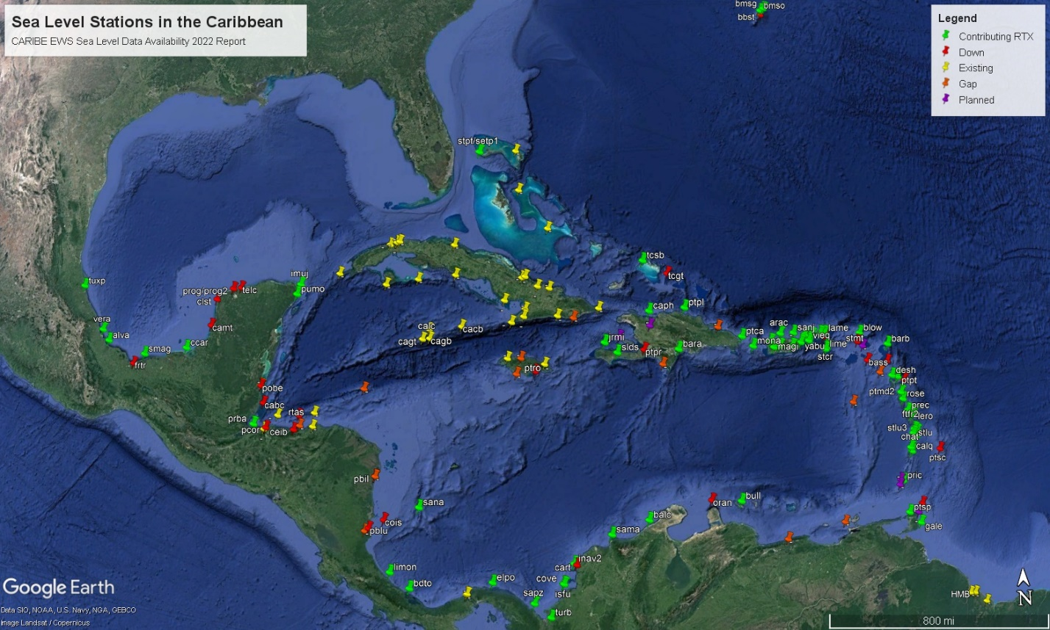

*Figure 1. December 2022 Sea Level Stations Status.*

*Graph 1. Biannual variability of number of Contributing RTX coastal sea level stations and DARTs from December 2020 through December 2022.*

*Graph 2. Station Status 2020-2022*

# **UNESCO - Intergovernmental Oceanographic Commission (IOC) Sea Level Monitoring Facility (SLMF)**

The objectives of this service are:

* to provide information about the operational status of global and regional networks of real time sea level stations;
* to provide a display service for quick inspection of the raw data stream from individual stations.

This service and website (Figure 2) initially focused on operational monitoring of sea level measuring stations in Africa and was developed from collaboration between Flanders Marine Institute (VLIZ) and the ODINAFRICA project of IODE. The site has since been expanded to a global station monitoring service for real-time sea-level measuring stations that are part of IOC programs, i.e. (i) the Global Sea Level Observing System Core Network and (ii) the networks under the regional tsunami warning systems in the Indian Ocean (IOTWMS), Northeast Atlantic & Mediterranean (NEAMTWS), Pacific (PTWS) and the Caribbean (CARIBE-EWS).

In the case of the IOC SLMF, the performance ratios of the desired stations for specific time periods are accessed. A manual check is done to verify operational status and check inconsistent data. For example, if there is no sea level data, a station might appear as Contributing RTX on IOC SLMF if data on battery voltage is available. ITIC-CAR and the managers of the IOC SLMF are regularly comparing data.

A document with figures highlighting the variability of data availability per station and sensor in SLMF can also be accessed through the ITIC-CAR website. Figure 2 shows a screenshot of the map of coastal sea level stations in the IOC SLMF data base taken on January 20, 2023. As of February 2023, SLMF has been including DART stations availability in their website. More information on DARTs will be discussed in another section of this report.

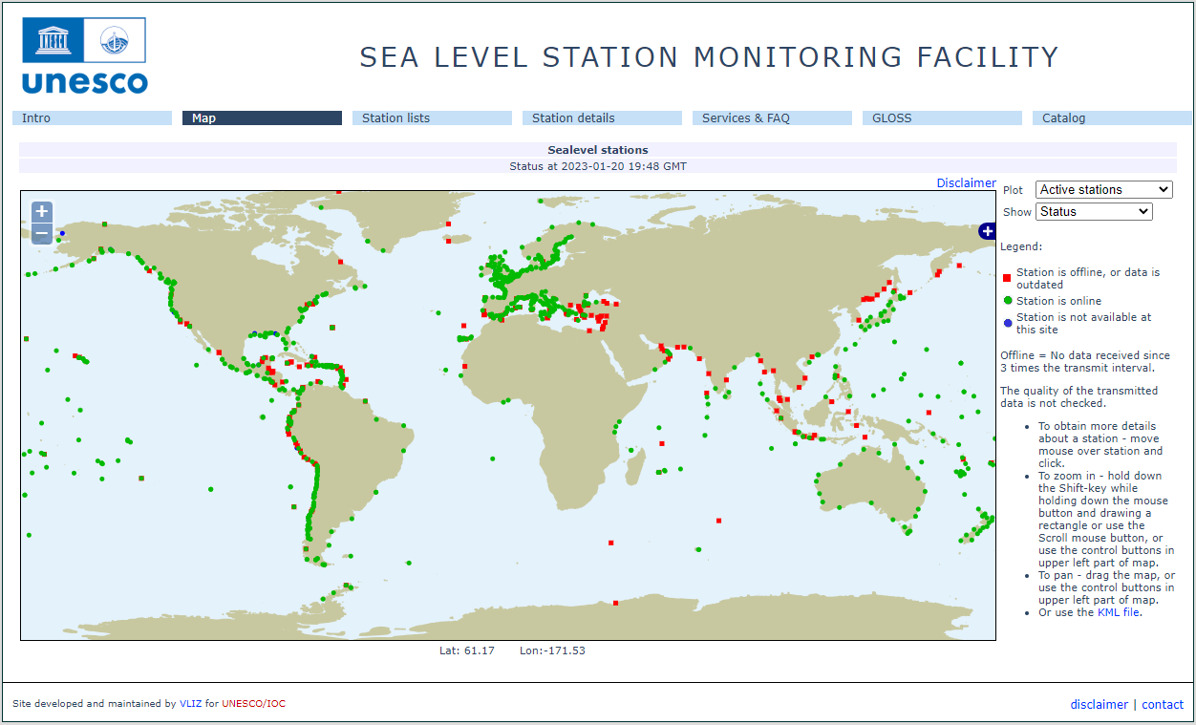

*Figure 2. Screenshot of IOC Sea Level Monitoring Station Website on Map on January 20, 2023*

# **Pacific Tsunami Warning Center (PTWC)**

The Pacific Tsunami Warning Center (PTWC) operated by the United States National Weather Service of NOAA served from 2005-2015 as the interim Tsunami Warning Center. Since 2016 the PTWC is designated as a Tsunami Service Provider (TSP) for the Tsunami and Other Hazards Warning and Mitigation System for the Caribbean and Adjacent Seas (CARIBE-EWS), a subsidiary body of UNESCO’s Intergovernmental Oceanographic Commission (IOC).

Products issued by PTWC to countries around the Caribbean in support of this mission have evolved over time as supporting data, analysis methods, computational capabilities, and communications have all improved. The products developed by the PTWC are for only advisory for the CARIBE EWS Member State. National authorities are responsible for determining the level of tsunami alert within each Member State.

On 1 March 2016, the US NOAA Pacific Tsunami Warning Center (PTWC) commenced issuance of new forecast-based Enhanced Tsunami Products for all Caribbean countries. The PTWC PTWS and CARIBE-EWS products use the same forecast methodologies and the same graphical formats to depict the tsunami threat for the basin and coastal polygons.

The PTWC depends on sea level data to confirm, forecast and determine end of threat from tsunamis in the region. In the case of non-seismic generated tsunamis, sea level data are the main mechanism used to detect and inform on tsunami threat. Over the past years the PTWC has been developing an alarm event detection system based on sea level data.

Since November 2019, the PTWC data have been incorporated into the ITIC-CAR Sea Level biannual reports to compare the data reported by the IOC SLMF with the data from PTWC. Stations reported in the PTWC are also included in the Tide Tool Sea Level Data Analysis Program. The PTWC generated map for December 2022 is shown in Figure 3. The color legend is included in the map; sea level stations are represented as circles while the DART stations are represented by triangles. These maps show the ranges of percentage availability of the *Contributing RTX* stations. *Down* stations are reported in black. *Removed*, *Planned, Gap* and *Unknown* stations are not included in the PTWC reports, nor do they appear on this map.

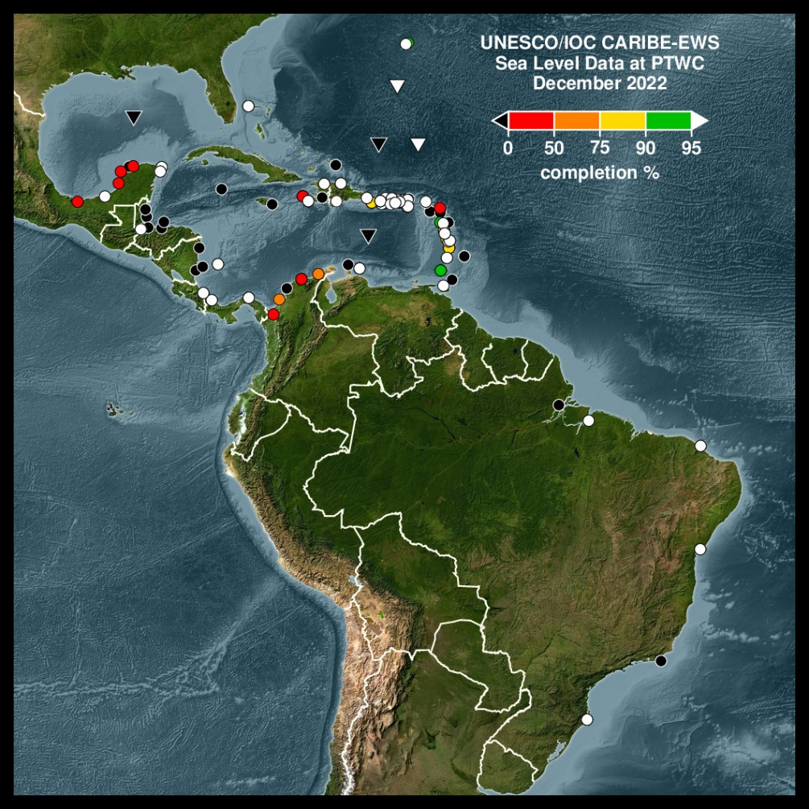

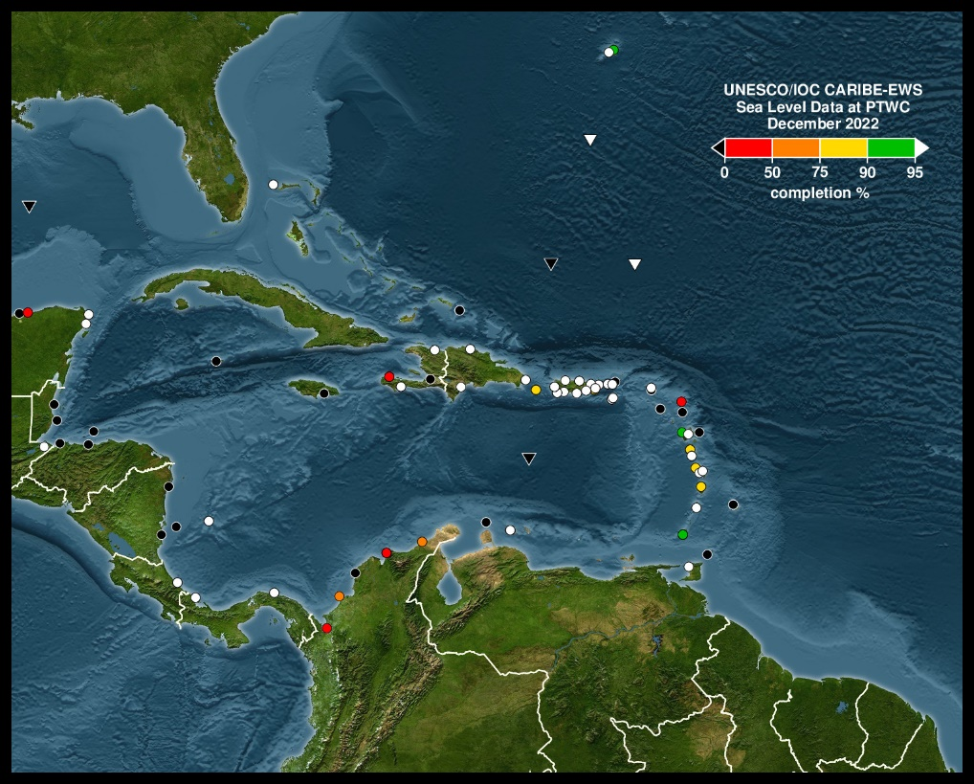

*Figure 3. Regional and Expanded maps of status data from Sea Level and DART Station at PTWCs for December 2022. Circles represent coastal sea level stations and triangles DARTs. The percentage refers to the percentage of data received at the PTWC within 15 minutes of recording.*

# **Contributing RTX Sea Level Stations**

The number of Contributing RTX stations increased during the 2021 to 2022 period from 44 stations in December 2021 to 59 stations in June 2022 and the 68 in December 2022 (Table 1). Note that the usual change goes from *Contributing RTX* to *Down* and vice versa. There were a few stations removed, and others reinstalled. Also, new stations were installed in the Cayman Islands, Saint Vincent and the Grenadines, Haiti, and Puerto Rico. Other stations like from the Dominican Republic were repaired. The evolution of sea level observations since 1960 is highlighted in Graph 3. In 2022, after several years of decreasing data availability due to the impacts of Hurricanes Irma, Maria, Eta and Iota and COVID 19 the trend has reversed thanks to contributions of Member States and Donors.

|  |  |  |  |  |  |
| --- | --- | --- | --- | --- | --- |
| **Status by amount** | | | | | |
|  | **Dec-20** | **Jun-21** | **Dec-21** | **Jun-22** | **Dec-22** |
| **Contributing RTX** | 59 | 46 | 44 | 59 | 68 |
| **Down** | 51 | 55 | 39 | 36 | 30 |
| **Existing** | 29 | 30 | 37 | 32 | 40 |
| **Gap** | 13 | 13 | 13 | 15 | 15 |
| **Planned** | 13 | 13 | 13 | 9 | 9 |
| **Removed** | 10 | 7 | 12 | 14 | 9 |
| **Unknown** | 1 | 1 | 19 | 16 | 13 |

*Table 1. Status of Sea Level Stations from December 2020 – December 2022.*

**MACC**

**CPACC**

Indian Ocean Tsunami

Hurricanes

Irma and Maria

COVID-19 Pandemic and Hurricane Iota

*Graph 3. Number of operational coastal sea level stations 1960 to 2022. )*

Of the 184 stations being reported, 176 stations are coastal sea level stations and 8 of are DARTs. The DARTs are going to be discussed in another section of this report. For the coastal Sea Level stations, each station has one or more sensors: radars (rad, ra1, ra2), pressure (prs, pr1, pr2), float (flt) or acoustic (Aquatrack, aqu). Graph 4 shows the distribution of types of sensors. For US stations, the nomenclature of primary water level sensor (pwl) or backup water level sensor (bwl) is used depending on operational status, not on the type of sensors. In the past, the pwl were mostly Aquatrack sensors, but these have been replaced with radar sensors, while bwl sensors are bubblers or pressure sensors.

For December 2022, 68 stations were contributing RTX while 30 stations were down. The other 86 stations are existing (data not available), removed, planned, unknown or represent gaps in monitoring.

*Graph 4. Types of sensors for 2022.*

# **DART**

To facilitate early detection of tsunamis and to acquire data critical to real-time forecasts, NOAA operates Deep-ocean Assessment and Reporting of Tsunami (DART®) stations at sites in regions with a history of generating destructive tsunamis. NOAA completed the original 6-buoy operational array (map of original six stations) in 2001 and expanded to a full network of 39 stations in March 2008. See [DART® development](https://nctr.pmel.noaa.gov/Dart/index.html) for more info. Since 2008 there have been changes of locations and upgraded technology.

The National Data Buoy Center (NDBC) currently is responsible for the operation of the DARTs. However, the Pacific Tsunami Warning Centre and the IOC Sea Level Monitoring Facility also report DART stations availability using NOAA web services.

The DARTs in the Caribbean and Atlantic and included in the report are: Southeast Block Canyon ([DART 44402](https://www.ndbc.noaa.gov/station_page.php?station=44402)), Sable Island Bank ([DART 44403](https://www.ndbc.noaa.gov/station_page.php?station=44403)), Southwest Bermuda ([DART 41425](https://www.ndbc.noaa.gov/station_history.php?station=41425)), South of Puerto Rico ([DART 42407](https://www.ndbc.noaa.gov/station_page.php?station=42407)), Gulf of Mexico ([DART 42409](https://www.ndbc.noaa.gov/station_history.php?station=42409)), Dart Wave Glider Station, West Florida Area ([DART 42429](https://www.ndbc.noaa.gov/station_page.php?station=42429)), North of St. Thomas ([DART 41421](https://www.ndbc.noaa.gov/station_page.php?station=41421)) and North of Santo Domingo ([DART 41420](https://www.ndbc.noaa.gov/station_page.php?station=41420)). At the end of 2022 the only stations reporting data online were the DARTs in the Southeast Block Canyon, Southwest Bermuda, and North of St. Thomas (Figures 4 and 5). Graph 5 illustrates the variability of availability of DART data between December 2020 and 2022.

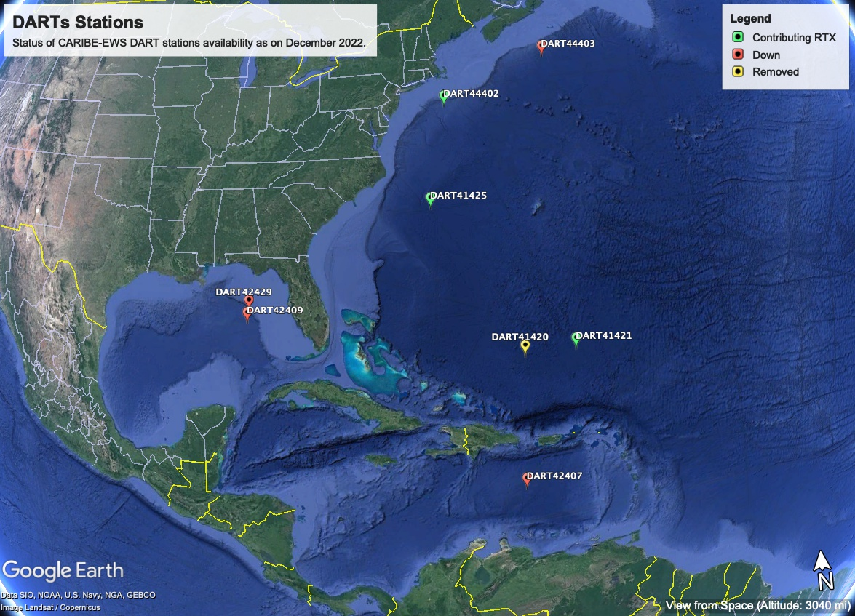

*Figure 4. Map of DART stations for December 2022.*

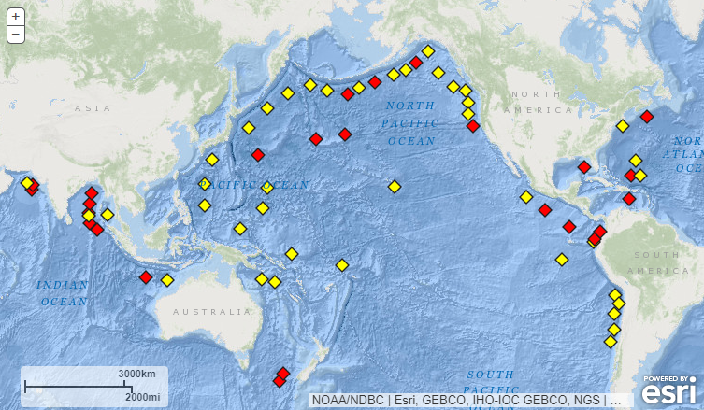

*Figure 5. Originally developed by NOAA, as part of the U.S. National Tsunami Hazard Mitigation Program (NTHMP), the DART® Project was an effort to maintain and improve the capability for the early detection and real-time reporting of tsunamis in the open ocean.[1] January 20, 2023. Stations in yellow are operational and in red non operational.*

*Graph 5. DART Buoys availability status December 2020 – December 2022.*

# **Appendix List**

* Appendix A: Sea Level Station List and Status 2022

|  |  |  |
| --- | --- | --- |
| ***Appendix A: Sea Level Stations December 2022*** | | |
| ***Station name*** | **Country** | **Status** |
| *Blowing Point* | Anguilla | Contributing RTX |
| *Barbuda* | Antigua and Barbuda | Contributing RTX |
| *Parham (Camp Blizard), Antigua* | Antigua and Barbuda | Down |
| *Oranjestad* | Aruba | Down |
| *Settlement Point* | Bahamas | Contributing RTX |
| *Lee Stocking Island, Exuma* | Bahamas | Existing |
| *Matthew Town, Inagua* | Bahamas | Existing |
| *Nassau Harbour, New Providence* | Bahamas | Existing |
| *Treasure Cay, Abaco* | Bahamas | Existing |
| *Bridgetown Port* | Barbados | Unknown |
| *Port St. Charles* | Barbados | Down |
| *Pelican Fort* | Barbados | Removed |
| *Conset Bay* | Barbados | Removed |
| *Speightstown* | Barbados | Removed |
| *Carrie Bow Cay* | Belize | Down |
| *Belize City* | Belize | Planned |
| *Belize* | Belize | Existing |
| *Port of Belize* | Belize | Down |
| *St. Georges Cruice Pier* | Bermuda | Contributing RTX |
| *St. Georges Island / Esso Pier* | Bermuda | Unknown |
| *Bermuda Biological Station* | Bermuda | Down |
| *Bermuda Somerset* | Bermuda | Contributing RTX |
| *Road Town Harbor, Tortola* | British Virgin Islands | Down |
| *Cayman Brac* | Cayman Islands | Existing |
| *George Town* | Cayman Islands | Existing |
| *Gun Bay* | Cayman Islands | Existing |
| *Little Cayman* | Cayman Islands | Existing |
| *Ballenas* | Colombia | Contributing RTX |
| *Cartagena* | Colombia | Down |
| *San Andres* | Colombia | Contributing RTX |
| *Santa Marta* | Colombia | Contributing RTX |
| *Capurganá* | Colombia | Removed |
| *Sapzurro* | Colombia | Contributing RTX |
| *Turbo* | Colombia | Contributing RTX |
| *Islas del Rosario* | Colombia | Removed |
| *Isla Naval* | Colombia | Contributing RTX |
| *Isla Fuerte* | Colombia | Contributing RTX |
| *Coveñas* | Colombia | Contributing RTX |
| *Puerto Estrella* | Colombia | Unknown |
| *Limón* | Costa Rica | Contributing RTX |
| *Cabo Cruz* | Cuba | Existing |
| *Cabo San Antonio - Morros de Piedra* | Cuba | Existing |
| *Gibara* | Cuba | Existing |
| *Isabela de Sagua* | Cuba | Existing |
| *Manzanillo* | Cuba | Existing |
| *Guantanamo* | Cuba | Gap |
| *Casilda* | Cuba | Existing |
| *Maisí* | Cuba | Existing |
| *Mariel Boca* | Cuba | Existing |
| *Bahia de la Habana* | Cuba | Existing |
| *Nuevitas Punta de Practicos* | Cuba | Existing |
| *Puerto Padre* | Cuba | Existing |
| *Nuevitas Bufaderos* | Cuba | Existing |
| *Siboney* | Cuba | Existing |
| *Santiago de Cuba* | Cuba | Existing |
| *Santa Cruz del Sur* | Cuba | Existing |
| *Carapachibey* | Cuba | Existing |
| *Cayo Loco* | Cuba | Existing |
| *Cayo Largo* | Cuba | Existing |
| *La Coloma* | Cuba | Existing |
| *Bullen Bay* | Curacao | Contributing RTX |
| *Portsmouth* | Dominica | Planned |
| *Marigot* | Dominica | Unknown |
| *Roseau* | Dominica | Contributing RTX |
| *Portsmouth* | Dominica | Contributing RTX |
| *Barahona* | Dominican Republic | Contributing RTX |
| *Puerto Caucedo/San Andres/Santo Domingo* | Dominican Republic | Unknown |
| *Puerto Plata* | Dominican Republic | Contributing RTX |
| *Punta Cana* | Dominican Republic | Contributing RTX |
| *Bahía de Luperón* | Dominican Republic | Gap |
| *Bahía de Samaná* | Dominican Republic | Gap |
| *Bayahibe* | Dominican Republic | Gap |
| *Pedernales* | Dominican Republic | Gap |
| *Puerto de Santo Domingo* | Dominican Republic | Removed |
| *Ile Royale* | French Guiana | Contributing RTX |
| *Prickly Bay* | Grenada | Contributing RTX |
| *Sauteurs* | Grenada | Planned |
| *The Sisters Island* | Grenada | Planned |
| *Pointe à Pitre* | Guadeloupe | Contributing RTX |
| *Deshaies Harbour* | Guadeloupe | Contributing RTX |
| *La Désirade Island, Grande Anse Marina Harbour* | Guadeloupe | Down |
| *Puerto Barrios* | Guatemala | Contributing RTX |
| *Harbour Master Boathouse* | Guyana | Existing |
| *Market Place Georgetown* | Guyana | Existing |
| *Rosignol* | Guyana | Existing |
| *Parika* | Guyana | Existing |
| *Cap Haitien* | Haiti | Contributing RTX |
| *Jacmel* | Haiti | Unknown |
| *Port au Prince* | Haiti | Down |
| *Gonaives* | Haiti | Planned |
| *Port de Paix* | Haiti | Planned |
| *Jeremie* | Haiti | Contributing RTX |
| *St. Louis du Sud* | Haiti | Contributing RTX |
| *Guanaja Island* | Honduras | Existing |
| *Omoa* | Honduras | Existing |
| *Puerto Cortes* | Honduras | Down |
| *Puerto De Castilla, Trujillo* | Honduras | Existing |
| *Roatan N* | Honduras | Existing |
| *Punta Gorda Harbor, Roatan S* | Honduras | Down |
| *Tela Harbor* | Honduras | Unknown |
| *Utila Island* | Honduras | Unknown |
| *Cabotaje Harbor, La Ceiba* | Honduras | Down |
| *Cochino Pequeño* | Honduras | Gap |
| *Swan Island* | Honduras | Gap |
| *Port Royal* | Jamaica | Down |
| *Montego Bay* | Jamaica | Existing |
| *Port Antonio* | Jamaica | Existing |
| *Discovery Bay, Jamaica* | Jamaica | Gap |
| *Alligator Pond* | Jamaica | Gap |
| *Fort de France Harbour* | Martinique | Contributing RTX |
| *Le Precheur Harbour* | Martinique | Contributing RTX |
| *Le Robert* | Martinique | Contributing RTX |
| *Alvarado* | Mexico | Contributing RTX |
| *Celestun* | Mexico | Down |
| *Ciudad del Carmen* | Mexico | Contributing RTX |
| *Lerma Campeche* | Mexico | Down |
| *Frontera* | Mexico | Down |
| *Isla Mujeres* | Mexico | Contributing RTX |
| *Progreso* | Mexico | Down |
| *Puerto Morelos, Q. R.* | Mexico | Contributing RTX |
| *Sanchez Magallanes* | Mexico | Contributing RTX |
| *Sisal* | Mexico | Unknown |
| *Tuxpan* | Mexico | Contributing RTX |
| *Telchac* | Mexico | Down |
| *Veracruz* | Mexico | Contributing RTX |
| *Montserrat* | Montserrat | Gap |
| *Corn Island* | Nicaragua | Down |
| *Blue Fields* | Nicaragua | Gap |
| *Puerto Bilwi* | Nicaragua | Down |
| *Puerto Cabezas* | Nicaragua | Gap |
| *Puerto El Bluff* | Nicaragua | Down |
| *El Porvenir* | Panama | Contributing RTX |
| *Bocas del Toro* | Panama | Contributing RTX |
| *Galeta Point* | Panama | Existing |
| *Limon Bay (replaced Coco Solo)* | Panama | Existing |
| *Aguadilla* | Puerto Rico | Unknown |
| *Arecibo* | Puerto Rico | Contributing RTX |
| *Culebra Island* | Puerto Rico | Contributing RTX |
| *Fajardo* | Puerto Rico | Contributing RTX |
| *Guayanilla* | Puerto Rico | Contributing RTX |
| *Isabel II, Vieques* | Puerto Rico | Contributing RTX |
| *La Esperanza, Vieques* | Puerto Rico | Contributing RTX |
| *Magueyes Island* | Puerto Rico | Contributing RTX |
| *Mayagüez* | Puerto Rico | Contributing RTX |
| *Mona Island* | Puerto Rico | Contributing RTX |
| *Salinas* | Puerto Rico | Contributing RTX |
| *San Juan* | Puerto Rico | Contributing RTX |
| *Yabucoa* | Puerto Rico | Contributing RTX |
| *Peñuelas* | Puerto Rico | Removed |
| *Caja de Muertos* | Puerto Rico | Removed |
| *Baseterre (Coast Guard Base)* | St. Kitts & Nevis | Down |
| *Dennery Harbour* | St. Lucia | Contributing RTX |
| *Soufriere* | St. Lucia | Contributing RTX |
| *Vieux Fort Bay* | St. Lucia | Contributing RTX |
| *Ganter's Bay* | St. Lucia | Contributing RTX |
| *Calliaqua (Coast Guard Base)* | St. Vincent & the Grenadines | Contributing RTX |
| *Chateau Bel-Air* | St. Vincent & the Grenadines | Contributing RTX |
| *Gustavia* | St. Barthelemy | Planned |
| *Saint Martin Island* | St. Martin | Down |
| *Cedros Bay* | Trinidad and Tobago | Unknown |
| *Charlotteville* | Trinidad and Tobago | Unknown |
| *Point Fortin* | Trinidad and Tobago | Unknown |
| *Port Of Spain* | Trinidad and Tobago | Contributing RTX |
| *Scarborough* | Trinidad and Tobago | Down |
| *Toco Trinidad* | Trinidad and Tobago | Planned |
| *Point Galeota* | Trinidad and Tobago | Contributing RTX |
| *Point a Pierre* | Trinidad and Tobago | Planned |
| *Grand Turk* | Turks and Caicos | Down |
| *Sapodilla Bay, Providenciales* | Turks and Caicos | Contributing RTX |
| *Charlotte Amalie, St. Thomas* | USVI | Contributing RTX |
| *Christiansted Harbor, St. Croix* | USVI | Contributing RTX |
| *Lameshur Bay, St. John* | USVI | Contributing RTX |
| *Lime Tree Bay, St. Croix* | USVI | Contributing RTX |
| *Aves Island* | Venezuela | Gap |
| *Punta Arenas, Margarita Island* | Venezuela | Gap |
| *La Guaira* | Venezuela | Gap |

1. <https://www.ndbc.noaa.gov/dart/dart.shtml>