ICG/CARIBE EWS-XVI/4.1

Costa Rica, April 2023


INTERGOVERNMENTAL OCEANOGRAPHIC COMMISSION

(of UNESCO)

Sixteenth Session of the Intergovernmental Coordination Group for the Tsunami and Other Coastal Hazards Warning System for the Caribbean and Adjacent Regions

(ICG/CARIBE EWS-XVIII)

26-28 April 2023

Agenda Item 4.1

Working Group 1 Monitoring and Detection Systems

Progress Report

This document presents the recommendations, conclusions and a proposed work plan of Working Group 1 "Monitoring and Detection Systems". The ICG is requested to consider, comment and eventually endorse the recommendations issued by Working Group 1.

Introduction, Summary, Considerations/Challenges

The purpose of Working Group 1 is to review and recommend, to the ICG, priorities and actions required towards the full establishment of a coordinated regional tsunami warning system. The functions of WG1 are:
- Advise member states on the monitoring and detection capabilities needed for operating national tsunami warning centers.
- Define the threshold criteria for the monitoring and warning systems.
- Assure the compliance with the agreed standards for the detection systems.
- Ensure the effectiveness of the warning system by promoting the open exchange of seismic, sea level and other observational data in real time.
- Promote the sharing of experience and expertise and capacity building essential to the effective monitoring.
- Support the establishment of a fully interoperable regional tsunami warning system

Working Group Inter-sessional Activity

According to ICG-VIII recommendations, the International Tsunami Information Center (ITIC) Caribbean Office (ITIC-CAR) hosts regular conference calls and/or webinars between WG1, data providers and users to address potential issues in data availability that included regional international networks, PRSN, US-NTWC, US-PTWC, USGS NEIC and IRIS DMC. In 2022, the IRIS DMC merged with UNAVCO to become the Earthscope data services (DS) and communication between WG1, ITIC-CAR and network operators was mostly done via email and online virtual webinars.

Summary of significant issues and activity during inter-sessional period 2022:

- PTWC is producing regular monthly maps of seismic and sea-level station data availability. These are very good summary maps that are used for WG1/ITIC-CAR communications with station operators.

- Updated the Earthscope Data Services (DS) (Formerly IRIS DMC) CARIBE-EWS virtual seismic network with current state of real-time data flow. Significant updates include changes in PRSN (net code PR) station naming since the post Maria rebuild and updates to seismic status operational status in Colombia (net code CM).

- Major seismic station outages in central America have continued in 2022. WG1 notes significant problems with data from Honduras, Nicaragua, Costa Rica, Panama.

- PRSN seismic station rebuild is 100% complete on the island of Puerto Rico. USGS and PRSN continue to resolve upgrades and maintenance issues on the outer islands.

- Sea-level station outages have increased significantly over the past few years. Currently, critical sea-level stations in Haiti, Jamaica, St Martin and Barbados are not operational. Stations in the eastern Caribbean near active volcanoes on Martinique and St. Vincent should be considered high priority.

- In 2022, NOAA Darts have been returned to their locations and are once again transmitting real-time data after becoming unmoored and stopped transmitting data.

- UNAVCO/Earthscope increased the number of real-time GNSS stations available for tsunami early warning systems by upgrading and .repairing stations in the NOTA network. The network is now 80% operational.

- Transitions in WG1 membership
  - Rotate off/Resignation
    - Emily Wolin, USGS GSN, United States - Invited seismic expert
  - New invited experts and members
    - Annie Zaino, Earthscope, United States - Invited GSNN expert

The Caribbean is unique in that multiple sources of tsunami hazard are present due to earthquake and volcanic activity and submarine landslides. Because of the multiple types of sources, a diverse multi-instrumental warning and detection system is critical.

Significant earthquake activity. In the years 2021-2022 only one significant earthquake with a moment magnitude (Mw) of 6 and larger occurred in the Caribbean region. On 2021-08-14 12:29:08 (UTC) a Mw 7.2 earthquake occurred near Nippes, Haiti. No tsunami was observed. In 2022, there were no earthquakes with Mw greater than 6.

Significant Volcanic Activity. There are currently two active volcanoes in the eastern Caribbean region. Since December 2020, La Soufrière on St Vincent Island has been active, with the growth of a lava dome inside the crater, and more recently by increasing explosive activity. Colleagues in charge of Soufriere volcano monitoring, the Seismic Research Center (SRC), report that pyroclastic flows produced by the eruption of Soufrière St Vincent have descended the western flank of the volcano and have reached the Caribbean sea. Our Tsunami Service Provider (TSP) has observed the 19th of April 2021 a 10-cm high tsunami on a tide gauge located to the south of St Vincent, 13 min after its origin. Therefore sea-level instrumentation was installed closer to the base of the volcano was deployed in Chateaubelair in 2021. The sensor continues to operate and monitor volcanic and landslide activity. In addition, Mount Pelée on the French island of Martinique is showing signs of reactivation (seismic swarms). The volcano is currently monitored by IPGP. For additional information see the report of the task team on tsunami procedures for volcanic crises submitted to the ICG Caribe EWS-XVIII.

Status of Monitoring systems in 2022

Seismic and sea-level data are critical for the timely and accurate issuance of tsunami messages and also for tsunami hazard research. The NOAA ITIC-CAR tracks data availability from the CARIBE EWS seismic and sea-level stations available in real-time to the international Pacific (PTWC) and US National (NTWC) tsunami warning centers. ITIC-CAR monthly reports on the status of seismic and sea-level stations are available online (https://www.weather.gov/ctwp/seismic; https://www.weather.gov/ctwp/stations). WG1 notes that ITIC-CAR has invested in automated report processing which has significantly reduced processing time and required resources.

Status of Seismic Monitoring Networks

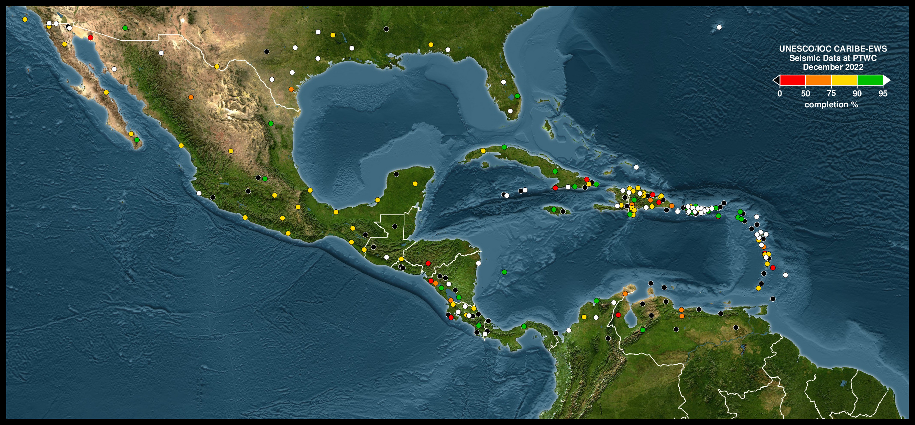
Seismic data is critical for the timely and accurate issuance of tsunami messages and also for tsunami hazard research. The NOAA ITIC-CAR tracks data availability from the CARIBE EWS seismic stations in real time for tsunami warning centers (TWCs) (Figure 1) and archived by EarthScope Data Services (DS) for distributions to partner real-time monitoring agencies and for research applications. A main task of the WG1 is to work with the Earthscope DS to update seismic station lists used in ITIC-CAR reports to ensure that the correct netcodes and station names are being used. The Earthscope DS CARIBE-EWS virtual seismic network was established to aggregate all the information on the seismic stations, (http://www.iris.edu/gmap/_CARIBE-EWS), including metadata (http://service.iris.edu/irisws/metadatachange/1/). In addition, Earthscope DS maintains status information for all contributing seismic networks. For additional information, see the examples from central America below:
- http://ds.iris.edu/mda/NU/ Nicaragua, INETER
- http://ds.iris.edu/mda/SV/ El Salvador, MARN
- http://ds.iris.edu/mda/GI/ Guatemala, INSIVUMEH
- http://ds.iris.edu/mda/PA/ Panamá
- http://ds.iris.edu/mda/OV/ Costa Rica, OVSICORI
- http://ds.iris.edu/mda/TC/ Costa Rica, University of Costa Rica

The PRSN website also shows the status of seismic stations contributing to the Caribe-EWS virtual seismic network (http://www.prsn.uprm.edu/English/EstacionesV3/seismometers.php.

Figure 1 is a map of the data availability at the US-PTWC. The map shows the uptime percentage of the real-time seismic stations received at the PTWC within 1 minute of recording in December 2022. In 2020, the PTWC began regularly producing the station status maps. These are very valuable for coordination between the WG1/ITIC-CAR and regional network operators.

Throughout 2022, there have been improvements in seismic data availability in the eastern and northeastern Caribbean. WG1 notes improvements made by the Dominican Republic and the US Virgin Islands. However, outages continue throughout much of Central America, Venezuela, the Caymans and throughout the lesser Antilles. Seismic station outages in Central America are of critical importance given the small distance between the Pacific Ocean and Caribbean Sea and possibility of locating hypocenters in the wrong ocean basin. Wilfried Strauch from INETER, Nicaragua is the WG1 vice-chair for seismic and has communicated with many network operators in the region to determine the source of the seismic data outages and status of repairs. Maintenance issues and scheduling are summarized by the country below.

Guatemala (GI). Numerous stations are down and need repair. Additional stations can be added to the PTWC real-time stream if needed.

El Salvador (SV). Several stations are down and need repair. Additional stations can be added to the PTWC real-time stream if needed.

Panama. One station (BRU2, network PA from Angel Rodríguez) is available at Earthscope DS and the PTWC. The national network (RP) is operated by the University of Panama and they have not been interested in sharing real-time data. The Panama Canal Authority operates a local network (PC). They have one broadband station; CATAC is receiving its data and PTWC could get the data by contacting the operator.

Costa Rica. Two distinct networks operate. OVSICORI (OV), Four stations are available at Earthscope DS but not at the PTWC. The number of their open stations has decreased dramatically in the past 3 years. Sylvia Chacon indicates that they are having IP problems and are in contact with PTWC to update IP addresses. University of Costa Rica (TC), Most of the network (15 stations) available in real-time at Earthscope but not at the PTWC. WG1 recommends adding additional real-time stations in Costa Rica to PTWC real-time monitoring systems.

Nicaragua (NU). CATAC/INETER maintains direct links to the PTWC, Earthscope, PRSN and USGS and notes that only PTWC are not receiving real-time data though they should have access to all Nicaraguan broadband stations. In previous meetings of the ICG, WG1 recommended checking on IP addresses used for INETER stations at the PTWC. CATAC/INETER has revised its seedlink server, updated dataless files and informed PTWC (Weinstein) about the changes indicating also the stations with the lowest noise. CATAC will provide a redundant seedlink server for PTWC of all INETER stations. CATAC asked Guatemala and El Salvador to take similar measures to ensure data availability to PTWC. WG1 recommends that CATAC act as a regional realtime seismic data aggregator/hub for central America and Earthscope DS act as a backup.

Colombia – Edwin Mayorga reports that the MON station was closed and a substitute being identified. WG1 recommends adding data from the new station will be sent in real-time to the PTWC. In general problems with OCA and CAP2 continue to occur and the PRWC reports inconsistent reception.

KNMI (NA) reports that real-time data from additional NA stations near existing stations SABA, SEUS, SMRT are available for PTWC as a backup to fill the gaps in the southeast and northwest Caribbean. WG1 recommends notifying KNMI if there is interest to use these data for backup and redundancy.

PRSN upgrades and repairs due to damage from Hurricane Maria are 100% complete on the island of Puerto Rico. Issues still remain for stations on the outer islands. The ANSS is in discussion with PRSN staff for planned work/logistics on Mona Island and Caja de Muertos. In addition, updates to station location code changes were required at the PTWC and Earthscope DS for stations recovered after Hurricane Maria repairs. These name change updates are required to ensure that real-time systems are configured correctly to ensure data flow.

Venezuela. The seismic network is completely down. Wilfried Strauch has contacted FUNVISIS to gather more information on the status of the network but no answer so far. WG1 recommends continued efforts to contact FUNVISIS regarding the status of their network.

Cuba: Only two stations are currently not operational. Nine stations are open and streaming real-time data to PTWC, CATAC, Earthscope DS, USGS and PRSN. The Cuban Seismic Network received significant equipment strengthening in 2020 and 2021.

WG1 member, Jean Marie Saurel from the IPGP in Paris, reports problems with three seismic stations in the Lesser Antilles. MPOM is done due to stolen solar power equipment and land ownership problems. We have the replacement equipment but are waiting the land property issue to be solved. Hopefully, issues will be solved and the station brought back online this year. MAGL has cable wearing issues due to constant ripping against concrete. This will be solved in the upcoming weeks and the station will be on again. SAM has power issues, the station only works during daylight. The solar station will be reinforced this year.

In summary, many of the stations in Figure 1 with low to no data availability are working but have problems due incorrect IP addresses, changes with the instrumentation and outdated metadata. WG1 recommends a complete review and update of seismic meta-data and IP addresses at PTWC and NTWC for problem stations. In addition, the WG1 recommends exploring alternate sources of seismic data in the region such as CATAC acting as a regional hub for central America, the RaspberryShake citizens network, existing stations available through the Earthscope DS and other redundant stations mentioned in the summary above.

USGS Activity in 2022. Figure 1 shows several stations operated by the USGS and PRSN as part of the Global Seismographic Network (GSN) and Advanced National Seismic System (ANSS). WG1 has a new invited expert from the USGS National Earthquake Information Center (NEIC) (Paul Earle) to report on the status of GSN and ANSS stations used by the CARIBE-EWS, PTWC and NTWC. Maintenance issues and scheduling are summarized below.

GSN and ANSS stations, shown in Figure 1, have been operating in stable conditions streaming data with relatively low latency during the inter-sessional period in 2022. There are no significant operational issues to report. Current real-time station latency status is available online at the following URLs.

ANSS Station Status:

https://earthquake.usgs.gov/monitoring/operations/network.php?virtual_network=ANSS

GSN Station Status:

https://earthquake.usgs.gov/monitoring/operations/network.php?virtual_network=GSN

WG1 notes the difficulty in operating seismic instrumentation in the Caribbean. The region is regularly exposed to hurricanes, tsunamis, earthquakes and volcanoes and as a result the regional network of seismic stations can have non-operational instrumentation for many months to years causing performance of the network to be significantly compromised.

Minimum seismic network performance requirements established by the CARIBE-EWS are assessed regularly by the WG1. Minimum seismic network performance requirements established by the CARIBE-EWS WG1 for initial earthquake locations include: 1) Earthquake detection within 1 minute, and 2) minimum magnitude threshold M=4.5. Previous WG1 reports indicate that these criteria are met when 100% of the CARIBE-EWS seismic stations are operating. When all CARIBE-EWS seismic stations are operational and reporting real-time data to the PTWC and NTWC, the minimum detection time of 1 minute is achieved throughout most of the Caribbean region where tsunamigenic earthquakes are most likely to occur McNamara et al., (2016).

Losing real-time data from a complete network, as is currently the case in Venezuela, and central America for most of 2022, can have a significant impact on the earthquake magnitude detection threshold and detection time. As an example, in a study of improvements in earthquake monitoring capabilities in the Caribbean, McNamara et al., (2016) modeled an increase in P-wave detection time of 30–60 s along the Caribbean coast of Venezuela can occur with the loss of real-time seismic stations (red triangles) operated by FUNVISIS (Fundación Venezolana de Investigaciones Sismológicas) (Figure 2). In this case, the minimum seismic network performance requirements established by the CARIBE-EWS WG1 for initial earthquake detection time are not achieved.

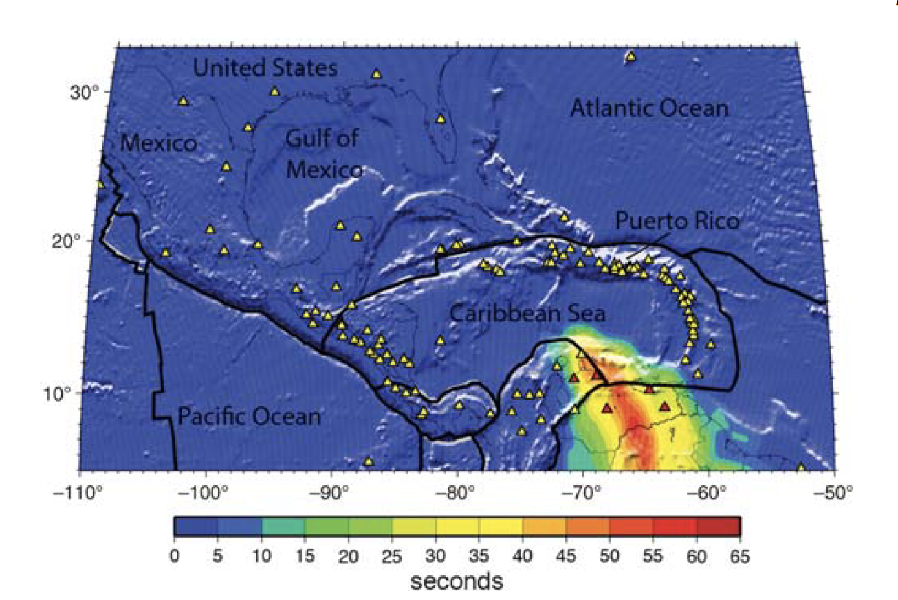

Figure 2: P-wave detection time increase modeled assuming the absence of the FUNVISIS seismic network (McNamara et al., 2016). Tectonic plate boundaries (black lines) are likely tsunamigenic earthquake source zones. Yellow triangles show seismic stations in the CARIBE-EWS virtual network. Real-time seismic stations operated by FUNVISIS (Fundación Venezolana de Investigaciones Sismológicas) (red triangles). Tectonic plate boundaries (black lines) are where earthquakes are most likely to occur from (Bird 2003).

Major seismic station outages in central America (Honduras, Nicaragua, Costa Rica, Panama, Guatemala, El Salvador) are of critical importance to tsunami warning systems. In addition to increasing earthquake detection time and magnitude threshold, significant increase in hypocenter uncertainty can result. Earthquake location uncertainty in central America is critical due to proximity of ocean basins and the possibility of locating a tsunamigenic earthquake in the incorrect basin.

Status of Sea-level Monitoring Networks

Real-time data sea level networks are one of the essential components of tsunami warning systems. After the seismic information has been received and analysed, certain seismic parameters are met establishing a potential tsunami threat; sea level and water pressure data allow PTWC to confirm the hazard and forecast its severity or to declare the threat is over. In the case that the tsunami is generated by a non-seismic source, the sea level data will be the primary tool for the detection and evaluation of the threat. There are different types of sea level data that can be used to detect tsunami waves: data from coastal tsunami ready sea-level stations, HF radar and offshore tsunameter ocean buoys. In 2022, two NOAA operated Darts stopped transmitting data (Figure 3).

According to the 2022 sea level report prepared by the ITIC-CAR, during the inter-sessional period it was noted by WG1 and ITIC-CAR in network operator discussions that sea-level station outages have increased significantly over the past few years (Figures 3). In the report of coastal sea level stations and DARTs contributing to the CARIBE EWS in 2022, as of December 2022, of 184 stations in the CARIBE-EWS sea level inventory, data from 68 were available in support of tsunami warning. This includes 3 of the 8 DART stations. In contrast, in December 2021 there were a total of 177 stations and 44 contributing data to the TWCs. A small increase in the number of available stations cured in 2022.

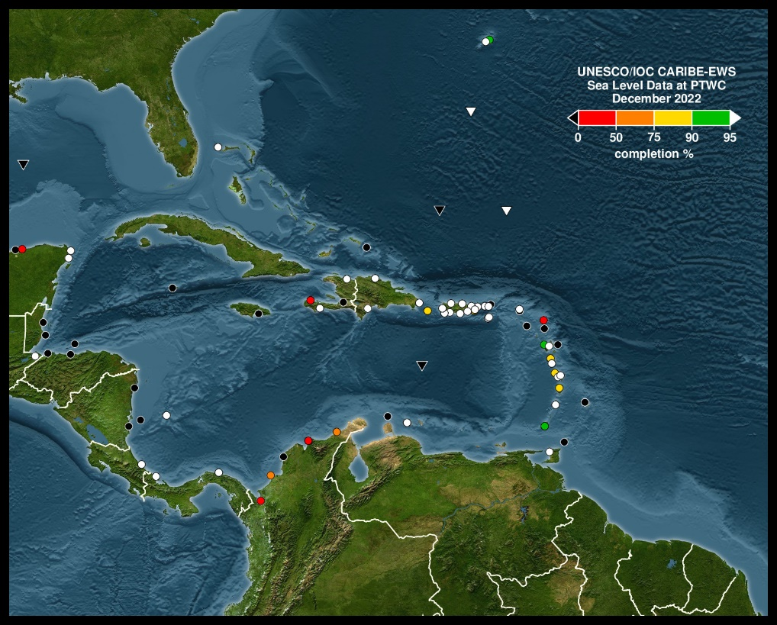
Figure 3. Regional and Expanded maps of status data from Sea Level and DART Station at PTWCs for December 2022. Circles represent coastal sea level stations and triangles DARTs. The percentage refers to the percentage of data received at the PTWC within 15 minutes of recording.

Currently, critical sea-level stations in Haiti, Jamaica, St Martin and Barbados are not operational. Stations in the eastern Caribbean near active volcanoes on Martinique and St. Vincent should be considered high priority. At the end of 2022 the only stations reporting data online were the DARTs in the Southeast Block Canyon, Southwest Bermuda, and North of St. Thomas.

WG1 notes the difficulty in operating sea-level instrumentation in the eastern Caribbean. The region is regularly exposed to hurricanes, tsunamis, earthquakes and volcanoes and as a result the regional network of sea-level stations can have non-operational instrumentation for many months to years. In this case, performance of the already sparse network is significantly compromised. WG1 strongly encourages the Member States which have non-operational stations to inform the Secretariat of their plans or needs for repair. WG1 also recommends that network operators seriously consider the experience from Hurricanes Harvey, Irma, Maria and Nate to increase the resistance of sea level facilities to powerful hurricanes and to recover and expand the DART services in the Caribbean basin (Figure 3).

Status of GNSS Monitoring Networks

The on-going work in the GNSS sub-group of WG1 includes a continuation of the work started in the GNSS Task Team, formed at the 12th Session of the ICG-CARIBE-EWS. The results of this task team included: 1) the development of a list of GNSS network operators in the region and their contact information, 2) an inventory of existing GNSS stations that matched the requirements criteria, 3) modelling of the detection capability of the initial GNSS network and, 4) a determination of locations where additional GNSS stations need to be installed in the region.

There are currently 130 real-time GNSS stations within the Caribbean region being processed at the Earthscope DS real-time data processing center in Boulder, CO (Figure 4). Many of these GNSS stations are currently not operational. These GNSS stations include stations operated from the NOTA network (48 stations) (Figure 5), UNAM (9 stations), OVSICORI (1 station), PRSN (6 stations), and other network operators in the Dominican Republic (4 stations), Ecuador (6 stations), Nicaragua (12 stations), and various other organizations (40 stations).

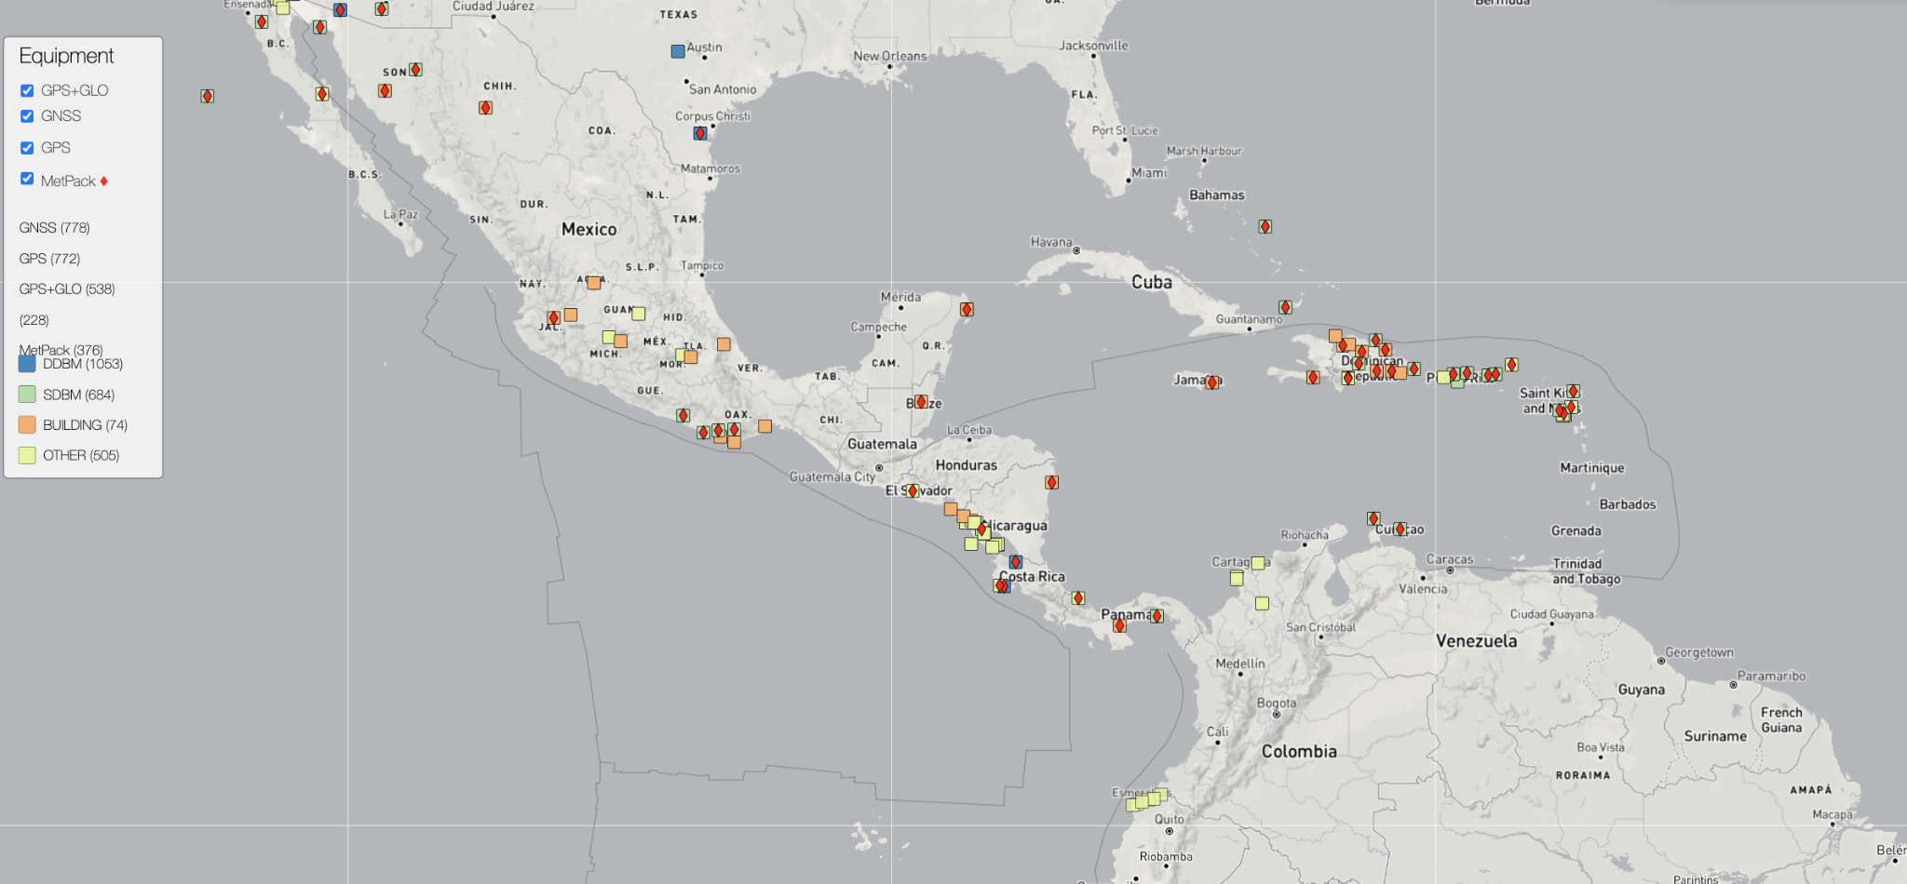

Figure 4. Real-time GNSS stations within the Caribbean region being processed at the Earthscope real-time data processing center in Boulder, CO. Still waiting for station metadata for some stations.

Network of the Americas (NOTA). During the intercessional period in 2022, a significant post-COVID field campaign was conducted to accomplish significant upgrades and improvements to NOTA. Beginning in April 2023, several GNSS sites were visited, repaired and upgraded. The field effort increased the overall uptime of the network from 45% to 80%. In addition, upgrades to communications infrastructure was conducted across NOTA to support real-time streaming of high-rate (1 Hz) data for earthquake and tsunami monitoring. The successful field campaigns were the result of the well-funded network by NSF, strong partnerships with local agencies and collaborators and over twenty site visits by Earthscope field engineers. Repair and recovery of the remaining 20% of the network is delayed due to geopolitical and safety restrictions of engineers visiting some locations and aging infrastructure and environmental conditions that increase the likelihood of equipment failures (i.e. hurricanes, corrosion and flora overgrowth).

Implementation of GNSS by NOAA. The NOAA Pacific Marine Environmental Lab (PMEL) continues to test the integration of the G-FAST software (Crowell, et al., 2018) into the SIFT (Short-term Inundation Forecasting for Tsunamis) system. The testing has been in place for about five months. After initial setup problems were overcome, testing is now on-going.

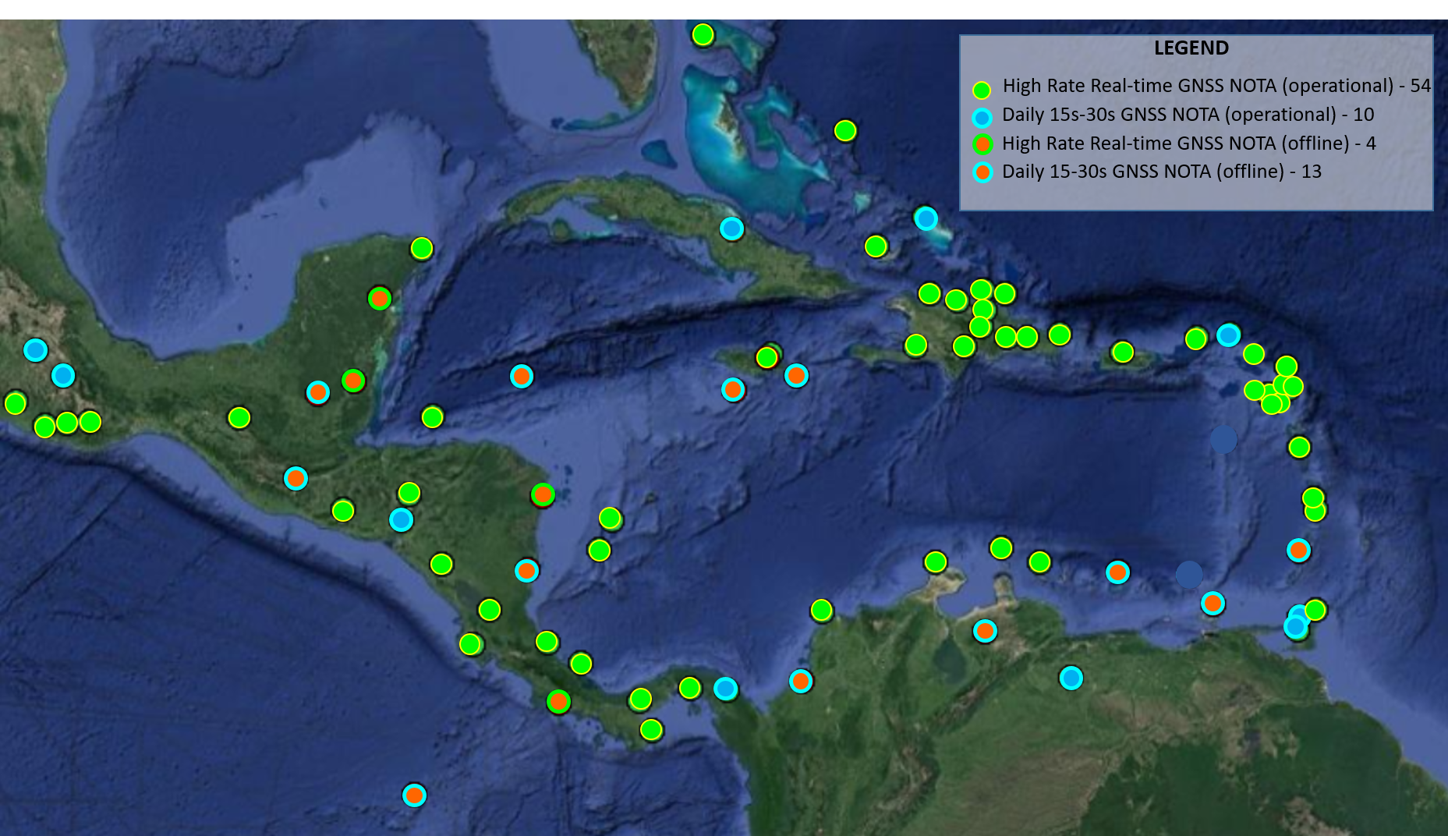

Figure 5: Network of the Americas (NOTA) GNSS stations operated by the Earthscope consortium.

Recommendations for ICG/CARIBE EWS

In light of the communication among working group members, the recommendations of Working Group 1 to the ICG/CARIBE EWS XV are as follows.

Considering​ the report of Working Group 1 on Monitoring and Detection Systems and having reviewed the status of the observational data availability in the Caribbean and Adjacent Regions;

General Recommendations

Appreciates the NOAA ITIC-CAR for improving the automated processing and continued reporting on the status of seismic and sea level stations;

Acknowledges NOAA support for the Puerto Rico Seismic Network (PRSN) to coordinate a training workshop for GNSS network operators in the region in August 2023;

Seismic Recommendations

Noting the significant outages of seismic networks in the Caribbean, WG1 recommends a study to quantify the impact of tsunami detection parameters and messaging performance;

Noting that while the PTWC reports significant seismic station outages throughout the Caribbean, WG1 recommends that the ITIC-CAR conduct a survey, with WG1, of alternate real-time stations available in the region. Sources to search include the Earthscope DS, Panama Canal authority, Raspberry shake server and other regional network with realtime data that is currently not streaming to the PTWC;

Noting the difficulty maintaining realtime data connections to the PTWC, recommends that, with permission from regional seismic network operators, CATAC act as a regional realtime seismic data aggregator/hub for central America and Earthscope DS act as a backup in order to assure the reliability;

Noting that tsunami warning time is strongly dependent seismic station distribution, WG21 recommends exploring the possibility of densifying seismic network instrumentation with new sea-floor cable technologies (SMART);

Noting the seismic station outages in the region, WG1 recommends a complete review and update of seismic meta-data and IP addresses at PTWC and NTWC for problem stations;

Encourages member state Canada to support capacity building by installing and repairing seismic instrumentation in Haiti with new federal funding opportunities;

Sea-level Recommendations

Appreciates the rapid deployment of sea-level monitoring instrumentation in response to the tsunami hazard posed by the eruptive activity and potential pyroclastic flows of La Soufrière Volcano on Saint Vincent and Mt Pelee on Martinique;

Notes that a high percentage of the stations in the CARIBE-EWS sea level network are currently non-operational and therefore can delay the proper assessment of tsunami events and the issuance of timely and accurate tsunami alerts;

Urge Member States and operators of sea level stations contributing to CARIBE EWS to maintain their sea-level stations in an operational status and regularly review and update the status of its stations in the IOC Sea Level Monitoring Facility and the ITIC-CAR reports prepared on behalf of the CARIBE EWS;

Recommends a survey of sea-level network operator status updates by WG1 and ITIC-CAR with the goal of improving the uptime of sea-level network, and strongly encourages the Member States that have non-operational stations to inform the Secretariat of their plans or needs for repair;

Encourages NOAA to rapidly repair two Darts that stopped transmitting data in 2022;

Recommends that seismic and sea-level network operators seriously consider the experience from Hurricanes Harvey, Irma, Maria and Nate to increase the resistance of sea level facilities to powerful hurricanes;

GNSS Recommendations

Recognizes the efforts of UNACVO/Earthscope to repair damaged stations and upgrade communications systems increase the availability of high rate (1 Hz), real-time GNSS data to improve earthquake and tsunamis detection and assessment, and further recommends adding and upgrading the GNSS stations needed to achieve earthquake detection requirements with sufficient redundancy;

Due to the saturation of seismic instrument for large magnitude earthquakes at near-source distances, WG1 recommends that the PTWC explore, develop and implement integrated seismic and GNSS systems for rapid earthquake source parameter estimation;

Recommends the the continuation of GNSS integration into real-time earthquake monitoring systems with periodic updates from NOAA on the progress of the system.

Working Group Internal Work Plan/Key Proposed Activities

PRSN has received funds from NOAA for a GNSS network operators workshop. Given the depreciated state of seismic monitoring in the region, the ICG should discuss including seismic network operators.

WG1 will continue to host regular network operators meetings with the ITIC-CAR to discuss monitoring status and issues in the Caribbean and to improve the capability of the PTWC and other regional tsunami warning centers.

Working Group Members

The membership of Working Group 1 in 2022 is:
Membership:
- Daniel E. McNamara - Earthscope, United States of America
- Laura Gonzales - DIMAR, Colombia
- Gloria Romero - FUNVISIS, Venezuela
- Wilfried Strauch - INETER, Nicaragua
- Christa G. von Hillebrandt-Andrade, ITIC-CAR (USA) -Invited Expert
- Lloyd Lynch, Research Fellow-Instrumentation-, Seismic Research Center -Invited Expert
- Graham Ryan, Seismic Research Center -Invited Expert
- Jean-Marie Saurel, Engineer, Observatoire de la Martinique, France (Chair).
- Marta Herrera Jiménez, INETER, Nicaragua –sea level
- Javier Ramirez, INETER, Nicaragua – seismic stations
- Ing. Wilder Alvarez, DIMAR, Colombia
- Emilio Talavera M, Instituto Nicaragüense de Estudios Territoriales, Nicaragua
- Mr. Venantius Descartes, Deputy Director, Saint Lucia Met. Services
- Audra Luscher, Center for Operational Oceanographic Products and Services, NOAA, USA
- Donald Simon, Antigua and Barbuda Meteorological Service
- Doug Wilson, IOCARIBE-GOOS Regional Project Coordinator
- Marvin Ryan Forde, Caribbean Institute for Meteorology and Hydrology, Barbados – Invited Expert
- Marck Oduber, UNESCO National Commission Aruba, Aruba
- Sébastien Deroussi, Observatoire Volcanologique et Sismologique de la Guadaloupe, France
- Clairmont Williams, Department of Meteorology, Barbados
- Bernard Naigre, Conseil Général de la Martinique, France
- Victor Huerfano, Director, PRSN, Puerto Rico, USA
- Annie Zaino, UNAVCO/COCONet, Invited Expert
- Leo Brewster, Director, CZMU, Barbados
- Reinoud Sleeman, KNMI, Netherlands
- Gerard Metayer, SEMANA, Haiti
- Claude Prépetit, Unite Technique de Sismologie, Haiti
- Stuart Weinstein, PTWC, NOAA/NWS, United States, Invited Expert
- Federico Duarte, MAE, Venezuela
- Steeve Symithe, BME, Haiti
- Jose Vega, UNA, Costa Rica

