Summary

The report starts with the strategic analysis by the Executive Secretary of the IOC’s situation and of work highlights.
It is followed by an assessment of progress in the implementation of the Programme and Budget (41 C/5) reached during the first year of the biennium (1 January-31 December 2022).
The Addendum to this document, in English only, provides a detailed update of the work accomplished over the period from June 2021 to May 2023 by IOC functions.
In addition, the ‘Report on 2022–2023 (41 C/5) Budget Implementation as at 31 December 2022’ (IOC-32/3.2.Doc(2)) and the ‘Report on the Financial Situation of the IOC Special Account at year end 2022 and forecast for 2023’ (IOC-32/3.2.Doc(3)) complete the documentation in support of the oral presentation of the Executive Secretary to the plenary session of the Assembly.
The complete Analytical Programme Implementation Report (APIR), covering the full programme quadrennium (1 January 2018–31 December 2021) and the assessment of the results framework against approved performance indicators and targets was presented to the IOC Executive Council at its 55th session in 2022 as document IOC/EC-55/3.1.Doc(1).
Decision proposed: The Assembly is invited to take note of this report and supporting documentation and consider the draft decision referenced as Dec. IOC-32/3.2 in the Provisional Action Paper (document IOC-32/AP).

strategic analysis by the Executive Secretary

- In this strategic introduction to the Executive Secretary’s Report, as customary, I will review key developments during the two-year period since the 31st IOC Assembly. However, because 31 December 2023 is my last day in office, please allow me to also share my thoughts on the IOC development during the whole period of my service for the Commission and UNESCO which I started on 1 March 2015.
- Despite the most challenging times we live in now, due to the pandemic, and, more recently, due to major and still increasing divide and tension in the world that resulted in a war in Ukraine and many other raging conflicts, the period has seen such historic developments as the endorsement of the UN 2030 Agenda with its Ocean Sustainable Development Goal no. 14, Paris Agreement—for the first time referring in its preamble to “the importance of ensuring the integrity of all ecosystems, including oceans”, UN Framework for Disaster Risk Reduction, Kunming-Montreal Global Biodiversity Framework and, in March 2023, international legally binding High Seas Treaty under UNCLOS. The international agreement on stopping plastic pollution, including in marine environment, is under negotiation. IOC contributed to all of them.
- The ocean has acquired higher visibility in the UN system. The first UN Ocean Conference, co-hosted by Fiji and Sweden at UN Headquarters in New York on 2017, was an awakening moment for the UN with regard to the ocean. The UNESCO/IOC was the most visible and, importantly, a stage-setting contributor. The UN Ocean Conference, co-hosted by Kenya and Portugal in 2022 in Lisbon, elevated the level, at which commitments of nations to address ocean issues was expressed, to the one of Heads of State and Government. Twenty-four (24) of them participated. Again, IOC’s major input helped to set the tone, direction, and strongly positively impacted the content of the discussions. The Political Declaration of the Conference reflected this contribution in an unprecedented explicit reference to IOC and the Ocean Decade. The UN Ocean Conference in June 2025, to be co-hosted by Costa Rica and France in Nice, may be able to deliver even more important practical results for the ocean. It represents a unique opportunity to start developing a consolidated plan for UN activities in the ocean, all based on science, addressing the ocean dimensions of climate change, conservation and protection of biodiversity, building sustainable ocean economy and contributing to sustainable and peaceful development of the world. Importantly, we know now what needs to be done and how.
- The key IOC deliverable of these eight years is the United Nations Decade of Ocean Science for Sustainable Development (2021–2030)—the Ocean Decade. The initial idea was born in early January 2016 at the IOC brainstorming in a small Danish coastal town Gilleleje. It was then supported by IOC Member States and turned into a proposal submitted to the 72nd Session of UN General Assembly, which proclaimed the Decade through its omnibus “Oceans and the Law of the Sea” resolution A/RES/72/73, in paragraph 292 . There is a dedicated item on the Ocean Decade in the agenda of this Assembly. It suffices to state here that the Decade has already grown into the largest undertaking in the history of ocean sciences and is a co-designed transformative movement, uniting, in a transdisciplinary way, the natural, social, economic, and political sciences with unprecedented human drive towards more harmonious relations between people and the ocean. IOC not only coordinates the overall Ocean Decade but is also leader or a partner in several flagship Decade programmes and projects.
- Ocean activities are now also more mainstreamed in UNESCO. The UNESCO Executive Board at its 214th session in April 2022 adopted a decision on “UNESCO and the Ocean” (214 EX/29) containing 14 action items, to strengthen and more closely connect multiple aspects of ocean-related activities of UNESCO, both in IOC and UNESCO Sectors. The progress in implementing this decision has to be reported to the 217th Session of UNESCO Executive Board in October 2023. The IOC’s (limited) functional autonomy has made a step forward since 2015: the current UNESCO planning and budgeting processes and documents contain dedicated chapters for IOC, while previously the IOC content of those documents had been a part of the Science Sector chapter.
- A key development in ocean activities has been associated with deliberations of the High-Level Panel for a Sustainable Ocean Economy (the Ocean Panel), which originally included 14 Heads of State or Government and at present involves 17 of them. IOC has participated in the activities of the expert group of the Ocean Panel. The science community guided the Panel. It produced more than 20 position papers which reviewed various aspects of human activities in the ocean. The suggested concept of Sustainable Ocean Planning has the potential of reverting the decline in ocean health, ensure sustainable use of the ocean, with major economic returns and a contribution to addressing some aspects of climate change. Science, somewhat simplistically referred to as “data” in the final “transformation” report of the Panel, is expected to be at the core of Sustainable Ocean Planning. While this concept still requires major elaboration, there is understanding now that it is feasible and opens previously unexpected opportunities of managing the ocean sustainably. To do so in their Exclusive Economic Zones by 2025 is the main commitment of the 17 members of the Panel, and they also urge all other countries to start sustainably managing waters under their national jurisdiction by 2030. The Ocean Decade is providing a global and neutral convening framework for transfer of knowledge and tools on Sustainable Ocean Planning between countries and will help advance this concept beyond the members of the Ocean Panel. Importantly, the recently agreed High Seas Treaty, the Global Biodiversity Framework, and some other frameworks provide a foundation for managing almost all areas of the ocean. This unique service to humanity should motivate IOC to provide corresponding services to turn this opportunity into real plan of activities.
- The period since 2015 has seen new major IOC deliverables. In 2017, IOC published its first Global Ocean Science Report (GOSR). Its second edition was completed in 2020. IOC is now a custodian UN agency responsible for reporting on indicators for SDG 14 Targets 14.3 (on ocean acidification) and 14.a (on the capacity of ocean science). Online portals for assembling information on these indicators were established. The indicators for the two targets were developed by IOC Secretariat and progressed in their level of maturity from Tier III to Tier II. IOC is working to develop capacity of nations to report on the IOC-affiliated indicators and is also helping UNEP to report on indicators for Targets 14.1 and 14.2. In 2022, the pilot edition of the IOC State of the Ocean Report was published. Ocean Literacy is now an established IOC activity which is appreciated in UNESCO and around the world. IOC has developed an ocean literacy portal and a toolkit. Ocean Literacy is the IOC contribution to the UNESCO Intersectoral Programme 2 and a constituent in the major UNESCO initiative of “Education for Sustainable Development”. New perspectives in the ocean literacy are associated with cooperation with the European Commission (DG MARE) and private sector, especially Prada and Panerai.
- International coordination of oceanographic research is the IOC’s «raison d’être». In the opinion of Executive Secretary, the present (positive) impact of IOC on the scope, direction and availability and sustainability of resources for global oceanography is stronger than previously. The research is increasingly focused on sustainable development. Very much this progress is achieved through the Ocean Decade and via effective cooperation with various organizations with similar mandate, such as the European Marine Board, ICES, PICES, and SCOR. In the UN, e.g. through UN-Oceans, a useful division of labour emerges among various UN agencies with an ocean mandate, and IOC has acquired a crosscutting position as an authoritative source (supporter, provider) of ocean science and knowledge for the UN system. In addition, IOC Secretariat supports a variety of working groups and projects spearheading modern ocean research, e.g. on ocean acidification, deoxygenation, harmful algal blooms, work on blue carbon ecosystems, non-indigenous species, coordination of research on the future of the ocean carbon sink—an issue of critical value for implementation of the Paris Agreement. IOC remains a devoted co-sponsor of the WMO/IOC/ISC World Climate Research Programme, a key source of climate knowledge, data, and predictions.
- Steady progress has been achieved in ocean observations, data management and services. However, the period since 2015–2016 has not been easy. In 2015, the Joint WMO-IOC Technical Commission for Oceanography and Marine Meteorology (JCOMM), which started to operate in 2001, was the main implementing arm of the Global Ocean Observing System (GOOS). Its dissolution in the result of the WMO constituent bodies restructuring led to creation of the WMO-IOC Joint Collaborative Board (JCB). Progress of GOOS, JCB, and GCOS will be discussed by the Assembly under agenda items 4.8, 4.9, and 4.10. GOOS is constructing its way forward in accordance with its 2030 Strategy adopted by IOC in 2019 at its 30th Assembly and the Roadmap for the Implementation of the Global Ocean Observing System 2030 Strategy. GOOS is brought to life as a system through the work of its three Expert Panels (physics and climate, biogeochemistry, and biology and ecology), ocean observing and forecasting coordination groups, and ocean observing networks and systems. Both IOC and WMO are working together on monitoring the implementation of the ocean observing system through the OceanOPS operational centre.
- The OBIS supports the BioEco portal for ocean biological and ecological observations, which ultimately will enable us to monitor the implementation of biological and ecological ocean observing components. In 2020–2022, major difficulties for ocean observations were experienced due to the Covid-19 pandemic, and currently the system is experiencing pressures from inflation. The lockdown was highly detrimental to many ocean observing networks and left “a permanent scar” in the ocean climatic records. At present, the GOOS Steering committee is undertaking highly commendable efforts in reviewing positioning of the programme, its visibility, outreach and communications mechanisms. The Executive Secretary believes that there is indeed a need to consider the optimal GOOS governance and, particularly, to concentrate the thought on how to make sure that ocean observing networks acquire a proper place in the existing science-policy interface in ocean matters, including on national scale. Establishment of National Focal Points for GOOS is a positive step but they will have to have an entry point to governmental structures related to ocean matters. An early way forward for GOOS was suggested by the Framework for Ocean Observations (FOO), in which links between networks and climate, biodiversity and ocean services issues were projected. These links with policy manifest in 35 Essential Ocean Variables (EOVs). Inter alia, the EOVs support the global climate, biodiversity, and the emerging plastics agreements.
- GOOS today delivers over 100,000 observations to weather and climate applications and is expanding steadily across the biogeochemistry, biological and ecological, and human pressures realms. However, the societal needs for ocean observations are growing even faster. The emerging notion of Sustainable Ocean Planning will likely be highly beneficial for developing ocean observations directly contributing to addressing key ocean matters. There is also an urgent need to re-establish close relations and coordination mechanisms with satellite agencies. GOOS is also evolving to become more user led as the GOOS 2030 Strategy is built around its value chain, from observations, through data, modelling and assessments, to user services. These connections are being actively developed through the work of the GOOS Expert Team on Operational Ocean Forecasting (ETOOFS), the three GOOS Ocean Decade Programmes (CoastPredict, Ocean Observing Co-Design, and Observing Together), and WMO constituencies.
- The time has arrived to start systematically expanding ocean data objective analysis, reanalysis, and forecasting, creating an ecosystem of digital twins of the ocean, of direct benefit for Sustainable Ocean Planning. The new intergovernmental organization, created in 2022, Mercator Ocean International, being built on the foundations of the Copernicus Marine Environment Monitoring Service (CMEMS), is a key contributor to this work. Similar activities exist in various leading oceanographic centres of the world.
- Major developments are currently taking place in the ocean data sphere. The Assembly will review the proposed innovative IOC Oceanographic Data Exchange Policy and the IOC Strategic Plan for Ocean Data and Information Management (2023–2029). The IOC Ocean Biodiversity Information System (OBIS), already the largest distributed database on marine life, is experiencing a major increase of data acquisition rate due to new eDNA observations. Capitalizing on the Ocean InfoHub project, the IODE has started the development of the Ocean Data and Information System (ODIS), to become the future global ocean data ecosystem. Most of these IOC-centred but fundamental developments are supported by the Government of Flanders (Belgium) through project-oriented funding. The IOC Project Office for IODE in Ostend, Belgium, itself is a combination of UNESCO staff and team members seconded by the Flanders Marine Institute (VLIZ). There is no doubt that the nearest future will see an explosion of ocean data work and its potential commercialization. IOC should remain not only competitive but also a leading organization in ocean data and information sharing. This is needed not so much for IOC’s wellbeing but to make sure that ocean data and information exchange develops as a coherent system, with necessary standards and interoperability. Again, a focus of the IOC data system on delivering towards Sustainable Ocean Planning could be a consolidating and strengthening factor in this work.
- In 2016, less than a year after the adoption of the 2030 Agenda by United Nations, the first World Ocean Assessment (WOA) was published, attracting the attention of the UN system to the fact that humankind was running out of time to start managing the ocean sustainably. The UN is now working on the 3rd edition of WOA. IOC will host together with UN DOALOS a meeting on WOA in December 2023 at UNESCO Headquarters. Ocean is a regular topic of the IPCC Assessments. Its Special Report on the Ocean and Cryosphere in a Changing Climate was highly instrumental in attracting attention of UNFCCC to the ocean and initiating the ocean and climate dialogues under the UNFCCC Subsidiary Body for Scientific and Technological Advice (SBSTA). The Intergovernmental Science-Policy Platform for Biodiversity and Ecosystem Services (IPBES) also reviewed ocean matters in its 2019 report. IOC has started to publish its State of the Ocean Report (StOR); its concept will be further reviewed by this Assembly in agenda item 4.2. The idea of StOR was to have a visible, action-oriented, and more frequent than WOA update on ocean situation. The focus of StOR on 10 Ocean Decade Challenges involves also ocean management issues, which helps to monitor progress or lack thereof in key ocean matters and, over time, will paint a clear picture of the impact that global Ocean Decade programmes—of which there are already close to 50 involving thousands of partners around the world—are generating across the science-policy-society interface. A special callout should be given to the relevant and forward-looking Copernicus Marine Service Ocean State Report, a reference report of the European Union that is based on a reanalysis of ocean data including from remote sensing. The plethora of ocean assessments is rich and is probably worth of some harmonization.
- In 2015, IOC had to decide, in view of budgetary constraints, whether to continue to co-sponsor GEBCO, or not. For the Executive Secretary this was the very first strategic decision to take since the start of his work on 1 March 2015. The recommendation to the 28th IOC Assembly in 2015 was to evaluate all aspects of IOC’s relation to GEBCO, focusing on programme needs in bathymetric data. The Assembly resolved to undertake such a review and established a working group for that purpose. Two years later, in 2017, the IOC Assembly at its 29th session unequivocally agreed to continue the joint IHO-IOC sponsorship of GEBCO. The progress since then has been most significant, especially due to the Nippon Foundation – GEBCO Seabed 2030 project, which mobilized significant resources and helped to acquire big volume of existed bathymetric data. In 2016, 113 years after His Serene Highness Prince Albert I of Monaco initiated GEBCO, the GEBCO grid covered roughly 5 percent of the ocean area. Today, only seven years later, the community added approximately 20% to the previous 5%, approaching the symbolic milestone of one quarter of the ocean area in the current GEBCO grid. This clearly demonstrates the enormous potential of international cooperation in ocean affairs.
- After the 2004 Indian Ocean tsunami and the 2011 Tohoku tsunami, the world have witnessed the 2018 Palu and Anak Krakatau tsunamis and the 2022 Hunga Tonga-Hunga Ha'apai event. These three events were special, because of the likely contribution of the underwater landslide to the magnitude of the Palu event, the cause of the Krakatau event—the collapse of the volcano slope, and the nature of the 2022 Tonga event—a major volcanic eruption. In all these cases there were people’s lives lost. These events motivated the tsunami community to think about finding ways of generating warnings for “nonstandard”, including non-seismic generated, tsunamis. Good cooperation with the UN Disaster Risk Reduction Office, especially on the occasion of World Tsunami Awareness Day (each 5 November), helped to increase the ambitions of the tsunami specialists. Clear understanding of the importance of the action at the “last mile” has led to the initiation of the Tsunami Ready Recognition Programme, with a noble and most ambitious goal of having 100% coastal communities prone to tsunami risk recognized as “Tsunami Ready” by 2030. Overall, the IOC tsunami programme is in a healthy state. The Working Group on Tsunamis and Other Hazards related to Sea-Level Warning and Mitigation Systems is providing intellectual leadership to this work. Eleven Member States (Australia, China, France, Greece, Japan, India, Indonesia, Italy, Portugal, Turkiye, and the USA) generate Tsunami Products to the four covered basins—a testimony of a truly intergovernmental cooperative system. The North-eastern Atlantic and Mediterranean regional tsunami strategy and an updated Pacific Ocean Medium-Term Strategy were launched very recently. The community builds the system on the networks of seismic and sea level stations with other data sources being currently explored. Many countries run national warning services, and Australia, Barbados, Indonesia, and the USA help IOC to provide secretariat for the IOC dedicated offices.
- The ocean should be managed sustainably. IOC has already created building blocks for the new system and is upbringing a growing set of IOC activities in ocean area based management, which involves coastal zone management, marine spatial planning (MSP) and management of Large Marine Ecosystems. Two global MSP conferences in 2017 and 2022 united global community and shared best practices. They were of great importance for increasing the interest of Member States in marine spatial planning. Close collaboration with the European Commission and its financial support to IOC were critical in developing the MSPGlobal programme and creating the MSPGlobal roadmap which will drive cooperation in the next five years to advance MSP in domains of climate change, ecosystem conservation and restoration, and sustainable ocean economy. IOC is tracking MSP progress globally and has reported over 300 initiatives in more than 100 countries. UNDP and GEF are now largest IOC sponsors through a growing portfolio of GEF International Water Projects executed by IOC (Sargasso Sea, IW:Learn, and Black Sea projects). It is now possible to take steps forward and build strategic partnership with UNDP and other GEF agencies, to strengthen the positioning of IOC and UNESCO Science Sector as the lead expert agency in areas of ocean and freshwater transboundary cooperation. This may increase fund-raising capacity of UNESCO and its IOC.
- Capacity Development has been and will always remain a core activity of the IOC. The current composition of IOC work on CD is significant and includes:
- 2nd generation of the OceanTeacher Global Academy (OTGA), with 17 centres around the world;
- 6 Regional Training and Research Centres (5 active and 1 in making) of WESTPAC;
- 3 ocean related UNESCO category 2 centres (in the Islamic Republic of Iran, India, and Iceland);
- Capacity Development (CD) activities in environmental DNA, ocean acidification, harmful algal blooms, etc.;
- Ocean CD-Hub, now available as a central repository of ocean-related capacity development opportunities worldwide;
- UNESCO chairs in marine sciences, which decided, at a recent UNITWIN Conference, to establish a network; and
- starting Ocean Decade CD activities, supported and coordinated by the Ocean Decade CD facility, funded by the Government of Flanders in collaboration with IOC.
- This Assembly will review the IOC Capacity Development (CD) Strategy for 2023–2030, as well as the “Outreach and Communications Plan to Promote the Visibility and Reach of the IOC Capacity Development Strategy”. These two major documents will guide the future IOC CD work at the global as well as regional level. Additionally, the recently agreed High Seas Treaty makes explicit reference to IOC in terms of its needs in capacity development. CD is a key element of work of IOC regional subsidiary bodies. Like many key areas of IOC functional activities, the IOC work on capacity development remains underfunded. Despite that CD is a foundational work for IOC, some of its components, for example OTGA and ODIS, are created through project-based funding, generously supported by the Government of Flanders (Belgium).

Successes/progress
- Successes of international organizations (agencies) are sometimes measured by increased budget, staff, seminal events and publications. In the opinion of Executive Secretary, the IOC success is much more fundamental: the IOC’s mandated work in all Functions of its Medium-Term Strategy and through the Ocean Decade has taken us to a historic moment in our relations with the ocean. For the 1st time in history, science tells us that there is a real possibility to reverse the decline in ocean health and to start living in harmony with the ocean. The way forward is the climate-smart, ecosystem-based, equitable and ethical ocean management on the basis of science-supported ocean planning for a sustainable ocean economy. But we still need to design it. This work will be guided by the IOC Medium-Term Strategy (MTS) 2022–2029 and the development of an IOC wide-strategy for Sustainable Ocean Planning and Management to be presented to the IOC Executive Council in 2024 for adoption. The MTS vision statement is “to bring together governments and science community in achieving the ‘Ocean We Need for the Future We Want.” The Executive Secretary suggests therefore a reflection, by IOC and partners, on the future of the ocean and the role of IOC in it. This subject will be considered by this Assembly under agenda item 5.

What went less well
- When IOC was created in 1960, its main purpose was to offer a platform for cooperation between oceanographers from different political systems. At present, the role of ocean science is existential: almost all global challenges have an ocean dimension, and the needed solutions are ocean-science intensive. This not only requires a more capable and focussed ocean science but also calls on IOC to work across the whole ocean science value chain, as a system, from observations, data and research, to systematically supporting Sustainable Ocean Planning. Unfortunately, more could have been done during the time of my service in linking the IOC Functions into an end-to-end system.
- IOC does not have an underlying international convention that makes ocean observations and research mandatory for countries. Our work is moving forward because of understanding of its importance and the good will of Member States and other stakeholders. The Ocean Decade, a global movement, is a manifestation of this good will. However, even if a binding convention had existed, the immature ocean science-policy interface would still hamper effective action in many countries. In addition, there is still a need to learn, through national accounting, how ocean knowledge contributes to the development of ocean economy, de-risking of investments and how national policies could reflect mutual benefits of ocean science and economy. The weak ocean science-policy interface is not a fault of IOC but just a mere consequence of previous undervaluing the role of ocean for humanity. It is hoped that IOC leadership and success in turning science into a key element of coordinated decision-making system in ocean affairs will be instrumental in speeding up the growth and strengthening of the ocean science-policy interface in nations. Undervaluing the ocean and the role of science in its management is also a key reason for chronic shortage of human and financial resources of IOC Secretariat. Much in the future of IOC will depend on how committed will be Member States, both of UNESCO and IOC, to its purpose and whether their commitment will manifest in increased, more predictable, sustainable and less strictly earmarked contributions to the work of IOC Secretariat. This will be not an expense per se, but a most efficient investment in the future of our civilization.

Expression of deep gratitude
- IOC is Member States, people, and the Ocean. It is UNESCO and UN. IOC builds science to create harmony in human relations with the ocean. Ocean helps in this process because it has a unique quality to bring together talented and kind people. We need to be grateful to the Ocean for that. Eight years of working for IOC were inspiring for me. Let me thank Chairs and Officers who guided IOC during my tenure (Sang-Kyung Byun, Peter Haugan, and Ariel Troisi), but also before that time. Yes, it is true that modern IOC stands on the shoulders of giants. Let me thank also my UNESCO colleagues who, all together, form the best organization in the world building defences of peace in the minds of people. My final words go to the IOC Secretariat. Thank you, dear friends, for the honour and privilege to be a part of our team. Best wishes to my successor in taking IOC to future depths and heights.

assessment of progress in the implementation of the programme and budget (41 C/5) reached during The first year of the biennium (1 January – 31 December 2022)

EXECUTION OF THE PROGRAMME ADOPTED BY THE GENERAL CONFERENCE
C/5 IMPLEMENTATION REPORT (EX/4)
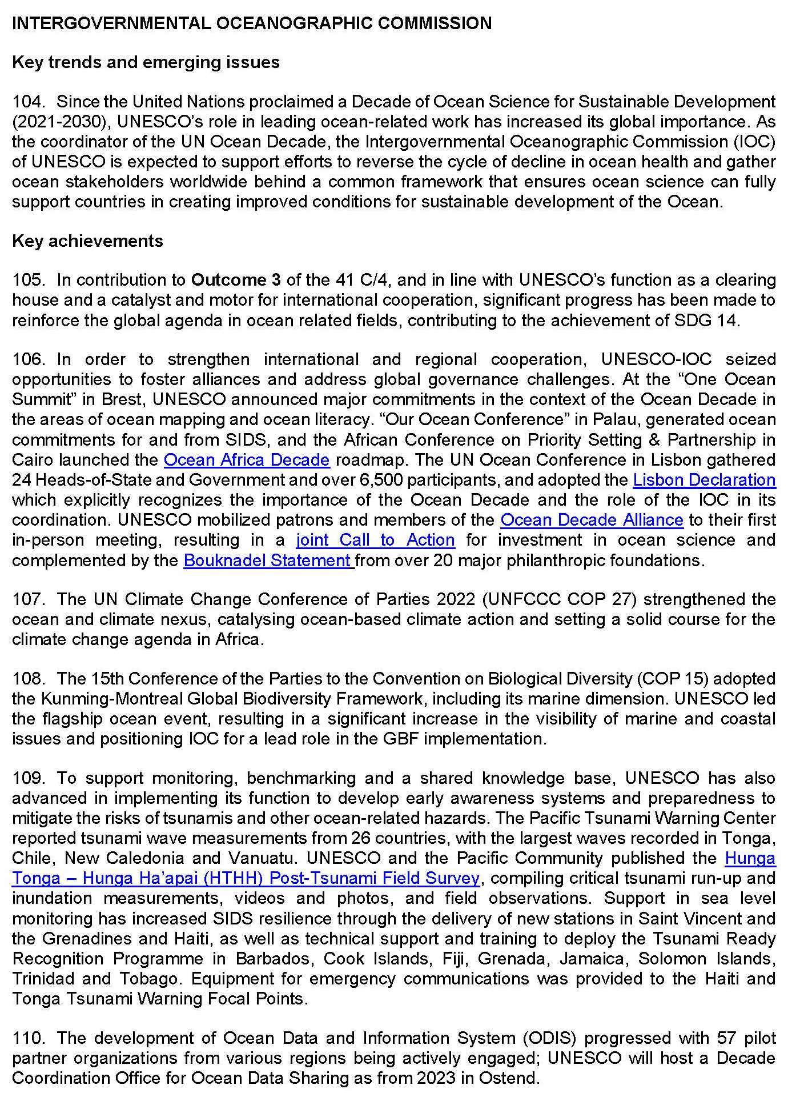
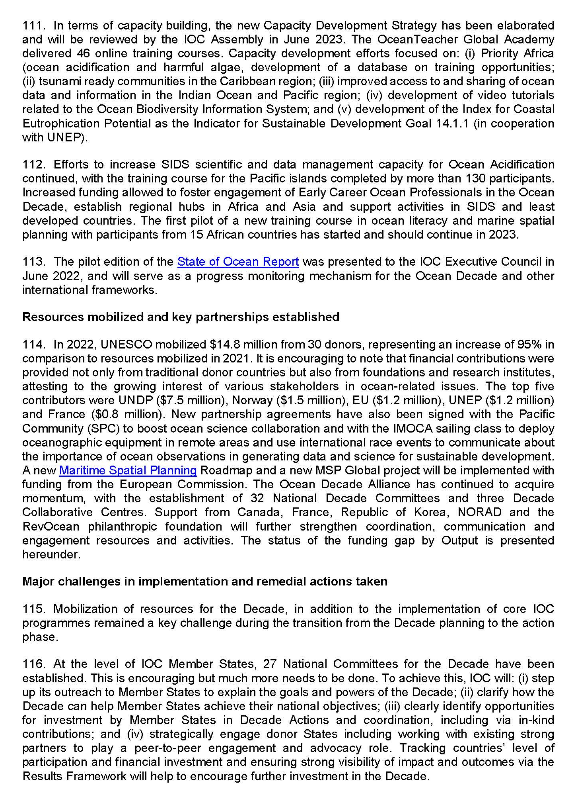

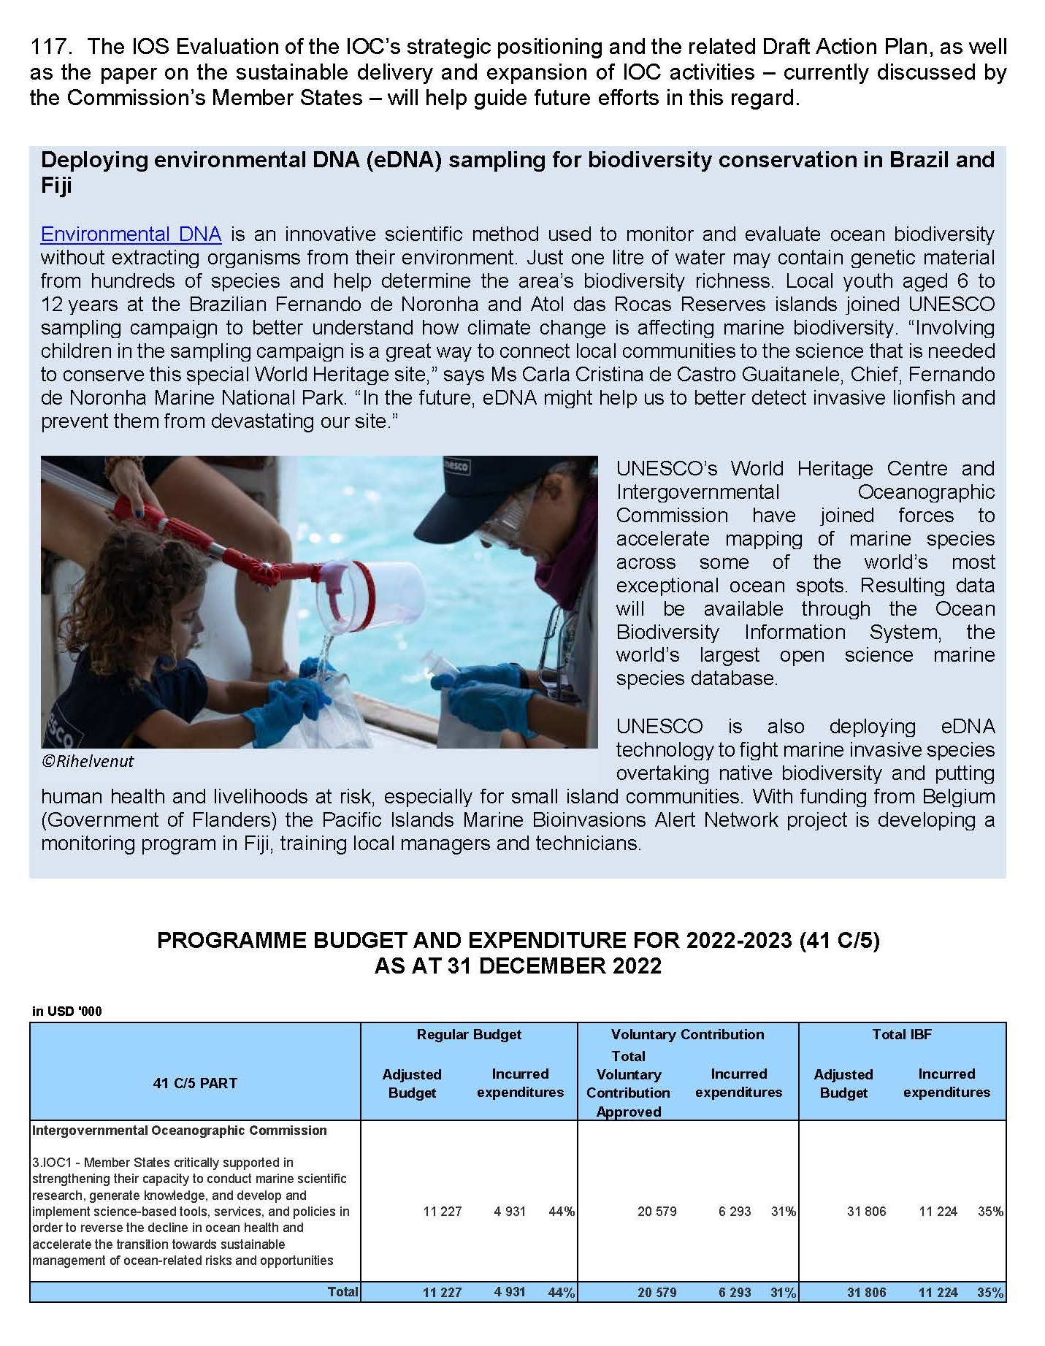

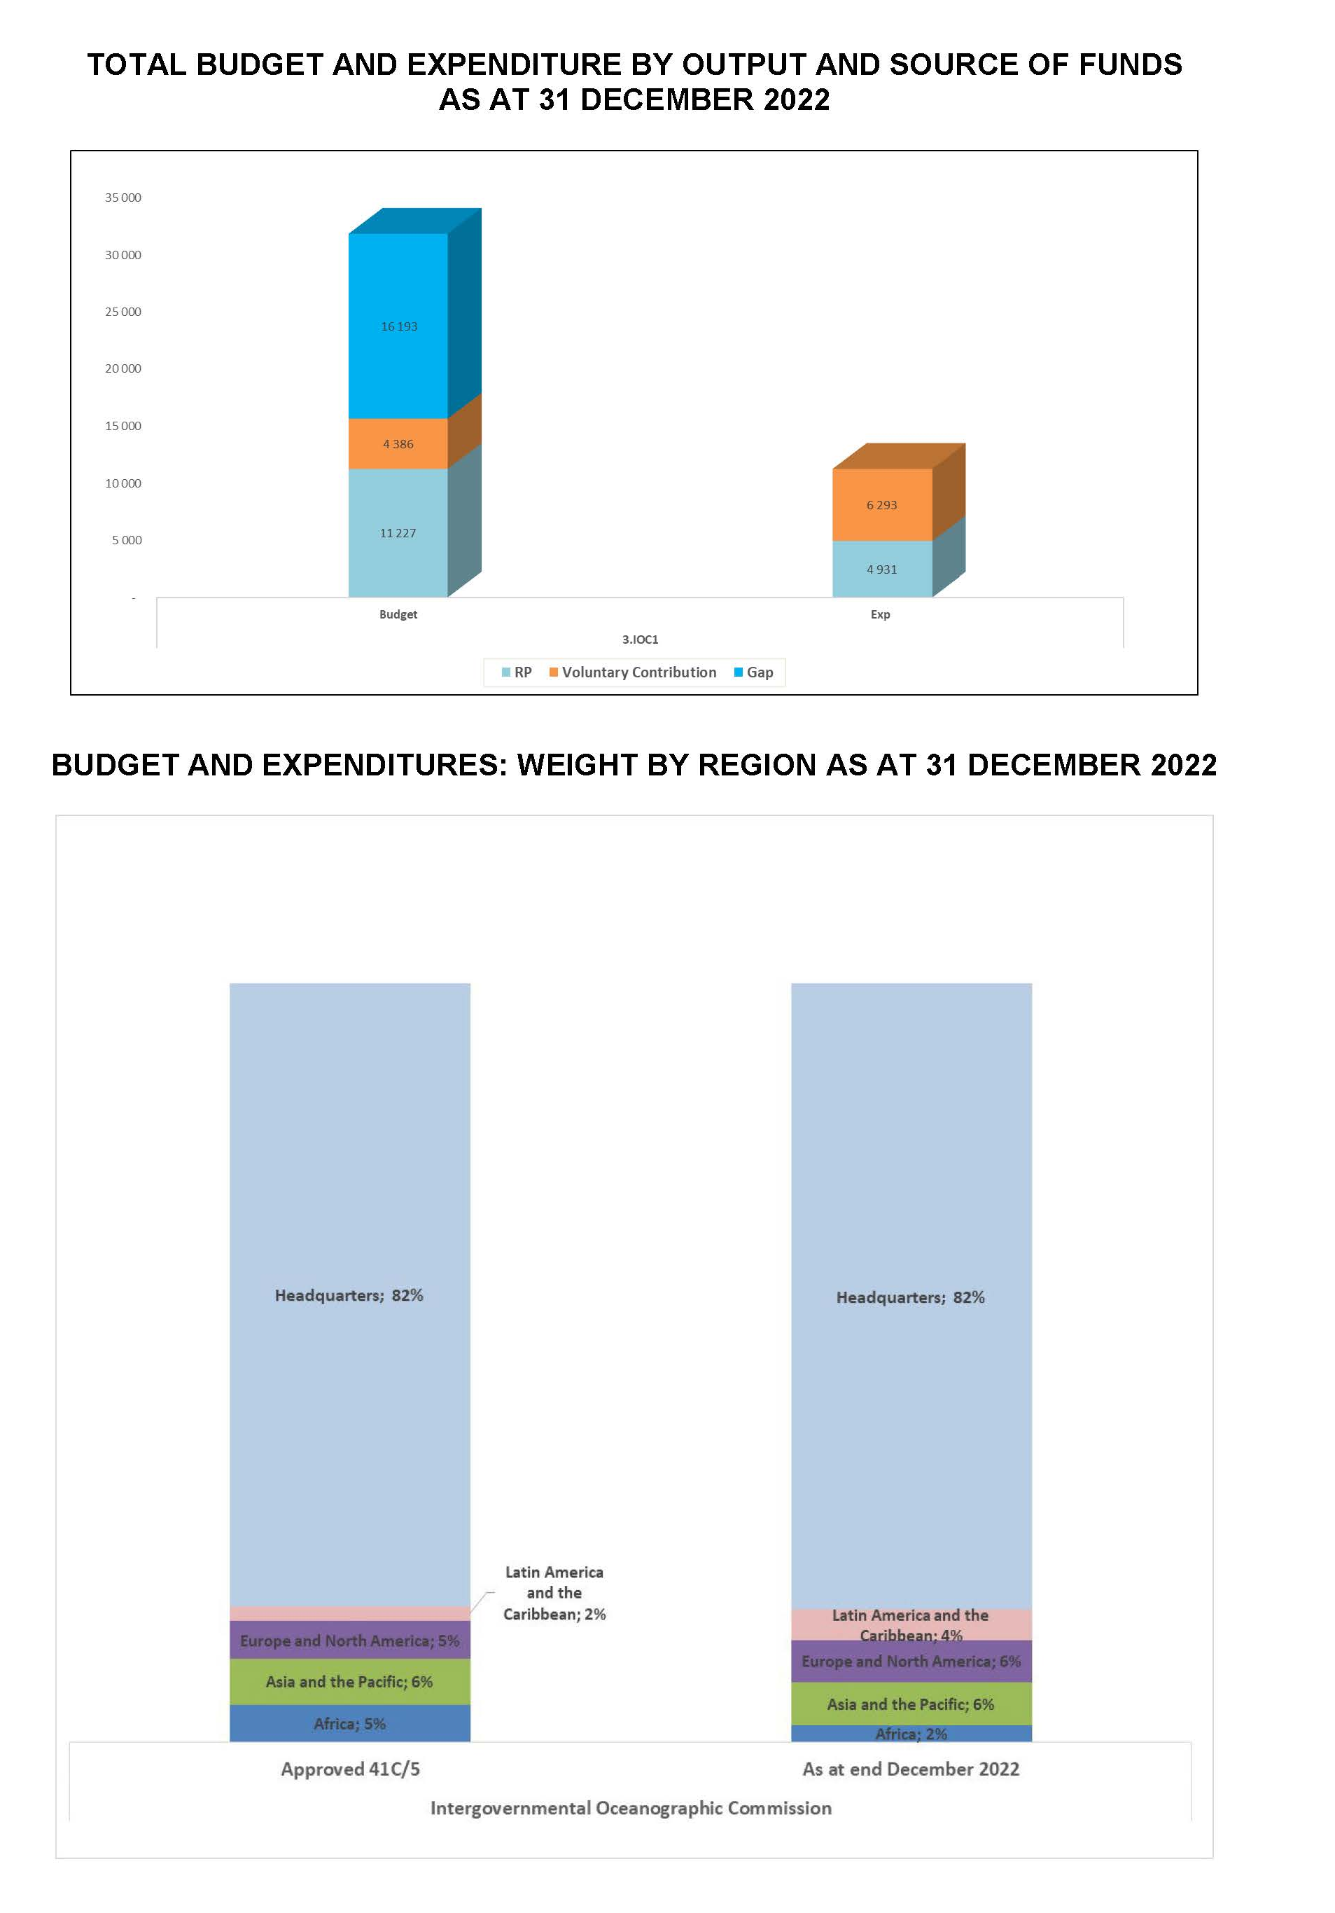
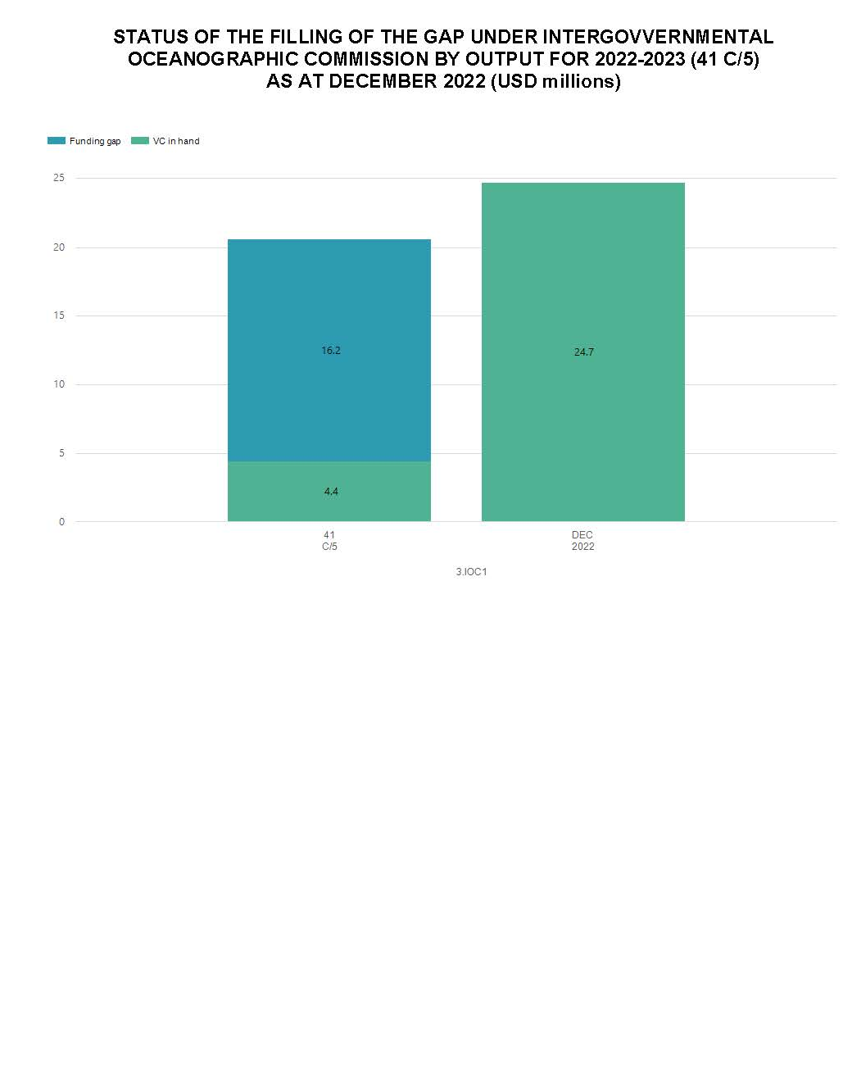

Execution of the programme adopted by the General Conference C/5 implementation report
Assessment of progress by output
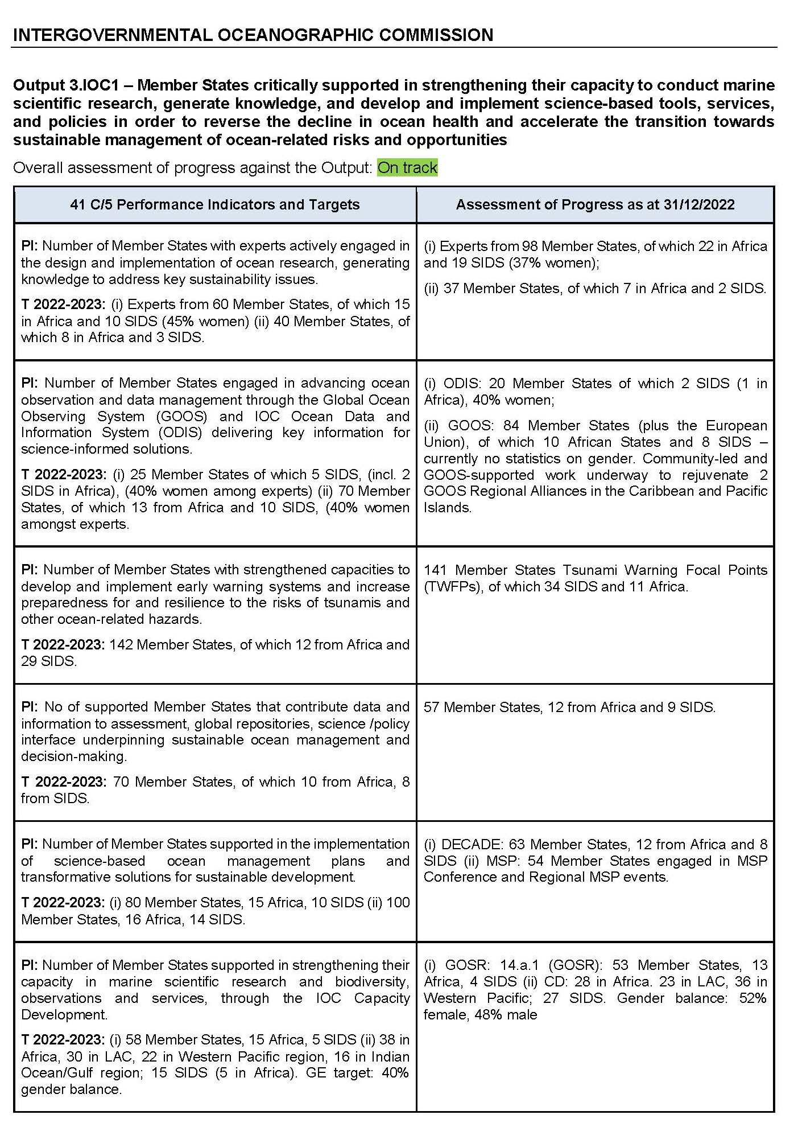
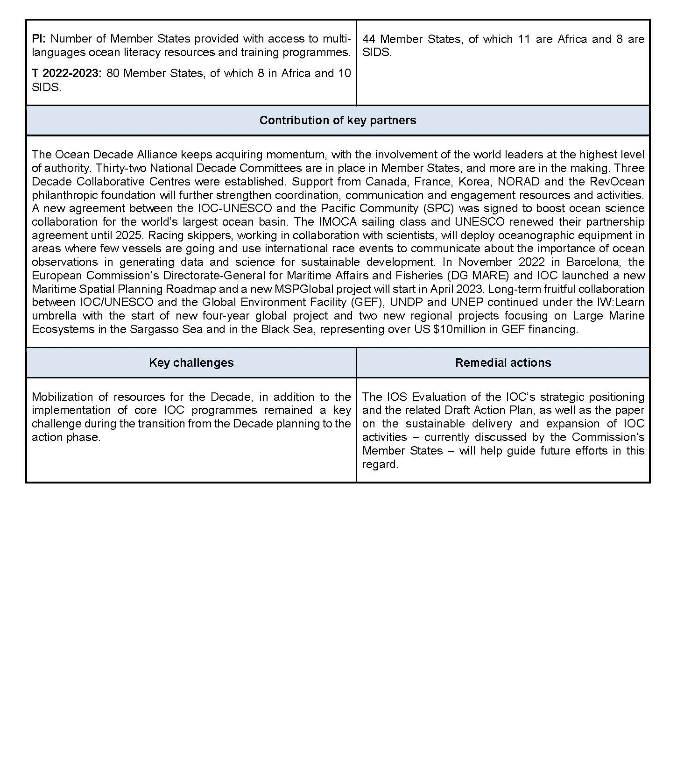

As submitted to the 216th session of the UNESCO Executive Board – ref. 216 EX/4 and 216 EX/4.INF

