Summary

This document presents an overview of the financial situation of the IOC Special Account at year-end 2022, including the proposed adjustments to 2022–2023 budgetary allocations and the updated forecast for year 2023. The Financial Report for the period 1 January 2022 to 31 December 2022 is provided in Annex in English only.
Decision proposed: After a brief introduction and discussion in plenary under item 3.2, the Assembly is invited to take note of this report and consider the draft decision referenced as Dec. IOC-32/3.2 in the Provisional Action Paper (document IOC-32/AP). The document will then be subject to an in-depth review by the sessional statutory open-ended Financial Committee and the decision reflected in the Draft Resolution that the Financial Committee will be submitting to the Assembly for adoption under item 6.4 in accordance with paragraph 15 of the Draft Revised Guidelines for the Preparation and Consideration of Draft Resolutions (IOC/INF-1315).

overview of the financial situation of the ioc special account

as at year end 2022 (in US dollars)

- In accordance with the Financial Report for the period 1 January 2022 to 31 December 2022 presented in the annex to this document, the total income in period amounted to $2,842,814.75 (comparative 31.12.2020 – $3.049,509.33), while total expenditure for the same period amounted to $2,670,109.29 (comparative 31.12.2020 – $1,652,925.42).
- At the end of year 2022, $804,886 were firmly committed by donors.
- At the end of year 2022, the Fund balance amounted to $6,446,921.96 (comparative 31.12.2020 – $4,950,766.90), with the following breakdown:
- General reserves: $ 4,021,650.71 (comparative 31.12.2020 – $ 3,645,899.98)
- OceanOPS : $ 234,277.83 (comparative 31.12.2020 – $ 159,473.54)
- IOTWMS ICG Secretariat: $ 311,201.27 (comparative 31.12.2020 – $ 542,971.25)
- UN Decade of Ocean
Science for Sustainable
Development: $ 1,699,792.15 (comparative 31.12.2020 – $ 602,422.13)
- In accordance with Articles 8.2 and 8.3 of the Financial Regulations for the IOC Special Account, the above-mentioned balance is carried over to year 2023 for the implementation of the budget approved by the IOC Governing Bodies. In this context, the proposal for a revision of budgetary allocations adopted by the IOC Executive Council through IOC Resolution EC-55/2 is submitted for the approval by the Assembly in Table 1.
- Table 2 provides an updated forecast, the initial one having been presented to the IOC Executive Council at its 55th session in document IOC/EC-55/3.1.Doc(3).

Table 1. proposed revised budgetary allocations for 2022–2023
(Expressed in US dollars)

Function/Activity Title | Budget Code | Approved Budget | Proposed Change | Revised Approved Budget
IOC Function A - Ocean Research |  | 450,000 | 40,000 | 490,000
 | 191ORS2041 | 450,000 | 40,000 | 490,000
WCRP | 191ORS2041.1 | 50,000 | -50,000
Ocean Carbon & Acidification | 191ORS2041.2 | 250,000 | 140,000 | 390,000
Impact of climate change on ocean and coastal ecosystems | 191ORS2041.3 | 150,000 | -50,000 | 100,000
IOC Function B - Observing Systems & Data Management |  | 1,750,000 | -560,000 | 1,190,000
 | 191OSD2041 | 1,300,000 | -560,000 | 740,000
GOOS design, development, engagement & impact | 191OSD2041.1 | 400,000 | -160,000 | 240,000
Observing system integration & delivery | 191OSD2041.3 | 400,000 | -300,000 | 100,000
Ocean forecast services & applications | 191OSD2041.4 | 200,000 | -100,000 | 100,000
IODE & OBIS | 191OSD2041.5 | 300,000 |  | 300,000
OceanOPS | 193OPS2041 | 450,000 |  | 450,000
IOC Function C - Early Warning & Services |  | 2,050,000 | -140,000 | 1,910,000
 | 191EWS2041 | 1,200,000 | -40,000 | 1,160,000
ICG NEAMTWS | 191EWS2041.1 | 100,000 | -20,000 | 80,000
ICG PTWS | 191EWS2041.2 | 200,000 | 100,000 | 300,000
ICG CARIBE-EWS | 191EWS2041.3 | 300,000 | -50,000 | 250,000
TOWs & inter-regional coordination | 191EWS2041.4 | 100,000 |  | 100,000
IOTIC | 191EWS2041.5 | 100,000 | -20,000 | 80,000
GLOSS - tsunami | 191EWS2041.6 | 300,000 | -50,000 | 250,000
HAB & NIS Research & Monitoring | 191EWS2041.7 | 100,000 |  | 100,000
ICG-IOTWMS Secretariat | 193EWS2041 | 850,000 | -100,000 | 750,000
IOC Function D - Assessment & Information for Policy |  | 450,000 | -235,000 | 215,000
 | 191AIP2041 | 450,000 | -235,000 | 215,000
Follow-up to SDGs, WOA & State of the ocean reporting | 191AIP2041.1 | 150,000 | -100,000 | 50,000
GEBCO | 191AIP2041.2 | 50,000 |  | 50,000
Science for reducing nutrient enrichment | 191AIP2041.3 | 100,000 | -35,000 | 65,000
Climate change adaptation in coastal zones | 191AIP2041.4 | 150,000 | -100,000 | 50,000
IOC Function E - Sustainable Management & Governance |  | 3,350,000 | -400,000 | 2,950,000
 | 191RCG2041 | 1,350,000 | -700,000 | 650,000
IOC Governance (representation & intersessional coordination) | 191RCG2041.1 | 150,000 | -50,000 | 100,000
IOCARIBE (office support & intersessional coordination) | 191RCG2041.2 | 100,000 | -50,000 | 50,000
IOCAFRICA (office support & intersessional coordination) | 191RCG2041.3 | 100,000 | -50,000 | 50,000
WESTPAC (office support & intersessional coordination) | 191RCG2041.4 | 250,000 | -50,000 | 200,000
IOCINDIO (intersessional coordination) | 191RCG2041.5 | 100,000 | -50,000 | 50,000
UN partnerships, global governance, policy and outreach | 191RCG2041.6 | 400,000 | -300,000 | 100,000
ICAM & Marine Spatial Planning | 191RCG2041.7 | 250,000 | -150,000 | 100,000
Un Decade of Ocean Science for Sustainable Development | 193UND2041 | 2,000,000 | 300,000 | 2,300,000
IOC Function F - Capacity Development |  | 1,350,000 | -5,000 | 1,345,000
 | 191ICD2041 | 1,350,000 | -5,000 | 1,345,000
CD coordination (incl. TMT) | 191ICD2041.1 | 200,000 | 25,000 | 225,000
GOSR | 191ICD2041.2 | 150,000 | -100,000 | 50,000
Ocean Literacy | 191ICD2041.3 | 300,000 | 300,000 | 600,000
IOCAFRICA Capacity development workplans | 191ICD2041.4 | 250,000 | -150,000 | 100,000
IOCARIBE Capacity development workplans | 191ICD2041.5 | 100,000 | 20,000 | 120,000
WESTPAC Capacity development workplans | 191ICD2041.6 | 250,000 | -50,000 | 200,000
IOCINDIO Capacity development workplans | 191ICD2041.7 | 100,000 | -50,000 | 50,000
TOTAL |  | 9,400,000 | -1,300,000 | 8,100,000

TABLE 2. FORECAST 2023, UPDATED AS AT 31 DECEMBER 2022
(Expressed in US dollars)

IOC Special Account
Forecast 2023
Opening balance: |  | 6,446,922
Working Capital Fund: |  | 1,000,000
Opening balance available: |  | 5,446,922
Signed commitments from donors:
 | Société des Explorations de Monaco | 74,547
 | Flanders Marine Institute | 21,299
 | ETT S.p.A. | 53,248
 | FUGRO | 2,500
 | REV Ocean Inc | 500,000
 | China | 1,500
 | Norway | 151,791
 |  | 804,886
Sub-total Funds available or signed commitments: |  | 6,251,808
Planned Expenditure*: |  | 5,429,891
Estimated Closing balance /Funding gap: |  | 821,917
*Based on revised proposed budget 2022-2023 - ref. Table 1

ANNEX
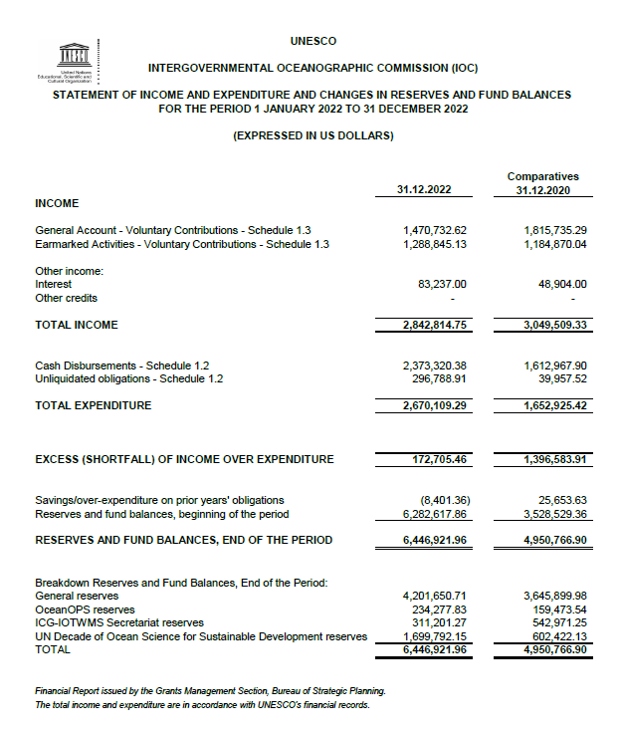

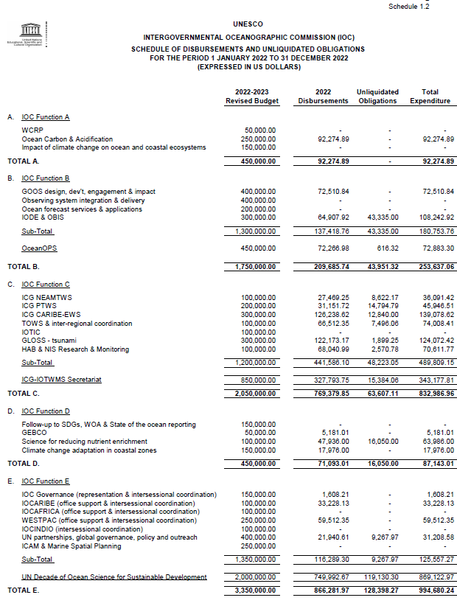

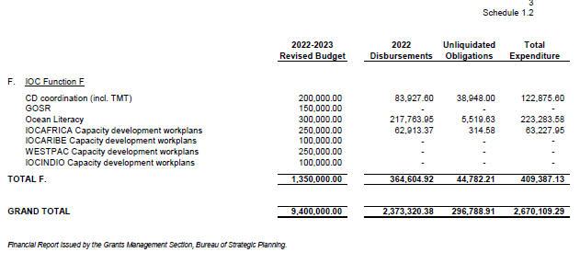

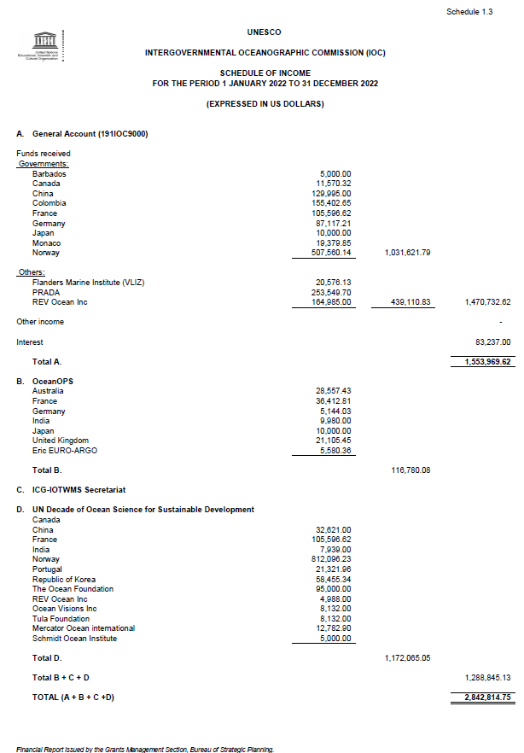

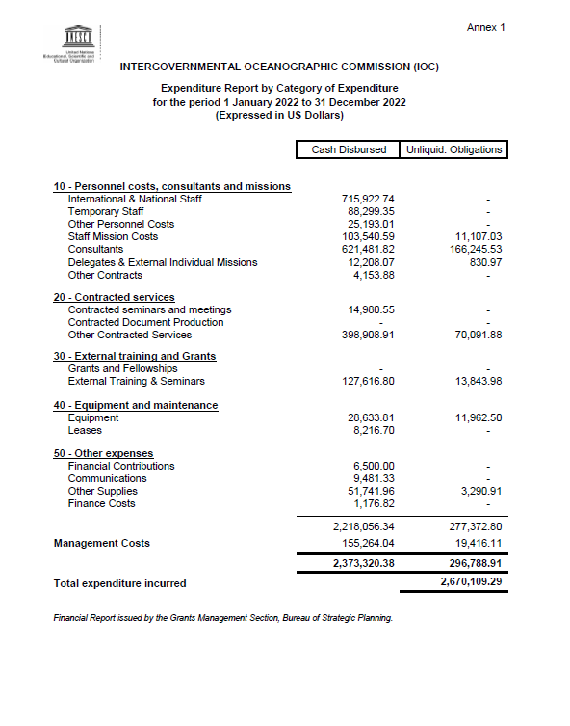

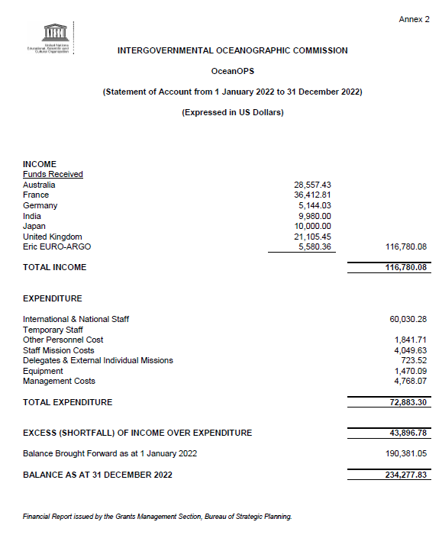

Includes contribution from NORAD in the amount of $507,560.14 credited on 30.12.2022
Includes contribution from NORAD in the amount of $812,096.23 credited on 30.12.2022
Proposed adjustments are based on observed capacity to mobilize the funds and expenditure trends.

