Summary
IOC Resolution XXVI-8 (2011) created the GOOS Steering Committee and requested it to “produce a biennial Workplan for consideration by the IOC Governing Bodies and adoption by the Assembly.”
This Work Plan Summary (2024–2025) provides an overview and analysis of implementation towards the Global Ocean Observing System 2030 Strategy (GOOS-239). GOOS has made considerable progress in the four years since the adoption of the 2030 Strategy. However, although GOOS has gained some additional resources, the demand for active global coordination is increasing. To achieve what society, policy and the Member States need—a truly integrated and responsive ocean observing system, GOOS will need additional resource across the next three years. In this document we report on progress towards the 11 GOOS Strategic Objectives and provide a clear view of where additional resource is needed for the next steps of implementation.
Financial and administrative implications: paragraph 26.
The proposed decision is referenced Dec. A-32/4.8.1 in the Action Paper (document IOC/A-32/AP Prov.)

Introduction
- The Global Ocean Observing System 2030 Strategy (GOOS-239), launched in 2019, was an ambitious call to advance our ocean observing system through expanding in key areas, and integrating across domains and along the ocean observing value chain, evolving a more fit-for-purpose and responsive system, with users and stakeholders.
- GOOS is delivered through the work of three Expert Panels (physics and climate, biogeochemistry, and biology and ecology), ocean observing and forecasting coordination groups, ocean observing networks and systems, and the GOOS Office is headquartered at UNESCO-IOC in Paris. These GOOS components are supported through staff located at WMO in Geneva, in Hobart, Australia, IOPAN in Sopot, Poland, and IFREMER in Brest, and through contributions from UNESCO-IOC, US, WMO, the Scientific Committee on Oceanic Research (SCOR), France, Australia, China, Canada, European Commission, United Kingdom, Japan, Germany, Italy, India, New Zealand, South Africa, and Monaco. These components coordinate the sustained ocean observing system made up of national contributions, and work to integrate, strengthen, advocate for, and develop a fit-for-purpose global ocean observing system. UNESCO-IOC is the lead sponsor of GOOS, with co-sponsors World Meteorological Organization (WMO), United Nations Environmental Porgramme (UNEP) and the International Science Council (ISC).
- The introduction of the UN Decade of Ocean Science for Sustainable Development 2021–2030 (Ocean Decade,) with its Calls to action for ‘the science we need for the ocean we want’, echoes the urgency of the GOOS 2030 Strategy. Ocean observing is one of the 10 Ocean Decade Challenges (Challenge 7), and with data management (Challenge 8) is one of two core 'infrastructure' challenges that will underpin the work of the Ocean Decade. Innovation and transformation come through the GOOS Projects, Task Teams and the Ocean Decade Programmes and Actions.
- Below is a brief report on progress across the 11 GOOS Strategic Objectives, the priorities set by the Steering Committee for the next intersessional period, and a clear outline of where additional resource is needed for the next steps in implementation.

Progress across the GOOS Strategic Objectives
- The Roadmap for the Implementation of the Global Ocean Observing System 2030 Strategy (GOOS-249, 2020) outlined the key outcomes across each of the 11 GOOS Strategic Objectives, which include partnership for delivery, communications and advocacy, evaluating impact, empowering end user applications, authoritative guidance on design, strengthening and expanding the system, open data, supporting innovation, developing capacity, human impact observations, and evolving GOOS governance.
- The Twelfth Session of the GOOS Steering Committee (25–27 April 2023, Halifax, Canada) focused on assessing the challenges, opportunities, and progress achieved in implementation across the 11 GOOS Strategic Objectives towards the outcomes articulated in the GOOS Roadmap. The Annex shows the distribution of the actions under the Strategic Objectives and GOOS Core Components. Below are a brief report and assessment of progress across the Strategic Objectives.
- Strategic Objective 1: Strengthen partnerships for delivery. GOOS has strengthened its connections and partnership with World Meteorological Organisation (WMO), Intergovernmental Ocean Data and information Exchange (IODE), the Global Climate Observing System (GCOS) through the work of the Ocean Observing Physics and Climate Panel (GOOS Expert Panel) for the Essential Climate Variables and ocean component of the GCOS Implementation Plan; UN Division for Ocean Affairs and Law of the Sea (DOALOS) on ocean observation in areas under national jurisdiction; Organisation for Economic Co-operation and Development (OECD) for the value of ocean observing work; Group of Experts on the Scientific Aspects of Marine Protection (GESAMP) and UN Environment Programme (UNEP) with regard to ocean plastic/marine debris; and the OceanPredict modelling community through work in the GOOS Co-Design and CoastPredict Programmes; the satellite community through CGMS, CEOS, NASA, ESA; and the Partnership for Observation of the Global Ocean (POGO) through a Memorandum of Understanding. The next actions include continuing to strengthen connections with WMO and the Group on Earth Observations Biodiversity Observation Network (GEO BON/MBON) as a priority, strengthening some relationships with partnership agreements, establishing a focal point for satellite community connections in the GOOS Steering Committee, mapping the GOOS partnerships by type, and to establish a regular review mechanism to ensure that the partnerships work for both parties, and assess priorities and needs for engagement.
Assessment: Objective 1 is on track.
- Strategic Objective 2: Advocacy and communications. The efforts here have contributed to increasing recognition of GOOS and ocean observations in many events such as the UN Ocean Conference, COP27 and CBD COP15. GOOS is implementing its Communications Plan, adopted in 2022, and in the last 12 months has published 20 original articles and 4 feature stories, many have also been shared by IOC and UNESCO news, plus CBS, Nautilus, ECO magazine, and Ocean Science & Technology News. GOOS flyers were developed with simple messages for target audiences, and were distributed in international events. For the first time the Global Ocean Observing System Report Card 2022, is fully cross-GOOS, and GOOS is building a growing community of vocal partners, such as the Marine Technology Society, The Ocean Race, industry, and the OECD. Advocacy and communication was identified as a continuing priority area for action by the GOOS Steering Committee, GOOS will continue refining key messages and strengthening communication relationships with partner organisations and UN advocacy work will be continued for upcoming events (e.g. UN ICP New Maritime Technologies, COP28).
Assessment: Objective 2 is on track.
- Strategic Objective 3: Evaluate System to assess fit-for-purpose. The GOOS Report Card 2022 included a more robust calculation of the observing network status indicators, and this work continues in the Observations Coordination Group (OCG) for 2023. The GOOS Expert Team on Ocean Forecasting (ETOOFS) is also assessing metrics for ocean forecasting systems. The GOOS Ocean Observing Co-Design Programme is working on exemplar projects which are designed to promote assessment and requirements from user needs perspective, and towards developing system design and metrics at an EOV level through requirements. The work with the WMO Rolling Review of Requirements process will also develop requirements for observing system assessment. Next steps include developing the first Co-Design pilot projects, ensuring GOOS Expert Panels are updated and integrated into the efforts, and engaging stakeholders in the observing system assessments.
Assessment: Some areas of Objective 3 are on track; however some still require work. There has been progress towards the identification of gaps at local, regional and global scales, through the Tropical Pacific Observing System (TPOS) and Co-Design Programme, but this is not yet consistent across GOOS, and capacity and resource are required to support the development of assessment tools for the observing system.
- Strategic Objective 4: Empower end user applications. The GOOS Expert Team on Operational Ocean Forecasting (ETOOFS) launched its Guide on ‘Implementing Operational Ocean Monitoring and Forecasting Systems’ at the Lisbon UN Ocean Conference in June 2022. It is published as an online document with DOI. This is a comprehensive document and the fruit of cooperation between 80 expert authors from 18 countries worldwide. Work has initiated in the GOOS Regional Alliances to develop product integration examples.
Assessment: Some areas of Objective 4 are on track, but in general this strategic objective still requires development. The concept of users is still ambiguous and dedicated resources are limited, we therefore only capture partial picture. GOOS needs to clarify the provider/user interface that it would like to improve, there are many, so priorities are important, and use the Ocean Decade framework. Ocean prediction centres should be one of foci for this provider/user interface.
- Strategic Objective 5: Authoritative guidance on design. The GCOS Essential Climate Variable (ECV) requirements were publicly reviewed and updated through cross-GOOS Expert Panel work led by the Ocean Observing Physics and Climate Panel (OOPC), including 11 physical, 6 geochemical and 2 biological (Item 4.10). A GOOS Essential Ocean Variable (EOV) paper and new (unified across GOOS) EOV Specification Sheet are close to completion. In the last 18 months new EOVs have been accepted, including the Ocean Sound and Bottom Pressure. The EOV on Marine Debris is a pilot EOV. The Ocean-Atmosphere Interface and Boundary Layers (OASIS), funded as a SCOR Working Group, is endorsed under the Ocean Decade and has engaged a large multidisciplinary community to advance capacity. Several actions have now been folded into the Ocean Observing Co-Design Programme, where there has been significant mobilisation of communities around 6 initial Exemplar Projects (Tropical Cyclones; Marine Heatwaves; Ocean Carbon; Boundary Currents; Marine Life; and Storm Surge), and work in the development of practice, process, and a framework for co-design action. The Steering Committee recommended that GOOS enhances the visibility of the EOVs and ECVs to the operational agencies and ensure the selection criteria for EOVs is transparent. A GOOS EOV paper that decribes the EOV process and addresses community issues, is close to completion. Increased engagement with operational services (not only ocean) and with the modelling initiatives around assessment of observing systems (e.g. OceanPredict and SynObs Ocean Decade Project) was also highted as important.
Assessment: Progress has been made through the EOV process and building observing networks around EOVs, however an improved design does not always lead to implementation. More progress is needed in refining the essential global observations required for global societal needs that maximize return on investment and in developing a modular design approach to guide and support implementation decisions at regional and national levels.
- Strategic Objective 6: Strengthening and expanding the ocean observing system. GOOS achieved a noticeable progress in network integration and three emerging networks are in their transition from pilot to mature status (AniBOS, OceanGliders, HF Radar), in addition potential new networks are interacting with the OCG including SMARTCables, Ship based ocean time series, Unmanned Surface Vehicules (USVs) and IMDOS for marine debris. The 12 EOV BioEco observing communities have also advanced, and a recent Nature Communications paper on zooplankton, supported by the GOOS BioEco Expert Panel and G7 Future Seas and Oceans Initiative (FSOI), was published. GOOS endorsed Best Practices are now available in the Ocean Best Practice System (oceanbestpractices.org). The multidisciplinary initiative VOICE is now integrated into GOOD (Global Ocean Oxygen Decade Programme), and the GOOS CoastPredict Programme, under the Ocean Decade, has developed the Global Coastal Experiment to implement regional pilot areas for coastal observing and prediction. Next steps include increasing the opportunities for coordination between OCG and the Biogeochemical (BGC) and biological and ecological (BioEco) Panels. Enhancing current partnerships in the BioEco area through a new MoU between GOOS, GEO BON/MBON and OBIS, building on a 2016 partnership agreement. Work to catalyse studies for the WMO Impacts Workshop in 2024 and to develop a process across GOOS to assess readiness and prioritize observing actions (e.g., for new networks and to technology readiness levels—TRLs), working with GOOS Regional Associations. The work on the taking sustained ocean observations in areas under national jurisdiction is under Item 4.8.2 at the Assembly. Finally, an important and ongoing task is addressing the global crisis in supply and distribution of seawater carbonate chemistry Reference Materials.
Assessment: Most areas are on track and/or making progress, however coordination towards achieving common goals across global, regional and national systems requires increased levels of coordination across GOOS and additional resouce to achieve this. The expansion into new areas based on requirements and solving global needs also requires additional resource.
- Strategic Objective 7: Open Data. Mapping the data and metadata flow across the OCG networks has been completed and is available online (GOOS-278). These were used to support the development of an OCG Data Implementation Strategy, with the aim to improve discovery and access to data across the global ocean observing networks. OceanOPS has worked to harmonize metadata across networks for monitoring capabilities and efficiency, this is also a contribution data flow into WMO OSCAR systems. A GDAC was created for biogeochemical EOV data, but the implementation of this has stalled, and remains an area of concern. The BioEco Portal 1.0 was launched in collaboration with the IODE Ocean Biodiversity Information System (OBIS) to provide metadata and information on networks monitoring BioEco EOVs. In next steps the OCG Data Implementation Strategy will be published and work on implementation started, this will be relevant across GOOS and is integrated with the WMO WIS 2.0 and IODE ODIS work.
Assessment: Objective 7 is on track, although this area will require increased resource for the next stages of development towards integrated frameworks for data and metadata across GOOS. The GOOS Roadmap foresaw EOV data products and in the biogeochemistry realm this is hampered by a lack of resource and the stalling of progress towards an IODE Global Data Assembly Centre (GDAC) for global biogeochemical data.
- Strategic Objective 8: Support innovation. GOOS launched the ‘Dialogues with Industry’ initiative, with such partners as b the Marine Technology Society (MTS) and the National Oceanic and Atmospheric Administration (NOAA), as a forum for dialogue between public and private sectors to dismantle barriers and engage around opportunities towards achieving a mature, multi-sectoral ocean observ34¢®Ω≈iC ?DSf469075ng enterprise. Four sessions were completed with panellists from industry, not-for-profit NGO and government. A Dialogues with Inductry Synthesis Report, summarizing the findings across the 4 sessions is available as GOOS-282. This provides important information for science, industry and government on how to enhance private sector involvement in ocean observing, growth of the blue economy, and efficiency in ocean observing and service delivery. A Dialogues with Industry Blueprint, with recommendations for action following consultation with public and private sector on priorities from the Synthesis Report, will be published in Q3 2023. This is an important area where partnership between private and public sector can deliver multiple benefits to society.
Assessment: Objective 8 is on track, the Dialogues with Industry initiative has opened an opportunity to mature the ocean observing and services ‘market’ with industry and represents an important route to speeding innovation for ocean observing. There are important steps that can be taken to develop ocean observing and services as a market, and to attract investment into the sector. This is also an action under the Ocean Decade.
- Strategic Objective 9: Guide capacity development. ETOOFS organised two online workshops on operational ocean monitoring and forecasting system, and over 270 participants joined from 65 countries. The BGC Panel has a BGC Sensors Summer Course (June 2023) and an online ocean acidification data tool. The Data Buoy Cooperation Panel (DBCP, one of the 13 global ocean obsreving netwoks) supported a capacity development workshop in Tunisia in April 2023.
Assessment: Objective 9 is on track, although a more overarching approach across GOOS would benefit activities, and a clear strategy for work with the IODE capacity development facility and greater work with partners is important.
- Strategic Objective 10: Observe human impacts on the ocean. The first human pressure EOVs have been developed in strong partnerships with international expert working groups and projects, including the Ocean Sound EOV, developed in partnership with the International Quiet Ocean Experiment (2022), and the Marine Plastics Debris EOV, with support from EU H2020 EuroSea and EU4OceanObs projects and many partners including, GESAMP WG 40, SCOR WG FLOTSAM, MSFD Tech Group on Marine Litter, IOCCG Task Force on Remote Sensing of Marine Litter and Debris. The Integrated Marine Debris Observing System (IMDOS) was publicly launched in June 2022, this is a strategic 3-way partnership between GOOS, GEO Blue Planet and UNEP Global Partnership on Marine Litter (GPML), and will play an essential role in establishing recommendations for sampling, co-design, and common protocols. IMDOS was accepted as a GOOS Project at the GOOS SC-12 in April 2023, and is positioned to support the newly negotiated international “Plastics Treaty”. IMDOS will work with OCG global networks and BioEco observing communities for monitoring of surface microplastics.
Assessment: There has been a noticeable progress the establishment of EOVs around variables related to human activities, the initial targets were (1) ocean noise, (2) marine plastic, and (3) harmful algal blooms, and two are underway. In additoion, pilot projects on ocean noise and marine plastic are on track in partnership with other organisations in each area. More dedicated effort is required for the pilot project on harmful algal blooms, and resource is required to continue to develop IMDOS as a project.
- Strategic Objective 11: Champion effective governance. The Terms of Reference for an Evolve GOOS Governance Task Team were agreed in Q3 2022, and an open call for members will go out via IOC and WMO Circular Letters in June 2023. The GOOS sponsors will be asked to support this important action, and the GOOS Office will hire a governance expert to support the Task Team. In the last 12 months there have been welcome developments to reinvigorate regional coordination in the Pacific Islands, Caribbean, Africa, and the Arctic. Supporting the development of strong and active GOOS Regional Alliances is essential to enabling nations to collaborate and develop the observing system they need, There has also been action to develop the GOOS National Focal Points (NFPs), the updated Terms of Reference for the GOOS NFP were adopted at the Steering Committee, and there are now 65 NFPs with more expected. GOOS has had some success in obtaining new in-kind and secondment support and interest in the implementation of the Ocean Decade Programmes. The Ocean Observing Decade Coordination Office is supported by the Decade Coordination Unit, and GOOS National Focal Points work have been partially supported by the IOC. So there has been an increase in support to GOOS, however work on fundraising in the philanthropic sector and developing a funding plan has been slow due to resource limitations at the GOOS Office. The Steering Committee welcomed the rejuvenation of PI-GOOS, work to revitalize IOCARIBE-GOOS and GOOS Africa, and to support ocean observing coordination in the Arctic region. Supporting regional coordination and evolving GOOS governance were both identiied as priorities by the GOOS Steering Commitee.
Assessment: Objective 11 is partially on track, the advances in GOOS regional coordination and NFPs are welcome, however evolving GOOS governance is now a clear priority.

Priorities
- Considerable progress has been made across all 11 Strategic Objectives, however the GOOS Steering Committee highlighted the need to focus on advancement in several priority areas:
- Advocacy and communication: the Steering Committee welcomed the progress made in communicating the value of ocean observing and the role of GOOS in the last 18 months and emphasised the importance of this work. GOOS must continue to advocate for the need for sustained and coordinated observations, ensuring that ocean observing is visible at international fora. Cooperation between GOOS components as well as sponsors can create more opportunities to amplify this message.
- Regional Coordination: The GOOS Steering Committee highlighted this as a priority area and welcomed the rejuvenation of PI-GOOS, and the recent development activities in IOCARIBE and GOOS Africa.
- The UN Ocean Decade: this continues to be viewed as an important opportunity for GOOS, and the work of the Ocean Observing Co-Design Programme was referenced as important across several of the Strategic Objectives.
- Evolving GOOS Governance: a key action for 2023.
- Strengthening GOOS Core: the Steering Committee noted that GOOS has several points of weakness in its core support structures, increasing support is vital to deliver on GOOS 2030 Strategy and Ocean Decade actions.
- The Steering Committee adopted the updated GOOS NFP ToRs, approved the Integrated Marine Debris Observing System (IMDOS) as a GOOS Project, and supported the development of a new Arctic Task Team subject to revisions in its implementation plan. The developing and deepening connections with WMO were also welcomed.

Resources and Implementation for the 2023–2026 period
- GOOS needs to harness its work across the GOOS 2030 Strategy to create a step-change in ocean observation, focusing on a set of key deliverables to nations in areas that are becoming increasingly urgent, including:
- Reporting on indicators to the Convention on Biological Diversity and the Convention on Climate Change.
- Understanding the rapidly changing probability of extreme events that threaten infrastructure and human life.
- Aiding governments and the private sector to make important choices about how to manage our global carbon/Green House Gas budgets.
- Delivering the observing and forecasting backbone for coastal services and management
- GOOS and its ocean observing and forecasting communities have deep experience and knowledge, and through the work of its core components, Decade Programmes, and initiatives, GOOS is the hub where global expertise gathers to define priorities and action.
- Society needs more ocean observations, but at the same time this needs to be efficient and fit for purpose, at global, regional, and local levels. This cannot be achieved without investment in the core coordination. GOOS has proven its ability to deliver and now requires investment to deliver a stronger, expanded, and fit-for-purpose system.
- At present critical components of GOOS are under threat, and GOOS needs support from IOC Member States to make the case at national and international levels for strengthening its support structure. GOOS needs to grow by 50% in the next 18 months and to double its staff by 2026.
- Critical now are:
- Core support staff for the BioEco Expert Panel.
- Core support staff for the Biogeochemistry Expert Panel.
- Support for OceanOPS.
- Increased support for data issues.
- GOOS Paris HQ needs help to execute and link across the core GOOS entities, as well as pulling in national focal points more effectively and communicating outwards to sponsors and supporters.
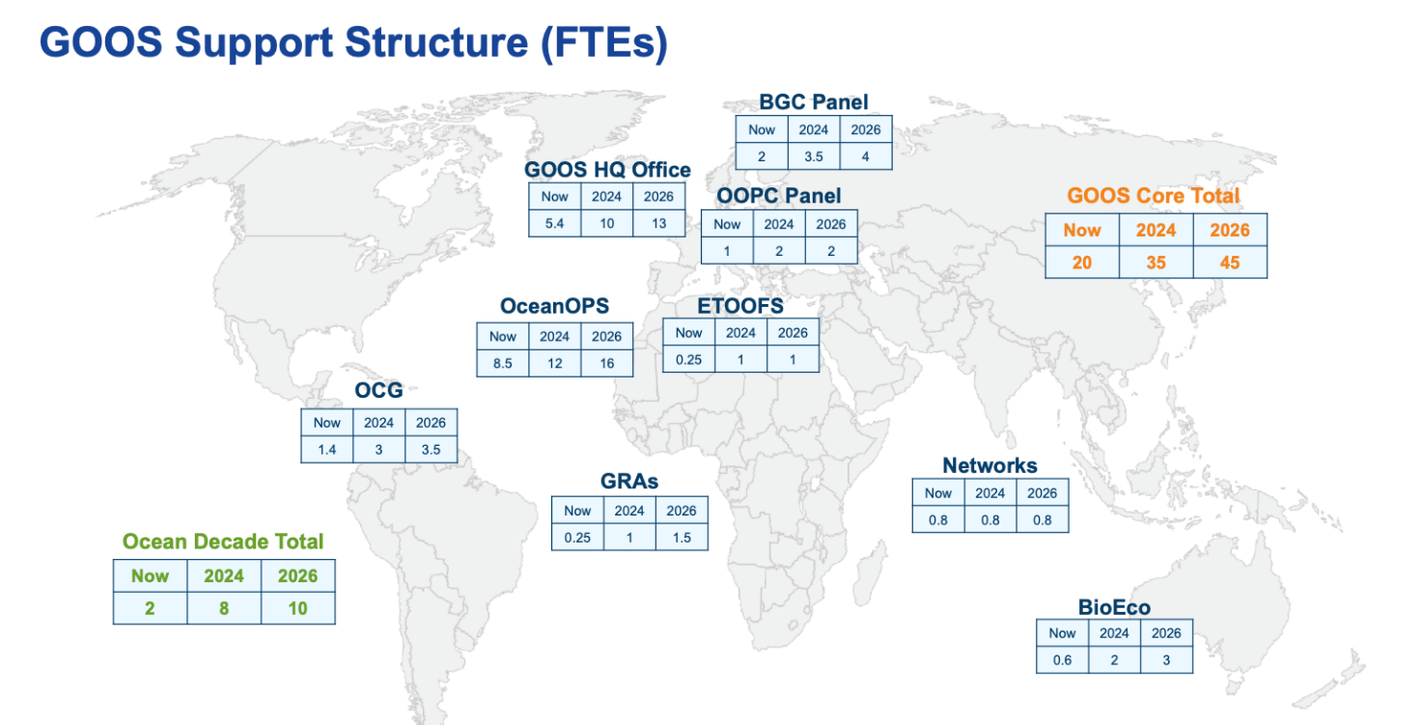
Figure 1. The FTE (Full Time Equivalent) people resource needs for GOOS are outlined by GOOS Core Component, and for the GOOS Core Total (sum of all the components) and the 3 Ocean Decade Programmes (what GOOS should provide to support integration for and with GOOS – not their total budgets), for what exists today (Now), what is needed in the near term (2024) and what is needed in the medium term (2026). Note resource could be provided through mechanisms such as loans and secondments, as well as through funding. The FTEs required are linked to actions under the GOOS Implementation Work Plan.

- The main support that GOOS currently receives is from the Intergovernmental Oceanographic Commission of UNESCO, the US and WMO are also more significant contributors, and in addition contributions are received from France, Canada, Italy, the European Commission, United Kingdom, Germany, China, Republic of Korea, Japan, India, Australia, New Zealand, South Africa and Monaco. GOOS needs support to both stabilise and grow, and the support of its sponsors, Member States and philanthropic organisations is sought to achieve this.

Financial and administrative implications
- Beyond the UNESCO-IOC Programme and Budget for 2024–2025 (C/5), Member States are encouraged to engage with GOOS on the specifics of its needs. Support can be through secondments, loans, staff at regional offices, and extra budgetary funding.

Annex
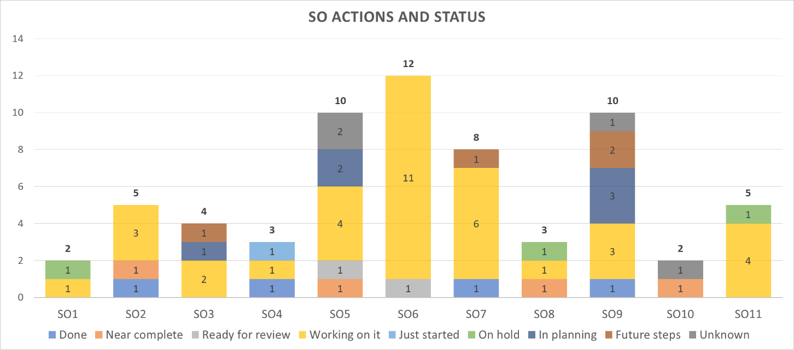
Figure 1: Distribution of actions across the 11 GOOS Strategic Objectives

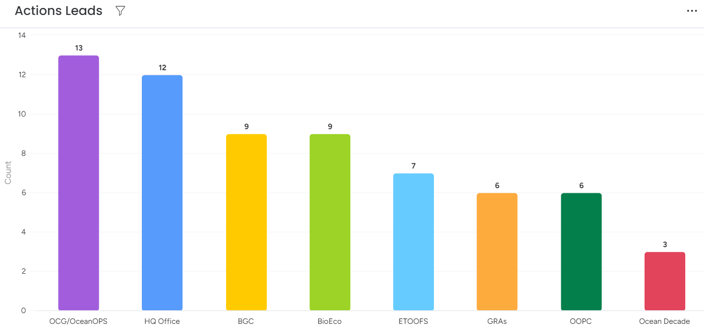
Figure 2. Lead GOOS component for actions under the 11 GOOS Strategic Objectives

