|  |
| --- |
| Summary  This report provides an overview with regard to the implementation of the 2022–2023 budget as at 31 December 2022, including updates on voluntary contributions mobilized, budgetary gap filling by function and staffing situation.  Voluntary contributions (VC) include:   * Cash contributions to the IOC Special Account * Cash contributions to specific projects/Funds-in-Trust (FITs) * Additional cash contributions (AC) intended to directly reinforce an existing regular programme budget line * In-kind contributions.   All financial information in this report is aligned with the authoritative reporting presented to the UNESCO Executive Board at its 216th session.  Proposed decision: This document is part of the report of the Executive Secretary to the Assembly. It will be further examined by the statutory sessional open-ended Financial Committee and the decision reflected in the Draft Resolution that the Financial Committee will submit for adoption by the Assembly under item 6.4 in accordance with paragraph 15 of the Revised [guidelines for the preparation and consideration of draft resolutions](http://www.ioc-unesco.org/index.php?option=com_oe&task=viewDocumentRecord&docID=9281) ([IOC/INF-1315](https://unesdoc.unesco.org/ark:/48223/pf0000265307.locale=fr)). |

**OVERVIEW OF BUDGET IMPLEMENTATION**

1. In compliance with Member States’ decisions, the 2022–2023 budget was based on an Integrated Budgetary Framework (IBF), allowing greater transparency of resources and helping to align resources with the collectively decided priorities.
2. Following the approval of the Organization’s Programme and budget for 2022–2023 by the UNESCO General Conference at its 41st session, the actual working budget of the Commission was set in accordance with the total IBF of $31,815,240: $11,236,000 for the IOC from UNESCO’s regular budget plus $20,579,240 of targeted Voluntary Contributions (of which $4,386,240 were secured at the moment of the budget adoption and $16,193,000 of projected resources to be mobilized and spent during the biennium (gap)[1].

Table 1. IOC Integrated Budgetary Framework 2022–2023 at IOC function level



Table 2. Consolidated Report on 2022 Expenditure, including obligations, under IBF as at 31 Dec. 2022

|  |  |  |  |
| --- | --- | --- | --- |
| **IOC Function/Activity** | **Regular Budget** | **Voluntary Contributions** | **Total** |
|  |
| **$** | **$** | **$** |  |
| FUNCTION A (Ocean Research) | 85,256 | 696,414 | 781,670 |  |
| FUNCTION B (Observing Systems/Data Management) | 286,857 | 2,105,382 | 2,392,239 |  |
| FUNCTION C (Early Warning & Services) | 108,334 | 1,906,220 | 2,014,554 |  |
| FUNCTION D (Assessment & Information for Policy) | 70,059 | 266,741 | 336,800 |  |
| FUNCTION E (Sustainable Management & Governance) | 288,682 | 2,614,604 | 2,903,286 |  |
| FUNCTION F (Capacity Development) | 88,766 | 1,359,208 | 1,447,974 |  |
| **Sub-total** | **927,954** | **8,948,568** | **9,876,522** |  |
| Common country programming |  |  |  |  |
| UN reform |  |  |  |  |
| Evaluations | 24,673 |  | 24,673 |  |
| IOC Operating costs | 28,840 |  | 28,840 |  |
| **TOTAL NON-STAFF** | **981,467** |  |  |  |
| **STAFF ALLOCATION** | **8,300,134** |  | **8,300,134** |  |
| **TOTAL** | **9,281,601** | **8,948,568** | **18,230,169** |  |

Chart 1. 2022 Expenditure, including obligations, by source of funding (total of $18,230,169)

Chart 2. 2022 Expenditure, including obligations, on operations by IOC function – all sources   
(total of $9,876,522)

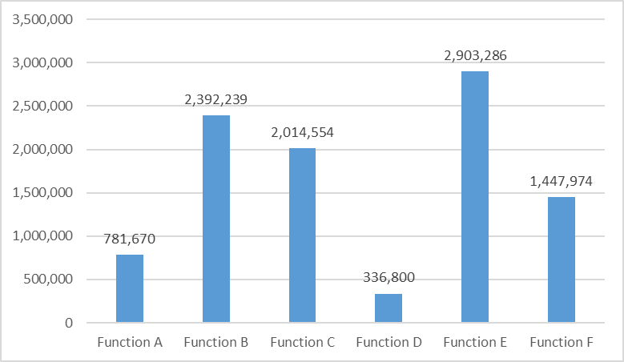

Table 3. 2022 Expenditure analysis by main categories of nature of cost



Chart 3. Expenditure, including obligations, by source of funds (total of $8,948,568)

Table & Chart 4. Status of extrabudgetary gap filling as at 31 December 2022



Table 5. Additional contributions received in 2022, as at 31 December 2022



Table 6. In-kind contributions received in 2022, as at 31 December 2022



Chart 5. Main voluntary contributions’ donors (based on funding agreements signed in 2022   
(total of $14,833,809)

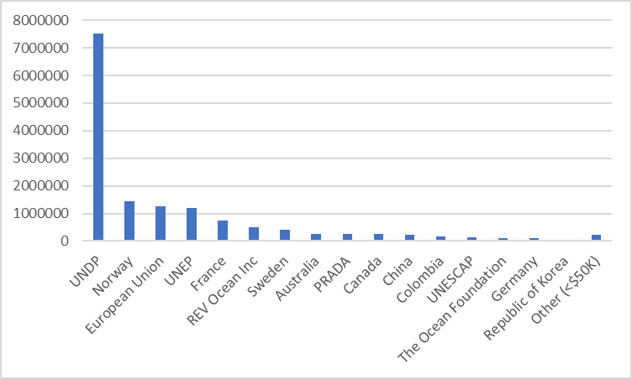

Chart 6. Main voluntary contributions’ donors   
(based on cash received in period 1 January–31 December 2022 (total of $5,982,768)

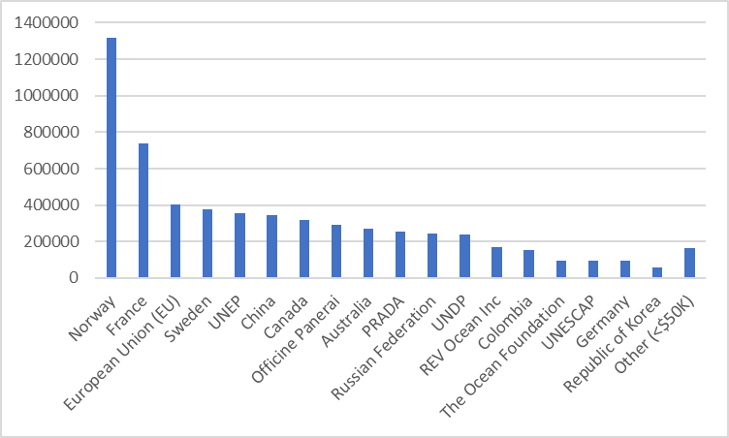

**DETAILED INFORMATION BY SOURCE OF FUNDS**

1. **REGULAR PROGRAMME BUDGET**

Table 7. IOC 2022–2023 regular budget allocations and expenditure as at 31 December 2022



1. **VOLUNTARY CONTRIBUTIONS**

**IOC SPECIAL ACCOUNT**

Table 8. Expenditure as at 31 December 2022



**FUNDS-IN-TRUST**

Table 9. Expenditure as at 31 December 2022



1. **OVERVIEW OF THE IOC STAFFING 2022**

Chart 7. Regular budget staff establishment

Chart 8. Actual FTE, all sources of funding

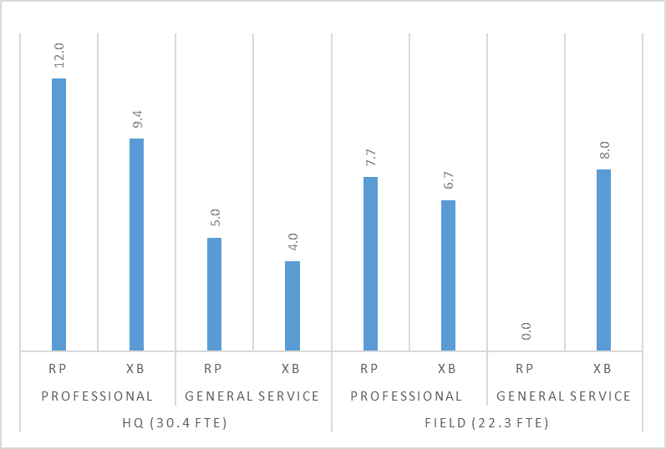

1. Reference IOC Resolution A-31/2 and IOC/A-31/4.2.Doc and Resolution EC-55/2 and IOC/EC-55/3.1.Doc(2)