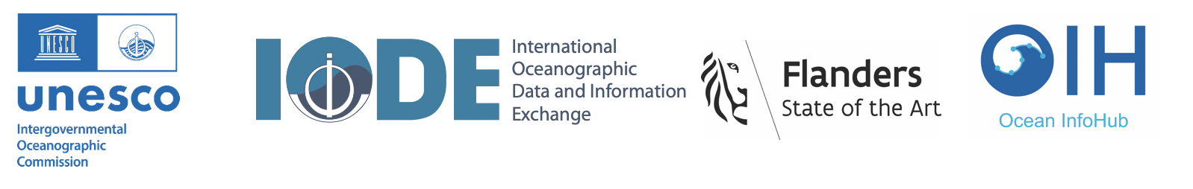
Fourth Session of the IODE Steering Group for the Ocean InfoHub Project
Provisional Agenda: 4-5 October 2023

We are pleased to share session information and a provisional agenda for the hybrid meeting.

Physical meeting location: InnovOcean Campus- Jacobsenstraat 1-8400 Oostende, Belgium
https://www.innovoceancampus.be/en/access-to-the-building

Link to recordings for asynchronous viewing [available after 24 hrs]: https://drive.google.com/drive/folders/14Rvfs53C6knan6AkDOKnOlsEIQ0VjWIo?usp=sharing

The participants list and available documentation can be found on OceanExpert: https://oceanexpert.org/event/3929

Working language of the meeting: English

Provisional agenda
4 October 2023 (all times in CEST)
09h30 | Arrival on site, tea and coffee
10h30-12h30 | Session 1
 | Opening of the meeting (Vladimir Ryabinin and Gert Verreet)
 | Administrative arrangements (Sofie De Baenst)
 | Adoption of the agenda (Harrison Ong’Anda)
 | Overview of the OIH work plan and deliverables (Lucy Scott and OIH team)
 | WP 1 : Project management, coordination and evaluation
 | WP 2 : Technology development
12h30 - 13h30 | Lunch
13h30 - 14h30 | Special session: OIH and MAREGRAPH cooperation
14h30 - 16h00 | Session 2
 | WP 3 : Establishment and initial support of the global hub and regional nodes, including end-user engagement in the three regions
WP 4 : Training and Capacity Development
WP 5: Communication (including end-user engagement)
16h00 | Tea and coffee
5 October 2023 (all times in CEST)
09h30 | Arrival on site, tea and coffee
10h30-12h30 | Session 3
UN Decade Data and Knowledge Management activities (Louis Demargne)
Decade DCO for Data Management (Jan-Bart Calewaert)
OceanData-2030 (Pier Luigi Buttigieg)
12h30 - 14h30 | Lunch
14h30 - 15h30 | Session 4
 | Election of the Chair
Next meeting: Final OIH Project meeting TBC
Thanks and closing
15h30 | Tea and coffee

