Intergovernmental Oceanographic Commission
Reports of Meetings of Experts and Equivalent Bodies

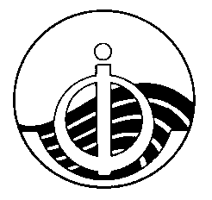

IODE Steering Group for the Ocean InfoHub Project

Annotated Agenda

Fourth Session (Hybrid)
4-5 October 2023

4-5 October 2023
English only

For bibliographic purposes this document should be cited as follows:

IODE Steering Group for the Ocean InfoHub Project (SG-OIH), Fourth Session, 4-5 October (hybrid meeting) 33pp. & Annexes, 2023. (Reports of Meetings of Experts and Equivalent Bodies).

Table of contents

page
1. Introduction 2
2. Opening of the meeting 2
3. Administrative arrangements 2
4. Adoption of the Agenda 2
5. Overview of the OIH work plan and deliverables 2
5.1 Work package 1: Project management, coordination and evaluation 3
5.2 Work package 2: Technology development 9
5.3 Work package 3: Establishment and support of the global hub and regional nodes 15
5.4 Work package 4: Training and capacity development of the nodes 22
5.5 Work package 5: Communication, user marketing and feedback 24
6. UN Decade Data and Knowledge Management activities 28
7. Decade DCO for Data Management 28
8. OceanData-2030 28
9. Election of the chair 28
10. Next meeting: Final OIH Project meeting (TBC) 28
11. Thanks and close of the meeting 28

ANNEXES

ANNEX I: Provisional agenda

ANNEX II: Summary of Additional Actions

ANNEX III: List of Participants

Introduction
The Fourth Session of the IODE Steering Group for the Ocean InfoHub Project was convened on 4-5 October 2023. A hybrid format was chosen to facilitate maximum participation of Steering Group members. Background documents were prepared and shared with all Steering Group meeting participants in advance of the meeting.

OE event link: https://oceanexpert.org/event/3929

The purpose of the meeting was to provide a comprehensive overview of progress on the work plan over the past 12 months, and to get feedback on plans for the remaining eight months of the project. All workshop materials will be permanently located at the Ocean Expert link provided above.

Opening of the meeting
Opening of the meeting (Mr Vladimir Ryabinin and Mr Gert Vereet TBC)

Administrative arrangements
Ms Sofie De Baenst shared some logistical and administrative information.

Adoption of the Agenda
Mr Harrison Ong’Anda (SG-OIH Chair) presented the draft agenda.

Overview of the OIH work plan and deliverables
A presentation was made by Lucy Scott and the OIH team, covering the deliverables to date and the upcoming work plans for the five work packages. The work plan is on track with no major technical delays. A no-cost extension has been granted for the project to run until June 2024; this has been factored in to the work programme.

The OIH Project has 5 work packages:

WP1: Project management, coordination and evaluation
WP2: Technology development
WP3: Establishment and initial support the global hub and regional nodes
WP4: Training and capacity development of regional nodes
WP5: Communication, user marketing and feedback

In reaching our milestones, grateful thanks are due to the IODE PO team, funder (Government of Flanders, Kingdom of Belgium), WP2 secretariat and contractors, WP2 working group, three regional coordination teams (Africa, LAC and PSIDS), implementation partners and other project partners.

Lucy Scott gave an overview of the timeline to date and the current status of the implementation of ODIS. This was followed by a detailed report on each of the work packages.

Ocean InfoHub highlights: past 11 months
- Three active communities of practice (Africa, PSIDS, LAC)
- Technical working group active, and two subcontractors renewed
- 19 partner organisations (representing 25 nodes) currently indexed
- Documentation and resources continue to grow
- Front end Global Search Hub contract (II) just started
- End-user feedback collected on the Global Search Hub
- Plans in place for expanding end-user engagement, particularly in regions
- A total of 96 organisations engaged and/or in the co-design process
- Animated video, brochure and other materials disseminated widely
- Four more training courses held (EN, SP, FR, PT) in 2023

Partners currently indexed by OIH/ODIS

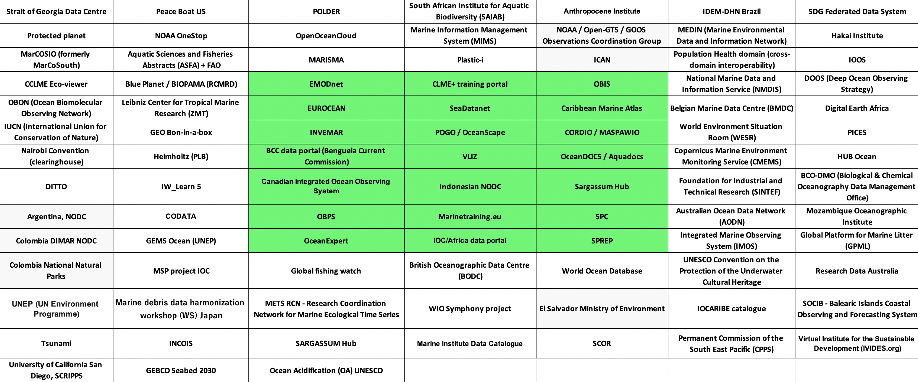

Ocean InfoHub Monitoring and Indicators
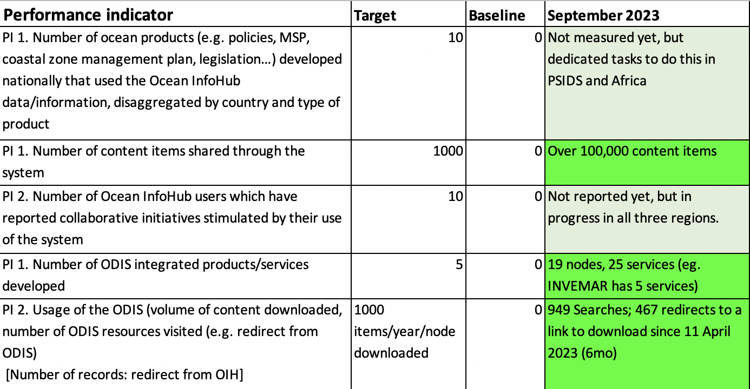

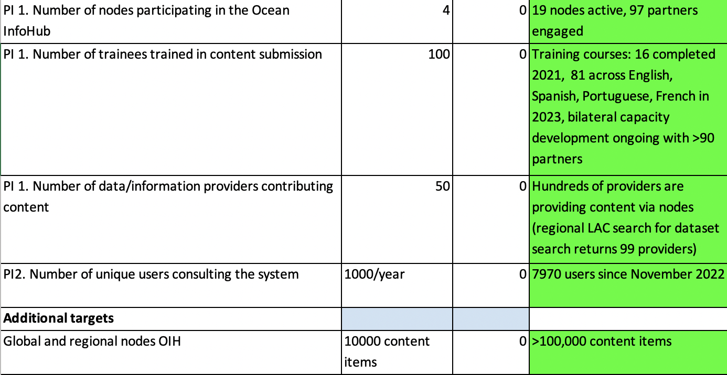

5.1 Work package 1: Project management, coordination and evaluation
This work package covers activities related to:
- overarching coordination and guidance
- planning and budget management
- monitoring and reporting
- risk and issue management
- project evaluation.

The role of the Steering Group is to:
- monitor and guide the implementation of the Ocean InfoHub
- propose remedial action where necessary
- advise the Project Manager
- ensure that the project serves user/region needs
- identify new opportunities and adjust the work plan according to changing needs and circumstances
- prepare annual progress reports

Table 1. Work Package 1 overview of timeline

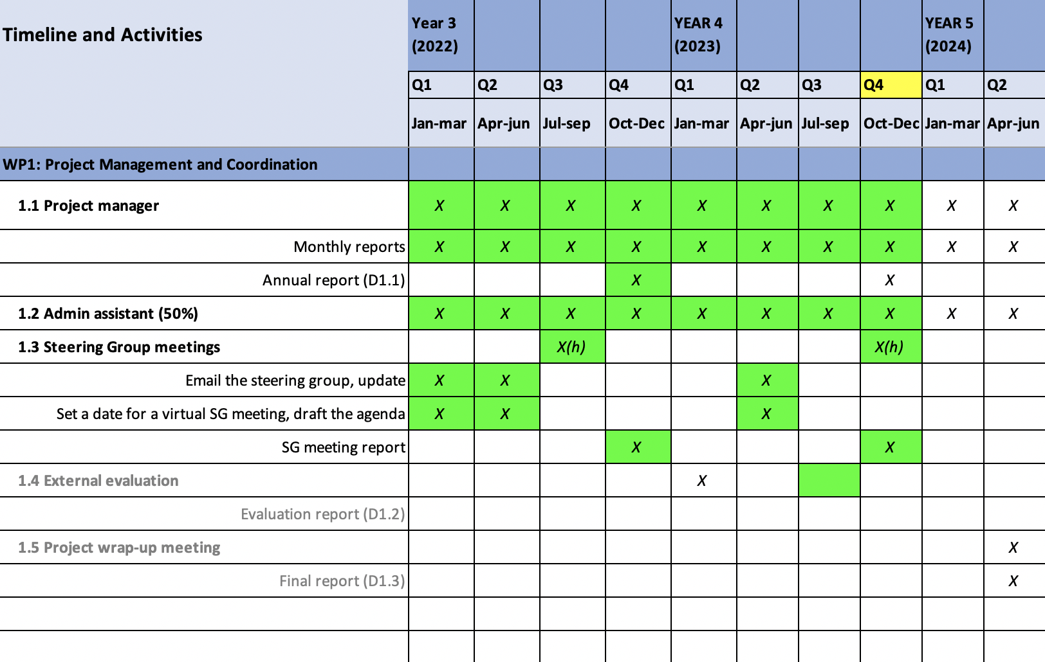

5.1.1 Deliverables September 2022 – September 2023

1. Tracking sheet for all project deliverables maintained and monthly reports written. (Reference doc 1. OIH Project Timeline and Deliverables).

2. Steering Group meeting convened

3. General administration tasks (project management tools, calendars integrated, dropbox, Gdrive, IODE / IOC meetings and ad hoc UNESCO meetings).

5.1.2 Objectives October 2023 – June 2024

1. Tracking sheet for all project deliverables maintained and monthly reports written

2. Final project meeting planned and final project report written.

3. General administration tasks continued

5.1.3 External Evaluation of the Flanders/UNESCO Trust Fund for the Support of UNESCO’s Activities in the Field of Science (presenter TBD)

Questions and discussion

5.1.4 Budget

Significant cost savings were made during 2021 and 2022 due to the travel restrictions imposed as a result of the global COVID-19 pandemic. A balance was found between additional spending (on consultancies, for example), while still retaining reserves to enable travel when permitted.

Costs to be spent for the remainder of 2023 and to June 2024 include:

- Two contracts for the ongoing development of the ODIS-architecture and support for partners in three regions.
- Co-financing of PSIDs regional activities
- Co-financing of activities at the IOC Sub-Commission for Africa
- Co-financing of activities in the LAC region
- Further development of the Global Search Hub based on end-user feedback
- Ocean Decade Conference 2024
- SG-OIH-Final meeting 2024 (hybrid or virtual TBC)

Co-financing received

2020-2021 NORAD
African database of training opportunities: There was no single database or portal for marine and coastal training opportunities for Africa, training opportunities and resources were sourced from numerous distributed resources. The Africa Marine training Database has been successfully developed and populated with training course records. The portal is online at: http://africa.marinetraining.org/ and provides ocean professionals with direct information on training opportunities. Records are discoverable through the OIH Global Hub

The database continues to be updated in 2023

2021-2022 NORAD
Establishment of new nodes in the Ocean Data and Information System: our two contractors continue to work with partners in all regions and bring new nodes into the system.

Questions

5.2 Work package 2: Technology development
This work package covers the technical developments needed to support the implementation of Ocean InfoHub nodes and the proof-of-concept ODIS reference architecture which will allow the nodes to interoperate with each other and external systems.

In terms of Ocean InfoHub development, this work includes:

● development of a Global Hub
● development of Regional/Thematic Node application (Virtual nodes part of the Global Hub or as separate regional/thematic nodes)
● continued population of ODISCat

Table 2. Work Package 2 overview of timeline

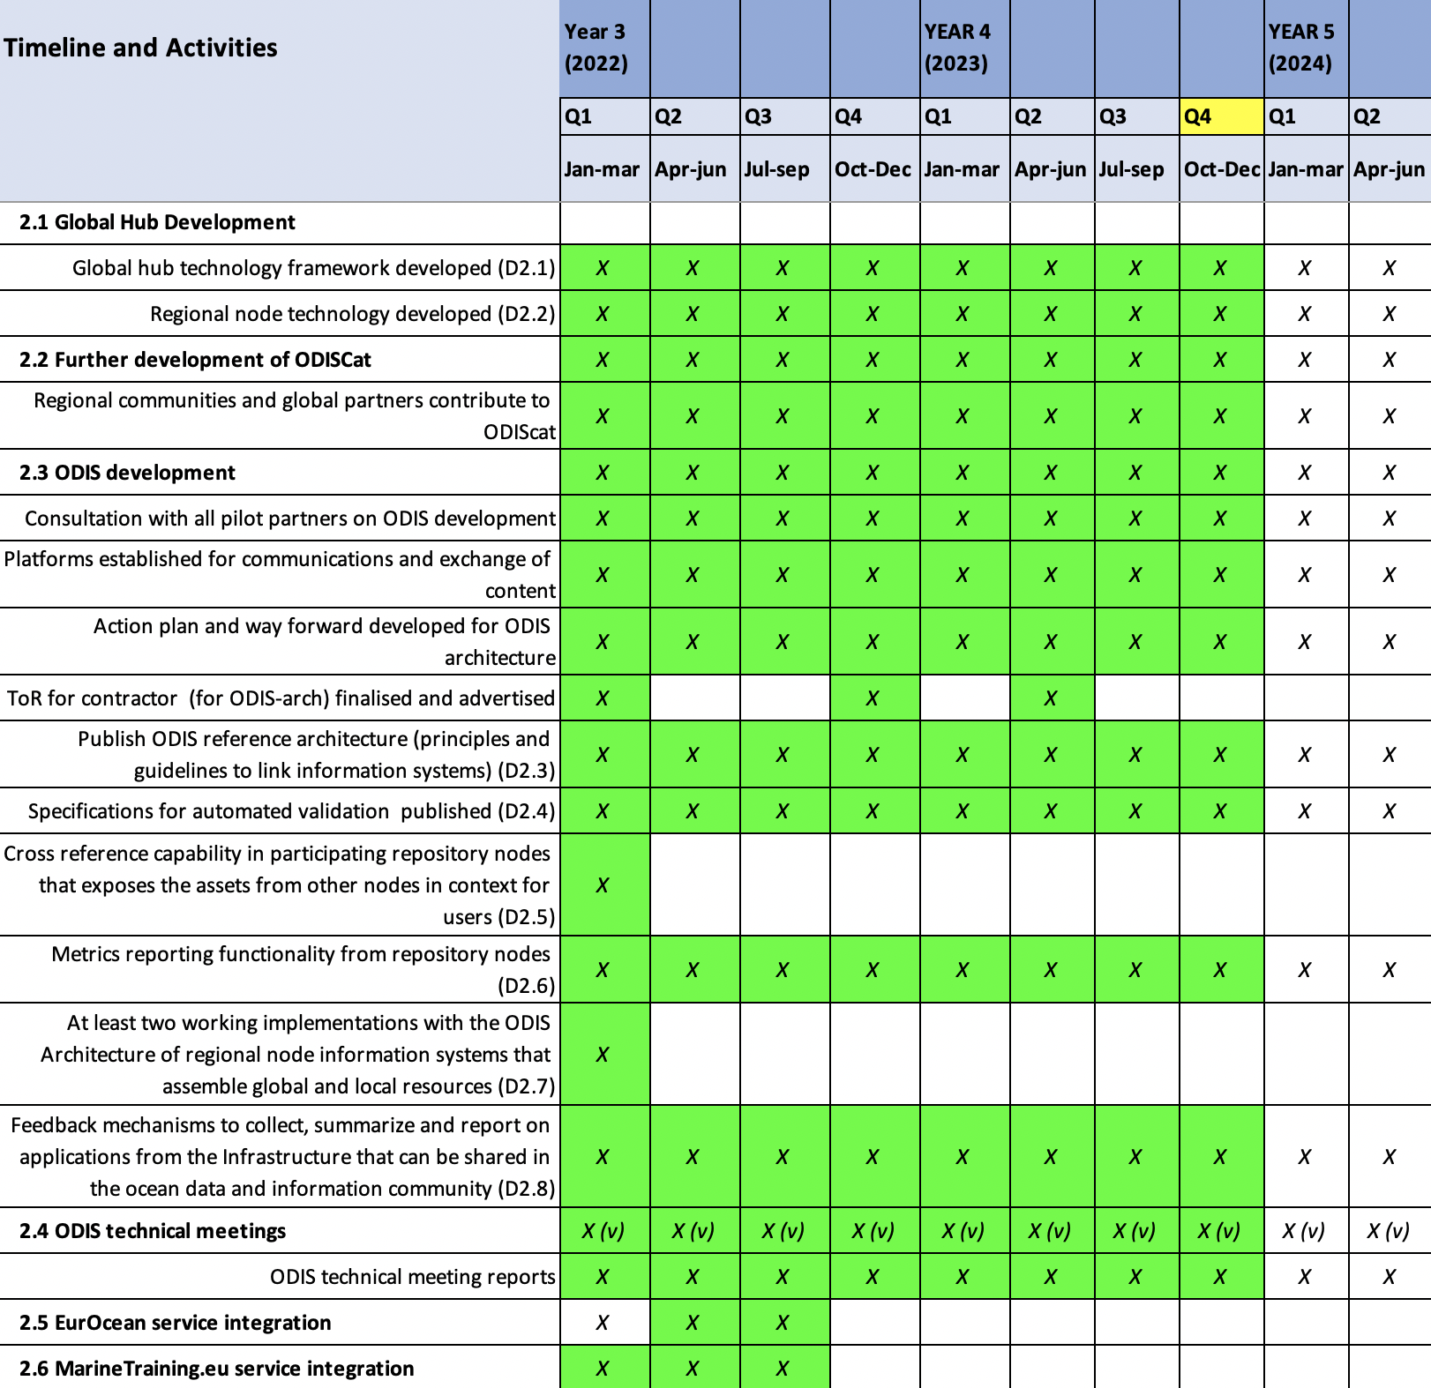

5.2.1 Deliverables September 2022 – September 2023

Global Hub Development
5.2.1.1 Global hub technology framework developed (D2.1)
- We have the Ocean InfoHub website at https://oceaninfohub.org/
- This site now includes the Global Search Hub as well as project information
- We have just contracted a service provider to work on further revisions of the global search (front end) in response to user feedback (this will be covered under WP5).

Start date for Google Analytics: 24 November 2022
Metrics as of 15 September 2023
- 7970 Users
- 129 Countries
- 949 Searches since 11 April 2023
- 467 Clicks away to an external link / download since 11 April 2023

5.2.1.2 Regional node technology developed (D2.2)
Regional nodes are currently online and indexed in the knowledge graph (discoverable via ODIS). Each of the three regions will report under WP3.
- INVEMAR CHM-TMT: http://portete.invemar.org.co/chm#/
- SPREP and SPC: https://www.spc.int/, https://www.sprep.org/
- IOCAfrica: Database of Training Opportunities, Projects database, Vessels database

- The global hub search portal showcases the three regions and in upcoming revisions will also be showing the communities of practice that we are supporting (including protected areas, EOV, SDG 14.3.1, marine debris).
- OIH-supported development work within each of the regions is actively bringing additional regional partners into the network (to be covered in WP3).

5.2.1.3 Further development of ODISCat
Regional communities and global partners contribute to ODIScat
- This is ongoing; at every new opportunity, organisations are asked to add records to ODIScat, and the projects have a close working partnership.
- Mr Arno Lambert presented an update on ODIS-cat recent developments and future plans.

ODIS development

5.2.1.4 Consultation with all pilot partners on ODIS development
This is ongoing. We hold regular WP2 core secretariat and partner meetings:
- 63 WP2 meetings since the last Steering Group meeting, plus 230 meetings with partners
- GitHub repositories: https://github.com/iodepo/odis-arch
- Slack: >3,600 posts in 33 channels. 120 Technical WG members.

5.2.1.5 Platforms established for communications and exchange of content
Completed in 2020 and reported on at OIH-SG-I.

5.2.1.6 Action plan and way forward developed for ODIS architecture
Completed in 2020 and reported on at OIH-SG-I.

5.2.1.7 ToR for contractor (for ODIS-arch) finalised and advertised
- Two contracts are currently underway (Doug Fils, Jeff McKenna).
- ODIS specifications for ten patterns/themes have been written and are developed on an ongoing basis.
- Documentation is available online at https://book.oceaninfohub.org
- Documentation is under continuous revision and improvement.

5.2.1.8 Publish ODIS reference architecture (principles and guidelines to link information systems) (D2.3)
Documentation for the Ocean InfoHub is located at https://book.oceaninfohub.org/. This documentation is structured to address the three primary personas expected in the OIH community. Those being Publisher, Aggregator and User. An introduction to these personas is found at https://book.oceaninfohub.org/personas/persona.html which links out to more specific documentation for each.

5.2.1.9 Specifications for automated validation published (D2.4)
Ocean InfoHub is leveraging and documenting the use of the W3C SHACL (https://www.w3.org/TR/shacl/) recommendation to address the issue of validation. Shape graphs for the OIH thematic types can be leveraged through existing tools to automate validation. The OIH documentation provides a reference implementation of such a validation.

5.2.1.10 Cross reference capability in participating repository nodes that exposes the assets from other nodes in context for users (D2.5)
The Ocean InfoHub Source and Provenance Approaches section (ref: https://book.oceaninfohub.org/thematics/identifier/id.html) describes some of the key approaches used to cross reference resources based on established identifiers. Specifically the documented identifier pattern (https://book.oceaninfohub.org/thematics/identifier/id.html#identifier) leverages an approach that allows both the expression of an ID value and the ID of the property itself. That is, the type of identifier it is, for example DOI and the value of that identifier.
Once encoded into the graph, the cross referencing capacity is expressed through the use of the SPARQL query language for RDF graphs. Itself documented at https://book.oceaninfohub.org/users/query.html and https://book.oceaninfohub.org/users/sparql.html.

5.2.1.11 Metrics reporting functionality from repository nodes (D2.6)
Reporting is supported both based directly on the graph generated by the providers and assembled into the Ocean InfoHub graph and by the supporting PROV (https://www.w3.org/TR/prov-overview/) based provenance data generated during the indexing processes.

This can then be used to support reporting functions.

5.2.1.12 At least two working implementations with the ODIS Architecture of regional node information systems that assemble global and local resources (D2.7)

At present the following 25 nodes from 19 partners are indexed in the Ocean InfoHub Knowledge Graph:

IOC Africa Data Portal
AquaDocs
Better Biomolecular Ocean Practices (BeBOP) as part of Ocean Biomolecular Observing Network (OBON)
Benguela Current Convention (BCC) GeoData Portal
Caribbean Marine Atlas catalogue
CIOOS
European Directory of Marine Environmental Research Projects (EDMERP) SeaDataNet
European Directory of Marine Organisations (EDMO) SeaDataNet
EurOcean Organizations
EurOcean Projects
EurOcean Vessels
European Marine Observation and Data Network catalogue
Indonesia National Oceanic Data Center
CHM LAC - Documents
CHM LAC - Experts
CHM LAC - Institutions
CHM LAC - Training
CHM LAC - Vessels
Marine Training EU
MASPAWIO - Marine Spatial Atlas for the Western Indian Ocean
Research Coordination Network for Marine Ecological Time Series (METS-RCN)
Ocean Biodiversity Information System
Ocean Best Practices System
OceanExpert UNESCO/IOC Project Office for IODE
Pacific Data Hub

We are currently working with a total of 94 partners to bring their holdings into the graph (up from 48 in 2022).

ODIS-architecture implementation by partners:
https://docs.google.com/spreadsheets/d/13bn9IPL8mYOwwoIKtTfx1XgW4FJsvofLSivevGTG7UE/edit?pli=1#gid=0

5.2.1.13 Feedback mechanisms to collect, summarize and report on applications from the Infrastructure that can be shared in the ocean data and information community (D2.8)
Ocean InfoHub has leveraged a range of approaches to collect feedback. These include the Slack channel (120 Technical WG members from partners), email, video conferencing and our GitHub repository. All tasks and partner interactions are documented in Github issues which are open and easy to track.

5.2.1.14 ODIS technical meetings
ODIS technical meeting reports
Regular WP2 core secretariat and partner meetings: 63 core WP2 meetings and 230 partner meetings since SG-III
All meetings are documented and notes are available.

5.2.1.15 EurOcean service integration
Completed 2021/2022 and reported on at OIH-SG-III.

5.2.1.16 MarineTraining.eu service integration
Completed 2021/2022 and reported on at OIH-SG-III.

5.2.1.17 ODIS Project update
- Mr Arno Lambert provided a brief report on ODIS-SG-II held on 3 October 2023

5.2.1.18 Supporting Matchmaking services / human brokerage

5.2.1.19 Supporting communities of practice (new patterns)
- Protected Areas
- EOVs
- SGDs, specifically 14.3.1 OA
- Marine debris

5.2.1.20 Supporting other domains
- Meteo / WMO WIS2,
- polar,
- population health
- Heimholtz implementation?
- Maregraph
- WorldFAIR

5.2.1.18 OIH WP2 contractor reports

Doug Fils provided a brief overview of some of his work

Jeff McKenna provided a brief overview of some of his work.

5.2.2 Objectives October 2023 – June 2024

5.2.2.1 Global hub development
- Work on the OIH Front end search portal is ongoing
- We have just engaged a new team to work with us on the front end
- Internally, we have been processing feedback from >60 end-users to triage requests for developments from users (more detail under WP3) in preparation for the front end work.

5.2.2.2 Regional node development
We will continue to work closely with the regions on the three regional hubs and inclusion of additional partners.

5.2.2.3 Development of ODIScat
- Continued development work is planned

5.2.2.4 ODIS development
- Two contracts are underway for the ongoing development of the ODIS-architecture and documentation.
- At a higher level, discussions are underway with the DCU and DCO as well as project partners for using the ODIS architecture to support federation of data and knowledge systems around the world.

5.2.2.5 ODIS meetings
Regular meetings will be ongoing and partners are welcome to join.
Everything appears on the OIH google calendar which can be shared with any interested SG members.

Questions and discussion

5.3 Work package 3: Establishment and support of the global hub and regional nodes
This work package addresses the establishment of the global hub and three regional nodes covering Latin America - LAC (IOCARIBE+), Africa and Pacific SIDS at the operational level.

The technical aspects are covered by work package 2.

This work package focuses on setting up procedures for the sourcing of content, submission of the content, developing of national and regional networking of content providers and users.

Table 3. Work Package 3 overview of timeline

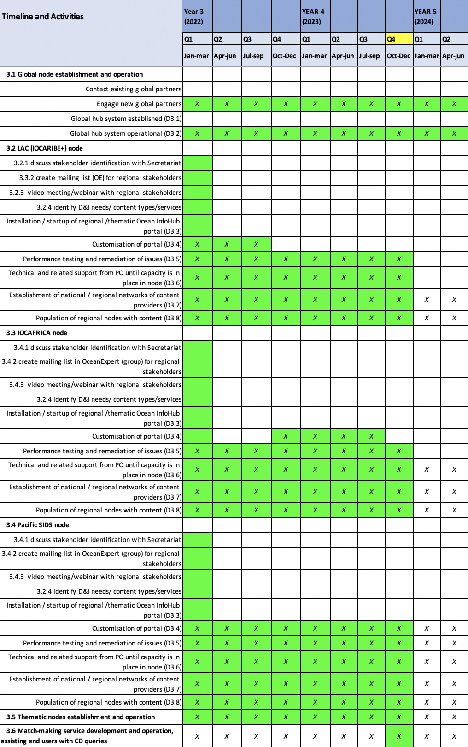

5.3.1 Deliverables September 2022 – September 2023 as well as objectives to June 2024

5.3.1.1 Global node establishment and operation

The project held 230 meetings during the last 11 months, under WP3, across the three regions, as well as bilateral meetings with regional and global partners. The project participated in numerous external meetings and events (reported under WP5).

5.3.1.2 Africa (John Ngatia) in person

- End-user engagement
Objective was to:
- Share information about the OIH project and its role in enabling transparent and efficient sharing and access of data and information
- Present the new ODINAFRICA Data Portal including its features i.e. existing data and information infrastructure
- Identify some initial end user needs/knowledge gaps in data sharing and access that can be addressed by OIH products not yet covered by existing OIH initiatives
- Map existing data and information infrastructures that could be potential partners with the Ocean Info Hub
- Discuss way forward for collaboration mechanisms, and review progress in implementation
- Identify some initial end user needs/knowledge products not yet covered by existing OIH initiatives

  - Engagement with National Oceanographic Data Centers (NODCs)
OIH facilitated the organization of three NODC-focused Sessions between 2022 and 2023.
The last session was on 30 May 2023.
In total, 14 NODCs participated in the session. The discussions focused on identifying:

- Current state of the individual NODCs with regards to sharing and accessing data
- Institution contact point’s description of the supporting community and on data the countries hold
- Future perspectives / planned activities and sharing of data / metadata
- Major challenges, needs and opportunities in access / sharing data within NODCs that OIH could help address
- Identification of other NODC data needs needs/knowledge products not yet covered by the OIH

Outcomes of the Sessions

- Outline of the diverse data themes among NODCs –
- Documents,
- Experts,
- Ocean Observations – Physical, Chemical and Biological parameters
- Marine Species including fish
- Geospatial Data
- Description of existing data sharing practices (platforms)
- Active exchange with other NODCs and other institutions
- Specific metadata formats.
- Sharing protocols (use of persistent and unique DOIs).
- Use of standardized classifications and vocabularies.
- Open data formats and standard interfaces.
- Many databases are hosted and backed up on local PCs and servers

- Updated list of NODCs contact persons and supporting communities
- Mapping of collaboration opportunities with NODCs (OIH intervention points)
- Inexistence of a Database Management System (DBMS) at the NODCs
- Lack of web accessed databases i.e. disconnect between NODCs’ Web Portal and their database
- Challenges in management of large marine biological imagery (spatial) datasets.
- Insufficient channels for collaboration with regional data repositories to maximize meta(data) sharing and discovery.
- Absence of regional standards for managing marine and coastal datasets.
- Lack of national data exchange policy and protocols
- Lack of dedicated sustained funding for developing and maintaining data exchange facilities
- Need for more robust database systems i.e. that can work with multiple operation systems

  - Engagement with other institutions and experts
Two general information sessions organized between 2022 and 2023.
Last Session in 8 August 2023, attended by app 160 participants. Sessions targeted marine-affiliated organizations in Africa and adjacent island states. The online session, aimed at providing ocean science-affiliated stakeholders in Africa and Adjacent Island States with an interactive platform for deliberating on ways through which they can actively engage and benefit from the Ocean InfoHub (OIH) project, especially in streamlining their access and sharing of marine data.
Main Outcome: Need for follow-up bilateral discussions of how individual institutions can participate in OIH project.

Regional partners so far
•MarCoSouth, CORDIO, Benguela Current Commission, IUCN, Regional Remote Sensing Centre, UNEP Nairobi Convention Secretariat etc.
• Partners have submitted documentation on data sources / architecture / vocabularies / ontologies / standards to the OIH GitHub Project
Possible new partners: -
RAFISMER Network, PRCM, FAO, COMHAFAT/ ATLAFCO, UEMOA initiatives, BLUE BELT Initiative
Potential Partner | Data Type
Digital Earth Africa | Spatial Data
BiCOME Project | Ocean Observation Data  Biodiversity
EU Science Hub  Africa Knowledge Platform | - Endemic species richness (sharks and rays) data
RCMRD- | Spatial data and maps
CCLME | Spatial data, Physical-chemical data

- Developing the OIH Africa Regional Node
OIH and IOCAFRICA engaged a contactor to develop the ODINAFRICA portal. The portal entails:
- New database for marine-related projects.
- Database for research vessels in the region,
- Past and upcoming research expeditions in the region,
- A view of the OceanExpert database that harvests in real time Africa region-specific experts and institutions from the main Ocean Expert Database.
- A view of the Aquadocs database that harvests in real time Africa region-specific ocean-related documents
- Ocean observation platforms - The database also comprise of data and information extracted from existing study reports on status of ocean observation platforms and infrastructure, while providing links to major ocean observation platforms in the region and allow for the monitoring of their status.
- Standard static web pages for each of the NODCs that link to either the NODC website or to the host institution

A catalogue service for Projects, research vessels, Past and Upcoming expeditions was setup. It exposes each record through JSON-LD, to become a node within OIH’s ODIS network
Spatial data – ACMA
Statistics

Data | Entries
marine-related projects | 240
research vessels | 28
Past Expeditions | 127
Upcoming Expeditions | 2
OceanExpert:  Experts  Institutions | 2702  628
Documents | 5252
Ocean Observation Platforms | -
Training and research opportunities (https://africa.marinetraining.org/map ) | 173

- Reactivating the ODINAFRICA Network
Workshop in 2022
  - The status, roles, challenges and opportunities of National Oceanographic Data and Information Centre (NODCs),
  - Progress in implementing the OIH project in Africa, specifically on addressing the six OIH project thematic areas: (i) experts and institutions/organizations, (ii) documents, (iii) Spatial data and maps, (iv) research vessels, (v) education and training opportunities, (vi) projects;
  - The steps towards developing a joint framework for member states and institutions in the region to actively engage and contribute to the Ocean Data and Information Ne

In 2023:
Revision of the strategic plan developed in 2022 to include ‘Ocean Observation and data management’ as an area of focus for a revitalized ODINAFRICA. This is based on the recommendations from the Seventh Session of the Sub-Commission (IOCAFRICA 7).
‘Urges the GOOS AFRICA Coordinating Committee to work with the Ocean Data and Information Network for Africa (ODINAFRICA) towards the establishment of an African Ocean Data Centre.’
With input from OIH, the ODINAFRICA Steering team is scheduled to deliberate/agree on 3 or 4 themes of focus of the revitalized ODINAFRICA in their routine meetings. Proposed themes of focus for ODINAFRICA so far:
- Reactivation of ODINAFRICA to contribute to the Ocean Information Hub (OIH) as a regional and multi-thematic node that will improve online access to and synthesis of existing regional and national data, information and knowledge resources, including existing clearinghouse mechanisms.
- Capacity development for transparent and efficient ocean data collection, management and sharing
- Strengthening the ocean observation, especially sea-level stations network in the region
- And / Or Alternatively
- Establish and advance the development of a regional ‘digital twin’ for Africa for centralizing marine data acquisition, data handling and management
Planned series of meetings:
  - Analysis of GAPS and Challenges for ODINAFRICA (Virtual Session)
Proposed time: 29 August 2023
  - Information Session: Aligning ODINAFRICA with Existing resources (virtual meeting)
Proposed time: 12 September 2023
  - Towards a Strengthened and Sustained Sea Level Observation Network (Joint GOOS -OIH AFRICA Workshop)
Proposed time: Feb 2024

5.3.1.3 Latin America and the Caribbean (Francisco Arias/ Paula Sierra) via Zoom

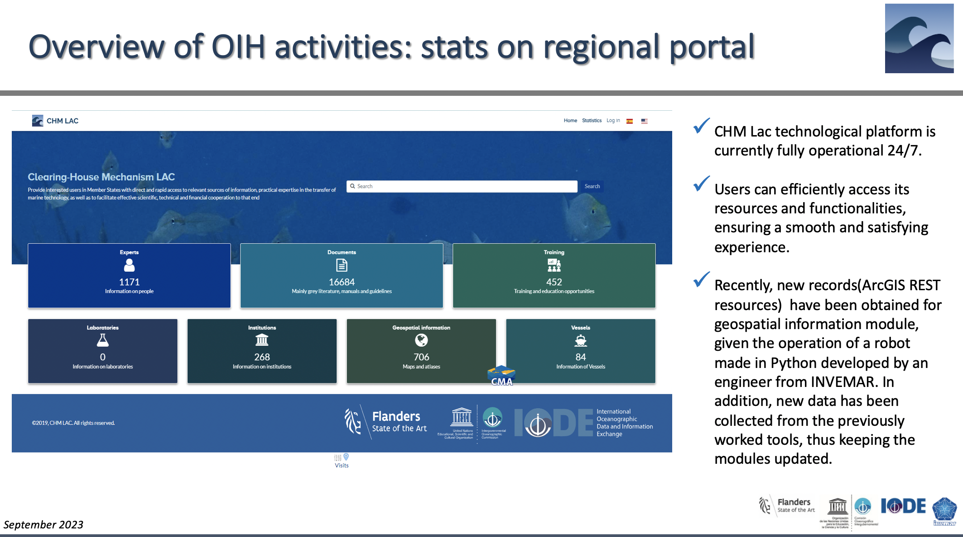

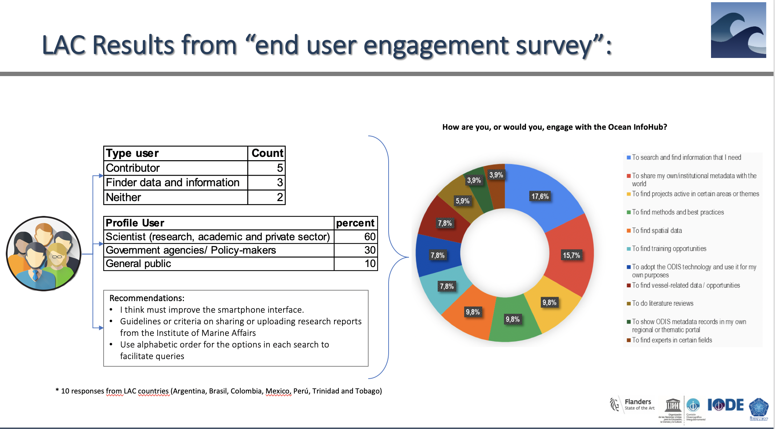

Recommendations:

- The most part of institutions/countries of the region don´t have published/online the offer of capacities (marine instrumentation/vessels mainly e.g.) and available to be linked from metadata. Given this, OIH LAC has not yet been able to capture all the real supply of capacity in the topics proposed for the region. Thinking about strengthening the capacities of institutions to publish information can be an activity to be taken into account in the framework of the Decade of Ocean Sciences (A transparent ocean...) and that in an important way also influences the results for the GOSR ( Global Ocean Science Report).
- The characterization of the "Laboratory" category lacks a template with minimum attributes, which means that no records have been reported for that category to date, despite the fact that there are records for the region.
- NODC and ADU must have more intense activity to promote information sharing to OIH

5.3.1.4 Pacific Small Island Developing States (PSIDS) (Tavita Su’a and Zulfikar Begg) Tavita in person

Questions and discussion

5.4 Work package 4: Training and capacity development of the nodes
This work package focuses on the development of a series of online training modules and tutorials as well as written documentation such as manuals. WP4 only commenced in 2021.

Table 4. Work Package 4 overview of timeline

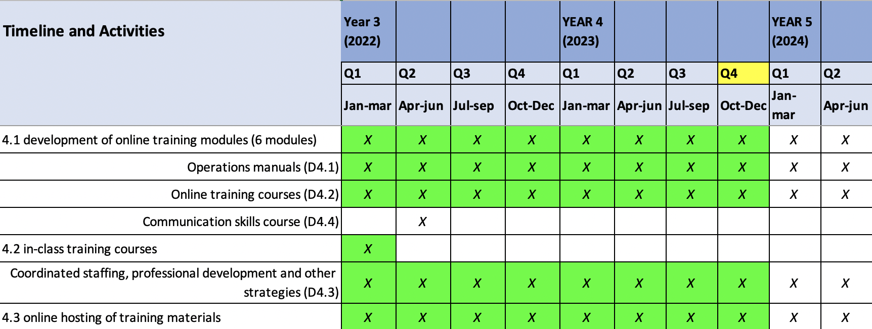

4.4.1 Deliverables September 2022 – September 2023

4.4.1.1 Development of online training modules
- IOC/OTGA/OIH Training course: Implementing the Ocean Data and Information System (ODIS) architecture. 25-29 October 2021 [online]
- All course materials have since been translated into Spanish, French and Portuguese.
- During April 2023, four courses were held (one in each language), and subsequently courses were made available for self-paced learning.

4.4.1.2 Operations Manuals: ODIS-architecture documentation
https://book.oceaninfohub.org

4.4.1.3 Online Training course:
IOC/OTGA/OIH Training course: Implementing the Ocean Data and Information System (ODIS) architecture. OceanExpert information: https://oceanexpert.org/event/3921 [online and then self paced].
Courses will be closed in December and then re-opened in January 2024.
- ENG: https://classroom.oceanteacher.org/course/view.php?id=928
- SPA: https://classroom.oceanteacher.org/course/view.php?id=929
- FRE: https://classroom.oceanteacher.org/course/view.php?id=930
- PORT: https://classroom.oceanteacher.org/course/view.php?id=931

Training course numbers
2021: 59 in english
2023: 81 across English, Spanish, Portuguese, French

4.4.1.4 Communication skills course
At OIH-SG-III it was resolved that elements of communication be incorporated into the existing courses, and also that tools be developed to assist global search hub users. This will be implemented by the new front-end development team.

4.4.1.5 In-class training courses
Held in 2021, but not repeated.

4.4.1.6 Online hosting of training materials
IOC/OTGA/OIH Training course: Implementing the Ocean Data and Information System (ODIS) architecture. 25-29 October 2021 [online]
- OceanExpert information: https://oceanexpert.org/event/3921
- ENG: https://classroom.oceanteacher.org/course/view.php?id=928
- SPA: https://classroom.oceanteacher.org/course/view.php?id=929
- FRE: https://classroom.oceanteacher.org/course/view.php?id=930
- PORT: https://classroom.oceanteacher.org/course/view.php?id=931

4.4.2 Objectives October 2023 – June 2024

4.4.2.1 Development of online training modules
Online resources continue to be developed and improved (related to reporting under WP2)

4.4.2.2 Operations Manuals: Further development of the ODIS-architecture documentation
https://book.oceaninfohub.org

Questions and discussion

5.5 Work package 5: Communication, user marketing and feedback
This work package covers the communications and engagement activities needed to ensure the relevance and usefulness of the Ocean InfoHub global and regional/thematic nodes, to promote community participation in the Ocean InfoHub as contributors and users, and to solicit input needed to foster ongoing development of the Ocean InfoHub nodes.

Table 5. Work Package 5 overview of timeline

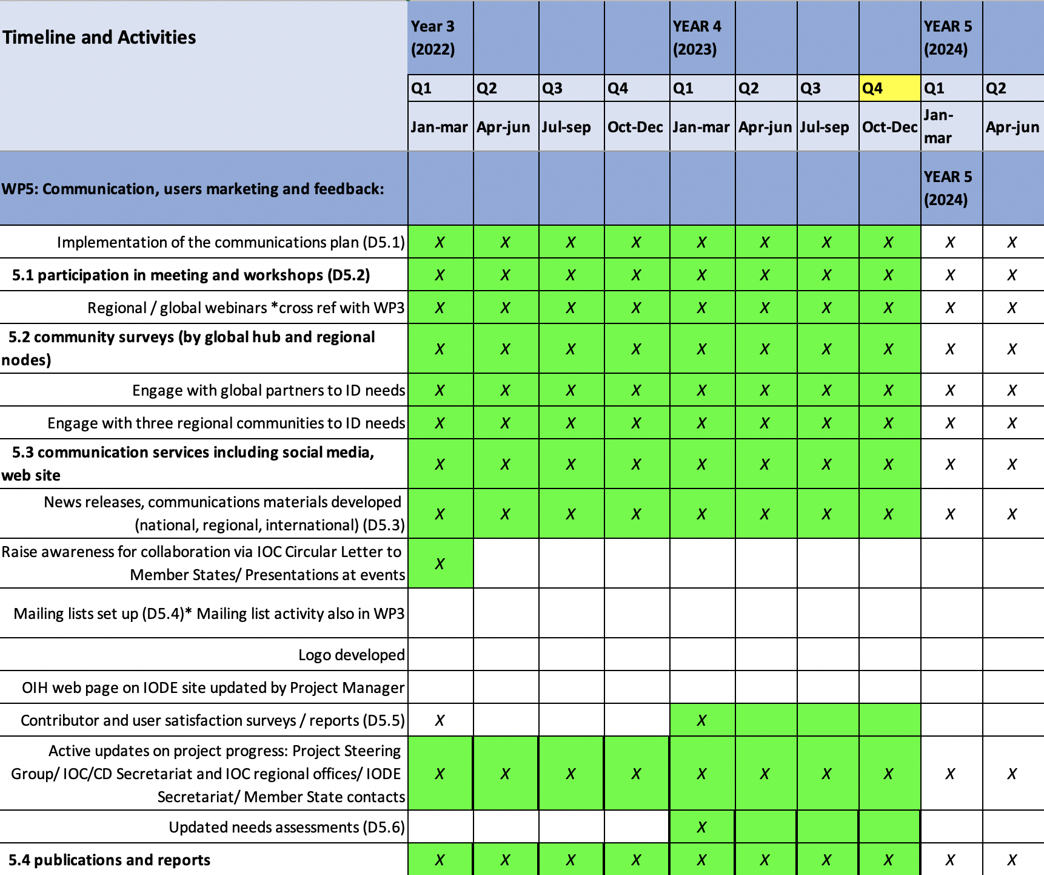

5.5.1 Deliverables September 2022 – September 2023

5.5.1.1 Participation in meetings and workshops
- Altogether, the project has organised or participated in 317 documented virtual, physical or hybrid meetings, webinars or events (besides staff meetings) since the last Steering Group meeting.
- Many of these were internal WP2 or WP3 meetings, but many internal meetings include partners and can also be seen to contribute to WP5.
- Many of these events contributed directly to awareness raising about OIH activities, objectives, and benefits of partnership.

Selected examples (a full list is available)

- WIOMSA Symposium, Ocean Decade special session (October 2022)
- GEF IWLearn 5 inception II (October 2022)
- Marine Spatial Data Infrastructure Workgroup meeting of Meso American-Caribbean Sea Hydrographic Commission (MACHC) (October 2022)
- IAMSLIC 2022 Conference & & 4th Grupo Regional LatinAmericano Meeting (October 2022)
- Gulf Caribbean Fisheries Institute GCFI 75th conference (November 2022)
- OIH: Expeditions Pattern ODINAFRICA (November 2022)
- OIH: Global Platform for Marine Litter (GPML) meeting (January 2023)
- Ocean Data and Information conference II (March 2023)
- IODE 27 (March 2023)
- Marine debris data harmonization workshop (August 2023)

5.5.1.2 Community surveys and end user engagement.

In May 2023, we opened an end-user feedback form to gather feedback on the global search hub, and the experiences of users in general. The survey is short and remains open.

- We have had 61 user responses up to 1 September 2023

- Country count 3 and over: Colombia, Canada, Belgium, Kenya, Portugal, South Africa
- Sector: 55% scientists, 30% NGOs, 18% NODCs, 15% Govt agencies.
- Gender: 51% male, 49% female

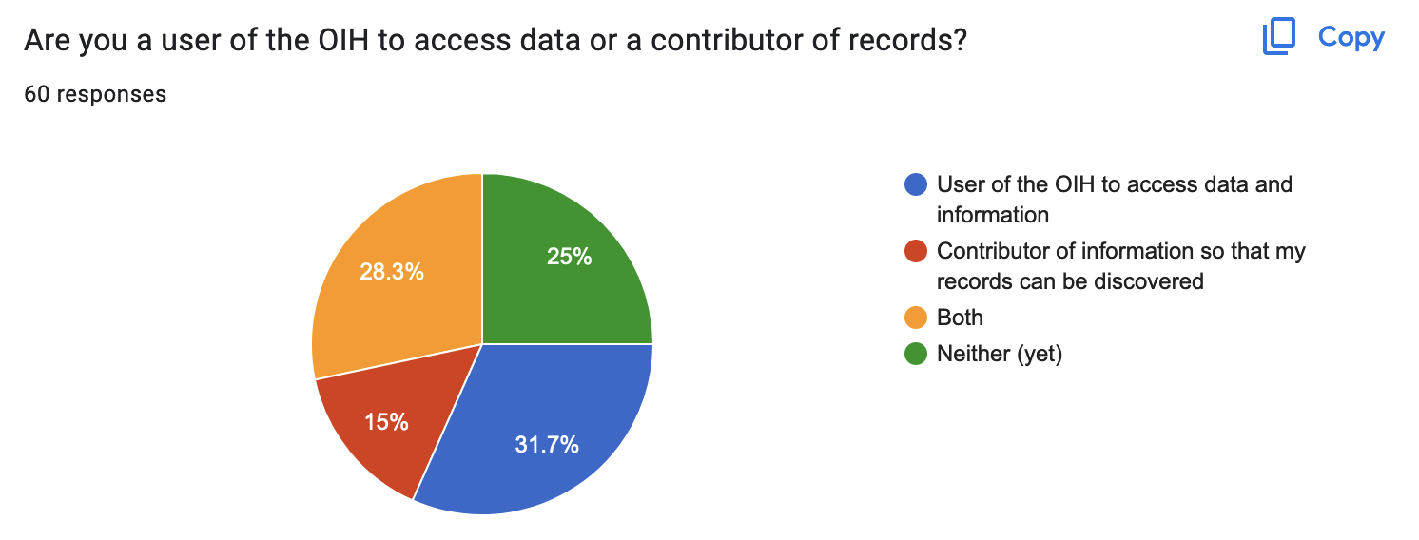
- 60% were users of the content
- 43.3% were users of the technology
- (28.3% replied both)

How are you engaging with the OIH?
- 90% to search and find information that I need
- 70% to share my own institutional data
- 53% to find information about projects
- 51% to find methods and best practices

Have you found what you are looking for? 60% yes. 40% no OR have not searched yet.

Examples of feedback:

- Performed a couple of searches with the following results: - Very fast!
- The 'Back-button' of the browser does not work
- Searched for specific people/experts using their names and this poped up with correct information. Likewise, searched key terms corals keya and got some recognisable results.
- I haven't searched for information yet
- OIH found all the papers I am aware of for the topic I am researching.
- Spatial data = EurOBIS - should also be linked to EDMED (SDN)
- only text search is used, it is required also to use advanced search taking into account the main metadata attributes.
- Could not get information on the Gulf of Guinea (Bathymetry, Storm surge)
- The results of the search engine are nicely categorized and it's easy to find info.
- I was searching for some very specific data from our own portal that has been ingested by OIH. We're still fine tuning a few things so not too concerned for now.
- I found some information I was looking for but not everything. I did not find my institution, or myself.
- found myself, finally, have been searching for 58 years already

Can you give some examples of other potential USERS of this system in your region?
- Had about 50 responses

Can you name other potential data catalogues/portals or
partner organizations in your region that you would like to see as part
of the Ocean InfoHub?
- Had about 45 responses

Any other recommendations or comments? About 20 responses, for example:

- I would list more metadata for organisation, like country. I see the json LD contains more metadata so should be possible. For projects the coordinator is important.
- Spatial filter for spatial data/map isnt that great. Would be usefull to render search by zoom extent. I.e., only show what is visble at zoomed scale. Else, provide a togle button that one can use to switch on and off layers.
- Brilliant work!! Really an incredible ocean resource. Well done to OIH team. I'm interested in the spatial datasets and it seems that there is more available online for Africa than is listed. Is that because you can only show partners who have come on board as contributors or can the system point to existing data portals (MASPAWIO or AllanCoralAtlas or Copernicus Marine for example)?
- You know already about needing a sort option; would appreciate under the provider tag an indication of when the data was last updated:
- Thank you very much for the training! We will do our best to include ODIS in all of our presentations about the UN Ocean Decade programming.
- There seems to be a number of duplicates in the individuals section.
- I think must improve the smartphone interface. But It' s a wonderful Repo of Ocean Data.
- use alphabetic order for the options in each search to facilitate queries

Would you be open to a 5-10 minute discussion in follow-up?
- 73% said yes

What do we do with this information?
- Meeting every two weeks for triage (importance and urgency H/M/L and responsibility)
- Create a Github issue for each action, assigned either to our core tech dev team or to the UI dev team with a timeline.
- Each region is using regional results to respond to specific needs (as presented under WP3).

5.5.1.3 Communication services (social media, website)
- The website is updated frequently and contains news items, media feeds.
- We are currently using the IODE social media channels.
- Three products have been developed together with Sciencecrunchers; a video, a brochure and a slide deck (2022). These will all continue to be used in outreach and public awareness activities.
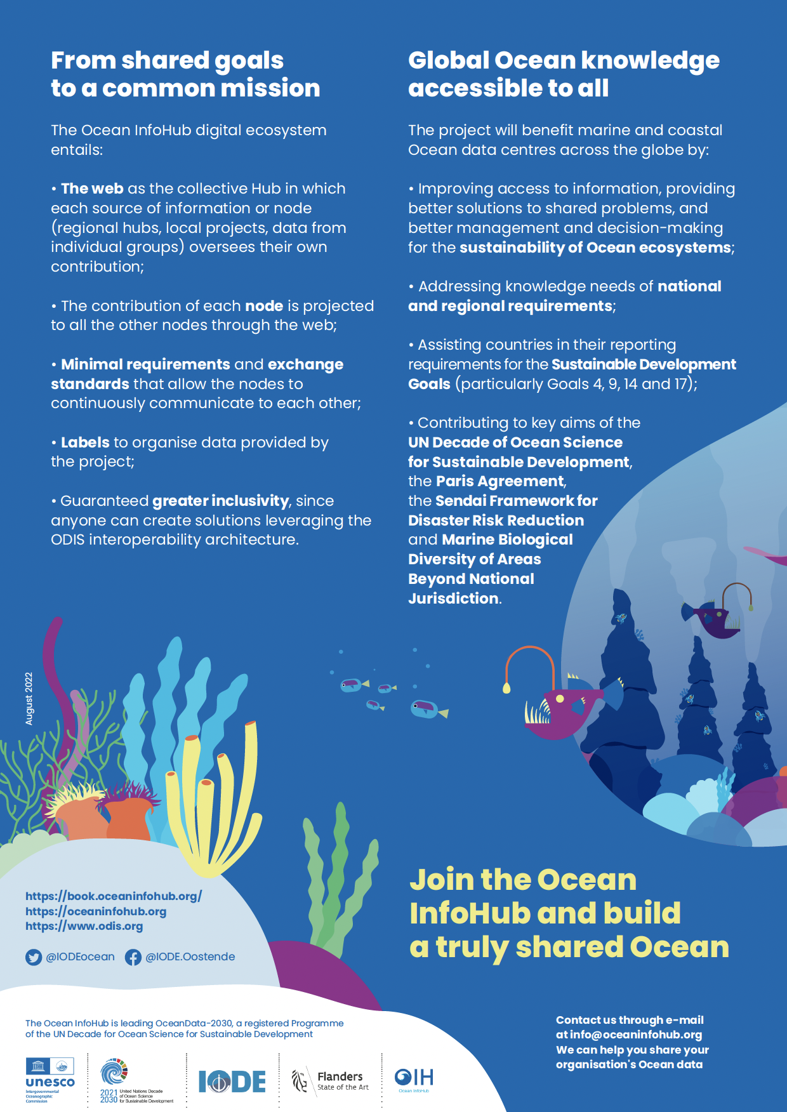
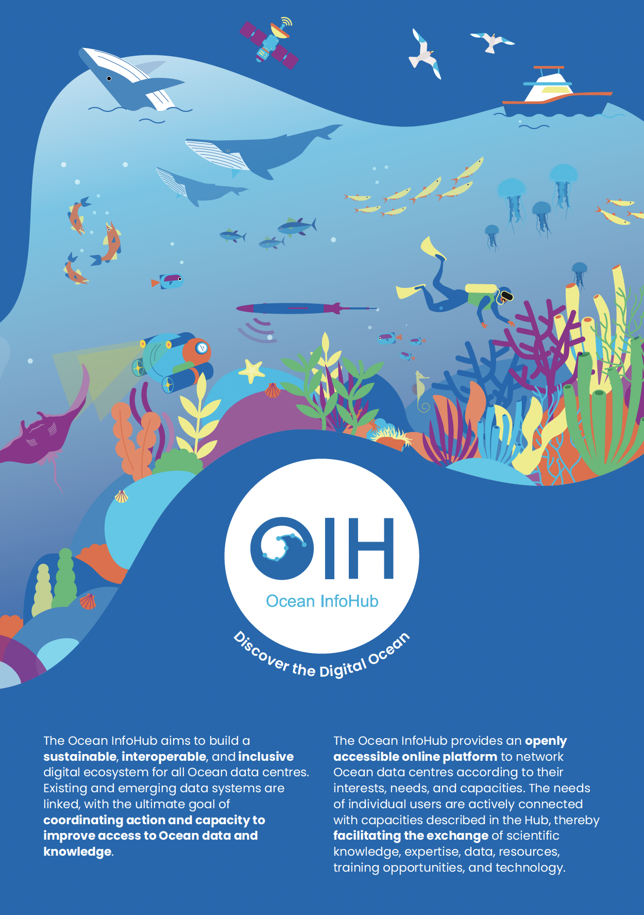
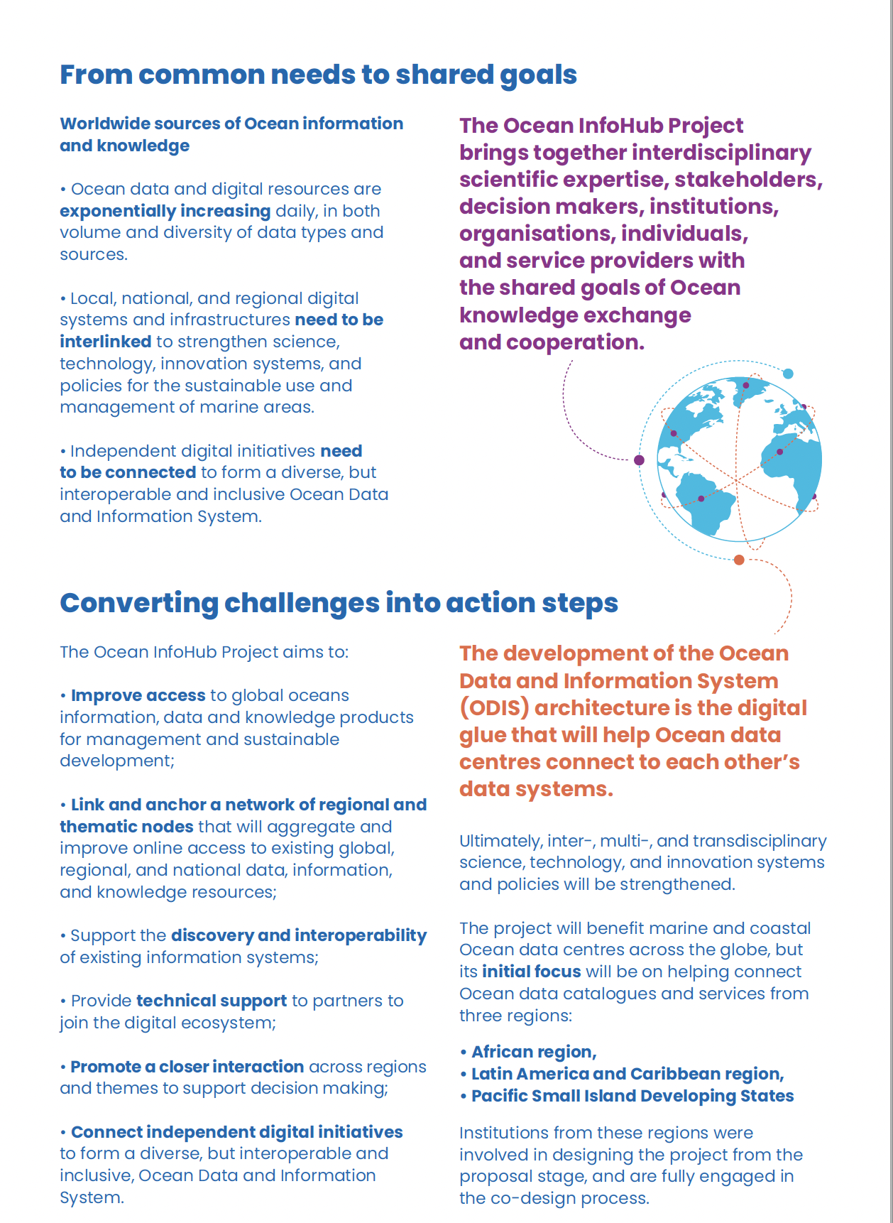
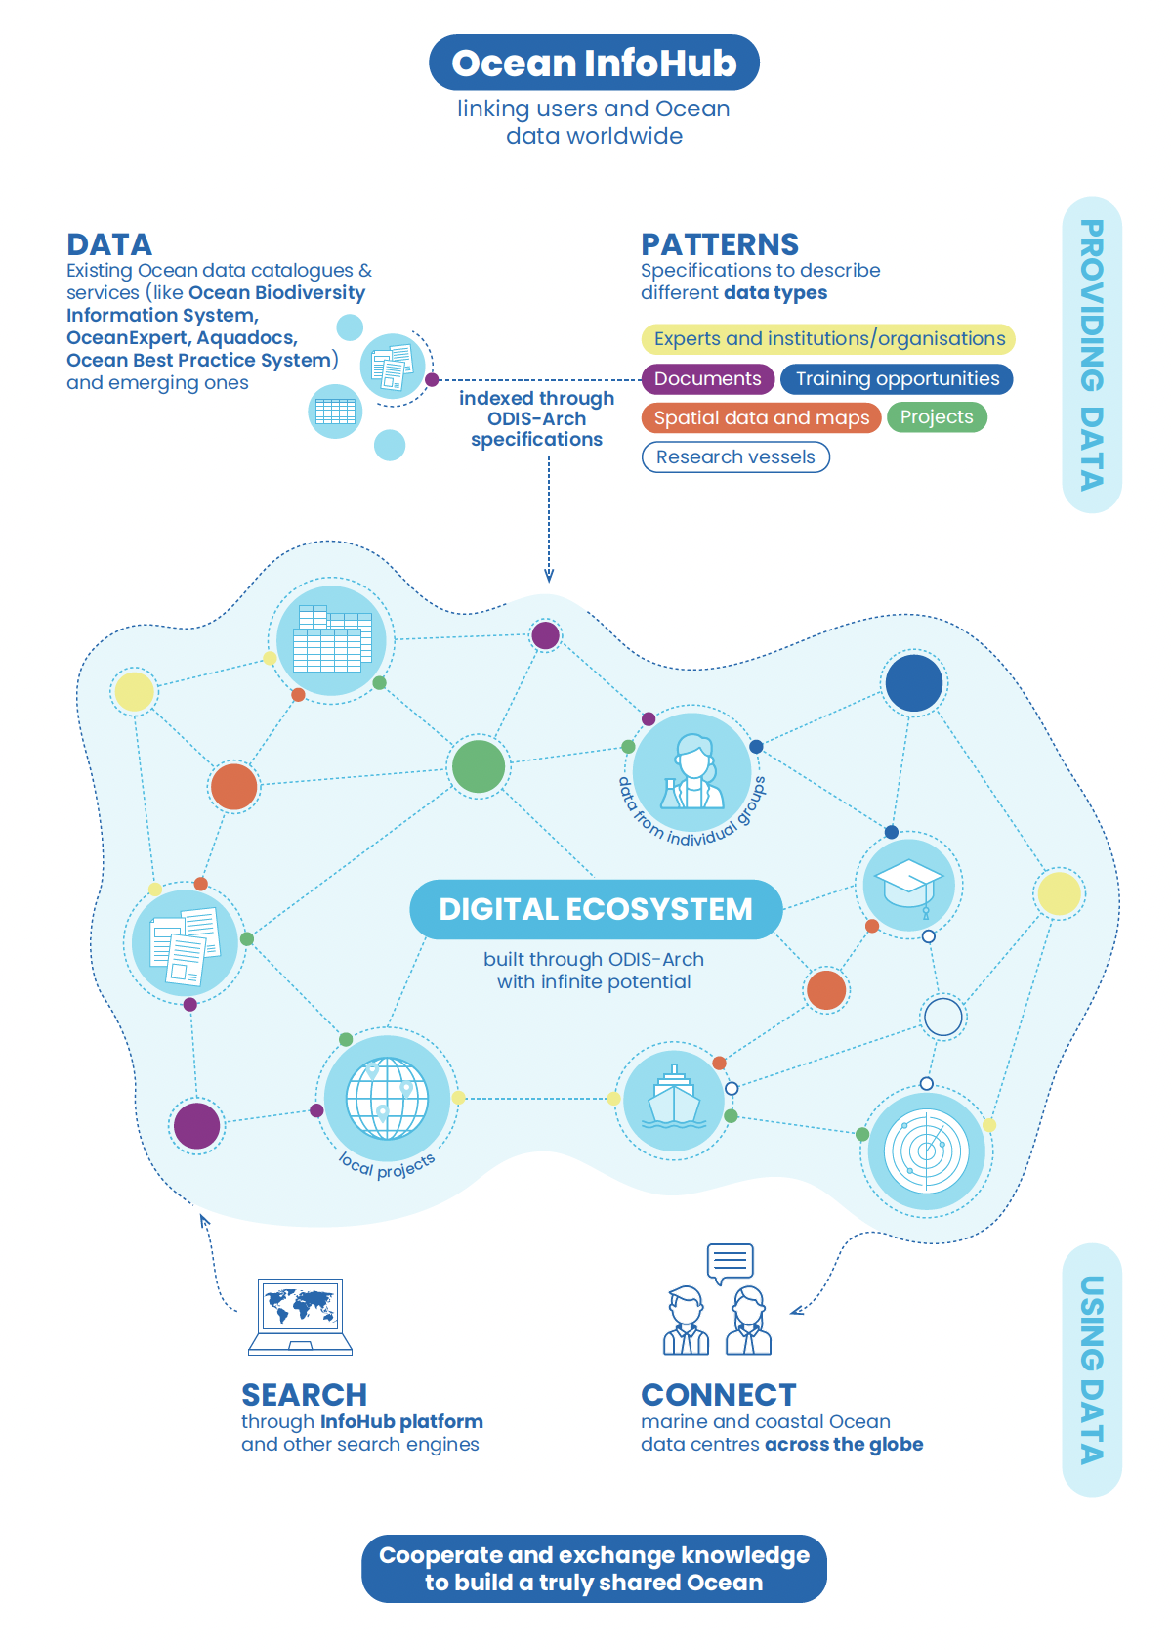

5.5.1.4 Awareness raising through communications and events
We use the mailing lists for important communications.
Regular communication uses Slack and email
Also see 4.6.1.1 above

5.5.1.5 Active updates on project progress
Through the website, Slack, Github and infrequent email updates.

5.5.2 Objectives October 2023 – June 2024

Multiple outreach activities ongoing & planned
Including meetings, webinars, conferences and user engagement in all regions, reported under WP3.

Questions and discussion

5.6 Summary of Actions SG-OIH-III

• We should develop a short text around ODIS, OIH and ODIScat to clarify their relationship.
This was done, and used together with a new slide (in all OIH presentations) showing the relationship between ODIS-cat, ODIS and the OIH Project.
• Follow up with SPREP and OIH usage to inform State of the Environment reports at national
Level
This was incorporated in the ToR for the PSIDs consultant, to investigate and report on OIH usage within the PSIDS region.
• Follow up with OIH integration with the World Ocean Database.
This has been done
• Follow up with the PSIDs region for examples of decision-grade data or products and formats that
decision-makers have requested.
This was incorporated in the ToR for the PSIDs consultant
• Develop a communications course or course component that assists existing and potential users
and providers – and for managers and decision-makers.
This will be incorporated into the Global Search Hub front end (contract just commenced) for end users
• Consider ODIS training in-person, B2B or as part of an event.
This will continue to be considered when cost effective opportunities arise (ideally when no or minimal additional travel costs are required)
• Consider doing a Global Search Hub pre-launch to get the perspective of the core partners, then
consider some dates in 2023 to have a launch event, at IODE-27 and the associated Conference,
with a sales desk for more information and to get more partners involved. Also consider an
event at the IOC Assembly in June.
We decided on a soft launch approach, and all of the above events (IODE-27, IODC and the IOC Assembly) were used to raise the visibility of OIH and ODIS.
• Lucy to email all participants for ideas of dates and events where OIH may be present.
That was done, and a follow-up also sent. Results were used to select dates for this meeting (OIH-SG-IV)
• Project evaluation: We should develop a short ToR for the self-evaluation, and establish a small
group of colleagues that could work on the ToR and help with the self-evaluation.
Done, and self-evaluation complete
• In the list of contributions from the Ocean InfoHub to the Ocean Decade, include a reference to
the IOC strategy on capacity development and knowledge transfer.
I believe this is done (https://oceandecade.org/news/flanders-funds-new-initiative-to-support-capacity-dpvt-as-part-of-ocean-decade/) although I cannot find a list of contributions as mentioned above.
• Make presentations and project materials (brochure and final video) available to project
partners.
Done – circulated widely
• Lucy to follow up with Jan-Bart regarding the Corporate Data Group
Done, but should be looked at again in light of additional links via the DCO and DSIG
• Together with SPC and SPREP, develop some materials that we could demonstrate at a new 5-
country project meeting; early 2023; what OIH is doing and some critical features.
Materials were shared; Paul Anderson departed SPREP
• Follow up with SPREP and other regional seas bodies to enhance links
Follow up was done and additions were made to the PSIDs TOR.
• Work with OBIS as a user node as well as a contributor.
Instead of the original suggestion (to make an OIH entry point via OBIS), we worked with the OBIS and GOOS teams to support the development and discovery of EOVs and to look at options for strengthening the GOOS BioEco Portal
• Awareness materials to be developed as required; postcards with QR codes and stickers are a
priority.
Done and disseminated at various meetings
• If there are any proposals for changes to the project, or key issues that need to be discussed,
information should be shared together with the agenda of the SG meeting ± one month in
advance of the next meeting.
This annotated agenda has been shared; no major changes to the project have been identified.
• All participants will be requested to share a list of meetings, either for OIH user engagement or
to consider for the Steering Group meeting (back-to-back). Note: please avoid the international
data week 23-27 October 2023.
Done
• Would it be possible to extract machine readable data from international funders and produce a
product that can be used for reporting. (Follow up PA, LS, PLB and PP).
This was looked into – unfortunately PA who made the request, left SPREP within days of OIH-SG-III so he was not available to further guide any product development.

UN Decade Data and Knowledge Management activities
Louis Demargne presented an overview of the UN Decade Data and Knowledge Management activities.

Decade DCO for Data Management
Jan-Bart Calewaert presented an overview of the DCO for Data Management.

OceanData-2030
Pier Luigi Buttigieg presented an overview of OceanData-2030.

Election of the chair

Next meeting: Final OIH Project meeting (TBC)

Thanks and close of the meeting

ANNEX 1

Third Session of the IODE Steering Group for the Ocean InfoHub Project

Provisional Agenda:

ANNEX II
Summary of Additional Actions

ANNEX III
LIST OF PARTICIPANTS

