**Earthquake Monitoring & Detection**

1. **Description of Solomon Islands Tectonic settings**

The Solomon Islands have formed along the converging Indo-Australian and Pacific plates (fig. 1). Southward subduction of the Pacific Plate began in the Eocene, along the Proto-North Solomon Trench System which coincides with the trace of the present-day Kia-Kaipito-Korigole fault zone, continuing until the Late Miocene-Pliocene. The later collision with the Cretaceous Ontong Java oceanic plateau stalled subduction of the Pacific slab beneath the Indo-Australia Plate triggering folding of the Central Solomon intra-arc basin and formation of the Malaita Accretionary Prism (MAP) (Phinney et al., 2004).

An arc polarity reversal occurred in the Late Pliocene-Pleistocene and the Indo-Australian Plate began subducting northwards, beneath the Pacific Plate, along the New Britain-San Cristobal Trench. The South Solomon Trench System (SSTS) comprises two deep trenches (up to 8–9000 m deep in the New Britain area and 7500 m in the San Cristobal=Makira area, Kroenke et al., 1983) linked by a much shallower and ill- defined trench system between the islands of Guadalcanal and Bougainville (maximum depths of 2500–5000 m).

The North Solomon Trench (Vitiaz trench) used to be considered to be relatively inactive seismically, and was interpreted as a relict subduction-related trench which was active between the Eocene and Early Miocene becoming inactive when the Ontong Java Plateau began impinging on the Solomon block at some 25– 20 Ma (e.g. Coleman and Kroenke, 1981; Kroenke, 1984; Yan and Kroenke, 1993). However, seismic and swath mapping evidence presented by Cooper and Taylor (1984), Sopacmaps (1994), Auzende et al. (1996) and most recently by Miura et al. (1996) and Mann et al. (1998) have demonstrated that southwest-directed subduction beneath the Vitiaz trench is still proceeding.

Most and current experienced earthquakes and tsunamis either recorded through oral or written history were associated with the Southern subduction and trench systems. Generally, earthquakes with magnitude > 4 are recorded and archived at the Solomon Islands Geological Survey Division in Honiara. Most severe to extreme felt events in the Solomon Islands have magnitudes of (Richter Scale) 7 – 8.2.

1. **Description of Western Solomon Island Seismicgenic segment**

The islands of New Britain, Bougainville, Solomon Islands, and Vanuatu are termed the ‘Greater Melanesian Arc’ (e.g. Kroenke, 1984) which marks the collisional zone between the Australian and Pacific plates. Subduction of the Woodlark basin beneath the Solomon block has resulted in: (1) tectonic uplift of the Solomon block; leakage of calc-alkaline material from source regions north of the SSTS to the Woodlark basin itself (south of the SSTS) through NE–SW-trending transform faults; (3) an anomalously small arc–trench gap (for example the active Kavachi volcano is situated only some 30 km north of the SSTS; Johnson and Tuni, 1987) and; (4) increased coupling between the Pacific and Australian plates (e.g. Dunkley, 1983, 1984; Crook and Taylor, 1994; Petterson et al., 1997). Bruns et al 1989, claimed back-arc thrusting is evident to be occurring along the trench east of the Kilinialu trench to the west of the western Solomon Islands. Historical tsunamigenic earthquakes ruptured along the, Australia, Woodlark – Pacific triple junction. Subduction at this margin is complex due the age of the sea floor and topographical conditions of locality.

The Western Region can be further divided into two (2) major segments in relation to seismic activities 1. The Mono/ Shortland segment and the New Georgia Group Segment, that include Vella la Vella, New Georgia, Rannoga, Simbo, Vangunu including MboroKua at the eastern extreme end. Felt and recorded earthquake events from Segment (1) often range from magnitude 4 – 6 (Richter Scale) whilst historical records from the New Georgia Group segment experienced earthquakes of magnitude ranging from 4 – 8.1 on the Richter Scale.

**Description of Central Solomon Islands Seismogenic segments**

The South Solomon’s MORB terrain (SSMT) initially formed within a ‘normal’ ocean ridge environment. Two stages of arc crustal growth subsequently developed. The two distinct stages of arc growth occurred with the Solomon block and created the basement of the central part of the Solomon Islands (the Central Solomon Terrain, CST) which includes Shorthand’s, Florida and South Isabel Islands.

Most earthquake occurrence are associated with the South Solomon Trench System. Concentration of seismic events are clustered within the proximity of Marasa/Mbiti (Cape Hunter) on South Guadalcanal and to the Southeast within the vicinity of Marau. Historical earthquake events recorded from these locations range from > 4 – 7.8 on the Richter Scale. Often associated with thrust movements indicated by the beach balls (focal mechanism) in Figure…..

**Description of Eastern Solomon Islands Seismogenic Segment**

The Solomon block is bounded by two trench systems: The Vitiaz trench (locally named the North Solomon trench) to the northeast and the New Britain–San Cristobal trench. Converging is occurring across the San Cristobal Trench (Fig. ). The Vitiaz trench extends for a distance of some 2500–3000 km and attains depths of 3000–6000 m. The SSTS comprises two deep trenches (up to 8–9000 m deep in the New Britain area and 7500 m in the San Cristobal=Makira area, Kroenke et al., 1983) linked by a much shallower and ill - defined trench system between the islands of Guadalcanal and Bougainville (maximum depths of 2500–5000 m). The SSTS marks the site of northeast-directed subduction of the Australian plate beneath the Pacific plate, with the San Cristobal Benioff zone recording subduction to 700 km (Dunkley, 1983; Cooper and Taylor, 1984; Petterson, 1995).

.

The Eastern Solomon Segment can be divided into two segments. *Segment 1* being the San Cristobal Group (Makira) and Santa Cruz Group segment as *Segment 2.* The concentration of seismic activities is associated with the SSTS clustered around the central and eastern part of the Island extending to the Santa Cruz group. The concentration of seismic events around Santa Cruz more along the trench and also to the northeast and northwest of the Island. Earthquake events recorded from Segment 1 (Makira) range from > 4 – 8.2 on the Richter scale whilst events from segment 2 (Santa Cruz) range from > 4 – 7.8 on the Richter Scale.

The Solomon Islands are highly prone to earthquake and Tsunamis can be generated anywhere along the Trench System and by some rare circumstances anywhere within the Solomon Islands. These could be from secondary effects resulting from major shaking remobilizing of loose unconsolidated sediments sitting precariously on the edge of offshore shelves or could be triggered by submarine landslides or submarine volcanic eruptions.

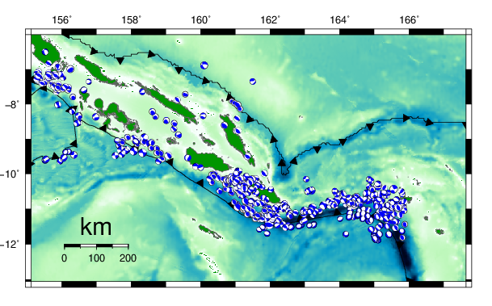

Figure 1 Solomon Islands seismogenic segements