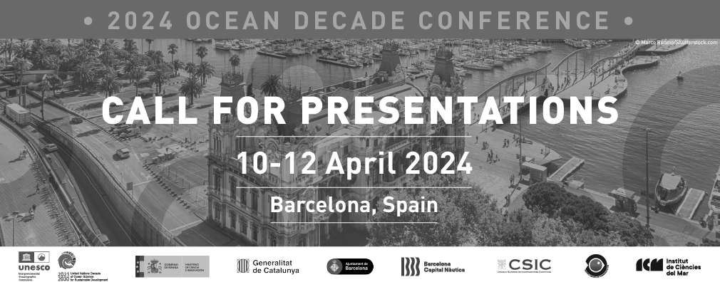

Call for Presentations - 2024 Ocean Decade Conference

As part of the 2024 Ocean Decade Conference, four sessions will address science and solutions across the Ocean Decade Challenges. During each of these sessions, presentations are being solicited to showcase innovative science and solutions relevant to the Challenges.

The presentations, which will each be 5 – 7 minutes in duration, should demonstrate how the work being showcased will contribute to the vision and mission of the Ocean Decade, including how it is ﬁlling critical gaps or priorities for the Ocean Decade Challenges.

If you are interested in submitting a presentation proposal, please ﬁrst read the Presentation Guidance Note and then ﬁll in this form before 23.59h CET on 1 December 2023.

To help you in the process, PDF and Word versions of the application form can be downloaded here.

For any questions please contact oceandecade@unesco.org.

Call for Presentations - 2024 Ocean Decade Conference

1. First name of lead author:

- 2. Last name of lead author:

3. Email adress of lead author:

4. Institutional aﬀiliation (if relevant) of lead author:

* 5. Is the lead author:

An Early Career Ocean Professional (ECOP)

Based in or from a Small Island Developing State or Least Developed Country

None of the above

6. Title of Presentation:

- Name of Co-Authors of Presentation:
(If relevant, please list the name of the co-authors. If there are more than 5 co-authors, please include the details of the remaining participants in question no. 10).
Co-Author No. 1:

Co-Author No. 2:

Co-Author No. 3:

Co-Author No. 4:

Co-Author No. 5:

Institutional Aﬀiliation of Co-Authors of Presentation:

Co-Author No. 1:

Co-Author No. 2:

Co-Author No. 3:

Co-Author No. 4:

Co-Author No. 5:

Please indicate if any of the Co-Authors are Early Career Ocean Professionals (ECOP) or based in or from a Small Island Developing State (SIDS) or Least Developed Country (LDC)

ECOP SIDS / LDC
Co-Author No. 01
Co-Author No. 02
Co-Author No. 03
Co-Author No. 04
Co-Author No. 05

If your presentation has more than 5 Co-Authors, please provide the information of the remaining participants in bullet points:
(Name, institutional aﬀiliation, and if the co-authors are Early Career Ocean Professionals (ECOP) or based in or from a Small Island Developing State or Least Developed Country)

* 11. To which Ocean Decade Challenge(s) does the Presentation most strongly contribute? (select maximum of 2)
Challenge 1: Understand and map land and sea-based sources of pollutants and contaminants and their potential impacts on human health and ocean ecosystems and develop solutions to remove or mitigate them.

Challenge 2: Understand the eﬀects of multiple stressors on ocean ecosystems, and develop solutions to monitor, protect, manage and restore ecosystems and their biodiversity under changing environmental, social and climate conditions.

Challenge 3: Generate knowledge, support innovation, and develop solutions to optimise the role of the ocean in sustainably feeding the world’s population under changing environmental, social and climate conditions.

Challenge 4: Generate knowledge, support innovation, and develop solutions for equitable and sustainable development of the ocean economy under changing environmental, social and climate conditions.

Challenge 5: Enhance understanding of the ocean-climate nexus and generate knowledge and solutions to mitigate, adapt and build resilience to the eﬀects of climate change across all geographies and at all scales, and to improve services including predictions for the ocean, climate and weather.

Challenge 6: Enhance multi-hazard early warning services for all geophysical, ecological, biological, weather, climate and anthropogenic related ocean and coastal hazards, and mainstream community preparedness and resilience.

Challenge 7: Ensure a sustainable ocean observing system across all ocean basins that delivers accessible, timely, and actionable data and information to all users.

Challenge 8: Through multi-stakeholder collaboration, develop a comprehensive digital representation of the ocean, including a dynamic ocean map, which provides free and open access for exploring, discovering, and visualizing past, current, and future ocean conditions in a manner relevant to diverse stakeholders.

Challenge 9: Ensure comprehensive capacity development and equitable access to data, information, knowledge and technology across all aspects of ocean science and for all stakeholders.

Challenge 10: Ensure that the multiple values and services of the ocean for human wellbeing, culture, and sustainable development are widely understood, and identify and overcome barriers to behaviour change required for a step change in humanity’s relationship with the ocean.

* 12. In which session of the Conference is the Presentation proposed:
Session 1: Science and Solutions for a Clean, Healthy and Resilient Ocean
Session 2: Science and Solutions for a Sustainable and Resilient Ocean Economy Session 3: Science and Solutions for a Safe and Predicted Ocean
Session 4: An Inspiring and Engaging Ocean for All

13. Brief Description of Presentation content (max. 3000 characters per question).
Brief description of the contribution of the Presentation to the Conference objectives

Brief description of the innovative and transformative nature of the substance of the Presentation,
including evidence of co-design and co- delivery of science and uptake of science and knowledge for solutions
Brief description of the contribution of the Presentation to ﬁlling critical gaps and priorities for the Ocean Decade Challenges

Description of the link of the Presentation author(s) to the Ocean Decade

