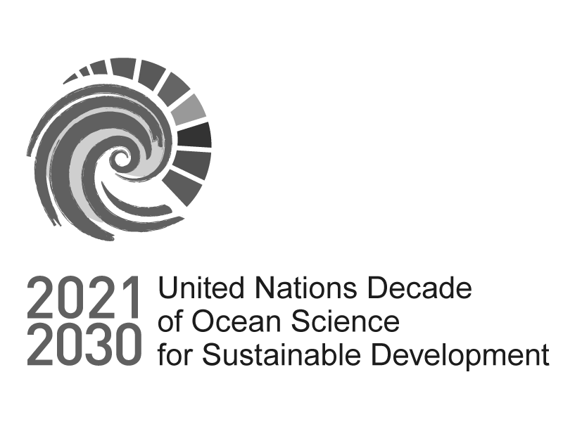

Information - Please read it entirely before proceeding with your application

Call for Decade Actions No. 06/2023 - Co-Design of Decade Actions

**This form should only be used by those that would like to submit a robust idea to co- design a Decade Action (Programme or Project) in Africa or Caribbean SIDS.**

**Please read all the supporting documentation to the Call carefully before submitting your application:**

1. [**Guidance Note**](https://oceanexpert.org/document/29169)
2. [**FAQ**](https://oceanexpert.org/document/29170)
3. **Ocean Decade Implementation Plan and Summary**
4. **UN List of** [**African**](https://www.un.org/dgacm/en/content/regional-groups) **and** [**SIDS**](https://www.un.org/ohrlls/content/list-sids) **countries**
5. **Co-designing the science we need for the ocean we want document**

**The deadline for submission for this form is 23.59h UTC 10 January 2024.**

**If you do not intend to submit a co-design idea for a Decade Action for Africa or Caribbean SIDS, please consider the options below:**

**For submitting an Expression of Interest for Programmes, please fill this form:** [**https://www.surveymonkey.com/r/EOI_CFDA6**](https://www.surveymonkey.com/r/EOI_CFDA6)

**For requests for endorsement for Decade Projects, please use this form:** [**https://www.surveymonkey.com/r/Proj_CFDA6**](https://www.surveymonkey.com/r/Proj_CFDA6)

**Important Information:**

**Please note that all character limits include spaces.**

**You may continue editing your submission until you are ready to submit. This is done via IP address recognition. Bookmark the survey when you first open it, and it should maintain your responses if you access it via the bookmarked link.**

**Please find the PDF and Word versions of the form** [**here**](https://oceanexpert.org/document/33355)**.**

**Please note that these are for your use only, e.g. to help prepare your submission.**

**Only submissions sent via the online form will be accepted.**

**If you need a copy of your responses please email us at** [**oceandecade@unesco.org**](mailto:oceandecade@unesco.org) **with the exact full name and contact name of your submission. Please be aware that it may take some time to provide you with the download.**

**For any questions please contact** [**oceandecade@unesco.org**](mailto:oceandecade@unesco.org) **with “Call for Decade Actions No. 06/2023” in the subject line.**



Proposal scope

Call for Decade Actions No. 06/2023 - Co-Design of Decade Actions

* 1. On which Ocean Decade Challenge will your Decade Action have a primary focus?

 Challenge 1: Understand and map land and sea-based sources of pollutants and contaminants and their potential impacts on human health and ocean ecosystems and develop solutions to remove or mitigate them.

 Challenge 2: Understand the effects of multiple stressors on ocean ecosystems, and develop solutions to monitor, protect, manage and restore ecosystems and their biodiversity under changing environmental, social and climate conditions.

 Challenge 3: Generate knowledge, support innovation, and develop solutions to optimise the role of the ocean in sustainably feeding the world’s population under changing environmental, social and climate conditions.

 Challenge 4: Generate knowledge, support innovation, and develop solutions for equitable and sustainable development of the ocean economy under changing environmental, social and climate conditions.

 Challenge 5: Enhance understanding of the ocean-climate nexus and generate knowledge and solutions to mitigate, adapt and build resilience to the effects of climate change across all geographies and at all scales, and to improve services including predictions for the ocean, climate and weather.

 Challenge 6: Enhance multi-hazard early warning services for all geophysical, ecological, biological, weather, climate and anthropogenic related ocean and coastal hazards, and mainstream community preparedness and resilience.

 Challenge 7: Ensure a sustainable ocean observing system across all ocean basins that delivers accessible, timely, and actionable data and information to all users.

 Challenge 8: Through multi-stakeholder collaboration, develop a comprehensive digital representation of the ocean, including a dynamic ocean map, which provides free and open access for exploring, discovering, and visualizing past, current, and future ocean conditions in a manner relevant to diverse stakeholders.

 Challenge 9: Ensure comprehensive capacity development and equitable access to data, information, knowledge and technology across all aspects of ocean science and for all stakeholders.

 Challenge 10: Ensure that the multiple values and services of the ocean for human wellbeing, culture, and sustainable development are widely understood, and identify and overcome barriers to behaviour change required for a step change in humanity’s relationship with the ocean.



Proponent and Partner Details

Call for Decade Actions No. 06/2023 - Co-Design of Decade Actions

* 2. Lead Institution

* 3. Lead Institution Type



* 4. Lead Institution Physical Address

Street Address

Town/City

Postal/Zip Code

* 5. Lead Institution Country



1. Lead Institution Website (if relevant)
   * 7. Lead Institution Primary Contact

*This is the person responsible for the proposal and who will be directly contacted in future communications throughout the review process, and will be expected to sign the letter of endorsement should your application be successful.*

First Name

Last Name

* 8. Lead institution primary contact gender

 Male  Female

 Prefer not to say

* + 9. Lead Institution Primary Contact Email Address
  + 10. Email contact of person completing survey

*This person might not be the same as the lead institutional contact, but will be someone we will include in future communications throughout the review process.*

* + 11. Partner Institution Names

Please provide the names of up to five partner lead institutions. Other partner details can be provided in the supplementary information section.

Partner No. 1 Institution name

Partner No. 2 Institution name

Partner No. 3 Institution name

Partner No. 4 Institution name

Partner No. 5 Institution name

* + 12. Partner focal points' contact details

Please provide the full name of the focal point person in the partner institution and their email address.

Partner No.1 Focal point contact details

Partner No.2 Focal point contact details

Partner No.3 Focal point contact details

Partner No.4 Focal point contact details

Partner No.5 Focal point contact details

* + 13. Partner Institution Type

Partner Institution Type



Partner No. 1

Partner No. 2

Partner No. 3

Partner No. 4

Partner No. 5

* + 14. Partner Institution Country

Partner Institution Country



Partner No. 1

Partner No. 2

Partner No. 3

Partner No. 4

Partner No. 5



Decade Action Description

Call for Decade Actions No. 06/2023 - Co-Design of Decade Actions

* + 15. Name of Decade Action

The public facing name used to refer to your Decade Action. Your Action name must be fewer than 50 characters.

* 16. Please select all countries in which the Decade Action will be implemented.

|  |  |  |
| --- | --- | --- |
| All Countries | Gambia (Republic of The) | Palau |
| Afghanistan | Georgia | Palestine |
| Albania | Germany | Panama |
| Algeria | Ghana | Papua New Guinea |
| Andorra | Greece | Paraguay |
| Angola | Grenada | Peru |
| Anguilla | Guatemala | Philippines |
| Antigua and Barbuda | Guinea | Poland |
| Argentina | Guinea-Bissau | Portugal |
| Armenia | Guyana | Qatar |

Australia Austria Azerbaijan Bahamas Bahrain Bangladesh Barbados Belarus Belgium Belize Benin Bhutan

Bolivia (Plurinational State of) Bosnia and Herzegovina Botswana

Brazil

British Virgin Islands Brunei Darussalam Bulgaria

Burkina Faso Burundi Cabo Verde Cambodia Cameroon Canada

Central African Republic (CAR)

Chad Chile China Colombia Comoros Congo

Cook Islands Costa Rica Cote d'Ivoire Croatia

Haiti Honduras Hungary Iceland India Indonesia

Iran (Islamic Republic of) Iraq

Ireland Israel Italy Jamaica Japan Jordan

Kazakhstan Kenya Kiribati Kuwait Kyrgyzstan

Lao People’s Democratic Republic

Latvia Lebanon Lesotho Liberia Libya

Liechtenstein Lithuania Luxembourg Madagascar Malawi Malaysia Maldives Mali

Malta

Marshall Islands Mauritania

Republic of Korea Republic of Moldova Romania

Russian Federation Rwanda

Saint Kitts and Nevis Saint Lucia

Saint Vincent and the Grenadines

Samoa

San Marino

Sao Tome and Principe Saudi Arabia

Senegal Serbia Seychelles Sierra Leone Singapore Sint Maarten Slovakia Slovenia

Solomon Islands Somalia

South Africa South Sudan Spain

Sri Lanka Sudan Suriname Sweden Switzerland

Syrian Arab Republic Tajikistan

Thailand Timor-Leste Togo

Tonga

Cuba Cyprus Czechia

Democratic People’s Republic of Korea

Democratic Republic of the Congo

Denmark Djibouti Dominica

Dominican Republic Ecuador

Egypt

El Salvador Equatorial Guinea Eritrea

Estonia Eswatini Ethiopia Fiji Finland France Gabon

Mauritius Mexico

Micronesia (Federated States of)

Monaco Mongolia Montenegro Morocco Mozambique Myanmar Namibia Nauru

Nepal Netherlands New Zealand Nicaragua Niger Nigeria

North Macedonia Norway

Oman Pakistan

Trinidad and Tobago Tunisia

Türkiye Turkmenistan Tuvalu Uganda Ukraine

United Arab Emirates (UAE)

United Kingdom of Great Britain and Northern Ireland (UK)

United Republic of Tanzania

United States of America (USA)

Uruguay Uzbekistan Vanuatu

Venezuela, Bolivarian Republic of

Viet Nam Yemen Zambia Zimbabwe

* 17. Please select all ocean basins in which the Decade Action will be implemented.

 North Atlantic Ocean  South Atlantic Ocean  North Pacific Ocean  South Pacific Ocean  Indian Ocean

 Arctic Ocean  Southern Ocean

 Mediterranean Sea

Other (including regional seas)

* + 18. Please succinctly describe your proposed Decade Action (max. 3000 characters).



* + 19. Please describe why the proposed Decade Action fills an important gap in the Ocean Decade and should be considered as part of the current Call for Decade Actions. In answering this question please consider other endorsed Decade programmes and projects (max. 3000 characters).



* + 20. Please describe how the science and knowledge generated through your proposed Decade Action would be used to contribute to local, national, regional or international sustainable development objectives (max. 3000 characters).



1. For Decade Actions planned to be implemented in Africa, please describe how the proposal contributes to the priorities of the Ocean Decade Africa Roadmap (max. 3000 characters).



* + [22. Please describe any discussions you have had with relevant National Decade Committees,](https://oceandecade.org/national-ocean-decade-ecosystem/) [Decade Collaborative Centres or Decade Coordination Offices](https://oceandecade.org/decade-collaborative-centres/) [in the](https://oceandecade.org/national-ocean-decade-ecosystem/) development of your proposal (max. 3000 characters).



* + 23. Please describe other stakeholder groups or partners that you would anticipate would be relevant to the design of your proposal and describe any contact that you have had with these groups. This should include consideration of those groups that would use the science and knowledge generated through your Decade Action (max. 3000 characters).



* + 24. Please describe how you would address questions of diversity, equity, inclusivity in your proposal particularly in relation to gender and geographic diversity, and the inclusion of Early Career Ocean Professionals and Indigenous and local knowledge holders (max. 3000 characters).



* + 25. Please describe the estimated resource needs for your proposal, any in-kind or financial resources that you have already secured, and your proposed approach to fundraising for the proposal (max. 3000 characters).



* 26. If your Decade Action is selected, do you commit to participating in a specially designed training and mentoring programme to co-design your Decade Action?

 Yes No