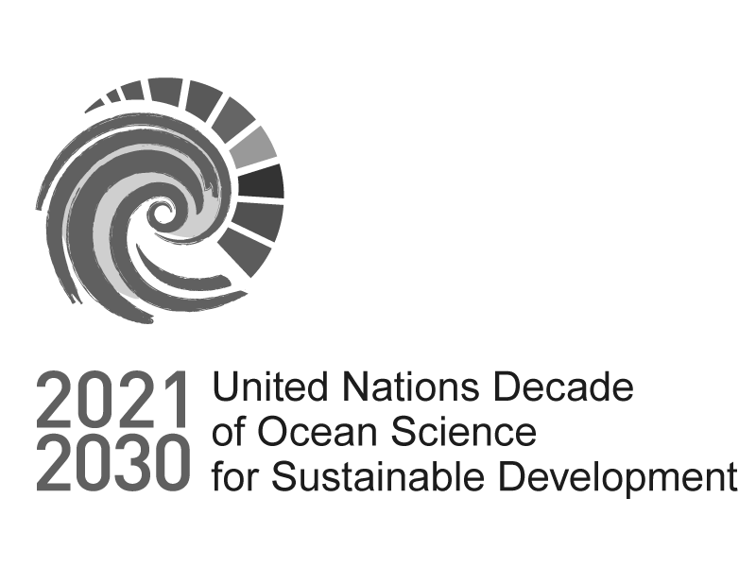

Information - Please read it entirely before proceeding with your application

Registration of Decade Actions from UN Agencies
This form should only be used to register Decade Actions from UN Agencies.

Please read all the supporting documentation carefully before submitting your application:

Ocean Decade Implementation Plan and Summary

Registrations via this form can be made on a rolling basis. We will endeavor to respond as promptly as we can. Please email oceandecade@unesco.org if you would like an update on the process.

Important Information:

Please note that all character limits include spaces.

You may continue editing your submission until you are ready to submit. This is done via IP address recognition. Bookmark the survey when you ﬁrst open it, and it should maintain your responses if you access it via the bookmarked link.

Please ﬁnd the PDF and Word versions of the form here: https://oceanexpert.org/document/30895

Please note that these are for your use only, e.g. to help prepare your submission. Only submissions sent via the online form will be accepted.

If you need a copy of your responses please email us at oceandecade@unesco.org with the exact full name and contact name of your submission. Please be aware that it may take some time to provide you with the download.

For any questions please contact oceandecade@unesco.org with “UN Decade Action Registration” in the subject line.

Proponent and Partner Details

Registration of Decade Actions from UN Agencies

1. Lead Institution Name

  - 2. Please conﬁrm that you are submitting this on behalf of a UN Agency
I conﬁrm that I am submitting this form on behalf of a UN Agency

3. Lead Institution Physical Address

Street Address

Town/City

Postal/Zip Code

4. Lead Institution Country

  - 5. Is your institution based in a Least Developed Country, Small Island Developing State, or Africa
Please ﬁnd a list of SIDS here: https://www.un.org/ohrlls/content/list-sids
Please ﬁnd a list of LDCs here: https://www.un.org/development/desa/dpad/least-developed-country-category/ldcs- at-a-glance.html

Yes No

6. Lead Institution Website

- 7. Lead Institution Primary Contact
This is the person responsible for the proposal and who will be directly contacted in future communications throughout the review process, and will be expected to sign the letter of endorsement should your application be successful.
First Name

Last Name

8. Lead Institutional Contact Email Address

- 9. Email contact of person completing survey
This person might not be the same as the lead institutional contact, but will be someone we will include in future communications throughout the review process.

Partner Institution Names
Please provide the names of up to ﬁve partner lead institutions. Other partner details can be provided in the supplementary information section.
Partner No. 1 Institution name

Partner No. 2 Institution name

Partner No. 3 Institution name

Partner No. 4 Institution name

Partner No. 5 Institution name

Partner focal points' contact details
Please provide the full name of the focal point person in the partner institution and their email address.
Partner No.1 Focal point contact details

Partner No.2 Focal point contact details

Partner No.3 Focal point contact details

Partner No.4 Focal point contact details

Partner No.5 Focal point contact details

Partner Institution Countries

Partner Institution Country

Partner No. 1

Partner No. 2

Partner No. 3

Partner No. 4

Partner No. 5

Decade Action Description

Registration of Decade Actions from UN Agencies

13. Name of Decade Action
The public facing name used to refer to your Decade Action. Your Action name must be fewer than 50 characters.

14. Short name or acronym of Decade Action

* 15. Is the project you are proposing an ongoing initiative or new?
Ongoing Initiative New Initiative

16. When will your proposed Action start and end?
Please use the ﬁrst of the month in which your Action will start if you do not have a speciﬁc start date.

Start Date

Date
DD/MM/YYYY

End Date

Date
DD/MM/YYYY

17. Total Budget estimate for the Decade Action to the nearest whole number with no punctuation.

  - 18. Please indicate the currency of the above budget.

19. Estimate of percentage of total budget secured
Can include in-kind and ﬁnancial resources.
0
50
100

20. Please tell us who your current funders are and from whom you are seeking or planning to seek additional ﬁnancial or in-kind support

  - 21. Please select all countries in which the Decade Action will be implemented.

All Countries | Gambia (Republic of The) | Palau
Afghanistan | Georgia | Palestine
Albania | Germany | Panama
Algeria | Ghana | Papua New Guinea
Andorra | Greece | Paraguay
Angola | Grenada | Peru
Anguilla | Guatemala | Philippines
Antigua and Barbuda | Guinea | Poland
Argentina | Guinea-Bissau | Portugal
Armenia | Guyana | Qatar

Australia Austria Azerbaijan Bahamas Bahrain Bangladesh Barbados Belarus Belgium Belize Benin Bhutan
Bolivia (Plurinational State of) Bosnia and Herzegovina Botswana
Brazil

British Virgin Islands Brunei Darussalam Bulgaria
Burkina Faso Burundi Cabo Verde Cambodia Cameroon Canada
Central African Republic (CAR)

Chad Chile China Colombia Comoros Congo
Cook Islands Costa Rica Cote d'Ivoire Croatia
Haiti Honduras Hungary Iceland India Indonesia
Iran (Islamic Republic of) Iraq
Ireland Israel Italy Jamaica Japan Jordan
Kazakhstan Kenya Kiribati Kuwait Kyrgyzstan
Lao People’s Democratic Republic

Latvia Lebanon Lesotho Liberia Libya
Liechtenstein Lithuania Luxembourg Madagascar Malawi Malaysia Maldives Mali
Malta

Marshall Islands Mauritania
Republic of Korea Republic of Moldova Romania
Russian Federation Rwanda
Saint Kitts and Nevis Saint Lucia
Saint Vincent and the Grenadines

Samoa

San Marino

Sao Tome and Principe Saudi Arabia
Senegal Serbia Seychelles Sierra Leone Singapore Sint Maarten Slovakia Slovenia
Solomon Islands Somalia
South Africa South Sudan Spain
Sri Lanka Sudan Suriname Sweden Switzerland
Syrian Arab Republic Tajikistan
Thailand Timor-Leste Togo
Tonga

Cuba Cyprus Czechia
Democratic People’s Republic of Korea

Democratic Republic of the Congo

Denmark Djibouti Dominica
Dominican Republic Ecuador
Egypt

El Salvador Equatorial Guinea Eritrea
Estonia Eswatini Ethiopia Fiji Finland France Gabon
Mauritius Mexico
Micronesia (Federated States of)

Monaco Mongolia Montenegro Morocco Mozambique Myanmar Namibia Nauru
Nepal Netherlands New Zealand Nicaragua Niger Nigeria
North Macedonia Norway
Oman Pakistan
Trinidad and Tobago Tunisia
Türkiye Turkmenistan Tuvalu Uganda Ukraine
United Arab Emirates (UAE)

United Kingdom of Great Britain and Northern Ireland (UK)

United Republic of Tanzania

United States of America (USA)

Uruguay Uzbekistan Vanuatu
Venezuela, Bolivarian Republic of

Viet Nam Yemen Zambia Zimbabwe

22. Please select all ocean basins in which the Decade Action will be implemented.

North Atlantic Ocean South Atlantic Ocean North Paciﬁc Ocean South Paciﬁc Ocean

Indian Ocean Arctic Ocean Southern Ocean Mediterranean Sea

Other (including regional seas)

23. Summary of Decade Action
This summary will be used publicly on the Ocean Decade Network should your Decade Action be endorsed. (max. 1000 characters)

24. Please provide details on how your proposal aligns with the following Ocean Decade endorsement criteria.

Please keep in mind that this section is essential to the evaluation of your application, and therefore please be as objective and explanatory as possible. In case a criterion does not align with your proposal, please provide 2 to 3 sentences on why not (max. 5000 characters per criteria)
Contributes to achieving one or more of the following Decade objectives: Objective 1: Identify critical ocean knowledge; Objective 2: Build capacity and generate knowledge; Objective 3: Increase the use of ocean knowledge.
Accelerates the generation or use of knowledge and understanding of the ocean, with a speciﬁc focus on knowledge that will contribute to the achievement of the SDGs and complementary policy frameworks and initiatives.
Is co-designed and/or co-delivered by knowledge generators and users, and thus facilitating the uptake of science and ocean knowledge for policy, decision-making, management and/or innovation.
Ensures that all data and resulting knowledge are provided in an open access, shared, discoverable manner

Strengthens existing or creates new partnerships across nations and/or between diverse ocean actors, including users of ocean science.

Contributes toward capacity development, including, but not limited to, beneﬁciaries in SIDS, LDCs and LLDCs.

Overcomes barriers to diversity and equity, including gender, generational and geographic diversity.

Collaborates with and engages local and indigenous knowledge holders.

25. Please select which of the Decade Outcomes your Decade Action contributes to (max. 3)

Outcome 1: A clean ocean where sources of pollution are identiﬁed and reduced or removed.

Outcome 2: A healthy and resilient ocean where marine ecosystems are understood, protected, restored and managed.

Outcome 3: A productive ocean supporting sustainable food supply and a sustainable ocean economy. Outcome 4: A predicted ocean where society understands and can respond to changing ocean conditions. Outcome 5: A safe ocean where life and livelihoods are protected from ocean-related hazards.
Outcome 6: An accessible ocean with open and equitable access to data, information and technology and innovation.

Outcome 7: An inspiring and engaging ocean where society understands and values the ocean in relation to human wellbeing and sustainable development.

26. Please select which of the Decade Challenges your Decade Action contributes to (max. 3)
Challenge 1: Understand and map land and sea-based sources of pollutants and contaminants and their potential impacts on human health and ocean ecosystems, and develop solutions to remove or mitigate them.

Challenge 2: Understand the eﬀects of multiple stressors on ocean ecosystems, and develop solutions to monitor, protect, manage and restore ecosystems and their biodiversity under changing environmental, social and climate conditions.

Challenge 3: Generate knowledge, support innovation, and develop solutions to optimise the role of the ocean in sustainably feeding the world’s population under changing environmental, social and climate conditions.

Challenge 4: Generate knowledge, support innovation, and develop solutions for equitable and sustainable development of the ocean economy under changing environmental, social and climate conditions.

Challenge 5: Enhance understanding of the ocean-climate nexus and generate knowledge and solutions to mitigate, adapt and build resilience to the eﬀects of climate change across all geographies and at all scales, and to improve services including predictions for the ocean, climate and weather.

Challenge 6: Enhance multi-hazard early warning services for all geophysical, ecological, biological, weather, climate and anthropogenic related ocean and coastal hazards, and mainstream community preparedness and resilience.

Challenge 7: Ensure a sustainable ocean observing system across all ocean basins that delivers accessible, timely, and actionable data and information to all users.

Challenge 8: Through multi-stakeholder collaboration, develop a comprehensive digital representation of the ocean, including a dynamic ocean map, which provides free and open access for exploring, discovering, and visualizing past, current, and future ocean conditions in a manner relevant to diverse stakeholders.

Challenge 9: Ensure comprehensive capacity development and equitable access to data, information, knowledge and technology across all aspects of ocean science and for all stakeholders.

Challenge 10: Ensure that the multiple values and services of the ocean for human wellbeing, culture, and sustainable development are widely understood, and identify and overcome barriers to behaviour change required for a step change in humanity’s relationship with the ocean.

27. In addition to SDG 14 (Life below water), which we assume is relevant to all Decade Actions, please indicate which of the other Sustainable Development Goals your Decade Action contributes to
GOAL 1: No Poverty. GOAL 2: Zero Hunger
GOAL 3: Good Health and Well-being GOAL 4: Quality Education
GOAL 5: Gender Equality

GOAL 6: Clean Water and Sanitation GOAL 7: Aﬀordable and Clean Energy
GOAL 8: Decent Work and Economic Growth GOAL 9: Industry, Innovation and Infrastructure GOAL 10: Reduced Inequality
GOAL 11: Sustainable Cities and Communities GOAL 12: Responsible Consumption and Production GOAL 13: Climate Action
GOAL 15: Life on Land

GOAL 16: Peace and Justice Strong Institutions GOAL 17: Partnerships to achieve the Goal

28. What is the high-level objective of your Decade Action? (max. 1000 characters)

- 29. What are key outcomes of your Decade Action? (max. 2000 characters)

30. What are key activities that you will carry out in the ﬁrst 3 years of your Decade Action? (max. 5000 characters)

- 31. Please describe the management structure which will be used to coordinate your Decade Action (max. 2000 characters)

Supplementary Information

Registration of Decade Actions from UN Agencies

32. Please provide any supplementary information you would like reviewers to take into account as they review your Decade Action. This may include details of additional partners.
There is a character limit of 5000.

