Intergovernmental Oceanographic Commission
Reports of Meetings of Experts and Equivalent Bodies

IODE Steering Group for OBIS (SG-OBIS)

Twelfth Session
Gunsan, Republic of Korea
25-29 March 2024

UNESCO

Table of Contents

Executive Summary 4
1. Opening of the session and adoption of the agenda 4
2. Hands-on sessions 4
2.1. OBIS basics/data formatting 4
2.1.1. DarwinCore 4
2.1.2. GitHub 4
2.1.3. Taxonomic matching and new annotation tool 4
2.2. OBIS Quality Control 5
2.2.1. OBIS QC tools 5
2.3. OBIS products portal 5
2.4. Visit to MABIK exhibition and collections 7
2.5. OBIS vocabulary 7
2.6. OBIS DNA derived data 7
2.7. Field trip to Baekje Cultural Land 7
3. OBIS reports 8
3.1. OBIS Secretariat 8
3.1.1. Staffing 8
3.1.2. Technical developments 9
3.2. OBIS Executive Committee 19
3.3. OBIS Nodes 19
3.4. OBIS Task Teams 20
3.4.1. OBIS Taxonomy Task Team 20
3.4.2. OBIS Capacity Development Task Team 20
3.4.2.1. IODE internship programme 23
3.4.2.2. OBIS propagules program proposal 23
3.5. OBIS project teams 24
3.5.1. OBIS Data Quality Control Project Team 24
3.5.2. OBIS Vocabulary Infrastructure Project Team 25
3.5.3. OBIS Grand Unified Data Model Project Team 26
4. OBIS Future 26
4.1. OBIS Management Structure 27
4.1.1. OBIS Vision, Mission and Objectives 31
4.1.2. TORs for OBIS Nodes 31
4.1.3. TORs for OBIS Steering Group 32
4.1.4. TORs for OBIS Co-Chairs 33
4.1.5. TORs for OBIS Secretariat 35
4.1.6. TORs for OBIS Coordination Groups 36
4.1.6.1. OBIS nodes coordination group 37
4.1.6.2. OBIS data coordination group 37
4.1.6.3. OBIS products coordination group 37
4.1.7. TORs for OBIS Executive Committee 37
4.2. OBIS data policy 37
4.3. OBIS communication plan 38
4.4. OBIS products 38
5. OBIS partnerships 39
5.1. GBIF 39
5.2. Other partnerships 40
6. OBIS workplan and budget 40
7. Adoption of the report 41
8. Date and place of next session 41
9. Closing 42
Annexes 43
Annex 1. SG-OBIS-12 agenda and time table 43
Annex 2. Concept note/Proposal OBIS Propagules program 45
Annex 3. Draft OBIS data policy 51
Annex 4. Draft OBIS Communication Plan 57
Annex 5. Concept note for an OBIS data product platform 61
Annex 6. GBIF and OBIS joint strategy and action plan for marine biodiversity data 68
Annex 7. List of Participants 73

IOC/IODE-SG-OBIS-XII
Gunsan, 25-29 March 2024
English only

[group picture]

Executive Summary

[to be added later]

Opening of the session and adoption of the agenda
SG-OBIS co-chairs: Martha Vides and Katherine Tattersall will open the session and thank the host.

Choi Wan-hyun, President of the National Marine Biodiversity Institute of Korea (MABIK) will welcome the participants.

Participants will be invited to present themselves briefly. List of participants is in annex 7.

The SG-OBIS adopted the agenda and time table.

Hands-on sessions

OBIS basics/data formatting

DarwinCore

Ms Elizabeth Lawrence will provide an introduction to Darwin Core with a focus on eMOF and particular use cases.

GitHub
Mr Pieter Provoost will cover this topic.

Taxonomic matching and new annotation tool

Mrs Leen Vandepitte will cover this topic.

OBIS Quality Control

OBIS QC tools

Mr Pieter Provoost will cover this topic.

OBIS products portal

Mr Silas Principe will cover this topic.

When the IWG on OBIS data products was established, our initial proposal was to have a catalogue to showcase products derived from OBIS data. However, as discussions took place, it became clear that there was an opportunity to create a whole set of tools that would enable users to work and take the maximum advantage of OBIS data more efficiently. The group then proposed to create a new platform consisting of (i) infrastructure and (ii) data components. This infrastructure will enable the production and publishing of data products based or partially based on OBIS.

The infrastructure will include a virtual laboratory and a products catalogue. The virtual laboratory is the main tool we are going to provide and is a JupyterHub with Python and R kernels. Users will be able to run their analysis online, taking advantage of an environment containing tools, cloud optimised data, the main packages used for biodiversity analysis, and one dedicated package to speed up pre-processing of OBIS data for specific purposes. Also, model scripts would be available.

On the data side, the proposal is to provide users of the virtual environments with cloud optimised data, providing a seamless and faster analysis. Also, we would provide users with data packages - pre-filtered data targeting specific uses. For example, a package of data including only long-term monitoring, or all eDNA data. We anticipate that this will facilitate the application of OBIS data for future research projects.

During the hands-on session we provided a demonstration of the JupyterHub and ran a few cases together.

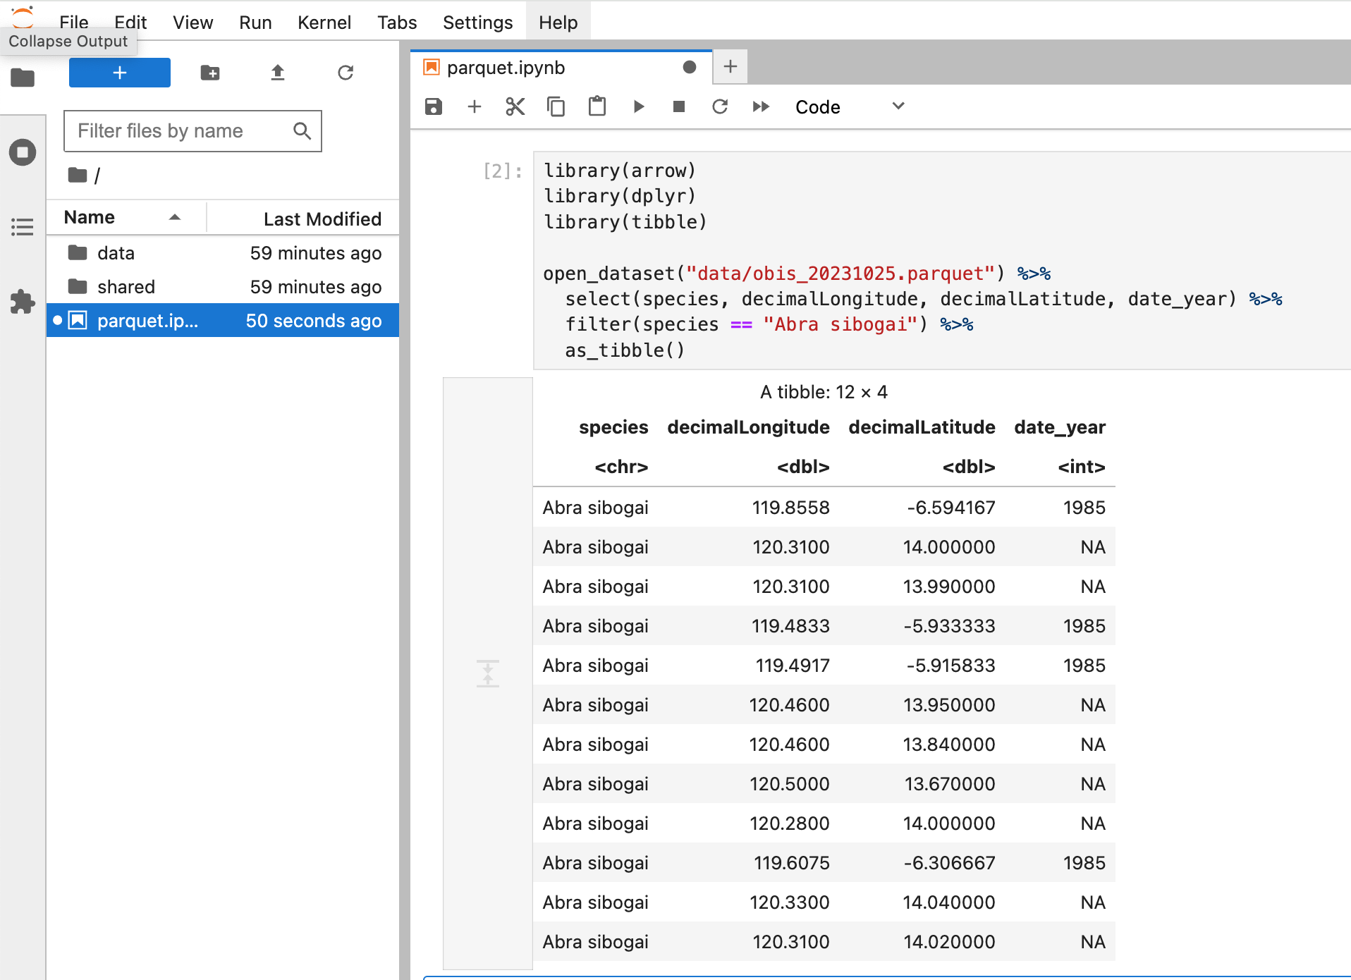
Example of access of OBIS full export through the JupyterHub.

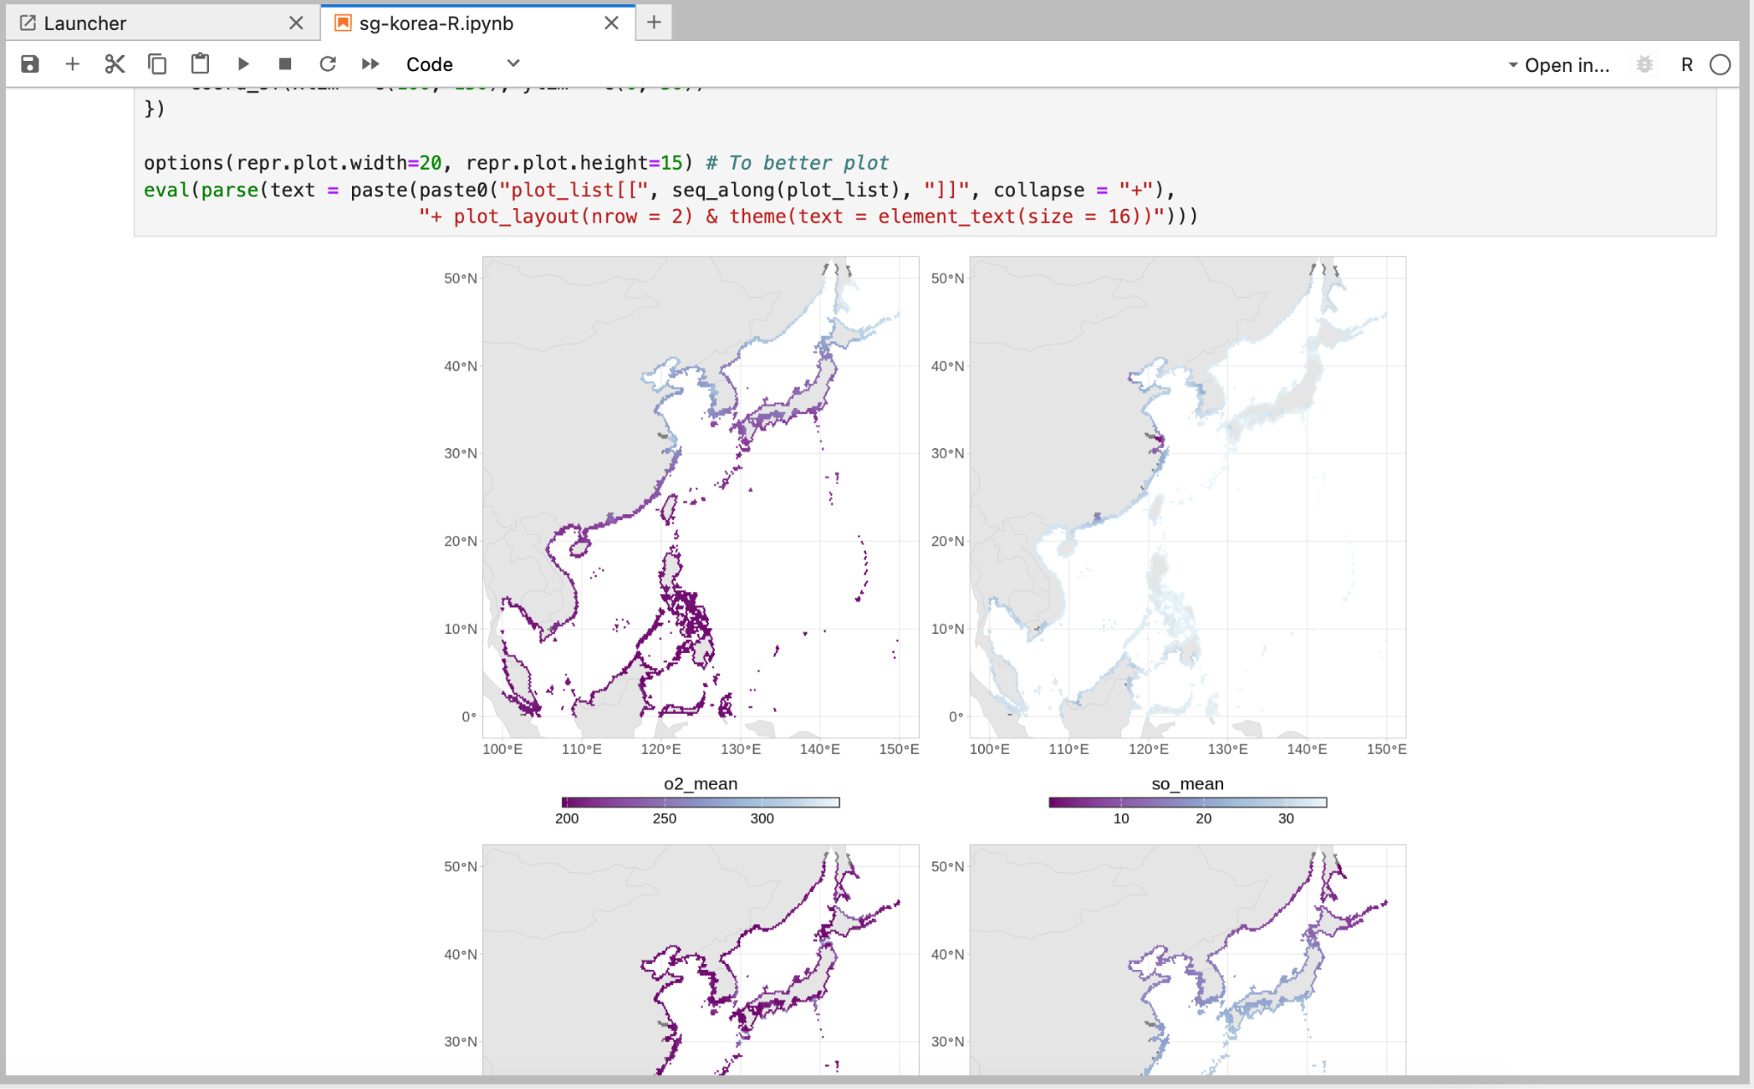
Figure. Example of data visualization generated with the use of the JupyterHub.

The full concept note of the OBIS data products platform is available in annex 5.

Visit to MABIK exhibition and collections
The participants are invited to a tour at MABIK.

OBIS vocabulary
Ms Elizabeth Lawrence will cover this topic.

OBIS DNA derived data
Mr Pieter Provoost will cover this topic.

Field trip to Baekje Cultural Land

The participants are invited to join a visit to Baekje Cultural Land.

OBIS reports

OBIS Secretariat

Staffing
Mr Ward Appeltans will report on the OBIS Secretariat staffing. Thanks to the increase in IOC’s budget and the priority setting of the Member States at the IOC Assembly, the OBIS secretariat will get a second position covered by UNESCO’s regular programme budget. This OBIS technical coordinator position has been advertised until 15 March 2024 and the selection process is ongoing.

We are involved in 5 new horizon Europe projects which allowed us to create an extra project appointment position. This position was advertised in December 2023 and Dr Saara Suominen was appointed and joined the office on 18 March 2024. Saara has been a consultant with us for over 3 years and did a tremendous job in coordinating the scientific work of PacMAN and eDNA expeditions and assisted in the proposal writing for several EU projects. The consultancy position of Saara is now filled by Dr Emilie Boulanger. Emilie has a PhD in marine biodiversity conservation and next generation sequencing tools with a focus on eDNA in Marine Protected Areas. Her scientific and technical skills and hands-on expertise with eDNA will be extremely valuable for OBIS. Dr Chandra Earl was part of our team for a short period (3 months) to help mobilize datasets into OBIS covering marine World Heritage Sites.

In addition to the staff at the OBIS secretariat, our Flanders funded projects also provide staff at the UNESCO World Heritage Centre and the University of the South Pacific in Fiji.

Table: OBIS secretariat staffing 2023-2024
Name | Title | Contract type | Until date
Ward Appeltans | Programme manager | P3 fixed term (100%) | permanent
TBD | Technical and scientific coordinator | P3 fixed term (100%) | permanent
Pieter Provoost | Data manager | P3 project appointment (100%) | Dependent on who will get the fixed term position
Saara Suominen | Associate project offer | P2 project appointment (100%) | Dependent on who will get the fixed term position
Silas Principe | Associate project offer | P2 project appointment (100%) | 30/04/2026
Sofie De Baenst | Admin officer | G3 project appointment (30%) | 31/12/2024
Elizabeth Lawrence | Capacity development officer | Consultant (100%) | 31/01/2028
Lisa Benedetti | Stakeholder engagement officer | Consultant (75%) | 31/08/2026
Emilie Boulanger | Scientific officer, DNA | Consultant (100%) | 31/08/2026
TBD | Community engagement officer | Consultant (50%) | 31/12/2025
Chandra Earl | Data officer | Consultant (25%) | finished Oct 2023

Technical developments

Mr Pieter Provoost will report on technical developments.

- Amazon cloud storage

OBIS has applied for the AWS Open Data Sponsorship Program and the application has been accepted. This means that we are eligible for free data storage and data transfer on AWS. To finalize the application we need to document how our data are structured, provide tutorials on using the data on AWS, and create an entry in the Registry of Open Data on GitHub. The documentation needs to be published on the OBIS website or on GitHub. This is ongoing.

- Mailman

Due to continuing issues with email bounces, we have decided to move the SG mailing list to Mailman. We will use https://www.mailmanlists.net/ for this. The new list has been created and configured, and all existing mailing list subscribers will be invited to the new list.

- JupyterHub

A Docker based JupyterHub instance has been set up at https://jupyter.obis.org/ and a notebook container has been created that is tailored to OBIS nodes and users, with all the necessary data processing and analysis packages for R as well as Python. This new platform will be used to share data product workflows and to organize trainings. We will also provide analysis ready datasets on the hub including a snapshot of the OBIS database. Anyone can register on the hub, but new users need to be approved by the administrators before they can start using the platform.

- Shiny server

We have also set up a new R Shiny server which is for now just being used to host the MPA Europe data products.

- eDNA related tools

A number of tools have been created within our eDNA projects eDNA Expeditions and PacMAN for the processing and analysis of eDNA data. This includes a workflow for creating reference databases based on publicly available sequence data, an R package for performing spatial gap analyses of reference databases based on OBIS and GBIF data, an R package for summarizing distribution data from OBIS/GBIF/WoRMS and the calculation of thermal envelopes, and an example application of this R package to aid manual quality control of the detections from eDNA Expeditions. Most of these tools are still actively being developed and need to be consolidated and documented a bit more.

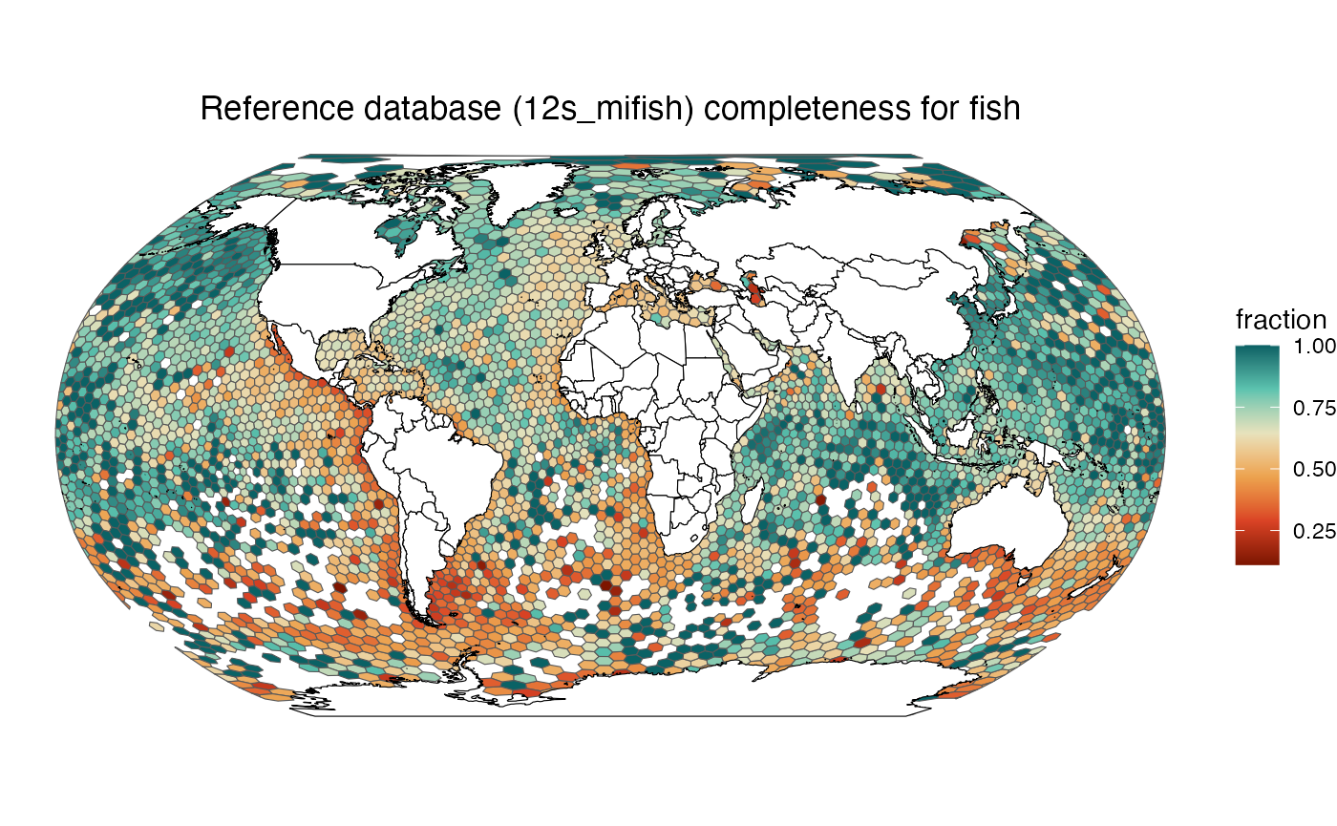
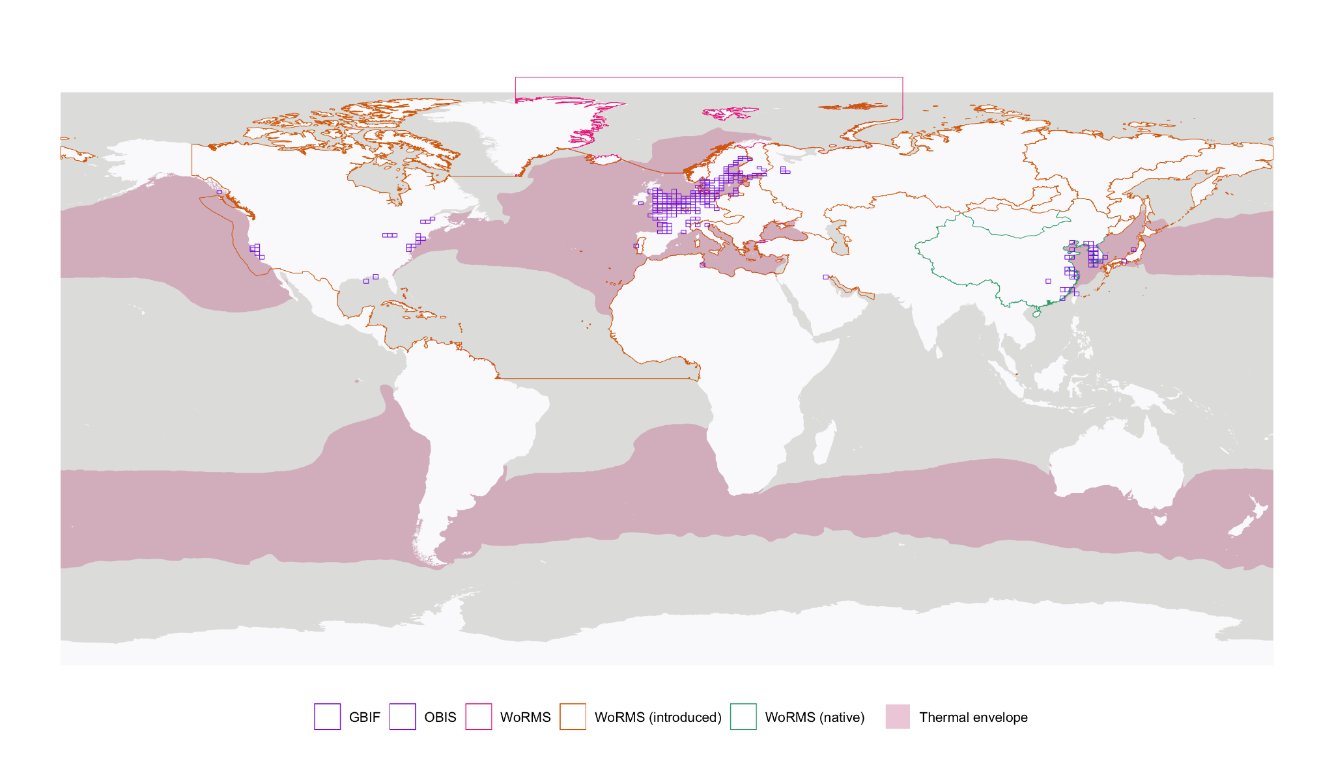

    - Extra-budgetary projects

The OBIS secretariat is involved in several Flanders and EU funded projects. These funded activities are key to allow the secretariat to further develop in-house as well as external capacity in ocean science and data management and has enabled the secretariat to continue delivering our services (our core funding would not be sufficient).

We will report on the major outcomes so far from these activities including the importance for OBIS.

      - PacMAN: Pacific Islands Marine Bioinvasion Alert Network (PacMAN)

Start Date:13/03/2020
End Date: 31/12/2024

The Flanders-UNESCO funded PacMAN project aims to establish a marine invasive species monitoring facility within Fiji's Suva Harbour. Leveraging both molecular techniques such as metabarcoding and qPCR, alongside visual methodologies like ARMS plates, the project is now entering its final phase. Right from its inception, the project has prioritized robust stakeholder engagement, adopting a co-design approach to optimize both fieldwork (including sampling and lab procedures) and foster a sense of local ownership endorsed by the Fijian government.

Furthermore, the comprehensive scientific training course hosted on OTGA and with on-site training has been instrumental in nurturing local capacity, while simultaneously enhancing project visibility amongst key stakeholders across Fiji. Importantly, the project contributes to ongoing reviews pertaining to Fiji’s Invasive Alien Species Policy and the country’s National Invasive Species Framework of Strategic Action Plan (NISFSAP), thus making a tangible contribution to shaping Fiji's environmental policies and conservation efforts.

The self-paced PacMAN training course hosted on the OTGA platform was successfully delivered, with 178 enrolled participants from 63 countries and 113 institutions, from which 68 (~40%) were able to complete the course and receive a certificate. According to the course feedback survey and post-course survey, participants valued the course and educational resources.

Capacity for DNA extraction and (q)PCR was developed at the University of the South Pacific. Leveraging these capabilities, metabarcoding analysis targeting commonly used markers such as COI and 18S revealed the presence of a total of 1,449 species. Among these, 124 were flagged in invasive species databases, with two species, Didemnum perlucidum and Perna viridis, being classified as invasive in the context of Fiji. Subsequent qPCR assays, developed and optimized by USP in collaboration with the Biosecurity Authority of Fiji, confirmed Didemnum perlucidum's presence.

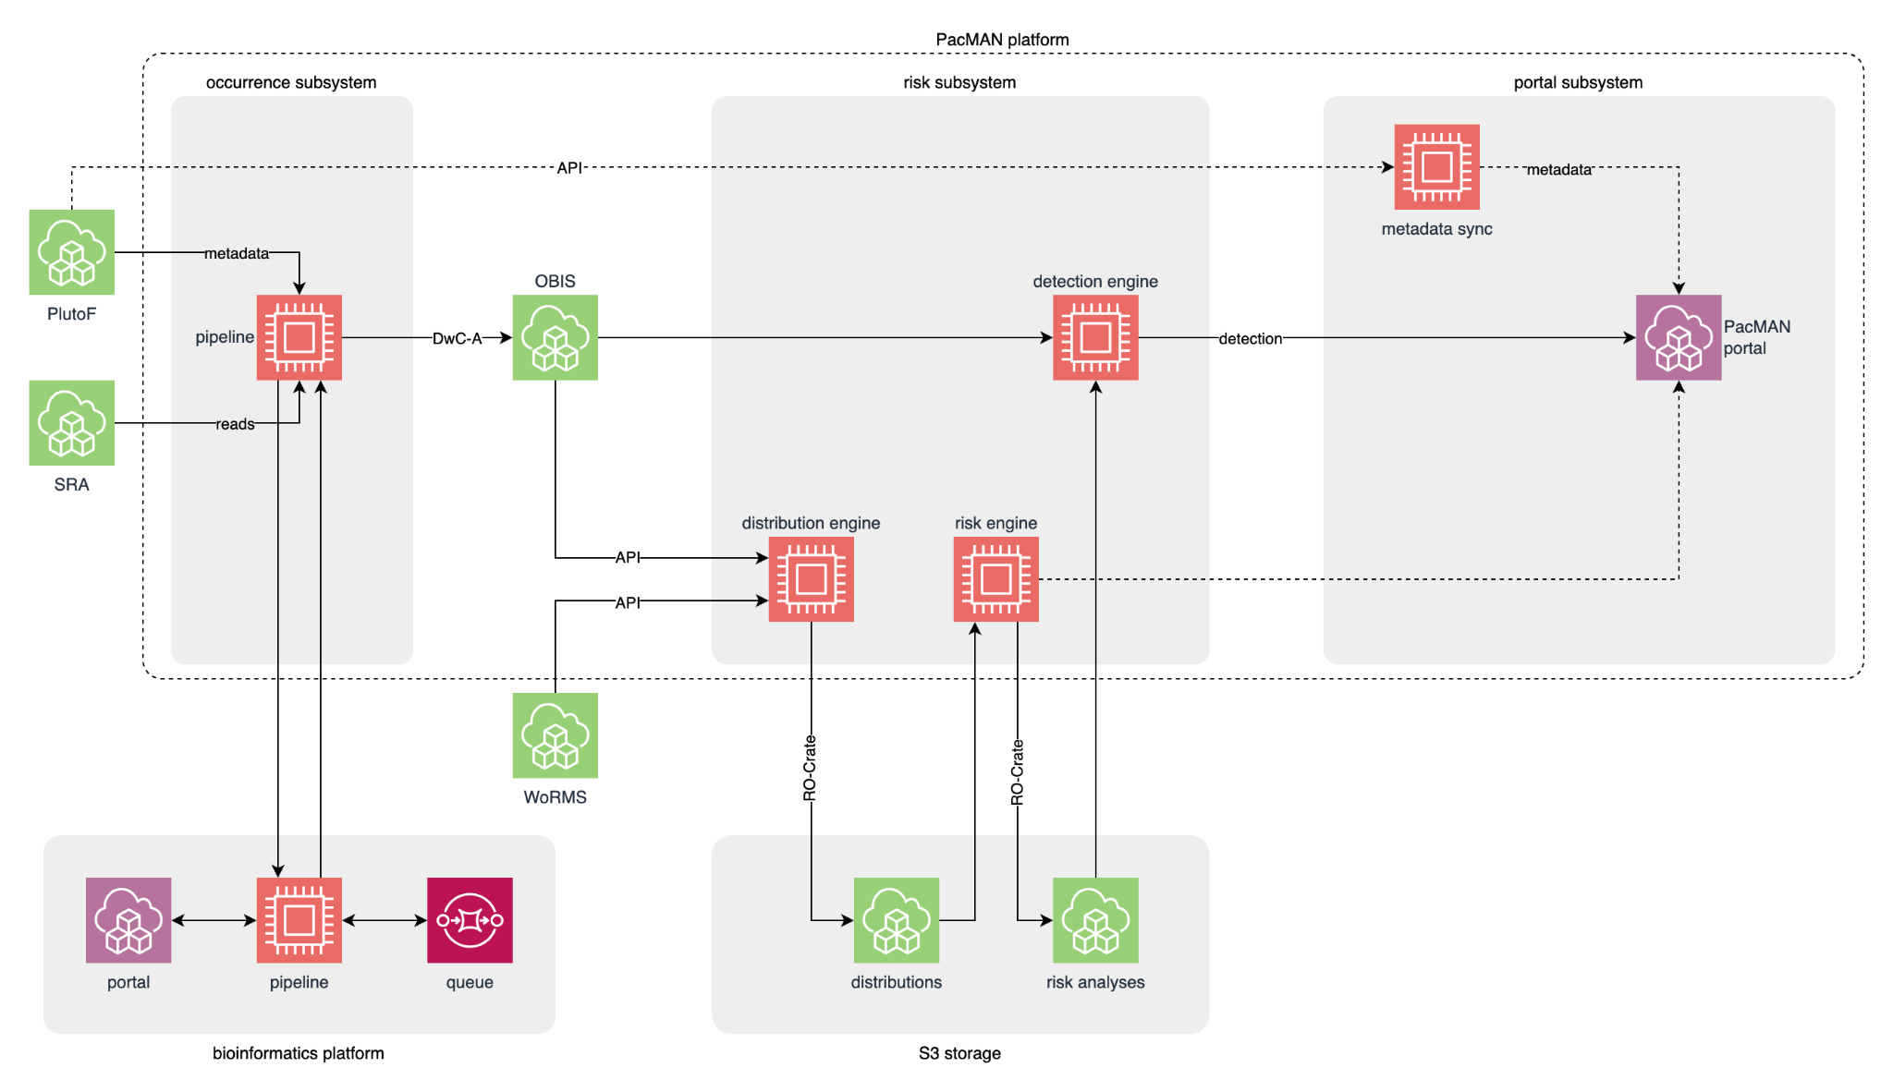
Figure. High level overview of the PacMAN data flow.

The PacMAN project envisions a robust data management platform designed to be user-friendly, adhering to FAIR principles—ensuring data are Findable, Accessible, Interoperable, and Reusable. Noteworthy progress has been made in various components of this platform, with particular emphasis on the bioinformatics pipeline. This pipeline, forged from a combination of publicly available metabarcoding data analysis tools, seamlessly transitions raw sequences from port surveys into formatted data tables, ready for submission to OBIS.

The PlutoF is used for managing primary data and metadata within PacMAN. Complementary software interfaces have been crafted to facilitate seamless integration between PlutoF and other components of the PacMAN data ecosystem, including the OBIS database and the evolving decision support system. Quality control protocols have been implemented, ensuring taxonomic annotations undergo scrutiny against established distributions and species thermal ranges.

The framework for the risk analysis and decision support system has been documented, drawing insights from an exhaustive review of existing frameworks, tools, and data sources. This framework underwent iterative refinement in collaboration with local stakeholders, resulting in the development of initial versions of all decision support system subcomponents. These include the distribution engine, detections engine, risk analysis engine, and portal frontend—pioneering steps towards an integrated platform aimed to support invasive species management and conservation efforts in Fiji.

      - eDNA Expeditions: Environmental DNA Expeditions in UNESCO World Heritage Marine Sites

Start date: 08/12/2021
End Date: 30/06/2024

This 2-year Flanders funded project is jointly coordinated by the secretariats of OBIS and the marine programme of the World Heritage Centre. This citizen-science project aims to assess the diversity and vulnerability of marine species to climate change. During 2023, eDNA expeditions were organized in 21 sites across the world, involving over 250 students and children. The project received a lot of media attention and is considered a high-profile project within UNESCO. The UNESCO Director General joined one of the expeditions.

The OBIS secretariat is responsible for the science and data management aspects. A sample registration application has been developed to record sample metadata such as time, location, and sample size in the field. The app, available at https://app.ednaexpeditions.org, can be used in a web browser or installed as a mobile app on Android or iOS.

In total 400 samples from 20 sites (due to the war we did not receive the samples from Sudan) were successfully processed and sequenced by the eDNA laboratory at KULeuven in Belgium, resulting in approximately 2 million sequences from each sample. All sample collection and DNA extraction information is collected on the PlutoF data management system. This system allows for the comprehensive registration of sample metadata including details on DNA extraction, PCR and sequencing runs.

We developed data pipelines to process and bring together all project data and metadata (from PlutoF and the LifeWatch bioinformatics server) as well as data from external sources (site shapefiles, OBIS and GBIF occurrence data), to feed into the sample tracking portal (https://samples.ednaexpeditions.org/), which provides reports, species lists, and the final analysis ready dataset to be used for the scientific analysis. The pipelines are documented at https://github.com/iobis/edna-expeditions.

The PacMAN bioinformatics pipeline has been further developed to accommodate for the use of the newest sequencing technology (NovaSeq), and to test the analysis and annotation of multiple biomarkers and target taxonomic groups, and special emphasis was put into accurate taxonomic annotation of the genetic sequences. Two separate taxonomic annotation methods were chosen. An automated quality report for all species detections is generated to help with cleanup of the species lists. This report is based on known species distributions in OBIS, GBIF, and WoRMS, as well as thermal ranges calculated from these distribution data. This quality control workflow was used for an initial check for incorrect species assignments. The species data was also provided to the sites, for an in-depth review of possible mis-characterizations to closely related species.

To support the scientific analysis, we also recruited Chandra Earl for 3 months who collected species occurrence data for the UNESCO marine world heritage sites. She reviewed and processed those data and ultimately published 53 new datasets to OBIS, contributing 40,340 new records of 4,949 marine species.

The OBIS secretariat, with support from a group of scientists, are now analyzing the data to assess biodiversity and the role those sites can play as refugia under climate change. The report will also include a review of the methodology to inform future monitoring. A UNESCO publication will be launched in June 2024.

      - MPA Europe: Marine Protected Areas Europe

Start date: 01/01/2023
End Date: 30/04/2026

MPA Europe is an Horizon Europe project that aims to identify the locations within the European seas where Marine Protected Areas (MPAs) would protect the highest number of species, habitats and ecosystems. This information is crucial to establish a functional MPA network and will help managers to propose further areas for conservation in the future. MPA Europe will also go one step further by considering the potential blue carbon benefits of the prioritization and the potential impacts of climate change on species distribution.

The OBIS secretariat is responsible for the Work Package 3, and is producing the following: (i) species distribution models (SDMs) of ~15,000 marine species; (ii) diversity metrics for European seas; and (iii) habitat maps considering habitat forming species. In all cases, models are being developed with the use of OBIS data and include predictions for future scenarios according to CMIP6 (for two time periods, 2050 and 2100, and 5 SSP scenarios).

During the initial year of the project, we successfully completed three deliverables. The primary deliverable entailed identifying supplementary datasets for integration into OBIS. A portion of these datasets had already been incorporated, and we anticipate adding over 10 million records to our database by the project's conclusion. To streamline dataset ingestion, we created an R package (leveraging the TrIAS Project checklist recipe) which is accessible at https://github.com/iobis/obisdi.

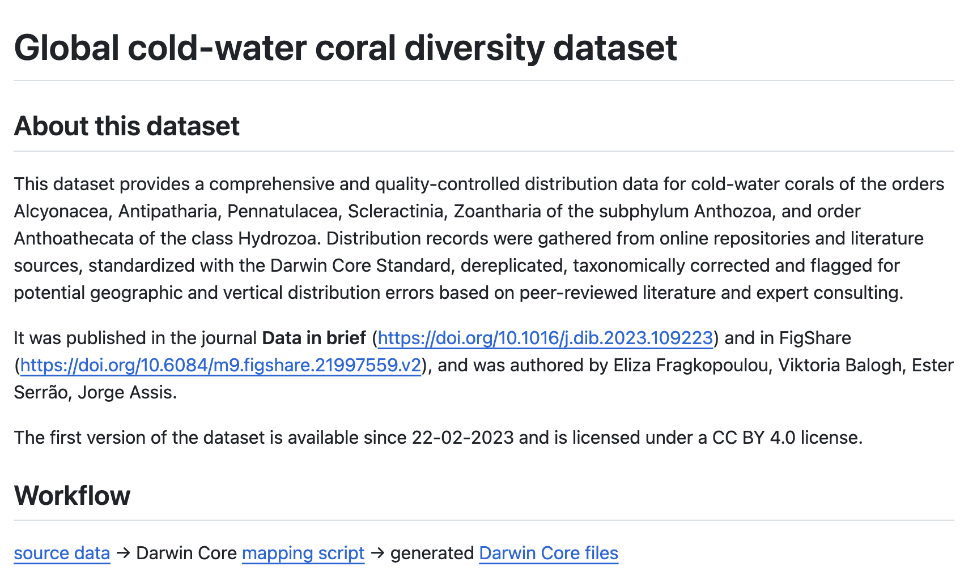
Example of a GitHub repository generated using the `obisdi` package for the ingestion of a cold-water corals dataset, as part of the MPA Europe project.

In parallel with identifying additional datasets, we commenced the development of a robust framework for generating marine species distribution models (SDMs). Given that models will be generated for a large number of species, it is necessary that all steps are automated, including the validation of outputs. Based on the results of the first models, we are now fine-tuning our pipelines and should produce the final species and habitat models by June 2024.

All species and habitat models will be openly accessible to the OBIS community. In addition, we are currently in the process of developing a Shiny app that will allow users to explore the results and download the maps. Furthermore, the pipeline for generating the distribution maps is open, with an accompanying R package (https://github.com/iobis/mpaeu_msdm) and documentation (https://github.com/iobis/mpaeu_docs).

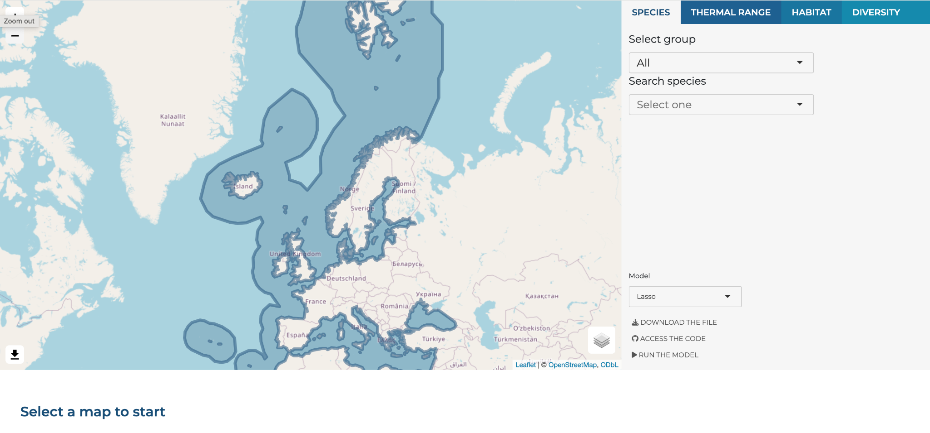
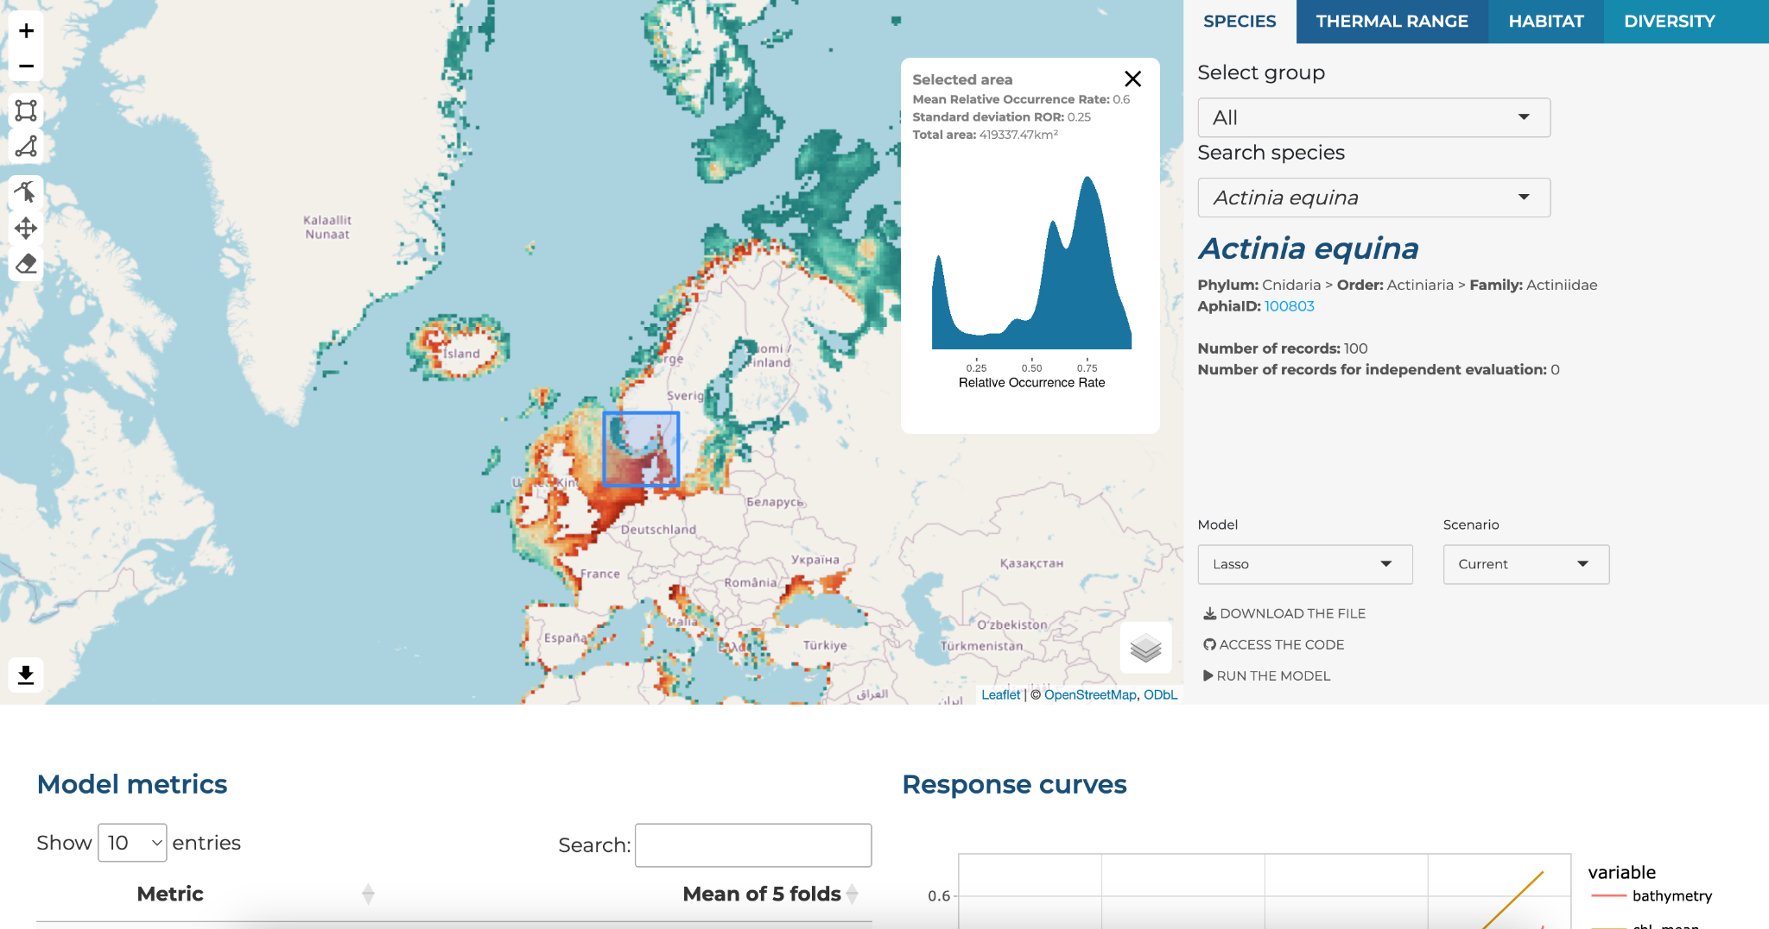
Screenshots from the Shiny app being developed for the MPA Europe deliverables. The tool will enable interactive exploration of distribution maps, and the development version is available on https://shiny.obis.org/distmaps

More information can be found on the project website: https://mpa-europe.eu/.

      - MARCO-BOLO: MARine COastal BiOdiversity Long-term Observations

Start date: 01/12/2022
End Date: 30/11/2026

MARCO-BOLO is an Horizon Europe project that will connect and strengthen existing European coastal and marine biodiversity observation capabilities across Europe, while linking these to global efforts. The project aims to improve the acquisition, coordination and delivery of marine, coastal and freshwater biodiversity observations to relevant users, and to test new tools, technologies using eDNA, robotics, optical and acoustic techniques, and develop data integration methods for environmental modelling.

The OBIS Secretariat is involved in several project activities, including delivering Essential Ocean/Biodiversity Variables (EOVs) for marine and coastal systems, developing protocols and standard operating procedures for eDNA-based approaches, and contributing to the establishment and co-coordination of a Community of Practice for the project (the “MARCO-BOLO CoP”). Through the CoP, biodiversity data generators and users will be brought together to co-design and co-develop tools and services that are fit for purpose and suit the needs of users, including policy makers, industry, researchers, civil society, and other stakeholder groups.

For more information, see the project's website: https://marcobolo-project.eu

      - eDNAqua-Plan: A Plan towards an eDNA reference library and data repository for Aquatic Organisms, navigating Europe towards the next generation biodiversity monitoring

Start date: 01/09/2023
End Date: 31/08/2026

In the face of climate change and the critical need for effective biodiversity conservation, the eDNAqua-Plan project will address the challenges associated with aquatic environmental DNA (eDNA) research and will represents a significant step forward in the harmonization and advancement of eDNA application, offering a promising future for the monitoring and conservation of aquatic ecosystems worldwide. More specifically, the project aims to design a coordinated reference library and eDNA repository to enable the broad use and application of genomics tools in marine and freshwater biodiversity observation, monitoring, and research.

The project aims to achieve the following:

- Harmonized and interoperable infrastructure for aquatic eDNA data, promoting consistency and comparability across monitoring programs and research endeavours;
- An integrated open-access reference library for marine and freshwater species facilitating access to eDNA information and supporting researchers, policymakers, and stakeholders in their conservation efforts;
- Advancement of aquatic biomonitoring through harmonised eDNA data, providing a crucial basis for understanding and addressing the impact of climate change and other impacts on aquatic ecosystems;
- Global collaboration creating an international network of researchers and institutions working together to advance our understanding of aquatic biodiversity.

The OBIS secretariat is involved mainly with the work packages related to data standards and data interoperability. These work packages will develop a plan for a digital ecosystem that will make the sharing, analysis and use of eDNA data easier and more transparent. This work will help bring eDNA forward as a monitoring tool, not only in Europe, but also worldwide, by showcasing and proposing how the interconnected data resources that are needed in eDNA work can be maintained. OBIS involvement in this project highlights our role in eDNA data management. The project will greatly benefit from our network, and data sharing experience and expertise.

For more information, see the project's website: https://ednaquaplan.com

      - DTO-BioFlow: Integration of biodiversity monitoring data into the Digital Twin Ocean

Start date: 01/09/2023
End Date: 28/02/2027

Data on biodiversity comes from a variety of sources, including omics, optical identification, imaging, acoustics, and others. Although new technology (imaging, acoustics, DNA-based, satellite) enables biodiversity observations at previously unattainable scales and frequencies, many of these types of data require one or more processing steps to become digital, and thus remain unavailable and inaccessible, the so-called "sleeping data". DTO-BioFlow will awaken "sleeping" biodiversity data, enabling the ongoing flow of these and new data into the EU Digital Twin Ocean via primary integrators and EMODnet, generating a digital replica of marine biological processes and transforming new and current data flows into evidence-based knowledge.

The OBIS secretariat supports several activities in this project including the development of an inventory of unavailable data sources, and constructing a priority list for integrating these unavailable sources. The inventory will inform the project as well as offer recommendations for enhancing or streamlining operational access and data flow.

[to be completed: Pieter and Elizabeth]

For more information, see the project's website: https://dto-bioflow.eu

      - BioEcoOcean: Co-Creating Transformative Pathways to Biological and Ecosystem Ocean Observations

Start date: 01/02/2024
End Date: 31/01/2028

BioEcoOcean is a new Horizon Europe project that focuses on raising the technical readiness for important Essential Ocean Variables (EOVs) and co-creating a guiding Blueprint that seeks to transform biological and ecosystem ocean observations. BioEcoOcean is spearheaded by Lina Mtwana Nordlund at Uppsala University. The project aims to create and test a globally applicable Blueprint for Integrated Ocean Science. This comprehensive blueprint will become a tool to guide ocean observing programs from the early planning stages, to data collection, to integrating results into policy and decision making. Importantly, the blueprint will include data management aspects to facilitate standardization of ocean observation data, and flow into global repositories like OBIS. As part of testing the Blueprint, the project is also conducting research on important EOVs to fill in knowledge gaps, particularly for plankton, marine organic carbon, fish, macroalgae, seagrasses, and other EOVs. Co-creation as a consortium and with stakeholders in the relevant fields is highly emphasized to ensure the Blueprint will be useable for a diverse range of projects.

The OBIS secretariat will lead the development of the project’s Data Management Plan, to ensure data generated by the project will seamlessly flow into OBIS as well as other relevant repositories like the GOOS BioEco Portal. Additionally, OBIS will lead development of the training materials that will enable widespread adoption of the Blueprint beyond Europe, extending the project's impact worldwide.

For more information, see the project's website: http://www.bioecoocean.org.

OBIS Executive Committee
Ms Katherine Tattersall will report on the OBIS Executive Committee activities and provide an update on IOC and IODE relevant decisions.

OBIS Nodes

Mr Ward Appeltans will report on the status of OBIS nodes. During the intersessional period (May 2023-March 2024), OBIS nodes published 18.1 million new records from 323 new datasets, adding 2,900 previously unreported marine species. OBIS has a total of 126.8 million occurrence records for 183,570 marine species from 5,099 datasets.

[stats to be updated as well as new data graph when EurOBIS harvesting and indexing is completed]

There are a few OBIS nodes that do not have new datasets, but they published new data in existing datasets. These are FishOBIS and HABOBIS.

No reports received from OBIS CPPS and OBIS Indonesia.
John Nicholls will report on the status of OPI-OBIS
[OBIS Brazil will be hosted by GBIF Brazil.]
[GBIF Norway will become an OBIS node]

At the SG meetings, OBIS nodes are required to report on their activities over the last year. The Co-chairs provided a template to help collect the same type of information from across all Nodes which could help to clearly present our network strengths and understand the needs and strategic plans of our Nodes. The following OBIS nodes responded:
[OTN, OBIS-SEAMAP, SWP-OBIS, IndOBIS,.. ]

Mrs Martha Vides will invite the OBIS nodes that are present to provide a summary on their activities and future plans.

OBIS Task Teams

OBIS Taxonomy Task Team

Mrs Leen Vandepitte will introduce this agenda item.

[text to be added]

[add draft recommendation/decision]

OBIS Capacity Development Task Team

Ms. Elizabeth Lawrence (in person) and Mrs Ana Carolina Peralta (in writing) will introduce this agenda item.
The CDTT has been actively involved in current training preparation and designing new programs with support from the OBIS Capacity Development Officer.
Carolina noted that the implementation of the new CD strategy has been initiated in accordance with the recommendations put forth by the IWG-OBIS-Structure. The strategy aims to enhance capacity building efforts within the OBIS community through a structured and regionally focused approach. The implementation plan will follow the new OBIS structure that is being discussed in the current SG meeting.
Below Elizabeth and Carolina outline various OBIS capacity development activities.
OBIS Manual Updating
- Updating the OBIS Manual is a continuous task, where team members have been working to identify or address issues documented in OBIS Manual GitHub repository. 10 issues have been closed since the last SG meeting and ~50 commits have been submitted by Elizabeth Lawrence and Pieter Provoost. Updates included an extensive reorganization of the OBIS Manual so that now specific data formatting sections are clearly identified. Elizabeth thanked members of the OBIS Secretariat, the OBIS DQC team, the OBIS Vocabulary Infrastructure team, the OBIS CDTT, and all others who contributed to this effort. The content of the Manual corresponds with the content on the OTGA/OBIS online course.
- Spear-headed by Elizabeth, 18 video training tutorials on data formatting were made available in English on the OBIS YouTube channel.
  - Collaborative efforts from four Latin American OBIS Nodes have led to two Spanish translations for the training videos becoming available, five audio translations currently in progress, and plans for the remaining 11 videos to be translated in the future. The Spanish videos can be found on this Spanish Data formatting playlist: https://www.youtube.com/playlist?list=PLlgUwSvpCFS6q2R0fstazk6HkFd2iSPs5
OTGA/OBIS Online Self-Paced Training Course
Elizabeth Lawrence reported on the OBIS/OTGA Online course as she developed the course based on the updated OBIS Manual with feedback from the OBIS Secretariat, and supported the course for its duration (Oct 2023 - Feb 2024).
- A total of 239 participants from 63 different countries enrolled in the English version of the course, with 41 receiving certificates of successful completion (>80% grade total across 22 assignments and quizzes). The course received feedback from 55 individuals and the majority of feedback was positive, with particular emphasis on the use of training videos and valuable instructor feedback. Critical feedback included requests for synchronous meetings to encourage more engagement with/among participants, use of more videos and short exercises, support for new R users, confusion around the OTGA platform’s navigation system, and a suggestion to reorder some course content (e.g. moving the module on controlled vocabulary earlier). The majority (72%) of participants noted that they spent between 20 to >40 hours on the course. Due to the intensive nature of the course, many participants were not able to complete the course and it is recommended to provide extensions and access for groups that require certification.
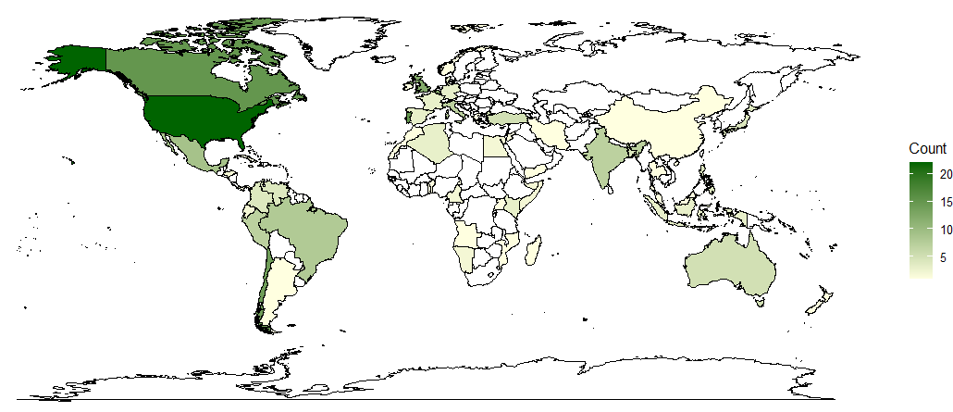
Figure. Map of participants' countries, coloured according to the number of participants from each country (Count).
- Carolina noted in writing that a Spanish version of the course is still under development and is expected to be open in May 2024. Due to exceptional circumstances in terms of loss of staff and lack of availability for the remaining staff to meet the set preparation times, the opening of the course was delayed. The Spanish training material was prepared in collaboration with four Latin-American Nodes, and was finalized and submitted to the OTGA RTC in 2023. Carolina pointed out that the development of modules for this course adheres closely to the outlined objectives of the "new OBIS Capacity Development Strategy," highlighting the potential for enhanced training outcomes through coordinated support among nodes, optimizing resources, personnel allocation, and curriculum development. Additionally, it ensures alignment with the specific needs and insights pertinent to the regions involved.
In-Person Workshop
- OBIS-ISA organized an in-person Workshop on Enhancing Biological Data Sharing to Advance Deep-Sea Taxonomy which was held in Vietnam in October 2023. Mr Ward Appeltans provided a demo of the OBIS portal and did an exercise/quiz with all participants.
Marine Biodiversity Data Mobilization Workshop
- The OBIS secretariat (Elizabeth) and .. are contributing training resources to the third annual Marine Biodiversity Data Mobilization workshop, a hands-on, interactive, virtual workshop focused on mobilizing marine biological observation datasets to OBIS by helping data providers standardize their data using Darwin Core. The workshop is jointly hosted by OBIS-USA, IOOS, Hakai, CIOOS, MBON, OTN, and OBIS. This year >400 participants applied to join the workshop, so the team selected 100 participants to join for the 8 hours divided into two days. The large interest in this workshop demonstrates a great need in our community for more training opportunities for data standardization.

[add draft recommendation/decision]

IODE internship programme

Mr Ward Appeltans will introduce the NORAD funded project on IODE internships.

[Johanna Diwa (IOC CD officer) and Carolina Mazzuco (OTGA coordinator) will provide more details on the implementation/timeline/process for interested OBIS nodes who can be potential hosts for the interns.]

[add draft recommendation/decision]

OBIS propagules program proposal

Mr Silas Principe will introduce the concept of an OBIS propagules program.

OBIS is an exceptional resource for marine researchers, however a significant number of individuals are unaware of the platform's full range of capabilities. In this sense, OBIS is constantly investing in capacity building. To add to this, we are now proposing the “Propagules program”, an initiative to increase awareness about OBIS capabilities among the next generation of marine scientists.

The OBIS “Propagules program” targets one part of the OBIS community - (under)graduate students - by inviting educators to incorporate OBIS content into their regular courses. This is achieved by providing resources, such as models for thematic classes, data kits, and virtual labs. Educators participating in the program also receive training and have the opportunity to engage in discussions and share their experiences within a community of like-minded educators. At the end, we anticipate paving the way for a newly skilled community of OBIS users.

Briefly, this program entails integrating OBIS data and tools into standard higher education courses with marine-related components, as well as into supplementary activities associated with those courses. The spectrum of implementation spans from straightforward thematic classes to the establishment of coding clubs. In addition to the resources curated by the secretariat and nodes (or guest educators), our objective is to establish a platform where every participant in the program can contribute their experiences and materials. This collaborative approach ensures that as the program progresses, a growing reservoir of resources will facilitate the emergence of novel and more innovative methods for integrating OBIS data into the curriculum. More information is provided in the annex.

[add draft recommendation/decision]

OBIS project teams

OBIS Data Quality Control Project Team

Ms Yi-Ming Gan will report this topic. She pointed to the full activity report which is available here: https://oceanexpert.org/document/33975.

In summary, to accomplish the objectives of the OBIS QC project team, we implemented a collaborative framework for quality control best practices within OBIS, which consisted of:

- The creation of communication channels: a dedicated slack channel and a GitHub repository
- Holding monthly online meetings, including data laundry events
- Organizing surveys: OBIS user survey and internal survey

This framework helped us to perform the assigned task, which was to align the OBIS QC pipelines with the TDWG and GBIF quality checks.

A joint online meeting between OBIS QCPT, OBIS Historical Data Project Team, OBIS Secretariat, GBIF Secretariat and TDWG Biodiversity Data Quality (BDQ) task group 2 (TG2) was held on 3 February 2023. The outcomes of this meeting were:

- The alignment of the OBIS quality checks with the core tests and assertions developed by the TDWG Biodiversity Data Quality Tests and Assertions task group (BDQ TG2). The mapping is summarized on a wiki as part of the QCPT GitHub repository.
- The incorporation of a link to the LifeWatch & EMODnet Biology QC tool in a dialog box when users add their dataset to the OBIS network on IPT, available since IPT version 2.7.3.
- A summary of the OBIS and GBIF quality control tools, data flagging approaches and procedures pre- and post- publication with the aim of standardizing the quality control procedures across networks. This summary triggered an open Github discussion on merging the GBIF and OBIS validators.

In summary, the project team completed the alignment of all obis-qc quality checks to the Core Tests and Assertions developed by TDWG Biodiversity Data Quality Tests and Assertions task group (BDQ TG2). The obis-qc is a Python library developed by the OBIS Secretariat that powers the quality checks behind the OBIS portal. The mapping is summarized in the project team wiki. Tasks that are deemed out of current scope were listed as GitHub issues with a tag “won’t fix”.

Future directions and Recommendations
While the project team addressed most of the tasks set out at the beginning, they were not always fully completed by the end of the project. In order to avoid the challenges encountered during these three years and with the intention of bringing OBIS data and procedures up to best practices, the project team proposes the following recommendations:

- Better align data quality procedures. Within OBIS, the obis-qc pipelines, and the R packages “obistools” and “EMODnetBiocheck” still need to be aligned for a standardization of quality control procedures within the network. It is essential that OBIS also aligns its quality procedures with the broader biodiversity informatics communities such as GBIF and TDWG.
- Request UNESCO to establish a permanent position for a full time data manager at the OBIS Secretariat. This position is currently lacking but is vital in order for OBIS to participate in working groups related to OBIS operations such as TDWG BDQ task group 2. This would help to implement and maintain the outcome and vision of this project team.
- Optimize the functioning of OBIS Task and Project Teams. An assessment of how OBIS Teams are designed and carried out in order to be made sustainable is essential for the correct functioning of these teams.

[add draft recommendation/decision]

OBIS Vocabulary Infrastructure Project Team

Ms Elizabeth Lawrence reported on the progress of the OBIS VIPT. The team held monthly meetings since the last SG to further develop important training resources for use of controlled vocabulary. Considerable development of resources have been created, including:
- The migration of Q01 terms to the P01 collection with assistance from Mrs Gwen Moncoiffe and the BODC team
- Near completion of a decision tree that helps users select vocabulary to populate the measurementTypeID, measurementValueID, and measurementUnitID fields
  - Work remaining includes creating a separate measurementTypeID branch for sampling measurements once Q01 terms have been fully migrated to the P01 collection
- Five training videos that introduce controlled vocabulary and the use of the decision tree. The videos [are/will be] hosted on the OBIS YouTube. Further videos to be developed include one for measurementValueID and the above mentioned branch for sampling measurements provided to measurementTypeID.
She also noted the team currently still does not have an official chair or co-chair.

OBIS Grand Unified Data Model Project Team

Stephen Formel, in lieu of Abby Benson, reported that the OBIS Grand Unified Data Model
Project Team (GUMPT) addressed most of the tasks identified at the beginning of the project.
However, not all tasks are completed, in part because the new data model (previously known as the Grand Unified Model) continues to develop and change. The project team met a total of
eight times from June 2022 until October 2023, and identified ten model use cases as relevant to OBIS. The most completely explored were “camera traps”, and “environmental and
community measurements.” The team also identified and explored a new use case, "absences". In conclusion, the project team noted that a future team could work with those publishing models once they are completed, to make a fuller assessment. Further details of all project tasks can be found in the report distributed to the SG-OBIS via email on September 26, 2023. The report can also be found at: https://oceanexpert.org/document/33975.

OBIS Future

Mr Ward Appeltans introduced this agenda item. He reported that recently there are several important events that have an impact on the future of OBIS.

(i) The IODE Committee approved the designation of IODE activities as Programme Components, Programme Activities and Projects, and decided to designate OBIS, and ODIS, and OTGA as Programme Components.

(ii) The IODE Committee approved the “Rules of Procedure for IODE Programme Components, Programme Activities or Projects (MG918)” and instructed all projects to adopt these in their management structure by the next meeting of the IODE Management Group (February 2024).

(iii) The return of the USA to UNESCO, and the UNESCO Executive Board decision to allocate extra financial resources to IOC as well as the IOC Assembly resolution to prioritise IODE, GOOS, CD and regional activities in the allocation of the additional budget. This means that we will have a much better base funding for our OBIS activities. The IOC Assembly also requested the IOC secretary to create a regular programme position for the OBIS data manager. The proposed new staffing allocation has been approved by the UNESCO General Conference in November 2023, and the recruitment process has started.

At SG-OBIS-11, the steering group established an IWG-OBIS management structure with the task to propose a new OBIS management structure and working methods to be in line with the new rules and procedures for IODE programme components. And to reconsider the tasks of the OBIS Strategic Advisory Task Team in this new structure.

The work of the IWG commenced at the EC-OBIS-5 meeting and started with reviewing the Strategic plan for OBIS (OBIS business plan) which was adopted in 2014 and included the OBIS' vision and mission, objectives, needs assessments, contributions to IOC functions, resource requirements and organizational structure. A survey was published where we asked OBIS nodes to provide feedback to the ToR of OBIS nodes, the ToR of SG-OBIS and the OBIS vision, mission and objectives. 21 OBIS nodes responded and the results of this survey were published as annex 1 in the EC-OBIS-5 report.

The EC-OBIS listed the elements in the IODE new rules and procedures that are important for OBIS or have an impact on OBIS (see p. 18-24 of EC-OBIS-5 report).

The EC-OBIS spent a considerable amount of time in reviewing the survey results, analyzing the new IODE rules and procedures, which was followed by brainstorming sessions on a new OBIS management structure and started drafting revised Terms of References for the OBIS steering group, co-chairs and OBIS nodes. The EC-OBIS did not manage to review the vision, mission and objectives, nor drafted the ToR of the new coordination groups.

The OBIS co-chair Katherine Tattersall debriefed the OBIS nodes of the proposed new structure and proposed ToRs during two online information sessions covering different time zones.

OBIS Management Structure

Ms Katherine Tattersall introduced this agenda item.

The first session of the IODE Steering Group for OBIS was held in 2011 following a recommendation from IODE-XX1.2. Under the original TOR it was recommended that “the membership of the Steering Group shall include the managers of OBIS Nodes or their designated representatives, and representatives from organizations contributing to the development and maintenance of the OBIS infrastructure.” OBIS now has 33 nodes and the current list of eligible SG members (Node Managers and potential designated representatives) is 72 people which exceeds the number of SG members indicated by the Rules of Procedure for IODE Programme Components (recommended to be “a manageable number, e.g. 20”). The IODE TORs also state that members of the SG should be selected based on their expertise and “not be considered as representatives of their country”. Under IODE TORs for SGs the responsibility of SG members to attend meetings is underlined, as decisions can only be made if a quorum (50% of membership +1) is present. The IWG-OBIS-Structure has sought to define an equitable way to reduce the size of our SG and to define a mechanism to rotate through eligible OBIS Node Managers and community members who are interested in joining the SG (see proposed TORs section 4.1.3). However, the IWG also very much wanted to provide a forum for all OBIS Nodes representatives, managers, staff and affiliate partners to meet, hold workshops, report on working groups, coordinate activity, share training and strengthen our community. In order to do this we have designed a flexible management structure that aims to give all OBIS community members an opportunity to participate in the SG, collaborate with other nodes, contribute to OBIS working groups, and that we hope will strengthen and grow our community.
The IWG-OBIS-Structure:
- Proposes one big OBIS conference/meeting every two years
  - Attended by all OBIS community members and Node representatives
  - Opportunity for nodes to discuss technical issues
- Proposes SG-OBIS meetings annually
  - Attended by a smaller OBIS SG
  - Focus on business and OBIS strategy
- Proposes creation of a Nodes Coordination Group
  - Membership is mandatory for all OBIS Nodes
  - Co-Chairs of the Nodes Coordination Group will be, by default, members of the SG (additional to representative Node membership of the SG)
  - Will define priority objectives to guide the efforts of OBIS Nodes
  - The Nodes Coordination Group will be tasked with some responsibilities that previously were the work of the Strategic Advisory Task Team

The IWG-OBIS-Structure anticipates that OBIS will continue to collaborate with GBIF to build and implement data infrastructure and publishing tools. OBIS will continue to focus on data mobilization (input) and data application (output), defining these as Priority Areas for OBIS. OBIS will collaborate with GBIF on the “middle layer”. Importantly:
- Many institutions now have an IPT and publish marine data directly to GBIF
- OBIS nodes will have a mentoring role for local data providers in publishing to both OBIS and GBIF, with a shift in OBIS node responsibility: not all marine data needs to be published on the OBIS node IPTs.

To guide and support Priority Area 1: Data Mobilization and Priority Area 2: Data Application across OBIS Nodes, the IWG-OBIS-Structure:
- Proposes two further Coordination Groups (to replace guiding role of task teams and project teams)
  - Data Coordination Group (data mobilization/input focus)
  - Products Coordination Group (data application/output focus)
- External (to OBIS) experts can be invited to join these groups and contribute
- All OBIS nodes can choose to sign up to any of the three new Coordination Groups.

Under the new IODE rules and procedures there is no scope for the Task and Project Teams that previously were fundamental to important work that the OBIS community has done at the direction of the OBIS SG. As discussed during SG-OBIS-11, we instead will have Intersessional Working Groups (to be established by SG-OBIS) and the three Coordination Groups.

To support our new Priority Area focus on data mobilization and data application, OBIS will enter into partnership agreements with long-term monitoring programmes. The IWG-OBIS-Structure:
- Proposes that regional and domain OBIS Nodes join these agreements as partners and provide support services for mobilization of data.

To comply with the ”Rules of Procedure for IODE Programme Components, Programme Activities or Projects” the IWG-OBIS-Structure needed to make several updates to the Terms of Reference for elements of OBIS management structure. The following four items are specified by IODE as TORs for Programme Components:
- Steering Groups (4.1.3)
- Members of a Steering Group (4.1.3 - Membership)
- Steering Group Co-Chairs (4.1.4)
- Project Managers (4.1.5 - OBIS Programme Manager)
Outcomes of the mandatory revisions are described in relevant sections of this document.

At the same time and to improve alignment with the above TORs the IWG-OBIS-Structure revised TORs for:
- OBIS Nodes (4.1.2)
- Executive Committee (4.1.7)

IWG-OBIS-Structure also intends to develop TORs for the Coordination Groups (4.1.6).

Changes for OBIS Nodes arising from this proposed new OBIS management structure are a. Nodes are members of the Nodes Coordination Group and must report to that group; b. Nodes need to express a desire to join the SG-OBIS and take on extra responsibilities; c. OBIS node staff (in addition to node managers) can join the data coordination group and product coordination group, which replace the task teams and project teams; d. Some money will be available to sponsor attendance at a bi-annual OBIS conference which is a different forum to the OBIS-SG meeting (all Nodes are invited to the conference); e. Nodes will be community/national focal points with an important coordination role supplementing an existing data publication role.

Major activities in the proposed new OBIS management structure are listed in the table below:

Activity | When | Participants | Frequency | Location
SG-OBIS meeting | Mar-24 | OBIS SG (current membership) | Annual | Korea
SG-OBIS meeting | Mar-25 | OBIS SG (new membership) | Annual | Colombia?
EC-OBIS meetings |  | OBIS Executive Committee | Quarterly | Online
OBIS DCG meetings |  | OBIS Data Coordination Group | Monthly | Online
OBIS PCG |  | OBIS Products Coordination Group | Monthly | Online
OBIS NCG |  | OBIS Nodes Coordination Group | Monthly | Online
OBIS Conference |  | All OBIS Nodes and community | Biannual | In person
GBIF/OBIS Partnership meeting | Feb-24 | OBIS Secretariat, OBIS Co-Chair, Past Co-Chair, PT Co-Chairs | Once off | In person
IODE MG meeting | Feb-24 | OBIS Secretariat, OBIS Co-Chair | Annual | In person
GBIF/OBIS collaboration feasibility study | Through 2024 | OBIS Secretariat, OBIS Data and Product CGs | Once off | Online
OBIS Coordination Group workshops |  | OBIS Data and Products Coordination Groups | Ad Hoc | In person
OBIS technical development activities: new website, improved data access (performance and filtering), data products platform | Through 2024 | OBIS Secretariat | Ongoing | NA
OBIS training in collaboration with OTGA | Ending Feb 2024 | OBIS Nodes, OBIS Secretariat | Ad Hoc | Online
Translating current OBIS course into other languages | Through 2024 | OBIS Nodes | Once off | Online
OBIS branding material development and distribution | Through 2024 | OBIS Secretariat | Once off | NA

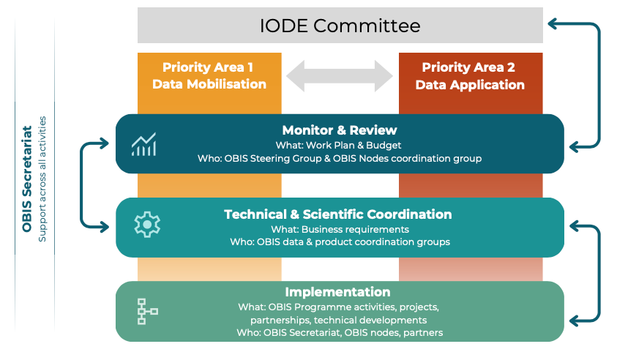

Figure. Overview of the new OBIS management structure.

OBIS Vision, Mission and Objectives

The IWG-OBIS-Structure has not finished reviewing the OBIS vision, mission and objectives.

TORs for OBIS Nodes

The IWG-OBIS-Structure invited the SG-OBIS to review the proposed new Terms of Reference for OBIS nodes:

Required
- OBIS nodes can be national, regional or thematic
- Be an NODC or ADU under IODE
- Be responsible for ensuring high-quality data (and metadata) and operational and sustained data flows from marine data providers to OBIS and other global aggregators (e.g. GBIF) following the principle of “publish once“ and the guidelines in the OBIS manual (with respect to obtaining permission, licenses, QC…)
- At least one staff member holds a current OBIS certification (completing recognized training)
- Be compliant with the IOC data policy and implementation guidelines from OBIS
- Ensure the long-term preservation of the data and metadata provided to OBIS, including version-control, through certified or recognized data archives or repositories
- Be a member of the Nodes Coordination Group (Nodes CG), and other OBIS coordination groups if desirable
- Provide an annual work plan to the Nodes CG and report on activities
- Provide user/stakeholder support (respond to data queries, analyses, and feedback)

Optional
- May maintain a presence on the Internet (e.g., a web page, social media or data portal) representing their specific area of responsibility
- May establish and/or join OBIS collaboration agreements with OBIS partners, and report on these collaborations to the Nodes CG
- Encouraged to undertake outreach and communication activities (e.g. social media, conferences), in accordance with the OBIS Communication Plan
- Encouraged to undertake capacity development activities in consultation with the OBIS secretariat (e.g., providing expertise, (academic and professional) training and support in data management, in publishing to global data aggregators (e.g. OBIS and GBIF), in using technologies, in applying standards and best practices)
- Encouraged to engage in stakeholder groups and actively seek new (data providing) partners
Notes:
- OBIS nodes are eligible to become a member of the SG and have voting rights. A formal letter expressing their commitment to serve the SG must be renewed every 2 years.
- OBIS nodes can become a member of and contribute to the various OBIS coordination groups

TORs for OBIS Steering Group

The IWG-OBIS-Structure invited the SG-OBIS to review the proposed new Terms of Reference for the IODE Steering Group for OBIS:

Required
- Propose, and revise as necessary, the vision, mission, objectives, strategies (sustainability), management structure, work plans and timetables for OBIS
- Review reports from OBIS coordination groups
- Monitor the development of the adopted work plan, identify any technical or scientific challenges and propose remedial action
- Invite additional experts as members of the SG, as needed by OBIS
- All members of the SG are encouraged to assist with resource mobilization
- Report to the IODE Management Group (every year) and IODE Committee (every two years)

Notes:
- Regular meetings of the Steering Group will be held (at least) once a year. The Co-Chairs can decide, in consultation with the members, to have more than one meeting a year if needed.
- OBIS Steering Group decisions are made by consensus. Voting will only be organized if no consensus can be reached.
Membership:
- Two Co-Chairs (2 seats), who are elected from the membership of the Steering Group. In exceptional cases one or more Co-Chairs can be invited from outside the Group if they can bring in exceptional expertise or experience or if no other candidates have come forward. In such cases the Steering Group will need to invite them as members first after which he/she/they can be elected (Co-)Chair(s). When (Co-)Chair(s) step down after one or two terms they may remain members of the Steering Group. They should inform the OBIS Programme Manager at the time they inform of their decision to step down as co-chair.
- Two past Co-Chairs (2 seats)
- Co-Chairs OBIS coordination groups (6 seats): appointments shall be for a term of 2 years, renewable for one further term.
- OBIS nodes (16 seats): OBIS node manager (and one alternate person). OBIS nodes should inform the OBIS secretariat of any membership changes as soon as possible. OBIS nodes need reconfirmation after two 2-year terms.
- Invited experts (4 seats): They act as observers. Membership term is for two years, starting at the first coming SG session, and can be renewed as necessary.
- OBIS secretariat (OBIS Programme manager as SG-OBIS technical secretary, ex-officio).

[Notes: OBIS nodes will be invited to become SG members via an official invitation letter ]

TORs for OBIS Co-Chairs

The IWG-OBIS-Structure invited the SG-OBIS to review the proposed new Terms of Reference for the OBIS Co-Chairs:

The role of (Co-)Chair(s) is:
- To (Co-)Chair sessions of the OBIS Steering Group and OBIS Executive Committee
- To monitor the development of the adopted work plan, identify any problems and propose remedial action, in close consultation with the IODE/OBIS Secretariat and SG members
- To call for meetings of the OBIS Steering Group, in close consultation with the Programme Manager and/or IODE/OBIS Secretariat
- To assist the Programme Manager and/or IODE/OBIS Secretariat with the preparation of project reports
- To represent OBIS and its Steering Group at meetings and other events
- To promote OBIS at meetings and other events

Notes:
- Co-Chairs must act independently of other affiliations and will not represent their institution or country while performing co-chair duties.
- Co-Chair(s) may focus (in addition to the tasks outlined above) on particular elements of the OBIS work plan if they have specific expertise in those elements.
- (Co-)Chairs should expect to dedicate a minimum of 160 hours per year to their duties, including monthly video conferences, one or more representations at IODE management group and Committee meetings, major international conferences or special events on behalf of OBIS, and leadership duties in preparation and execution of annual SG-OBIS meetings.
- (Co-)Chairs positions are not funded by IODE/OBIS, and SG-OBIS members seeking nomination to become Co-Chair are encouraged to obtain full support from their home institutions to cover time and expenses of the role as part of core duties. Travel support may be provided by the IODE OBIS Programme component when available.
- It is recommended that Programme Managers, IODE/OBIS Secretariat and OBIS (Co-)Chair(s) communicate regularly.
- Co-Chair(s) are elected based on their level of activity in the work of the Steering Group over a period of time, the respect they have gained from the membership of the Group and their professional expertise related to the subject of OBIS. Proficiency in the working language of the group is essential.
- Experience in mobilizing resources is an additional element but not a requirement.
- Elections of (Co-)Chair(s)s can only be held during regular meetings of the Steering Group during which a quorum of the membership is present.
- (Co-)Chair(s) are elected for one inter-sessional period of the Steering Group (regular meeting), with the possibility of re-election for an additional term. In exceptional circumstances Co-Chairs (or one of them) can be re-elected for a third term. If more than one regular meeting is organized within a calendar year then the term of office will be one year. Exceptions (e.g. further extensions) are possible by a decision of the IODE Committee.
- When (Co-)Chair(s) step down after one or two terms, they will become Past (Co-)Chair(s) and will be invited to provide guidance to the incoming (Co-) Chair(s) during the first term of the new (Co-) Chairs. This will be a voluntary service to the new (Co-)Chair(s) and the outgoing (Co-)Chairs may decline.
- (Co-)Chair(s) should inform the OBIS Programme Manager and IODE Secretariat of their desire to step down at least 6 months before the expiry of their term of office or next regular meeting of the Steering Group, whichever comes first. This will allow the Programme Manager and IODE Secretariat to start the election procedure for the new (Co-)Chair(s).
- The (Co-)Chair(s) are not involved in the day-to-day implementation of OBIS which is the remit of the OBIS Programme Manager.
- Nominations for (Co-)Chairs shall be accepted from members of the SG-OBIS in good standing as either nomination on behalf of another or self-nominations.

TORs for OBIS Secretariat

The IWG-OBIS-Structure invited the SG-OBIS to review the proposed new Terms of Reference of the OBIS secretariat:

The OBIS secretariat, hosted at the UNESCO/IOC project office for IODE in Oostende (Belgium), provides training and technical assistance to its network of partners including OBIS nodes and data providers, guides and advices on the development of new data standards and technical developments, and encourages international cooperation and implement the OBIS work plan and oversees the budget, to foster the group benefits of the network.

The OBIS Secretariat currently has 2 fixed term regular programme positions: an OBIS programme manager and an OBIS technical coordinator with the following tasks and objectives:

The OBIS programme manager will

- Coordinate the planning and implementation of the OBIS work plan, including organizing meetings of the OBIS steering group, OBIS executive committee, OBIS coordination groups (data, products and OBIS nodes), and supervising the OBIS secretariat staff.
- Coordinate the planning and implementation of other Extra Budgetary projects.
- Support the implementation of the IODE work plan and assist with the planning and implementation of the IODE/OBIS contribution to the UN Decade of Ocean Science for Sustainable Development.
- Establish, maintain and strengthen (international) partnerships (e.g., GBIF, MBON, GOOS, MarineLife2030, CBD, BBNJ, IPBES etc).
- Ensure a performance management culture within the secretariat team. Through regular staff team meetings: listen, seek views, monitor performance, solve problems and meet needs of colleagues and collaborators. More specifically:
  - set clear objectives for the team and ensure effective/timely completion of all performance management related tasks.
  - provide regular performance feedback on the implementation of set task objectives, including expected behavior and development needs.
  - address all performance related issues in a timely manner and propose corrective measures for any under-performance. In cases of strong performance, commend staff and seek ways to leverage for improved overall team performance.
- Set professional and inter-personal development objectives.

The OBIS technical coordinator will

- Be responsible for the technical and scientific coordination, implementation and maintenance of the OBIS data system and planning of related programme activities.
- More specifically:
  - In close collaboration with the Head of the IOC Project Office for IODE, OBIS programme component manager and OBIS team, establish technical programme goals, plan of activities, budget proposals, and performance measures - in accordance with technical guidance from the IODE Committee and OBIS coordination and steering groups.
  - Coordinate and provide technical maintenance and further development of the OBIS technology stack and infrastructure; Manage the technical implementation of the OBIS work plan; Manage and provide support to the OBIS technical and scientific working groups; Provide terms of reference for, and monitor/evaluate progress of, contractors hired to provide technical work; Collaborate closely with the Ocean Data and Information System (ODIS) team to ensure interoperability between ODIS and OBIS.
  - Resource mobilization: Manage drafting technical and scientific aspects of extra-budgetary project proposals, as well as the technical and scientific implementation of approved extra-budgetary projects.
  - Networking and Outreach: Participate in meetings of technical groups as well as the OBIS steering group and other relevant events; Assist with the promotion and communication of the OBIS programme component.
  - Provide assistance with technical support of IODE databases and other IT services of, or hosted by, the IOC Project Office for IODE, Oostende, Belgium.

TORs for OBIS Coordination Groups

The IWG-OBIS-Structure has not finished drafting the Terms of Reference of the OBIS coordination groups. The role and responsibilities of coordination groups is not regulated by IODE rules and procedures and tIWG seeks input from the SG about how these coordination groups will best meet the needs of our network.

OBIS nodes coordination group

OBIS data coordination group

OBIS products coordination group

TORs for OBIS Executive Committee

The IWG-OBIS-Structure invited the SG-OBIS to review the proposed new Terms of Reference of the OBIS Executive Committee

The OBIS Executive Committee will:

- Support the secretariat and assist with the management of OBIS
- Address issues that arise intersessionally
- Work with the secretariat to draft documents, monitor the work plan, and otherwise ensure that the work of the Steering Group and Coordination Groups progresses.

Notes:
- The OBIS EC meets 4 times per year, online and in-person if necessary
- The OBIS EC can invite experts to join a meeting as required

Members:
- SG-OBIS Co-Chairs and past Co-Chairs
- Coordination groups Co-Chairs
- Secretariat/ Programme Manager

OBIS data policy

Mr Ward Appeltans reported that the IOC Assembly adopted a new IOC Data Policy and Terms of Use (IOC Decision A-32/4.4, 2023) and requested that IOC programmes, projects as well as other communities of practice should develop and/or apply, where applicable, detailed metadata, data and products sharing guidelines that are consistent with this new policy.

The OBIS guidelines on the sharing and use of data in OBIS was agreed at SG-OBIS-IV (Feb 2015) and adopted at IODE-XXIII (March 2015) and was based on the principles of the previous IOC data exchange policy. The SG-OBIS-11 (May 2023) decided to set up an IWG Data Policy to fulfill this task before the next SG meeting and suggested combining this task with the IWG OBIS-Structure.

The OBIS secretariat started developing a draft OBIS data policy which is available in annex.

The SG-OBIS is invited to review and provide input and if agreed adopt the policy.

OBIS communication plan

An outreach and communication strategy for OBIS is essential for effectively sharing information, engaging with stakeholders, and promoting the programme's goals and achievements. The SG-OBIS tasked an intersessional working group to develop a new OBIS Outreach and Communication Plan. During the EC-OBIS meeting in November 2023, we started creating a draft OBIS Communication Plan which is available in Annex..

The SG-OBIS is invited to review and provide input and if agreed adopt the plan.

OBIS products

OBIS developed the OBIS2030, an UN Ocean Decade endorsed project, to provide a biodiversity data hub made up of standardised, quality controlled and managed data to support the Ocean Decade objectives. This will help researchers, practitioners and decision makers to protect and restore marine ecosystems and protect life in the ocean.

One integral part of the OBIS2030 targets is to create and publish information products, at global, regional and national scale to feed directly into reporting and assessment processes. This should occur by providing a platform to (jointly) develop and share reliable biodiversity indicators and information products that describe changes in marine ecosystems.

To start with the implementation of those solutions, the SG-OBIS decided to establish an open-ended intersessional working group on OBIS-based marine biodiversity indicators and information products (IWG-OBIS-PRODUCTS).

The IWG-OBIS-Products is a collaborative and interdisciplinary group that is driven by the importance of creating indicators and information products that are scientifically sound, practical, and relevant to decision-makers in government, industry, and civil society. Our main objectives are to:
- Review existing OBIS information products
- Identify products needs (at local, regional or broader scales) in order to create a plan for future products implementation by contacting nodes and stakeholders, including the community of users
- Perform a systematic analysis of the data in OBIS, identifying geographic and taxonomic gaps, which can help identify indicator species and ecosystems or strategies for species distribution modelling
- Contact ecological synthesis centres/groups to promote an exchange of knowledge and gather suggestions/advice on possible products that could be derived from OBIS
- Propose a process for frequent expert validation of information products by consulting with local scientific experts and end-users (including local communities and indigenous people)
- Discuss the relevance of supporting community generated OBIS products and establish a potential framework for receiving and portraying those products.

Part of those objectives were already completed and generated a concept note for an OBIS data product platform, which is available in annex.

The SG-OBIS is invited to review and provide input to the concept note.

OBIS partnerships

GBIF

As a follow up and upon the request of the SG, we organized an OBIS-GBIF consultation meeting that took place at the OBIS secretariat on 8-9 February 2024 in Ostend, Belgium. There were 15 participants representing the secretariats of OBIS and GBIF, the OBIS co-chair, OBIS nodes (Antarctica, Australia, Europe, USA) and GBIF nodes (Norway, France, USA) and external advisors representing MBON.

To recap, GBIF and OBIS have signed a five-year agreement (in 2020, which was the second agreement after the first one signed in 2014), to promote further cooperation across a wide range of activities and services between the two global biodiversity data networks. The Letter of Agreement targets both technical collaboration covering data standards, publishing and processing; and institutional collaboration to ensure closer ties between OBIS and GBIF nodes, shared training opportunities and aligned documentation.

During the 2024 meeting a draft joint strategy, action plan and annual work plan has been developed and is now up for review by the respective communities (see annex 6). The proposal is that this new agreement would replace the current one and will run until 2030.

The SG-OBIS is invited to review and if agreed adopt the joint GBIF-OBIS marine strategy and action plan.

Other partnerships

[Protected Seas.]

[GOOS (BioEco portal).]

OBIS workplan and budget

OBIS had to submit its workplan and budget to IODE before the end of November 2023 and was adopted by the IODE Management Group during its meeting on 5-7 February 2024.

Activity |  | 2024 | 2025 | 2026 | 2027
Meetings (travel & subsistence) | SG-OBIS meeting 25-29 March 2024, South Korea, in person | 15000
 | SG-OBIS meeting ?March? 2025, Colombia, back-to-back with IODE Committee meeting, in person |  | 15000
 | SG-OBIS meeting 2026, TBD |  |  | 15000
 | SG-OBIS meeting 2027, TBD |  |  |  | 15000
 | OBIS conference, bi-annually, in person, back-to-back with another major conference (e.g., IODC-3, WCMB 2026 in Ostend) |  | 40000 | 40000
 | EC-OBIS meetings, quarterly, online | 0 | 0 | 0 | 0
 | OBIS Data Coordination Group meetings, monthly, online | 0 | 0 | 0 | 0
 | OBIS Product Coordination Group meetings, monthly, online | 0 | 0 | 0 | 0
 | OBIS Nodes Coordination Group meetings, quarterly, online | 0 | 0 | 0 | 0
 | OBIS coordination group workshops (data & products), time and place TBD, in person | 20000 | 20000 | 20000 | 20000
 | IODE MG meetings (e.g. 5-7 February 2024, Ostend, Belgium, in person), in-kind co-chairs | 0 | 0 | 0 | 0
 | GBIF/OBIS meetings (e.g. 8-9 February 2024, Ostend, Belgium in person | 0 | 0 | 0 | 0
Staffing | Part-time consultant, community engagement officer, to assist the various OBIS Coordination Groups and partnerships | 30000 | 30000 | 30000 | 30000
 | Other OBIS staff (currently 6) covered by RP and XB projects | 0 | 0 | 0 | 0
Technical infrastructure | OBIS website and portal developments. Covered by additional RP position | 0 | 0 | 0 | 0
 | Cloud, software and hardware | 15000 | 20000 | 25000 | 30000
Capacity Development | OBIS training courses in collaboration with OTGA. Covered by XB funding (NORAD, FUST) | 0 | 0 | 0 | 0
Communication and Outreach | OBIS branding material development and distribution | 5000 | 5000 | 5000 | 5000
 |  | 85000 | 130000 | 135000 | 100000

Adoption of the report

Date and place of next session

Closing

Annexes

Annex 1. SG-OBIS-12 agenda and time table

Monday 25 March 2024 (MABIK)

08:30-09:00 Bus from hotel to MABIK
09:00-09:30 Opening of the session and adoption of the agenda
09:30-10:30 Hands-on sessions: Darwin Core
10:30-11:00 Break
11:00-11:30 Hands-on sessions: GitHub.
11:30-12:30 Hands-on sessions: Taxonomic matching and new annotation tool
12:30-13:30 Lunch
13:30-15:00 Hands-on sessions: OBIS QC tools
15:00-15:30 Break
15:30-16:00 Hands-on sessions: OBIS products portal
16:00-17:30 Visit to MABIK exhibition and collections
17:30-18:00 Bus from MABIK to hotel

Tuesday 26 March 2024 (MABIK)

08:30-09:00 Bus from hotel to MABIK
09:00-10:30 Hands-on sessions: OBIS vocabulary
10:30-11:00 Break
11:00-12:30 Hands-on sessions: OBIS DNA derived data
12:30-13:30 Lunch
13:30-14:30 Bus from MABIK to Baekje Cultural Land
14:30-17:30 Visit Baekje Cultural Land
17:30-18:30 Bus from Baekje Cultural Land to hotel

Wednesday 27 March 2024 (Ramada hotel)

09:00-09:30 OBIS reports: secretariat
09:30-10:00 OBIS reports: executive committee
10:00-10:30 OBIS reports: OBIS nodes
10:30-11:00 break
11:30-12:30 OBIS reports: OBIS nodes
12:30-13:30 Lunch
13:30-14:00 OBIS reports: OBIS Taxonomy Task Team
14:00-14:30 OBIS reports: OBIS Capacity Development Task Team
14:30-15:00 OBIS reports: OBIS Data Quality Control Project Team
15:00-15:30 Break
15:30-16:30 OBIS reports: OBIS Vocabulary Infrastructure Project Team
16:30-17:00 OBIS reports: OBIS Grand Unified Data Model Project Team
18:00-20:00 Reception and dinner offered by MABIK

Thursday 28 March 2024 (Ramada hotel)

09:00-10:30 OBIS Future: OBIS management structure: SG, CHAIRS, SEC, NODES
10:30-11:00 break
11:00-11:30 OBIS Future: OBIS management structure: coordination groups
11:30-12:30 OBIS Future: OBIS data policy
12:30-13:30 Lunch
13:30-14:30 OBIS Future: OBIS communication plan
14:30-15:00 OBIS Future: OBIS products
15:00-15:30 Break
15:30-16:30 Partnerships: GBIF
16:30-17:00 Partnerships: other partners

Friday 29 March 2024 (Ramada hotel)

09:00-11:00: OBIS workplan and budget
11:00-11:30 Break
11:30-12:30 Adoption of the report
12:30-13:00 Date and place of next session & Closing

Annex 2. Concept note/Proposal OBIS Propagules program
Training a new generation of OBIS users
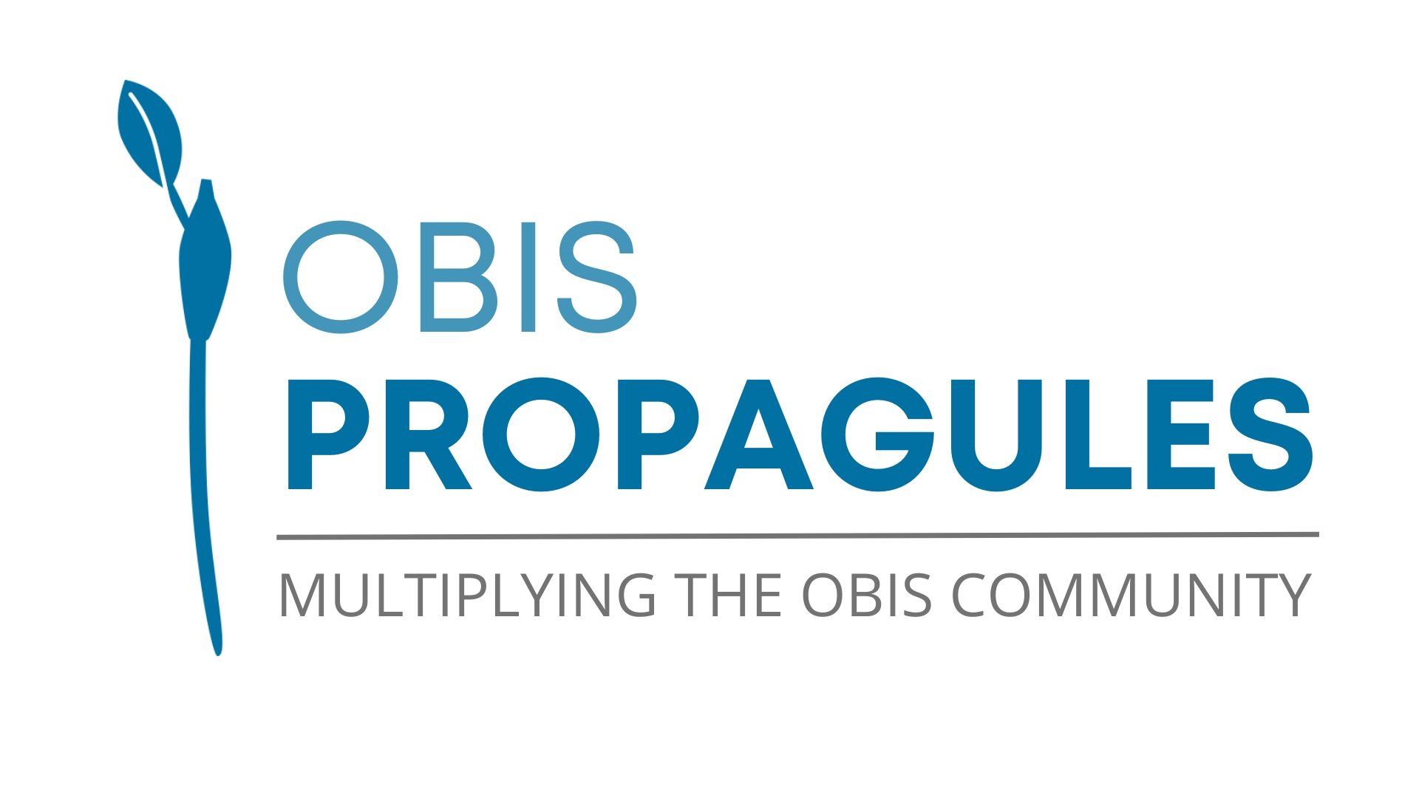
1. Rationale and background
OBIS is the primary biodiversity platform dedicated to the marine environment, currently hosting over 122 million occurrence records along with a wealth of data related to abundance, environmental information, eDNA, and more. This renders OBIS an exceptional resource for marine researchers. However, a significant number of individuals are unaware of the platform's full range of capabilities.

In addition to the limitations this lack of knowledge imposes on the potential for new research questions and answers, it also hinders the sustainability of OBIS. Many researchers do not grasp the process of data submission to OBIS, including how to properly format their data. In this sense, OBIS is constantly investing in capacity development. To add to this, we are now proposing the “Propagules program”, an initiative to increase awareness about OBIS capabilities among the new generation of marine scientists.

2. Overall purpose (objectives) and relevance: needs and issues:

The OBIS “Propagules program” targets one part of the OBIS community - graduate students - by inviting educators to incorporate OBIS content into their regular courses. This is achieved by providing resources, such as models for thematic classes, data kits, and virtual labs. Educators participating in the program also receive training and have the opportunity to engage in discussions and share their experiences within a community of like-minded educators. At the end, we anticipate paving the way for a newly skilled community of OBIS users.

The core of the “Propagules program” are the educators, which will guide a new generation of OBIS users. Because of that, we term them “multipliers” in this proposal.

This program entails integrating OBIS data and tools into standard higher education courses with marine-related components, as well as into supplementary activities associated with those courses. The spectrum of implementation spans from straightforward thematic classes to the establishment of coding clubs. OBIS will furnish educators with resources such as models, use cases, and data kits, which they can subsequently incorporate into their curriculum. Rather than providing a rigid structure, the 'Propagule program' is designed to offer a foundation upon which educators can customize according to their specific circumstances.

Additionally, OBIS will offer online training sessions via the OceanTeacher Global Academy (OTGA), demonstrating various methods for integrating OBIS into their curriculum. Furthermore, OBIS nodes, the local branches of OBIS, will be equipped to supply regional or local use cases that are more closely aligned with the specific context of the area.

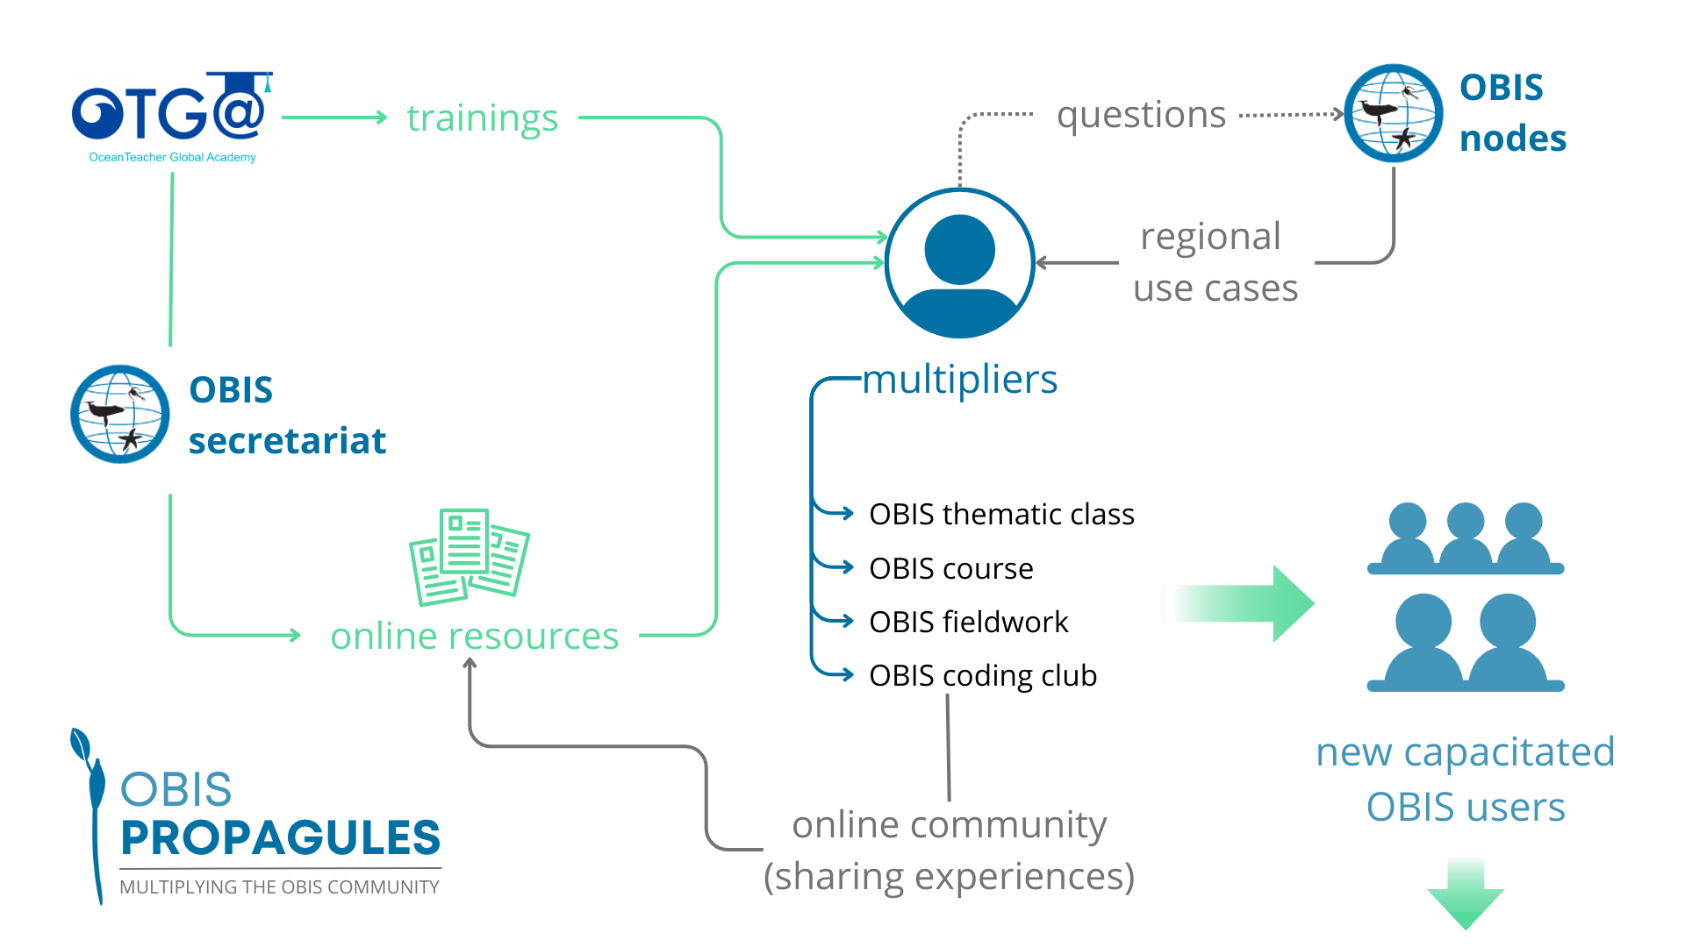

Multipliers can have different levels of engagement, all equally acceptable:

OBIS thematic class

The most straightforward method of implementing the OBIS propagules program is by incorporating one or more thematic modules into the course curriculum. For instance, one could use OBIS data to exemplify diversity patterns within a specific region when teaching a class on diversity indices. Educators would have access to numerous online resources to facilitate the seamless integration of one or more themes into their regular curriculum, requiring minimal adjustments.

Examples of contents that will be available for OBIS thematic classes:

Lesson Plans: Comprehensive outlines encompassing various topics, designed as complete lessons integrating OBIS data or data management concepts.

Use Cases: Curated instances derived from OBIS datasets, intended for exercises, peer instruction, problem-based learning (PBL), or as illustrative examples for explanatory sessions.

Data Kits: Selected OBIS datasets or data collections tailored for practical classes. These kits encompass instructions for one or more practical activities that can be implemented.

OBIS course

OBIS courses facilitate the integration of OBIS data and tools throughout the entire curriculum. Engagement with and utilization of OBIS resources grow as the course advances, and can be incorporated into explanatory sessions, exercises, as well as other activities such as Problem-Based Learning (PBL) practices or peer-learning exercises.

To prepare OBIS courses, educators will have access to all the aforementioned content (lesson plans, use cases, data kits), structured to cover various aspects of a typical marine-focused ecology or zoology course. These resources will be organized to align with the progression of student learning, offering increasing levels of complexity as students advance in their studies.

OBIS fieldwork

Fieldwork constitutes an indispensable element of courses related to the environment, serving as a bridge between theory and practical application. OBIS can be seamlessly integrated into various aspects of fieldwork activities. For instance, let's consider a straightforward exercise involving the assessment of species richness in a rocky shore. Before heading out to the field, OBIS can be employed to identify the species known to inhabit that specific area, providing valuable context. During data processing, students can utilize the OBIS structure for proper data formatting. Finally, students may also have the opportunity to contribute their own data to OBIS, completing the cycle of information flow to the platform.

Educators that chose to apply an OBIS fieldwork would have available fieldwork guides, containing detailed instructions and ideas for including OBIS concepts within regular fieldwork activities. This would include a set of instructions to help educators to apply the life cycle concept (collection, data preparation and submission) within their course, providing the students the knowledge on how to properly prepare and curate their datasets, as well as how to submit it to a biodiversity database.

OBIS coding club

Coding clubs offer an excellent avenue for fostering the utilization of OBIS data among students, providing a deeper and more comprehensive engagement with OBIS tools and functionalities. Moreover, these clubs aid students in acquiring crucial skills in data analysis through programming languages. Educators keen on incorporating this approach can leverage the examples provided by the secretariat to initiate their own coding groups. The dynamics of such groups may vary, ranging from weekly or monthly meetings to progressive data work or even a 'hackathon'-style format. In any case, they consistently create an engaging environment for students.

For coding clubs, the Propagules program will provide data kits alongside specific problems to be tackled through programming routines. These data-challenge kits will encompass varying degrees of complexity, considering the learning curve of the participants.

Of course, the outcomes in terms of capacity development will be higher if the educator sets higher engagement targets.

In addition to the resources curated by the secretariat (or guest educators), our objective is to establish a platform where every participant in the program can contribute their experiences and materials. This collaborative approach ensures that as the program progresses, a growing reservoir of resources will facilitate the emergence of novel and more innovative methods for integrating OBIS data into the curriculum.

3. Contribution to IOC programmes and international frameworks (e.g. SDGs, Ocean Decade):
This proposal supports the IOC Capacity Development Strategy, by developing human resources at individual and institutional levels, more specifically with the actions 1.2.1 (“Promote and assist with the organisation of training courses, workshops and “summer schools”, relevant to the IOC mandate, including training of trainers/technicians and executive career development for institutional managers/decision makers, in collaboration with other organisations”) and 1.2.5 (“Promote the development and sharing of training materials and tools”). The proposal is also aligned with output 2, by promoting the development and use of global data and information systems (action 2.2.1) and promoting the sharing of ocean data and information (action 2.2.2).
The Propagules program will also contribute to the long-term sustainability of OBIS, and its regional nodes, by fostering a new generation of data users and providers, with better capacity to adequately collect, prepare and share its data.
Finally, this proposal also contributes to the SDG 14 (Conserve and sustainably use the oceans, seas and marine resources for sustainable development the project outcomes should in the long-term contribute to an Increase scientific knowledge, develop research capacity and transfer marine technology), investing in the development of future marine professionals, and to the SDG 4 (Ensure inclusive and equitable quality education and promote lifelong learning opportunities for all) by creating new learning opportunities, specially for developing regions.

4. Implementation strategy:

We firmly believe that the 'Propagules program' should not impose an additional significant burden on educators, who are often already engaged in various educational and administrative responsibilities. On the contrary, we envision the program as offering straightforward and engaging avenues to incorporate new activities into their courses. Adhering to the program involves minimal effort:

- Implementing one of the program's recommended activities.
- Participating annually in the 'Propagules meeting,' an online forum for educators to share their experiences with the program.
- Providing brief feedback to the secretariat once a year on how the activities were implemented and their perceptions of the outcomes. This feedback, not longer than a single page, serves primarily as a basis for us to assess the program's application and identify potential enhancements.

While we encourage educators to participate in the community fostered by the program, we understand that this is not a strict requirement.

As a counterpart, beyond the access to the “Propagules program” resources, educators will receive a badge of “OBIS multiplier” in their OceanExpert profiles, highlighting their engagement in an official UNESCO program.

OBIS nodes will also have the opportunity to voluntarily participate in the program, contributing on two fronts: (1) providing local use cases or activities with specific regional context; (2) acting as a primary point of contact for educator inquiries.

The program will be implemented in 6 phases:

- Phase 1 - design of the program and structuring of the platform
- Phase 2 - creating activities, data kits, examples. Invite guests to produce material.
- Phase 3 - pilot implementation: invite a group of educators to take part in the program (preference for developing countries). Provided there is funding, make a local training.
- Phase 4 - evaluate the pilot implementation.
- Phase 5 - open the program for all the public (announce in communication channels).
- Phase 6 - evaluate the program.

5. Stakeholders, beneficiaries, partners:
Regions and their higher education institutions would be direct beneficiaries, as its students will gain improved access to biodiversity data management concepts and to the potential utilization of OBIS data. Partners will include OBIS nodes, which will also be benefited by the capacity development of future data providers.

6. Preliminary budget:

Activity | cost  (USD)
Consultant contract (11-months) for the creation of educational content (e.g. lecture notes, data kits, use cases) and prepare training content to be served through OTGA | 66,000
In-person meeting (50 participants) for first program training (pilot implementation). | 24,000
Publishing and hosting content on online platform (e.g. OTGA) for sharing educational content and promoting discussion between educators. | 10,000
Total | 100,000

Annex 3. Draft OBIS data policy

Section 1. Preamble
The OBIS data policy follows the guidelines from the Intergovernmental Oceanographic Commission (IOC) data policy. In this regard, we recognize that: the timely, open and unrestricted international sharing, in both real-time and delayed mode of ocean metadata, data and products is essential for a wide variety of purposes and benefits including scientific research, innovation and decision making, the prediction of weather and climate, the operational forecasting of the marine environment, the preservation of life, economic welfare, safety and security of society, the mitigation of human-induced changes in the marine and coastal environment, as well as for the advancement of scientific understanding that makes this possible. Innovation of specialised products can be stimulated and encouraged by timely, open and unrestricted access to metadata and data. Metadata, data, and products should be accessible, interoperable and openly shared with minimum delay and minimum restrictions.
This document describes how the IOC data policy is implemented by OBIS. Although this document broadly covers the requirements for metadata, data, and data products, more detailed guidance for the OBIS community is also provided in the OBIS manual (manual.obis.org).

Section 2. Purpose
The purpose of this data policy is to outline the requirements with respect to sharing, access, preservation, and attribution to facilitate the broad use and reuse of metadata, data and data products.

Section 3. FAIR & CARE principles
To support knowledge discovery and innovation both by humans and machines and to acknowledge indigenous data governance, data should meet the FAIR Guiding Principles (Findable, Accessible, Interoperable and Reusable)[1] and In the case of indigenous data and information, data should meet the CARE principles (Collective Benefit, Authority to Control, Responsibility, Ethics)[2] to the greatest extent practicable.
The Fair Principles related to Findability state that data and metadata are assigned globally unique and persistent identifiers. For OBIS this means that all event and occurrence records published to OBIS should have a globally unique identifier in the appropriate field. Care must be taken to preserve these identifiers across dataset updates. Datasets should be assigned a DOI (Digital Object Identifier) upon publishing. Findability also means that datasets are described using rich metadata. In practice, this means that OBIS dataset metadata records must contain a title, a detailed description including information on the methodology used to collect the data, contact information, a license, a citation, and geographic and taxonomic scope.
Regarding the Accessibility aspect of the FAIR data principles, OBIS datasets’ metadata should always be accessible via the data provider IPT instance even when the data is no longer available. In addition, OBIS datasets should be retrievable by using a DOI that leads to the data.
Interoperability principles state that knowledge must be described using a shared language which has been formally specified, so that the knowledge can be interpreted not just by humans but also by machines. OBIS data are described using the Darwin Core standard, which includes a set of terms with identifiers and definitions as well as a number of vocabularies which should be used wherever possible. In order to optimize interoperability of measurements and sampling facts data, it is recommended that OBIS datasets use terms and identifiers from the BODC NERC vocabulary server, or other vocabulary collections with machine interpretable identifiers.
OBIS data must also be Reusable, that is, enough information is available so that others can use that data in different settings. In this sense, all metadata associated with records needs to be complete and accurate, containing at least the minimum information described in the OBIS manual. Ideally, providers should go well beyond the minimum and provide as much information as possible. Both the data and metadata should comply with the standards adopted by OBIS, for example Ecological Metadata Language (EML) for metadata and Darwin Core for biodiversity data. It is also necessary that all data provided is clearly linked to a usage license, respecting the licenses currently accepted by OBIS (i.e. CC 0, CC BY, CC BY-NC), ensuring that users are able to fully understand how they can reuse the data and also to give the correct acknowledgement to data providers.
Beyond complying with FAIR principles, OBIS data must also be in accordance with the CARE principles. That is, indigenous data and information should always be handled with sensitivity and respect. Authority of indigenous data holders must be respected, and indigenous peoples’ rights and wellbeing should be considered at all stages of the data life cycle.

Section 4. Conditions of use
Data should be licensed (respecting Section 8) under a minimally restrictive and voluntary common-use licence[3] that grants permission, ensures proper attribution (for example, citable using a persistent identifier) and allows others to copy, distribute and make use of the data. Section 5. Data Repositories and the IOC ocean data and information system (ODIS) Data should be quality controlled (using community adopted and documented best practices or standards), accompanied by complete metadata and stored in an openly discoverable and accessible long-term data repository and made available through standards-based data services. Member States shall encourage convergence and interoperability and, where possible, use IODE data centres (National Oceanographic Data Centres or Associate Data Units) or other IOC programme related data centres that share metadata and data using the IOC Ocean Data and Information System (ODIS). ODIS is an interoperability layer and supporting technology, to allow existing and emerging ocean data and information systems to interoperate with one another.
Data provided to OBIS must be licensed with one of the accepted licenses described in the OBIS manual. Data users should be encouraged to appropriately attribute data publishers, for example by providing a license, clear citation instructions, and a DOI. OBIS, through the work of its nodes, is also concerned in providing high-quality marine biodiversity data for users. Thus, all data submitted to OBIS needs to undergo rigorous quality assurance and validation processes before submission. Minimally, data providers must check data for locality issues, taxonomic mismatches, and proper formatting. They must also ensure that all necessary information fields are available. Guidance on how to perform data quality control is provided by the OBIS community, through its OBIS manual. An inseparable part of high quality data is that it must have complete and comprehensive metadata, as described in the Section 3.
All data and products published through OBIS are freely available to any user, following the principles of equitable access and benefit sharing. In this sense, users can build products based on OBIS data without any cost. Whenever possible, users should consider sponsoring or partnering with OBIS and its OBIS nodes in grant proposal writing. Creating a global database like OBIS cannot happen without the, often voluntary, contribution of many scientists and data managers all over the world. Several activities, such as coordination, data integration, quality control, database and website maintenance require resources including manpower at national and international level.
Any use of OBIS data and/or derived products should be cited. The following formats are recommended:

General OBIS citation:
OBIS (YEAR) Ocean Biodiversity Information System. Intergovernmental Oceanographic Commission of UNESCO. www.obis.org.
Use the following format to cite data retrieved from OBIS (dataset citations are available in the zip downloads as html file):
[Dataset citation available from metadata] [Data provider details] [Dataset] (Available: Ocean Biodiversity Information System. Intergovernmental Oceanographic Commission of UNESCO. www.obis.org. Accessed: YYYY-MM-DD.
For example:
Sousa Pinto, I., Viera, R. (Year: if not provided use year from dataset publication date) Monitoring of the intertidal biodiversity of rocky beaches with schools in Portugal 2005-2010. CIIMAR - Interdisciplinary Centre of Marine and Environmental Research, Porto. [Dataset] (Available: Ocean Biodiversity Information System. Intergovernmental Oceanographic Commission of UNESCO. www.obis.org. Accessed: 2015-01-01)
When data represents a subset of many datasets taken from the integrated OBIS database, you can, in addition to cite the individual datasets (and taking into account the restrictions set at each dataset level), also cite the OBIS database as follows:
OBIS (YEAR) [Data e.g. Distribution records of Eledone cirrhosa (Lamarck, 1798)] [Dataset] (Available: Ocean Biodiversity Information System. Intergovernmental Oceanographic Commission of UNESCO. www.obis.org. Accessed: YYYY-MM-DD)
The derived information products from OBIS are published under the CC-0 license and can be cited as follows:
OBIS (YEAR) [Information product e.g. Global map showing the Hulbert index in a gridded view of hexagonal cells] [Map] (Available: Ocean Biodiversity Information System. Intergovernmental Oceanographic Commission of UNESCO. www.obis.org. Accessed: YYYY-MM-DD)
Section 5. Data Repositories and the IOC ocean data and information system (ODIS)
Data should be quality controlled (using community adopted and documented best practices or standards), accompanied by complete metadata and stored in an openly discoverable and accessible long-term data repository and made available through standards-based data services. Member States shall encourage convergence and interoperability and, where possible, use IODE data centres (National Oceanographic Data Centres or Associate Data Units) or other IOC programme related data centres that share metadata and data using the IOC Ocean Data and Information System (ODIS). ODIS is an interoperability layer and supporting technology, to allow existing and emerging ocean data and information systems to interoperate with one another.
As explained in section 3, data providers are responsible for performing quality control on all data prior to its submission to OBIS. Details on quality control procedures are provided in the OBIS manual, which is regularly updated by the OBIS secretariat and OBIS nodes. OBIS is connected to ODIS and is an integral part of the IODE data structure.

Section 6: Secure long-term data archives
To support long-term and secure archival, data and associated metadata should be submitted, to the best practicable degree, to IODE’s World Ocean Database (WOD), the Ocean Biodiversity Information System (OBIS), Global Sea Level Observing System (GLOSS), other IOC related global data archives, and data centres linked to the World Data System (WDS), their successors or other global data archives.
OBIS and its nodes should maintain long-term data repositories and adhere to best practices for data preservation. OBIS secretariat will archive the curated database, but nodes are responsible for archiving individual datasets. Data and data products provided by OBIS and its nodes must also be available through standards-based data services that allow users to access, query, and retrieve data in various formats. OBIS currently provides several ways through which users can access its data and follows the best practices for data sharing, and in this sense, any newly developed product must ensure maximum accessibility and interoperability.

Section 7. Access restrictions
Data and associated metadata should be made available with minimal restrictions on use unless there are valid reasons to restrict access. Legitimate reasons to restrict access to, and reuse of, data include, inter alia, privacy and confidentiality, protection of species, populations, or habitats of concern, and national security.
OBIS datasets should be published as open data using any of the three accepted CC licenses, with a preference for the most permissive CC0. In case access to information must be restricted for any of the above reasons, data providers should censor or generalize the data before publishing to OBIS, and ensure that these changes are reflected in the dataset metadata.
When data is made available to OBIS, OBIS is granted permission to:
- Distribute the data via its data and information portal
- Build an integrated database, use the data for data quality control purposes, complement the data with other data such as climate variables and build value-added information products and services for science and decision-making
- Serve the data to other similar open-access networks in compliance with the terms and conditions for use set by the data providers.
In pursuance of copyright compliance, OBIS endeavors to secure permission from rights holders to ingest their datasets. In the event that the inclusion of a dataset in OBIS is challenged on the basis of copyright infringement, OBIS will follow a take-down policy until there is resolution.

Section 8. Data sharing policies of Member States
This Policy acknowledges the right of Member States and data owners to determine the terms of metadata, data and products sharing in a manner consistent with national jurisdictions, international conventions, and treaties, where applicable.
Whenever possible, data should be made available in its fullness. However, in any case access to data must be restricted to respect Member States jurisdictions, conventions or treaties, it is the responsibility of data providers to censor or generalize the data before publishing to OBIS, as explained in Section 7.

Section 9. Data and metadata sharing guidelines
IOC programmes, projects as well as other communities of practice should develop and/or apply, where applicable, detailed metadata, data and products sharing guidelines that are consistent with this IOC Data Policy and Terms of Use.
OBIS and its nodes provide detailed guidelines on how to publish and use OBIS data. This information is made available in the OBIS manual (https://manual.obis.org/) and is regularly revised and improved to adhere to best practices.

Section 10. Definitions
‘Data’ is a set of values, symbols or signs (recorded on any type of medium) that represent one or more properties of an entity[4]. ‘Metadata’ is 'data about data' describing the content, quality, condition, and other characteristics of data that allows their inventory, discovery, evaluation or use. ‘Timely’ in this context means the distribution of data and/or products, sufficiently rapidly to be of value for a given application. ‘Openly’ means data that can be freely used, re-used and redistributed by anyone - subject only, at most, to the requirement to attribute and share alike. ‘Product’ means a value-added enhancement of data applied to a particular use.
OBIS uses the same definitions as IOC.

Disclaimer
Appropriate caution is necessary in the interpretation of results derived from OBIS. Users must recognize that the analysis and interpretation of data require background knowledge and expertise about marine biodiversity (including ecosystems and taxonomy). Users should be aware of possible errors, including in the use of species names, geo-referencing, data handling, and mapping. They should cross check their results for possible errors, and qualify their interpretation of any results accordingly.
Unless data are collected through activities funded by IOC/IODE, neither UNESCO, IOC, IODE, the OBIS Secretariat, nor its employees or contractors, own the data in OBIS and they take no responsibility for the quality of data or products based on OBIS, or its use or misuse.

Annex 4. Draft OBIS Communication Plan

The (draft) OBIS communication plan has the following components, designated with high, medium, or low priorities. Priorities may change over time as tasks are developed and completed.

Clear Objectives and Goals (high): Define the specific objectives and goals of OBIS's outreach and communication efforts. What do we want to achieve, and how will we measure success?

Target Audience Identification (medium): Identify our target audiences, including scientists, policymakers, students, the general public, or specific demographics. Tailor our messages and methods to each group.

● Marine scientists, academics and researchers
● Policymakers, inter-governmental and government agencies
● Educators (e.g. universities and schools) and students
● NGOs and conservation organisations
● General public interested in marine science
● Donors
● Private sector
● OBIS Community (internal)

Key Messages (high): Develop clear and concise key messages that highlight the importance and impact of OBIS. These messages should be easy to understand and resonate with our target audiences.

● OBIS is a vital resource for accessing marine biodiversity data.
● Join a global community and publish your marine biodiversity data with OBIS.
● OBIS Marine biodiversity information contributes to better understanding and conservation of the ocean.
● OBIS is the world leader in marine biodiversity information sharing.
● OBIS is a close-knit community of practice composed of supportive marine experts. For example:
○ Scientists (biologists, geographers, geneticists, chemists, physicists, etc.)
○ Data experts
○ Oceanographers
○ Taxonomists
○ Maritime Historians
● UNESCO-OBIS informs and supports marine policy making.
○ For example: marine spatial planning, environmental impact assessment
● OBIS offers so much more than just occurrence data
○ DNA, measurements, event records, historical and archaeological records

Communication Channels (medium): Determine the most effective communication channels for reaching our target audiences.

● Website: Maintain a user-friendly website as a central hub for OBIS information, data access, and updates.
● Social Media: Active presence on platforms like Twitter, Facebook, YouTube, and LinkedIn to share news, data, and engage with the community.
● Newsletters: Regularly distribute newsletters to subscribers with updates and featured datasets.
● Media Releases: press releases, media coverage, etc.
● Scientific Journals: Publish articles and papers highlighting OBIS contributions.
● Conferences: Host and participate in relevant events to showcase OBIS's work.
● Workshops: Host and participate in relevant workshops
● Online Webinars: Organise webinars for scientists and educators.
● Public Outreach via personal interactions: Participate in science festivals and public events to engage with a broader audience
● Outreach with digital resources: produce, use, and distribute OBIS digital resources
● Educational Institutions: produce materials to showcase OBIS to be used by educators

Content Creation (medium): Create a content plan that includes articles, videos, infographics, and other materials to effectively convey your program's findings, research, and achievements.

● Develop a shared workspace for co-creating communication material such as articles, videos, infographics, and data highlights.
● Showcase real-world applications (products?) or use cases of OBIS data.
● Collaborate with scientists to create compelling case studies.
● Produce educational resources for students and educators.
● Develop branding guidelines

Website and Online Presence (high): Maintain an informative and user-friendly website that serves as a hub for all program-related information. Ensure the website is regularly updated and optimised for search engines.

● Keep the OBIS website structure and content up-to-date.
● Ensure easy access to data, news, and educational resources, etc.
● Ensure messages are easily understood by target audiences
● Optimise website for search engine visibility.
● Maintain statistics updates, e.g., number of records, species, datasets, nodes, etc.
● Regularly monitor analytic information, i.e., website traffic.
● Ensure outreach and branding materials are easily accessible

Social Media Engagement (medium): Establish and maintain a presence on social media platforms. Use social media to share updates, engage with your community, and foster discussions about your program.

● Share regular updates, datasets, and marine science facts.
● Use visuals, videos, and infographics to make content engaging.
● Respond to comments and engage in conversations.
● Encourage the use of keywords where useful: obis, ocean biodiversity, ocean decade, training, etc.
● Use the following hashtag: #OBIS and tag OBIS in posts (@OBISnetwork)
● Leverage international ocean related events for social media outreach: World Ocean Day (WOD), World Environment Day (WED), World Mangrove Day, etc
○ Ensure all acronyms used are clearly defined.

Media Relations (low): Develop relationships with science journalists and media outlets to help disseminate programme news and research findings from the OBIS community. Prepare press releases and media kits for major announcements.

● Maintain contacts with journalists and media outlets with a marine focus.
● Prepare press releases for relevant OBIS data releases or OBIS research findings.
● Create templates that can be used by OBIS community members engaging with the media/press.

Events and Workshops (medium): Host or participate in events, workshops, and webinars to share knowledge, and foster collaborations.

● Organise in-person and online workshops for researchers on data submission and usage.
● Participate in international marine science conferences and expos.
● Host webinars and online workshops.

Partnerships and Collaborations (low): Collaborate with other organisations, institutions, or science programs that share similar goals.

● Collaborate with marine research organisations and institutions.
● Collaborate with communications officers of community institutions
● Partner with government agencies, NGOs and research institutes for data sharing and conservation initiatives.

Internal Communication (high):

● Develop a plan to keep OBIS nodes and partners regularly connected and in communication with each other
● Develop a way for OBIS nodes and partners to report on activities and make those visible via OBIS.
● Facilitate joint meetings that encourage knowledge sharing and development of joint, regional events (e.g. data and product coordination meetings, hackathons, training events)

Evaluation and Feedback (medium): Establish metrics and key performance indicators to assess the effectiveness of outreach and communication efforts.

● Regularly assess website analytics and social media metrics.
● Collect and collate feedback from users and stakeholders to improve data access and user experience.

Risk Mitigation Plan (low): Develop a plan for addressing potential crises, such as controversial findings or negative public perceptions.

● Develop a plan for addressing any data-related, public facing, or sensitive material controversies or issues transparently and professionally.

Budget and Resource Allocation (high):

● Allocate available resources, including budget, staff, and time, for effective outreach and communication.

Training and Capacity Building (low): Ensure that the team and network members are well-equipped with the necessary skills and knowledge for effective communication and outreach activities.

● Train OBIS staff and node managers in effective science communication and outreach techniques by established Communication Officers within the OBIS community.

Regular Updates and Maintenance (low):

● Keep communication strategy dynamic and adaptable. Regularly review and update approach based on feedback and changing circumstances.

Ethics and Responsible Communication (high):

● Ensure public communication from OBIS is scientifically accurate and ethical
● Avoid sensationalism and communicate scientific uncertainty when necessary.
● Maintain ethical and transparent communication guidelines, especially in data handling and sharing.
● Ensure data disclaimers are visible where applicable

Annex 5. Concept note for an OBIS data product platform
Outcome of the IWG on OBIS data products
Contributors (in alphabetical order)
Anton Van de Putte, Charlie Plasman, Elizabeth Lawrence, Hanieh Saeedi, John Nicholls, Johnny Konjarla, Jon Pye, Katherine Tattersall, Lisa Benedetti, Pieter Provoost, Sachit Rajbhandari, Salvador Fernandez, Silas Principe, Stephen Formel, Takashi Hosono, Ward Appeltans, Yi-Ming Gan
March 2024
Background
OBIS developed the OBIS2030, an UN Ocean Decade endorsed project, to provide a biodiversity data hub made up of standardised, quality controlled and managed data to support the Ocean Decade objectives. This will help researchers, practitioners and decision makers to protect and restore marine ecosystems and protect life in the ocean.
One integral part of the OBIS2030 targets is to create and publish information products, at global, regional and national scale to feed directly into reporting and assessment processes. This should occur by providing a platform to (jointly) develop and share reliable biodiversity indicators and information products that describe changes in marine ecosystems.
To start with the implementation of those solutions, the SG-OBIS decided to establish an open-ended intersessional working group on OBIS-based marine biodiversity indicators and information products (IWG-OBIS-PRODUCTS).
The IWG-OBIS-Products is a collaborative and interdisciplinary group that is driven by the importance of creating indicators and information products that are scientifically sound, practical, and relevant to decision-makers in government, industry, and civil society. Our main objectives are to:
- Review existing OBIS information products
- Identify products needs (at local, regional or broader scales) in order to create a plan for future products implementation by contacting nodes and stakeholders, including the community of users
- Perform a systematic analysis of the data in OBIS, identifying geographic and taxonomic gaps, which can help identify indicator species and ecosystems or strategies for species distribution modelling
- Contact ecological synthesis centres/groups to promote an exchange of knowledge and gather suggestions/advice on possible products that could be derived from OBIS
- Propose a process for frequent expert validation of information products by consulting with local scientific experts and end-users (including local communities and indigenous people)
- Discuss the relevance of supporting community generated OBIS products and establish a potential framework for receiving and portraying those products.
Part of those objectives were already completed and generated this concept note.
Proposal
Expanding the toolbox of OBIS users
When the IWG was established, our initial proposal was to have a catalogue to showcase products derived from OBIS data. However, as discussions took place, it became clear that there was an opportunity to create a whole set of tools that would enable users to work and take the maximum advantage of OBIS data more efficiently. The group then proposed to create a new structure based on infrastructure and data components. This infrastructure will enable the production and publishing of data products based or partially based on OBIS.
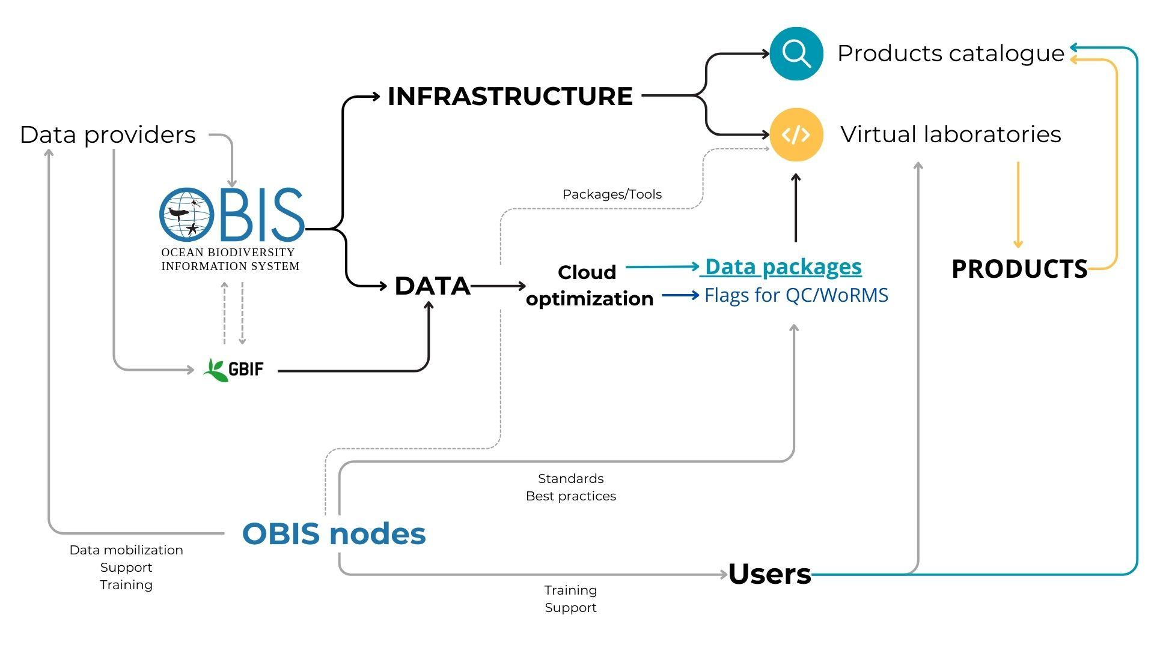
Diagram of the proposed infrastructure for OBIS data products.
Infrastructure
The infrastructure will include (1) a virtual laboratory (phase 1) and (2) a products catalogue (phase 2). The virtual laboratory is the main tool we are going to provide and is a JupyterHub with Python and R kernels, including an RStudio interface (like an RStudio server). This will provide users the opportunity to run their analysis online, taking advantage of an environment containing tools and cloud optimised data (for example, the full export of OBIS and data packages, see on “Data” section). Users would have available an environment containing the main packages used for biodiversity analysis and one dedicated package to speed up pre-processing of OBIS data for specific purposes. Also, model scripts would be available, with the nodes contributing in both cases.
Since data and analytical tools reside on the same machine (the server), analyses are faster, and the user does not need to download any additional data or tools. This type of infrastructure is mature and is being successfully used by other organisations (e.g. Copernicus/WeKEO: https://www.wekeo.eu/; Digital Earth Australia: https://www.dea.ga.gov.au/developers/sandbox). This is also aligned with the Digital Twins of the Ocean idea, which aims to speed up the production of data products from ocean observation.
We consider data products being any type of analysis (description, data visualisation, etc.) that synthesises and generates new information from data hosted on OBIS and other sources. Some examples are the contribution of OBIS to the State of the Ocean Report (see pages 26 and 27 of the report); species distribution maps such as AquaMaps (https://www.aquamaps.org); and the Marine Biodiversity Observation Network (MBON) early alert dashboards (https://marinebon.org/data-products). Those are just illustrative examples, as the potential uses are multiple. One particular type of product that the IWG perceives as a priority would be data visualisation, such as maps, as those are constantly requested by the community and can be used by multiple stakeholders.
In a second moment we would also implement a products catalogue, to showcase those products being produced through the virtual environment, but also elsewhere. This was a particular demand received from some stakeholders, as they want to contribute with OBIS products, but do not have their own systems/websites. Also, this would enable users with less familiarity with programming languages and JupyterHub to access and use the products. Our first suggested solution was CKAN, but we will also test the GeoNetwork platform. All products on the catalogue will be accompanied by extensive metadata, in a way that it could be easily integrated with ODIS.
JupyterHub → JupyterHub is a multi-user server environment designed to facilitate collaborative and interactive computing in an academic or research setting. It serves as a platform for deploying Jupyter Notebooks, which are open-source, interactive web applications that allow users to create and share documents combining live code, equations, visualisations, and narrative text. JupyterHub, as a centralised system, enables multiple users to access and utilise a shared computational infrastructure concurrently. This centralised approach enhances efficiency, scalability, and resource management in academic environments where collaborative data analysis, scientific computation, and research are paramount.
CKAN → The Comprehensive Knowledge Archive Network (CKAN) is a robust and extensible open-source data management system widely employed in academic and research contexts. Functioning as a data portal platform, CKAN facilitates the storage, management, and dissemination of diverse datasets. Its architecture is designed to support the systematic organisation of data resources, ensuring metadata quality, version control, and accessibility. CKAN serves as a centralised repository, empowering institutions, researchers, and policymakers to efficiently share, discover, and access datasets. Its modular and customizable nature, coupled with a rich ecosystem of extensions, renders CKAN a versatile solution for institutions seeking a standardised, transparent, and collaborative approach to data management and dissemination within the scholarly domain.

Data
On the data side, the proposal is to provide users of the virtual environments with cloud optimised data, providing a seamless and faster analysis. Also, we would provide users with data packages - pre-filtered data targeting specific uses. Example, a package of data including only long-term monitoring, or all eDNA data. Of course, for some studies the data package will still need some treatment, but hopefully it would maximise the effort of researchers by skipping some steps.
As a starting point, we would leverage recent developments created for projects and partnerships that OBIS is involved in, such as the State of the Ocean Report (StOR, in partnership with ProtectedSeas; https://github.com/iobis/protectedseas-statistics), the eDNA expeditions (https://www.unesco.org/en/edna-expeditions) and the MPA Europe (https://mpa-europe.eu/). The StOR, for example, already applied one of the suggestions of the IWG team - to have the full export of OBIS indexed by the H3 system (a geospatial indexing system developed by Uber Technologies; https://h3geo.org).
It is well known that OBIS data presents good quality data, thanks to the efforts of OBIS nodes, and is already quality controlled in multiple ways. It was suggested that, when creating those data packages, we have the possibility to add additional QC steps focused on the purpose (for example, on a long-term monitoring tag a year with a very different number of samples). Another suggestion is to make available scripts to perform this type of QC in standardised ways, saving scripting time for users, while sharing experiences among researchers.
OBIS nodes are key for the data component in two aspects: they are the point of contact with the local community, understanding data needs, and they provide best practices guidelines for QC of data. The idea is that OBIS nodes would be able to implement routines (through scripts) to generate specific data packages, and those could be run on the OBIS server.
One of the concerns, as outlined in the 'critical points', is that for this data to be truly useful for the user, it must be consistently updated. This necessitates the creation of pipelines for automatic data updates in a timely manner. Naturally, all data should be accompanied by a versioning system to keep users informed of changes, and the generation codes should be openly available, providing users with the option to generate the data package independently.
Cloud optimised data → Cloud optimised data refers to a paradigm in data storage and organisation tailored for efficient and scalable utilisation within cloud computing environments. This approach involves structuring and formatting datasets in a manner that aligns with the distributed and parallel processing capabilities inherent to cloud platforms. Characterised by columnar storage, partitioning, and utilising formats conducive to parallel data processing, such as Apache Parquet, Zarr and COGeo, cloud-optimised data aims to enhance query performance, reduce data transfer costs, and facilitate seamless integration with cloud-based analytical tools.

Examples of products needs
The proposed infrastructure would enable the OBIS community, including the secretariat, to generate products that are constantly required by stakeholders. We identified some of those needs (with contributions of the community):
- Spread and distribution of non-native species over time
- Distribution of records by depth and bottom depth
- Animation of OBIS records through time and depth
- eDNA data dashboard
- Diversity indicators (with possible corrections)
- Harvesting marine datasets from GBIF
The IWG group agreed that a stakeholders assessment would be important as a next step, to identify the priority products, and also data and tools needs.
Critical points
The IWG also recognizes some challenges in the implementation of the proposed plan. Those are by no means impeditive, but will require a thorough consideration by the team.
- Frequency of update of data - to be meaningful, the data packages (or any full data export) need to have a reasonable update frequency. Of course, the frequency may vary depending on the data purpose. This will need automated pipelines.
- Infrastructure costs - while we plan to start/test the infrastructure with our available computational resources, in the mid/long-term it is expected that new resources will be needed. In this sense, there will be costs involved. Possible ways of tackling this problem are approaching partners to share infrastructure (e.g. LifeWatch) or finding specific funds for this project.
- Training needs - it is anticipated that many users may not be familiar with JupyterHub. Also, some of the OBIS users do not have knowledge of programming languages like Python and R. In that sense, it will be essential to provide training to ensure the progressive adoption of JupyterHub as a tool by the OBIS community.
Implementation plan
Step 1 - Test of infrastructure
- Implementation of a JupyterHub instance [done]
- Implementation of a CKAN or GeoNetwork instance
- Test of data packages
- Test of “recipe scripts”
Step 2 - Prepare tools and data packages (with OBIS nodes)
- Prepare an R package with main tools (specifically tailored for our infrastructure)
- Collect sample scripts that may be of interest
- Prepare a first set of data packages
Step 3 - Open to test with community
- Collect users perceptions
- Evaluate platform functioning and make adjustments
Step 4 - Open to use and implement the CKAN for showcasing products

Annex 6. GBIF and OBIS joint strategy and action plan for marine biodiversity data

Preamble

GBIF and OBIS—the Ocean Biodiversity Information System—have signed a five-year agreement to promote further cooperation across a wide range of activities and services between the two global biodiversity data networks.
The Letter of Agreement targets both technical collaboration covering data standards, publishing and processing; and institutional collaboration to ensure closer ties between OBIS and GBIF nodes, shared training opportunities and aligned documentation.
OBIS, originally called the Ocean Biogeographic Information System, was founded in May 2000 under the Census of Marine Life, and is now a programme component of the International Oceanographic Data and Information Exchange (IODE) programme of the Intergovernmental Oceanographic Commission (IOC) of UNESCO. It aims to be the most comprehensive data and information gateway on the diversity, distribution and abundance of marine life to support its Member States in achieving a healthy and resilient ocean ecosystem.
GBIF—the Global Biodiversity Information Facility—was formally established in September 2001 as a voluntary collaboration between governments, with the aim of providing anyone, anywhere with free and open access to data about all types of life on Earth. The mission of GBIF, as agreed by its Governing Board within the 2023-2027 Strategic Framework, is ‘to mobilize the data, skills and technologies needed to make comprehensive biodiversity information freely available for science and decisions addressing biodiversity loss and sustainable development’.
This strategy and plan builds on the letter of agreement to set out a set of shared organizational objectives and actions to ensure that marine biodiversity data is freely and openly available through both GBIF and OBIS for the benefit of science and decision making.
OBJECTIVES

GBIF and OBIS will collaborate and seek efficiencies where possible, respecting the vision, mission and values of each, supporting the mandates and nurturing the strengths and expertise of their respective networks and communities of practice. This collaboration aims
to achieve the following objectives by 2030:

- The best available marine biodiversity data, respecting FAIR and CARE principles, is available to meet the needs of all relevant users, supporting the goals and targets of the UN Ocean Decade, including the OBIS 2030 UN decade project, the Kunming-Montreal Global Biodiversity Framework, the 2030 Agenda for Sustainable Development, the future UN High Seas Treaty and other international policy objectives
- Marine biodiversity data is securely archived and our respective networks persist and can operate sustainably into the future

Areas of Collaboration

GBIF and OBIS agree to collaborate in two focus areas:

Technical Cooperation - GBIF and OBIS will explore opportunities for technical cooperation, including the development of interoperability standards, data exchange protocols, and tools to facilitate the exchange and integration of biodiversity data.

Community and Capacity - GBIF and OBIS will collaborate on capacity-building activities and resources to enhance the skills and expertise of data providers and users for data integration, biodiversity informatics and marine biodiversity research.

Action Plan

To reach the objectives, OBIS and GBIF will develop:
- Clear pathways to support holders of marine biodiversity data to publish their datasets using interoperable data standards and flexible data structures, ensuring that full data provenance, lineage and attribution is retained
- Mechanisms to enable efficient, regular and effective collaboration and communication among the secretariats, nodes and relevant partners at global, regional, national and thematic levels, based on clear guidance and support from the OBIS and GBIF governing bodies.
- Joint training resources to support information exchange and capacity development across the GBIF and OBIS communities of practice
- Joint communication resources, in which the respective roles of GBIF and OBIS, as well as the collaboration between them, are effectively communicated through consistent messaging, and are well understood by all relevant stakeholders and audiences

The following actions and suggested specific tasks are proposed. Those in bold are considered priorities by the partnership. Detailed timelines and budgeting for each task will be scheduled into the respective work programme cycles for GBIF and OBIS, taking account of the financial and human resources available and balancing other priorities. A regular review of progress on these items will determine whether implementation is on track, or if more resources are needed to accelerate progress.

Implementation/work plan to be revised annually

Technical Cooperation
Action | Suggested tasks and responsibilities
Further develop biodiversity data standards | Engagement with TDWG in the development of standards for both organizations  Task responsibility: GBIF secretariat, OBIS secretariat, individual nodes
Further develop biodiversity data standards | Vocabulary of traits with TDWG to increase interoperability between WoRMS and Catalogue of Life
Further develop the new GBIF data model to accommodate OBIS practices | Develop the tools for publishing and accessing marine data in an expressive way i.e. event core, eMoF, basic view and extended view  Task responsibility: OBIS Products coordination group, OBIS and GBIF informatics teams
 | Data publishing tools (e.g IPT) to support data packages and frictionless data under new data model
Support the development of Essential Ocean Variables, Essential Biodiversity Variables, Essential Climate Variables | Provide input into the data/metadata specifications documentation for the development of essential variables
Implement traits-based filtering | Aligning species Traits from WoRMS with CoL
Implement traits-based filtering | Extend occurrence data services by enabling discovery based on selected checklists (e.g WoRMS)
Improve representation of marine data in the GBIF portal | Enhance the delivery of the extended Measurement or Fact extension in GBIF  Task responsibility: OBIS data coordination group, OBIS and GBIF informatics teams
Improve representation of marine data in the GBIF portal | Improve event based data representation in GBIF
Improve representation of marine data in the GBIF portal | Implement environment flags and filtering abilities within GBIF  Task responsibility: OBIS data coordination group, OBIS and GBIF informatics teams
Improve representation of marine data in the GBIF portal | Extend search and download services by filtering marine records by WoRMS-AphiaID
Improve representation of marine data in the GBIF portal | Show the AphiaID for species records from WoRMS on GBIF.org
Improve representation of marine data in the GBIF portal | Enable marine data discovery within GBIF using the standard list of Marine Regions https://www.marineregions.org/
Improve representation of marine data in the GBIF portal | Improve interpretation of what is considered is_marine at records level  Task responsibility: OBIS data coordination group,WoRMS, OBIS and GBIF informatics teams
Support download DOI services and citation tracking for OBIS | Support download DOI services and citation tracking for OBIS
Review of development options and specifications for shared infrastructure components | Review of development options and specifications for a shared infrastructure  Task responsibility: GBIF and OBIS secretariat, interested OBIS and GBIF nodes

Community and Capacity
Action | Work programme items
Joint data mobilization and data calls | Campaigns and incentives for data mobilization through grants to mobilize data that supports data paper publications  Task responsibility: GBIF secretariat, OBIS secretariat, individual nodes
Joint data mobilization and data calls | Integrating marine data publication within data mobilization programmes and projects e.g. Biodiversity Information for Development (BID)  Task responsibility: GBIF secretariat, OBIS secretariat, individual OBIS and GBIF nodes
Joint data mobilization and data calls | Explore a special issue journal publication on marine data
Enable coordination mechanisms between networks and communities of practice | Regular, at least 6 monthly meetings between GBIF and OBIS communities  Task responsibility: GBIF secretariat, OBIS secretariat, interested individual nodes or relevant (OBIS) working group members
 | Joint conference between OBIS and GBIF
Develop mechanism to allow for knowledge exchange and capacity building at a regional level between GBIF and OBIS nodes including regional meetings and regional helpdesk services and inclusive of thematic nodes

Task responsibility: GBIF secretariat, OBIS secretariat, individual nodes
Develop guidance on engaging with the marine community for GBIF nodes

Task responsibility: GBIF secretariat, OBIS secretariat, individual nodes
Develop clear messaging around the partnership | Develop a partnership communication strategy
Develop clear messaging around the partnership | Review of the OBIS membership options within GBIF network  Task responsibility: GBIF and OBIS Secretariats
Develop joint training resources | Develop a shared training curriculum  Responsible: GBIF secretariat, OBIS secretariat, interested individual nodes or relevant (OBIS) working group member
Develop joint training resources | Incorporate training materials within the Ocean Teacher Global Academy
Hosted portals for nodes (or any partner) | Hosted portals for nodes (or any partner)  Task responsibility: GBIF secretariat, OBIS secretariat, individual nodes
Develop joint fundraising proposals | Engage with funders such as GEF, ARDC, EU amongst others to promote the work of this plan  Task responsibility: GBIF and OBIS Executive Committees
Develop joint fundraising proposals | Explore shared funding for community engagement officer
Governance
OBIS and GBIF are to extend invitations to each other´s Steering Group and Governing Board meetings where they will be asked to report on progress on the actions outlined within this strategy and action plan. Implementation of the action plan will be monitored by an implementation committee composed of representatives of OBIS and GBIF Secretariats and nodes that reflect activities across technical cooperation and community and capacity. Both the GBIF Nodes Steering Group and OBIS Nodes Steering Group should be regularly updated on progress towards the objectives of this strategy and action plan by the respective Secretariat focal point:

GBIF - Andrew Rodrigues - Data Partnerships Officer - arodrigues@gbif.org
OBIS - Ward Appeltans - Programme Manager - w.appeltans@unesco.org

Duration
The current letter of agreement between GBIF and OBIS remains in effect until 31 August 2025 and this strategic plan is aligned with its ambitions. Upon the Letter of Agreement´s expiration, this strategy and action plan will replace it until 2030.

Annex 7. List of Participants

SG-OBIS Co-Chairs

Ms. Katherine TATTERSALL
Data Architect
Information and Data Centre
CSIRO National Collections and Marine Infrastructure
PO Box 1538
Hobart TAS 7001
Australia
Email: katherine.tattersall@csiro.au

Ms. Martha VIDES CASADO
Jefe Línea de Investigación ITE-BEM
Biodiversidad y Ecosistemas Marinos
Instituto de Investigaciones Marinas y Costeras José Benito Vives de Andreis
Calle 25 No. 2-55, Playa Salguero, Rodadero
Santa Marta D.T.C.H., Magdalena,
Colombia
Tel: +57 4328600 Ext 283
Email: martha.vides@invemar.org.co

SG-OBIS members

Mr. Yong-Rock AN
Director
Division of Marine Biodiversity
National Marine Biodiversity Institute of Korea
101-75, Jangsan-ro, Janghang-eup,
Seochun-gun,
Chungchungnam-do
South Korea
Tel: +82-10-2929-7625
Email: rock@mabik.re.kr

Mr. Sangho BAEK
Information Management Team Manager
Information Management Team
National Marine Biodiversity Institute of Korea
National Marine Biodiversity Institute of Korea
101-75, Jangsan-ro, Janghang-eup
Seochun-gun,
Chungchungnam-do
-
South Korea
Tel: +82419500780
Email: shbaek@mabik.re.kr

Mr. Yasin BAKIS
Senior Manager Biodiversity Informatician and Data Engineer
Ecology and Evolutionary Biology
Tulane University
6823 St. Charles Avenue
New Orleans, Louisiana 70118
United States
Tel: +14133463904
Email: ybakis@tulane.edu

Mr. Izwandy BIN IDRIS
University Lecturer
South China Sea Repository and Reference Centre
Institute of Oceanography and Environment
Universiti Malaysia Terengganu (UMT),Mengabang Telipot
21030 Kuala Terengganu
Terengganu
Malaysia
Tel: +60136732985
Email: izwandy.idris@umt.edu.my

Ms. Maria CORNTHWAITE
Biologist
Fishery and Assessment Data Section - Groundfish Data Unit
Pacific Biological Station (DFO – PBS), Fisheries and Oceans Canada
3190 Hammond Bay Rd.
Nanaimo BC V9T 6N7
Canada
Tel: 1-778-268-2739
Email: maria.cornthwaite@dfo-mpo.gc.ca

Ms. Angela DINI
Database Manager
Data Team
Ocean Tracking Network
Steele Ocean Sciences Building - Dalhousie University
Halifax Nova Scotia B3H4R2
Canada
Email: angela.dini@dal.ca

Mr. Christian ELLORAN
Division Director
Biodiversity Knowledge Management Department
ASEAN Centre for Biodiversity
Domingo M. Lantican Avenue
University of the Philippines
Los Baños
4031 Laguna
Philippines
Email: cbelloran@aseanbiodiversity.org

Mr. Stephen FORMEL
Biologist
Science Analytics and Synthesis (SAS) Program
U.S. Geological Survey HQ
12201 Sunrise Valley Drive, MS 917
Reston, Virginia 20192
United States
Email: sformel@usgs.gov

Mr. Katsunori FUJIKURA
Senior Scientist
Marine Biodiversity and Environmental Assessment Research Center
Japan Agency for Marine-Earth Science and Technology, Yokosuka
2-15 Natsushima
Yokosuka, Kanagawa
237-0061
Japan
Tel: 81-46-867-9555
Email: fujikura@jamstec.go.jp

Yi Ming GAN
Koninklijk Belgisch Instituut voor Natuurwetenschappen
Vautier Street 29
1000 Brussels
Belgium
Email: ymgan@naturalsciences.be

Mr. Takashi HOSONO
Senior engineer
Global Oceanographic Data Center
Japan Agency for Marine-Earth Science and Technology (JAMSTEC), Global Oceanographic Data Center (GODAC)
224-3 Toyohara
Global Oceanographic Data Center (GODAC)
Nago, Okinawa
905-2172
Japan
Tel: +81-90-2988-0269
Email: hosonot@jamstec.go.jp

Mr. Dan LEAR
Head of Data, Information & Technology
The Marine Biological Association of the United Kingdom
The LaboratoryCitadel Hill
Plymouth
PL1 2PB
United Kingdom
Tel: +44(0)1752633291
Email: dble@mba.ac.uk

Mr. Noah NGISIANG'E
Researcher/ PhD student
Oceanography and Hydrography
Kenya Marine and Fisheries Research Institute, Headquarter & Mombasa Station
PO Box 81651
Mombasa
080100
Kenya
Tel: +254720412384
Email: ngisiange@gmail.com

Mr. Jonathan PYE
Director of Data Operations
Ocean Tracking Network
Steele Ocean Sciences Building - Dalhousie University
Halifax Nova Scotia B3H4R2
Canada
Tel: +1 9024 947 560
Email: jonpye@gmail.com

Mr. Tshikana RASEHLOMI
Marine Information Management System (MIMS) Manager
Oceans and Coasts Research Directorate
Department of Forestry, Fisheries and the Environment
P/Bag X2Rogger Bay
Cape Town
8012
South Africa
Tel: (+27) 711 758407
Email: Tshikana.deff@gmail.com

Ms. Hanieh SAEEDI
Coordinator Biodiversity Information
Marine Zoology
Senckenberg Gesellschaft für Naturforschung
Senckenberganlage 25
60325 Frankfurt
Germany
Tel: 01746210915
Email: hanieh.saeedi@gmail.com

Mr. Narayanane SARAVANANE
Scientist E
ITIS-GROUP
Centre for Marine Living Resources & Ecology, Ministry of Earth Sciences, Government of India
ATAL BHAVAN
LNG Road, Puthuvypin South, Ochanthuruthu PO
Kochi 682508
Kerala
India
Tel: 914842108164
Fax: +914842421888
Email: saravanane@cmlre.gov.in

Ms. Leen VANDEPITTE
Senior scientist
Data Centre
Vlaams Instituut voor de Zee
InnovOcean Campus
Jacobsenstraat 1
8400 Oostende
Belgium
Email: leen.vandepitte@vliz.be

Mr. Kuidong XU
Professor
Institute of Oceanology
Institute of Oceanology Chinese Academy of Sciences, Qingdao
7 Nanhai Road
Qingdao
Shandong, 266071
China
Tel: +86 532 82898776
Email: xukd@hotmail.com

OBIS secretariat

Mr. Ward APPELTANS
Programme manager OBIS
UNESCO / IOC Project Office for IODE
InnovOcean Campus
Jacobsenstraat 1
8400 Oostende
Belgium
Email: w.appeltans@unesco.org

Ms. Elizabeth LAWRENCE
OBIS training officer
UNESCO / IOC Project Office for IODE
InnovOcean Campus
Jacobsenstraat 1
8400 Oostende
Belgium
Tel: +15193839539
Email: e.lawrence@unesco.org

Mr. Silas PRINCIPE DE SOUZA
Research assistant
UNESCO / IOC Project Office for IODE
InnovOcean Campus
Jacobsenstraat 1
8400 Oostende
Belgium
Email: s.principe@unesco.org

Mr. Pieter PROVOOST
OBIS Data Manager
UNESCO / IOC Project Office for IODE
InnovOcean Campus
Jacobsenstraat 1
8400 Oostende
Belgium
Email: p.provoost@unesco.org

https://github.com/iobis/obis-qc/
https://github.com/tdwg/bdq/projects/2
https://github.com/iobis/quality-taskteam/wiki/Mapping-of-checks-in-obis%E2%80%90qc-to-TDWG-BDQ-core-tests-and-assertions
https://github.com/iobis/quality-taskteam/issues
https://rshiny.lifewatch.be/BioCheck/
https://github.com/gbif/portal16/issues/1837
https://github.com/iobis/obis-qc/
https://github.com/tdwg/bdq/projects/2
https://github.com/tdwg/bdq/tree/master/tg2
https://r.obis.org/quality/
https://github.com/iobis/quality-taskteam/issues?q=label%3Awontfix+is%3Aclosed
http://iode.org/policy
https://oceanexpert.org/document/33552
https://oceanexpert.org/document/32232
https://oceanexpert.org/document/32232
https://oceanexpert.org/group/230
https://oceanexpert.org/event/4048
https://obis.org/2020/09/07/obis-gbif/

