GOOS Network OCG-15 Report Template

GO-SHIP
Prepared/submitted by Elaine McDonagh, Letitia Barbero and Martin Kramp

- Highlight the key network successes

The 7th face-to-face meeting of the GO-SHIP Committee took place on 16 and 17 February in New Orleans (USA), just before the opening of the 2024 Ocean Sciences Meeting. 48 participants from 17 nations had registered for the hybrid meeting, with 30 participants attending on site.

The 3rd decadal survey was completed in 2023, 115 cruises were carried out on core reference lines supported by 10 nations providing ship time, with US, UK and Japan each having completed at least 20 cruises. 94% of all lines are occupied by at least one country; only P3E, I1E, I1W and I3 were not occupied.

New floating map status: it is now easier to compare the GO-SHIP network performance in an ongoing way; the floating status looks a few years back and forward, and status should thus be rather stable throughout the decadal survey (and ideally high).
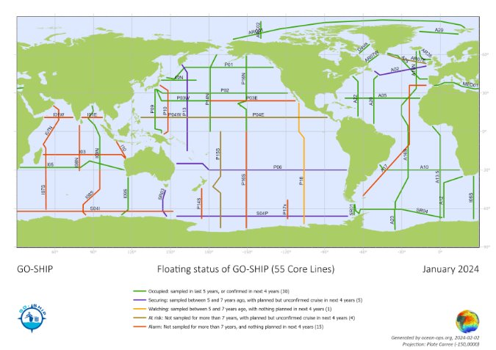
Growing BioGO-SHIP activities: Italy, Australia, Spain, UK and US have all supported some initial BioGO-SHIP activities. A request by this community was made at GO-SHIP 7 to consider moving eDNA to level 2. Bio GO-SHIP is not requesting that the full program be moved to Level 2 because there are multiple parameters and collection of all would be a major drain on capabilities.

- How has the network advanced across the OCG Network Attribute areas

Network Attributes: Global in Scale :: sustained observation :: community of practice :: data delivery :: EOVs :: network mission and targets :: standards and best practices.

GO-SHIP continues to operate in each of these attribute areas. Ongoing work is being done to keep GO-SHIP up-to-date in each of these areas.

Particular work is ongoing in data delivery. The mapping of GO-SHIP data flows continues and a related survey (as part of the EuroGO-SHIP project, driven by the TC) will be launched in April. The recently implemented OceanOPS Cruise-ID facilitates data tracking.

- Future Plans and Opportunities - at network and/or cross-network OCG level

Begun the forth decadal survey. 19 nations contribute to maintaining 55 reference lines, including 4 nations that joined GO-SHIP recently. GO-SHIP remains a cornerstone of the Global Ocean Observing System, and is also expanding, with associated challenges

Streamlining efforts between networks, in particular Argo, with both networks fully recognizing interdependency. Argo will have a permanent place in the GO-SHIP committee (before this had been in the case organically)

GO-SHIP 7 agreed to build a team of authors to work on an updated version of the 2016 Talley et al GO-SHIP review paper.

Formalize the process for application to become an Associated GO-SHIP section.
Set up a BioGO-SHIP working group to focus on the issues around integrating BioGO-SHIP into the international programme.

- Challenges and Concerns - at network and/or cross-network OCG level

Only a limited number of groups has the expertise to measure transient tracers. For example in Europe there are 3 groups (UK, Norway, Germany). This requires sustained funding and coordination (what cruises need transient tracer measurements, how to share technical staff). In the US, training is undertaken to ensure continuity while Australia partners with other groups who are self-funding. The scientific value of transient tracers is so important (e.g. to input into models) and this must articulated more clearly to the funding bodies. CD actions were formulated at GO-SHIP 7. Similar challenges exist for other parameters.

Some sections of high scientific value, in particular in the Indian Ocean, have not been sampled for a long time; actions were formulated at GO-SHIP 7 to find solutions and volunteers to occupy these sections, and new national representative for India on the Committee.

CCHDO, as recognized GDAC, prioritizes US cruises, and it was recommended to seek additional funding for CCHDO, to achieve international balanced priority.

Ongoing issues with supply of carbon and inorganic nutrient reference materials.

- Asks from OCG (Exec, networks, OceanOPS, and/or GOOS), perhaps related to the responses to parts 3 and 4 and how OCG can support your network

Clarify processes to foster sustained and increased funding of OceanOPS.

Environmental stewardship used to be a network attribute. Why was this dropped?

- Recent publications, articles, etc. (if you want to share)

More than 640 items are in the GO-SHIP bibliography, which is maintained as Google scholar and Zotero repository. These publications have been cited around 34000 times over the last 4 years and almost 80000 times in total. Publications are polled in the regular Committee meetings by the TC who then adds them to the repositories.

https://oceanexpert.org/downloadFile/45372
Future plans on implementation, instrumentation, data management, test, new sensors, plan for new EOV/ECV observations, capacity development, etc.

