Task Team CARIBE WAVE 24
UNESCO/IOC
ICG CARIBE-EWS

CARIBE WAVE 2024

Supplement Report

Kimberly Maisonet Gonzalez
Claudia Guzman Soto
Christa von Hillebrandt-Andrade
International Tsunami Information Center Caribbean Office
May 2024

Summary of CARIBE WAVE

The CARIBE WAVE exercise is conducted within the framework of the UNESCO Intergovernmental Coordination Group for Tsunamis and other Coastal Hazards for the Caribbean and Adjacent Regions (CARIBE-EWS). The 2024 annual tsunami exercise took place on March 21rst to test Tsunami Warning Systems and promote tsunami preparedness in the Caribbean and adjacent regions. The exercise was coordinated by the CARIBE WAVE task team, the NOAA International Tsunami Information Center Caribbean Office, and supported by the Caribbean Tsunami Information Center and Pacific Tsunami Warning Center. It was left up for Member States and Territories to choose between the Puerto Rico Trench and Panama scenarios and to decide the level of participation and activity to be held in their country.
CARIBE WAVE exercises focus on communications and evaluating procedures and programs within Member States and Territories. The Pacific Tsunami Warning Center (PTWC), the Regional Tsunami Service Provider, issued a “Dummy” message through the different warning systems at 1500 UTC to test communications with Tsunami Warning Focal Points (TWFP) and National Tsunami Warning Centers (NTWC). Different methods of communications were used to test and disseminate the message: The World Meteorological Organization (WMO), Advanced Weather Interactive Processing System (AWIPS), Aeronautical Information Replacement System (AIRS), NOAA Weather Wire, GEONETCast Americas, Fax, Email, and social media. According to feedback as well as social media and web posts, the dummy message was successfully received. The Central America Tsunami Advisory Center also disseminated simulated products for the Panama scenario to its stakeholders.

When PTWC issued its simulated “end of threat” messages for the exercise, over 475,000 people from across the entire Caribbean basin had registered on the Tsunami Zone website (tsunamizone.org). The majority of the participants were from K-12 Schools. Local/State governments, universities and preparedness organizations also had a high level of participation. Social media platforms, which has become the primary source for communicating tsunami awareness, reached many people worldwide during the exercise.

Sea level data availability is important to forecast and confirm a real tsunami event. If a tsunami had occurred during the day of the exercise, data of 67 of the 101 sea-level stations in the region would have been available for event analysis. Only four of the Deep Ocean Assessment and Reporting on Tsunamis (DARTs) were operational during the exercise. CARIBE WAVE has been improving and validating tsunami preparedness since 2011, which is why tsunami exercises are crucial to maintain readiness in case of a real tsunami event.

Supplement Survey Results

Caribe Wave 2024 Survey Report from TWFP/TNC

CARIBE WAVE 24 exercise was conducted at various levels and sophistications. The survey was available through the Survey Monkey services from the start of the exercise on March 21 and extended through April 11. The following Member States and Territories participated in the post-exercise evaluation:

- Aruba
- Antigua and Barbuda
- Barbados
- Belize
- Colombia
- Costa Rica
- Cuba
- Curacao
- Dominica
- Dominican Republic
- France (Martinique, Guadeloupe, Saint Martin, St. Barthelemy)
- Guatemala
- Guyana
- Haiti
- Jamaica
- Mexico
- Netherlands (Bonaire, Saba and Sint Eustatius)
- Panama
- Saint Lucia
- Saint Vincent and the Grenadines
- Trinidad and Tobago
- United Kingdom (Anguilla, Bermuda, British Virgin Islands, Cayman Islands)
- United States (Puerto Rico, US Virgin Islands)
- Venezuela (Bolivarian Republic of Venezuela)

Contact Information – Agency

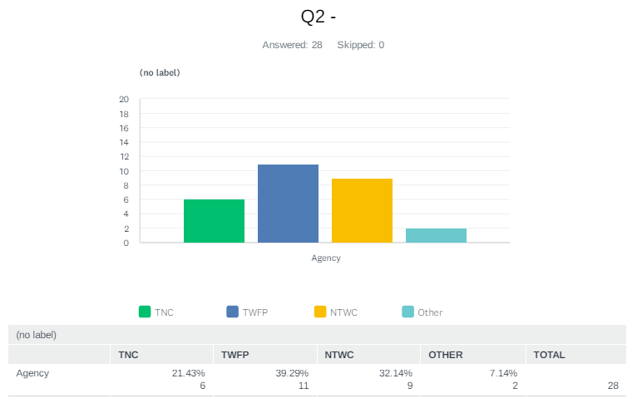

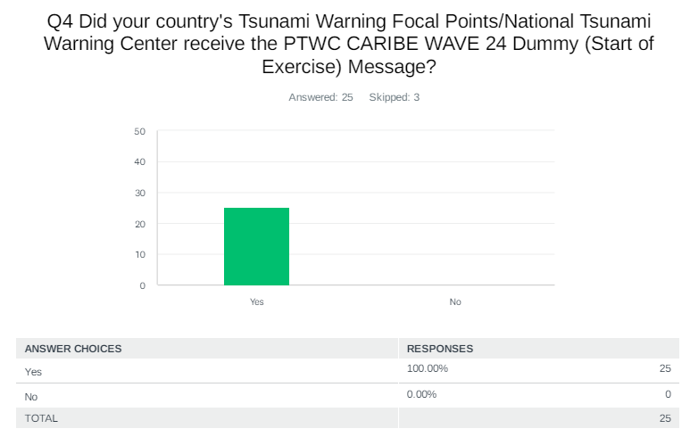
Comments:

Anguilla: It was only seen by one person. The TWFP. The others on the list are not currently active with Government or out on sick leave.

Dominican Republic: on time

Jamaica: The message came to the sdpeododpem@gmail.com email address. We also have another email which we are now sharing neocoperations.odpem@gmail.com

Panama: The Geosciences Institute received the PTWC CARIBE WAVE 24 Dummy

UK - Cayman Islands: Confirmation from Hazard Management Cayman Islands, Cayman Islands National Weather Service and Department of Public Safety Communications

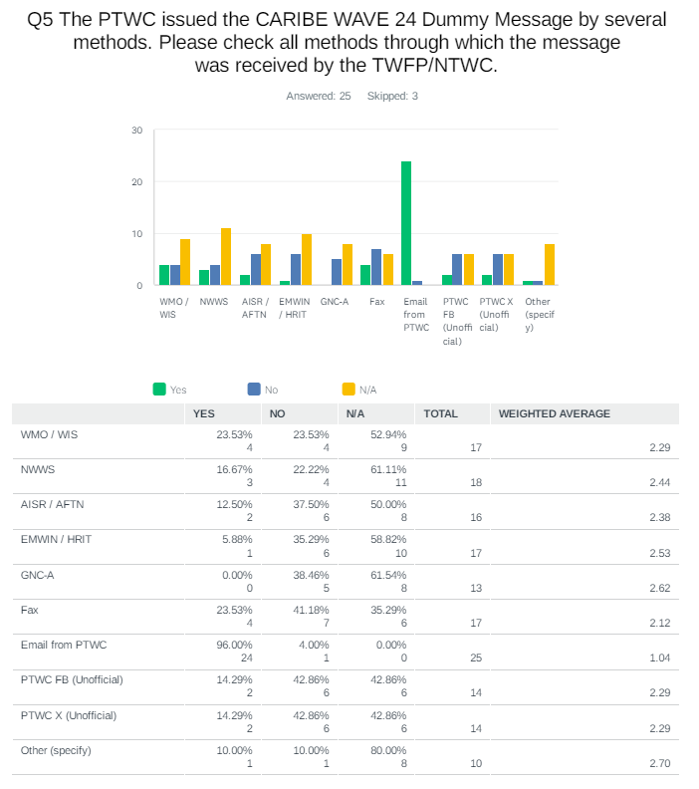
Comments:

NL - Bonaire, Saba, Sint Eustatius: GTS

Panama: The PTWC messages came all on time but the #2 was repeated.

UK - Anguilla: We heard the EMWIN alert going off but could not find the message. The Email on the station at the NTWC was not up and running at the time.

UK - Cayman Islands: Email messages from PTWC

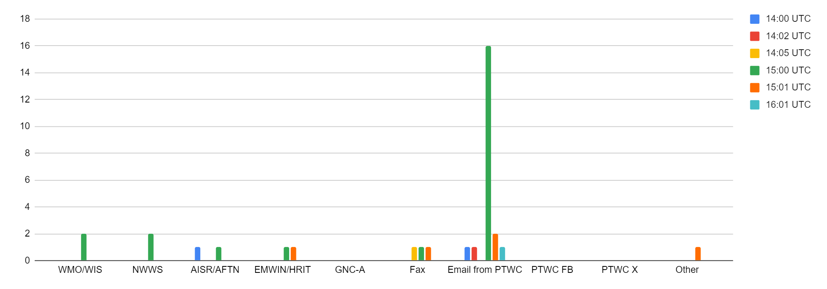

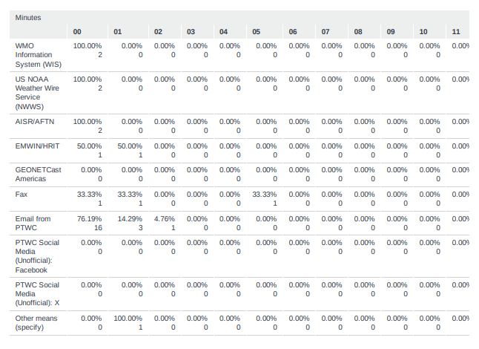

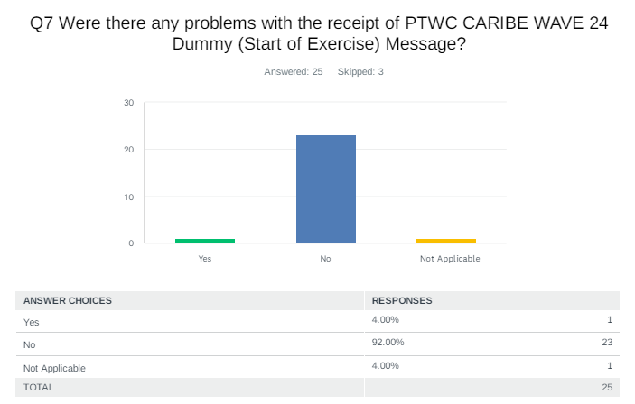
Comments:
Haiti: many problems with the emails
Jamaica: The message came to sdpeododpem@gmail.com. We would have preferred if it was sent to neocoperations.odpem@gmail.com

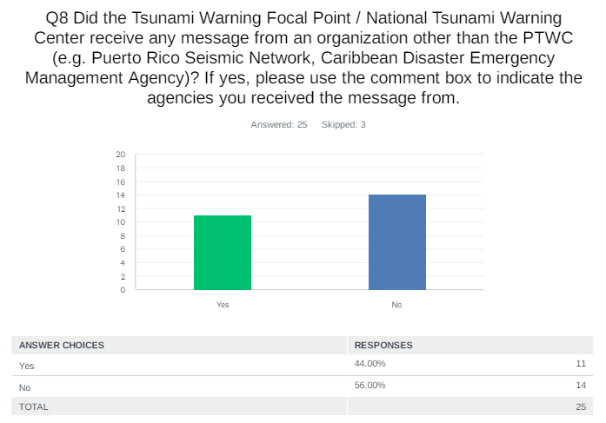
Comments:

Costa Rica: Comisión Nacional de Prevención del Riesgo y Atención de Emergencia (CNE) Sistema Nacional de Monitoreo de Tsunamis (SINAMOT)

Dominican Republic: Red Sísmica de Puerto Rico.

Guatemala: Centro de Asesoramiento de Tsunamis para América Central

Jamaica: We received a message from CDEMA to participate in a communications test regarding the testing of satellite phones within the subregion coordinated out of the Virgin Islands

Panama: The Central America Tsunami Advisory Centre (CATAC)

St. Vincent and the Grenadines: Not part of the SOP for St. Vincent and the Grenadines

UK - Cayman Islands: HMCI reached out to CDEMA by Satellite Phone

USA - Puerto Rico: Puerto Rico Seismic Network and NWS-San Juan Forecast Office

USA - US Virgin Islands: Puerto Rico Seismic Network - messages by fax and email.

Venezuela: El Servicio Sismológico Venezolano envió avisos to the Civil Protección, nacional, estatal and municipal Vice Ministry of Risk Management and Civil Protection community leaders regional civil protection
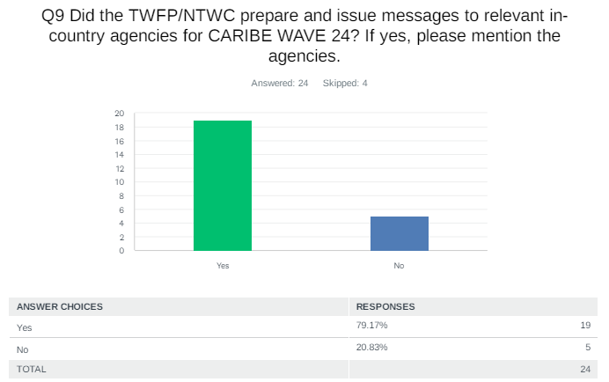
Comments:

Antigua and Barbuda: The message was conveyed to the National Office of Disaster Services(NODS)

Aruba: CMO, Police Department , Fire Department, Crisis Team

Colombia: Servicio Geológico Colombiano y Unidad Nacional para la Gestión del Riesgo de Desastres

Cuba: National Civil Defense Staff

Dominican Republic: We agreed with the Emergency Operations Center COE, the generation of tsunami warning and alert bulletins within the simulation of the Caribe Wave 2024 exercise.

France: French TWFP to French NTWCs French NTWC to all predefined agencies : Fire stations, harbor authorities, municipalities, TV and radio medias, regional authorities, etc

Guatemala: Coordinadora Nacional para Reducción de Desastres

Haiti: Direction General of Protection Civil Haitian Red Cross (CRH) Bureau of Mines and Energy (BME)

Jamaica: Ministries, Departments and Agencies who are on the Tsunami Contact list. Meteorological Service of Jamaica (MSJ); Earthquake Unit, UWI Mona; Ministry of Local Government and Community Development (MLGCD); Jamaica Fire Brigade (JFB); Jamaica Constabulary Force (JCF); Jamaica Defence Force (Maritime Air and Cyber Command (MACC); Ministry of Health and Wellness (MOHW); Airports Authority; 14 Municipal Corporations, National Water Commission (NWC); National Works Agency (NWA), Norman Manley International Airport (NMIA); Port Authority of Jamaica (PAJ); Ministry of Labour and Social Security (MLSS); Ministry of Foreign Affairs and Foreign Trade (MFAFT); Ministry of National Security (MNS); Jamaica Public Service (JPS); Jamaica Red Cross (JRC); National Emergency GIS Response Team (NERGIST) and Senior Officers and Middle Managers of the Office of Disaster Preparedness and Emergency Management (ODPEM) -National Tsunami Warning Centre.

Mexico: Coordinadora Nacional de Protección Civil Municipal and state emergency management authorities

Netherlands - Bonaire, Saba, Sint Eustatius: DCC Local governments Saba, St Eustatius, Bonaire Rijksvertegenwoordiger Caribbean Netherlands

UK - Anguila: Police, Anguilla Fire Rescue, and NDMC members were called to the NEOC. Schools, CERTs would have received messages via the CAPIT App. Flow and Digicel would have received separate messages to distribute to their customers.

UK - Bermuda: We produced messages for our Government Emergency Measures Organisation's Disaster Risk Reduction and Mitigation Team

UK - British Virgin Islands: General message was sent to the populace

USA - Puerto Rico: PREMB Radio and WEA

Venezuela: The seismological service of Venezuela in Funvisis issued messages to the focal points and the communication center

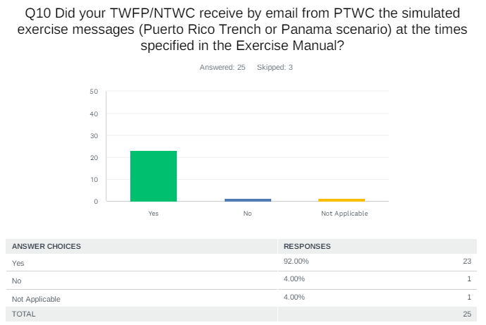
Comments:
Colombia: we received Inicial tsunami threat 3 minutes before the timeline and tsunami bulletin 2 after 6 minutes

Haiti: Exact on AISR and WMO, but no on email for the dummy message

Panama: The messages from PTWC were on time and in order, but the messages from CATAC were not.

UK - British Islands: Message were prompt as well as the phone calls

USA - US Virgin Islands: Times were in local (AST) for the USVI

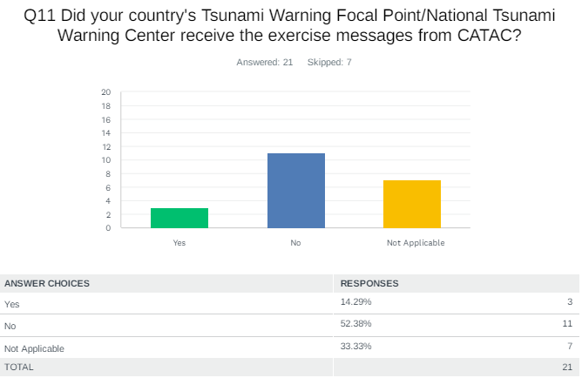

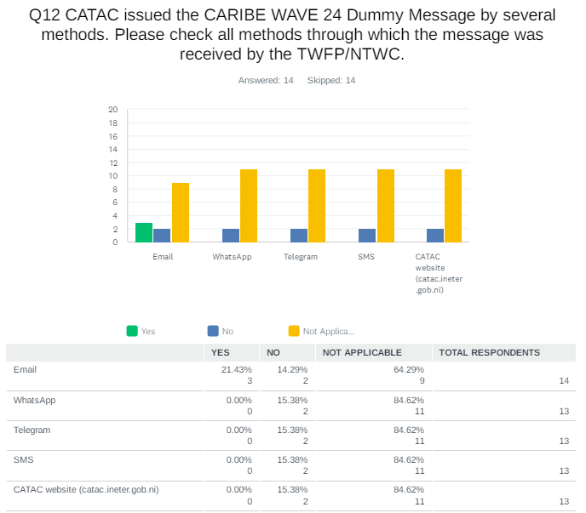

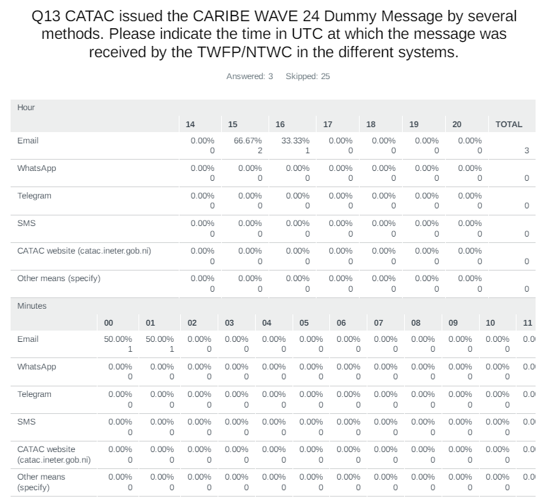

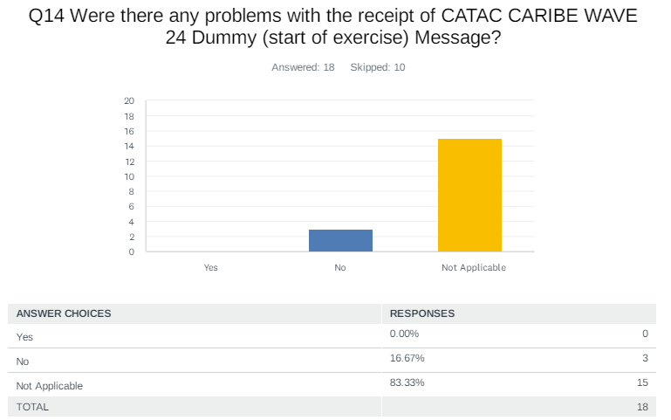

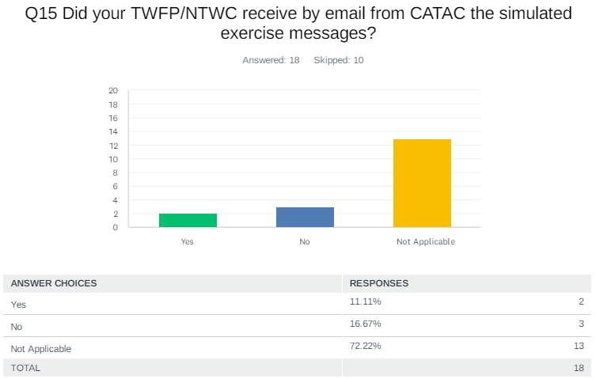

Comments:
Guatemala: Some messages were received not in order

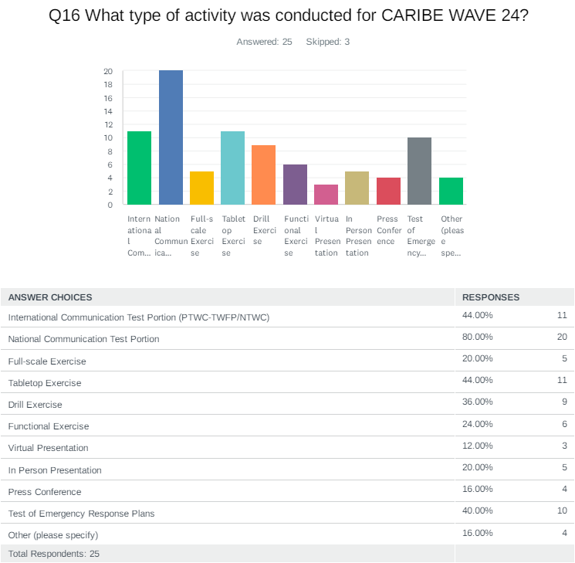

Comments:

Belize: Acknowledgment of receipt of Test Messages.

Costa Rica: News report (teletica)

Dominica: Radio Program for to raise awareness on Tsunami Hazards, Dominica's Ready Recognition Program or Town of Portsmouth and safety information was provided

France: Test of the FR-Alert system: anyone with a cellphone in the FWI territories received a text message.

Haiti: It was not possible to do other activities because of the worse political situation
Jamaica: National Communications Test was conducted with stakeholders. Messages were sent by email and telephone calls were made. We also tested satellite phones through CDEMA. One industry player, Jamaica Energy Partners conducted a full scale simulation exercise involving fire, earthquake and tsunami. This was done in partnership with the ODPEM and the St. Catherine Municipal Corporation. The Portmore City Municipality developed a Tsunami Evacuation Map for the Hellshire Community and this was disseminated in strategic locations throughout the community.

Panama: As part of the "Comité Nacional de Tsunami de Panamá", we worked in Group 2 (Six groups in total).

UK - Bermuda: Due to being short staffed, we had a scaled down version of the exercise this year.

USA - Puerto Rico: Communication exercise (RSS, Dedicate Phone, Radio, Amateur, Email, Fax, social media), NOAA Radio, WEA, EAS

USA - US Virgin Islands: Activated 2 of 3 EOCs, St Croix and St. John. St. Thomas EOC located in evacuation zone, exercised COOP.

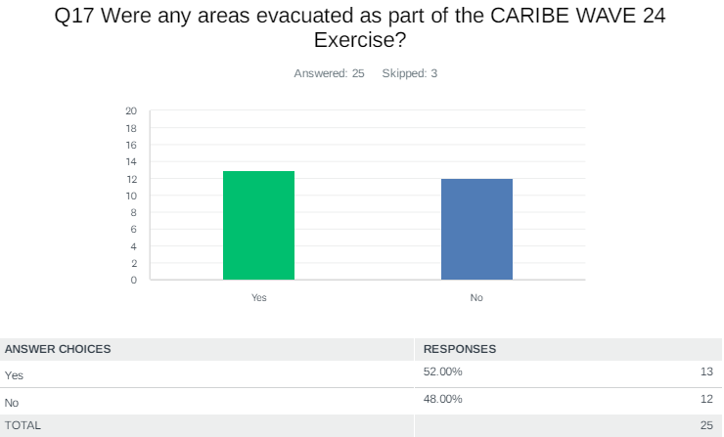

Comments:

France: The Martinique NTWC evacuated its building and installed a new operational room in another part of the. city. Several schools were evacuated.

Jamaica: The exercise by Jamaica Energy Partners in Old Harbour Bay. This was an industry based exercise. The entity has a plan of action and the assembly points are known as reflected in the Old Harbour Bay Tsunami Response Plan

NL- Bonaire, Saba, Sint Eustatius: Local exercises on Saba, St Eustatius and Bonaire may have included evacuations but we are not aware of this.

Panama: The participants evacuated from six schools in Piña, Icacal, Palmas Bellas, Salud and Chagres (Colón-Panamá).

USA - Puerto Rico: Centro Sor Isolina Ferre Ponce, TsunamiReady Supporter - Edif Plaza

USA - US Virgin Islands: Many public schools and businesses, to include Legislatures (STT, STX) and Government House (STX).

Venezuela: In funvisis, plan and protocols were activated before earthquake and tsunami

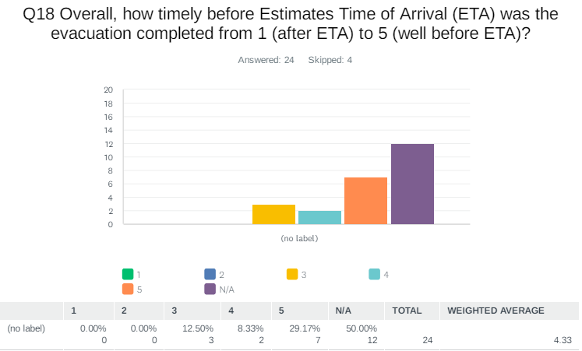

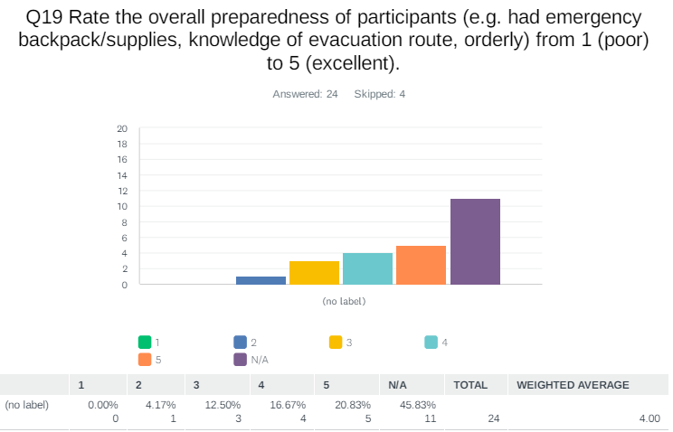

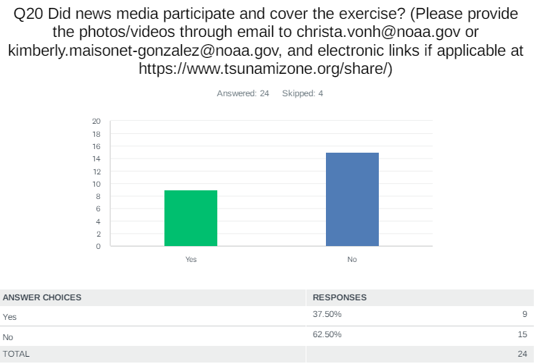

Comments:

Costa Rica: https://www.facebook.com/share/v/2LwwcHj25FHjajB9/?mibextid=WC7FNe

France: https://viaatv.tv/exercice-carib-wave-le-systeme-fr-alert-teste-ce-jeudi-en-martinique/

Jamaica: The St, Catherine Municipal Corporation posted on their Facebook Page and on other social media platforms.

Panama: The exercise was covered by the media (Photos, videos, dron).

UK- Cayman Islands: Will share with Christa von H

USA - US Virgin Islands: will be sent to Christa by Regina Browne

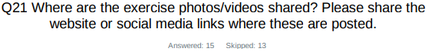
Aruba: Facebook CMO

Colombia: https://x.com/Dimarcolombia/status/1770841947906703522

Costa Rica: https://www.facebook.com/share/v/2LwwcHj25FHjajB9/?mibextid=WC7FNe

France: https://www.youtube.com/watch?v=KJGyQ6wE-3o

Haiti: no photo and video

Jamaica: St, Catherine Municipal Corporation Facebook page

Panama: https://www.instagram.com/tsunami_comite?igsh=MXVpMm1rcWd6NmF4bA==

St. Vincent and the Grenadines: when available they will be uploaded to the NEMO SVG facebook page

UK - Anguilla: Media content is part of the report document.

UK - Cayman Islands: Will share with Christa von H

USA - Puerto Rico: Sent to Christa von Hillebrandt

USA - US Virgin Islands: will be sent to Christa by Regina Browne

Venezuela: https://ven911.gob.ve/?p=6066

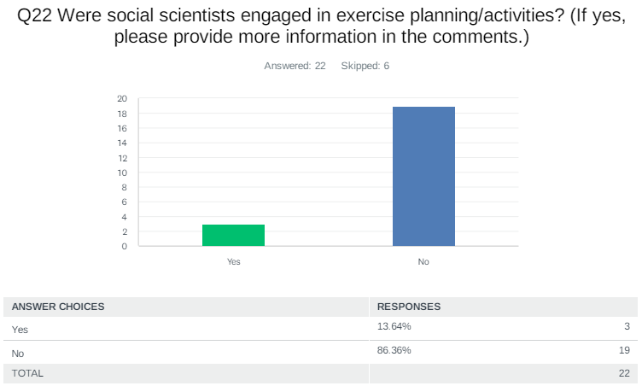

Comments:

Costa Rica: Raul Ortega, Psychologist

Jamaica: The exercise was planned by the ODPEM

Panama: They were members of institutions part of the "Comité Nacional de Tsunami de Panamá".

Venezuela: Yes, several geological scientists, seismologists, geophysicists and environmental scientists debated the effects of the earthquake and tsunami.

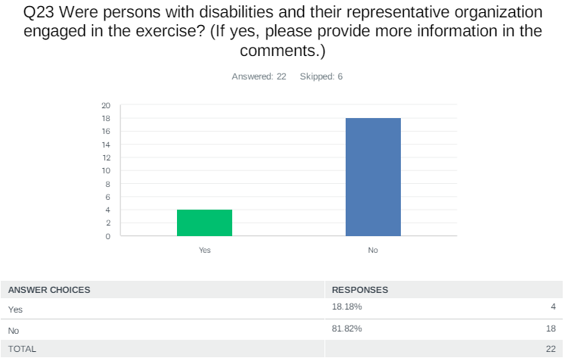

Comments:
St. Vincent and the Grenadines: However some persons with a few injuries participated in full

UK - Anguila: Though we did not target this group, messages were sent out to the general public. Once they received these messages the assumption is they would use assistive technology to access these messages.

UK - British Virgin Islands: These institutions were engaged prior to the exercise to ensure they are knowledgeable of their procedures.
US - Puerto Rico: Individuals from Centro Sor Isolina Ferre

USA - US Virgin Islands: Shared by the Government House ADA Coordinator to their contacts within the USVI.

Venezuela: In Funvisis and DNPC there are people with disabilities and they participated in the exercise

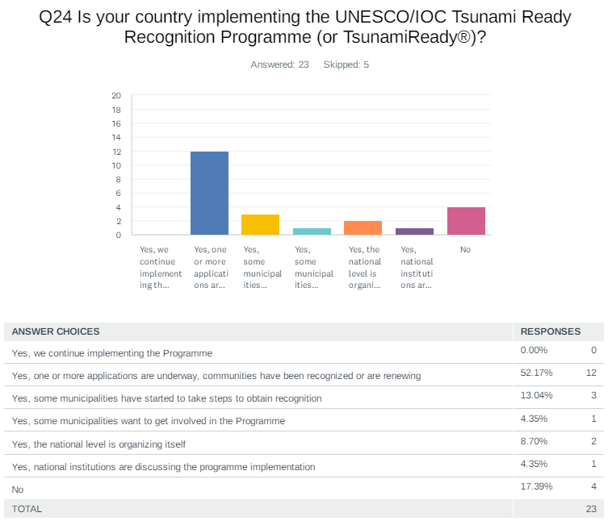

Comments:

Cuba: Interested in implementing the program - Implement tsunami ready in the city of Baracoa which is located in the northeastern area of Cuba through a local development project for 2026

Curacao: This exercise was used to put this milestone again on the agenda

Dominica: Application is being reviewed for the town of Portsmouth

Haiti: Jeremie and Cap-haitien want to be involved. Fort-Liberte wants to renew

Jamaica: The ODPEM is still working on a TR project for Port Maria, St. Mary. This is supported/ funded by UNESCO/ IOC/ CTIC

Panama: The District of Barú in the Province of Chiriquí took some steps to obtain recognition (TsunamiReady) in 2019.

Saint Vincent and the Grenadines: The program is being implemented incrementally in SVG. With every iteration communities within a specific section of the main island of St. Vincent will be brought into focus to undertake tsunami ready activities. On the Grenadine Islands implementation is done using an island wide approach. to date one grenadine island (Union Island) has been recognized as tsunami ready. However they are expected to go through their renewal procedures this year 2024. On mainland the coastal communities from Kingstown to Argyle have also been recognized.

UK - British Virgin Islands: Received recognition in 2021

UK - Anguilla: We are in the process of renewing.

USA - Puerto Rico: 46 municipalities recognized

Venezuela: Yes, community activities are started in favor of the tsunami ready program, there are still a lack of resources for the respective visits and observations

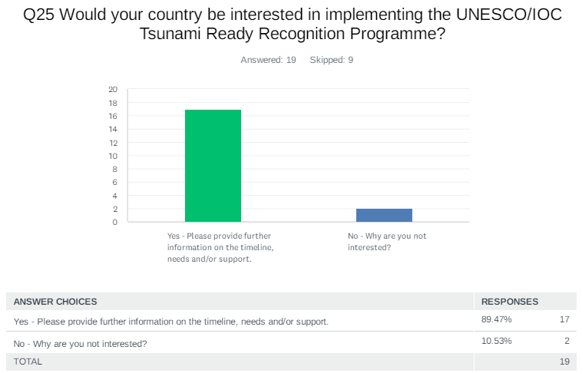
Comments:

Dominica: In the process of considering the Ready Recognition Program for another community once the submitted application is approved.

Dominican Republic: in the Dominican Republic, for example: San Felipe Puerto Plata, Palenque, Nigua and Haina. Great efforts have been made in these communities, however, in the case of Puerto Plata we were unable to get the authorities to agree to create the Codinadira Board required for recognition. We need cooperation in that direction.

Guatemala: We have interested in implementing the Recognition Programme on two news communities, and the renewal of the previously two recognized. Our timeline will be: 1. Create educational material on national agencies (on the way) and spread it in social media to begin people knowing about tsunamis. 2. Coordinate between CONRED (civil protection agency) and INSIVUMEH. 3. Coordinate between CONRED and coastal communities for small talks about activities. 4. Validate evacuation routes with communities on preliminary inundation maps 3. Begin training and talks with schools and leader communities. 3. Begin simulation exercices. Our main needs: Capabilities on improving our preliminar inundation maps. Some funds on training communities.

Haiti: when the political situation will be clear

Jamaica: We are implementing one coastal community at a time.

Mexico: The municipality of Puerto Vallarta, Jalisco is complementing the guidelines for the recognition of the Tsunami Ready Program, as well as the towns of Zihuatanejo, Gro. and Manzanillo, Col. presented their interest in being part of the communities recognized by the Tsunami Ready Program.

Panama: We need the UNESCO/IOC Tsunami Ready Recognition Programme in the near future.

St. Vincent and the Grenadines: As stated in the previous question SVG has already started this process in two broad areas. We also started work on another Grenadines island (Bequia) and the communities in the southwestern section of the island. These activities carry significant cost overhead thus there is an urgent need for funding/financial support and public education and support material

UK - British Virgin Islands: This recognition was bestowed on the Territory

UK - Cayman Islands: Will be presenting findings of the Tsunami Inundation Model to the Cayman Islands Executive shortly and hope to provide updates following that

USA - Puerto Rico: We already are TsunamiReady.

USA - US Virgin Islands: USVI is already recognized as Tsunami Ready

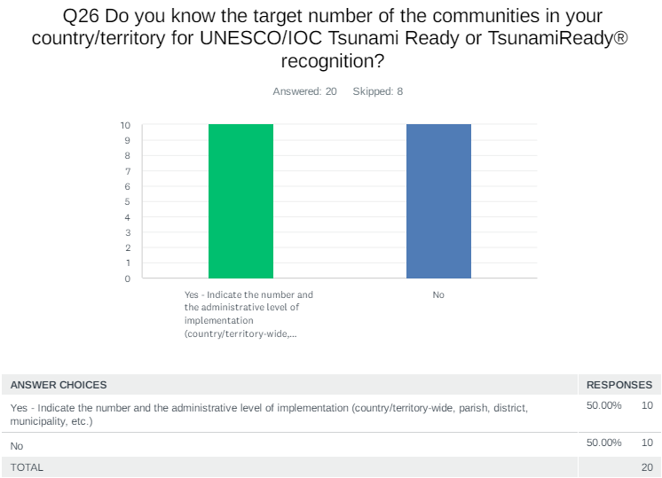
Comments:

Costa Rica: We have 10 TR communities in pacific coast, we are waiting for get soon one in caribbean coast, probably is Cahuita

Dominican Republic: We have worked with 4 communities, which belong to two provinces, these are: San Felipe Puerto Plata Palenque, San Cristobal. Haina, San Cristobal

France: 2

Guatemala: 2: Puerto de San Jose, Sipacate

Haiti: about 10 municipalities

Jamaica: Approximately over 50

Mexico: None are currently recognized.

Panama: District of Barú, Municipality of Pedasi, Bocas del Toro Islands, City of Colón, Guna Yala islands and continent

St. Vincent and the Grenadines: We want to implement the program nationwide, i.e. 12 broad areas/zones/ islands. Program implementation is complete for one area on the mainland and one grenadine island. Therefore10 broad/ areas/ island remain. A brief breakdown of the remaining areas are as follows: On mainland St. Vincent the island will be divide into five (5) zones. Zone one Kingstown to Argyle is already complete. Zone two Edinboro to Buccament Bay is set to commence. The remaining zones (3) on mainland we intend to complete implementation over the next four years. In the grenadines preliminary work has started on largest island (Bequia) whilst NEMO also endeavor to secure program support for implementation on the five (5) remaining populated islands

UK - Anguilla: Country wide population of 15000

UK - Bermuda: We have 9 parishes, but am unsure of any further administrative levels the Government would be interested in creating.

UK - British Virgin Islands: This recognition was bestowed on the Territory

Venezuela: There are at least three states with a lot of experience in the event of a tsunami, this year we are going to do a check on them and start with the necessary requirements for a future Tsunami ready recognition

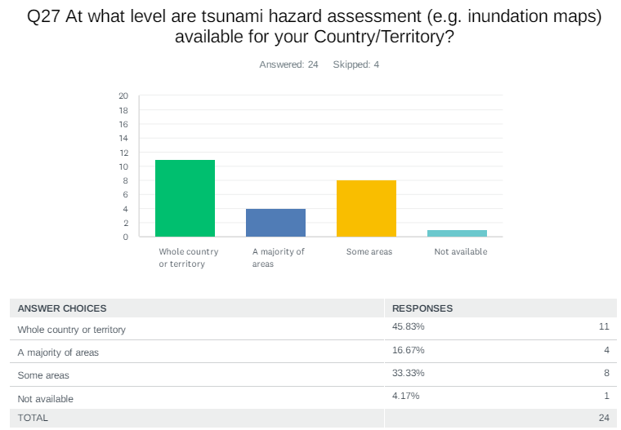

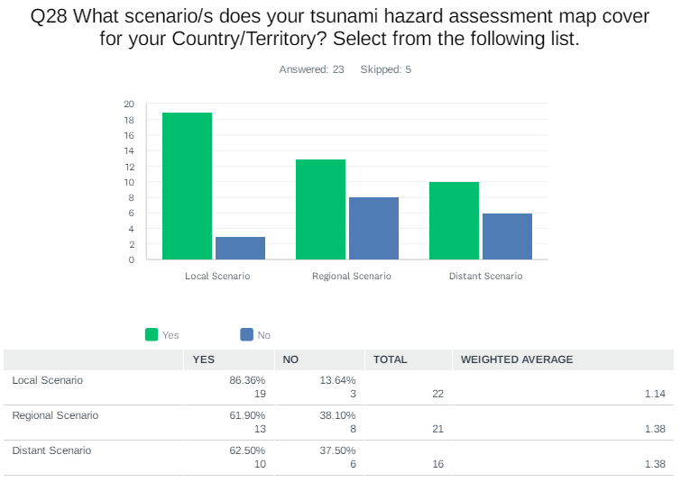
Comments:

Cuba: All possible regional scenarios, mainly those of the North Fault of Hispaniola

Mexico: Currently, there are no tsunami hazard evaluation maps for the coast of the Gulf of Mexico and the Mexican Caribbean, however, some localities in the Mexican Pacific do have tsunami flooding maps, as well as evacuation maps.

NL- Bonaire, Saba, Sint Eustatius: There is no such map

Panama: We need to work a lot in all the scenarios.

Saint Vincent and the Grenadines: Maximum worst case scenario

UK - Anguilla: The scenario is several miles outside of Anguilla.

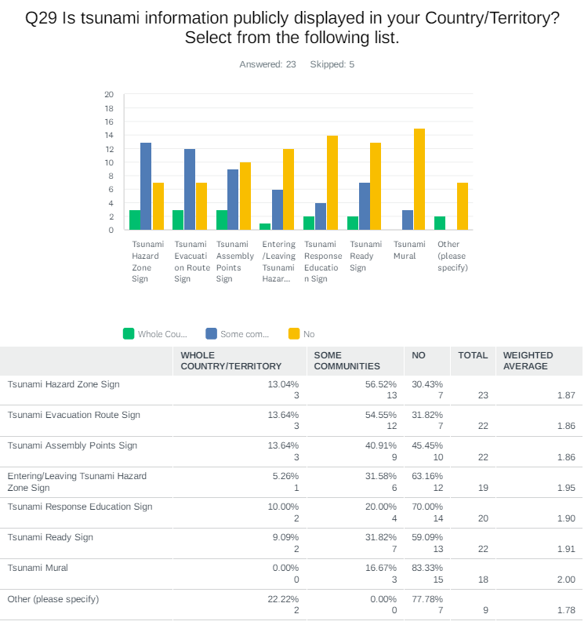

Comments:

Cuba: Seven signs in the city of Baracoa which is located in the northeastern area of Cuba

France: signs - 10%

Guatemala: 10 signs

Jamaica: Signs have been installed in the following communities: Old Harbour Bay (full coverage), Farquahar Beach (partial coverage), Port Maria (partial coverage), Alligator Pond (partial to move to full coverage through the Manchester Municipal Corporation. A total of 32 (approximate) With the Manchester MC it will move to 40. Port Maria to be implemented as well. Signage Plan incomplete

Panama: 20 signs

St. Vincent and the Grenadines: Require some analysis. However we need a billboard for each coastal community and other tsunami signage for all beaches and frequently visited low lying areas as well as signs that indicate tsunami routes, assembly points and hazard zones.

UK - Anguilla: 9 total verified signs

UK- Cayman Islands: Website

USA - Puerto Rico: Pavement Markings -Traffic Surface sign

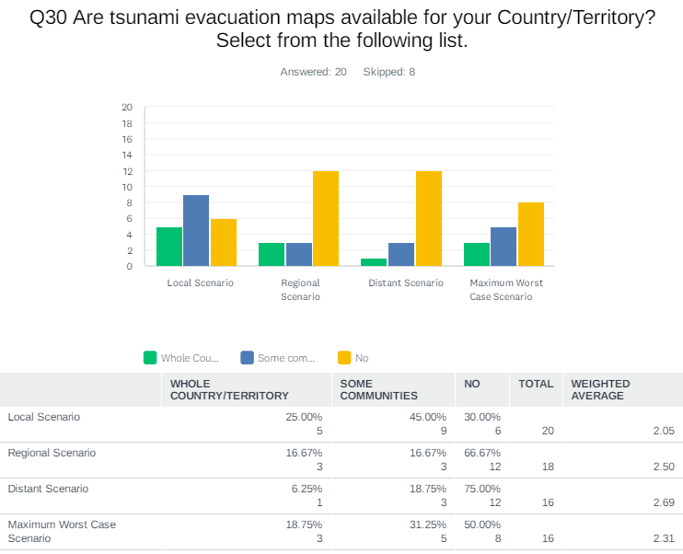
Comments:

Cuba: Fixed height/distance in the Baracoa City

Dominican Republic: Was in project that start at 2019 take all the

France: fixed height

Guatemala: Fixed height/distance

Jamaica: Jamaica has developed a National Tsunami Inundation Extent (Blue Line) for the country with the kind support of the ITIC (Puerto Rico)

Panama: Fixed height/distance and numerical modeling.

UK - Anguilla: Numerical using MOST and HYSEAS

USA - Puerto Rico: Maximum worst case scenario for local events -numerical modeling.

Venezuela: some numerical model
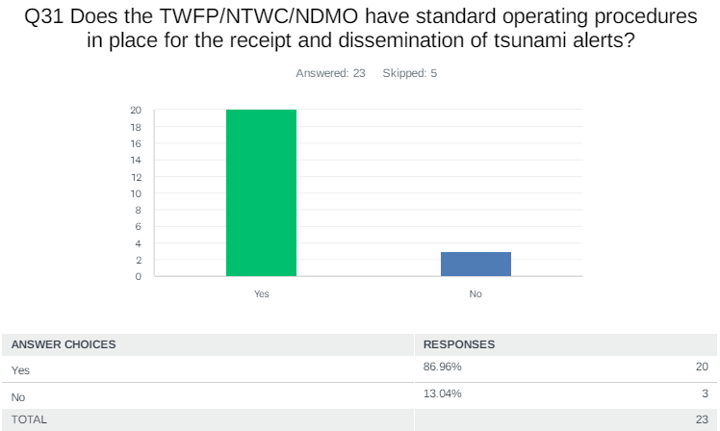

Comments:

Antigua and Barbuda: T

Dominican Republic: t has all the necessary requirements

Jamaica: The country has a National Tsunami Plan and SOPs developed, a Parish Tsunami Template (SOPs) and three community based response plans so far

UK - Cayman Islands: Duty Officer Handbook

USA - US Virgin Islands: 911 EOC Procedures

Venezuela: Yes, the Venezuelan seismological service has developed an action protocol in case of earthquake and tsunami, it is currently being executed

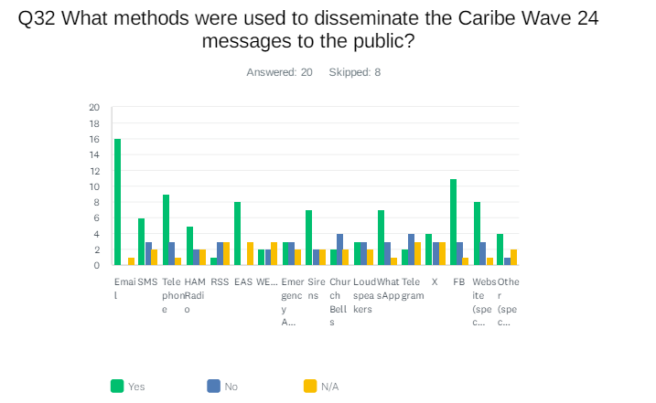

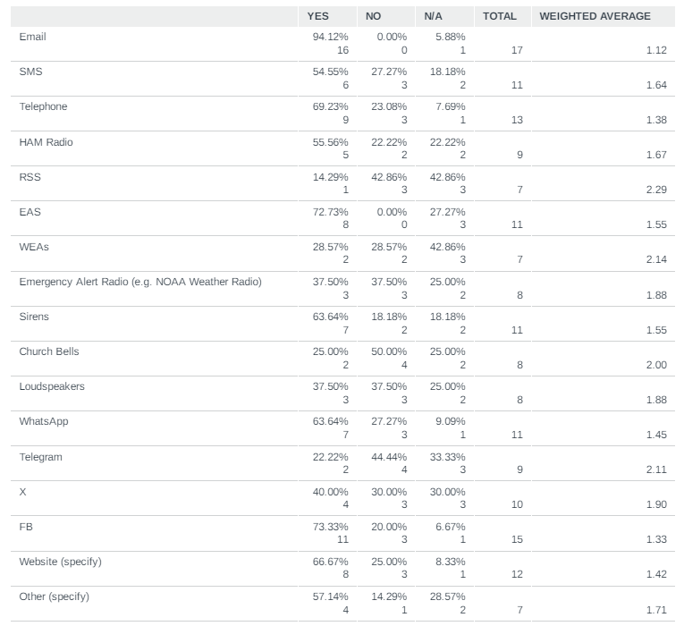

Comments:

Antigua and Barbuda: The message was not disseminated by the TWFP, but by the NODS.

Aruba: cmo-aruba.com

Barbados: local weather website and cell phone application

Cuba: Dissemination to the public is carried out through the Cuban civil defense system and government and state institutions which are structured at the national, provincial and municipal level in the country, mainly by means of cell phone, taking into account the specific conditions of the hazard and vulnerability in each locality. at risk

Curacao: Message was not disseminated to public

Dominica: caribe wave exercise did not focus on alerting the public.
France: About phone: a dedicated number is open during the exercise by the NTWCs

NL - Bonaire, Saba, Sint Eustatius: For local dissemination have to ask local governments

UK - British Virgin Islands: RDS, VHF Maritime

UK - Cayman Islands: Instagram - messages were confined to activities

USA - Puerto Rico: PRSN used Instagram

Venezuela: Instagram

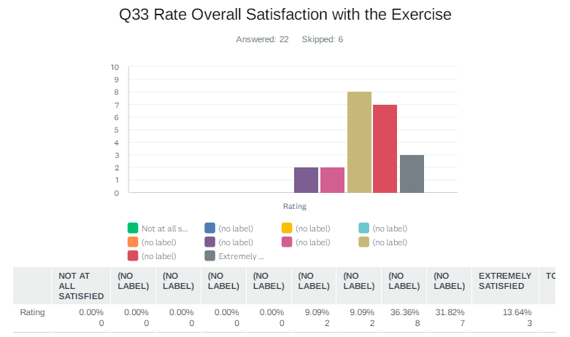

Comments:

Curacao: Exercise served as an eyeopener for the members of the NDMO

France: One remark: the schedule of the exercise might be sooner in the morning, so that the wave arrival does not occur during lunch time (which is problematic for schools)

Panama: The CARIBE WAVE Exercises are great, but we as a country have many things to improve.

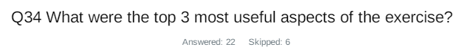
Country | Exercise Caribe Wave 24
Aruba | 1. Evacuation 2. Command & Control 3. Response
Barbados | Testing communication in and out of Barbados' TFP & WC  Practice evacuation methods  Practice radio communication
Belize | The messages were received in a timely manner and were detailed enough to assist in decision making.
Colombia | It was useful to prove: the communications with TSP and NTWC national tsunami protocol interpret the graphical products from PTWC
Costa Rica | Community preparation  Answer's capacity  Communication
Cuba | The improvement of national and regional experiences to cope with a possible tsunami event. New experiences for modelling development and hazard assessment processes with a positive cumulative effect. Progress in the consensus on the design of new scenarios to gain regional experience was made
Curacao | - Tsunami information available from the messages  - exercise book  - scenario maps
Dominican  Republic | I think the scenario in general was well prepared. It was understandable and easy to interpret, which allowed the Dominican Tsunami Division team to manage what was necessary to carry it out.
France | Yearly occurrence.  Different scenarios each year.
Guatemala | 1. It helps on testing our disseminations of tsunami warning messages to local agents.  2. Encourage and make us not forget the tsunami hazards we have.  3. It's a remainder of continuing working in mitigation plans.
Jamaica | The products, the messages, the instructions to countries embedded in the messages
Mexico | • Communication test  • Drill  • Coordination of response actions
NL-Bonaire, Saba, and Sint Eustatius | * Check of communication lines  * Check of contact details people/numbers to be reached  * refreshment of procedures
Panama | 1. Communication. 2. Education. 3. Group participation.
Saint Vincent and the Grenadines | 1. Understand and interact with the message templates  2. testing the time taken to disseminate an alert  3. Using the information to make local decision (discussions on the decisions)
UK - Anguilla | Identifying gaps in our response plans.  Seeing how there can be conflict of Human resources.  The chance to exercise the SOPs of the responders.
UK- Bermuda | The webinars beforehand are always useful for additional information and any changes to the exercise. We really find the graphical products useful as well.
UK - British Virgin Islands | 1) Participation in the public and private sector as well as interest from individuals.  2) Evacuation numbers improved
UK- Cayman Islands | Realistic scenario that helps us plan.  Encourages us to think about the threats and vulnerabilities so we can work to close the gaps.  Exercise helps to engage with stakeholders and partners
USA- Puerto Rico | The scenario was applicable for PR.  More participation about amateur radio.  Communication between agencies.
USA-US Virgin Islands | 1. Track messages from PTWC and PRNS  2. Activation of Emergency EOCs.  3. Community Evacuation drill.
Venezuela | Coordination between authorities and scientists  Effective communications  Community participation

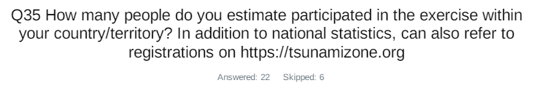
Country |  | Participants according to Member States
Antigua and Barbuda |  | 7,034*
Aruba |  | 27,000
Bahamas |  | 0*
Barbados |  | 500
Belize |  | 2*
Brazil |  | 13*
Colombia |  | 50
Costa Rica |  | 120
Cuba |  | 200
Curacao |  | 20
Dominica |  | 19*
Dominican Republic |  | 1,500
France |  | 173,823
Grenada |  | 14,724*
Guatemala |  | 1,500
Guyana |  | 1,240
Haiti |  | 40
Honduras |  | 0*
Jamaica |  | 85
Mexico |  | 11,000
Netherlands  (Bonaire, Saba, Sint Eustatius, other) |  | 40
Nicaragua |  | 30*
Panama |  | 1,240
Saint Kitts and Nevis |  | 2,100*
Saint Lucia |  | 313*
Saint Vincent and the Grenadines |  | 35
Sint Maarten |  | 0
Suriname |  | 0*
Trinidad and Tobago |  | 450*
United Kingdom | Anguilla | 51*
 | Bermuda | 324
 | British Virgin Islands | 4,000
 | Cayman Islands | 25
 | Montserrat | 0*
 | Turks and Caicos | 10*
United States | Puerto Rico | 135,952
 | US Virgin Island | 23,672
Venezuela |  | 60,573
TOTAL |  | 467,685

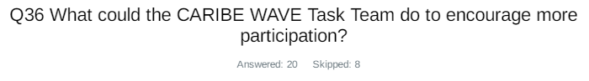
Country | Exercise Caribe Wave 24
Aruba | Short Promo Videos for the Region
Barbados | Outreach leading up to Caribe wave exercise
Costa Rica | keep doing annually
Cuba | To encourage more participation, we need to strengthen risk perception. In this sense, we could model the consequences of possible tsunami impacts using the current local socio-economic and geographical information of the Intra Americas Seas coastal areas using multiple maximum scenarios already available, mainly obtained for annual Caribbean exercises. The goal is to ensure that the population and its leaders are more aware of tsunamis in terms of hazard, vulnerability and risks, by disseminating the results through a wider and better designed outreach national and regional campaign.
Dominican  Republic | Supporting us in the creation of generalized infographics of the event, this way countries could take it to motivate citizen participation.
France | Make it begin earlier in the morning : as western and eastern territories generally do not use the same scenario, it might be possible to adjust the beginning of the exercise for eastern territories
Guatemala | Add more educational material.
Jamaica | Answer emails seeking clarification as communicated
Mexico | Promote the registration of all agencies in charge of emergency management and decision-making in matters of civil protection, as well as the use of the hashtag #caribewave to achieve greater dissemination of the exercise on social networks.
NL-Bonaire, Saba, and Sint Eustatius | * Send sponsor materials to local governments (leaflets to hand out, stickers).  * Possibility to order tsunami information panels/signs through the Task Team.
Panama | I think we have been increasing our country's participation by the years
Saint Vincent and the Grenadines | 1. greater visibility and awareness of the exercise.  2. incorporate ads and promote them on social media pages (ads on YouTube, X, Facebook, and Instagram)  3. Quiz - collaborate with stakeholders to offer awards to persons for tsunami and caribewave-specific quizzes  4. us social media influencers to explore opportunities for their participation.
UK - Anguilla | They have done well in showing the benefits of participation by states. They have provided tracking mechanisms to show the registration of persons and departments participating. They should keep it up.
UK- Bermuda | I'm not sure, there is a lot of material available including nice YouTube videos.
UK - British Virgin Islands | Continue to promote & show the benefits. Real life events usually help especially that we have felt several large quakes recently
UK- Cayman Islands | Put out a save the date reminder.  Engage Key stakeholders such as Florida Caribbean Cruise Association and Caribbean Tourism Organisation.  Have a Caribe Wave impact considerations meeting for Ports.
USA- Puerto Rico | Promotion of the exercise at the beginning of the year promoting the scenario.
USA-US Virgin Islands | Use the multiple language tool provide by the Task Team.
Venezuela | Improving communications is important  Provide information in the 3 languages English, French and Spanish  Improve tsunami education in coastal institutions

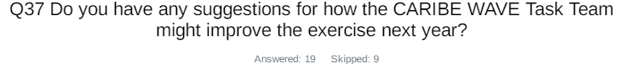
Country | Exercise Caribe Wave 24
Aruba | Workshop
Barbados | Start planning earlier
Belize | Possibly a few more workshops or seminars to aid in outreach and sensitization
Costa Rica | one exercise local for each country, because some of this selected not affect at a
France | Someone suggested to implement a kind of challenge between territories to increase the participation
Jamaica | Place the promotional video link in the letter sent to all parties. That would help as we did not receive it despite requests
NL-Bonaire, Saba, and Sint Eustatius | We always request exercise text messages by mail, they could be made available on-line. We did not receive the request to fill in this questionnaire (usually it send to more people)?
Panama | I think increasing courses related to the Exercise can help
Saint Vincent and the Grenadines | 1. See question 36.  2. support countries with the preparation of country-specific simulations with injects to support messaging  3. consider simulations and actions for a local source earthquake for SIDS  4. provide practical scenarios and opportunities to use decision support tools
UK - British Virgin Islands | None at the moment
UK- Cayman Islands | I think it is a very well run exercise.  Perhaps to encourage countries to get their regional tsunami warning sensors operating, the scenarios could involve mock 'readings' that can assist downstream countries with decision making.
USA-US Virgin Islands | Keep it on the 3rd Thursday at 1500 UTC.
Venezuela | Training for members of the task team to know how to accompany or carry out the exercise with authorities, technical personnel and response personnel.  Make more propaganda in three languages  Conduct coastal workshops for at least three months before the exercise  Support response entities with accompaniment and basic resources such as water and candy for participants
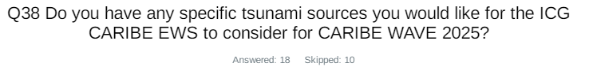
Country | Exercise Caribe Wave 24
Aruba | Jamaican Trench & Puerto Rico Trench
Barbados | Volcanic source - Kick 'em Jenny  Martinique scenario
Costa Rica | maybe one close to Costa Rica
Cuba | Emphasize less frequent source scenarios such as landslides and volcanic eruptions and return to sources of earthquakes that produced tsunamis in ancient times.
Dominican  Republic | Groove of the Dead (SMT 1 or 2)
France | - non-seismic sources  - alternating remote and local scenarios, so that ETA should vary  - people seem to be more concerned when the expected wave is high (ie > 1m)
Guatemala | Any near to Central America
Mexico | Tsunami due to underwater volcanic eruption by the Kick-'Em-Jenny located in Granada
NL-Bonaire, Saba, and Sint Eustatius | Large eruption of Kick 'em Jenny volcano.
Panama | I suggest any volcanic source should be very interesting consider a cold reaction after Tonga eruption.
Saint Vincent and the Grenadines | Yes volcanic sources La Soufriere, Mt Pelee and Kick em Jenny
UK - British Virgin Islands | Kick em Jenny
UK- Cayman Islands | Kingston Harbour vicinity (Jamaica))
USA-US Virgin Islands | EMWIN (Emergency Managers Weather Information Network)
Venezuela | I like volcanic scenarios, but they could be involved with a hurricane and an earthquake under the seabed in such a way that it moves the response entities of the meteorological area

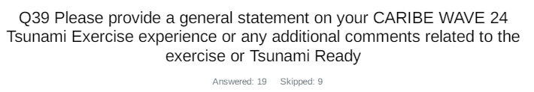
Country | Exercise Caribe Wave 24  General Statements
Aruba | Dedicated Tsunami Risk for the Region. Motivation in the All Hazard Early Warning System for the Region.
Barbados | The Caribe wave exercise was good overall in Barbados. Bulletins were issued in a timely manner across all platforms used during the exercise. Radio etiquette training and tsunami bulletins are required for the BMS Staff.
Bermuda | We really appreciate the annual exercise. Our small staff size limits what we can do and the Government also has limited resources to  implement plans. We continue to advocate for improvements.
Colombia | It was a very useful tabletop exercise. As NTWC we would like to generate a bigger scope in the next participation, so we have to coordinate with national agencies for an evacuation exercise.
Cuba | In general, this exercise was carried out in tabletop modality in the new conditions in which the Physical Oceanography group is already working in the Marine Meteorology Center of the Meteorological Institute of Cuba, which is located very close to the National General Staff. of the Civil Defense. From the exercise itself, it was possible to appreciate the benefits that these conditions have for immediacy in the management of an alert system.
Curacao | As indicated the exercise served as an eyeopener for NDMO into what needs to be done to achieve tsunami ready status.
Dominican  Republic | The timing of the exercise's publication should be to publish it in December or the first week of January. This allows us to better organize actions. This year's exercise was well organized, it was not complex to take on. Congratulations to the entire organizing team. We are grateful for continued efforts to improve our preparation to respond to and provide early warning of tsunamis.
France | Many thanks to the CARIBEWAVE task team
Guatemala | This kind of exercise tests our dissemination tsunami warning message and evaluates time to react in case of a real hazard. Also i think, to encourage more participation, it would possible send a invitation to CONRED.
Jamaica | CARIBE WAVE is a great way to promote Tsunami Preparedness and Response. The correspondence invitation was very informative and was disseminated to relevant parties. We hope Jamaica will be able to conduct more live exercises and even include the Executive of the country participating as we have seen in countries such as the BVI.
Mexico | The exercise was very useful to check the receipt of the alert, follow-up and cancellation bulletins by all participants, plan and practice the emergency action and response protocols, and improve the areas of opportunity that need to be strengthened.
Panama | The CARIBE WAVE 24 Tsunami Exercise brought a lot of new experiences especially because of the participation of more people and institutions, everyone doing their respective tasks. At the end we accomplish the objectives and, of course, there are a lot of things to improve mostly in evacuation procedures, effective participation including disable people, and technically in tsunami inundation maps.
Saint Vincent and the Grenadines | The exercise was a success for NEMO SVG (NTWC). We were really able to go through the messages and discuss the implications for SVG including making determinations on the appropriate Alert levels. Operational staff were able to practices dissemination of messages that provided participants with an opportunity to simplify messages with the pertinent information require by stakeholders. Participants seemed very engaged but opined that there is a lot to execute in a short period of time. As such the general reflection was a greater need for more exercises to increase familiarity with Sops, messages and use of the decision support tools.
UK - Anguilla | The team from PTWC has been very supportive and helpful in our Tsunami recognition.
UK- British Virgin Islands | The exercise is helpful in kicking off preparation for the hurricane season. The felt earthquakes in the last few months & over the years have helped persons to take it seriously. Tsunami Ready is a valuable process in ensuring all mechanisms and systems are functional and that all SOPs and protocols are up to date.
UK- Cayman Islands | Wonderful job again - you are doing so much to build awareness and encourage us to prepare for this threat in the Caribbean region. Thank you - your efforts are appreciated!
USA- Puerto Rico | The scenario was an amazing opportunity to put on practice our tsunami evacuation plans and communication plans taking under consideration a tsunami with a major impact in our coast. It helps us to reinforce our relationship with Tsunami Ready Supporters agencies. More communities got organized and evacuate like Villa del Carmen in Ponce. (Complete response in supplement report.)
USA-US Virgin Islands | The US Virgin Islands deliberately increased the number of activities for the 2024 exercise. Besides the normal evacuations to safe elevations drills with schools, local businesses, and government agencies, VITEMA sounded its 44 tsunami sirens, and activated two (2) emergency operations centers and provided exercise messages of damages which required interagency coordination. VITEMA conducted a Tactics meeting to determine priority of efforts based on approved exercise objectives. A COOP exercise was also conducted for one (1) EOC which was in the tsunami inundation zone. VITEMA conducted 30-minute After Action Review / Hotwash on the EOC actions and a 30-minute After Action Review / Hotwash on the COOP activities. Governor Bryan and the USVI Cabinet members were provided Dummy Message and provided updates on anticipated arrival times / wave heights through the existing group WhatsApp. FEMA Region 2 liaison officer was notified of the exercise dummy message and participated in the exercise as observers at the EOCs. Amateur Radio Operators (Auxiliary Coms / ARES) provided alternate communications on exercise Dummy message.
Venezuela | This Caribe Wave 24 was very active, contacts were resumed with the highest authorities and it was possible to convince the authorities of the importance of the Caribe Wave 24 exercise, coordination with scientists and communities was very important. With great enthusiasm, the state and municipal civil protections, given their experience in previous exercises, assumed participation with their own methodologies and adapted their participation. The authorities decided in this exercise to establish a command and control post with the objective of monitoring the entire country, in the event of a possible tsunami warning. This drill was vital to evaluate our protocols and improve coordination between the various security agencies and government entities. We worked with the document prepared by the Vice Ministry of Risk Management and Civil Protection and its team called “Order of Operations” for the Caribe Wave, with the participation of radio amateurs, communications were strengthened in this exercise. We must rescue international communications with the other alert centers in the region, to obtain confirmation and exchange of data, among others. Evaluations were carried out on coastal areas that can be prepared for the tsunami ready program.

One survey submitted by the Member States for all constituents.

