Task Team CARIBE WAVE 24
UNESCO/IOC
ICG CARIBE-EWS

CARIBE WAVE 2024

Media Report

Kimberly Maisonet Gonzalez
Claudia Guzman Soto
Christa von Hillebrandt-Andrade
International Tsunami Information Center Caribbean Office (ITIC-CAR)
April 2024

Contents
UNESCO-IOC 4
PRSN 5
TsunamiZone 6
Antigua and Barbuda 7
Aruba 9
Barbados 10
Bermuda 11
Colombia 13
Costa Rica 15
France 16
Guadeloupe 16
Martinique 17
Grenada 20
Panama 23
Saint Kitts and Nevis 24
Saint Lucia 27
Saint Vincent and the Grenadines 27
Turks and Caicos 28
Trinidad and Tobago 28
United Kingdom 29
British Virgin Islands 29
Cayman Islands 31
Montserrat 32
United States 33
Puerto Rico 33
US Virgin Islands 39
Venezuela 40

CARIBE WAVE 2024
Regional Tsunami Exercise

The CARIBE WAVE exercise is conducted within the framework of the UNESCO/IOC Intergovernmental Coordination Group for Tsunamis and other Coastal Hazards Warning System for the Caribbean and Adjacent Regions (ICG/CARIBE-EWS). The thirteenth annual tsunami exercise CARIBE WAVE took place on 21 March 2024. It was carried out with the purpose of validating and advancing tsunami resilient communities in the Caribbean and Adjacent Regions. The exercise was coordinated by the CARIBE WAVE 24 task team, the NOAA International Tsunami Information Center Caribbean Office, and supported by the Caribbean Tsunami Information Center and Pacific Tsunami Warning Center.
Over 475,000 people from the entire Caribbean basin were registered to participate in the exercise (https://tsunamizone.org), accessed on April 26, 2024)). Registered participants included designated Tsunami Warning Focal Points (TWFPs), National Tsunami Warning Center (NTWCs), as well as emergency and preparedness organizations, K-12 Schools, healthcare, businesses, disabilities organizations, among others. It was left up to the Member States and Territories to determine the level of participation and activity to be held in their country, and to use the simulated messages for one of the two tsunami scenarios: Puerto Rico Trench and Panama.
Most countries and territories publicized the exercise through social media to encourage the participation of the community. The hashtag #CARIBEWAVE was commonly used to track their activities online from February 21 through March 27, resulting in worldwide reach. Several Emergency Management agencies from countries informed citizens through online article publications and social media posts that their country would participate in the exercise. The International Tsunami Information Center Caribbean Office and the Puerto Rico Seismic Network also published informative posts related to tsunami awareness in preparation for CARIBE WAVE.
This report includes 73 associated publications accessed through the internet from 21 Member States and Territories in the Caribbean and Adjacent Regions, as well as international organizations.

UNESCO-IOC

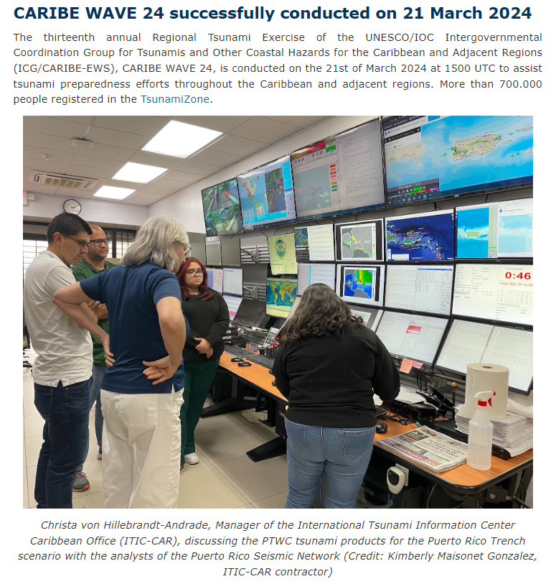

Retrieved from: http://www.ioc-tsunami.org/index.php?lang=ru

PRSN
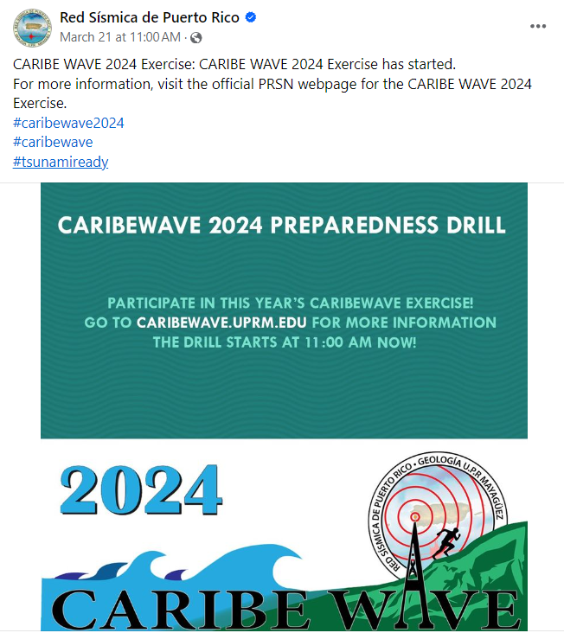

Date of publication: March 21, 2024
Retrieved from: https://www.facebook.com/redsismicadepuertorico/posts/pfbid0JQmNFW29GhtDH87wrL5tsvhhUXD7CTwequsBz4xcLpZALr8RzTXjVXy1gdhmiCBSl

Tsunami Zone
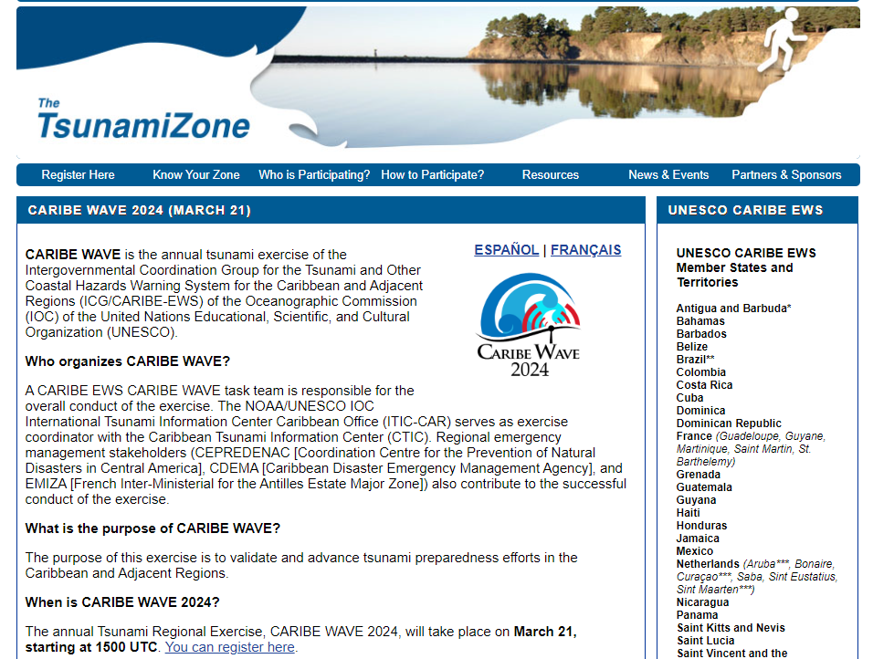

Retrieved from: https://www.tsunamizone.org/caribewave/

Antigua and Barbuda
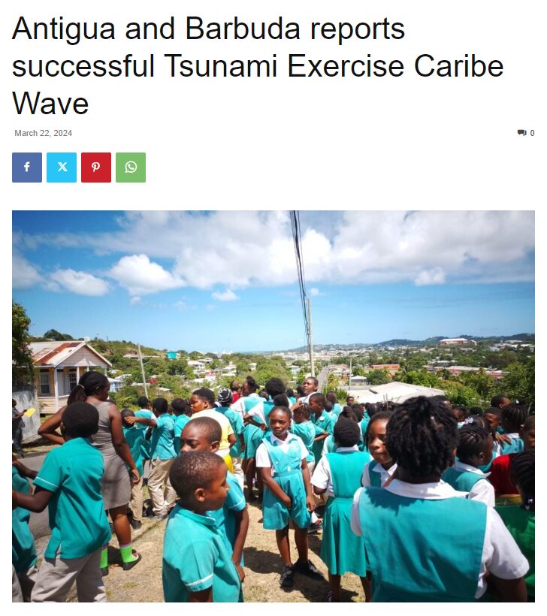
Date of publication: March 22, 2024
Retrieved from:
https://antiguanewsroom.com/antigua-and-barbuda-reports-successful-tsunami-exercise-caribe-wave/?fbclid=IwAR3NYSj-Fj2Oou7WwLvCrxqhn_0KlGwX7uImU36yYYgpM279kOWyhWPZcT8

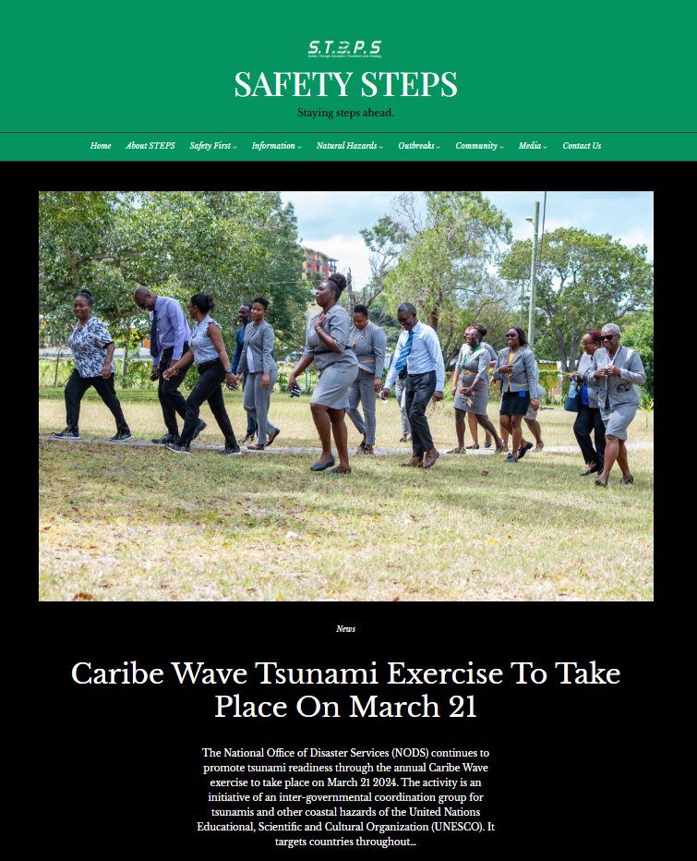
Date of publication: February 22, 2024
Retrieved from: https://safetysteps.org/2022/02/24/nods-caribe-wave-tsunami-exercise/
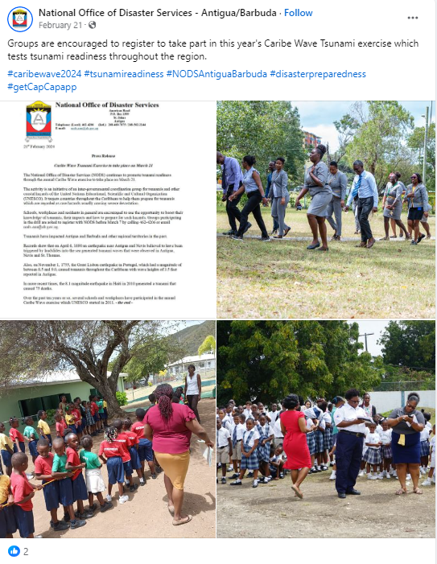
Date of publication: February 21, 2024
Retrieved from:
https://www.facebook.com/NodsAntiguaAndBarbuda/posts/pfbid02HkDC3Krw6C3JF6EQzomF17zCw778Brk23jUYCi31v82Jk21s14DmcRW1zTH1uheKl

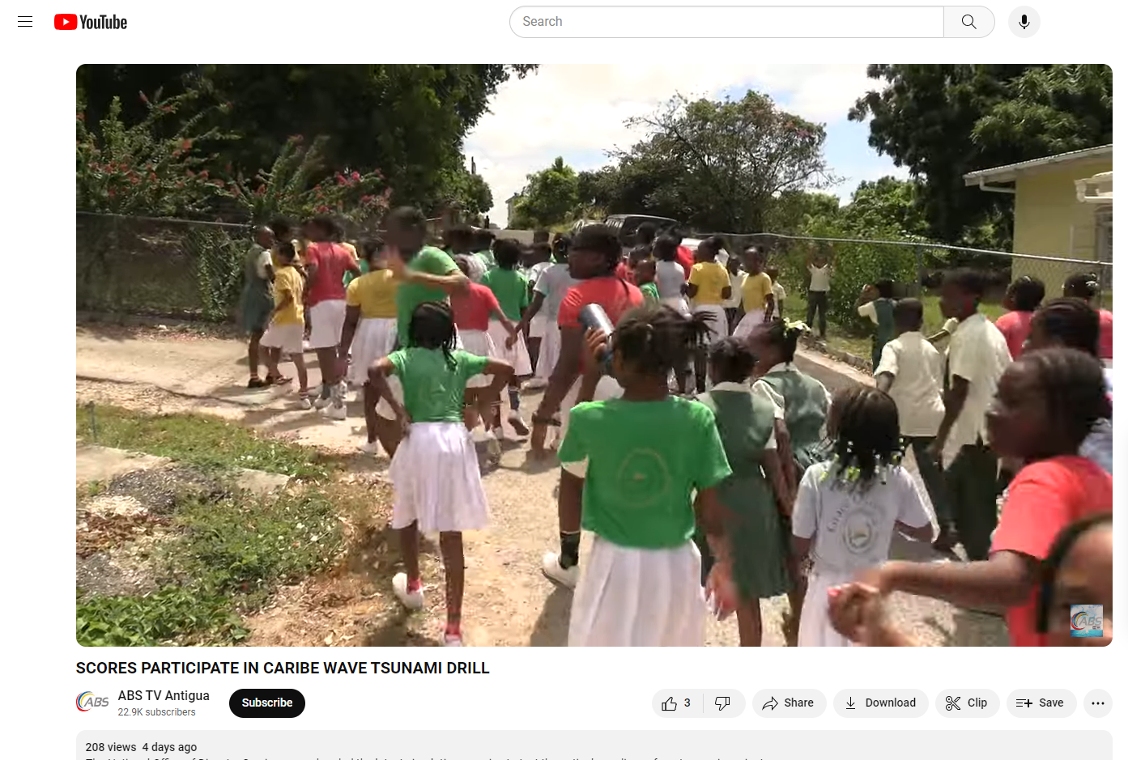
Date of publication: March 23, 2024
Retrieved from: https://youtu.be/jr-QL8G0wi4?feature=shared

Aruba

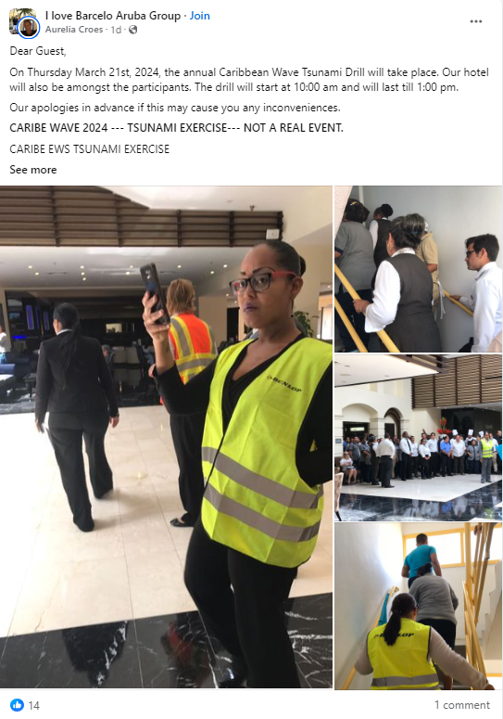
Date of publication: March 21, 2024
Retrieved from: https://www.facebook.com/groups/297791084508117/permalink/1472063057080908/

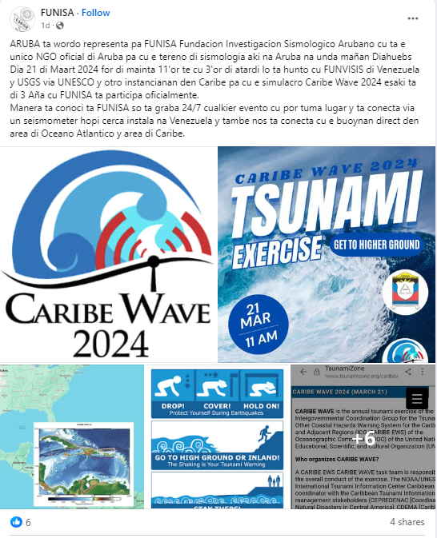
Date of publication: March 20, 2024
Retrieved from: https://www.facebook.com/funisaruba/posts/pfbid02muSvSzHP21MXL8S9FrpKjyVdA7jyhPZF7K5rLQaQPXfSz2LcrcVTian95cpqkKwYl

Barbados
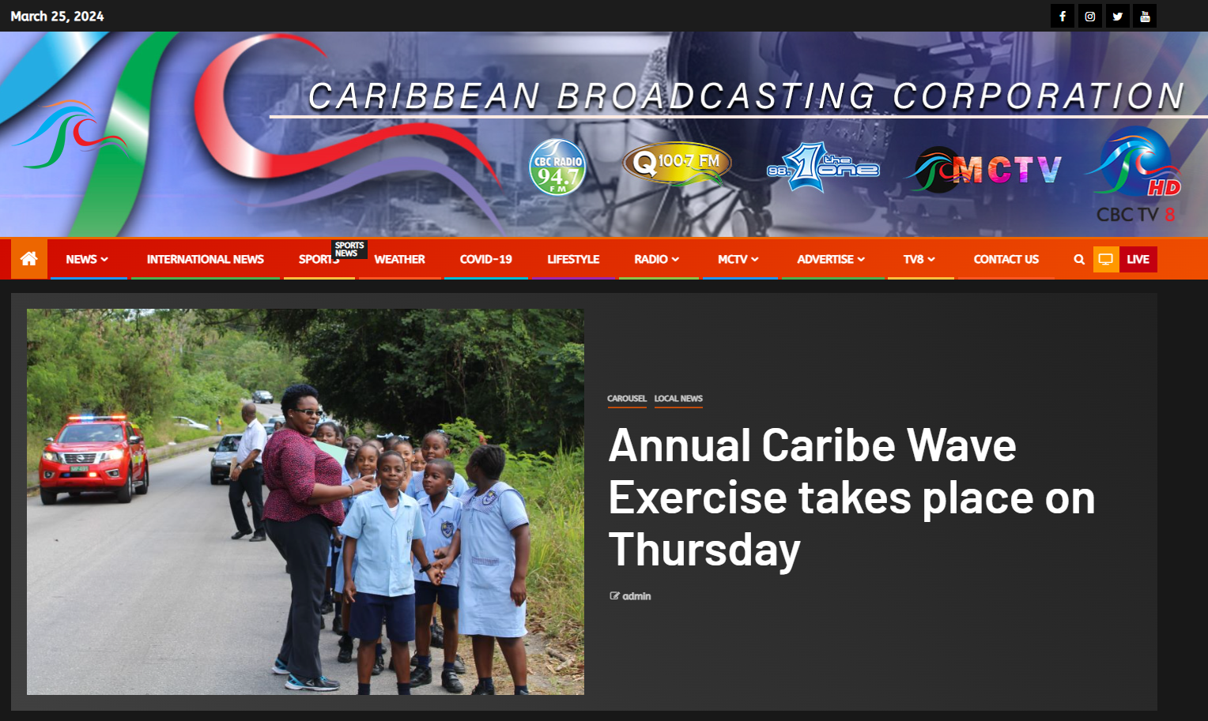
Date of publication: March 20, 2024
Retrieved from: https://www.cbc.bb/news/local-news/annual-caribe-wave-exercise-takes-place-on-thursday/

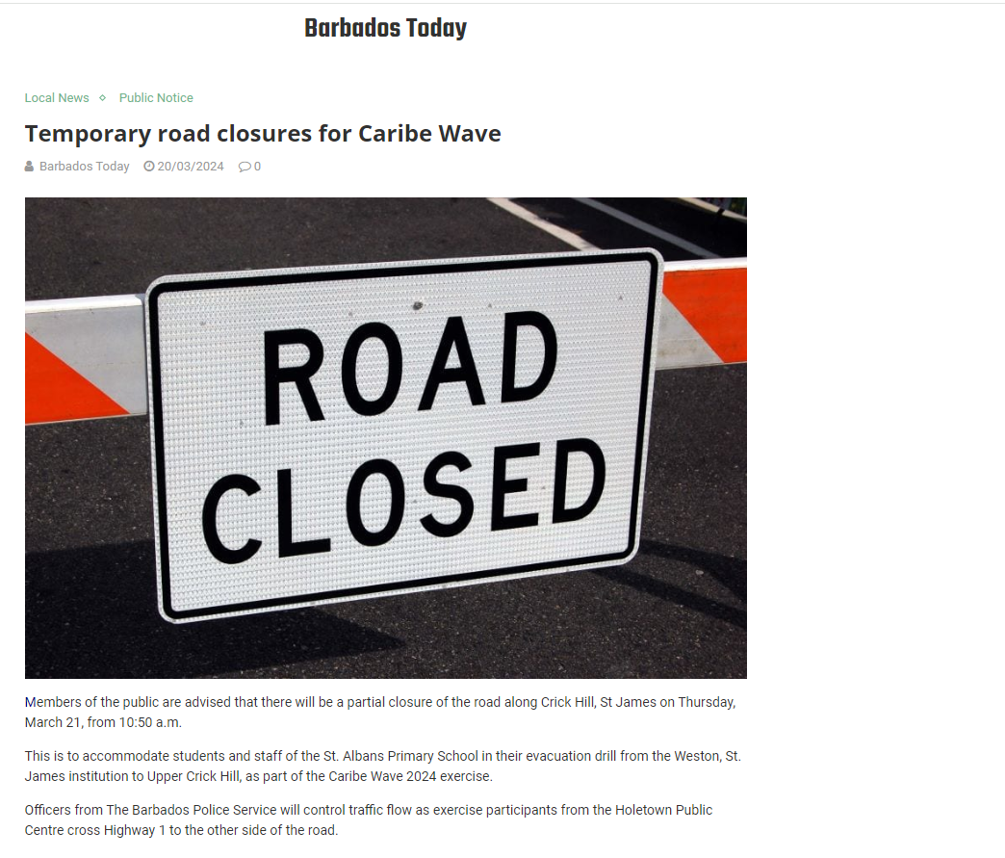
Date of publication: March 20, 2024
Retrieved from: https://barbadostoday.bb/2024/03/20/temporary-road-closures-for-caribe-wave/amp/

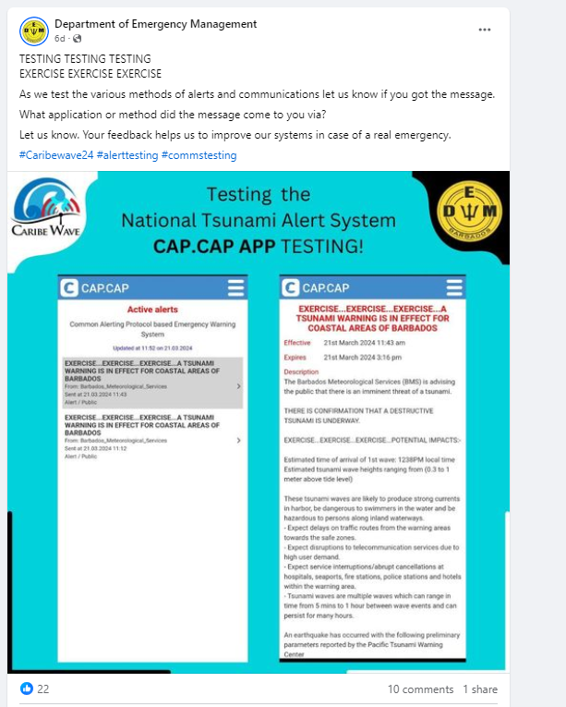
Date of publication: March 21, 2024
Retrieved from:
https://www.facebook.com/dem246/posts/pfbid02mafSc8U9LX385gV2tnXzLFmhxhjH7bNzdzphSsNtFYBHE2Xo6Cu45k1YPJDSoyjRl

Bermuda
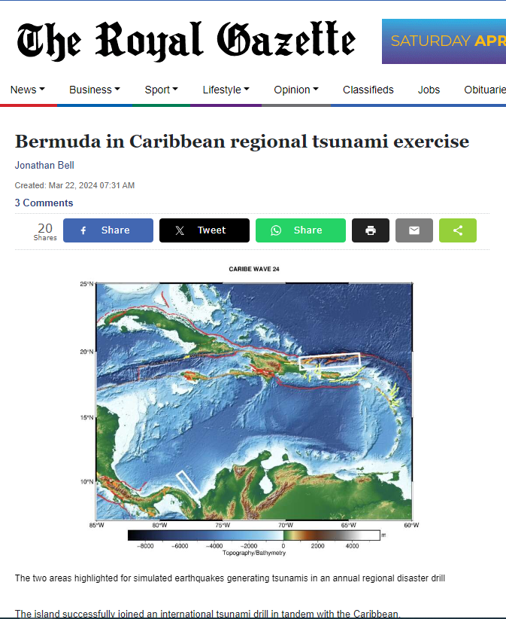
Date of publication: March 22, 2024
Retrieved from:
https://www.royalgazette.com/general/news/article/20240322/bermuda-in-caribbean-regional-tsunami-exercise/
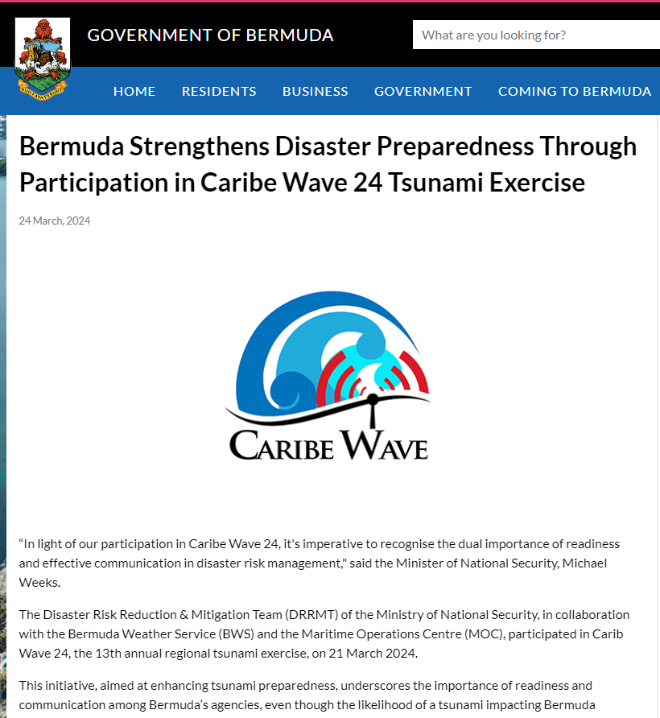
Date of publication: March 24, 2024
Retrieved from:
https://www.gov.bm/articles/bermuda-strengthens-disaster-preparedness-through-participation-caribe-wave-24-tsunami

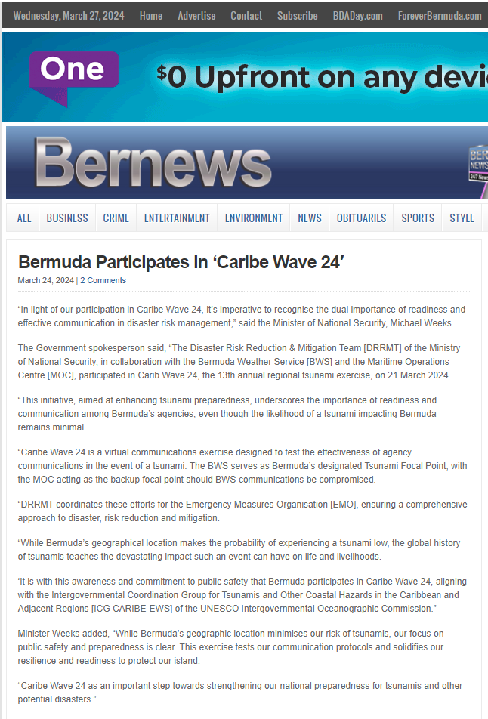
Date of publication: March 24, 2024
Retrieved from: https://bernews.com/2024/03/bermuda-participates-in-caribe-wave-24/

Colombia
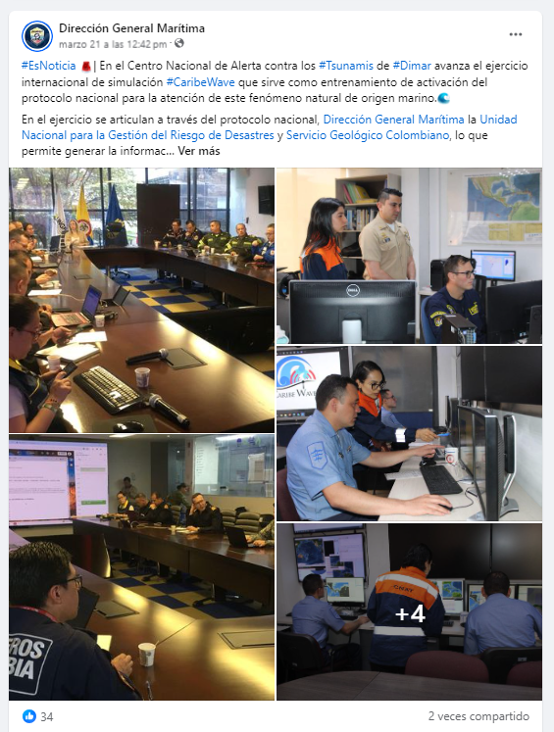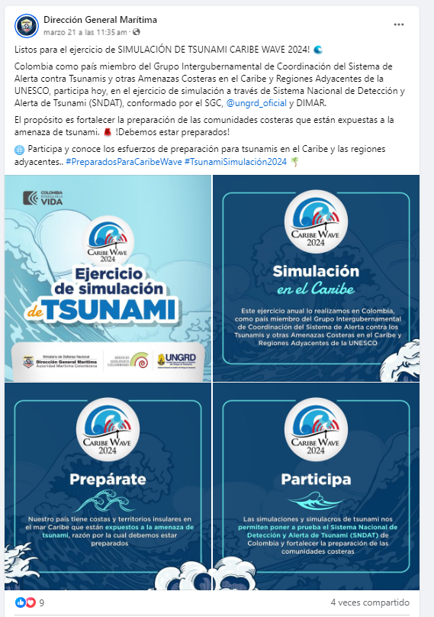
Date of publication: March 21, 2024
Retrieved from:
https://www.facebook.com/DimarColombia/posts/pfbid02Ksj8ZJpwEetgoTPxQKUT8t5jrboU56d1eNWb2h9kjMnebgAc123dRiWZZWSN3nQxl
https://www.facebook.com/DimarColombia/posts/pfbid0qnrmTkbUSezyhhvfEGUKaWYNxaGomRBVGz2bKXH74D3G9u5SDcKv3iksZBYxkmtXl

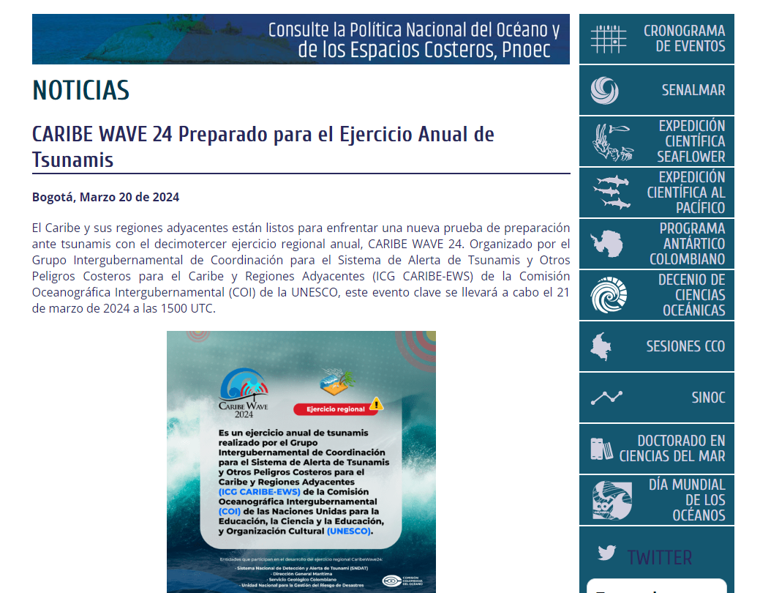
Date of publication: March 20, 2024
Retrieved from:
https://cco.gov.co/cco/prensa/noticias/1013-caribe-wave-24-preparado-para-el-ejercicio-anual-de-tsunamis.html

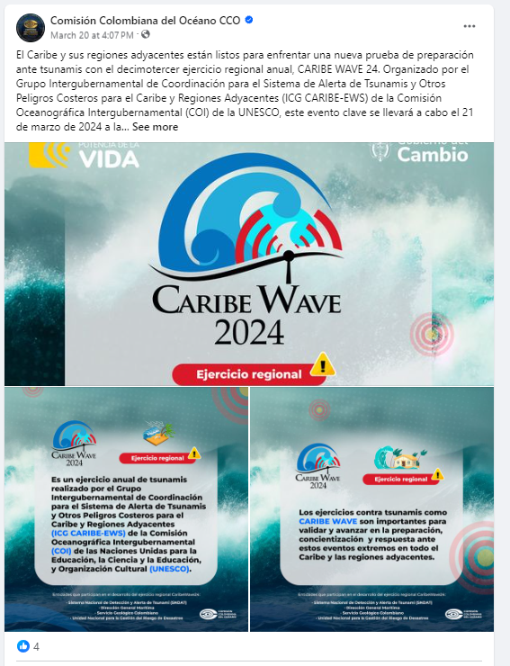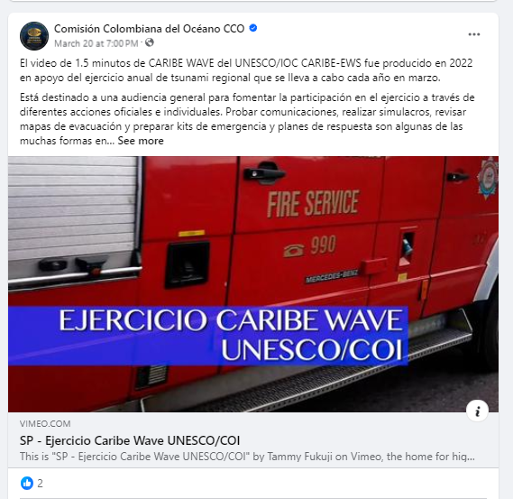
Date of publication: March 20, 2024
Retrieved from:
https://www.facebook.com/comision.deloceano/posts/pfbid0RZS6iPGhR39m8LLve6SDCBffo89GubHHss6qxaDxwsCC1C3yv8cuEFyN4kFeNeV5l
https://www.facebook.com/comision.deloceano/posts/pfbid0z6aqaV6Fe5xFfAGCpKEbKbGofkkup5kXHFPoaHeQmQ9cNTbtmw6ehH5c18x58SzBl

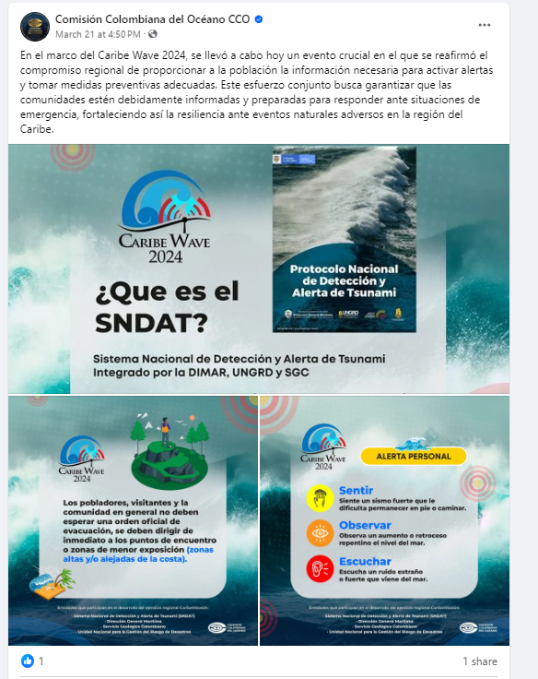
Date of publication: March 21, 2024
Retrieved from:
https://www.facebook.com/comision.deloceano/posts/pfbid032Wv8HzqTQRdaoK8Jcku6Tx59MhFEWTWjyww2KRTbZ2kA6DtVYyJv5bJBZyW2Vgql

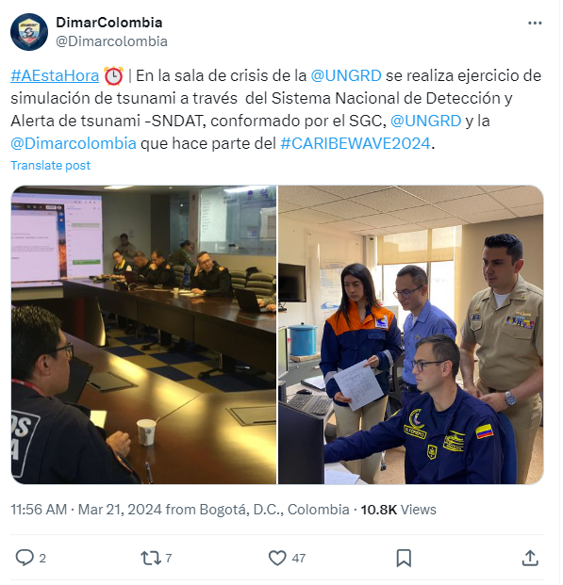
Date of publication: March 21, 2024
Retrieved from: https://x.com/Dimarcolombia/status/1770841947906703522

Costa Rica
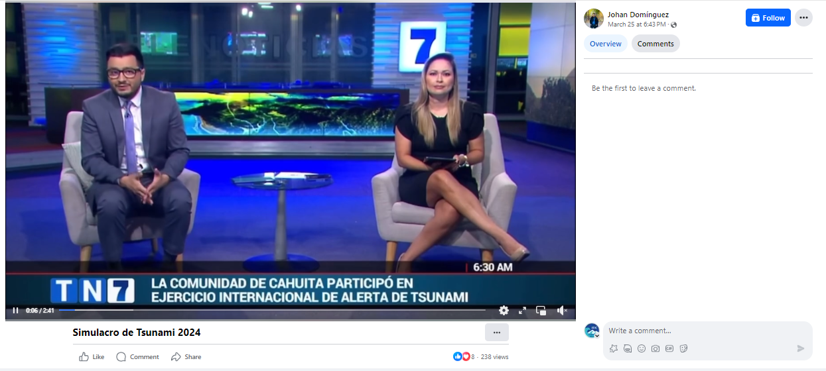
Date of publication: March 21, 2024
Retrieved from: https://www.facebook.com/watch/?mibextid=w8EBqM&v=988788059523355&rdid=IbLUHgKjcjfAFgPP

France

Guadeloupe
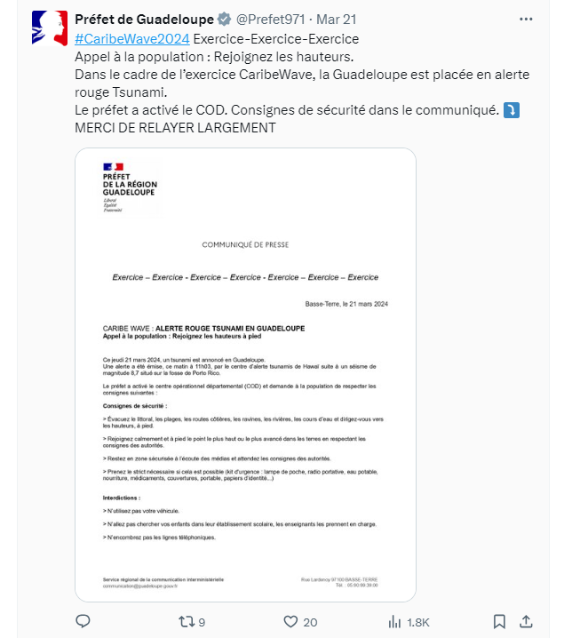
Date of publication: March 21, 2024
Retrieved from: https://x.com/Prefet971/status/1770841921377734958?s=20

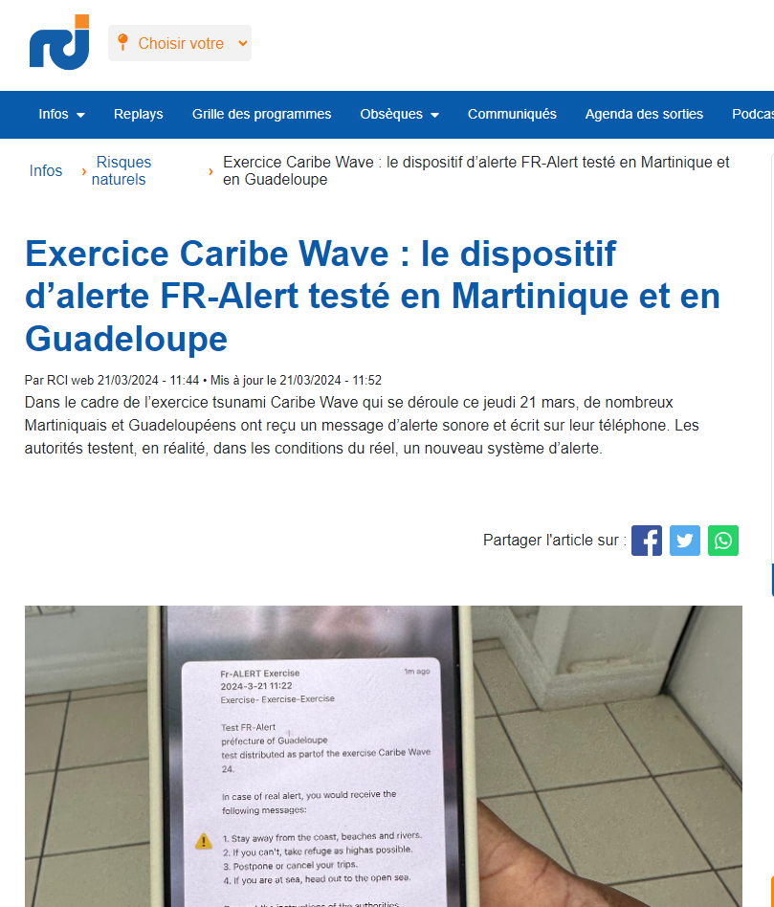
Date of publication: March 21, 2024
Retrieved from: https://rci.fm/deuxiles/infos/Risques-naturels/Exercice-Caribe-Wave-le-dispositif-dalerte-FR-Alert-teste-en-Martinique-et

Martinique
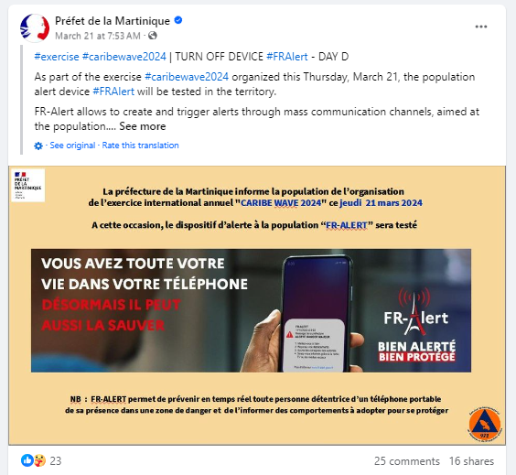
Date of publication: March 21, 2024
Retrieved from:
https://www.facebook.com/prefet.martinique/posts/pfbid0HmCEX8uy391tPmJQc3FnDUiumWpPvHaQLk2Cxt4wvaoTuWNGg9hKXyM5RPHfRrful

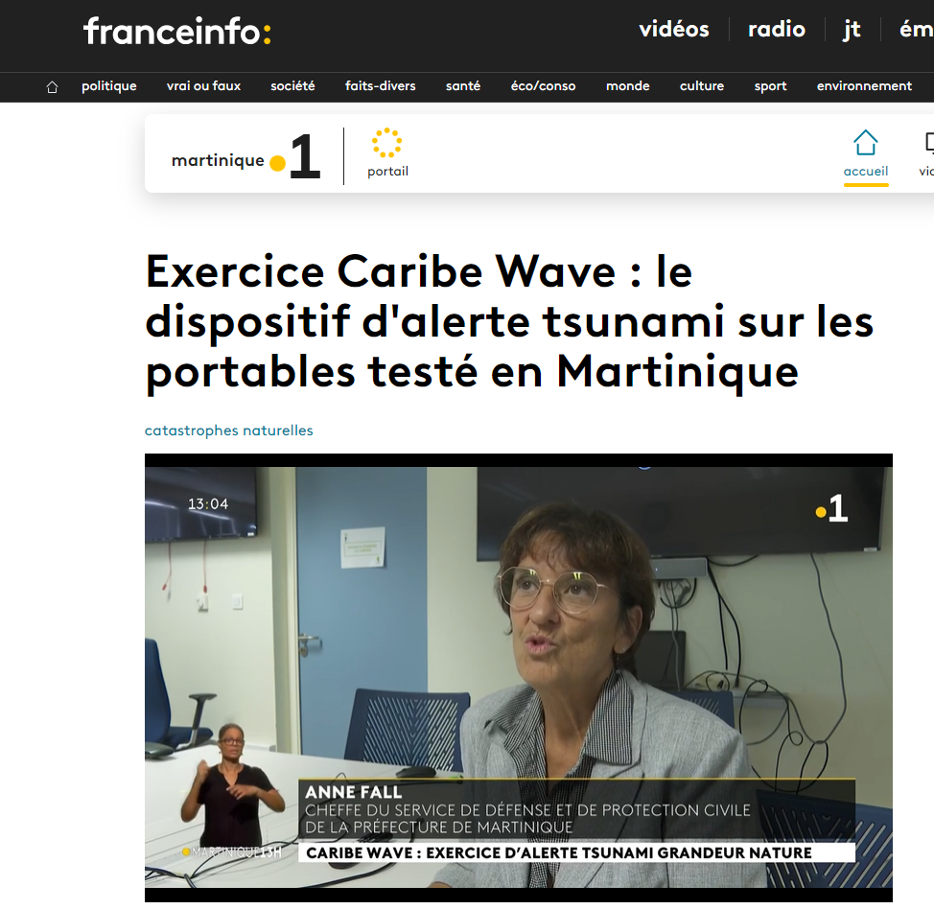
Date of publication: March 21, 2024
Retrieved from: https://la1ere.francetvinfo.fr/martinique/exercice-caribe-wave-le-dispositif-d-alerte-tsunami-sur-les-portables-teste-en-martinique-1474206.html

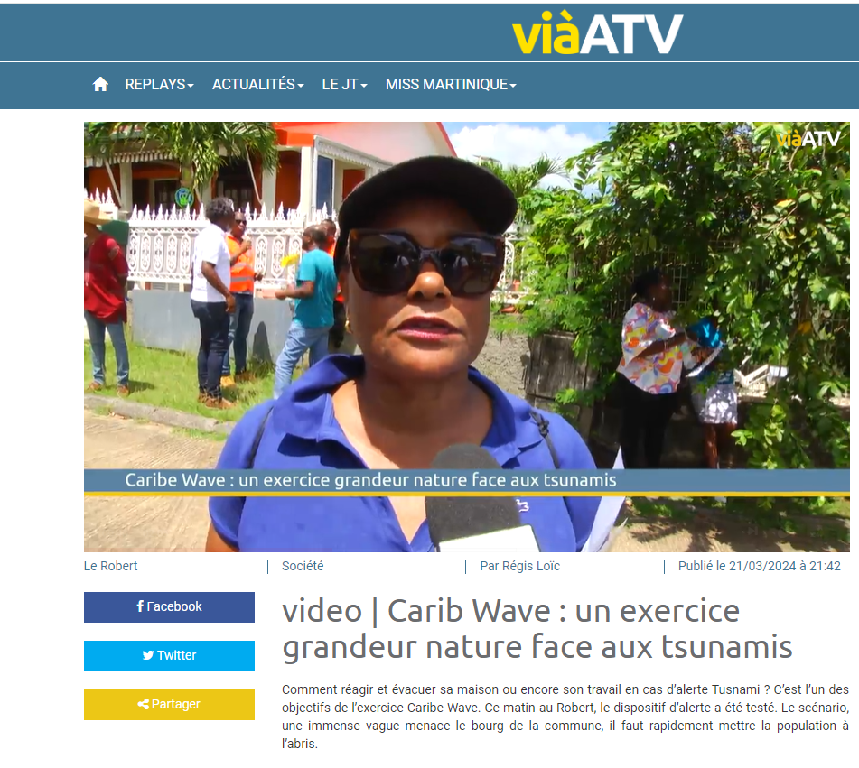
Date of publication: March 21, 2024
Retrieved from: https://viaatv.tv/video-carib-wave-un-exercice-grandeur-nature-face-aux-tsunamis/

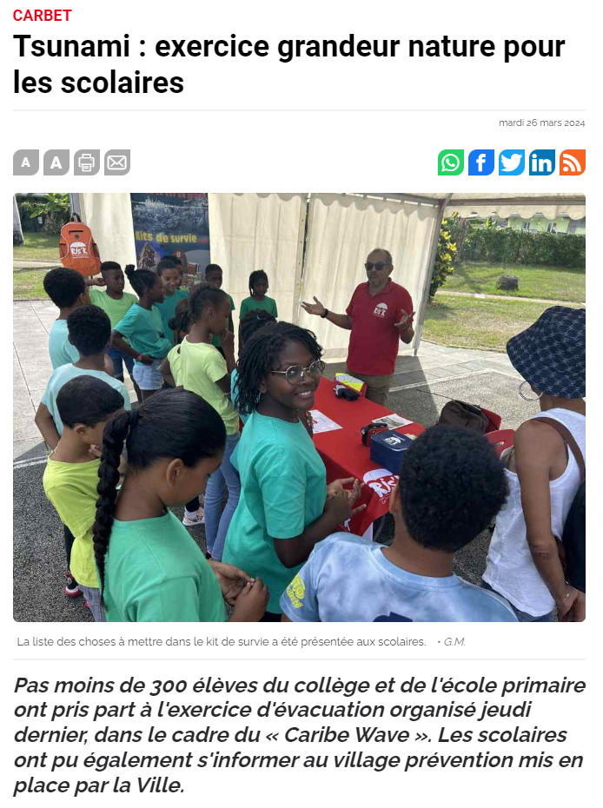
Date of publication: March 26, 2024
Retrieved from: https://www.martinique.franceantilles.fr/actualite/vielocale/tsunami-exercice-grandeur-nature-pour-les-scolaires-980791.php

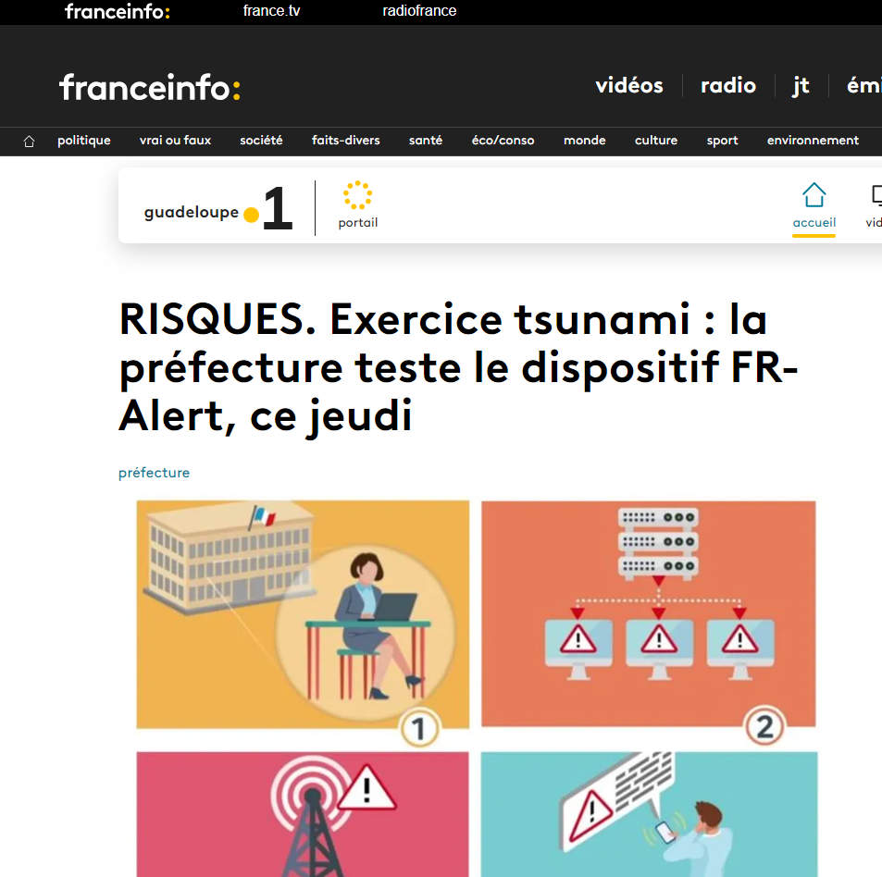
Date of publication: March 21, 2024
Retrieved from: https://la1ere.francetvinfo.fr/guadeloupe/risques-exercice-tsunami-la-prefecture-doit-tester-le-dispositif-fr-alert-ce-jeudi-1473936.html

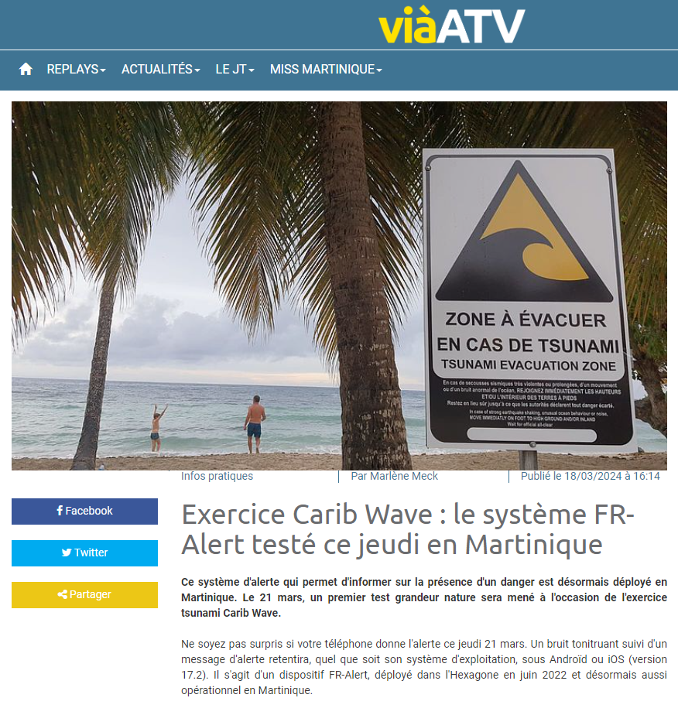
Date of publication: March 18, 2024
Retrieved from: https://viaatv.tv/exercice-carib-wave-le-systeme-fr-alert-teste-ce-jeudi-en-martinique/

Grenada
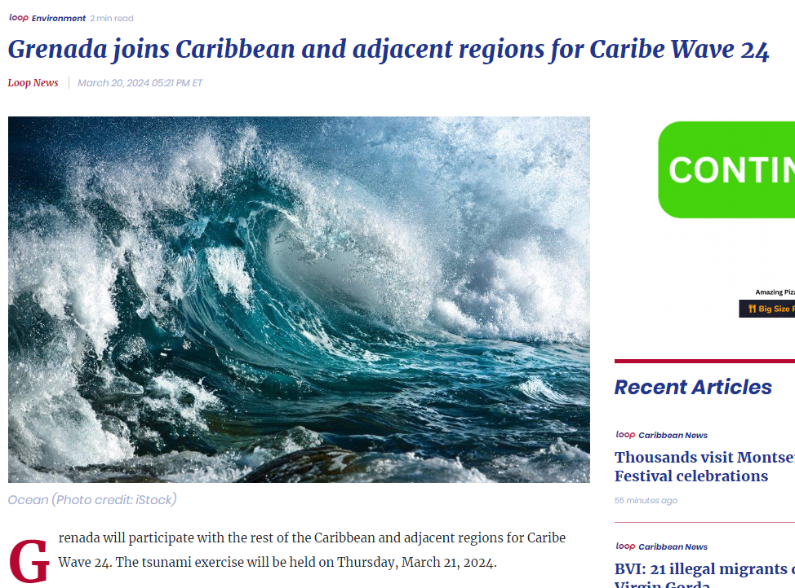
Date of publication: March 20, 2024
Retrieved from:
https://caribbean.loopnews.com/content/grenada-joins-caribbean-and-adjacent-regions-caribe-wave-24

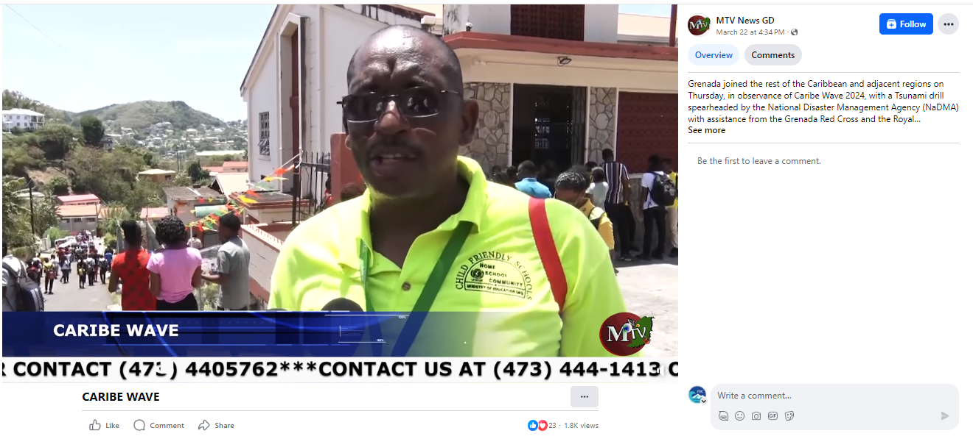
Date of publication: March 22, 2024
Retrieved from: https://fb.watch/r1wkJY72Xb/

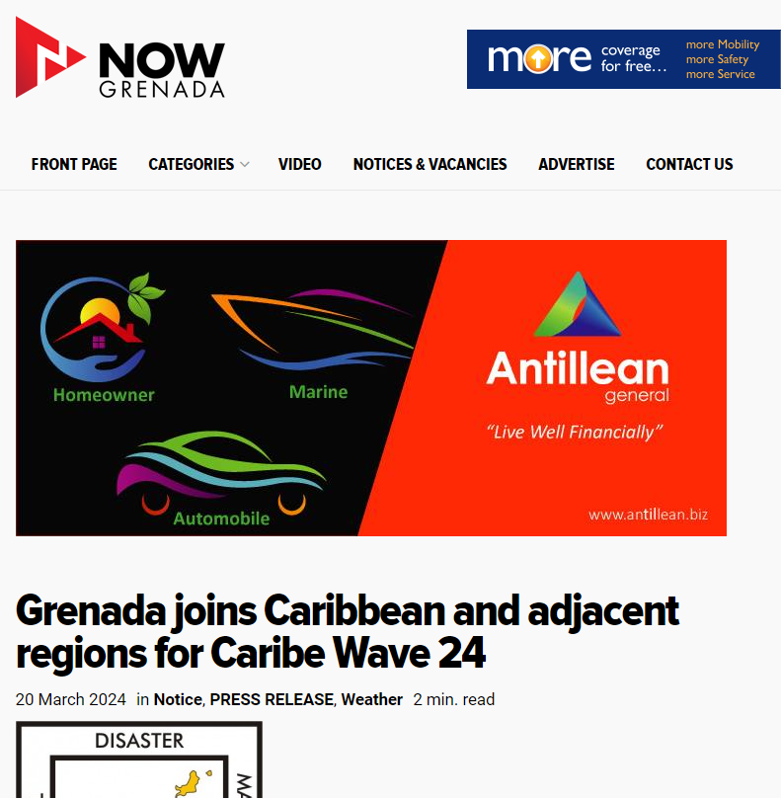
Date of publication: March 20, 2024
Retrieved from:
https://nowgrenada.com/2024/03/grenada-joins-caribbean-and-adjacent-regions-for-caribe-wave-24/

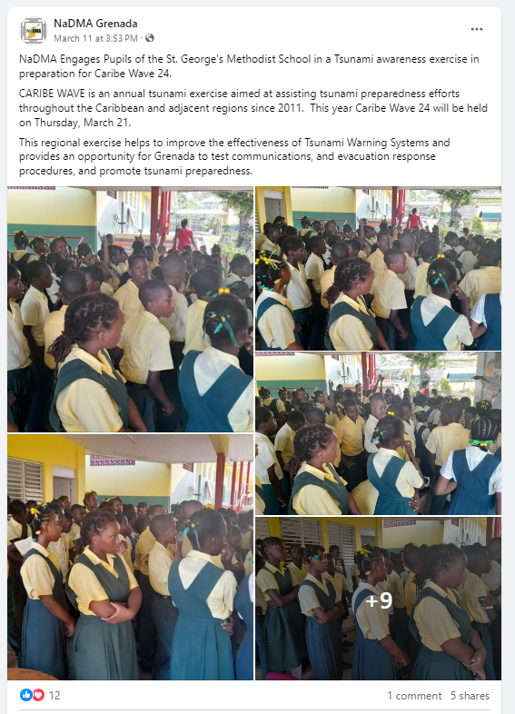
Date of publication: March 11, 2024
Retrieved from:
https://www.facebook.com/nadmagnd/posts/pfbid0Cz8QLy9jmKnf3hXqJ3wsh8ArVDAAxtLv2SSenxpBVPpeP8KjudJHfpksufzJMeJ8l

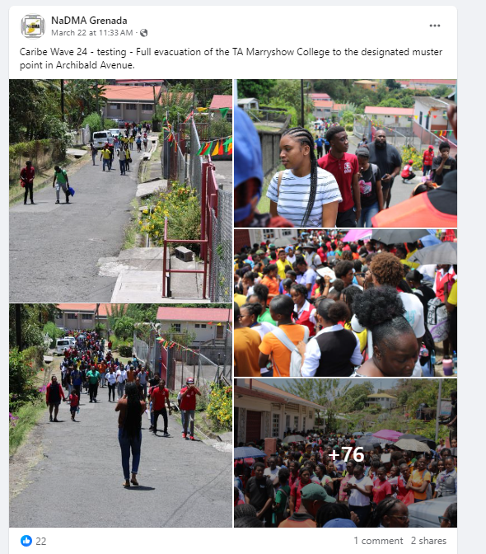
Date of publication: March 22, 2024
Retrieved from:
https://www.facebook.com/nadmagnd/posts/pfbid02KrrUvvRqeZA796uNTdQJsx3GXF2nczthFM5GiMwJKTzeTVvXZXepDZz3rxMcBUh4l

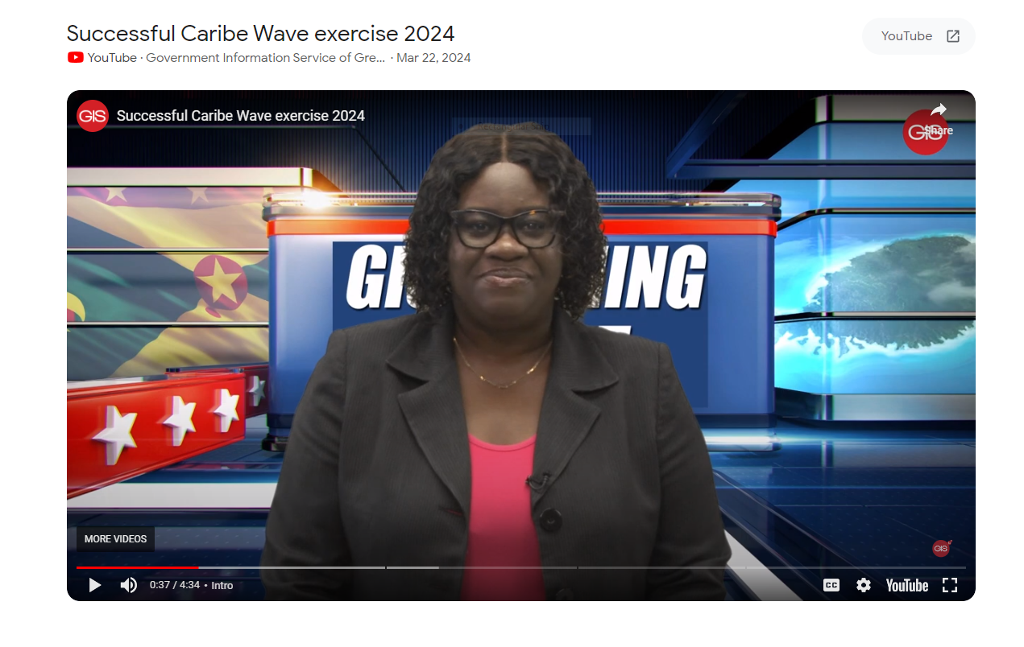
Date of publication: March 22, 2024
Retrieved from:
https://www.google.com/search?q=Caribe+wave+2024#fpstate=ive&vld=cid:43e86586,vid:e6IEyGFEdzI,st:0

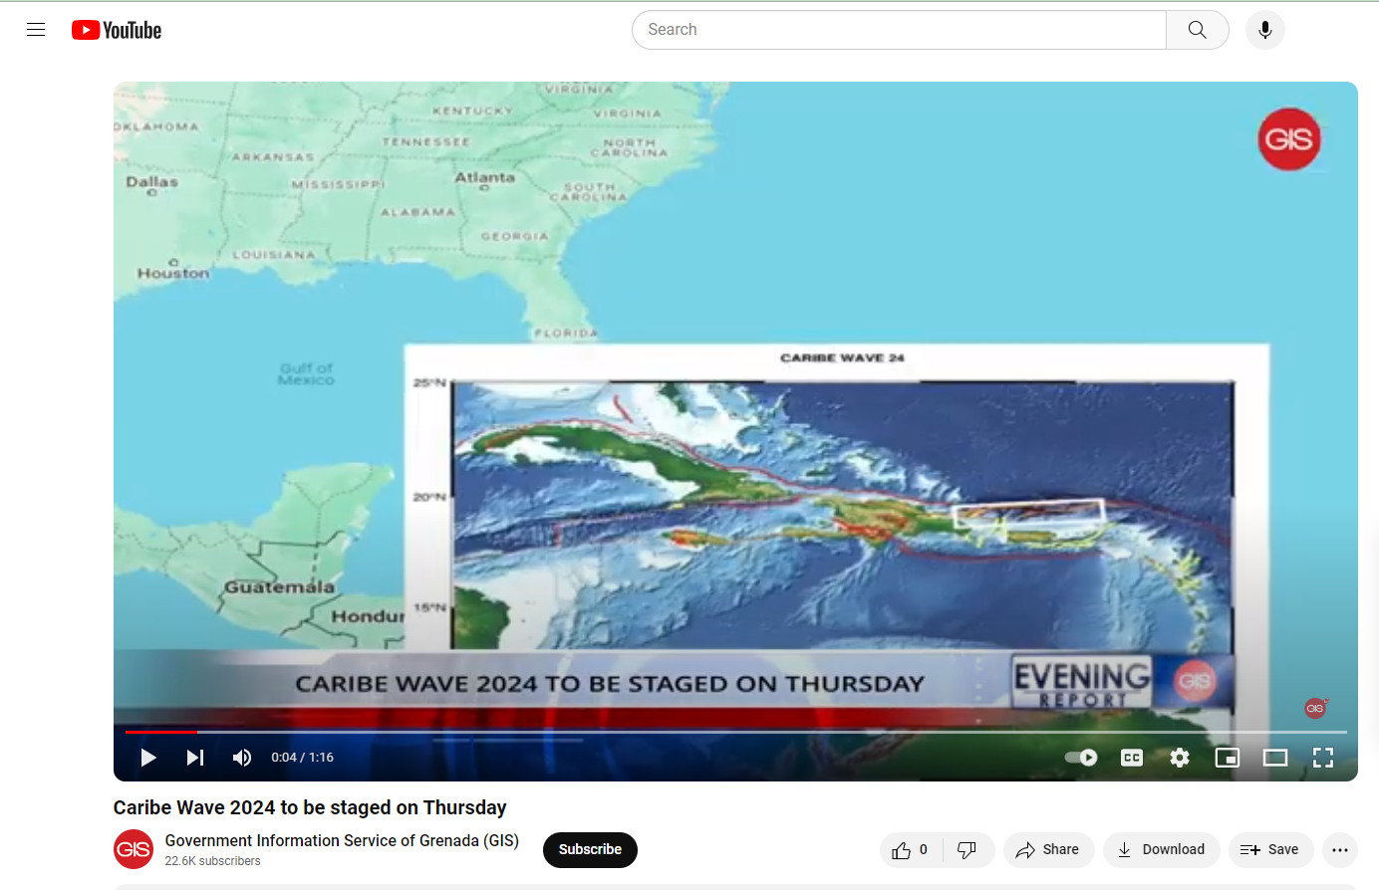
Date of publication: March 21, 2024
Retrieved from: https://www.youtube.com/watch?v=njqXK5hlQjw

Panama
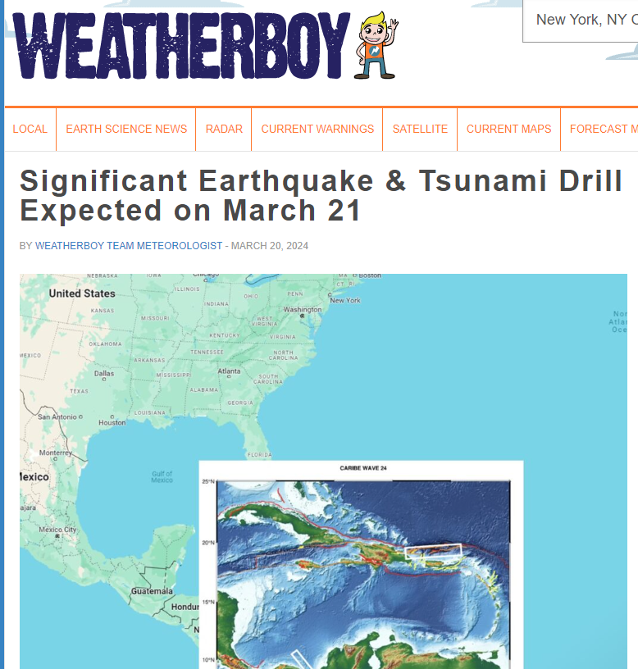
Date of publication: March 20, 2024
Retrieved from: https://weatherboy.com/significant-earthquake-tsunami-drill-expected-on-march-21/

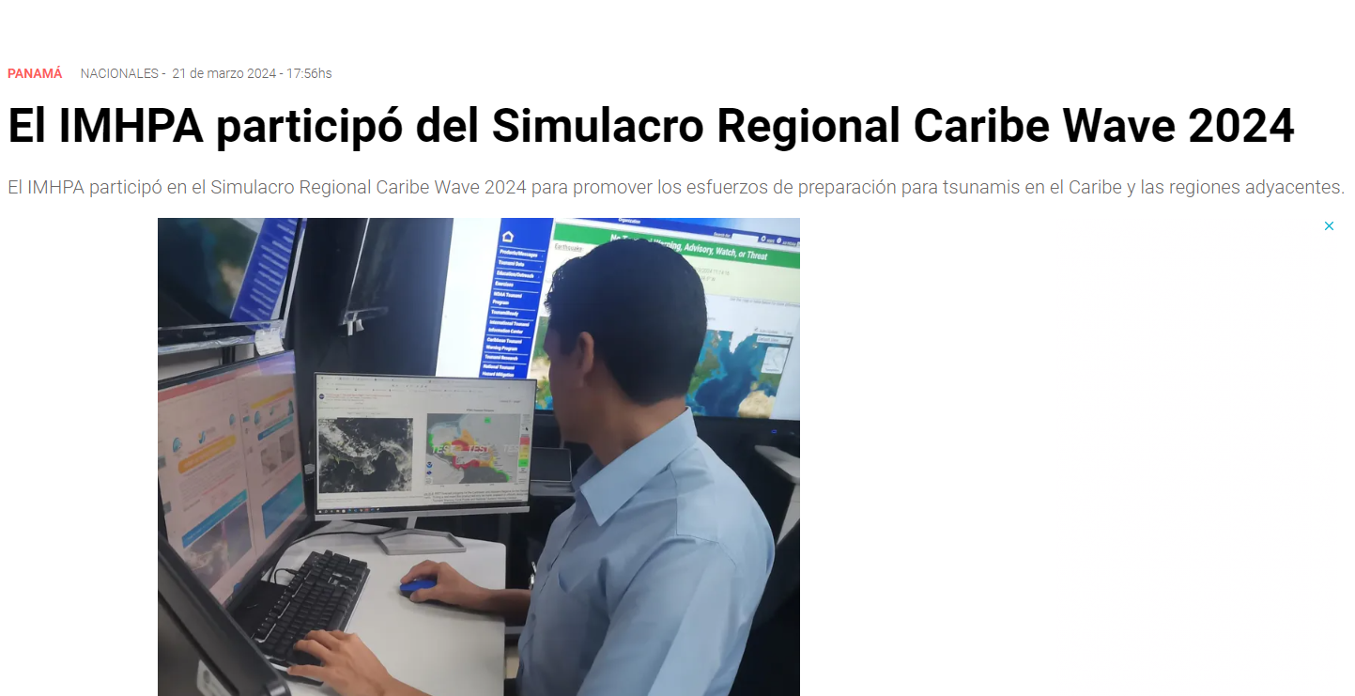
Date of publication: March 21, 2024
Retrieved from:
https://www.telemetro.com/nacionales/el-imhpa-participo-del-simulacro-regional-caribe-wave-2024-n5973557

Saint Kitts and Nevis
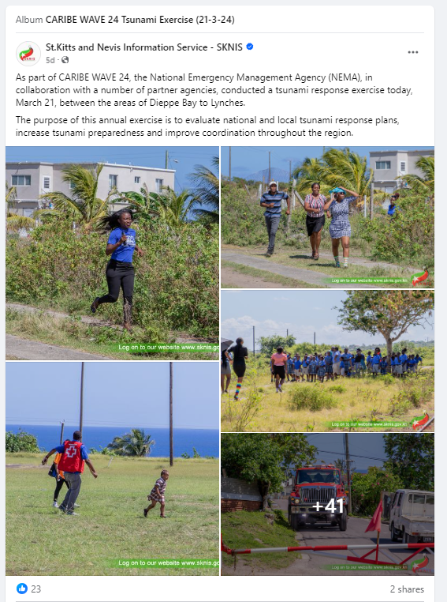
Date of publication: March 21, 2024
Retrieved from:
https://www.facebook.com/sknismedia/posts/pfbid02cnYUxhjxmH8f1LAh6Gocn4rKZH28zQYZjJrknyjeWG4iGDzB8FM8s1j7GH7r5Wryl

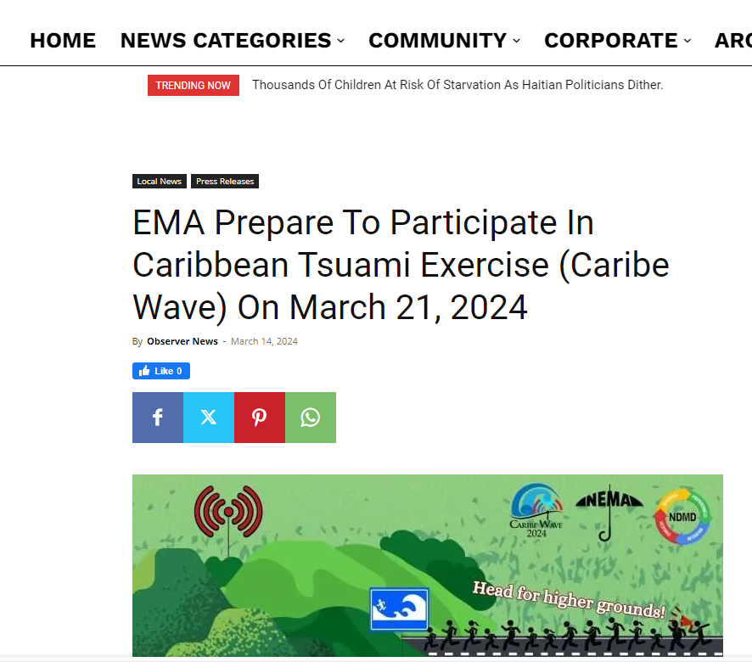
Date of publication: March 14, 2024
Retrieved from:
https://www.thestkittsnevisobserver.com/ema-prepare-to-participate-in-caribbean-tsuami-exercise-caribe-wave-on-march-21-2024/

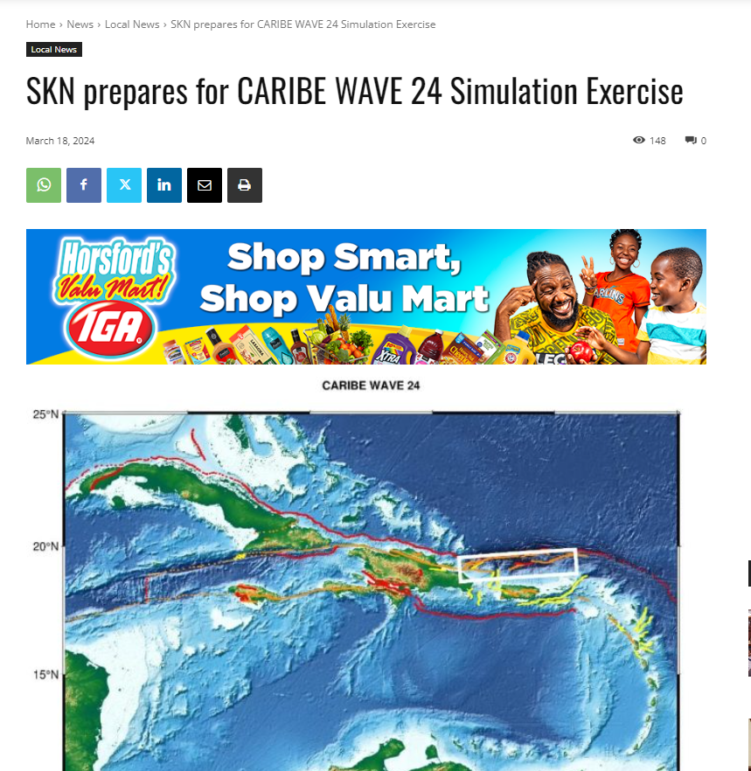
Date of publication: March 18, 2024
Retrieved from: https://www.winnmediaskn.com/skn-prepares-for-caribe-wave-24-simulation-exercise/

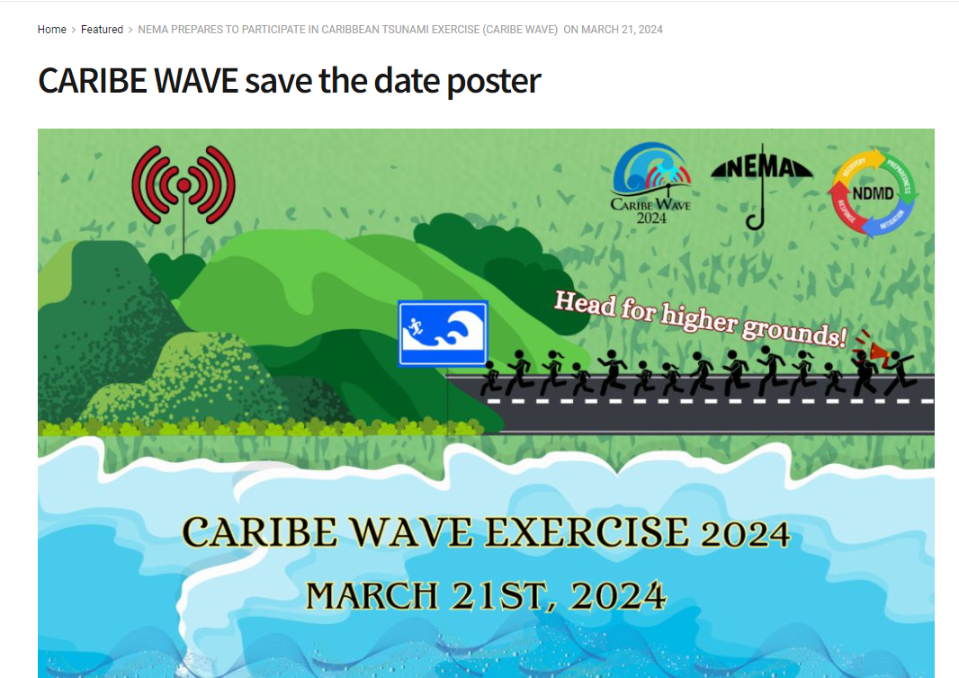
Date of publication: March 21, 2024
Retrieved from:
https://www.sknis.gov.kn/2024/03/14/nema-prepares-to-participate-in-caribbean-tsunami-exercise-caribe-wave-on-march-21-2024/caribe-wave-save-the-date-poster/

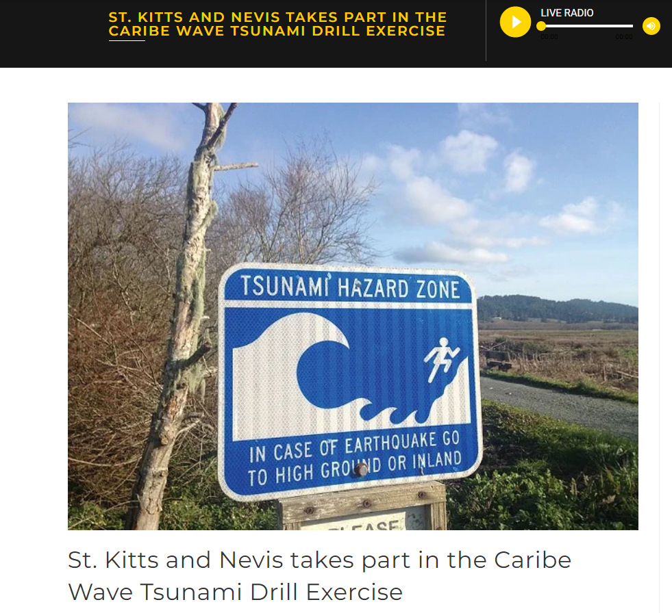
Date of publication: March 24, 2024
Retrieved from: https://vonradio.com/st-kitts-and-nevis-takes-part-in-the-caribe-wave-tsunami-drill-exercise/

Saint Lucia
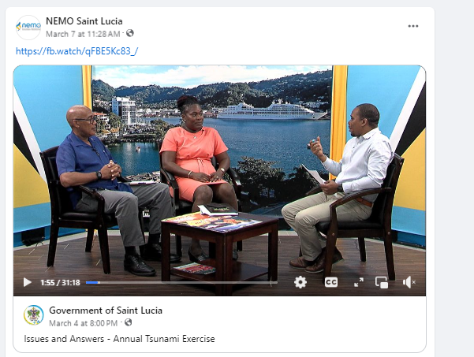
Date of publication: March 4, 2024
Retrieved from: https://fb.watch/rdcnhFg7zy/

Saint Vincent and the Grenadines
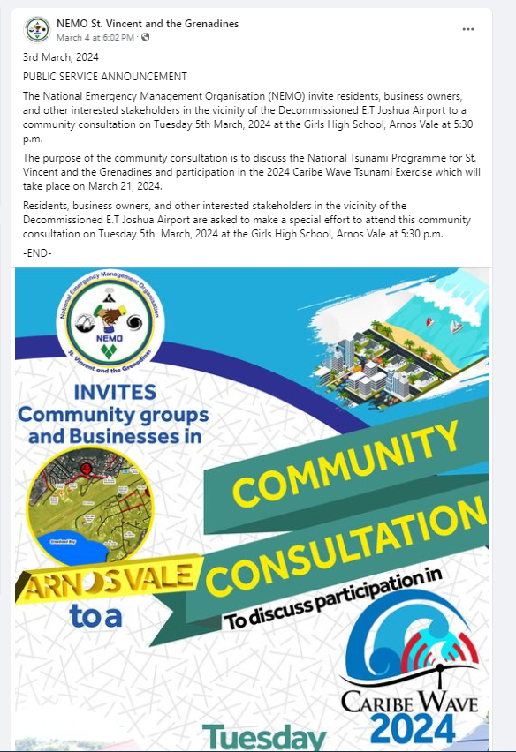
Date of publication: March 4, 2024
Retrieved from:
https://www.facebook.com/nemosvg/posts/pfbid027ooLAQjMK9eiGXZUMVhQwmDE3sh8grCAdMbAPQXs17kpYXdVwYtxKLgArH4nknntl

Turks and Caicos
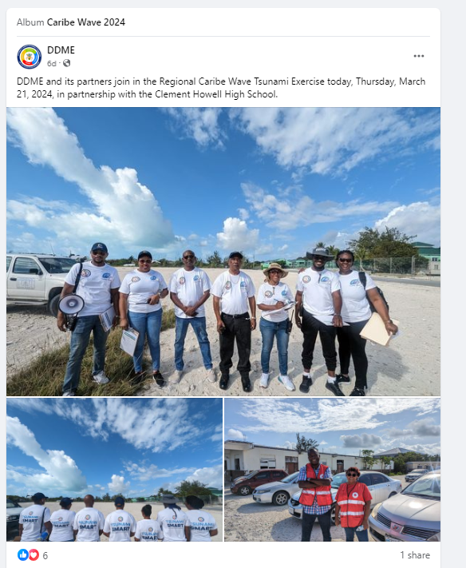
Date of publication: March 21, 2024
Retrieved from:
https://www.facebook.com/TCI.DDME/posts/pfbid09a8XKXpLdMvW9YtPXJeF9WNZofv7nyXcs2zaSTyGSrikvykv3QqW7d9noME6CLxRl

Trinidad and Tobago
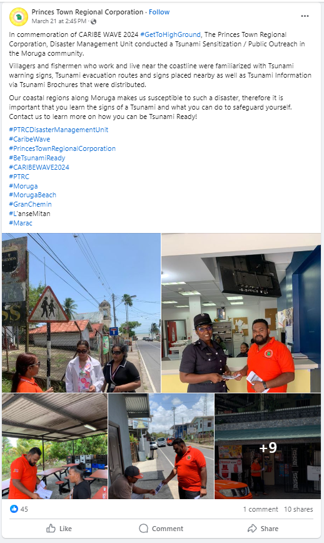
Date of publication: March 21, 2024
Retrieved from: https://www.facebook.com/PrincesTownRegionalCorporation/posts/pfbid02ZamywVf7veU5ro1oQi4mNyrgefs6fa3GZT8tfXGLPpgp7bKf66DGDG2PHmRDz4jGl

United Kingdom:

British Virgin Islands
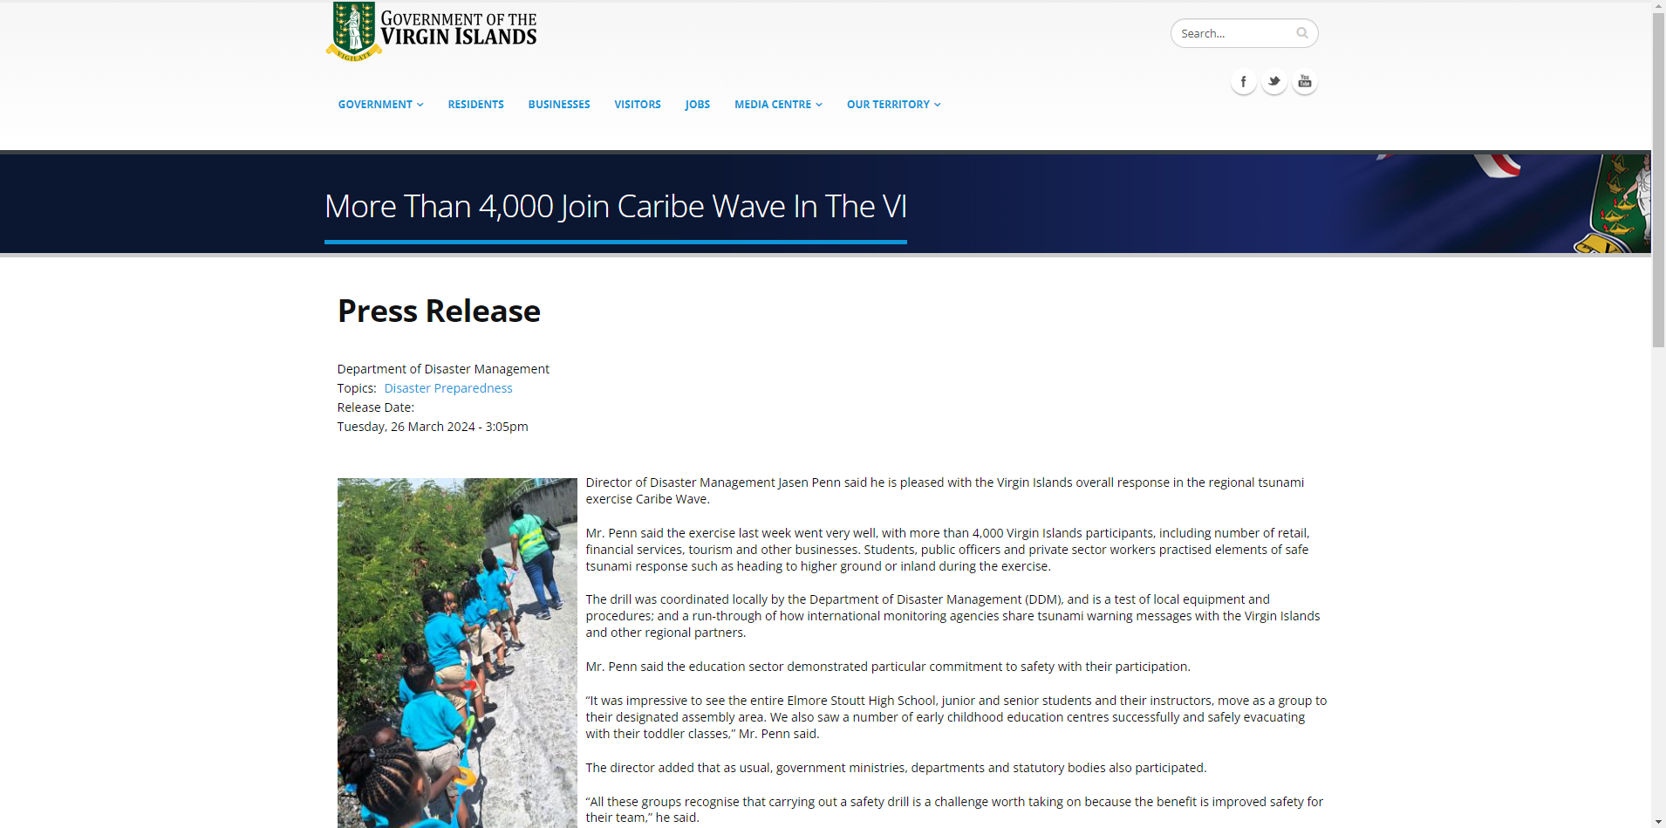
Date of publication: March 26, 2024
Retrieved from: https://bvi.gov.vg/media-centre/more-4000-join-caribe-wave-vi

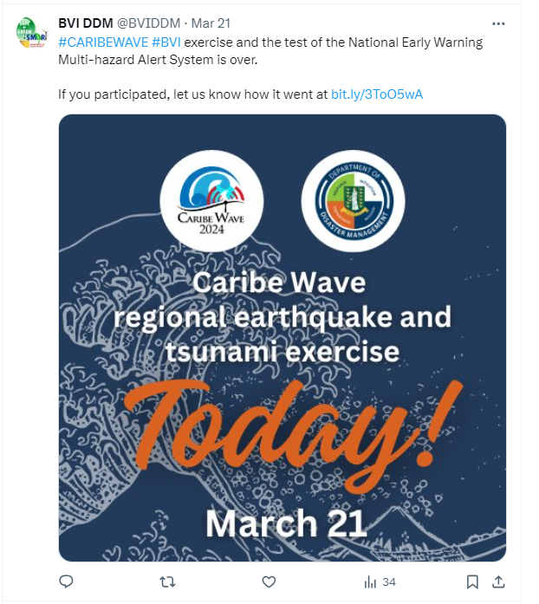
Date of publication: March 24, 2024
Retrieved from: https://x.com/BVIDDM/status/1770827711667376128?s=20

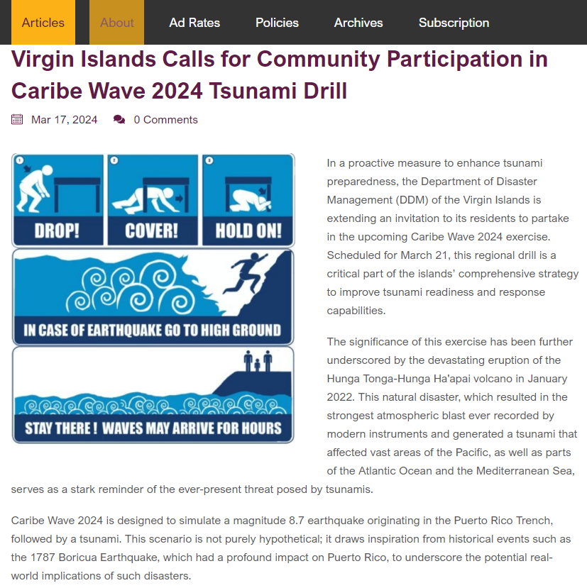
Date of publication: March 17, 2024
Retrieved from:
https://www.gbmediahouse.com/Articles/Article/468/Virgin-Islands-Calls-for-Community-Participation-in-Caribe-Wave-2024-Tsunami-Drill

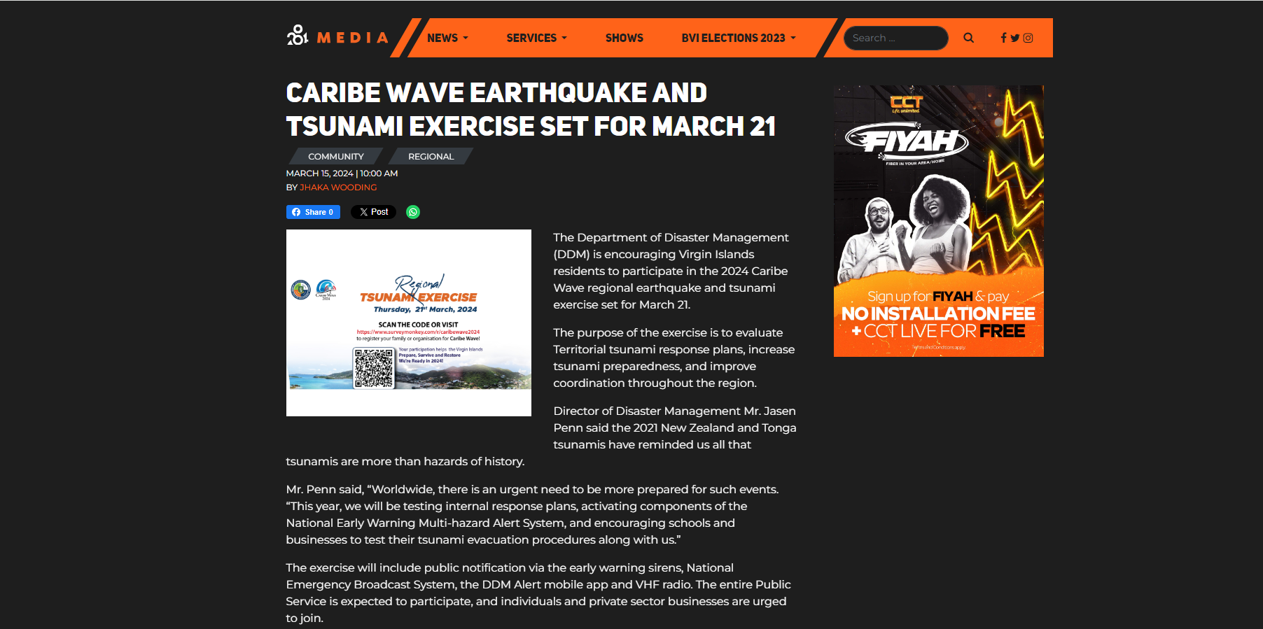
Date of publication: March 15, 2024
Retrieved from:
https://www.284media.com/community/2024/03/15/caribe-wave-earthquake-and-tsunami-exercise-set-for-march-21/

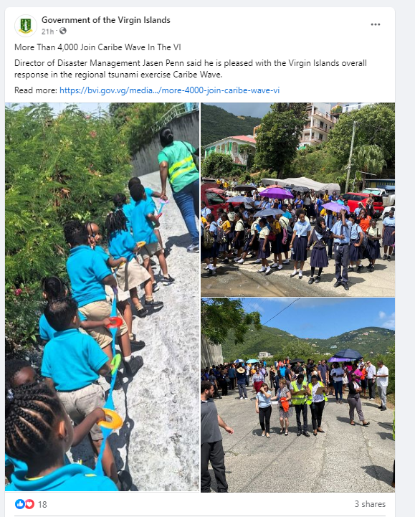
Date of publication: March 26, 2024
Retrieved from:
https://www.facebook.com/BVIGovernment/posts/pfbid033aJ29bBpubdA2WFyLVtg2LBp55cpEmXXpxwGZBYqspWo2H9NAeMhghCCmUWSQX5el

Cayman Islands
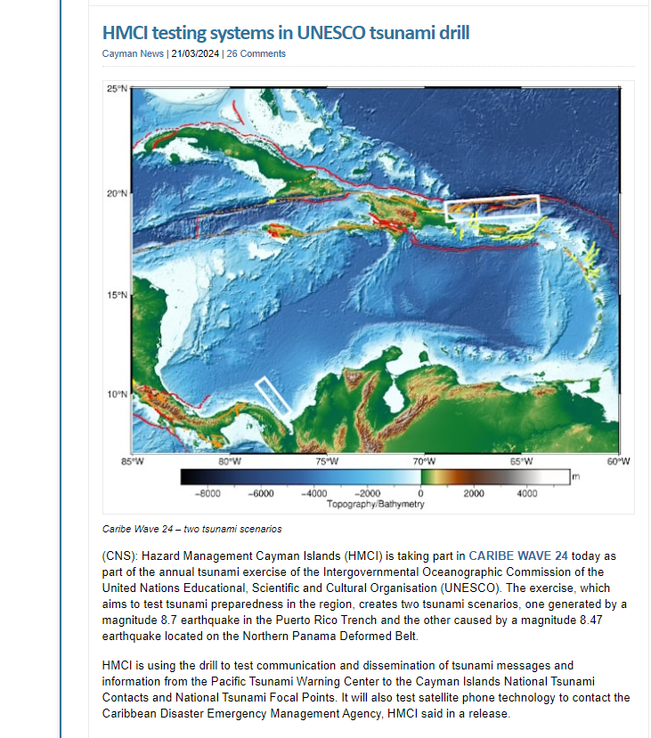
Date of publication: March 21, 2024
Retrieved from: https://caymannewsservice.com/2024/03/hmci-testing-systems-in-unesco-tsunami-drill/

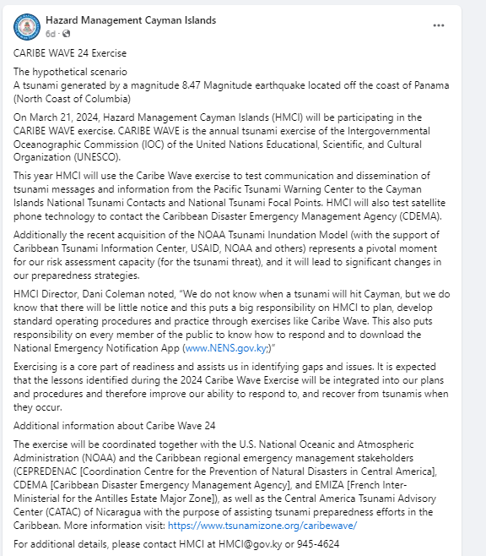
Date of publication: March 20, 2024
Retrieved from:
https://www.facebook.com/caymanprepared/posts/pfbid02qhiyZmaoYFanw9acLFfMLpk476DzPriaicPiGnWDkCFFDfbztwdX8tmSUjAsPim1l

Montserrat
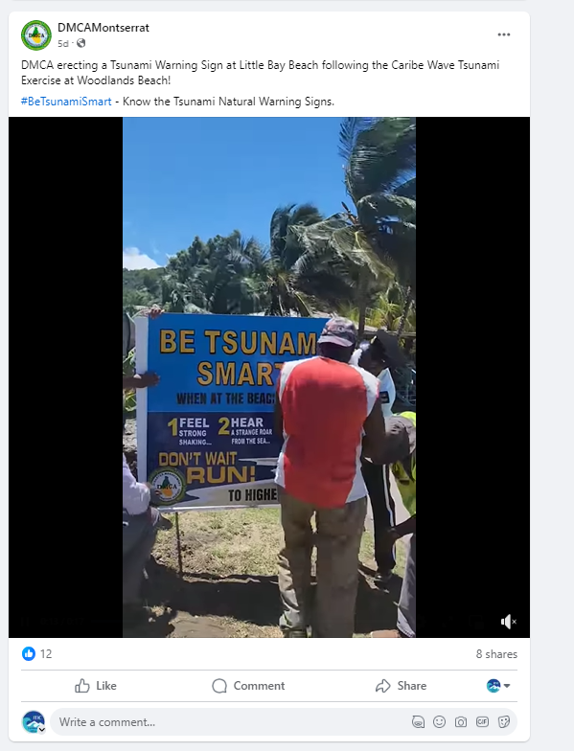
Date of publication: March 22, 2024
Retrieved from: https://www.facebook.com/reel/448922977562568

United States:

Puerto Rico
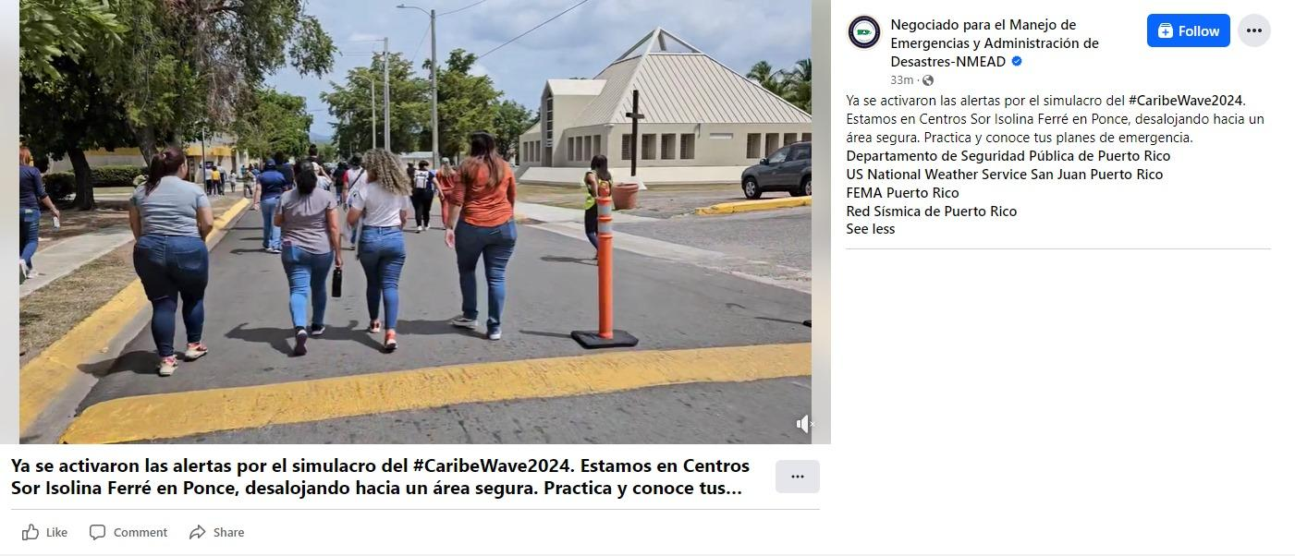
Date of publication: March 21, 2024
Retrieved from: https://fb.watch/qY3zIntXX6/

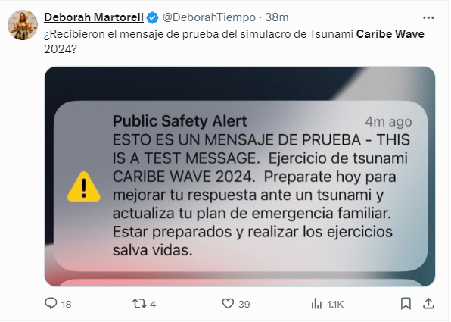
Date of publication: March 21, 2024
Retrieved from: https://x.com/DeborahTiempo/status/1770829801781096679?s=20

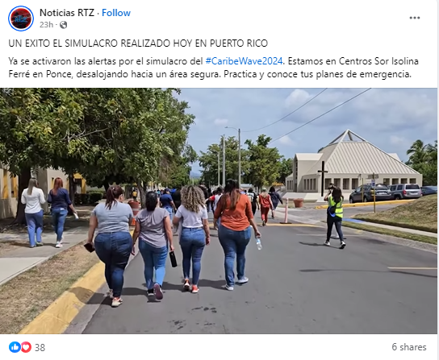
Date of publication: March 21, 2024
Retrieved from: https://fb.watch/qZl_UoBlCV/

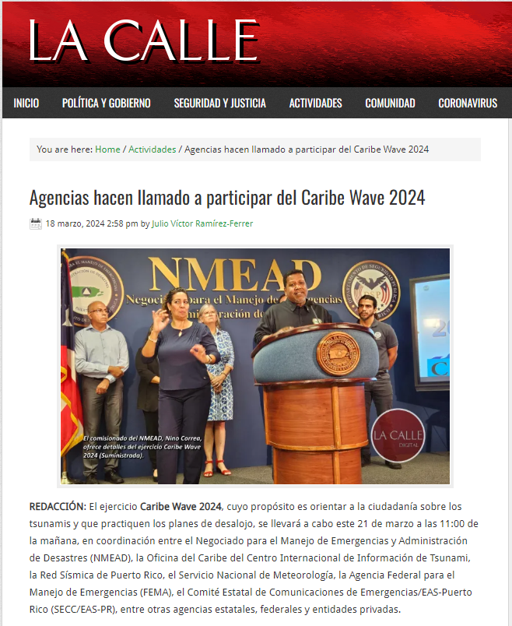
Date of publication: March 18, 2024
Retrieved from:
http://lacallerevista.com/portada/agencias-hacen-llamado-a-participar-del-caribe-wave-2024/74178?fbclid=IwAR2vGY7Aw9daNglSeAk5Wu6Mul8hU7MefZloCYAfPJDKsnfiSzBE61gzpLc

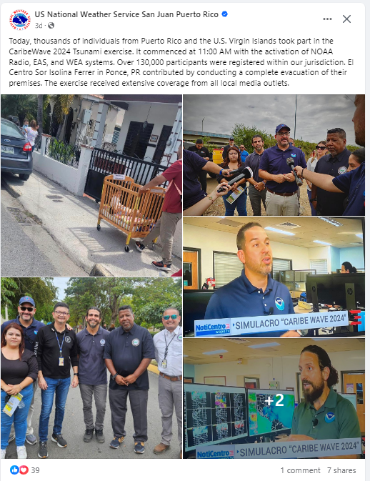
Date of publication: March 21, 2024
Retrieved from:
https://www.facebook.com/NWSSanJuan/posts/pfbid02XG7yp5MCvgX5zvqcCuHgqqmwbZTd6beXHF7ixenjz1A719mx56ZGaeC8n7nB3WLel

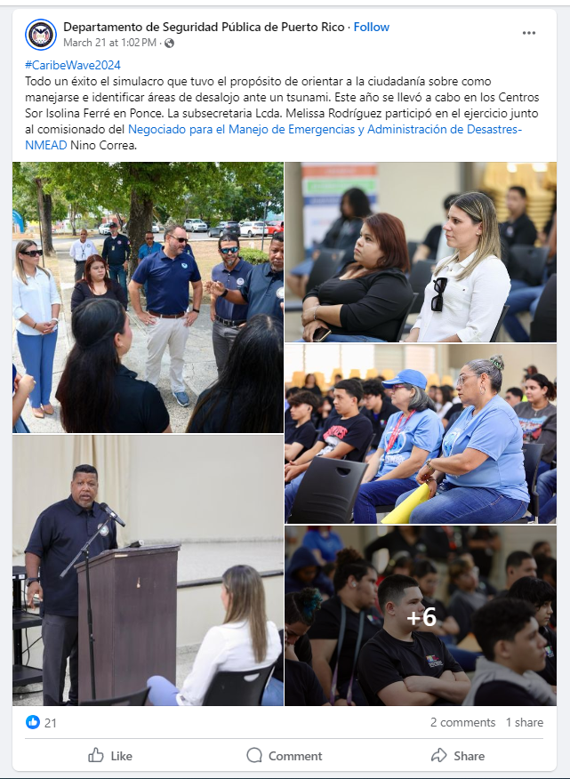
Date of publication: March 21, 2024
Retrieved from:
https://www.facebook.com/DSPnoticias/posts/pfbid021DTKXdmHFgW5aX9h5CeAS2jg6YesjnFXk8PGqqtukweKfiKR96uBHfkBjLesPeiEl

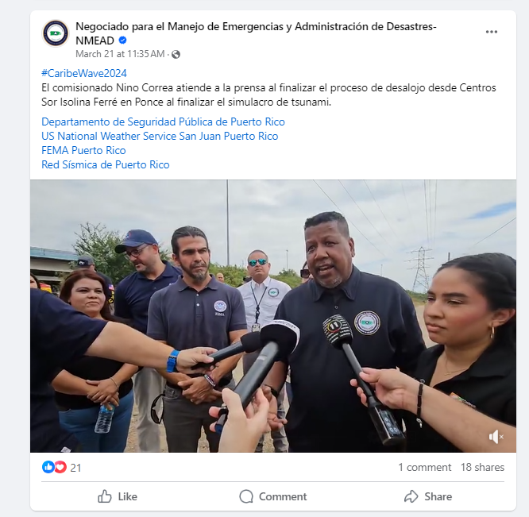
Date of publication: March 21, 2024
Retrieved from: https://fb.watch/rbSS8OHKSh/

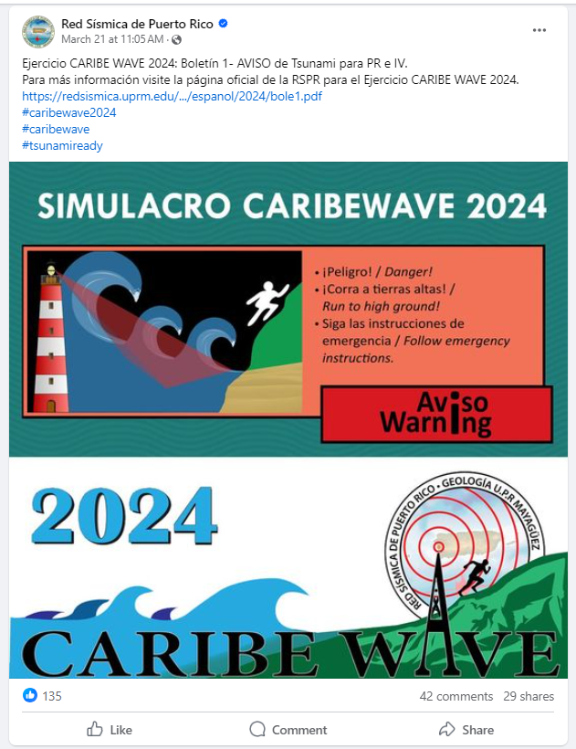
Date of publication: March 21, 2024
Retrieved from:
https://www.facebook.com/redsismicadepuertorico/posts/pfbid02XGZGUR66xipXRjsNRvAN5CGWnBcpYMU6SR5Ho5c1gpodm1GCjRX3H35k2R1iABnCl

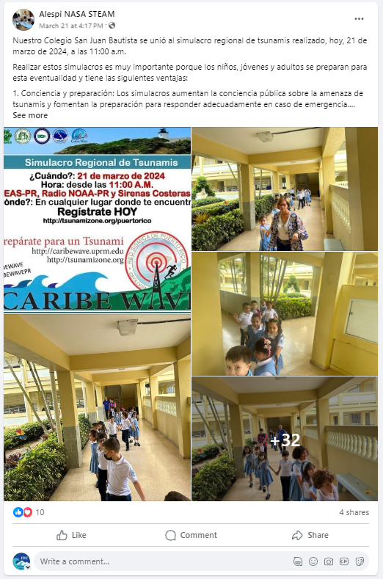
Date of publication: March 21, 2024
Retrieved from: https://www.facebook.com/permalink.php?story_fbid=pfbid02MYAAhnyjJib3HuFPCLeu3gPN68B1Bfwhwr5qikSFKeDNcRxR7MqjW1R1Sm3cnB23l&id=100064311303419

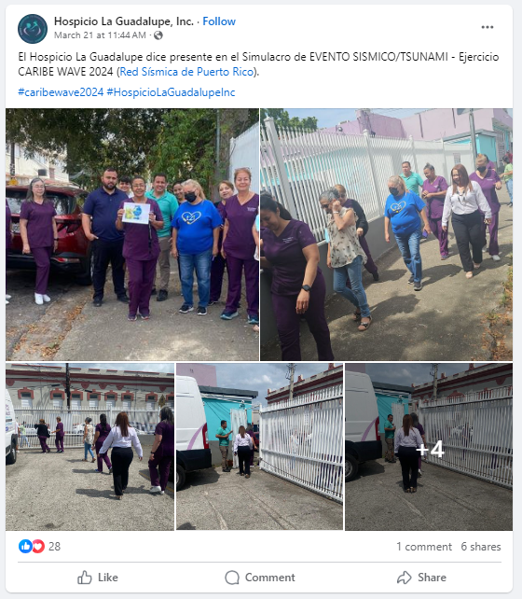
Date of publication: March 21, 2024
Retrieved from:
https://www.facebook.com/hospiciolaguadalupepr/posts/pfbid02RNqaF2tCFX1hjNR9Ccz5s4N8thhnTMVSK8qMTERUhmKVdDN8WJjVGQv7oFfwdxUTl

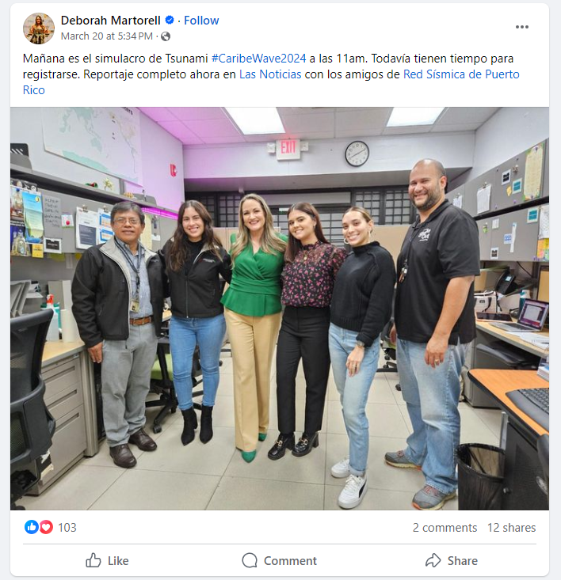
Date of publication: March 20, 2024
Retrieved from:
https://www.facebook.com/martorell.deborah/posts/pfbid0G9Grk5UtUn7r1i6R4umLZewcDRHFJx5r2Z6rr6NNz8d2NByyDomn35bxapsog4AFl

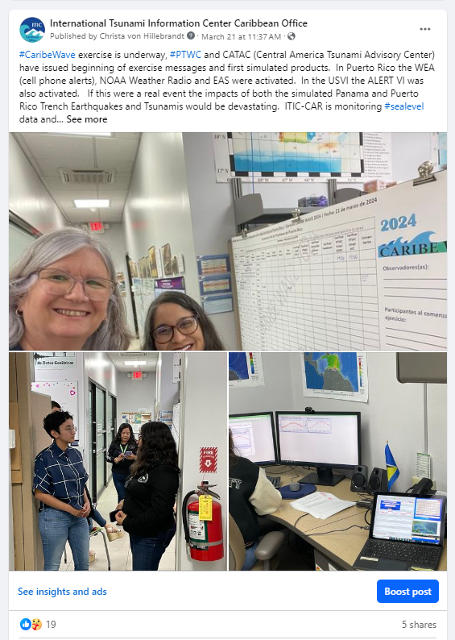
Date of publication: March 21, 2024
Retrieved from: https://www.facebook.com/NWS.ITICCAR/

U.S. Virgin Islands
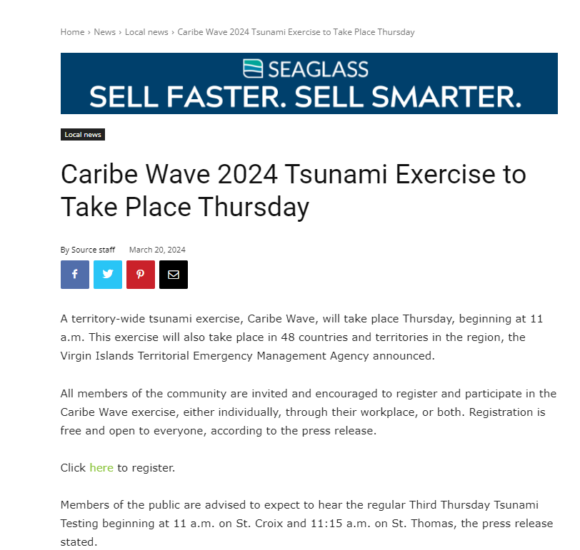
Date of publication: March 20, 2024
Retrieved from: https://stthomassource.com/content/2024/03/20/caribe-wave-2024-tsunami-exercise-to-take-place-thursday/

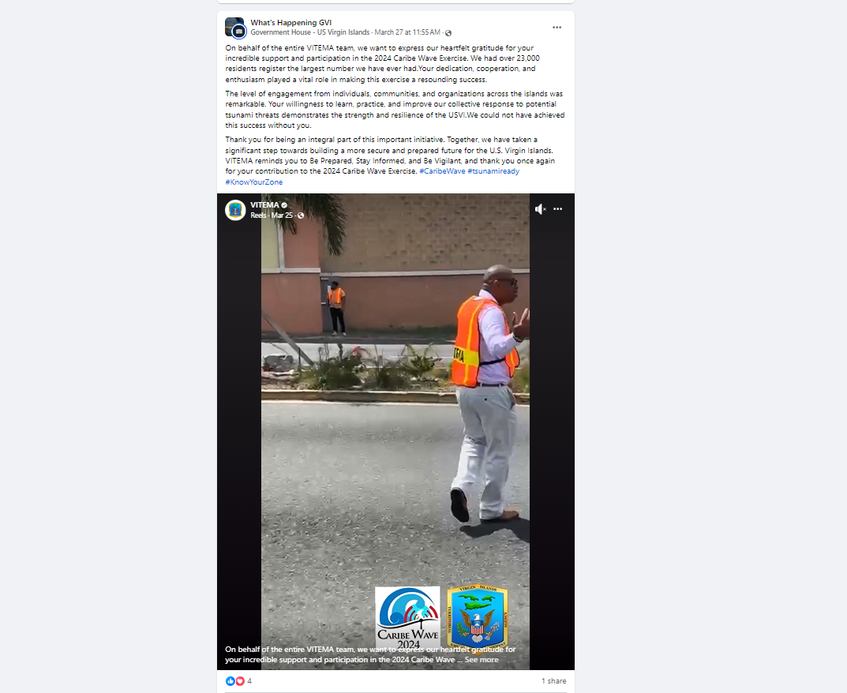
Date of publication: March 27, 2024
Retrieved from: https://www.facebook.com/groups/854448499708910/permalink/928991132254646/

Venezuela
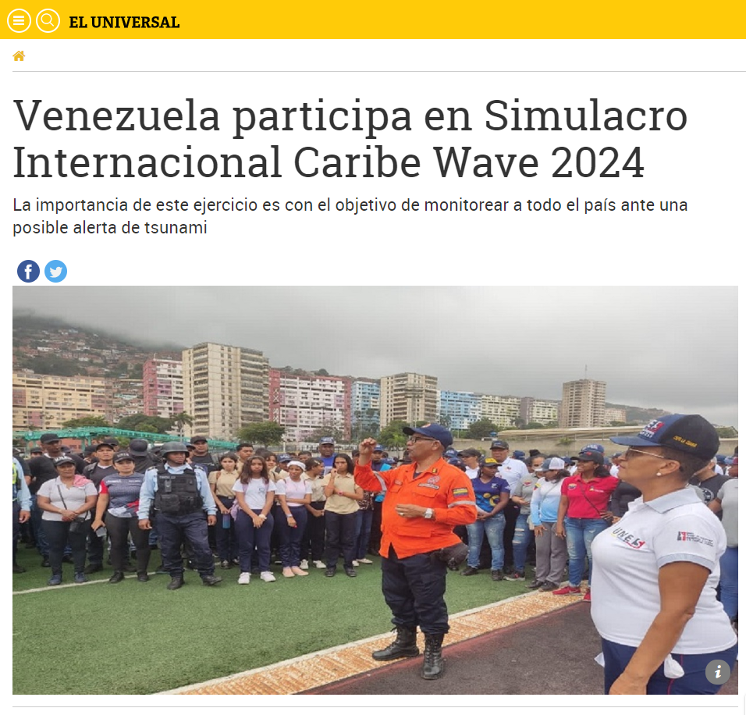
Date of publication: March 22, 2024
Retrieved from:
https://www.eluniversal.com/venezuela/177734/venezuela-participa-en-simulacro-internacional-caribe-wave-2024?fbclid=IwAR0vMHm0-iCXfU6PoG-zThneBkFbiqoJ6zuEbR3pbfpYfUlsjrSYq3H5Pa0

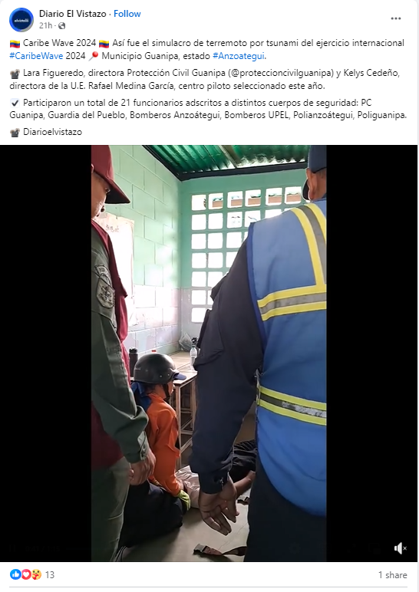
Date of publication: March 21, 2024
Retrieved from: https://www.facebook.com/reel/1171074220725493

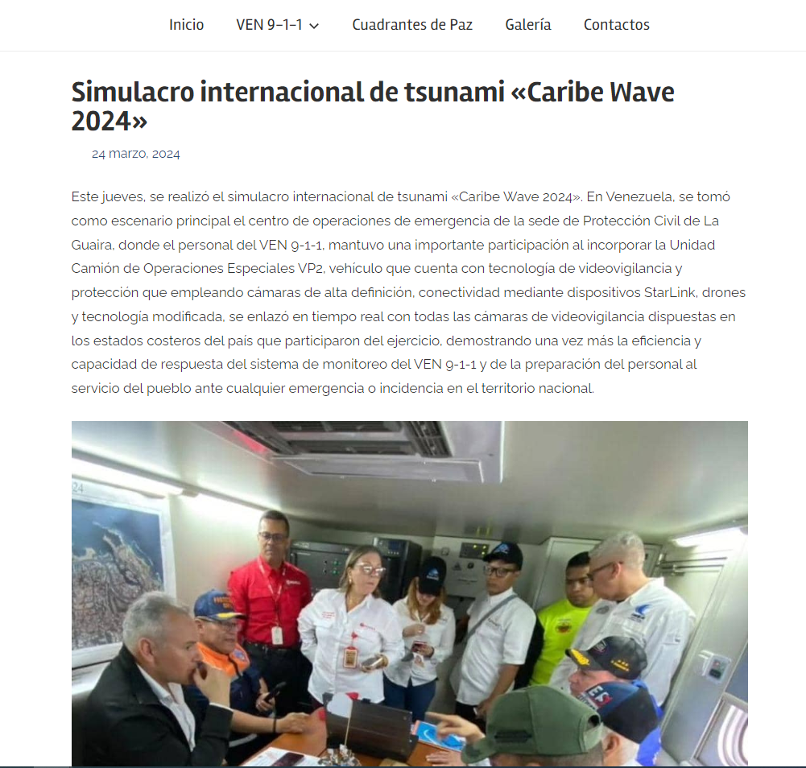
Date of publication: March 24, 2024
Retrieved from: https://ven911.gob.ve/?p=6066

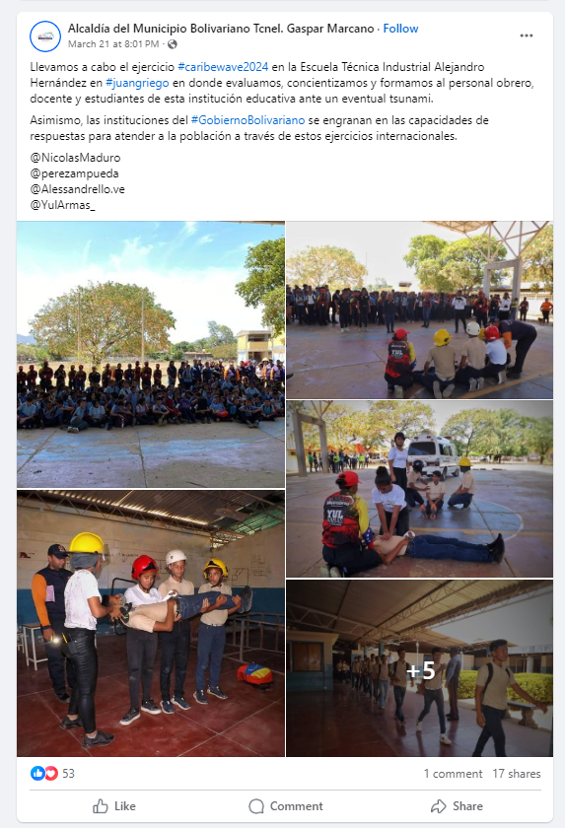
Date of publication: March 21, 2024
Retrieved from: https://www.facebook.com/permalink.php?story_fbid=pfbid0J32fbHiBotTXW7V4EMy3zzpRgUX5M2oo74JcTyVjh3LNqpZMmjTbxhLLp9PkZ5dhl&id=100080248325542

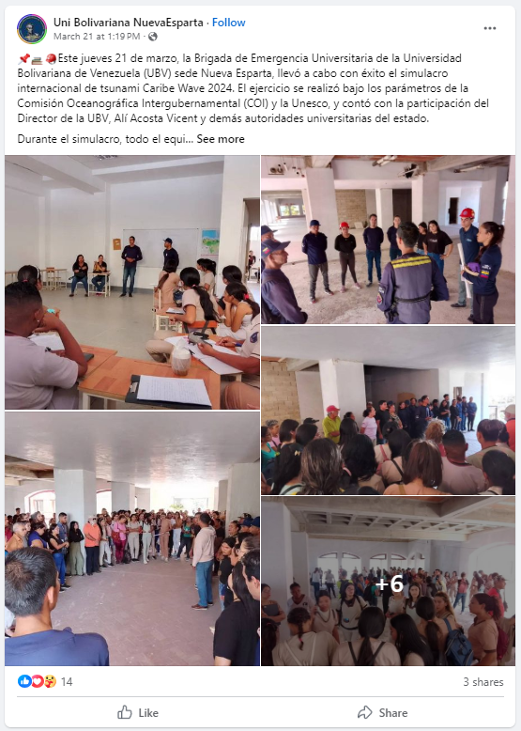
Date of publication: March 21, 2024
Retrieved from:
https://www.facebook.com/unibolibariana.nuevaesparta/posts/pfbid0WsBp2GUViizvZQ4QaDy8KhLCGe2s823Nh9AC7cgEamrUN51k4SGE8PQwzoPNYGERl

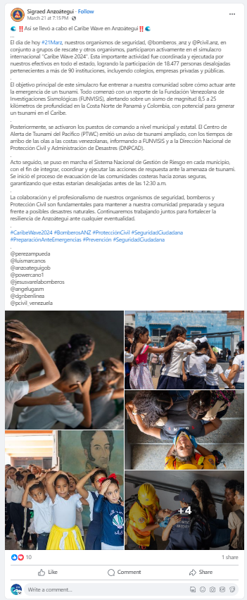
Date of publication: March 21, 2024
Retrieved from:
https://www.facebook.com/permalink.php?story_fbid=pfbid0n3XgoyPmJuaqPZKaYkV7z353ctg8AsCvpL3FGuUkYWeHng4mQ4Kio5noxWmgjyGul&id=100067445795615

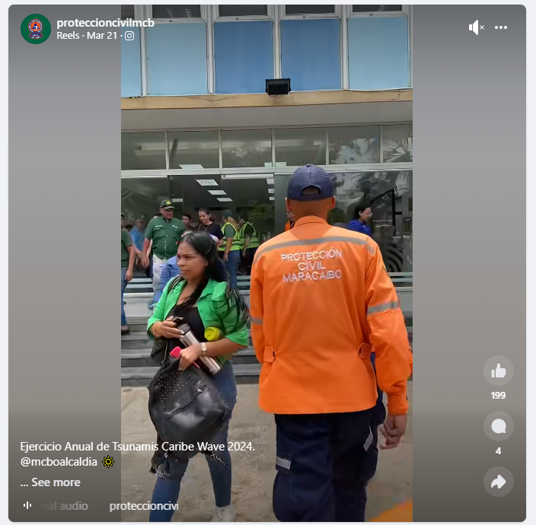
Date of publication: March 21, 2024
Retrieved from: https://www.facebook.com/reel/810407494454390

