NATIONAL REPORT
Submitted by Antigua and Barbuda

BASIC INFORMATION

- ICG/CARIBE EWS Tsunami National Contact (TNC)

Name: Sherrod James
Title: Director
Organization: National Office of DisasterServices
Postal Address: P.O.Box 1399, St Johns, Antigua W.I.
E-mail Address: sherrod.james@ab.gov.ag/
nods.anu@ab.gov.ag/
nodsanu@gmail.com
Telephone Number: 1(268) 562-2144
Fax Number: 1(268) 462-4742
Cellular Telephone Number: 1(268)464-8457
- ICG/CARIBE EWS Tsunami Warning Focal Point (TWFP)/ National Tsunami Warning Centre

Name: Dale Destin
Title: Director
Responsible Organization: Antigua and Barbuda Meteorological Services
Postal Address:
E-mail Address: dale.destin@ab.gov.ag/
metoffice@ab.gov.ag
Emergency Telephone Number: 1(268) 462-3017/0930
Emergency Fax Number:
Emergency Cellular Telephone Number:

ILLUSTRATION - ANTIGUA & BARBUDA TWFP/TWCP SOP’s
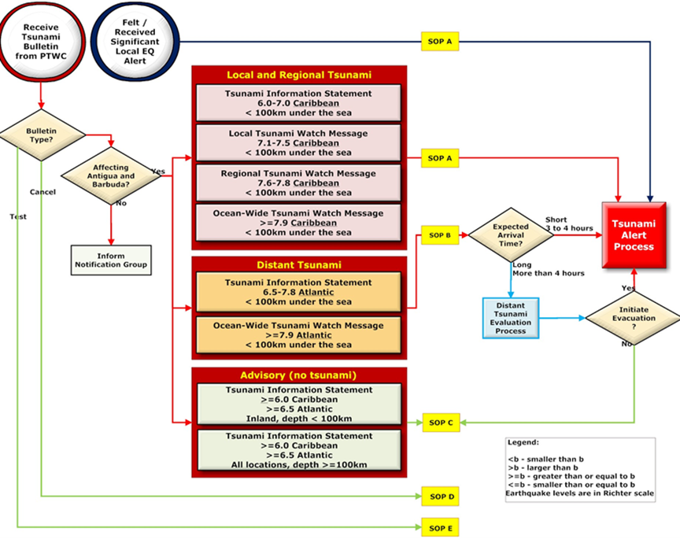

4. Tsunami Standard Operating Procedures for a Local Tsunami (when a local tsunami threat exists, less than 1 hour travel time)
- SOP A: For any potential Caribbean generated tsunami whether it is considered local or regional.

5. Tsunami Standard Operating Procedures for a Regional Tsunami (when a regional tsunami threat exists, 1–3 hour travel time)
- SOP A: For any potential Caribbean generated tsunami whether it is considered local or regional.

6. Tsunami Standard Operating Procedures for a Distant Tsunami (when a distant tsunami threat exists, more than 3-hour travel time)
- SOP B: For any potential Atlantic generated tsunami (distant tsunami) and in the event of early notification of a potential volcanic eruption which may result in sea water displacement.

ILLUSTRATION 1. ANTIGUA & BARBUDA ADAPTED TSUNAMI WARNING PROTOCOL

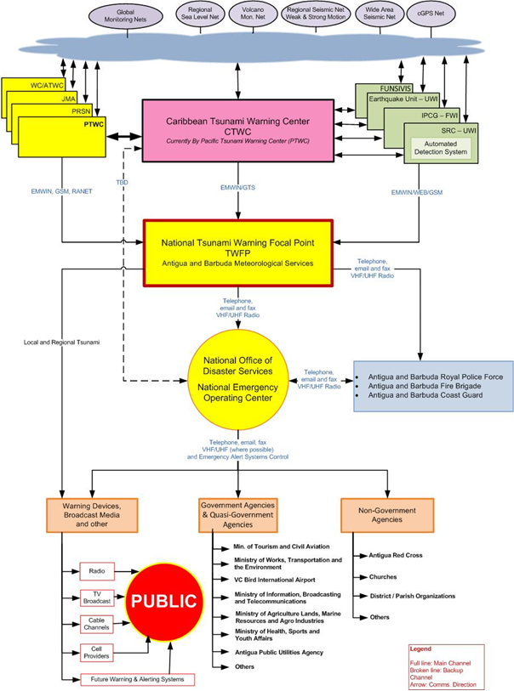
- What organization identifies and characterizes tsunamigenic events?
  - Regional - PTWC and UWI Seismic REaserch,
  - Nationally - ABMet services and National Officeof Disaster Services
- What is the threshold or criteria for declaring a potential tsunami emergency?
  - Magnitude
    - Local - Event in the Caribbean Sea 6.0 to 7.5
    - Regional – Event in th eCAribbean Sea 7.6 to 7.8
    - Distant – Event in the Atlantic 6.5 to 7.8
  - Depth
    - Less than 100km in all scenarios
- What organization acts on the information provided by the agency responsible for characterizing the potential tsunami threat?
  - National Office of Disaster Services/ National Emergency Operation Centre
    - Royal Police Froce of Antigua and Barbuda
    - Antigua and Barbuda Fire Brigade
    - Antigua and Barbuda Defence Force (Coast Guard)
- How is the tsunami information (warning, public safety action, etc) disseminated within country? Who is it disseminated to?
  - National EWS Common Alering Protocol (CAP) System
    - Mobile serivces Providers- Cell phones
    - Televison and Radio interrupts
      - National Television and Radio
      - Radio Stations
  - National E911 Ssytem
    - VHF radios – Response agencies
  - District Disaster Committee Volunteer network (Community level)
- How is the emergency situation terminated?
  - All clear is issued form NEOC after conformation from
    - Regional authroties for end of event
    - National Consultation with Local focal point and assessment report for responders aftetr Intitial Situation Overview (ISO) conducted
- For Distant Tsunami Procedures:
What actions were taken in response to warnings issued by PTWC and/or US NTWC, during the intersessional period?

7. National Sea Level Network
NOAA Bouy (https://www.ndbc.noaa.gov/) – Barbuda
UWI-Seismic Terrestrial stations Antigua (3) and Barbuda (1)
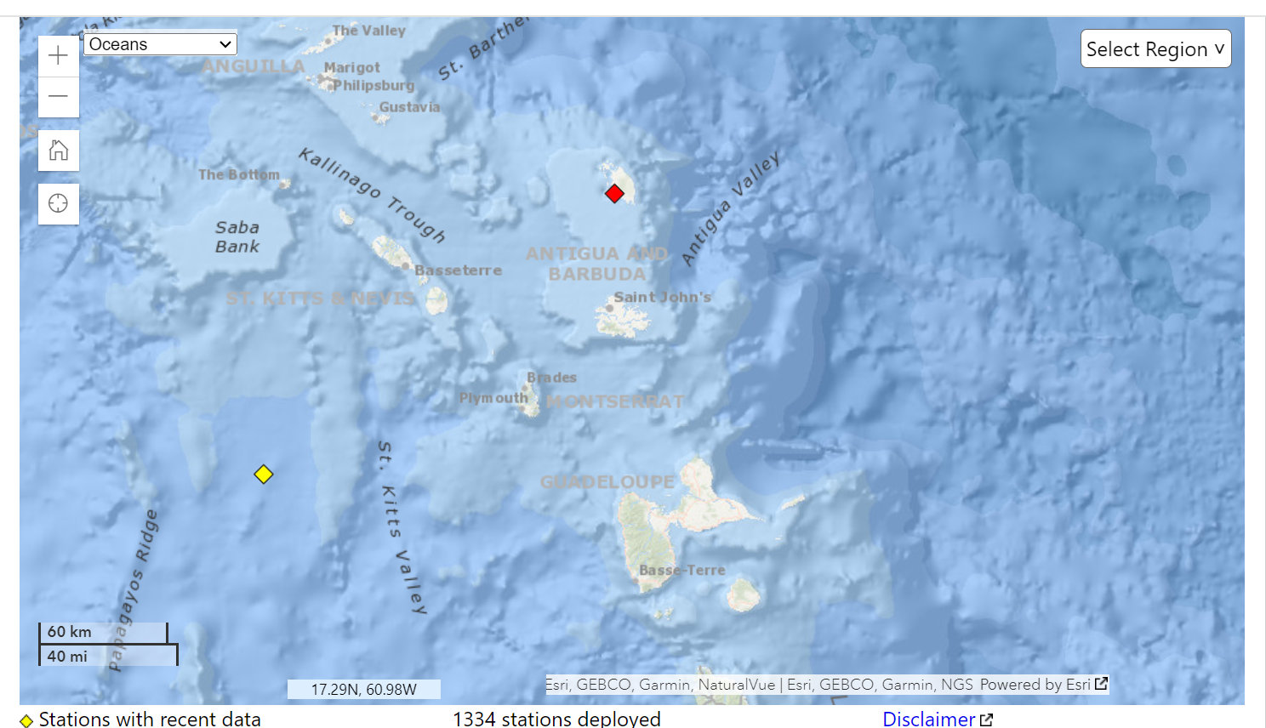

8. Information on Tsunami occurrences/Tsunami Exercises
Antigua and Barbuda has been in engaged in a number of Tsunami/coastal hazard related DRM activities
EXERCISES
CARIBWAVE 2024
- Stakeholders involved included response agencies including Police, Military, EMS and Local NGO’s – ABSAR and ABRed Cross with evalautors form the repsonse agencies and Distrit Disaster Committee Volunteers network
- Public Awareness throguh local media houses radios stations, Electronic billboards, and social media plantforms
- Particiapation saw approximately 5000+ paticipants 70 participating groups simulating evacuation included
- Pre-schools, primary schools, secondary schools (Inclusive of special needs schools for physcially and autistic children), tertiary institutions and businesses/offices
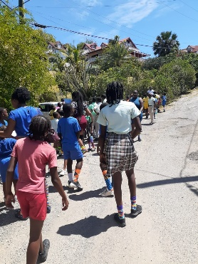
Local Tsuanmi exercies included evacuation drills by shcools and District Disascter Committeee volunteers as well as preparednessaa talks and prientations to churches in the NODS outreach programme

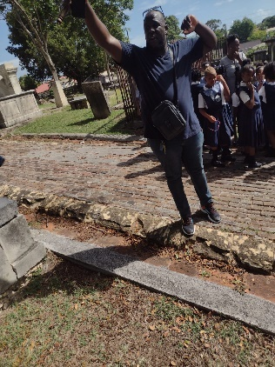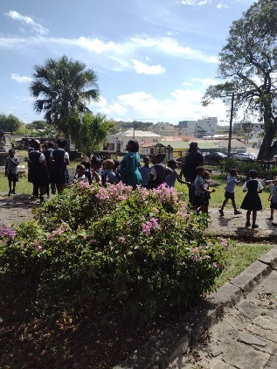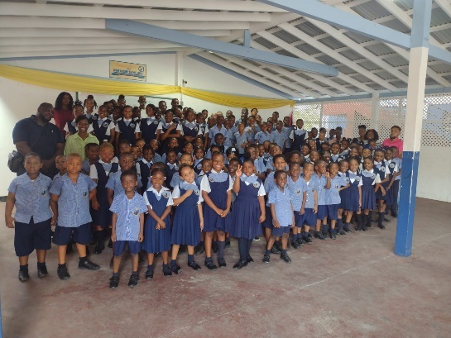
9. Web sites (URLs) of national tsunami-related web sites

Antigua and Barbuda Metoerological Services - http://www.antiguamet.com/
National Officeof Disaster Services - https://nods.gov.ag/

10. Summary plans of future tsunami warning and mitigation system improvements.
NODS support to assitng response agencies develop training, equipment and improve their plans and protocol for repsonse
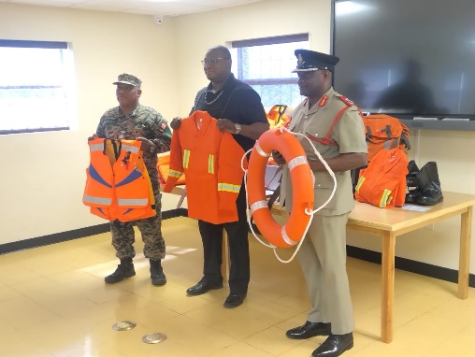

EARLY WARNING SYSTEMS (EWS)
The national mechanism spear-headed by NODS and Antigua and Barbuda Meteorrological Services (ABMS) through EW4ALL initiative and UNDRR the completion of the ‘Scaling up EWS Implementation Road Map’ plan for Antigu and Barbuda.
- It outlines a series of recommended actions intended to prioritize investments in EWS and DRR in alignment with Target G of the Sendai Framework
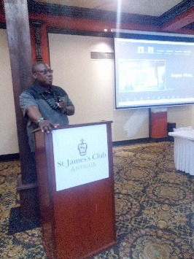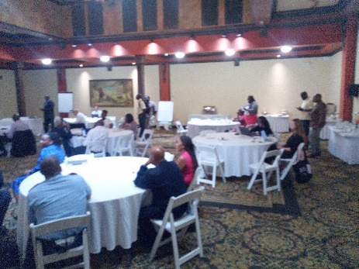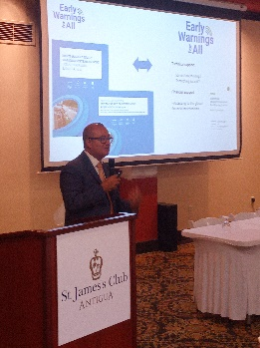

ON-GOING:
PROJECT/PROGRAMME
Currently through support from CDEMA’s Early Recovery Fund (ERF), a national consultation of stakeholders community, technical and developmental partners for type and location of sirens to buildout the National Common Alerting Protocol(CAP) MH-EWS system already operational in-country
Current capabilities of CAP are
- Mobile phones, social media,
- radio and television interrupts at participating major radio station and
- Interrupts for state-owned media (TV and Radio)
The NODS with the assistance with ITIC and CTIC will seek to gain ‘Tusnami Ready’ certification for another commuity, targeting Barbuda for the upcoming iteration of the programme.
- NODS in collaboration with ABMS has engaged ITIC and CTIC on deliberations for support in improving capabilities of TWFP and NODS and the National Mechanism in areas of tsunami and ocean science

The NODS, ABMS and other national staekholders is also integrated Tsuanmi awarenes in its outreach programmes and calaendered event including its Disaster Mangment Week and Exhibition, highlighting harazads, national stalkehilders capabilties and capacites.
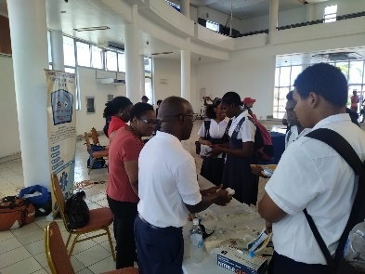
The NODS has established a natioanl Youth in Disaster Risk Management’ day fodcusing on future developemnt needs.
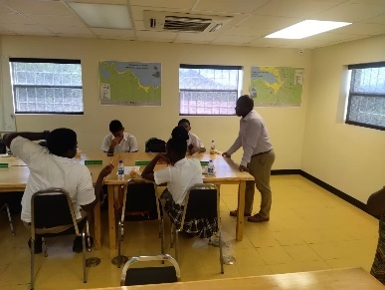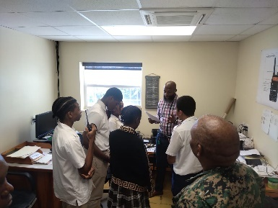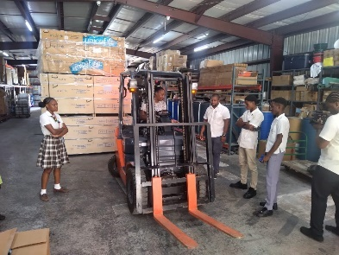
IN-DEVLOPMENT: In tandem with these activirtres the NODS in consulations with RPFAB, ABDF,
has embarked on activities to build out the modality of the EWS system on the community level. This new project will seek to develop sirens on each of the countrys police, fire statiosn and military bases.
- These sites omprove coverage of the EWS at a granualr level
- Will enhance loacl and community-based exercises/drills and targetted response to events
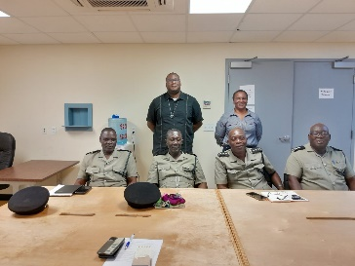

NATIONAL PROGRAMMES AND ACTIVITIES INFORMATION

11. EXECUTIVE SUMMARY
The national activites through intitiatives by NODS and ABMS activities in tsunami related intitiatives covers its ivivovlment in Exercises such as the organinazin of the national participationin the CARIBEWAVE Regional exercise
Local Exercises - Asssiting Shcools, Chucrhcs , business and government departments and communites

Conductong sensitaisation and oreintation sessions through the NODS Outreach programme in promoting Educationa d awareness throguh media engagemgnta nd the annual Disaster Managemnet Awareness Week & Exhinbiton and Youth in Disaster Risk Manamgnetn day.

Build out and further develoment of the national CAP EWS through revison and developemnt of measures to address identified gaps with the support of UNDRR and EW4ALL intitiative.

With the supportof the CDEMA, its Developemnt partners and The ERF project to also pursue the next pahse for eastablishemnt of sirens.

Antigua and Barbuda is currently in deveopment of projects seeking to pread out reach at the community level through projects to equipment commuity critical facilities (police, fire stations) to improve reach of national EWS and efficacy of community level activites and drill.

………………………..…………………………………….…………………………………….…………
12. NARRATIVE
The NODS supported by ABMS activities in tsunami related intitiatives, covers invovlment in Awareness & Education outreach; Orientation and Planning; Training and Exercises, such as the organinazin of the national participationin the CARIBEWAVE Regional exercise
- PSA and community notice also scripted for local registration of participation
- A national sub-committee established withn the NODS to govern planning
- An early registration date was set
- The Ministry of Education assisted with pushing the event in the schools
- Chamber of Commerce distributed invitation to their members
- Hotel association did circulate to the various properties
- Public awareness about the drill
  - several media houses
  - PSA was developed and televison and radio interviews
  - awareness on social media (facebook and Instagram)
  - Electronic billboards along highways
  - sponsored text messaging through national Telecom sevice providers
- Oreintation meetings done with Evaluators from DDC teams, defence and police forces, fire department, red cross, emergency medical services.
  - Deployed on day of exercise with Evacuation observation forms
  - Police, fire, red cross, EMG and local SAR NGO also supported with the sounding of sirens along with contracted hi-fi

Local Exercises - Asssiting Shcools, chucrhcs , business and government departments and communites
- Implemented throgh support of
  - NODS Preparedness & Repsonse Unit,
  - Ministry Liaison Officer Networks, Ministry of Education Disastet Liaison Unit
  - District Disaster Committee Volunteers

Conductong sensitaisation and oreintation sessions through
- the NODS Outreach programme with stekeholders
- media engagemgnta nd the annual Disaster Managemnet Awareness Week & Exhinbiton and Youth in Disaster Risk Manamgnetn day.
- Work witht School safe programme in Ministry of Education and CDEMA

Build out and further develoment of the national CAP EWS through revison and developemnt of measures to address identified gaps with the support of UNDRR and EW4ALL intitiative.
- The 2017 Sendai Readiness Review Report for Antigua and Barbuda and 2022 Situational Analysis of Antigua and Barbuda concluded
- foundation laid for MHEWS within regulatory & governance framework,
- ongoing efforts needed o address identified gaps and enhance various aspects of the system
Through EW4ALL initiative and UNDRR the completion of the ‘Scaling up EWS Implementation Road Map’ plan for Antigu and Barbuda.
- It outlines a series of recommended actions intended to prioritize investments in EWS and DRR in alignment with Target G of the Sendai Framework

Conducting the gap analysis and developing the implementation plan involved the carrying out an intitial sensitization meeting. This was then followed by bilateral discussions ensued with various stakeholders to gather comprehensive data, involvoing stakeholders from - international, regional, governmental agencies, non-governmental organizations, and community representatives,
two national consultative workshops
- One fundamental principle identified was the establishment of an approved MHEWS national governance framework
- Another was the promotion of greater data-sharing collaborations and consolidation
- Encouraging a culture of transparency and collaboration, this principle emphasized the need for seamless information flow between relevant agencies
This was then circulated for feedback and verififcation.

With the support of the CDEMA, its Developemnt partners and The ERF project to also pursue the next phase for eastablishemnt of sirens. A consultatnn is curerntl[y in the process of conducting wode ranging consualtations in preapration to guide the implementation stage.

Four pilot sistes will be identifeid in Antigua and one (1) in Barbuda to begin the national sirne buidl out componenet of the national CAP EWS.

Antigua and Barbuda is currently in deveopment of projects seeking to pread out reach at the community level through projects to equipment commuity critical facilities (police, fire stations) to improve reach of national EWS and efficacy of community level activites and drill.
This is being developed to build on the work of the national CAP siren consultancy project.

………………………..…………………………………….…………………………………….…………
Date: …06th May 2024……………….. Name: …………………………..

