[Date]

Dr. Vladimir Ryabinin
Executive Secretary, IOC and
Assistant Director-General of UNESCO
7 Place de Fontenoy
75352 Paris Cedez 07 SP
France

Attn: Mr. Bernardo Aliaga
Head, Tsunami Unit, UNESCO/IOC

Dear Dr. Ryabinin and Mr. Aliaga,

This letter is to inform that [Country] expresses interest in implementing the Tsunami Ready Programme in [Community]. This project is funded through [Name of organization]. [Name of community] is [the first community to be recognized or [number] to pursue Tsunami Ready recognition]. [Name, Position, & Contact Details of Project In-Country Liaison/Focal Point] will serve as the in-country point of contact for this Tsunami Ready project.

The implementation of this programme will support the education, preparedness, and response for tsunami events as well as to contribute significantly to the UNESCO/IOC UN Decade of Ocean Science for Sustainable Development, including the target of recognizing 100% of at-risk coastlines as Tsunami Ready by 2030.

Signed,

Tsunami National Contact

CC Corresponding TIC, Funding Agency

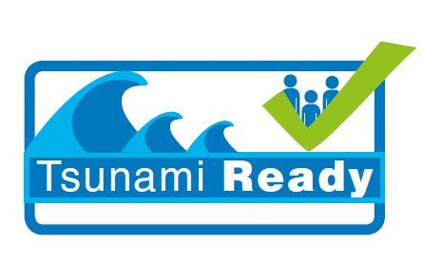
TSUNAMI READY COMMUNITY

Resources Information Form
(Optional)

NAME OF COUNTRY
NAME, POSITION & CONTACT DETAILS OF PROJECT IN-COUNTRY LIAISON/FOCAL POINT
NAME OF NOMINATED COMMUNITY
AVAILABLE DATA TO SUPPORT TSUNAMI INUNDATION AND EVACUATION MAPPING FOR SELECTED COMMUNITY
POPULATION OF COMMUNITY
DESCRIPTION OF HOW THE COMMUNITY IS ADMINISTERED e.g. does it fall under one administrative/political/municipal area i.e. parish, electoral district/municipality (please specify)
PRESENCE OF AUTHORITIES & FACILITIES FOR DISSEMINATIING TSUNAMI WARNING INFORMATION e.g. national/community-level disaster management office/organisation, police, fire station, ambulance, defence force, sirens, government facilities (please list)
PRESENCE OF GOVERNMENT & NON-GOVERNMENT INSTITUTIONS, OFFICES AND RESOURCES e.g. educational, religious, social facilities, markets, community groups, volunteers etc. (please list)
COMMUNITY DEMOGRAPHIC BREAKDOWN | Infants & Young Children (0-59 months)
Children
(5-17yrs)
 | Adults (18-49yrs)
 | Adults >50 years
INFO & DATA ON SPECIAL GROUPS/PERSONS AT-RISK e.g. senior citizens and associated institutions, nursery/crèche, disabled persons, women, children etc.
DETAILS ON PREVIOUS OR EXISTING TSUNAMI INITIATIVES IN THE SELECTED COMMUNITY
e.g., signage, evacuation maps, etc.
KEY STAKEHOLDERS AND PARTNERS ENVISAGED FOR THIS PROJECT
ANY OTHER RELEVANT INFORMATION

