Restricted Distribution IOC/ IOCARIBE/TASK FORCE 3/Doc 7
Cartagena, 24 May 2024
Original: English

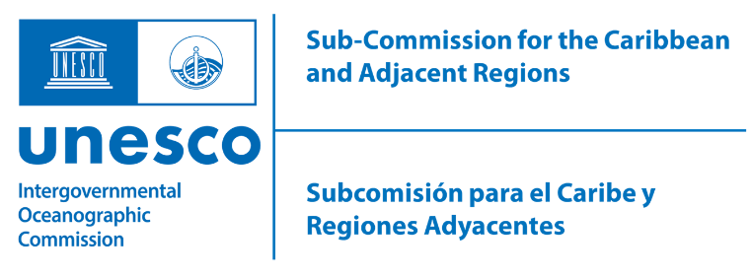

INTERGOVERNMENTAL OCEANOGRAPHIC COMMISSION
(Of UNESCO)

In-Person Meeting of the UN Decade TAC Task Force
(June 4 – 06, 2024)

Projects endorsed in Call 6 of the Decade of the Oceans for the Caribbean SIDS

No. | PROJECT NAME
1 | The Grouper School.
2 | SIDS Ocean Observing Toolbox
3 | CaribeCoast
4 | Ocean Literacy Caribbean - The Ocean and Me
5 | Seascape Symphony-Brushstrokes for a Blue Planet
6 | Weaving Coasts
7 | Invasive sargassum valorization
8 | A Caribbean SIDS Pollutants Observatory
9 | Caribbean Clean Seas Initiative
10 | Thinking Beyond The Tides
11 | Proactive actions & partnerships brings solutions

