**

*Manuals and Guides 81*

**Procedures for Proposing and Evaluating IODE Programme Components, Programme Activities and Projects**

***(3nd revised edition)***

**UNESCO**

*Manuals and Guides 81*

**Procedures for Proposing and Evaluating IODE Programme Components, Programme Activities and Projects**

***(3rd revised edition)***

**UNESCO**

IOC Manuals and Guides 81

August 2024

English only

For bibliographic purposes this document should be cited as follows:

Paris. Intergovernmental Oceanographic Commission of UNESCO. 2024. *Procedures for Proposing and Evaluating IODE Programme Components, Programme Activities and Projects (3rd Revised edition)*. (IOC Manuals and Guides, 81, 3rd rev. ed.) 18pp. (English) (IOC/2021/MG/81)

© UNESCO 2024

Table of Contents

1. Background 1

2. Terminology 1

3. Proposing New Programme Activities & Projects 2

3.1 Process For Proposing New Programme Activities & Projects 3

4. Evaluating New Programme Activities & Projects Proposals 4

4.1 Criteria For Evaluating New Programme Activities & Projects Proposals 4

5. Evaluating Existing Programme Components, Programme Activities & Projects 4

5.1 Criteria For Evaluating Programme Components, Programme activities & Projects 5

6. IODE Management Group Actions 5

Annex I. IODE New Programme Activity/Project Form 6

Annex II. IODE Programme Component/Programme Activity/Project Report Form 8

Annex III. Evaluation Score Sheet. New IODE Programme Activity/Project 10

Annex IV. Evaluation Score Sheet. Existing IODE Programme Component/Programme Activity/Project 11

Annex V. Process Diagram For Proposing New Programme Activity/Project 12

# Background

At its 24th session (2017) the IODE Committee approved the *Report of the Inter-sessional Working Group to Propose a Re-structuring of IODE* which recommended revising the current structure, projects and activities of IODE and decided that the relation between projects (e.g. data flow) should be better communicated within the IODE community but also to the user communities. The 27th session of the IODE Committee (2023) approved the designation of IODE activities as Programme Components, Programme Activities and Projects.

Existing and new Programme Components, Programme Activities and Projects need to ensure that they meet IODE strategic goals and objectives. These procedures apply to both existing and new projects and activities.

This revised edition includes changes requested by the IODE Management Group to address the following issues: *(i) all Programme Components, Programme Activities and Projects should develop work plans that have clear performance indicators and measurable deliverables, and (ii) the reporting template should align with the work plan and which would allow for more straightforward evaluation by the IODE Management Group.*

# Terminology

The following terminology is used:

* **Programme Component (PC).** Long-term activity receiving core UNESCO-IOC RP funding and staff support, supplemented by in-kind and/or extra-budgetary support, that enables the activity to operate on a sustainable basis. These are long-term and core actions that define the IODE programme and are sustained (at least for their baseline funding) by guaranteed UNESCO regular programme funding. This means that even without any extra-budgetary support these actions will continue to operate. However, it is preferable that the UNESCO funding is supplemented by extra-budgetary support that enables further development and expansion of the action. Programme Components can contribute to, or cooperate with, other Programme Components and their Programme Activities and Projects.
* **Programme Activity (PA)**. Long-term activity receiving minimal UNESCO-IOC RP funding supplemented by in-kind and/or extra-budgetary support. These are long-term actions that support/contribute to one or more Programme Component. They receive some UNESCO regular programme funding (if available). These actions should always be co-funded from extra-budgetary sources (including in-kind staff time contributions). They may also contribute to other Programme Activities or Projects in the same or different Programme Components. If Programme Activities are unable to mobilize extra-budgetary funding or in-kind (staff time) contributions, then the IODE Committee may decide to terminate a Programme Activity or identify another “parent” organization.
* **Project**. Activity that is limited in time and is fully funded from extra-budgetary sources. These are actions that are limited in time (typically 1-4 years) that are fully funded from extra-budgetary sources (including in-kind staff time contributions). They should not operate independently but support at least one Programme Component, either directly or indirectly (via a Programme Activity). Projects can only be renewed/extended beyond their funded term if new extra-budgetary funding has been mobilized and theIODE Committee has agreed on the need for continuation.
* **IODE Management Group Executive**. Members of the Management Group comprising Co-Chairs and Past Co-Chairs.
* **Output**. The result achieved by a specific activity and can be directly measured and often include deliverables such as products or services.
* **Outcome**. The impact or result of one or more outputs.
* **Performance Indicator**. A quantifiable measure of performance to monitor achievement of the outcome and output.

# Proposing New Programme Activities & Projects

It is essential that all IODE Programme Activities and Projects carry out tasks that serve the objectives of the IODE Programme[1] and the IOC High Level Objectives[2].

Programme Activities and Projects that serve only the needs of a sub-community of IODE and are not linked to the main objectives and strategic goals of IODE and IOC are not sustainable. Every Programme Activity and Project will therefore need to justify its resourcing from IODE by explaining how it meets these objectives.

Proposals for new Programme Activities and Projects are considered by the IODE Committee and included in the IODE work plan and budget. The IODE Committee must balance the work plan with available financial and human resources. As the demand for resources is likely to be higher than available resources it is important to “score” submitted proposals so they can be ranked in accordance with their score.

New proposals must address the questions presented in the *New Project/Activity Template*. Project proposals should also include additional documentation to support the submission and must include a SWOT analysis. A SWOT analysis is used to evaluate the Strengths, Weaknesses, Opportunities and Threats involved in the project and to identify the internal and external factors that will influence the ability to achieve the project objectives. Only proposals up to 5 pages long will be evaluated.

The IODE Committee sessions are held every two years, usually around February/March, and all working documents must be available to Committee members on 1st January of the year in which the Committee meeting is held. This includes all project or activity proposals requiring funding. The deadline for submission of proposals for new projects and activities should start no later than 1st September of the year preceding the IODE Committee Session.

## 3.1 Process For Proposing New Programme Activities & Projects

The process for proposing Programme Activities and Projects will include the following:

1. All Programme Activities and Projects will be submitted to the IOC Project Office for IODE using the *New Programme Activities/Projects* *Form* (Annex I). The template should be completed in English. Additional documentation, including a SWOT analysis, to support the proposal should also be attached.
2. The Project Office will check all submitted proposals for compliance with the template. Proposals that do not comply will be returned to the submitter with a note explaining what is missing. Submitters have 10 working days to re-submit. Failure to re-submit within that period will result in rejection of the proposal.
3. Re-submitted proposals are checked for compliance with the template. Proposals that were re-submitted but still do not comply are rejected. The submitters will be informed of this by email.
4. All proposals that comply with the proposal template are sent to the IODE-MG Executive by email, with a request to review and score the proposals, not later than a given deadline.
5. IODE-MG Executive will review and evaluate proposals using the proposal evaluation criteria. IODE-MG Executive may select a pool of independent or subject matter experts from the IODE community to provide peer-review comments regarding proposed projects and activities.
6. The IODE Co-chairs will review the evaluations for all proposals and calculate the average score for each proposal, rank the proposals by their average score, and prepare a summary table according to descending scores including title, score and evaluation comments.
7. The IODE Co-chairs will provide a summary table to the IODE-MG Executive requesting approval.
8. The IODE-MG Executive will review the summary table and inform the IODE Co-chairs of their approval. If a submission is unsuccessful, the IODE-MG Executive will inform the Head of the Project Office who will notify the proposer of the outcome.
9. The IODE Co-chairs will prepare a working document for the upcoming IODE Committee Session including the reviewed proposals, the summary table with scores and evaluation comments.
10. The IODE Co-chairs will submit the working document to the Head of the IOC Project Office for IODE, who will post the document on the web site for the upcoming IODE Committee Session.

Based upon the above, the total process will require approximately four months. Taking into account the deadline for submission of working documents this means that step 1 should start no later than 1st September of the year preceding the IODE Committee Session.

This process is mapped in the diagram in Annex V.

# Evaluating New Programme Activities & Projects Proposals

The IODE-MG Executive will act as the evaluation panel to assess each proposal within the context of IODE and IOC objectives. Each member of the evaluation panel will issue an overall evaluation results based on their individual evaluation. Assessments from all panel members will be added and the Programme Activity/Project must not receive ‘not approved’ to be considered for recommendation by the IODE-MG Executive to the IODE committee.

Members of the IODE-MG Executive may choose to serve on the evaluation panel or may nominate expert(s) to carry out the evaluation on their behalf. No evaluation panel member may provide an evaluation of a project or activity in which they are involved. Once the evaluation is completed, a written report of results will be made available to IODE-MG Executive no later than two months after the reports are received. Results of the evaluation will be anonymized and shared with proponents.

## 4.1 Criteria For Evaluating New Programme Activities & Projects Proposals

The Evaluation Score Sheet (Annex IV) will be used to assess new IODE Programme Activity and Project proposals.

# Evaluating Existing Programme Components, Programme Activities & Projects

All approved IODE Programme Components, Programme Activities and Projects, whether ongoing or ending, must meet the evaluation criteria defined by the IODE-MG Executive and will be evaluated biennially based on the report provided. The report will describe the results achieved and future proposed work.

**Programme Components** should submit a report to the IODE Committee every two years but are not subject to termination or removal of funding. The Committee will instruct to implement remedial action to be defined by the IODE-MG Executive. If the remedial action does not lead to a positive evaluation, then the IODE Committee or IOC Governing body (Assembly or Executive Council) may decide to close the Programme Component. In this regard it is noted that while mobilization of extra-budgetary funding is desirable it is not mandatory. If the IODE Committee would decide, for any valid reason, to close down a Programme Component, then the Committee will consider the positioning of the Programme Activities and/or Projects that were attached to that Programme Component.

**Programme Activities and Projects** should include Performance Indicators (PI) that are clearly identified and measurable in order to enable evaluation and review. Programme Activities and Projects are subject to evaluation. If Programme Activities or Projects do not provide a report or if progress is less than satisfactory with respect to deliverables, then they will not be considered for another funding cycle unless clear actionable remedies are put in place. For example, if stated deliverables or objectives for which funding and support was made available are not met then this could be considered as a reason for not recommending further support or endorsement.

Members of the IODE-MG Executive may choose to serve on the evaluation panel or may nominate expert(s) to carry out the evaluation on their behalf. No evaluation panel member may provide an evaluation of a project or activity in which they are involved. Once the evaluation is completed, a written report of results will be made available to IODE-MG Executive no later than two months after the reports are received. Results of the evaluation will be anonymized and shared with proponents.

All approved IODE Programme Components, Programme Activities and Projects must complete the *IODE Programme Component/Programme Activity/Project Report Form* (Annex II). This report is to be submitted biennially no later than December of the year preceding the next IODE Committee Session. All reports will be evaluated by the IODE-MG Executive and the IODE Committee at its session.

## 5.1 Criteria For Evaluating Programme Components, Programme activities & Projects

All approved IODE Programme Components, Programme Activities and Projects will be evaluated by the IODE-MG Executive, based on the reports provided. The Evaluation Score Sheet in Annex IV will be used to score existing IODE Programme Components, Programme Activities and Projects.

# IODE Management Group Actions

Proposals for new projects that do not receive a positive evaluation will be rejected and the project proposal submitter will be notified of the reason for rejection. Rejected proposals may be resubmitted.

Existing Programme Components, Programme Activities and Projects that do not receive a positive evaluation (“Not satisfactory or satisfactory with modifications requested”) will be notified of what actions need to be taken to improve performance and given an appropriate time frame for improvement.

Programme Activities and Projects that do not implement requested actions may have IODE endorsement withdrawn at the discretion of the IODE-MG Executive. The Programme Activities or Projects may not continue to operate nor funds expended unless an approved workplan and budget is developed and approved by the IODE-MG Executive.

# Annex I. IODE New Programme Activity/Project Form

This form is to be completed for all **new** IODE Programme Activities or Projects and submitted as a separate document to [info@iode.org](mailto:info@iode.org) (with *IODE New Programme Activity/Project* in the subject line). Attach any additional project documentation to support the new Programme Activity or Project.

|  |  |  |  |  |  |  |  |
| --- | --- | --- | --- | --- | --- | --- | --- |
| 1. **Title of IODE Programme Activity/Project and acronym** | | | | | | | |
|  | | | | | | | |
| 1. **FULL DESCRIPTION OF THE Programme Activity/Project** | | | | | | | |
| **General objective** *(Describe the aim and rationale)* | | | | | | | |
| **Project outcomes** *(Describe the expected outcomes and deliverables. Add more Outcome if needed.)* | | | | | | | |
| **Outcome N° 1.** | | | | | | | |
| **Performance indicators** *(list 2-5 indicators)* | | | | | **Status** *(completed, in progress, cancelled)* | | |
| **Deliverables** | | | | |  | | |
| **Outcome N° 2** | | | | | | | |
| **Performance indicators** *(list 2-5 indicators)* | | | | | **Status** *(completed, in progress, cancelled)* | | |
| **Deliverables** | | | | |  | | |
| **List of partners and key stakeholders.** *(Indicate the main partners and the areas of expertise the partners will contribute)* | | | | | | | |
| **Describe the governance model.** *(e.g., steering group, advisory group)* | | | | | | | |
| **Explain how the Programme Activity/Project will target one or more IODE or IOC objectives.** | | | | | | | |
| **Expected duration.**  Start date:  End date: | | | | | | | |
| 1. **PROPOSED LEAD AND TEAM MEMBERS** | | | | | | | |
| **Role** | **Name and Surname** | | **Profession/Position** | | | **Organisation name** | |
| Lead* |  | |  | | |  | |
| Member |  | |  | | |  | |
| Member |  | |  | | |  | |
| …. |  | |  | | |  | |
| **\*Please attach Curriculum Vitae of the Programme Activity/Project lead** *(CV should include project management capacity and any previous involvement in UNESCO-IOC and other international activities).* | | | | | | | |
| 1. **BUDGET** *(Provide an estimated budget for the next two years. List sources of extra budgetary contributions)* | | | | | | | |
| Budget requested from IODE (USD) | | | | Confirmed extra budgetary contributions (USD) | | | |
| 20xx: | | 20xx: | | 20xx: | | | 20xx: |

Signed by Programme Activity/ProjectProposer.

Date.

*For IODE use only.*

Date received:

# ****Annex II. IODE**** Programme Component/Programme Activity/Project Report Form

This form is to be completed for all **approved** IODE Programme Components/Programme Activities/Projects. Reports are to be submitted biennially prior to the IODE session to [info@iode.org](mailto:info@iode.org) (with *IODE Programme Component/Programme Activity/Project Report* in the subject line). Attach any additional documentation.

|  |  |  |  |  |  |
| --- | --- | --- | --- | --- | --- |
| 1. **Title of IODE Programme Component/Programme ACTIVITY/Project AND ACRONYM** | | | | | |
|  | | | | | |
| 1. **established *(provide reference to IODE Committee session and Decision)*** | | | | | |
|  | | | | | |
| 1. **REPORT SUBMITTED BY *(Name/Date)*** | | | | | |
|  | | | | | |
| 1. **General overview/Executive summary** | | | | | |
|  | | | | | |
| 1. **Describe the status of workplan implementation and the results achieved** | | | | | |
| **Outcomes** *(add more outcomes if needed)* | | | | | |
| **Outcome N° 1.** | | | | | |
| **Performance indicators** *(list 2-5 indicators)* | | **Status** *(completed, in progress, cancelled)* | | | |
| **Deliverables** | |  | | | |
| **Outcome N° 2** | | | | | |
| **Performance indicators** *(list 2-5 indicators)* | | **Status** *(completed, in progress, cancelled)* | | | |
| **Deliverables** | |  | | | |
| **List of partners and key stakeholders.** *(Indicate how partners and stakeholders contribute to the action)* | | | | | |
| **Explain how the Programme Component/Programme Activity/Project is contributing to other IODE or IOC programmes and activities.** | | | | | |
| **Provide details on the long-term sustainability.** *(including confirmed extra budgetary resources)* | | | | | |
| **Risks.** *(Describe the potential risk of not achieving the expected results)* | | | | | |
| 1. **Submission of workplan and budget for the next intersessional period** | | | | | |
| **Workplan and budget for the next intersessional period.** *(show amount in USD)* | | | | | |
|  | Budget request from IODE | | | Confirmed EB funds | |
|  | 20xx: | | 20xx: | 20xx: | 20xx: |
| Outcome 1. |  | |  |  |  |
| Outcome 2. |  | |  |  |  |
| **TOTAL** |  | |  |  |  |
| 1. **DRAFT TEXT FOR THE ANNOTATED AGENDA AND SUMMARY REPORT** *(to be used for reporting to IODE session)* | | | | | |
|  | | | | | |

Signed by IODE Programme Activity/ProjectLeader.

Date.

*For IODE use only.*

Date received:

# Annex III. Evaluation Score Sheet. New IODE Programme ****Activity/Project****

|  |  |
| --- | --- |
| **New IODE Programme Activity/Project. Evaluation score sheet.** |  |
| **Name of Programme Activity/Project:** | **Score** |
| **1. The IODE Management Group concluded that the new Programme Activity/Project****targets IODE/IOC objectives:** | |
| *a. Completely (score 4)* |  |
| *b. Partially (score 2)* |  |
| *c. Absent (score 0)* |  |
| **2. The IODE Management Group concluded that the new Programme Activity/Project****governance model (e.g., Steering Group) is:** | |
| *a. Satisfactory. Approved without the need for modifications (score 4)* |  |
| *b. Satisfactory. Approved with the need for minor modifications (score 3)* |  |
| *c. Satisfactory. Approved with the need for major modifications (score 2)* |  |
| *d. Not satisfactory. Rejected (score 0)* |  |
| **3. The IODE Management Group concluded that the new Programme Activity/Project****outcomes and PIs are:** | |
| *a. Satisfactory. Approved without the need for modifications (score 4)* |  |
| *b. Satisfactory. Approved with the need for minor modifications (score 3)* |  |
| *c. Satisfactory. Approved with the need for major modifications (score 2)* |  |
| *d. Not satisfactory. Rejected (score 0)* |  |
| **4. The IODE Management Group concluded that the proposed workplan and budget is** | |
| *a. Satisfactory. Approved without the need for modifications (score 4)* |  |
| *b. Satisfactory. Approved with the need for minor modifications (score 3)* |  |
| *c. Satisfactory. Approved with the need for major modifications (score 2)* |  |
| *d. Not satisfactory. Rejected (score 0)* |  |
|  | |
| **Overall evaluation result** |  |
| *Approved* |  |
| *Approved with minor remarks* |  |
| *Approved with major remarks* |  |
| *Not approved* |  |
|  | |
| **Summary of evaluation** | |

# ****Annex IV. Evaluation Score Sheet. Existing IODE Programme Component/Programme Activity/Project****

|  |  |
| --- | --- |
| **Existing IODE Programme Component/Programme Activity/Project. Evaluation score sheet.** |  |
|  |  |
|  |  |
| **Name of Programme Activity/Project:** | **Score** |
| **1. The IODE Management Group concluded that the level of performance of the Programme. Component/Programme Activity/Project****is:** | |
| *a. Satisfactory and should continue* |  |
| *b. Satisfactory and agree with the suggestion to close the project/activity* |  |
| *c. Not satisfactory and recommend closing the project/activity. A proposal for a new project/activity can be submitted* |  |
| **2. The IODE Management Group concluded that the proposed workplan and budget is:** | |
| *a. Satisfactory. Without the need for modifications* |  |
| *b. Satisfactory. With the need for minor modifications* |  |
| *c. Satisfactory. With the need for major modifications* |  |
| *d. Not satisfactory. Closure or resubmission of a workplan and budget is recommended* |  |
|  | |
| **Overall evaluation result** | |
| *Satisfactory* |  |
| *Not satisfactory* |  |
|  | |
| **Summary of evaluation** | |

# ****Annex V. Process Diagram For Proposing New Programme Activity/Project****

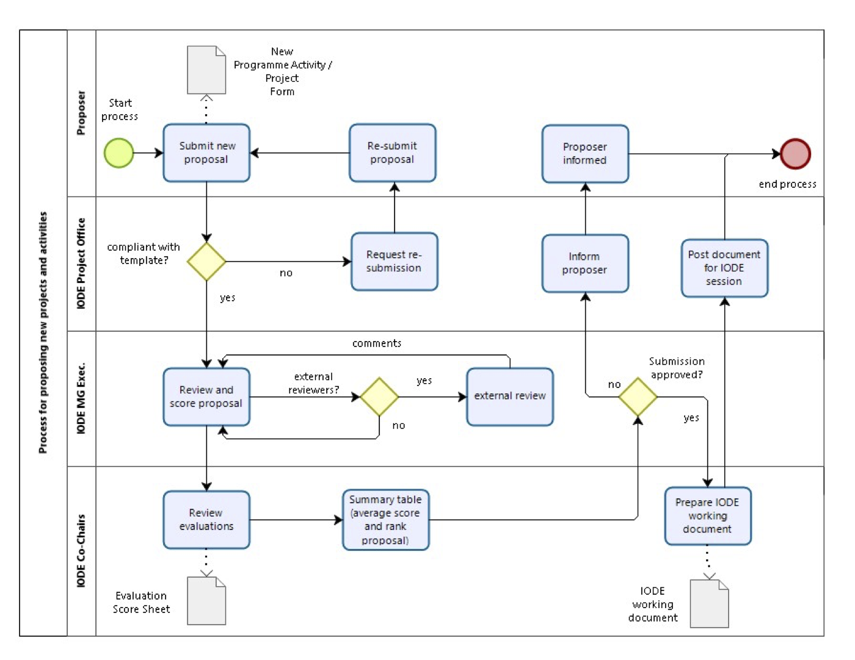





|  |  |  |
| --- | --- | --- |
| **Intergovernmental Oceanographic Commission of UNESCO**  7 Place de Fontenoy  75352 Paris Cedex 07 SP, France  Telephone: +33 1 45 68 39 84  Fax: +33 1 45 68 58 12  http://ioc.unesco.org |  | **IOC Project Office for IODE**  Jacobsenstraat 1  8400 Oostende, Belgium  Tel: +32 59 34 21 34  Email: info@iode.org  http://www.iode.org |

1. <https://iode.org/about/who-we-are/>
2. <https://www.ioc.unesco.org/en/mission-and-objectives>