**Intergovernmental Oceanographic Commission Technical Series ###**

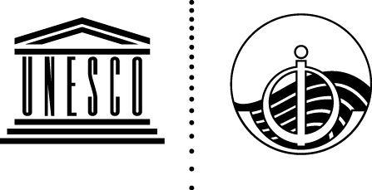

**EXERCISE NEAMWAVE 23**

**A Tsunami Warning**

**and Communication Exercise for the North-Eastern Atlantic, the Mediterranean, and Connected Seas Region**

**6 & 7 November 2023**

**Volume 2 Evaluation report**

**UNESCO**

**Intergovernmental Oceanographic Commission Technical Series ###**

**EXERCISE NEAMWAVE 23**

**A Tsunami Warning and Communication Exercise   
for the North-Eastern Atlantic, the Mediterranean, and Connected Seas Region**

**6 & 7 November 2023**

**Volume 2 Evaluation report**

**UNESCO 2025**

IOC Technical Series, ### (volume 2)

Paris, November 2025 English only

The designations employed and the presentation of the material in this publication do not imply the expression of any opinion whatsoever on the part of the Secretariats of UNESCO and IOC concerning the legal status of any country or territory, or its authorities, or concerning the delimitation of the frontiers of any country or territory.

**For bibliographic purposes, this document should be cited as follows:**

IOC-UNESCO. 2024. NEAMWave 23 Tsunami Exercise. A Tsunami Warning and Communication Exercise for the North-eastern Atlantic, the Mediterranean, and Connected Seas Region. Exercise Manual (Vol.2): Evaluation report. IOC Technical Series ### Vol. 2 and supplement. Paris: UNESCO. (English only)

Report prepared by:   
Co-Chairs Tsunami Exercise: Ceren Özer Sözdinler & Marinos Charalampakis

Secretariat: Denis Chang Seng, Alejandro Rojas Aldana

Contributions

Members of Task Team on Tsunami Exercise:

Fabrizio Romano, Fernando Carrilho, Nikos Kalligeris and Pascal Roudil.

DG ECHO Emergency Response Coordination Centre of the European Commission

This document has a supplement: *Evaluation by Message Providers and Civil Protection Authorities*

Published in 2025

by United Nations Educational, Scientific and Cultural Organization

7, Place de Fontenoy, 75352 Paris 07 SP

© UNESCO 2025

(IOC/2025/TS/### Vol.2)

**Table of contents**

1. INTRODUCTION 5

2. ACTIVITIES UNDERTAKEN BY THE NEAMTWS SECRETARIAT 8

3. ACTIVITIES UNDERTAKEN BY THE EXERCISE TEAM 8

4. EVALUATION OF NEAMWAVE23 PHASE A 9

4.1 INTRODUCTION 9

4.2 EVALUATION OF NEAMWave23 FROM TSPs 10

4.3 EVALUATION OF NEAMWave23 FROM TSRs 12

5. EVALUATION OF NEAMWAVE23 PHASE B 13

5.1 INTRODUCTION 13

5.2 SUMMARY OF THE PHASE B ONLINE FORMS PROVIDED BY MEMBER STATES 16

5.3 PARTICIPATION OF COUNTRIES IMPLEMENTING THE TSUNAMI READY RECOGNITION PROGRAM 17

6. EVALUATION OF NEAMWAVE 21 PHASE C 19

7. CONTACT WITH THE MEDIA 21

8. CONCLUSIONS AND RECOMMENDATIONS 22

REFERENCES 26

ANNEX I - IOC CIRCULAR LETTER 27

ANNEX II - NEAMWave23 Exercise Online Platform 28

ANNEX III- IOC-UNESCO NEWS 29

ANNEX IV - NEAMWave23 Information Leaflet 31

ANNEX V - TSPs’ EVALUATION REPORTS 32

ANNEX VI - COUNTRY PARTICIPATION in NEAMWave23 33

ANNEX VII - LIST OF ACRONYMS 34

# INTRODUCTION

While tsunamis are less common in the Mediterranean and North-East Atlantic compared to the Pacific and Indian Oceans, they can still cause significant loss of life and property in these regions. The risk in the Mediterranean is heightened by the short distance between tsunamigenic areas and the coastline, which means that the impact of waves can occur in less than an hour after a tsunamigenic event.

To mitigate the effects of such events, a Tsunami Early Warning System (TEWS) is crucial for saving lives and minimizing damage. Therefore, maintaining a high level of readiness is essential for the TEWS to respond efficiently and effectively to potential tsunamis. To enhance preparedness, [UNESCO/IOC](https://www.ioc.unesco.org/en), through its Intergovernmental Coordination Groups (ICGs), regularly organizes tsunami exercises.

In this context, the fifth tsunami exercise ‘NEAMWave23’ was conducted from 6 to 7 November 2023, in connection with the World Tsunami Awareness Day (WTAD) celebrated each year on 5th November. Two different exercise scenarios were utilised for the North-Eastern Atlantic and the Eastern Mediterranean regions, structured, and organised in 3 phases: Phases A, B and C.

The five accredited Tsunami Service Providers (TSPs) in NEAM region issued exercise messages using two different exercise scenarios prepared for the: (1) North-Eastern Atlantic and (2) Eastern Mediterranean domains. On 6 November 2023, TSPs CENALT (France) and IPMA (Portugal) executed one joint scenario in the North-Eastern Atlantic based on a M8.5 earthquake similar to the 1761 Atlantic event, west of the Strait of Gibraltar. On the 7 November 2023, TSPs INGV (Italy), NOA (Greece) and KOERI (Türkiye) conducted a triple joint scenario in the Eastern Mediterranean based on an earthquake of magnitude M8.1 occurring at the central segment of the Hellenic Arc subduction interface, South of Crete. This was the first time, a joint scenario was conducted between three TSPs. Figure 1 shows the locations of earthquake scenarios prepared by the TSPs. The technical details of each scenario are described in [IOC/2023/TS/184 Vol.1](https://unesdoc.unesco.org/ark:/48223/pf0000386836).

**Part 1 is the Exercise Instructions**. It is the generic information part of the NEAMWave Exercise Manual, containing general and extensive information about the overall activities, the general scope, objectives and concepts, the roles of participants, as well as media arrangements.

**Part 2 is the Exercise Supplements.** It contains more specific information about the actual exercise conducted.. It details the exercise scenarios in NEAMWave23, the registration procedures for participation, the contact information of exercise team members, as well as the evaluation procedure of the exercise.

* **Phase A** (*early warning*) was the simulation of an earthquake and consequent tsunami detected by the Tsunami Services Providers (TSPs), namely CENALT [(CENtre](http://www.info-tsunami.fr/) [d’ALerte aux Tsunamis](http://www.info-tsunami.fr/), France), NOA ([National Observatory of Athens,](http://hl-ntwc.gein.noa.gr/en/) Greece), INGV ([Instituto Nazionale di Geofisica e Vulcanologia,](http://www.ingv.it/it/) Italy), IPMA ([Instituto Português do Mar e da Atmosfera](https://www.ipma.pt/en/index.html), Portugal) and KOERI ([Kandilli Observatory and](http://www.koeri.boun.edu.tr/depmuh_index_eng.aspx) [Earthquake Research Institute,](http://www.koeri.boun.edu.tr/depmuh_index_eng.aspx) Turkiye), which produced and disseminated alert messages to the Tsunami Service Recipients (TSRs). All TSPs executed joint scenarios (CENALT & IPMA and INGV, NOA & KOERI) and issued their tsunami exercise messages to their subscribers regarding these scenarios.

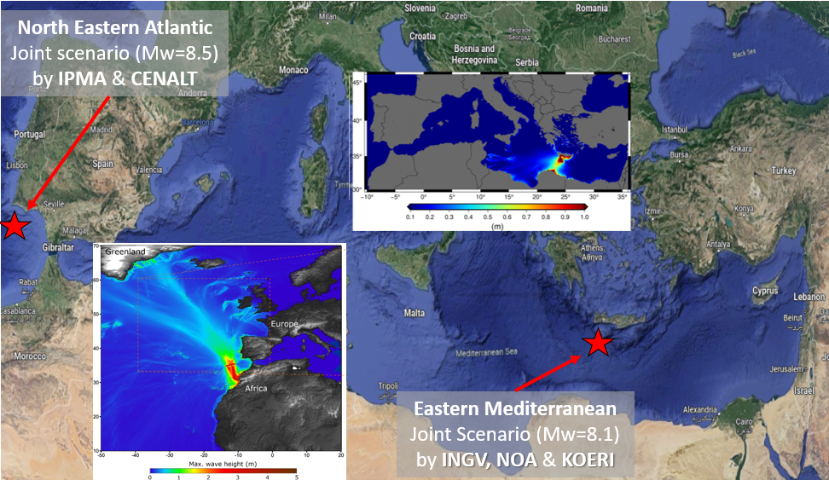

***Figure 1.*** *Exercise scenarios followed during the NEAMWave23 (satellite image from Google Earth).*

* **Phase B** (*early action, national level*) took place as soon as the message produced in Phase A was received by the TWFP/NTWC/TNC which then provided tsunami alerts to the national Civil Protection Authorities (CPAs). A simulation of the operational actions was then performed in some countries, which included one of the following types of exercise: orientation, drill, table top and functional exercise, as decided by the participating national agencies.
* **Phase C** (*early response, international leve*l) simulated a request for international assistance from an affected country through the Civil Protection Mechanism of the European Union and of the European Commission Emergency Response Coordination Centre (ERCC). This phase was only performed for the Eastern Mediterranean scenario at the international level on 7 November to simulate a real tsunami disaster situation. In the event a country is impacted by a big disaster, it needs to work out the damage assessment before requesting for international assistance. The Emergency Response Coordination Centre ([ERCC](http://ec.europa.eu/echo/en/what/civil-protection/emergency-response-coordination-centre-ercc)) of the European Commission ([EC](http://ec.europa.eu/index_en.htm)) through the Civil Protection Mechanism ([CPM](http://ec.europa.eu/echo/en/what/civil-protection/mechanism)) was responsible for planning and activating the procedures for the provision of international assistance to those affected countries which requested international assistance.

**The objectives of NEAMWave23 were as follows:**

1. Validate and evaluate the Tsunami Service Providers (TSPs) dissemination process of issuing Tsunami Messages in the NEAM region, also utilizing communication technologies, like SMS;
2. Validate and evaluate the procedures for countries to receive the Tsunami Messages issued by the TSP through their National Tsunami Warning Centres (NTWC), or the country Tsunami Warning Focal Points (TWFP) or the country Tsunami National Contacts (TNC);
3. Test the dissemination of the tsunami messages to the relevant agencies that are responsible for emergency response (CPA);
4. Assess the organizational decision-making process about public warnings and evacuations thus raising awareness of launching and contributing to the development of a national policy to tackle the tsunami risk.
5. Identify best practices (to be shared), criticalities (to be addressed by the programme in the future activities) and room for improvements in the entire process (including the procedures already tested between TSPs and TWFPs/NTWCs and also the heterogeneous panorama of national capacities to handle tsunami risk).
6. Test procedures for international assistance between the European Commission and participating Member States.
7. For this exercise (NEAMWave 23), a key objective is the involvement of Member States that participate in the CoastWAVE project, coordinated by UNESCO and those of other non-project countries (France, Italy). This exercise will test the efficiency and the abilities of the pilot UNESCO-IOC Tsunami Ready communities to respond in a complex and realistic situation, overcoming any challenges that may arise.

Within the above framework, each country was invited to develop its own specific objectives for the NEAMWave23 exercise. Table 1 lists the Member States (MS) that subscribed through the online subscription platform and the scenario or scenarios chosen to be followed by each country.

|  |  |  |  |  |  |
| --- | --- | --- | --- | --- | --- |
| **Country** | **NE Atlantic Scenario** | | | **Eastern Med. Scenario** | |
| **Phase A** | **Phase B** | **Phase C** | **Phase A** | **Phase B** |
| Cyprus |  |  |  |  | X (T) |
| Denmark | X | X (F) |  |  |  |
| Egypt |  |  |  |  | X (D) |
| Finland | X | X (O) | X |  |  |
| Germany |  | X (T) |  |  |  |
| Greece | X |  |  | X | X (T) |
| Israel |  |  |  |  | X (T) |
| Italy |  |  |  |  | X (D) |
| Lebanon |  |  |  | X |  |
| Malta |  | X (F) |  |  | X (F) |
| Monaco |  |  |  | X |  |
| Portugal | X | X (FS) |  |  |  |
| Romania |  |  |  | X | X (O) |
| Spain |  | X (FS) |  |  |  |
| Turkiye | X |  |  | X | X (T) |
| **TOTAL** | **5** | **6** | **1** | **5** | **8** |

***Table 1.*** *Member States subscription in NEAMWave23 exercise scenarios.* ***X*** *represents participation in the Phases. Letters in parenthesis denote type of activity during Phase B: D-Drill, F-Functional, FS-Full Scale, O-Other and T-Table top.*

For the first time, one of the key objectives for NEAMWave23 was the involvement of Member States that participate in a project (IOC-DG/ECHO CoastWAVE) , through the ongoing implementation of Tsunami Ready communities in Cyprus (Larnaka), Egypt (Alexandria), Malta (Marsaxlokk), Morocco (El Jadida), Greece (Samos), Spain (Chipiona), Türkiye (Büyükçekmece), as well as in communities in France (Cannes) and Italy (Minturno, Palmi, and Marzamemi). The purpose of this synergy was to test the efficiency and the abilities of the pilot UNESCO-IOC Tsunami Ready communities to respond in a complex and realistic situation, overcoming any challenges that may arise.

# ACTIVITIES UNDERTAKEN BY THE NEAMTWS SECRETARIAT

The NEAMTWS Secretariat, as foreseen by its mandate, was active during the preparation, the exercise itself and during the evaluation of the Exercise NEAMWave23 ([IOC/2023/TS/184 Vol.1](https://unesdoc.unesco.org/ark:/48223/pf0000386836)).

The **exercise announcement** for the NEAMWave23 was issued through IOC [Circular Letter](http://www.ioc-unesco.org/index.php?option=com_oe&amp;task=viewDocumentRecord&amp;docID=19996) ([CL 2950](https://oceanexpert.org/document/32898)) on 10 July 2023. The CL provided the dates, TSP’s scenarios and objectives of the exercise, the link of exercise online platform to download or access the exercise manual, exercise brief (also enclosed with this letter) and exercise subscription forms. Member States were also invited to provide details of updates concerning their Tsunami National Contact (TNC), Tsunami Warning Focal Point (TWFP) and National Tsunami Warning Centre (NTWC) to the ICG/NEAMTWS Secretariat (ANNEX I).

The IOC Secretariat established NEAMWave23 online platform (ANNEX II), was available by 15 August 2023, for disseminating the exercise manual, sharing the NEAMWave23 Exercise Brief and receiving exercise subscription of the Member States.

A **NEAMWave Exercise Brief** enclosed with the Circular Letter CL-2950 was prepared, referring to the concept note provided by TT-TE co-chairs, to encourage participation, especially of Civil Protection Agencies and other entities who are not yet familiar with the exercise. The exercise brief had Arabic, French and Spanish versions and was available at the online platform by 15 August 2023 (ANNEX III).

An **exercise information leaflet** was prepared to announce the NEAMWave23 Tsunami Exercise. This leaflet was also published by some Member States, especially CoastWAVE Project countries, through social media accounts (ANNEX IV).

A **short video announcement** was published through [UNESCO Representation to the European Institutions](https://www.facebook.com/watch/?v=1515313152604986) Facebook account on 27 October 2023, as a last call for the upcoming NEAMWave23 exercise.

The IOC Secretariat and the UNESCO Press Office published press information ahead of the exercise entitled [Upcoming Tsunami Exercise for the North-eastern Atlantic and Mediterranean](https://www.unesco.org/en/articles/upcoming-tsunami-exercise-north-eastern-atlantic-and-mediterranean" \l ":~:text=Countries%20around%20the%20North%2Deastern,celebrated%20annually%20on%205%20November.) and [NEAMWave Tsunami Exercises.](https://www.unesco.org/en/articles/neamwave-tsunami-exercises)

# ACTIVITIES UNDERTAKEN BY THE EXERCISE TEAM

A key expectation of NEAMWave23 was to increase the involvement of Civil Protection Authorities (CPAs) in the exercise. The co-chairs of the Task Team on Tsunami Exercise (TT-TE) were in close contact with the IOC secretariat to arrange targeted meetings with the members of IOC-DG/ECHO CoastWAVE project. At the TSP meeting in September 2022, TT-TE proposed the TSPs for having NEAMWave23 in combination with CoastWAVE partners’ exercises.

NEAMWave23 Exercise Manual Volume 1 and Volume 2 were prepared, submitted to the IOC Secretariat and finalized according to the Secretariat’s feedback in July 2023.

An online meeting was organized with the CoastWAVE coordination team to discuss the participation of project countriesin NEAMWave23 in parallel with their project activities.

A concept note was prepared to inform CPAs, NTWCs and other exercise actors about the general concept of NEAMWave and submitted to the IOC Secretariat. This concept note was then visually improved by the Secretariat and shared through the Circular Letter and exercise online platform as the “Exercise Brief”.

The online forms for the subscription and evaluation were revised and submitted to the Secretariat for the publication.

A request was conveyed to Civil Protection Authorities,through the TNCs with experience in NEAMWave exercises to prepare a one-page guiding document to share with other non-experienced CPAs, describing their experience in implementing Phase B of NEAMWave Exercises. However, no response was received.

# EVALUATION OF NEAMWAVE23 PHASE A

## 4.1 INTRODUCTION

Phase A (early warning) was the simulation of the first step of the early warning process, in case of a tsunamigenic seismic event. It consisted of the detection of the earthquake event and the timely provision of the alert messages by the Tsunami Service Providers (CENALT, NOA, INGV, IPMA and KOERI) to the Tsunami Service Recipients (TSRs), as well as to the Emergency Response Coordination Centre of the European Commission.

NEAMWave23 consisted of 2 different scenarios. This was the first time that one joint scenario was implemented by three TSPs while another joint scenario was used by two TSPs (Table 2). In these joint scenarios each TSP issued its own tsunami exercise messages.

|  |  |  |  |
| --- | --- | --- | --- |
| **Date & Time** | **Scenario** | **Region** | **TSPs** |
| **6 November 2023**  **08:00 UTC (6 hours)\*** | **1761 Atlantic Earthquake**  **[8.5 Mw]** | **North-Eastern Atlantic**  **[35°N, 12°E, 10 km]** | **IPMA - CENALT** |
| **7 November 2023**  **08:00 UTC (3½ hours)\*** | **Hellenic Arc**  **[8.1 Mw]** | **Eastern Mediterranean**  **[34.52°N, 24.57°E, 10 km]** | **INGV – NOA – KOERI** |

***\* Duration of message dissemination by TSPs***

**Table 2.** Timetable of NEAMWave23 Scenarios and responsible TSPs.

Both North-Eastern Scenario and Eastern Mediterranean Scenario consisted of two phases as Phase A and Phase B. Phase C was implemented only for the North-Eastern Atlantic scenario.

All TSP Member States (Greece, France, Italy, Portugal, Türkiye) submitted online exercise evaluation forms through the online platform (see sections 4.2). Nine Member States ( Cyprus, Finland, France, Greece, Italy, Portugal, Romania, Spain and Türkiye), and one international body, ERCC, provided their evaluations for Phase A. Four Member States, (Cyprus, Italy, Spain & Türkiye)provided evaluations for Phase B and one Member State, Finland, submitted Phase C evaluation forms as TSRs (see sections 4.3).

## 4.2 EVALUATION OF NEAMWave23 FROM TSPs

Alongside with the online evaluation forms, TSPs submitted the NEAMWave23 final evaluation reports (ANNEX V). A preliminary evaluation of NEAMWave23 tsunami exercise was presented by TSPs at the 18th ICG/NEAMTWS Session Steering Committee held in Paris on 6-8 February 2024. Further analysis of both the online forms and the submitted reports regarding the performance of the TSPs is presented hereafter.

Overall, the exercise was a positive experience. TSPs found the exercise useful with the integration of several new coordinates and two more countries which shows the international interest for this exercise. TSPs evaluated NEAMWave23 as a very good opportunity for checking the preparedness of the personnel on shift to manage message issuing, testing in almost real conditions some new features in the analysis and reporting software. NEAMWave exercise had a great impact throughout the country and made an importantcontribution to the development of bilateral relations, especially between the stakeholders. The exercise enabled TSPs to implement distribution of messages to a local level in the civil protection system, reaching directly some selected municipality levels and contributing to more effectiveness in the system. NEAMWave23 exercise was an opportunity to distribute messages to the lower levels in the civil protection system, reaching directly the regional and the district levels. It was a chance to test the dissemination of “National message” in almost real conditions in terms of new analysis and reporting procedures. Updating the communication channels, verifying the TSPs operational system and raising awareness among the end-user community, and further validation of the message recipient details were further contributions of NEAMWAve23 to the TSPs. The overall evaluation of TSPs reveals the exercise was very useful for testing both the procedures and the performance of TSPs.

Minor communication issues were identified, especially for the fax numbers that were unreachable. INGV reported that failures in message dissemination by fax during the exercise were at the same rate with the situation observed during monthly communication tests. Some issues were also identified in sending messages via email, which shows the need of multi-technology message transmission and the need to finaliz the implementation of a supplementary redundant service, using exterior email service provider.

KOERI reported some incompatibilities between the exercise scenarios provided in the exercise manual and the disseminated messages during the exercise. Specifically, the maps presented in the tsunami exercise manual by NOA were not received during the exercise as attachment tothe first tsunami message. Besides, some differences were also observed between the exercise messages in the exercise manual and the disseminated ones by INGV, i.e. the issuing time of the fourth exercise message and its sea level observations at Portopalo and Otranto Sea level stations.Otherwise, NEAMWave23 exercise was found very useful in terms of raising awareness among the end-user community and verifying the operational readiness of TSP.

CENALT reported errors in message dissemination such as blockage of emails at the TSP message server and associated latencies, GTS message receiving problem, delivery of national messages to other Member States unintentionally, issues with the sender’s names («tsunamis» appeared as the sender’s name instead of the email address).

All 5 TSPs distributed the complete set of messages to their Tsunami Service Receipients (TSRs) using email, fax and GTS. NOA, IPMA (at national level only) and KOERI also disseminated messages by SMS, although it is not an official means of communication for the IOC yet. INGV tested the dissemination of CAP-TSU messages to TSRs automatically by means of the software developed by CAT-INGV, at national level: as an email attachment and through a RESTful service to the Italian Civil protection (see the exercise manual for details).

NOA had an online debriefing meeting among the exercise planning team and the staff members that participated 30 minutes after the exercise ended. The issues that were noted and discussed during the debriefing was the complication of simultaneous dissemination and reception of messages from multiple TSPs, especially for fax messages, raising awareness of the Member States acting as Tsunami Service Recipients and the need for closer collaboration between TSPs, through a series of interoperability tools. During the debriefing, the issue with the e-mail messages was extensively discussed and possible measures proposed to avoid such problems in the future.

The details about the Communication System that TSPs are using for disseminating the warning messages are available in the detailed evaluation reports of the TSPs (ANNEX V).

TSPs have **recommended** the following for future implementation of NEAMWave Exercises:

* A new approach can be accommodated for the exercise duration in the case of NE Atlantic Scenario, since tsunami propagation and arrival time of first waves to the coasts of some TSRs in NE Atlantic take longer time than in the Mediterranean Sea.
* Concerning the content of the exercise, the complexity of the tsunami messages should be further improved, taking into consideration the needs and suggestions of the message recipients.
* The subscription mechanism needs to be improved, since it still causes some confusion to the various agencies wishing to register for the exercise. More detailed attention should be taken in preparing future exercises for local community participation.

TSPs have **suggested** the following for future implementation of NEAMWave Exercises:

* More frequent Phase A exercises (scenario-based communication tests) could be promoted to verify: i) operational readiness of TSP- availability of communication links, and ii) message recipient list.
* Efficient ways should be applied to have as many scenarios as possible to attract more Member States, as conducted in previous NEAMWave exercises, but at the same time avoid separating them too much. This can only be achieved through stronger collaboration between the TSPs in preparing the scenarios for the exercise.
* Producing more attractive, tailor-made messages by making them shorter and more comprehensive, and enriching them with enhanced products, such as various maps. should
* The TWFP/TNC contact form should preferably be structured and simplified as an Excel spreadsheet that would allow the TSP to easily use it as a database.
* An online database should be implemented to handle the contact details of the recipients in order to prevent any malfunctioning in message dissemination caused by any typo in exercise subscription forms.
* A mechanism should be introduced with the option for TSPs to test the emails provided by the exercise subscribers prior to the execution of the exercise, as is done for the subscribers’ list for the regular TSP service via the Communication Tests on a monthly basis.
* Standardisation in message sender’s name can be determined including sending TSP’s name and its email address, i.e. INSTITUTION NAME + TSP + COUNTRY CODE.
* Questions in evaluation form should be improved in a way that the information for more than one TSPs with different timestamps can be added. Besides, the form should allow choosing more than one role, i.e. NTWC and TWFP, as an exercise participant.
* Pre-exercise meeting(s) should be organised with all exercise participants.
* NEAMWave exercise should be conducted more frequently to better maintain communication and alert preparedness.

## 4.3 EVALUATION OF NEAMWave23 FROM TSRs

Table 3 summarises the online evaluation forms submitted by the Member States. **It is worth noting that almost half of the countries who submitted online subscription forms did not participate in the evaluation procedure**.

It is recalled that the evaluation of the exercise was primarily conducted by the five TSPs, which accounted for over half of the online forms submitted by a total of nine Member States.In addition, one international body (ERCC) also submitted evaluation forms for message dissemination of all TSPs.

|  |  |  |  |  |  |
| --- | --- | --- | --- | --- | --- |
| **Member State** | **Eastern Mediterranean NOA** | **Eastern Mediterranean KOERI** | **Eastern Mediterranean INGV** | **North-eastern Atlantic**  **CENALT** | **North-eastern Atlantic**  **IPMA** |
| Cyprus | **x** | **x** | **x** |  |  |
| Finland |  |  |  |  | **x** |
| France |  |  |  |  | **x** |
| Greece |  | **x** | **x** | **x** | **x** |
| Italy | **x** | **x** |  | **x** | **x** |
| Portugal | **x** | **x** | **x** | **x** |  |
| Romania |  | **x** |  |  |  |
| Spain (CPA) |  |  |  | **x** | **x** |
| Spain (IGN) |  |  |  | **x** | **x** |
| Türkiye | **x** |  | **x** | **x** | **x** |
| ERCC | **x** | **x** | **x** | **x** | **x** |
| **TOTAL** | **5** | **6** | **5** | **7** | **8** |

***Table 3.*** *List of NEAMWave23 participants that sent feedback for Phase A through the online evaluation forms.*

The delivery performance of the warning messages by the TSPs is presented in detail in the evaluation reports of the TSPs (ANNEX V). In general, according to the timestamps of messages received, the delivery duration of messages by e- mail and GTS is generally less than a couple of minutes with a few exceptions. Issues were observed for fax message and SMS delivery. Some Member States received only one SMS during the exercise or did not receive fax from one TSP.

Below there are feedbacks and recommendations submitted by the TSRs via the online evaluation forms:

* NEAMWave23 was very useful:
  + to verify operational readiness of TSP as message recipient.
  + to assess transmission delays and evaluation of messages associated with large tsunami events.
  + for having immediate and efficient communication between all agencies.
  + for testing the communication channels.
  + for having chance to evaluate operating procedures and manuals.
* It might be interesting to have a discussion with the TSPs before or after the exercise so that they can explain the differences between their products, i.e. different wave arrival times, message content,
* It might be interesting for the scenario to be a little more complex, with, for example, an intermediate alert level rising to a higher level.
* Standardisation in the list of observations would be useful, such as COUNTRY CODE-COMPLETE NAME OF THE TIDE GAUGE, for better analysis of alerts from different TSPs.
* It could be useful to have a meeting with the rest of the countries previously participating in the exercise (for the selected scenario), as well as the involved TSPs and the Task Team on Tsunami Exercise.
* It would be useful to create a digital tool for managing and updating contacts both for preparing for the exercise and for managing new subscriptions.
* The exercise duration for NE Atlantic Scenario should be extended considering that the tsunami propagation and arrival times at NE Atlantic Member States are much longer than the other seas in NEAM region due to the further distance from the tsunami source.
* Subscription mechanism needs to be improved, since it still causes some confusion to the various agencies wishing to register for the exercise.
* Exercise scenarios in the Black Sea should be more engaging and also directly "affected" in the NEAMWave scenario.
* Paperwork, meetings and the procedures in the preparation of the exercise can be reduced to diminish the workload that is needed for the preparation before the exercise. In that way, NEAMWave exercises can be conducted more frequently.
* Increasing the frequency of NEAMWave exercises may play a significant role in maintaining communication and preparedness among various stakeholders involved in tsunami early warning systems within a country.

Further details can be found in the submitted evaluation forms.

# EVALUATION OF NEAMWAVE23 PHASE B

## 5.1 INTRODUCTION

This section provides an evaluation of the Phase B (early action, national level) -tsunami alerts to the CPAs and simulation of the operational actions- of NEAMWave23.

Phase B was open to Member States and it was foreseen that different types of exercises canbe carried out including orientation exercise, drill, table-top or functional exercise all within the discretion of each Member State. The types of exercises were described in more detail in *Annex I* of the Exercise Manual of NEAMWave23 ([IOC/2023/TS/184 Vol.1](https://unesdoc.unesco.org/ark:/48223/pf0000386836)).

For the first time, an important objective (7) of the NEAMWave 23 exercise was to involve CoastWAVE project pilot communities implementing UNESCO-IOC Tsunami Ready and those of other countries (Italy, France). NEAMWave 23 served as an opportunity for IOC DG ECHO CoastWAVE project partner countries to work towards fulfilling indicator 8 on conducting community tsunami exercises, thus contributing to achieving UNESCO-IOC Tsunami Ready Recognition.

The CoastWAVE project aimed to improve the preparedness and response of coastal communities to tsunami events. As part of this project, the participating counties were expected to take part in Phase B, which involves conducting a local exercise using the NEAMWave 23 scenario. By participating in Phase B, the counties tested their tsunami warning systems, emergency plans, and public awareness campaigns, by implementing one of the following options:

1. Conduct a functional/full-scale exercise, on the day of NEAMWave 23, with the scenario provided;
2. Conduct a functional/full-scale exercise, on a different date, with the scenario provided for NEAMWave 23;
3. Conduct a drill/table-top exercise, on the day of NEAMWave 23, with the scenario provided.

The countries that decided to use NEAMWave23 exercise scenarios for implementing local exercises, selected options (i) or (iii).

If a Member State (TWFPs/NTWCs and CPAs) chose to participate in Phase B of NEAMWave23, it was also required to submit the type of exercise that would be followed during this phase of the exercise. Table 4 summarises the MS subscription for Phase B (Figure 3). All types of exercises were selected and performed, aside from the orientation exercise.

|  |  |
| --- | --- |
| **Type** | **MS** |
| Orientation | 0 |
| Drill | 2 |
| Table-top | 5 |
| Functional | 3 |
| Full scale | 2 |
| Other | 2 |
| **Total** | **14** |

***Table 4.*** *Types of Phase B exercises of NEAMWave23, according to the subscription forms of the Member States.*

It is to be noted that four Member States out of ten that had subscribed to participate in Phase B filled the online evaluation forms (Table 5). It is important to underline that these numbers are higher than the participation during the previous NEAMWave21 exercise (2 out of 8). The information provided in the following section presents the results obtained through the online evaluation forms.

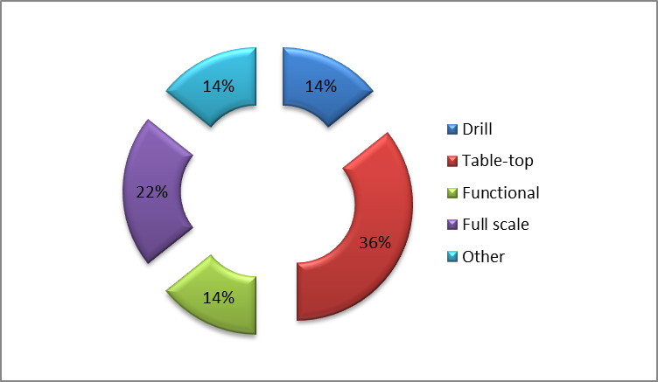

***Figure 3.*** *Types of Phase B exercise of NEAMWave23, according to the subscription of the MS.*

Although, the majority of the participants (⅓) decided to have a table-top exercise, it is of great interest to note that two Member States reported that they undertook a full-scale exercise. It is the first time in the NEAM region that NEAMWave exercises were carried out across the whole tsunami warning chain, from the TSPs to the local emergency managers. However, a detailed look at the activities undertaken during the exercise indicates that a full-scale exercise might not be fully justified according to the definition of the various types of exercises. Therefore, a more precise clarification should be included in the next exercise manual.

|  |  |  |  |  |
| --- | --- | --- | --- | --- |
| **Country** | **Eastern Mediterranean** | | **North-eastern Atlantic** | |
| ***Sub.*** | ***Ev.*** | ***Sub.*** | ***Ev.*** |
| Cyprus | T | T |  |  |
| Denmark |  |  | F |  |
| Egypt | D |  |  |  |
| Finland |  |  | O |  |
| Germany |  |  | T |  |
| Greece | T | T + D |  |  |
| Israel | T |  |  |  |
| Italy | D | D |  |  |
| Malta | F |  | F |  |
| Portugal |  |  | FS |  |
| Romania | O |  |  |  |
| Spain |  |  | FS | FS |
| Turkiye | T | T |  |  |
| **TOTAL** | **8** | **5** | **6** | **1** |

***Table 5.*** *Member States participation in NEAMWave23 Phase B exercise (Sub.: according to the subscription, Ev; according to the evaluation forms or the TSP evaluation report). Letters denote type of activity during Phase B: O-Orientation, D-Drill, T-Table top, F-Functional, FS-Full Scale and o-Other.*

## 5.2 SUMMARY OF THE PHASE B ONLINE FORMS PROVIDED BY MEMBER STATES

Due to the limited number of participants in the Phase B exercise (Table 5) who completed the evaluation forms, the responses were analyzed qualitatively rather than quantitatively.

According to the submitted evaluation forms, the type of activities that were implemented during the exercise were:

* 2 Table-top (Cyprus and Türkiye);
* 1 Drill (Italy);
* 1 Full-scale (Spain).

The evaluation was performed mainly by the Civil Protection Authorities of Cyprus (Civil Defence), Italy (Italian Department of Civil Protection) and Türkiye (AFAD - Ministry of Interior Disaster and Emergency Management Presidency, Türkiye). In Spain, besides the Directorate General of Civil Protection and Emergencies, the Autonomous Administration of Andalusia (AAA) and the National Geographic Institute (IGN) participated in the evaluation procedure. All agencies received the tsunami messages by the national TWFP/NTWC.

The tsunami messages between the TWFPs and the national CPAs/EMOs are transmitted / received mainly by email, while the use of fax, SMS and IVR (Interactive Voice Response) were also used by some agencies. There were no problems reported at this stage, besides a comment by the Spanish CPA (DGCPE) on the subject of the messages that were circulated regarding the lack of the warning message identification number.

It is worth noting that all TWFPs (4) reported that the messages were modified before their re-transmission at national level, either automatically or manually. The most common modification of the messages is to translate them into the local language to make them more understandable to end users.

All the agencies, besides the GSD (Cyprus) already have procedures in place to receive tsunami messages and activate emergency operations as per dedicated Emergency Response Plans and Standard Operating Procedures (SOPs). GSD reported that they are currently drafting emergency response plans for tsunamis at national level, and they will be rolled out at municipal level in 2024.

As for the tsunami alert levels, all agencies rely on the alert levels defined and used at the NEAMTWS by IOC-UNESCO.

Some general suggestions were the following:

* GSD: The scenario of an extreme event is ultimately simple to manage in terms of the decision-making chain. It would be interesting to play more complex scenarios, for example with evolving alert levels, or even different alert levels between the different TSPs because they are at the limit of the decision matrix.
* GSD:The number of forecast points for TTTs differs between TSPs.
* GSD):TTT values are sometimes very different between TSPs.
* GSD:Cartographic products are not harmonised.
* GSD:INGV messages are very long.
* AAA: It would be very interesting to organize exercises including the 62 coastal municipalities of Andalusia.
* AAA:Tsunami alert levels defined in the national alerting mechanism:
  + Aviso (ADVISORY) - Beach and low areas flooding.
  + Alerta (WATCH) - Other areas are flooding.
* IGN:Improve internal procedures and organization of a national exercise in 2024.
* GN:nAbout the online form: include a SAVE button to postpone the submission of the form.
* IGN:It could be useful to have a meeting with the rest of the countries previously participating in the exercise (for the selected scenario), as well as the involved TSPs and the Task Team on Tsunami Exercise.

In general, participants found that the NEAMWave23 exercise served as a significant platform/tool for participants to enhance their tsunami preparedness. It facilitated valuable feedback through questionnaires sent to all relevant stakeholders, fostering collaboration at both national and local levels. Additionally, the exercise allowed participants to review and refine their incident-based plans and standard operating procedures (SOPs), ensuring a comprehensive approach to tsunami response. Overall, such exercises are considered vital for improving awareness and readiness against tsunami threats.

## 5.3 PARTICIPATION OF COUNTRIES IMPLEMENTING THE TSUNAMI READY RECOGNITION PROGRAM

For the first time, an important objective of NEAMWave23 exercise was to involve CoastWAVE project pilot communities implementing UNESCO-IOC Tsunami Ready, as well as those of other countries (Italy, France). NEAMWave23 served as an opportunity to IOC DG ECHO CoastWAVE project partner countries to work towards fulfilling indicator 8 on conducting community tsunami exercises, thus contributing to achieving UNESCO-IOC Tsunami Ready Recognition.

The CoastWAVE project aimed to improve the preparedness and response of coastal communities to tsunami events. As part of this project, the participating counties were expected to take part in Phase B, which involves conducting a local exercise using the NEAMWave23 scenario. By participating in Phase B, the counties had the chance to test their tsunami warning systems, emergency plans and public awareness campaigns, by implementing one of the following options:

1. Conduct a functional/full-scale exercise, on the day of NEAMWave 23, with the scenario provided;
2. Conduct a functional/full-scale exercise, on a different date, with the scenario provided for NEAMWave 23;
3. Conduct a drill/table-top exercise, on the day of NEAMWave 23, with the scenario provided.

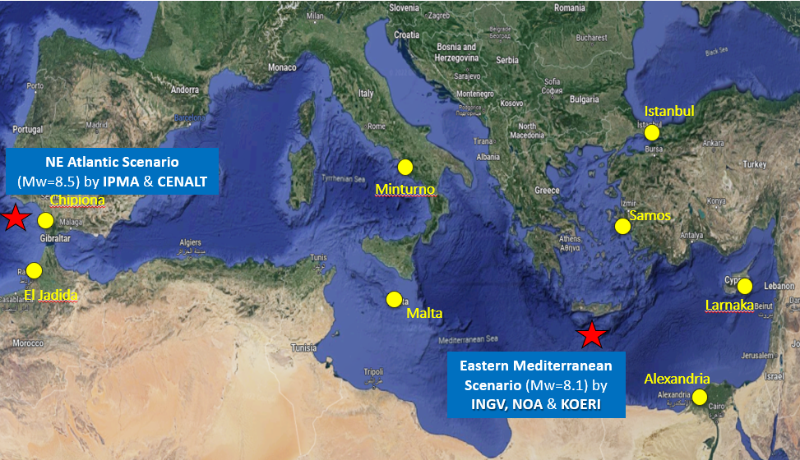

***Figure 2.*** *Map illustrating the communities where Tsunami Ready Recognition Program was implemented during the NEAMWave23 exercise.*

Below is a summary of the activities carried out by each country during the NEAMWave23 exercise:

Cyprus - Table-Top Exercise:

A workshop was held in Larnaka on the 26th and 27th of September 2023, co-organised by NOA, INGV & IHC with the collaboration of the GSD, regarding evacuation mapping in the city of Larkana.

During the exercise, participants focused on enhancing their understanding of tsunami inundation modeling and developing evacuation plans. It also served as a chance to initiate drafting standard operating procedures (SOPs) and to rekindle discussions with the municipality of Larnaka, the pilot site for the CoastWave project. Additionally, a Probabilistic,? Tsunami Hazard Assessment (PTHA) was carried out for Larnaka as part of the CoastWAVE initiatives.

Egypt – Drill Exercise:

Evacuating a middle school in Alexandria using the Eastern Mediterranean scenario involved coordination with the Directorate of Education to conduct this exercise in schools, addressing concerns about children's safety. Managing the flow of students along the evacuation route proved to be quite challenging.

Greece – Table-Top and Drill Exercises:

An earthquake and tsunami exercise, called SAMOSWAVE23-CW was organized in the city of Samos by the Municipality of Eastern Samos and NOA utilising the Eastern Mediterranean Scenario. It included two components that unfolded in parallel, a Table-Top Exercise and an Earthquake and Tsunami Preparedness Exercise in two Middle Schools of Samos.

Italy – School Drill Exercise:

Using the NEAMWave23 Eastern Mediterranean scenario, a school drill was conducted in Minturno. A local nursery school participated in the drill by vertical evacuation of the children and staff to a higher floor of the building. The drill aimed to test the preparedness and response of the school community in case of a real tsunami event.

Malta – Full Scale Exercise:

A Tsunami Hazard Assessment and Evacuation Modeling/Mapping were conducted in Marsaxlokk. The exercise at the local level focused on the Eastern Mediterranean scenario, with activities including the development of sea level time series at Marsaxlokk in collaboration with Malaga University. Key achievements involved testing communication protocols, the mobile incident command unit, tsunami simulation and support systems, and tsunami alert devices. Students successfully evacuated from the shore to a safe zone upon hearing the sirens. While it was officially classified as a Functional Exercise, it was more accurately aligned with a Full-Scale exercise, according to the organisers.

Morocco – Full Scale Exercise:

CoastWAVE activities encompassed the preparation of tsunami inundation and evacuation maps for Jorf Lasfar El Jadida. These efforts included social events, workshops, and meetings to raise awareness about the exercise. This was a full-scale community tsunami evacuation drill involving local authorities, residents, and emergency services. The main challenges involved a lack of knowledge among authorities, concerns about public attitudes, and fears within the community. After several meetings, the exercise was successfully conducted and evaluated.

Spain – Full Scale Exercise:

The exercise in Spain involved the evacuation of a school in Chipiona Municipality, coordinated by the local police operational center to guide students to the meeting point. Prior outreach activities in Chipiona included conferences, a "Tsunami Walk" to familiarize participants with evacuation routes, and meetings with institutions involved in the exercise.

Türkiye – Table-Top Exercise:

In order to oversee the dissemination chain during the NEAMWave23 Tsunami Exercise, KOERI conducted a Table-Top Exercise focused on the tsunami message dissemination chain for Büyükçekmece, Istanbul. All relevant stakeholders were invited, including the Disaster and Emergency Management Department (AFAD), Istanbul Metropolitan Municipality, the District Governorate and Municipality of Büyükçekmece, Middle East Technical University (METU), and the Turkish Wireless and Radio Amateur Society (TRAC). Observers from the Office of Navigation, Hydrography, and Oceanography (SHOD) and Boğaziçi University also participated in the exercise.

All the above-mentioned activities aimed to enhance the readiness and resilience of the participating countries against potential tsunami threats.

# EVALUATION OF NEAMWAVE 21 PHASE C

Phase C (early response, international level) of the NEAMWave23 exercise was only performed for the Eastern Mediterranean joint scenario conducted by INGV (Italy), NOA (Greece) and KOERI (Türkiye). During this phase the three TSPs distributed their initial tsunami messages. The Emergency Response Coordination Centre ([ERCC](http://ec.europa.eu/echo/en/what/civil-protection/emergency-response-coordination-centre-ercc)) of the European Commission [(EC](http://ec.europa.eu/index_en.htm)) through the Union Civil Protection Mechanism (U[CPM)](http://ec.europa.eu/echo/en/what/civil-protection/mechanism) was responsible for planning and activating the procedures for provision of international assistance to those affected countries which requested it.

It should be noted that in the Exercise Manual, templates were also provided for requesting assistance, which was particularly useful for the participants who were not familiar with the ERCC and UCPM procedures. In principle, the ERCC contacts the CPA in potentially affected countries to enquire about a possible request for assistance after their submission of a preliminary impact assessment. Requests for international assistance and offers are channelled through the UCPM, via the ERCC/CECIS.

Unfortunately, this year only one country (Finland) registered and took part in Phase C, although only ERCC submitted an evaluation form. The ERCC was simulating Greece requesting for assistance and posted the needs according to previous experiences and the tsunami scenario that was built in 2023 by the ERCC Situational Awareness Team. The assistance offered through the Union Civil Protection Mechanism (UCPM) takes the form of "modules" which are a pre-defined and agreed combination of experts and assets performing a specific task.

In general, the ERCC supports such exercises, since they always represent an excellent opportunity to refresh our knowledge regarding tsunamis and tsunami warning systems in the NEAM region and to test the UCPM response procedures. During the exercise, the ERCC experienced a real problem of the network delaying the actions and creating communication problems with Finland, which was the offering country in phase C. This allowed to highlight the importance of making sure that the contact list of the national contact points is always up to date.

The ERCC reported that the purpose of phase C would servebetter with the participation of at least one country requesting assistance and two or more offering. These could be set as minimum criteria for the conduct of phase C. In addition, both IOC-UNESCO and ERCC should aim to strengthen the involvement of Civil Protection authorities from Member States.

Below is a short summary of the exercise and actions taken, as it was shared by ERCC:

* Phase C was played by the ERCC playing both as ERCC and as requesting country.
* The only country registered in Phase C was Finland who played an assistance offering country.
* On 6 November, ERCCa preparatory meeting with Finland to fine-tune the plan of action. For the meeting a briefing was shared.
* On 7 November, following the reception of the tsunami messages by 2 out of 3 Tsunami Service Providers, namely INGV and KOERI, the ERCC started the exercise opening in the Common Emergency Communication and Information System (CECIS) an information sharing page to inform about the triggering of a tsunami due to an earthquake of magnitude M8.1 occurring off-shore South Crete of the Hellenic Arc at the 10 km depth.
* Following the opening in CECIS of an information sharing page, the ERCC started having real network problems. Therefore, some planned actions were delayed. In addition, the ERCC used the telephone to communicate with Finland.
* Once the network was re-established, the ERCC, simulating Greece, one of the most affected countries by the tsunami, could open an emergency in CECIS.
* The ERCC/Greece posted the first identified priority needs (e.g. search and rescue team, emergency medical team, water purification, shelters, generators and structural engineers). The needs were identified according to the ERCC previous exercise as well as following the tsunami scenario that was built in 2023 by the ERCC Situational Awareness Team with the European Natural Hazard Scientific Partnership (ENHSP) established by ARISTOTLE consortium.
* Following the request for assistance by “Greece” (played by the ERCC), the ERCC asked for nomination of experts to compose an EU Civil Protection Team to be deployed in Greece. The EUCPT would have been accompanied by an ERCC Liaison Officer and a TAST Team (which supports the EUCPT in fields such as communication, logistics and self-sufficiency).
* Finland, playing as realistic as possible, offered 1 TAST team.
* The offer was accepted.
* The exercise ended.

After the exercise, a hotwash meeting was held, which resulted in highlighting the following main points:

* NEAMWAVE23 provided a good training opportunity to Duty Officers of both the ERCC and EU Member States.
* To exercise the UCPM procedures is always useful.
* Due to real network problem, it was reiterated the importance to have the list of contact details of EU Member States and UCPM Participating States always up to date
* **The ERCC highlighted the complexity of the Tsunami messages and proposed at least to list the “affected country” by wave arrival time and not by country.**
* **The ERCC did not receive the tsunami messages from NOA. To have the 3 messages seems to be important because they have different information on “affected countries”. On this, maybe some simplification amongst Tsunami Service Providers should be considered.**
* It was underlined that for the next exercise, there is a need toenhance efforts to inform well in advance the civil protection community and aim at a bigger participation to phase C.

The ERCC found the exercise an appropriate opportunity to test procedures, train ERCC Duty Officers and new recruits in both the ERCC and Situational Awareness Team. It drew important lessons on how to improve the support system, including the ICT systems, as well as raise awareness of tsunami in the NEAM region.

**Overall, the exercise was a valuable experience with clear benefits, including identifying lessons to enhance ERCC working processes.**

**For the next exercise**, it might be worthwhile to organise informative sessions with CPAs of non-Member State countries that would be affected by a tsunami according to the different scenarios. This would allow raising awareness on how the EU emergency management system works.

Some issues were encountered with the internet-based communication network. **This highlighted the importance to have the list of contact details of EU Member States and UCPM Participating States always up to date**.

The participants found the exercise useful in terms of understanding the EUCP Mechanism and its activation procedures. These types of exercises are very useful as information flow and procedures are tested. Everyone who participated felt more familiar with a real potential tsunami and how actions should be taken. The Tsunami Exercise Manual provided a good insight on how the exercise should be developed. It helped the end-user to prepare at a regional and local level.

# CONTACT WITH THE MEDIA

Several countries advertised and informed about the exercise in the local media. The following are the responses submitted by the Member States through the online evaluation form.

**Spain** (IGN) was contacted by Spanish national radio and a regional radio giving interviews about the exercise. Additionally, the Autonomous Administration of Andalusia was also contacted by local media.

**Turkiye** issued a press release prepared by the Corporate Communication Office of the Boğaziçi University. A representative of KOERI gave a report to the media before the exercise.

<https://www.cnnturk.com/yerel-haberler/antalya/antalyada-tsunami-tatbikati>

<http://www.erdemli.gov.tr/tsunami-tatbikati-bilgilendirmesi>

In **Greece**, the national public television channel broadcasted an interview of the National Contact of the Exercise (NOA-HLNTWC) right after the end of the exercise in Samos, where the CoastWAVE project is implemented.

**Cyprus** (GSD) published an article in an electronic newspaper.

**Italy** (INGV) posted news about the NEAMWave23, in Italian, on the INGV blog and on the CAT website, as well as in local media. INGV also published a video in youtube entitled “*Esercitazione per rischio tsunami nell'area Euro-Mediterranea*” by Dr. Alessandro Amato. The Italian Civil Protection Department also posted information about the exercise on their web page.

<https://ingvterremoti.com/2023/11/07/7-novembre-2023-lesercitazione-tsunami-neamwave23/>

<https://youtu.be/qKfP_mrgJdc?feature=shared>

<https://www.telegolfo.com/minturno-tsunami-neamwave23-esercitazione-preventiva-rischio-maremoti/>

<https://www.protezionecivile.gov.it/it/notizia/world-tsunami-awareness-day-come-prepararsi-ad-affrontare-il-maremoto-1/>

<https://iononrischio.protezionecivile.it/it/notizia/world-tsunami-awareness-day-come-prepararsi-ad-affrontare-ilmaremoto/>

**Portugal** (IPMA) issued a joint press release together with the Portuguese National Authority for Emergency and Civil Protection (ANEPC), answering questions about the exercise.

# CONCLUSIONS AND RECOMMENDATIONS

NEAMTWS Member State was invited to participate in the Exercise NEAMWave23. For each scenario chosen, Member States specified which phase (Phase A, Phase B, and Phase C for North-eastern Atlantic scenario only) to participate. The level of commitment of each Member State was decided at national level and reflected on the subscription form filled by the Member States online. Different from the previous exercises, Member States that are already the recipients of TSPs also subscribed for NEAMWave23 Scenarios since they did not receive Phase A messages from their message providers as default. In total, 15 out of 40 NEAMTWS Member States took part in the exercise (ANNEX VI), noting that in general not more than 50% of Member States are actually consistently active in ICG/NEAMTWS activities[1].

The key operational components of a tsunami warning centre are to provide real-time monitoring, alert of seismic and tsunami activities, make decisions in a timely manner, and disseminate tsunami warnings, advisories, and information. Similar to previous exercises, NEAMWave23 provided a unique opportunity to all stakeholders involved in the NEAMTWS, not only to test existing operational capabilities of the early warning chain, but more importantly to enable TSPs implement the distribution of messages to a local level in the civil protection system.

Similar to previous exercise, NEAMWave23 exercise confirmed the advanced operational level status of the TSPs in the dissemination of messages to CPAs in national languages, as well as the provision of tsunami enhanced products (tsunami travel time and alert level maps). The exercise showed that a **closer collaboration among the TSPs is essential**, and interoperability is one of the key areas to fulfil in NEAMTWS.

NEAMWave23 exercise demonstrated enhanced collaboration between TSPs for the second time. Similar to NEAMWave21, joint exercise scenarios were prepared by TSPs in which they disseminated their exercise messages separately. In NEAMWave23, it was the first time that one joint scenario was used by three TSPs, INGV-KOERI-NOA, for message dissemination in the Eastern Mediterranean. Also, one joint scenario was prepared by two TSPs, CENALT and IPMA, in the North-Eastern Atlantic.

The involvement of the CoastWAVE project (funded by DG-ECHO and coordinated by IOC-UNESCO) in NEAMWave23 increased the participation of CPAs in the exercise Phase B. NEAMWave23 enabled Member States to test the efficiency and the abilities of the pilot UNESCO-IOC Tsunami Ready communities to respond in a complex and realistic situation. With this synergy, TSPs directly reached some selected municipality levels and contributed to more effectiveness in the system. In that sense, NEAMWave23 was able to achieve for the first time a significant engagement and participation of the Civil Protection Authorities.

Two Member States from North-African Countries, Egypt and Morocco, participated in Phase B with more comprehensive exercises in NEAMWave23. It was a good achievement that Morocco implemented Full-scale evacuation exercise in NEAMWave23 Phase B within the scope of CoastWAVE TsunamiReady activities.

**Provision of international assistance under the Union Civil Protection Mechanism ERCC of the European Commission was tested for the fourth time** within the context of the NEAMWave23 through Phase C. Only one Member State, Finland, participated in Phase C and requested assistance from ERCC. It was a good opportunity to test the mainstreaming of the Standard Operating Procedures of the ERCC of the European Commission with the NEAMTWS in regard to providing international assistance through the Union Civil Protection Mechanism. However, the lack of participation in Phase C brings out the discussion of defining minimum criteria for the implementation of Phase C in NEAMWave exercises.

As foreseen in NEAMWave21 final evaluation report, NEAMWave23 exercise included three full-scale exercises, conducted by Malta, Morocco and Spain, in the frame of the CoastWAVE Project organized by IOC-UNESCO and DG ECHO. NEAMWave23 Phase B activities were successfully overlapped with the Tsunami Ready activities by CoastWAVE Project Member States in the form of Functional and Drill as well as Table-top Phase B exercises in the NEAM region.

A NEAMWave Exercise Brief was prepared by TT-TE and the IOC Secretariat and distributed through the Circular Letter for the first time in NEAMWave23. The aim was to encourage participation, in a more user-friendly way, especially of Civil Protection Agencies and other entities who were not yet familiar with the exercise.

It was the first time that NEAMWave23 online exercise platform was established by the IOC Secretariat for disseminating exercise documents and distributing online subscription and evaluation platforms. Not all the countries that subscribed and/or participated completed the Phase B and C evaluation questionnaires. The online evaluation is more user friendly in NEAMWave23, however it proved a challenge to analyse the statistics to prepare a more comprehensive and quantitative evaluation report.

Most countries modified the tsunami alert messages for national dissemination. **The international messages are still not user friendly**, as it continues to be highlighted by several countries in all evaluations (NEAMWave12, NEAMWave14 and NEAMWave17, NEAMWave21).

Overall, all the countries agreed that the exercise was an important opportunity to **raise awareness on tsunami risk**, as well as **test communication channels and emergency procedures** between TWFPs and CPAs/EMOs. Media coverage for this exercise was extensive and was supported by national coverage of Project CoastWAVE Tsunami Ready activities. There is a constant need to engage and involve the media in NEAMTWS activities and tsunami exercises to raise awareness on tsunami risk and EWS in the public.

There is a need to further improve internal coordination (among IOC Secretariat, ICG/NEAMTWS Task Team members and TSPs) in regard to the development of TNC/TWFP databases, refinement of online tools (documents repository, subscription mechanism and evaluation forms), better configuration of exercise evaluation mechanism and timely finalisation and distribution of the exercise material.

Below highlights some new and previous lessons:

1. Reorganise content and format of the Tsunami messages;
2. Graphic information, such as maps are desirable in the messages;
3. Use of more user-friendly online tools (documents repository, subscription mechanism and evaluation forms);
4. Organise meetings between TSPs and the exercise participants, especially NTWCs, for better understanding of exercise scenarios and procedures;
5. Better timing in preparation and distribution of exercise material to the participants;
6. Better configuration of questions in evaluation forms, which enable TT-TE a better evaluation of exercise;
7. Civil Protection Agencies/Organizations/Local authorities participation is a key to success and advancing exercises in the NEAM region.

A number of best practices have been identified during the NEAMWave exercise:

1. Use online tools for the subscription and evaluation of the exercise.
2. Effect only essential changes to the exercise manual (e.g. scenarios and specific objectives) by the use of Volume 1-generic exercise information and Volume 2-exercise scenarios and specific implementation procedures, in order to sustain a general knowledge about the exercise.
3. Balance between the minimum number of scenarios and the maximum potential participating Member States.
4. Apply Full-Scale evacuation exercises with the synergy of CoastWAVE Project.
5. Use joint scenarios to strengthen the cooperation among the TSPs.
6. Tailor made national messages (language) and enhanced products (maps) to users.
7. Carry out exercise in a multi-hazard crisis context and within World Tsunami Awareness Day framework.

Finally, based on lessons learnt from previous NEAMWave tsunami exercises, as well as the objectives set for this exercise, participants of the exercise made the following recommendations:

* More frequent Phase A exercises (for example scenario-based communication tests) could be promoted in order to verify: i) operational readiness of TSPs, ii) availability of communication links and iii) message recipient list;
* Conducting a communication test a few days before the exercise to verify the contact list that the TSPs have prepared for the exercise;
* Tsunami messages should be simplified and standardised by restructuring of their content and omission of certain parts, noting that there are Member States who also recommended longer and more informative messages. A right balance need to be established regarding messages;
* Possibility for more information from TSPs, as well as chat function or e-mail exchange between TSPs and TSRs, during the exercise;
* Provide wave heights and run-up values at forecast points. However, such information is not practised under the current NEAMTWS TSP operational standards;
* Appreciated and requested the dissemination of enhanced products (maps) together with the text messages, which are easily and quickly understandable in comparison with the standard text messages;
* Theexercise can also have a monitoring component on an online platform, instead of just being conducted only on a warning mail message exchange basis;
* Further improvements in the online submission forms for both subscription and evaluation;
* Option to print out or e-mail the online forms after filling them, for future reference;
* Reaffirmed to repeat the exercise periodically (e.g. biannual);
* Ensure that CECIS, and other relevant programmes, are part of the CPA’s business continuity plans to guarantee their ability to coordinate at EU level;
* There is a need for more resilient IT systems and back up processes to overcome any network connectivity issues that negatively affected team use of specialised mapping programmes, during remote working and information sharing;
* Appreciate the scenarios prepared in NEAMWave23 and requested multiple joint scenarios between more than one TSPs in order to simulate real-life operational activities, which is expected to increase the level of participation of non-subscriber Member States.

The TT- TE and IOC-UNESCO Secretariat have suggested the need to organise several face-to-face and/or online preparatory meetings before the exercise, among different groups of participants (e.g. TSPs, CPAs, etc.), in order to engage as many participants as possible. Moreover, similar to NEAMWave23, the forthcoming NEAMWave exercises could be an opportunity for greater synergies within Tsunami Ready recognized communities. It could strengthen networks and partnerships with Civil Protection Agencies/Organizations and also make a greater use and application of enhanced products.

**Executive Summary: NEAMWave23 Exercise Feedback**

NEAMWave23 provided a valuable opportunity for Tsunami Service Providers (TSPs) to assess the preparedness of personnel, test new software features in real-world conditions, implement local message distribution, update communication channels, and evaluate both operational systems and performance. However, challenges were encountered in disseminating messages, particularly through fax systems[2], due to non-unique fax numbers, and in email transmission, highlighting the need for a multi-technology approach to message delivery.

For Tsunami Service Recipients (TSRs), the exercise was instrumental in verifying the operational readiness of TSPs as message recipients, assessing transmission delays, and evaluating the clarity of messages related to large tsunami events. It also facilitated immediate and efficient communication between agencies and provided an opportunity to test communication channels and evaluate operational procedures, enhancing overall preparedness.

Feedback from Phase B highlighted the need for improvements in National Messages, as they are sometimes not well understood at the local level, and the importance of including more municipalities and local communities in future exercises. Additionally, there were calls to promote self-protection measures in coastal and maritime sectors. Some participants also recommended holding a preparatory meeting before the exercise, involving all participating countries, TSPs, and the Tsunami Exercise Task Team. There was a request for more complex scenarios in future exercises, particularly those with evolving or varying alert levels across TSPs, where decision-making may be more nuanced. Other feedback included inconsistencies in forecast points, varying tsunami arrival times, lack of harmonization in cartographic products, and messages that were seen as too lengthy. Notably, it was also suggested that Member States might be more advanced than initially thought in adapting to threat levels.

Phase C feedback emphasized the need for improved network reliability, as delays in communication with Finland highlighted the importance of maintaining an up-to-date contact list. The effectiveness of Phase C could be enhanced by ensuring and setting a criteria of at least one country requests assistance and two or more countries offer international assistance.Hence, there is a need to further discuss with ERCC. Additionally, there is a need to better communicate ans share information on the types of exercises conducted in Phase B through consultations with CPAs or ERCC. Greater involvement of Civil Protection Authorities (CPAs) was also recommended. The ERCC suggested simplifying tsunami messages by listing affected countries with corresponding wave arrival times and emphasized the importance of informing the civil protection community well in advance to ensure broader participation.

Overall, in general there was an observed increase in CPA participationdue to synergies with the CoastWAVE project.. Another important achievement was the division of the manual into two parts which improved the efficiency of preparing, organising NEAMWave23.

# REFERENCES

Intergovernmental Oceanographic Commission. 2011. *Reducing and managing the risk of tsunamis.* Paris, UNESCO. IOC Manuals and Guides, 57 ([IOC/2011/MG/57 REV.2](http://unesdoc.unesco.org/images/0021/002147/214734e.pdf))

Intergovernmental Oceanographic Commission. 2012. *How to plan, conduct and evaluate IOC-UNESCO tsunami wave exercises.* Paris, UNESCO. IOC Manuals and Guides, 58. ([IOC/2012/MG/58 REV.](http://unesdoc.unesco.org/images/0021/002189/218967e.pdf)) (English and Spanish)

Intergovernmental Oceanographic Commission. 2013. *Tenth session of the Intergovernmental Coordination Group for the Tsunami Early Warning and Mitigation System in the North Eastern Atlantic, the Mediterranean and Connected Seas (ICG/NEAMTWS-X): executive summary.* Paris, UNESCO*.* ([IOC/ICG/NEAMTW S-X/3S)](http://unesdoc.unesco.org/images/0022/002281/228121e.pdf) (English, French, Spanish and Russian)

Intergovernmental Oceanographic Commission. 2014. Exercise NEAMWAVE 14. A Tsunami Warning and Communication Exercise for the North-Eastern Atlantic, the Mediterranean, and Connected Seas Region, 28–30 October 2014, Volume 2: Evaluation report. Paris, UNESCO, IOC Technical Series No 114 Vol.2. ([IOC/2014/TS/114Vol.2)](http://unesdoc.unesco.org/images/0023/002301/230172e.pdf) (English only)

Intergovernmental Oceanographic Commission. 2017. *Exercise NEAMWAVE 17: A tsunami warning and communication exercise for the North-eastern Atlantic, the Mediterranean, and Connected Seas Region, 31 October – 3 November 2017, volume I: manual.* Paris, UNESCO. IOC Technical series; 134 ([IOC/2017/TS/134VOL.1)](http://unesdoc.unesco.org/images/0025/002591/259196E.pdf)

Intergovernmental Oceanographic Commission. 2017*. Information Meeting on North-Eastern Atlantic, the Mediterranean and Connected Seas Tsunami Early Warning and Mitigation System (NEAMTWS) and NEAMWave 17 Tsunami Exercise: Summary Recommendations, Tunis, Tunisia, 13-14 September 2017*. Paris, UNESCO. Workshop reports, 280. ([IOC/2018/W R/280](http://www.ioc-unesco.org/index.php?option=com_oe&amp;task=viewDocumentRecord&amp;docID=21530)) (English/Arabic/French)

# ANNEX I - IOC CIRCULAR LETTER

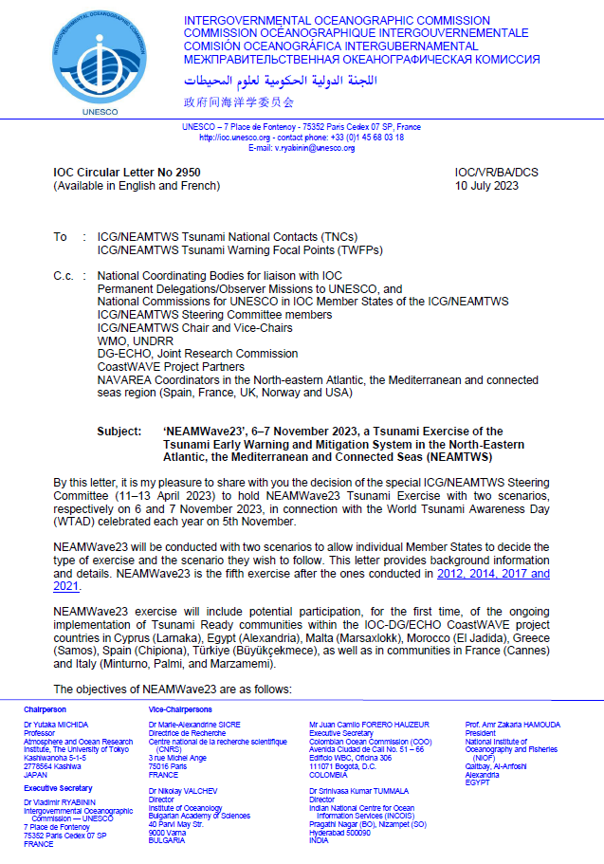

# ANNEX II - NEAMWave23 Exercise Online Platform

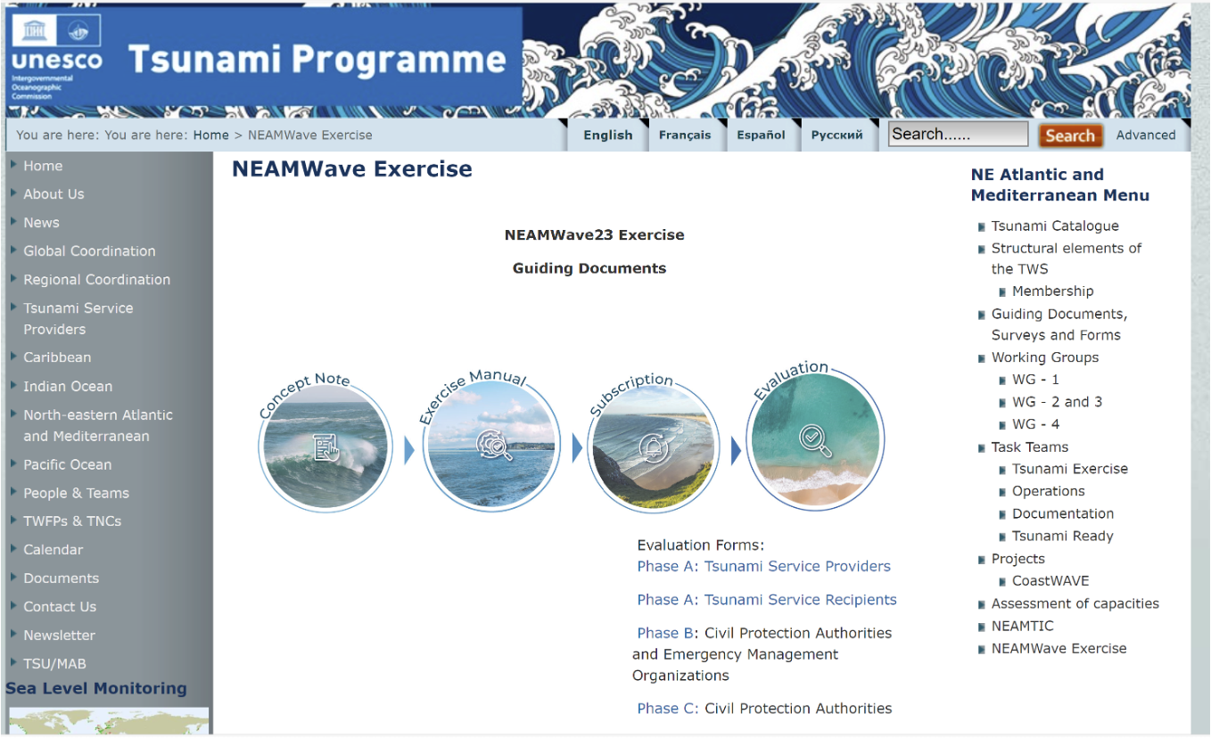

# 

# 

# 

# 

# 

# 

# 

# 

# 

# 

# 

# 

# 

# 

# 

# 

# 

# 

# 

# 

# 

# 

# 

# 

# 

# 

# 

# 

# 

# 

# 

# 

# 

# 

# 

# 

# ANNEX III- [IOC-UNESCO NEWS](https://www.unesco.org/en/articles/neamwave-tsunami-exercises)

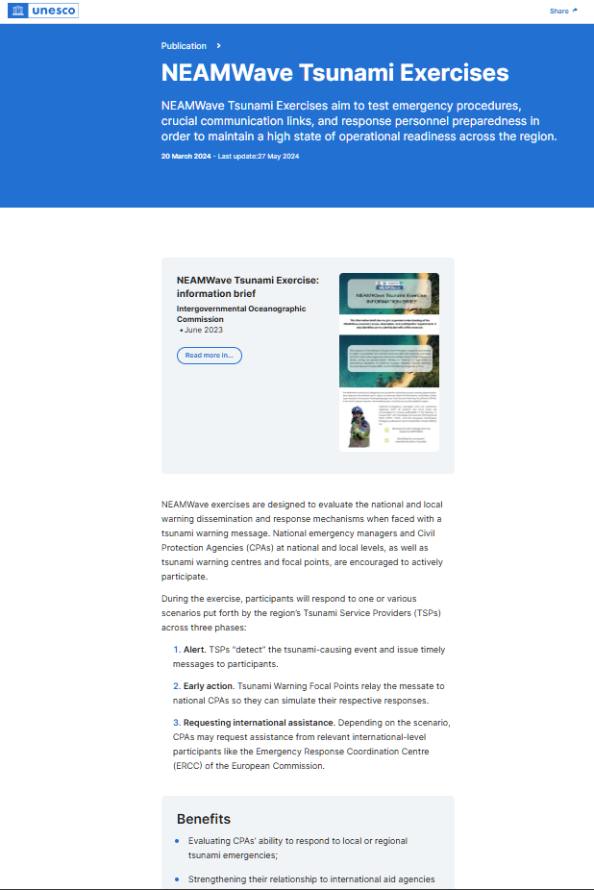

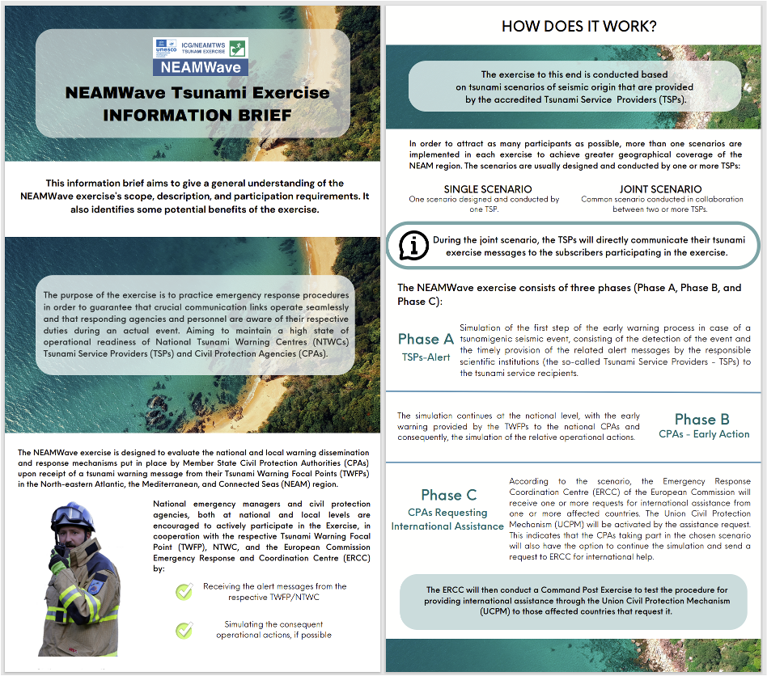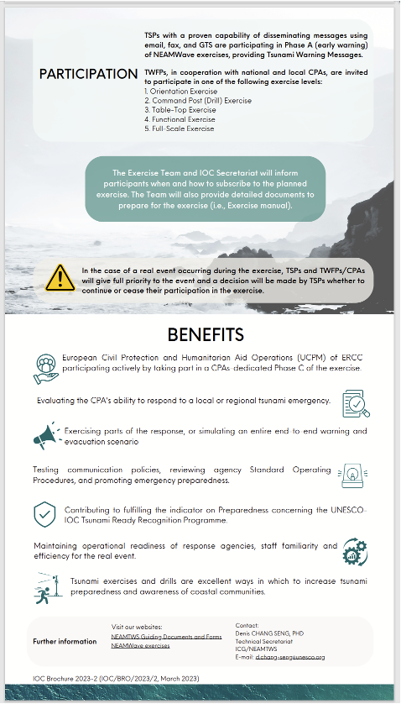

# ANNEX IV - NEAMWave23 Information Leaflet

## 

# 

# ANNEX V - TSPs’ EVALUATION REPORTS

* Link to CENALT (France) TSP Evaluation report
* Link to HLNTWC-NOA (Greece) TSP Evaluation report
* Link to CAT-INGV (Italy) TSP Evaluation report
* Link to KOERI (Turkiye) TSP Evaluation report

| **Member State** | **SCENARIO** | | | | | |
| --- | --- | --- | --- | --- | --- | --- |
| **NORTH-EASTERN ATLANTIC** | | **EASTERN MEDITERRANEAN** | | | |
|  | | **requires international assistance** | **offering international assistance** |
| **Phase A** | **Phase B** | **Phase A** | **Phase B** | **Phase C** | |
| *Albania* |  |  |  |  |  |  |
| *Algeria* |  |  |  |  |  |  |
| *Belgium* |  |  |  |  |  |  |
| *Bulgaria* |  |  |  |  |  |  |
| *Cape Verde* |  |  |  |  |  |  |
| *Croatia* |  |  |  |  |  |  |
| *Cyprus* |  |  | **X** | **X (T)** |  |  |
| *Denmark* | **X** |  |  |  |  |  |
| *Egypt* |  |  | **X** | **X (D)** |  |  |
| *Estonia* |  |  |  |  |  |  |
| *Finland* | **X** |  |  |  |  | **X** |
| *France* | **X** |  | **X** |  |  |  |
| *Georgia* |  |  |  |  |  |  |
| *Germany* | **X** |  | **X** |  |  |  |
| *Greece* | **X** |  | **X** | **X (T) (D)** |  |  |
| *Iceland* |  |  |  |  |  |  |
| *Ireland* |  |  |  |  |  |  |
| *Israel* |  |  |  |  |  |  |
| *Italy* | **X** |  | **X** | **X (D)** |  |  |
| *Lebanon* |  |  |  |  |  |  |
| *Libya* |  |  |  |  |  |  |
| *Malta* |  |  |  | **X (FS)** |  |  |
| *Mauritania* |  |  |  |  |  |  |
| *Monaco* |  |  | **X** |  |  |  |
| *Montenegro* |  |  |  |  |  |  |
| *Morocco* |  | **X (FS)** |  |  |  |  |
| *Netherlands* |  |  |  |  |  |  |
| *Norway* |  |  |  |  |  |  |
| *Poland* |  |  |  |  |  |  |
| *Portugal* | **X** |  | **X** |  |  |  |
| *Romania* |  |  | **X** |  |  |  |
| *Russian Federation* |  |  |  |  |  |  |
| *Slovenia* |  |  |  |  |  |  |
| *Spain* | **X** | **X (FS)** | **X** |  |  |  |
| *Sweden* |  |  |  |  |  |  |
| *Syria* |  |  |  |  |  |  |
| *Tunisia* |  |  |  |  |  |  |
| *Turkiye* | **X** |  | **X** | **X (T)** |  |  |
| *Ukraine* |  |  |  |  |  |  |
| *United Kingdom* |  |  |  |  |  |  |

# ANNEX VI - COUNTRY PARTICIPATION in NEAMWave23

# *Letters denote type of activity during Phase B: D-Drill, T-Table top, and FS-Full Scale*

# ANNEX VII - LIST OF ACRONYMS

|  |  |  |
| --- | --- | --- |
| **AAA** | | Autonomous Administration of Andalusia |
| **ALECSO** | | Arab League Educational, Cultural and Scientific Organization |
| **CENALT** | | CENtre d’ALerte aux Tsunamis, France |
| **CL** | | Circular Letter |
| **CNRST** | | Centre National pour la Recherche Scientifique et Technique |
| **CPA** | | Civil Protection Authority |
| **CPM** | | Civil Protection Mechanism |
| **C/TSP** | | Candidate/Tsunami Services Provider |
| **DG ECHO** | | European Commission Directorate General for Humanitarian Aid and Civil Protection |
| **EC** | | European Commission |
| **ERCC**  **EU** | | Emergency Response and Coordination Centre  European Union |
| **GSD** | | Geological Survey Department |
| **ICG** | | Intergovernmental Coordination Group |
| **ICG/NEAMTWS** | | Intergovernmental Coordination Group for the Tsunami Early Warning and Mitigation System in the North-Eastern Atlantic, the Mediterranean and Connected Seas |
| **IGN** | | National Geographic Institute |
| **INGV** | | Instituto Nazionale di Geofisica e Vulcanologia, Italy |
| **INM** | | Institut National de la Météorologie |
| **IOC** | | Intergovernmental Oceanographic Commission |
| **IPMA** | | Instituto Português do Mar e da Atmosfera, Portugal |
| **ISESCO** | | Islamic Educational, Scientific and Cultural Organization |
| **KOERI** | | Kandilli Observatory and Earthquake Research Institute, Turkiye |
| **MS** | | Member States |
| **NEAM region** | | North-Eastern Atlantic, the Mediterranean and Connected Seas |
| **NEAMTIC** | | Tsunami Information Centre for the North-Eastern Atlantic, the Mediterranean and Connected Seas |
| **NEAMTWS** | | Tsunami Early Warning and Mitigation System in the North-Eastern Atlantic, the Mediterranean and Connected Seas |
| **NOA** | | National Observatory of Athens, Greece |
| **NTWC** | | National Tsunami Warning Centre |
| **TEWS** | | Tsunami Early Warning System |
| **TFP** | | Tsunami Forecast Point |
| **TNC**  **TSR**  **TSP** | | Tsunami National Contact  Tsunami Service Recipient  Tsunami Service Provider |
| **TT–TE** | | Task Team on Tsunami Exercise |
| **TWFP** | Tsunami Warning Focal Point | |
| **UNESCO** | United Nations Educational, Scientific and Cultural Organization | |
| **WR** | Workshop Report | |

1. A total of 67 experts from 17 Member States participated in the ICG/NEAMTWS XIX session held in Paris, 27-29 November 2024. It was considered well attended compared to other years with the participation of two new countries (Algeria and Tunisia) who had not participated for many years,
2. ### NB: - IOC has issued [CL 3006](https://oceanexpert.org/document/35087) concerning Cessation of fax transmissions of tsunami information products by Tsunami Service Providers by 31 March 2025

  