Intergovernmental Oceanographic Commission
Technical Series | 130



TSUNAMI WATCH OPERATIONS
Global Service Definition Document

UNESCO

Intergovernmental Oceanographic Commission
technical series | 130

TSUNAMI WATCH OPERATIONS
Global Service Definition Document

UNESCO 2024

IOC Technical Series, 130
Paris, December 2024
English only

The designations employed and the presentation of the material in this publication do not imply the expression of any opinion whatsoever on the part of the Secretariats of UNESCO and IOC concerning the legal status of any country or territory, or its authorities, or concerning the delimitation of the frontiers of any country or territory.

This Global Service Definition Document (GSDD) describes the operational global tsunami warning services provided by regional tsunami warning systems operating in different ocean basins as a global system of systems coordinated by the Intergovernmental Oceanographic Commission and operated by its Member States.

It is an official document of the Intergovernmental Oceanographic Commission (IOC). Changes to this document can only be authorized by the IOC’s Working Group on Tsunamis and Other Hazards related to Sea-Level Warning and Mitigation Systems and its Inter-ICG Task Team on Tsunami Watch Operations.

For bibliographic purposes, this document should be cited as follows:
Intergovernmental Oceanographic Commission. 2024. Tsunami Watch Operations Global Service Definition Document. IOC Technical Series No. 130. Paris: UNESCO. (English)

This report was prepared and updated by the Task Team on Tsunami Watch Operations established by the Working Group on Tsunamis and Other Hazards related to Sea-Level Warning and Mitigation Systems.

The IOC publication Tsunami Glossary, 2016 (IOC Technical Series, 85; IOC/2008/TS/85 rev.2) is useful complement to the GSDD.
Published in 2016 by: United Nations Educational, Scientific and Cultural Organization
7, Place de Fontenoy
75352 Paris 07 SP

(IOC/2016/TS/130)
CONTENT
page
1. INTRODUCTION 1
2. SYSTEM ARCHITECTURE OF THE GLOBAL TSUNAMI WARNING SYSTEM 1
3. COASTAL AREAS COVERED BY EACH RTWS AND ITS TSPS 2
4. OPERATIONAL ELEMENTS OF A REGIONAL TSUNAMI WARNING SYSTEM 2
4.1 TSUNAMI SERVICE PROVIDER 2
4.2 NATIONAL TSUNAMI WARNING CENTRE 2
4.3 TSUNAMI WARNING FOCAL POINT 3
4.4 TSUNAMI NATIONAL CONTACT 3
4.5 BILATERAL, MULTILATERAL, AND SUB-REGIONAL ARRANGEMENTS 3
4.6 OBSERVATIONAL NETWORKS 5
4.7 FORECASTING TECHNIQUES 6
4.8 STANDARD OPERATING PROCEDURES (SOPS) 7
5. REQUIREMENTS FOR TSPS, NTWCS, and TWFPS 10
5.1 ROLES AND RESPONSIBILITIES OF A TSP 10
5.2 ROLES AND RESPONSIBILITIES OF AN NTWC: 10
5.3 ROLES AND RESPONSIBILITIES OF TWFP 10
5.4 CAPABILITY REQUIREMENTS FOR A TSP 11
6. TSP SERVICES OF EACH RTWS 11
6.1 CARIBE-EWS 11
6.2 IOTWMS 12
6.3 NEAMTWS 12
6.4 PTWS 12
7. TSP PRODUCTS 12
7.1 PUBLIC PRODUCTS 12
7.2 NON-PUBLIC PRODUCTS 13
7.3 TEXT PRODUCTS 13
7.4 GRAPHICAL PRODUCTS 14
8. TSP PRODUCTS FOR THE MARITIME COMMUNITY 15
9. COMMON SPATIAL DATASET 15
10. EVENT ASSESSMENTS & PROCEDURES 15
10.1 EVENT ASSESSMENTS 15
10.2 PROCEDURE FOR INITIAL NAMING OF TSUNAMIGENIC EARTHQUAKES 15
10.3 PROCEDURE FOR HANDLING MULTIPLE EARTHQUAKES IN QUICK SUCCESSION 16
10.4 PROCEDURES FOR NON-SEISMIC TSUNAMI SOURCES 16
10.5 PROCEDURES FOR HANDLING NEAR-FIELD TSUNAMIS 17
10.6 PROCEDURES FOR REPORTING FORECAST AND OBSERVED TSUNAMI WAVES 17
10.7 PROCEDURES FOR TERMINATING EVENT SERVICES 19
10.8 PROCEDURES IN CASE A FALSE OR INCORRECT PRODUCT IS ISSUED 19
10.9 COMMUNICATIONS TESTS AND WAVE EXERCISES 19
11. DISSEMINATION METHODS 19
12. KEY PERFORMANCE INDICATORS 20
12.1 TSP PERFORMANCE 21
12.2 TSP FUNCTIONAL STATUS 21
12.3 NTWC FUNCTIONAL STATUS 21
12.4 TWFP FUNCTIONAL STATUS 22
13. LIMITATIONS OF THE SYSTEMS/PROCEDURES 22
13.1 EARTHQUAKE PARAMETERS 23
13.2 INITIAL ESTIMATED ARRIVAL TIMES AND WAVE AMPLITUDES 23
13.3 AREA OF THREAT AND NO THREATS 23
14. TRAINING AND CAPACITY BUILDING 24
15. CONCLUSION 24
ANNEX I - Earthquake Source Zone Maps of the Regional Tsunami Warning Systems 1
ANNEX II - List of Acronyms 1

INTRODUCTION

Through Resolution XXIV-14, the Intergovernmental Oceanographic Commission (IOC) Assembly at its 24th session in 2007 decided on the establishment of a Working Group on Tsunamis and Other Hazards Related to Sea-Level Warning and Mitigation Systems (TOWS-WG), tasked primarily to advise the IOC Governing Bodies on the coordinated development and implementation activities of common priority to all four of its regional systems around the globe. Each of these systems is governed by its own Intergovernmental Coordination Group (ICG) and the TOWS-WG provides a mechanism for ICG coordination and cooperation. The Assembly adopted Resolution XXV-13 at its 25th Session in 2009, which established an Inter-ICG Task Team on Tsunami Watch Operations (TTTWO) which has since been working towards harmonization of methods and standards for issuance of tsunami products, advising on modalities of operation, and developing guidelines for the requirements of regional and sub-regional warning systems. This Task Team routinely evaluates global system operations and provides important recommendations to make it more effective. The TOWS-WG during its seventh meeting held at Paris in February 2014 actioned the Task Team to develop a Global Tsunami Service Definition Document based on agreed concepts and guidelines as informed by the Task Team in its report to TOWS-WG-IV. Accordingly, this document describes global tsunami warning services provided by regional tsunami warning systems operating in different ocean basins as a global system of systems coordinated by the IOC. The initial version was finalized and published in 2016. This 2024 version is the first update and it incorporates various changes to the service made since 2016.

SYSTEM ARCHITECTURE OF THE GLOBAL TSUNAMI WARNING SYSTEM

There are four Regional Tsunami Warning Systems (RTWS): 1) the Pacific Tsunami Warning and Mitigation System (PTWS), 2) the Indian Ocean Tsunami Warning and Mitigation System (IOTWMS), 3) the Tsunami and Other Coastal Hazards Warning System for the Caribbean and Adjacent Regions (CARIBE-EWS), and 4) the North-Eastern Atlantic, Mediterranean and Connected Seas Tsunami Early Warning and Mitigation System (NEAMTWS). These are the building blocks of the global tsunami warning system. Each RTWS includes one or more Tsunami Service Providers (TSPs) operated voluntarily by a Member State that act as “advice-only” tsunami warning centres for some or all of the other Member States covered by the RTWS. TSPs issue their operational products in response to earthquakes that occur within an area that may be the entire or a subset of the designated Earthquake Source Zone (ESZ) of their RTWS. Each Member State covered by the global system also operates its own National Tsunami Warning Centre (NTWC) with the authority to issue the official alerts to its population. Each of these Member States also has a designated Tsunami Warning Focal Point (TWFP) for receiving and if necessary informing the NTWC on a 24x7 basis. The TWFP may be the NTWC if it operates 24x7, but otherwise it is another 24x7 office.
TSPs distribute their products to NTWCs and TWFPs and to other TSPs operating within their RTWS. Ultimately it is the NTWCs, operating within the legal framework of the sovereign nation in which they reside and serve, that provide the authoritative tsunami alerts for saving lives within their respective countries or territories. These alerts are based either on the NTWC’s own analysis of the situation, or on the forecast information received from TSPs, or on a combination of information from these and other sources.
TSPs strive to be interoperable, not only between multiple TSPs in a single system, but also between TSPs of different systems. This involves sharing, comparing, and migrating towards common formats for information exchange, addressing standard service requirements, following agreed-upon high-level Standard Operating Procedures (SOPs), and compiling and analyzing information on the performance of procedures and processes to identify and adopt best practices. Proper backup should be built into the TSP services of each RTWS to facilitate uninterrupted TSP services in case of unavailability of these services. This should include backup systems within each TSP to prevent, for example, the failure of a single computer making a TSP unable to operate. It should also include multiple communication paths for data input to the TSP and product output from the TSP. Lastly, there should be redundancy in TSP services for all coastal service areas to cover situations when a TSP is taken out of service by, for example, an extreme weather event. This situation can be covered if every coast is routinely serviced by more than one TSP, if the service area of one TSP can be covered on a temporary basis by another TSP, or if the functions of a TSP can be temporarily covered by another center within the country hosting the TSP. The global tsunami warning system operates as a “system-of-systems”.

COASTAL AREAS COVERED BY EACH RTWS AND ITS TSPS

The Area of Responsibility (AoR) of each of RTWS and the Area of Service (AoS) of each TSP within those systems is decided by the respective ICGs. While addressing the above aspects, it is the goal that these systems should offer coverage to the coastal regions of all IOC as well as non-IOC Member States that are vulnerable to hazardous tsunami impacts.
The current AoR map delineating the coastal areas of responsibility of the four systems as well as the AoS covered by the TSPs of those systems is shown in Figure 1. The goal of 100% coverage is nearly met by the combined coverage of the TSPs and areas otherwise covered independently by Member States as shown on the map.

OPERATIONAL ELEMENTS OF A REGIONAL TSUNAMI WARNING SYSTEM

At the heart of each RTWS are the TSPs operating 24 hours per day, 7 days per week, and the NTWCs and TWFPs of each Member State covered by those systems. A TSP should do two things as fast as possible: determine the location and depth of any moderate or larger sized earthquake, and assess its magnitude. Once that is accomplished, they can begin to assess any potential tsunami threat to the coastal regions within its AoS. The first tsunami product issued by a TSP is usually based only on the preliminary seismic information. Later products follow with model-based forecasts and sea-level observations. Real-time sea-level observations are a key element as they are used to confirm the existence of a tsunami, constrain and validate forecasts, and determine when the threat has passed.
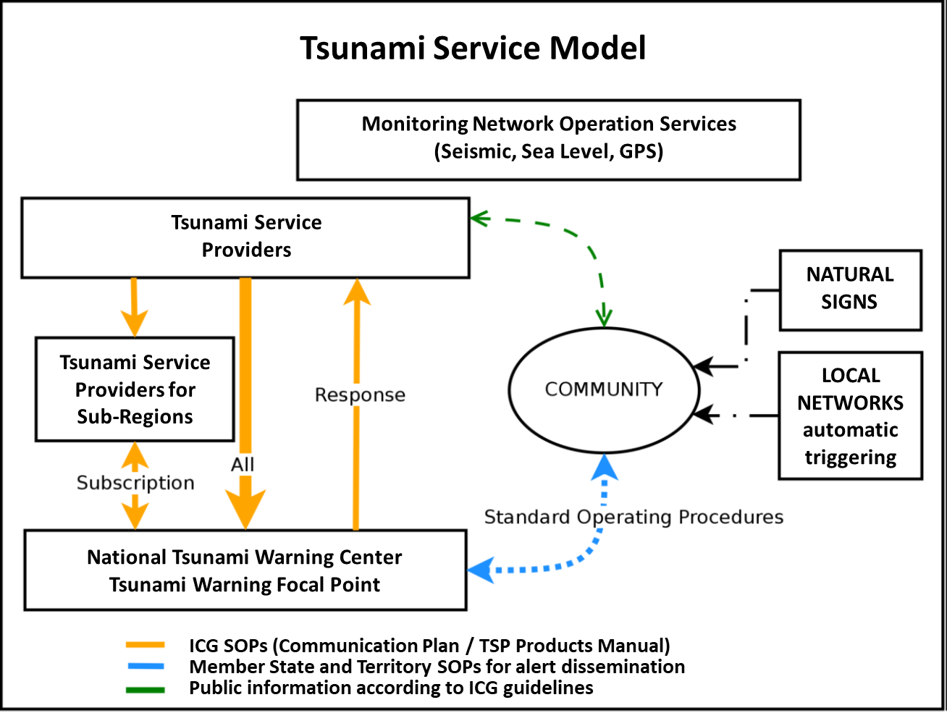
An example service model shows how the TSPs and NTWCs and their supporting infrastructure serve the community during a tsunami event.

For coastal areas located very close to the source, the response to save lives may need to occur before there is tsunami detection and forecasting by TSPs and/or NTWCs. In such cases the potential tsunami threat should be based on historical data and/or numerical modelling of potential impacts that is done in advance. Pre-determined scenarios that fit most closely with the preliminary earthquake parameters, taking into account potential error in those parameters, is the basis for indicating which nearby coasts have a tsunami threat and the general level of that threat. In general, the preparedness and response to a local tsunami threat is addressed primarily by the NTWCs and Disaster Management Organizations of the Member States facing such a threat.

4.1 TSUNAMI SERVICE PROVIDER

A Tsunami Service Provider (TSP) is an operational centre hosted by a Member State that monitors seismic and sea-level activity and issues timely tsunami threat information within the ICG framework of one of the four RTWS to the TWFPs, NTWCs, and other TSPs of that system. NTWCs may use these products to develop and issue tsunami warnings for their respective countries and territories. TSPs may also issue public advice messages for their AoS. Although a TSP may also function as the NTWC of its host country, TSPs follow rules and procedures guided by the ICG of their RTWS, independent of the NTWC rules and procedures. Bi-lateral, multi-lateral and sub-regional arrangements may also exist to provide products for a subset of Member States covered by a particular system.

4.2 NATIONAL TSUNAMI WARNING CENTRE

A National Tsunami Warning Centre (NTWC) is a centre designated by the government of each covered Member State to monitor and issue tsunami warnings and other related statements within their country according to established national SOPs.

4.3 TSUNAMI WARNING FOCAL POINT

A Tsunami Warning Focal Point (TWFP) is a 24x7 point of contact (office, operational unit or position, and not a person) officially designated by the NTWC or the government to receive and disseminate tsunami information from a TSP according to established national SOPs. The TWFP may or not be the NTWC.

4.4 TSUNAMI NATIONAL CONTACT

A Tsunami National Contact (TNC) is a person designated by a Member State to represent his/her country in the coordination of international tsunami warning and mitigation activities for a particular RTWS. The person is a main stakeholder in the RTWS and may be from the Member State’s national disaster management organization, from one of its technical or scientific organizations, or from another organization with tsunami warning and mitigation responsibilities.

4.5 BILATERAL, MULTILATERAL, AND SUB-REGIONAL ARRANGEMENTS

Bilateral or multilateral arrangements are sometimes used for enhancing observational networks for tsunami warning including the exchange of data streams from seismic and sea-level sensors as well as other data streams applicable to tsunami warning (e.g., from Global Navigation Satellite System reference stations).
Through other bilateral arrangements, NTWCs may receive TSPs products or information directly by methods of their own choosing rather than through methods prescribed by the ICG of their RTWS. NTWCs or their TNCs may also consult with TSPs to add or delete forecast points along their coasts or to correct the locations and names of places within their country or territory.
NTWCs may also develop bilateral arrangements with TSPs for customized advice on how to best utilize TSP products to determine their own local impacts/threats.
Multilateral arrangements may also be made between Member States in a sub-region of an RTWS for exchanging information during events. This type of arrangement can be very useful for enhancing the effectiveness of the system where those Member States share a common language and culture and personal contacts and can thus more easily exchange their local data and experiences as an event unfolds. Sometimes these arrangements lead to the formation of new sub-regional TSPs.

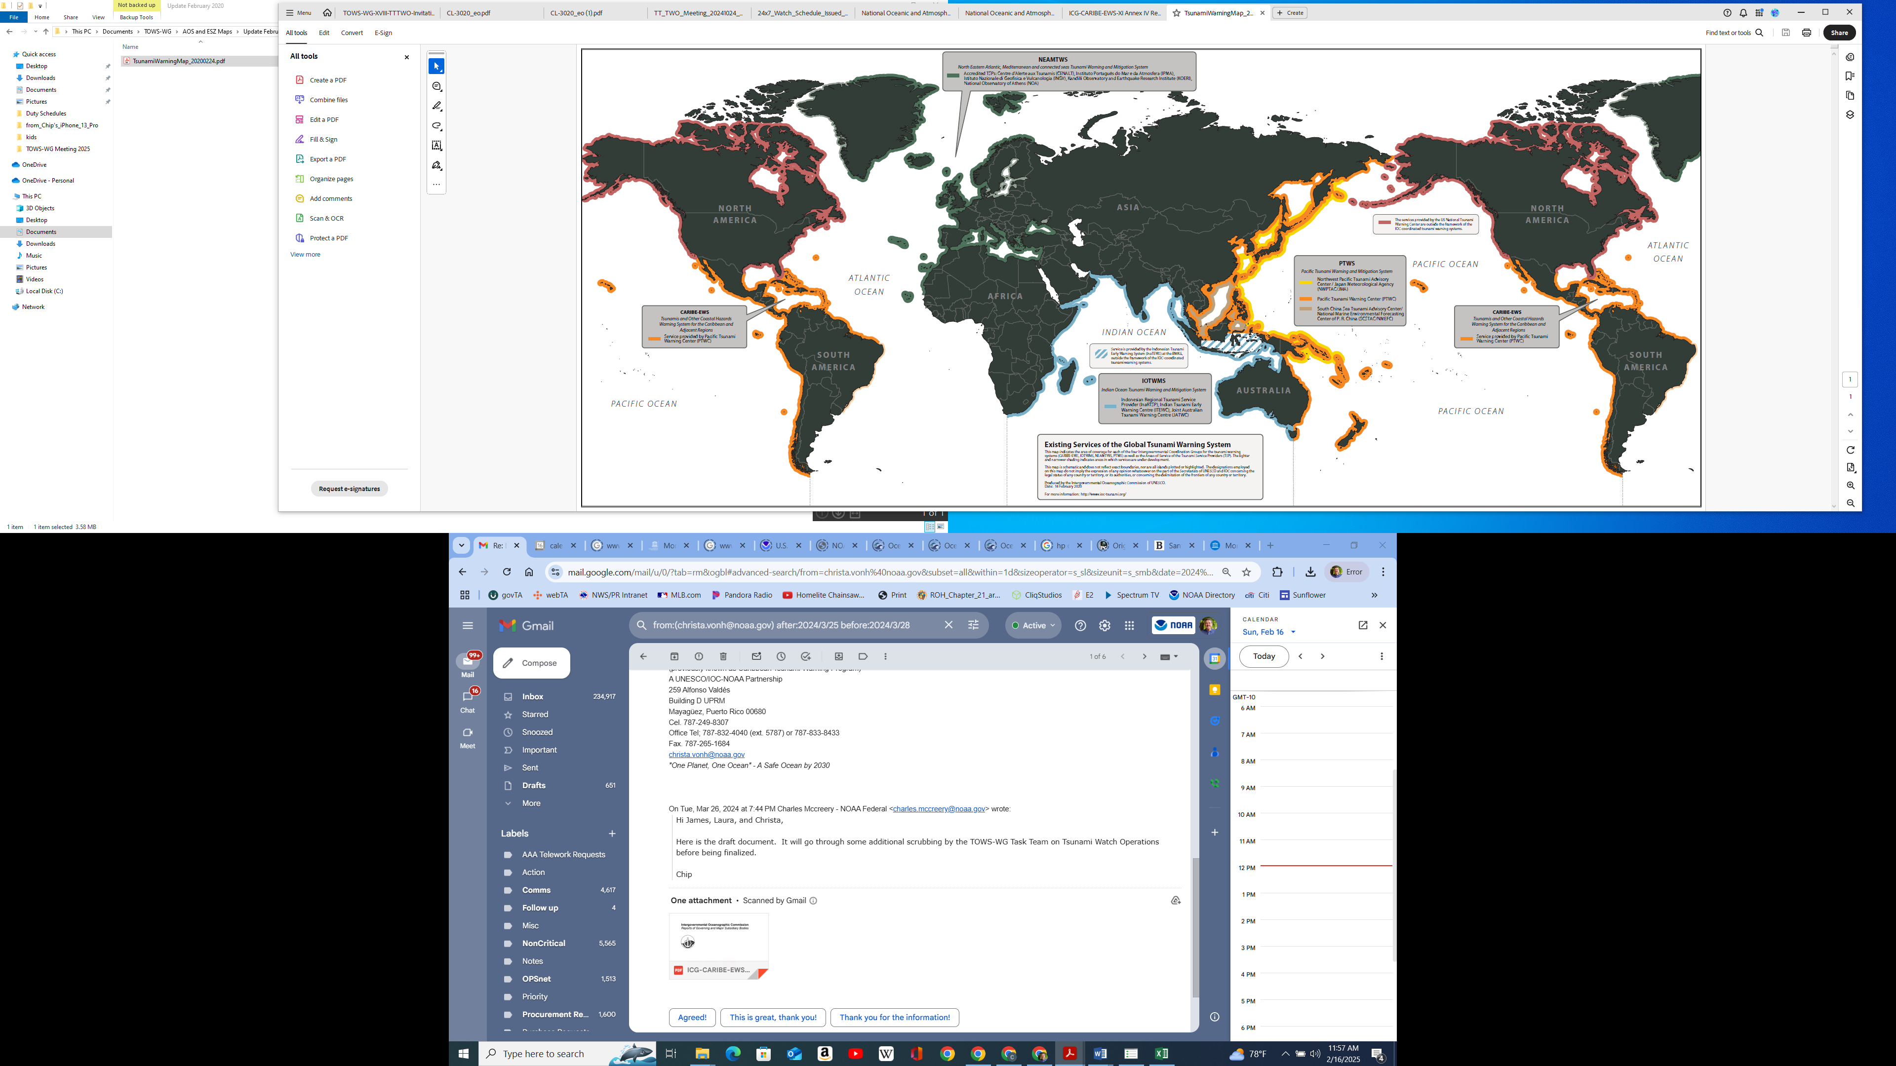
Figure 1: Global coverage of the four IOC Regional Tsunami Warning Systems and their Tsunami Service Providers (Reference: IOC/TOWS-WG-XII/3 Annex IV, page 19)

4.6 OBSERVATIONAL NETWORKS

Effective tsunami warning depends in part on the rapid detection and assessment of earthquakes, followed by confirmation that a tsunami has been generated, and measurement of the tsunami waves. These functions require significant observational data.
Seismic Networks:

All TSPs utilize automatic monitoring systems to assess earthquakes as they occur. When the seismic signals or automatically-determined earthquake parameters meet certain criteria, analysts at a TSP are alerted and they begin interactively assessing the event. For large earthquakes this usually happens within one to several minutes of the initial rupture depending upon the density of the seismic network in the region of the earthquake.
The seismic monitoring network used by TSPs in each regional warning systems is based on various real-time networks being operated by organizations such as the Global Seismographic Network (GSN), Comprehensive Nuclear Test Ban Treaty Organization (CTBTO), the French Global Network of Seismological Broadband Stations (GEOSCOPE), and the German Research Centre for Geosciences Seismic Network (GEOFON) as well as stations from many other national and regional networks. A map of the seismic stations currently used by PTWC in support of their TSP functions for the PTWS and CARIBE-EWS is shown in Figure 2 as an example.

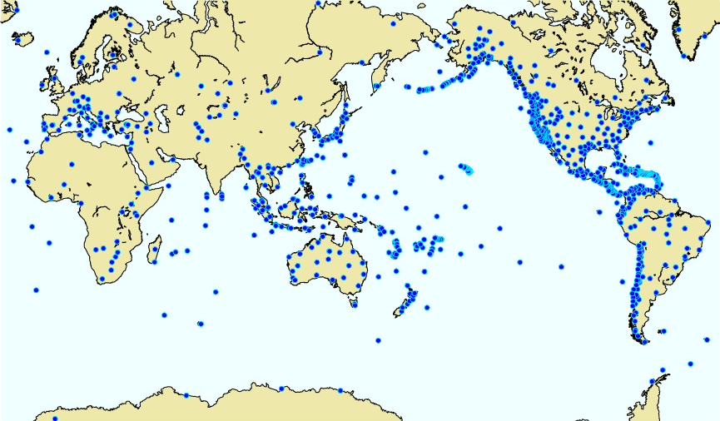
Figure 2: Network of seismic stations (blue dots) operated by various Member States and used by PTWC. Not all of the stations are in operation all of the time due to various network or individual station outages. (Image courtesy of PTWC, February 2024)

Sea-level Network:
To confirm whether an earthquake has triggered a tsunami, and then to characterize the hazard it represents, it is essential to directly measure the tsunami waves. There are two basic types of sea-level gauges used for this purpose: deep-ocean tsunami gauges (commonly referred to as “tsunameters”) and coastal sea-level gauges. Tsunameters provide the best information to characterize the tsunami because in the deep-ocean the waves have not been significantly altered by reflections, refractions, and resonances that occur near the coast. Tsunami waveforms from a tsunameter are therefore the most appropriate waveforms for comparison to, or assimilation in, numerical tsunami forecast models used by TSPs to estimate wave heights and basin-wide propagation characteristics. There currently are many more coastal sea-level gauges than tsunameters primarily due to their multi-purpose function (e.g., for harbor navigation and global sea-level rise as well as tsunami monitoring) and the higher cost for installing and maintaining tsunameters. Coastal sea-level gauges are often the first to record tsunami waves and validate that a tsunami has been generated. They also provide information on the coastal impact of a tsunami and are used to determine when the tsunami threat has passed. Tsunameters and coastal sea-level gauges are operated by a number of countries and organizations. A map showing many of the currently available tsunameters and coastal sea-level gauges is given in Figure 3.

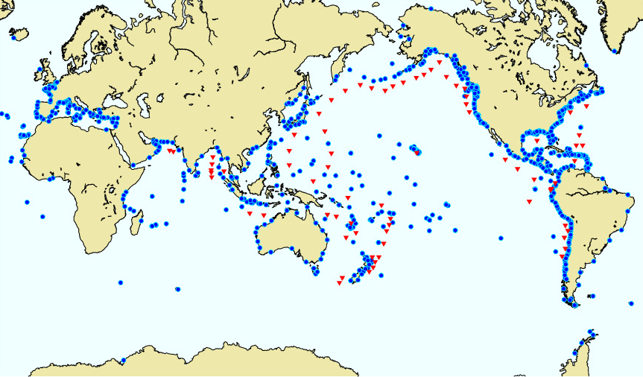
Figure 3: Network of coastal sea level gauges (blue dots) and deep ocean tsunameters (red triangles) operated by various Member States that are used by PTWC. Not all of the stations are in operation all of the time due to various network or individual station outages. (Image courtesy of PTWC, February 2024)

4.7 FORECASTING TECHNIQUES

TSPs initially forecast tsunami impacts somewhat qualitatively based only on the preliminary earthquake parameters and more quantitatively later using numerical hydrodynamic ocean models constrained by those parameters and other information as it becomes available. The size and spread of an earthquake-generated tsunami depends on the amount and areal extent of the vertical deformation of the sea floor caused by the earthquake. This, in turn, moves the sea above to initiate the tsunami. The tsunami hazard also depends on the bathymetry across which the tsunami travels because the waves are focused, defocused, and reflected by this bathymetry. Numerical forecast models are thus initialized with estimates of how the sea was moved above the earthquake and the models include bathymetric data for the ocean being traversed by the tsunami.
Initial tsunami products must be issued within minutes of an earthquake occurrence to be effective. Consequently all TSPs use a streamlined process for estimating from the preliminary earthquake parameters whether there is a hazardous tsunami threat and what areas might be affected. That process might be a simple rule that for a given earthquake magnitude a corresponding area around the earthquake has a potential threat. The process might also be to use results from a pre-run tsunami model for comparable seismic parameters to estimate the amount and extent of the potential threat. This method requires constructing in advance a database of scenarios using a range of possible earthquake parameters. Scenario databases can be quickly compared to observed earthquake characteristics, so that the best match can be selected as the basis for forecasts. However, neither of these methods provide a forecast with a very high degree of certainty, and they generally are constructed and applied in a conservative way leaning towards an over-estimation of the hazard to be safe. Within those first few minutes after a large earthquake there is simply too much uncertainty about the earthquake and how it may have deformed the seafloor to produce a reliably accurate forecast.
As time passes additional information is received by the TSPs to help constrain forecasts and make them more accurate. More information about the earthquake becomes available including the geometry of its mechanism, the areal extent of the rupture, and the amount of slip along the fault. This information can be used to produce a more accurate estimate of how the seafloor deformed. In addition, the tsunami itself can be measured on coastal gauges as well deep-ocean tsunameters. These data can be used to compare forecast waveforms with observed waveforms to validate or modify model results. Tsunameter waveforms can also be used to construct a proxy tsunami source capable of duplicating those waveforms. The proxy source can then be used to create a tsunami forecast for the entire ocean. TSPs will thus use a variety of methods to refine and improve their forecasts as time passes.
The various models used by different TSPs provide different types of results. Some carry the wave all the way to coast and onto land and forecast inundation – how far inland the tsunami may flood the land. These models require fine scale grids of coastal bathymetry and topography and take much longer to run since there are many more grid points and they require much smaller model time steps – a problem when the wall time to impact is short. One strategy is to only compute inundation for select small sections of coast with high vulnerability. Other models more simply and quickly estimate tsunami amplitudes at the coast using an approximation called Green’s Law that scales amplitudes as a function of the water depth. Green’s Law may be applied directly from nearby deep-ocean grid-point values to produce a rough estimate of coastal amplitudes. However, it is derived from a plane wave traversing uniformly decreasing bathymetry and it doesn’t take into account friction or local bathymetry that is different from theory such as that at small islands, where there are near-shore submarine canyons or plateaus, and for coral reefs. A modified application of Green’s Law that takes into account local characteristics has been developed and validated for French Polynesia and the French Rivera that is more accurate than the generic application.

4.8 STANDARD OPERATING PROCEDURES (SOPS)
TSPs primary capacity is to provide operational advice for earthquake-generated hazardous tsunamis. All TSPs have a common high-level SOP that describes their operational stages in this regard. Those stages are:
- Stage 1:
  - Rapidly detect the occurrence of any large earthquake within the earthquake source zone monitored by that TSP.
  - Determine the earthquake preliminary parameters – its location, depth, and magnitude at a minimum.
  - Assess the potential tsunami threat from that earthquake.
  - Issue an initial product to the TSP service area indicating any areas with a potential tsunami threat.
- Stage 2:
  - Validate the initial forecast or produce a more quantitative and accurate forecast using additional seismic analyses, the observation of tsunami waves, or other applicable information.
  - Issue subsequent products that indicate the coastal areas with a threat and contain, at a minimum, estimated tsunami arrival times and amplitudes for those areas.
  - Include any observations of tsunami waves.
- Stage 3:
  - Revise the forecast if necessary with additional source information or tsunami wave observations.
  - Issue additional products on a regular basis with updated forecasts if necessary, and with additional or updated tsunami wave observations, until the threat has passed.
Each of the four RTWSs as well as their individual TSPs have more detailed SOPs that reflect their own capabilities, operating environment, and hazard characteristics. Figure 4 is an example SOP being followed by TSPs of the IOTWMS including its three stages of activities, the roles and interactions of its components, and the typical input and output of information between the TSPs and IOTWMS Member State NTWCs. The TSP SOPs of other RTWSs have similarities but are not identical.
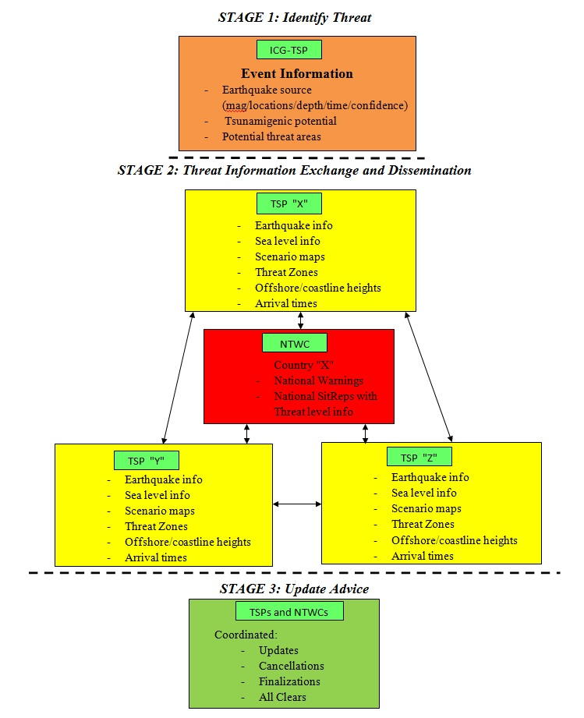
Figure 4: Typical Standard Operating Procedure (SOP) followed in the IOTWMS

REQUIREMENTS FOR TSPS, NTWCS, and TWFPS

5.1 ROLES AND RESPONSIBILITIES OF A TSP
The basic roles and responsibilities of a TSP are given below.
- Determine and provide timely initial information to TWFPs and NTWCs about large earthquakes indicating whether they pose a potential tsunami threat and which coasts have a threat.
- Determine more specific threat information using model output from scenario databases or from tsunami models run in real time that are based on additional or more refined earthquake source information and verified or constrained by tsunami observations as they become available.
- Provide timely tsunami forecast information to TWFPs and NTWCs for use, as needed, in the preparation and issuing of national tsunami warnings.
- Monitor tsunami propagation and provide the observed tsunami measurements to TWFPs and NTWCs.
- Provide additional timely information such as standardized Situation Reports (SitReps) for use by other TSPs and NTWCs, if required by their respective ICG.
- Serve as a backup centre to other TSPs within an RTWS, as required by the respective ICG.
- Participate in communications tests, tsunami exercises, and the maintenance of Member State contact information for product distribution in consultation with the IOC and respective ICG.
- Seek to improve its own and other TSP services through the sharing of best practices that is facilitated through the TOWS-WG and its TTTWO, the ICGs, scientific meetings and journal articles.

5.2 ROLES AND RESPONSIBILITIES OF AN NTWC:

The recommended roles and responsibilities of an NTWC are described below:
- Make decisions, using their own analyses and/or TSP advice of their choice, and issue tsunami warnings when necessary as per their national SOP.
- Provide timely standardized SitReps for use by other NTWCs and TSPs within their RTWS, including the status of their warnings, as mandated by their respective ICG.
- Consult with and provide information to their TSPs on forecast point locations and names.
- Consult with their TSPs for advice on how to utilize TSP products to determine local impacts/threats within their country or territory.
- Establish criteria for and develop SOPs for creating and issuing tsunami alerts.
- Work with national and local emergency management authorities to define the criteria for and institutions in charge of issuing the All Clear.
- Provide timely updates to the IOC Secretariat and TSPs of NTWC contact information.

5.3 ROLES AND RESPONSIBILITIES OF TWFP
- Receive TSP forecast information and take necessary actions including alerting the NTWC when necessary based on the national SOPs.
- Provide timely updates to the IOC Secretariat and to TSPs of TWFP contact information.

5.4 CAPABILITY REQUIREMENTS FOR A TSP

In order for a TSP to provide the required services, they need to have certain essential capabilities common to all TSPs of the four RTWSs. They may also need to have additional capabilities as prescribed by the ICGs of each RTWS. Some of the key essential capabilities are listed below:
- Access to real time seismic data and the capability to rapidly analyze earthquakes within their ESZ to determine their hypocenter location and depth as well as their magnitude
- Access to real time data from coastal sea-level gauges and deep-ocean tsunameters in the region of their ESZ and AoS and the capability to measure and interpret tsunami signals recorded on those gauges.
- Access to historical data of earthquakes and tsunamis within the region of their ESZ and AoS.
- Capability to forecast tsunami arrival times and coastal amplitudes using a database of pre-run tsunami scenarios and/or by running tsunami forecast models in real time.
- Capability to validate and/or revise forecasts in light of additional seismic and sea-level data
- Capability to create and disseminate tsunami advisory products in a standardized format in conformance with any standards agreed upon by the IOC or the ICG of their RTWS.
- Capability to disseminate tsunami advisory products freely and timely to TWFPs and NTWCs within their AoS as well as to any other TSPs within their RTWS using the Global Telecommunications System (GTS), the Internet, and/or any other means that ensure a secure and reliable receipt.
- Have adequately trained and experienced staff, utilities, and resources to operate functionally 24 hours per day, seven days per week (24/7).
- Have adequate infrastructure, redundancies, and back-up facilities to continue operating during power cuts and other emergencies and outages.
- TSP staff should be able to communicate in English.

TSP SERVICES OF EACH RTWS

The services of a RTWS and its TSPs commence whenever an earthquake of more than a pre-determined magnitude occurs in an area where a resulting tsunami would impact that RTWS’s AoR. While the AoR specifies which coasts are covered by each RTWS, the fact that tsunamis can have impacts at long distances from the earthquake source means that it is also necessary to define the area in which earthquakes will be routinely monitored and assessed by the TSPs of each RTWS. Maps delineating the Earthquake Source Zones (ESZs) monitored by each RTWS and the magnitude thresholds for issuing TSP products within each ESZ are provided in Annex I. TSP threat messages, those that indicate a potential tsunami threat initially, and that later contain forecasts and may have tsunami confirmation and measurements, are also triggered by pre-determined magnitude thresholds.

6.1 CARIBE-EWS

TSP services in the CARIBE-EWS commence whenever an undersea or coastal earthquake occurs in the Caribbean ESZ with a magnitude of 6.0 or greater or in the Atlantic ESZ with a magnitude of 6.5 or greater. TSP threat messages are issued for shallow undersea or coastal earthquake in the Caribbean ESZ with a magnitude of 7.1 or greater or in the Atlantic ESZ with a magnitude of 7.9 or greater.

6.2 IOTWMS

TSP services in the IOTWMS commence whenever an undersea or coastal earthquake occurs in the Indian Ocean, Pacific Ocean or South Atlantic ESZ with a magnitude of 6.5 or greater. TSP threat messages are issued for shallow undersea or coastal earthquakes within the Indian Ocean ESZ with a magnitude of 6.5 and greater, and within the Pacific and South Atlantic ESZ with a magnitude of 8.0 and greater.

6.3 NEAMTWS

TSP services in the NEAMTWS commence whenever an undersea or coastal earthquake occurs in the North-Eastern Atlantic or the Mediterranean and Connected Seas ESZ with a magnitude greater than 5.5 and for the North-Western Atlantic ESZ with a magnitude greater than 7.5. TSP threat messages are issued for shallow undersea or coastal earthquakes in the North-Eastern Atlantic or the Mediterranean and Connected Seas ESZ with a magnitude greater than X.X and for the North-Western Atlantic ESZ with a magnitude greater than 7.9.

6.4 PTWS

TSP services in the PTWS commence whenever an undersea or coastal earthquake occurs in the South China Sea region of the ESZ with a magnitude of 6.0 and above or in the rest of the Pacific ESZ with a magnitude of 6.5 and above. TSP threat messages are issued for shallow undersea or coastal earthquakes with a magnitude of 7.1 and above.
TSP products in all RTWSs may also be issued for earthquakes outside of their ESZ when there are either forecast or observed tsunami waves with amplitudes of the minimum threat level for the PTWS of 30 cm or more along that TSP’s AoS. Such exceptions are necessary to cover cases like the 2004 Indian Ocean tsunami that was recorded deep inside the Pacific Ocean on a gauge at Manzanillo, Mexico, with an amplitude greater than a meter.

TSP PRODUCTS

TSPs may generate and disseminate two general categories of products to cover the coasts within their AoS - Public Products and Non-Public Products. The basic TSP products within these two categories are text products but graphical products may also be produced and disseminated.

7.1 PUBLIC PRODUCTS

TSP public products are widely distributed in various formats and through public and private communication systems (GTS, Email, Fax, Web, SMS, etc.) to facilitate reliable communication to TWFPs and NTWCs as well as broad reception to other partners and the public, including the global media. There will be a first product, and in the case of a potential or confirmed threat, updates will be issued.
- First Product. This product will include the preliminary earthquake parameters (origin time, latitude, longitude, depth, magnitude) and indicate if there is the potential for a destructive tsunami for a certain area. Expected tsunami arrival times will be included for coasts with a potential threat. The product may also include a preliminary tsunami forecast based only on the earthquake parameters. The potential for a destructive tsunami may be qualified in some way based upon the time left until the expected impact. Nearby coasts may need to act immediately based only on a potential tsunami hazard while more distant coasts may choose to wait until the threat is better defined. Initial products are usually issued within a few minutes of the earthquake.
- Subsequent Products. These products may provide any updates on the earthquake parameters, a confirmation of tsunami waves and the tsunami amplitudes measured on gauges where the tsunami has reached, a forecast of expected tsunami amplitudes based upon available information, and contain information on the alert levels issued by NTWCs within the TSP’s AoS. Subsequent products are typically issued at least once an hour or when there is significant new information to disseminate.
- Final Product. A final public product is issued when, based upon all available data, the TSP determines that, in general, the threat has passed.

7.2 NON-PUBLIC PRODUCTS

Non-Public products may be issued by TSPs to TWFPs and NTWCs containing more specific and detailed information such as the forecast of tsunami amplitudes at a finer scale or forecasts of coastal inundation. This additional information may be helpful to NTWCs in their decision-making about local alerts and actions. Distribution of these products is through private methods or is password-protected. The intent of having certain products be non-public is to avoid public or media confusion about information coming from a TSP as advice that may conflict with the authoritative information and alerts coming from NTWCs. Non-public products may be issued by TSPs simultaneously with the public products or on an independent schedule.

7.3 TEXT PRODUCTS
The following describes a general structure for TSP text products. Not all TSP products may follow this structure nor contain all the sections listed depending upon the nature of the event, the capability of the TSP, and any guidance from the ICG it serves.
Header – Indicates the issuing authority – the name of the TSP, the sequential product number for the event, the type of product - informational or tsunami threat, and the date and time in UTC that the product was issued.

Disclaimer Statement – It is important that the TSP products contain appropriate disclaimers to clarify the intent of the information in the products, particularly the public products. An example of such a statement that may be included in public text products is below:

MEDIA AND PUBLIC SHOULD NOTE THE FOLLOWING –

THIS STATEMENT IS ISSUED FOR INFORMATION ONLY IN SUPPORT OF THE UNESCO-IOC PACIFIC TSUNAMI WARNING AND MITIGATION SYSTEM AND IS MEANT FOR NATIONAL AUTHORITIES IN EACH COUNTRY OF THAT SYSTEM.

NATIONAL AUTHORITIES MAY DETERMINE AN INDEPENDENT... DIFFERENT... OR MORE REFINED LEVEL OF THREAT.

Earthquake Parameters – These are the preliminary earthquake parameters including the earthquake magnitude (usually the Moment Magnitude, Mw), the epicentral location (latitude and longitude) and hypocentral depth (km), the date and time of earthquake (UTC), and a descriptive name for the location of the epicenter.

Tsunami Evaluation – This is a statement to describe the current state of evaluation of the tsunami threat. For example, it might include a qualitative statement that based only on the earthquake parameters there is the threat of a widespread hazardous tsunami. It might also indicate whether tsunami waves have been observed yet or not.

Tsunami Threat Information – If model results indicate a tsunami threat, this section is included from the second product onwards and includes a list of the coastal regions or points where a threat is forecast and an indication of the level of that threat such as a forecast maximum tsunami amplitude.

Recommended Actions – This section includes general statements about recommended actions by the NTWCs and their partners such as emergency managers and national disaster management agencies. It may also include recommended actions for the public and media. The statements are constructed in such a way to not interfere with any procedures or instructions being followed or issued by the national authorities.

Estimated Times of Arrival – This section provides the estimated time of arrival (ETA) of the tsunami for specific locations within the part of the AoS with a tsunami threat. ETAs may be reported not only for the first wave, but the first wave exceeding a certain amplitude, and the maximum wave.

Observations – This section reports on maximum tsunami amplitudes observed so far on coastal and/or deep-ocean tsunameter gauges that the tsunami has reached. It may also include the time of those measurements, the type of measurement such as a peak or a trough, and/or the time of tsunami first arrivals.

Potential Impacts – This section describes the general characteristics of the tsunami hazard as a reminder since tsunami impacts are so rare for any particular coast. For example, it might remind that a tsunami is a series of waves and that the first wave may not be the largest. It might also remind that the time period between successive flooding and draining cycles can range from 5 minutes to an hour.

Advice – This section indicates that the product is issued as an advice only and that the condition of the alert and determination of action based on threat status is up to national or local authorities.

Other Centres’ Information – This section indicates products that may be issued by other TSPs or NTWCs that cover all or part of the AoS of this TSP, or even other parts of this RTWS’s AoR. This is to inform recipients where other appropriate information on the event may be found.

Next Product – This is a statement indicating when the next product will be issued, or in the case of a final product that no further products will be issued for the event.
Formats for the TSP text products, as well as other products such as graphical products, should be determined and approved by respective ICGs taking into consideration the requirements of the TWFPs and NTWCs and any other relevant factors.

7.4 GRAPHICAL PRODUCTS
TSPs may also issue graphical products to facilitate more rapid communication and understanding of tsunami threats. These might include:
- Maps with isochrons showing the estimated tsunami travel across an ocean basin
- Maps showing the forecast pattern of tsunami energy crossing an ocean basin
- Maps showing the forecast maximum tsunami amplitudes along coasts

TSP PRODUCTS FOR THE MARITIME COMMUNITY

TSPs have been requested by representatives of the International Hydrographic Organization’s (IHO) World-Wide Navigational Warning Service to produce special products for the maritime community. These products, under development by TSPs at the time of publication of this document, are for dissemination to NAVAREA Coordinators of the 21 IHO NAVAREAS that cover all the world’s oceans. NAVAREA Coordinators will disseminate these messages to vessels at sea as a way of alerting them in case they are approaching a port with a potential tsunami hazard. NAVAREA Coordinators perform this function already, but only by manually parsing through existing TSP products. Further details regarding these maritime products will be included in this document once those products are fully implemented by TSPs within the RTWSs.

COMMON SPATIAL DATASET

The level of risk posed by a tsunami as it is underway requires an understanding of complex and changing spatial and temporal data. It is a challenge for disaster response authorities to analyze these data under emergency conditions without error to make their alerting and response decisions. When multiple TSPs are involved in presenting the analyses, the possibility of misinterpretation can increases if there are multiple ways of presenting the information in space and time. To ensure interoperability between multiple TSPs and to help reduce potential confusion it is important to use a common spatial data for delivery of their tsunami products.
TSPs should strive to use a common spatial dataset and corresponding nomenclature for generation of their public as well as non-public products. Recipients can then more easily compare and evaluate information provided from multiple TSPs for particular coastal regions to make decisions regarding their own actions during an event. Use of common spatial data can also facilitate inter-TSP performance comparisons. For example, each element in a common spatial dataset represents a specific point/region along the coast that is well known to emergency managers and the populace. Those elements may be associated with model-derived information such as the expected tsunami amplitude, arrival time, and threat level as advice for making decisions during an event. Common spatial datasets should be finalized by TSPs in consultation with the NTWCs they serve.

EVENT ASSESSMENTS & PROCEDURES

EVENT ASSESSMENTS

Post-event assessments are a valuable tool for measuring and improving system performance. The TOWS-WG, at its 8th meeting, recommended a standardized post-event assessment template for use by all ICGs. TSPs, in coordination with their respective RTWS TICs and the ICG Secretariat will help conduct post-event assessments. The trigger for implementing an assessment should be a forecast or observed tsunami of greater than one meter amplitude in one or more countries or territories of an RTWS. Over and above this trigger level, the final decision to implement a survey should be decided by the TIC in consultation with the ICG Steering Group and Secretariat taking into consideration whether the tsunami resulted in a national response in one or more countries or territories.

PROCEDURE FOR INITIAL NAMING OF TSUNAMIGENIC EARTHQUAKES

Potential and actual tsunamigenic earthquakes (i.e. those requiring the issuing of TSP tsunami threat products) may be named by TSPs in their products using a scheme based on the Flinn-Engdahl geographic designator for the earthquake location plus the year of the event and with a sequence number to allow for multiple events in the same region within a calendar year. An example would be "Banda Sea-2013-1". A subsequent Banda Sea event in 2013 would be designated "Banda Sea-2013-2". If an event proves to be significant, the final name could be decided in consultation with the country in which it occurred. This final name may be more representative of the region than using the name given in the Flinn-Engdahl list.

PROCEDURE FOR HANDLING MULTIPLE EARTHQUAKES IN QUICK SUCCESSION

If multiple tsunamigenic earthquakes occur in quick succession and within the same earthquake source zone, it is desirable that TSPs include mention of the subsequent event in the products they are already issuing for the first event, rather than commencing the issuing of a new series of products. This should help avoid confusion by NTWCs and the other product recipients. It is important to take into consideration the time and spatial separation between events and also differences in their tsunamigenic potential or resulting tsunamis. When successive tsunamigenic earthquakes are referred to in one product, it must be made very clear in the initial part of the product which event the areas of threat, ETAs, forecast amplitudes and observations are associated with, so that recipients understand whether they are for a main shock, an aftershock, or a new event. In some cases it may be necessary to be issuing two sets of products simultaneously. Standard terminology identifying each event, for example the use of the naming convention described above, should be used in the products to make clear which event is the subject of the product.

PROCEDURES FOR NON-SEISMIC TSUNAMI SOURCES

Although most tsunamis are generated by earthquakes, tsunamis may also be generated by any large-scale sudden disturbance of the sea. This can include volcanic eruptions or landslides that occur under or next to the sea. There are many examples in the historical record including most recently the December 22, 2018, tsunami from Anak Krakatoa Volcano and the January 15, 2022 tsunami from Hunga Tonga – Hunga Ha`apai (HTHH) Volcano.
Rapidly detecting, evaluating, and forecasting tsunami waves from such events is an ongoing challenge for TSPs. Unlike major earthquakes, these events do not produce significant seismic waves to alert TSP staff about a potential tsunami. And unless there are real-time reporting sea level gauges nearby that are armed to produce alarms, a tsunami could be generated by a non-seismic source and go undetected until after the damage is done. The main responsibility for such events is the country where the source occurs. They are more likely to know about an impending or occurring volcanic eruption, or movements that are precursors to major landslides. Nevertheless, the event may still come as a complete surprise to the country and the TSP. This shortcoming in tsunami warning capabilities has long been recognized and efforts continue at the national and TSP levels to improve the situation. A recent study regarding potential volcano-generated tsunamis resulted in a report “Monitoring and Warning for Tsunamis Generated by Volcanoes (IOC Technical Series 183). The unusual tsunami created by the explosive eruption of the HTHH Volcano was handled locally using natural warning signs and later on an ad-hoc basis by PTWC as a Pacific TSP. The follow-up to that event including the procedure for future HTHH-created tsunamis is described below.
On January 15, 2022, an explosive eruption at the Hunga Tonga - Hunga Ha`apai Volcano (HTHH) generated a tsunami with major impacts on nearby Tongan islands, and smaller hazardous impacts on coasts around the Pacific located much further away – even causing damage and casualties as far away as Peru and with waves observed in the Caribbean and Mediterranean Seas and the Atlantic and Indian Oceans. (copy and paste)
Considering the possibility that the January 15, 2022, event might be only the first in a series of eruptive and possibly tsunamigenic events at HTHH, a Task Team was formed under Working Group 2 of the PTWS and by PTWC to facilitate a “best effort” response. A procedure was devised for PTWC to quickly detect tsunami signals on either the sea-level gauge at Nuku`alofa or on the New Zealand DART gauge NZG if another tsunami generation event occurs at HTHH. A forecast could be produced by scaling what was observed across the Pacific on January 15, 2022, with signals now observed at Nuku`alofa or NZG. A detailed description of the procedure with example products and dissemination methods is given in the document “Hunga Tonga – Hunga Ha`apai Volcanic Tsunami Hazard Response; Intergovernmental Coordination Group for the Pacific Tsunami Warning and Mitigation System (ICG/PTWS); PTWC Interim Procedures and PTWS Products User’s Guide” (IOC Circular Letter No 2902, 17 August 2022).

PROCEDURES FOR HANDLING NEAR-FIELD TSUNAMIS

When a tsunami source is located very close to a vulnerable coast, with hazardous tsunami impacts that can begin within minutes, that part of the tsunami hazard is referred to as the near-field tsunami. Near-field tsunami waves are typically the largest and they cause the most damage and casualties. The strategy for best responding to near-field tsunamis involves community preparedness and education as well as rapid warning mechanisms to help prevent loss of life. The responsibility for handling near-field tsunami threats is primarily with the local government and their NTWC. Natural warning signs such as strong and long earthquake shaking or a withdrawal of the sea can be used to trigger self-evacuation. Evacuation zones and routes can be identified to help facilitate a rapid escape to safe ground. NTWCs may implement special equipment and procedures to most rapidly identify a near-field tsunami threat and disseminate warning signals and instructions. The ITIC can help communities to become “Tsunami Ready” through the IOC’s Tsunami Ready Recognition Program (TRRP) and TSPs will respond as quickly as possible with threat advice.

PROCEDURES FOR REPORTING FORECAST AND OBSERVED TSUNAMI WAVES

Amplitude: All TSPs should report tsunami amplitudes, either forecast or observed, without the effect of the tides. This should be clearly communicated in products. In practice, observed amplitudes are usually measured by first removing the tides. This can be accomplished by various methods including a subtraction of the predicted tide or by using a high-pass filter that passes the shorter-period tsunami signal and attenuates the longer-period tidal signal. The resulting time series should have a mean value of zero. Tsunami amplitudes are then measured as 1) the absolute value of the maximum peak (maximum positive wave) or the maximum trough (maximum negative wave), or 2) half of the difference between a maximum adjacent trough to peak or peak to trough. Of course, reported observed values may change over time as additional data are received and the maximum peak or trough changes. Each TSP uses its own methodology to accomplish this goal. Results are usually reported in meters or centimeters. Forecast amplitudes should be considered by NTWCs in combination with the expected tide for decision-making. There could be a significant difference in the hazard whether the tsunami arrives at high tide or low tide.
Arrival Times: While it is necessary to report estimated tsunami arrival times in TSP threat products and it can also be useful to report observed tsunami arrival times. There are many kinds of arrival times in a tsunami signal that can be useful. They are described below. Special codes noted for each type of arrival are those currently used by the IOTWMS.
- Estimated time of arrival of the first tsunami wave (t1) with positive or negative amplitude as calculated by Huygen’s method or a hydrodynamic forecast model.
- Observed time of arrival of the first tsunami wave (o1) with positive or negative amplitude as measured from sea-level station records.
- Estimated time of arrival of the first tsunami wave with an amplitude greater than the minimum threat threshold (t2) with positive or negative amplitude as calculated by a hydrodynamic forecast model.
- Observed time of arrival of the first tsunami wave an amplitude greater than the minimum threat threshold (o2) with positive or negative amplitude as measured from sea-level station records.
- Estimated time of arrival of the maximum positive tsunami wave (t3) as calculated by a hydrodynamic forecast model.
- Observed time of arrival of the maximum positive tsunami wave (o3) as measured from sea-level station records.
- Estimated time of arrival of the last tsunami wave with positive amplitude over the threat threshold (t4) as calculated by a hydrodynamic forecast model.
- Observed time of arrival of the last tsunami wave with positive amplitude over the threat threshold (o4) as measured from sea-level station records.
- Estimated time of arrival of the maximum negative tsunami wave (t5) as calculated by a hydrodynamic forecast model.
- Observed time of arrival of the maximum negative tsunami wave (o5) as measured from sea-level station records.
As a minimum requirement, the estimated time of arrival of the first tsunami wave (t1) and the observed time of the maximum tsunami wave (o3) should be included by the TSPs in their products.
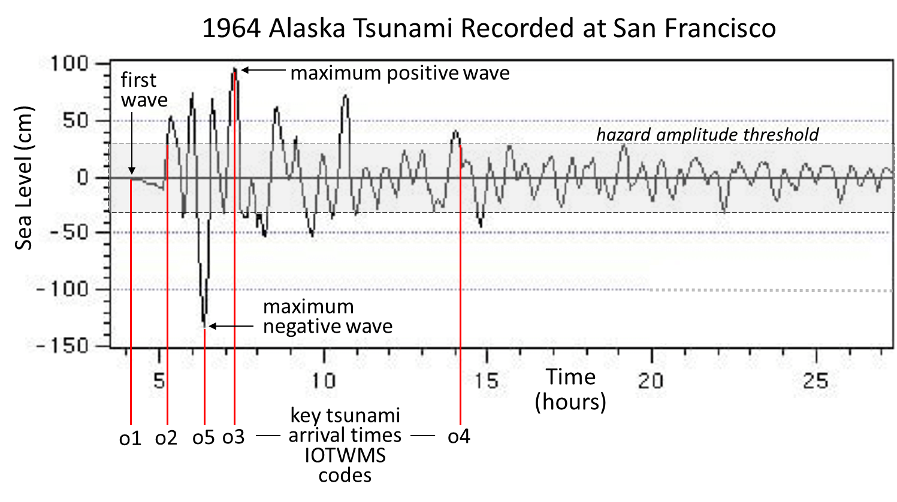
Figure 5. Example observed tsunami arrival times (o1 to o5) using a record of the 1964 tsunami from Alaska arriving in San Francisco (taken from Borrero et al., “Numerical Modeling of Tsunami Effects at Marine Oil Terminals in San Francisco Bay”). The light gray band is to illustrate the range of tsunami wave amplitudes that might be considered a non-threat.

PROCEDURES FOR TERMINATING EVENT SERVICES

TSP services will conclude for an event that prompted TSP issuance of tsunami threat products when one of the following occurs:
- further evaluation of the source event indicates unequivocally that there is no tsunami threat,
- hazardous tsunami waves were not observed on any gauges located near the source and thus a hazardous tsunami is not expected to have occurred,
- there are insufficient gauges near the source to evaluate if a hazardous tsunami occurred there, but a hazardous tsunami is not expected elsewhere based upon gauge readings far from the source, and
- following the observance of a hazardous tsunami, tsunami amplitudes have diminished on all or most gauges to levels below the minimum hazard level and additional new hazardous impacts are not expected elsewhere.
A product will then be issued by the TSP indicating it is the final product for the event. In the case of a hazardous tsunami having been generated, the final product does not mean that all coasts are now out of danger. That determination must be made by the appropriate authorities of each Member State based upon their own local sources of information.

PROCEDURES IN CASE A FALSE OR INCORRECT PRODUCT IS ISSUED

If a TSP issues a false or incorrect product, the TSP will issue a correction to all recipients as quickly as possible indicating that either 1) the original product was issued in error and should be ignored, or 2) correcting any wrong information in the product.

COMMUNICATIONS TESTS AND WAVE EXERCISES

TSPs shall conduct regular Communication Tests in which TSPs send test messages to TWFPs and NTWCs. TSPs may collaborate with the IOC/ICG Secretariat and respective Tsunami Information Centres in the preparation of tests to make them more effective. The TSP or the IOC Secretariat may announce the conduct of the test in advance or tests may be conducted by TSPs unannounced to help evaluate communications and readiness as they would be needed for a similarly unannounced tsunami. It is preferable that a report of results is prepared and disseminated to Member States within three months of the test. TSPs, NTWCs and TWFPs shall also participate in ICG wave exercises in coordination with the IOC/ICG Secretariat and the Tsunami Information Centres.

DISSEMINATION METHODS

NTWCs/TWFPs and TSPs should use all possible means of communication available to them to reach the target groups. The most widely used means for dissemination of tsunami advisories/alerts in different ICGs are GTS, AFTN, FAX, email, Web, SMS, RSS, CAPS, AWIPS, NWW, NAWAS, HAWAS, IDN, CISN, etc. In addition to the above, the following methods may be most suitable for dissemination of public and exchange products to specific target groups:
- TSPs to the Public: Tsunami Public products may be disseminated by GTS, Email, FAX, SMS, Websites, etc. The IOC Public List Server may also be available for subscribers. These products should be carefully designed to not cause confusion or be in conflict with warnings issued by local authorities.
- TSPs to TWFPs and NTWCs: Non-public tsunami products from TSPs to TWFPs and NTWCs need to be disseminated privately, either by being specifically addressed versus a broadcast, or by using password-protected methods. A brief notification alerting the NTWCs/TWFPs to the issue of a detailed product could be sent by GTS, Email, FAX, SMS, etc.
- NTWCs/TWFPs to TSPs: SITREPS or Warning Status reports from NTWCs/TWFPs to TSPs could be sent by Email, Telephone, FAX, Websites, etc.
- NTWCs/TWFPs to Public: Public alerting could be done through Email, SMS, Websites, TV/Radio, Loudspeakers, Sirens and other traditional methods.
- Note that TSP dissemination by FAX has become increasingly unreliable. It is scheduled to be discontinued by March 31, 2025, across all four RTWSs unless a recipient TWFP or NTWC requests that their service be continued because they do not have sufficient redundancy with other methods to ensure they can reliably receive the TSP products. In those cases, TSPs and their respective ICGs will work to provide redundancy using methods other than FAX.

Procedures for TSPs to disseminate products for events outside of the RTWS ESZ
For earthquakes located outside the ESZ of an RTWS, TSPs of that RTWS may issue Products to their AoS only in situations when tsunami waves above the minimum threat level are either forecast or observed within that TSPs coastal service area.

KEY PERFORMANCE INDICATORS

The following key performance indicators (KPIs) are proposed to measure and track the operational performance of the TSPs, NTWCs, and TWFPs. Values for each parameter are intended as representative targets. Detailed investigations, both scientific and sociological, would be necessary to arrive at more precise values of the KPIs associated with an optimal performance of the system. These values would likely vary between different RTWSs and their TSPs based upon the local seismo-tectonic settings of the earthquake and upon the vulnerability and location of the coastal communities being covered. It should be noted that there are no absolute measures to serve as the standard for comparing earthquake parameters such as location, depth and magnitude, and that accuracy can only be best gauged in some cases by comparing with analyzed values of other competent agencies (i.e., the absolute accuracy of the earthquake parameters is not known).

12.1 TSP PERFORMANCE

No. | Key Performance Indicator | Target Value¹
Earthquake Detection
 | Elapsed time² of the first product in response to an earthquake within the AoS | 10 minutes (when no coordination is required between TSPs)
 | Probability of detection of an earthquake within the ESZ meeting the minimum magnitude threshold for informational product issuance³ | 100%
 | Accuracy of earthquake parameters in both initial and subsequent products³ | Magnitude: ≤ 0.3 units  Depth: ≤ 30 km  Location: ≤ 30 km
Threat Assessment
 | Elapsed time² to issuing first quantitative threat assessment product |  | 20 minutes (when no coordination is required between TSPs)
 | Probability of detection of an earthquake within the ESZ meeting the minimum magnitude threshold for threat product issuance³ |  | 100%
 | Accuracy of forecast tsunami amplitudes⁴ |  | Within a factor of 2
 | Accuracy of forecast tsunami arrival times⁴ |  | Within 5% of the total tsunami travel time
Products
 | Number of false or incorrect products issued |  | 0
 | Percent of TWFPs and NTWCs issued timely products |  | 100%
1 – Target values may adjusted to fit the specifics of each RTWS by its ICG
2 – Elapsed time from the earthquake origin time
3 – Reference is to the earthquake parameters of the USGS at least one month after the event
4 – Compared with tsunami amplitudes on sea-level gauges

12.2 TSP FUNCTIONAL STATUS

No. | Key Performance Indicator | Target Value
 | Operational 24 hours/day, seven days /week (24/7) |  | 99%
 | Notify TWFPs and NTWCs of planned major service changes |  | ≥ 3 months in advance
 | Notify TWFPs and NTWCs of planned major interruptions |  | ≥ 3 months in advance
 | Return to service after planned interruptions |  | < 1 day
 | Return to service after an unplanned interruptions in during an event |  | < 30 mins

12.3 NTWC FUNCTIONAL STATUS

No. | Key Performance Indicator | Target Value
 | Notify authorities of planned service changes |  | > 3 months
 | Notify authorities of planned interruptions |  | > 3 months
 | Return to service after planned interruptions |  | < 1 day
 | Return to service after unplanned interruptions |  | < 30 mins
 | Elapsed time of issuing tsunami warnings and other related statements according to SOPs |  | < 10 mins after earthquake for local and 30 mins for regional tsunami threat to their country
 | Notify IOC of changes to Tsunami Warning Focal Point information |  | < 1 week
 | Maintain an overlap period between the old TWFP contact information and the new TWFP contact information to allow time for the IOC and TSPs to implement the change |  | > 3 months

12.4 TWFP FUNCTIONAL STATUS

No. | Key Performance Indicator | Target Value
 | Operational 24 hours/day, seven days /week (24/7) |  | 99%
 | Notify authorities of planned service changes |  | > 3 months
 | Notify authorities of planned interruptions |  | > 3 months
 | Return to service after planned interruptions |  | < 1 day
 | Return to service after unplanned interruptions |  | <30 mins
 | Notify IOC of changes to Tsunami Warning Focal Point information |  | < 1 week
 | Maintain an overlap period between the old TWFP contact information and the new TWFP contact information to allow time for the IOC and TSPs to implement the change |  | > 3 months
 | Elapsed time of disseminating TSP products according to Standard Operating Procedures |  | < 10 mins after TSP product issuance for local and regional tsunami threat to their country

LIMITATIONS OF THE SYSTEMS/PROCEDURES

The science of rapidly and accurately forecasting tsunamis has made important strides in recent years but challenges remain. Limitations of warning systems should be known and understood in order to best plan for and execute an appropriate response. For example, the current tsunami warning systems are designed to provide tsunami forecast information for tsunamis caused by submarine and coastal earthquakes; not those caused by other sources such as submarine and coastal landslides, volcanoes, etc.
The greatest unknown about the tsunami in real-time (and even later) is the nature of earthquake. How did the seafloor deform? How much was it displaced up or down and over what areas? Models all make assumptions about the source based upon the seismic analysis or later upon nearby sea-level gauge readings, but they only approximate the actual rupture geometry. The second greatest unknown is how the tsunami will interact with the coast. In most cases a general approximation must be used. Even when detailed coastal inundation models are available, properly capturing coastal resonances, trapped wave energy, and multiple wave interactions after even a few wave cycles is not possible. For these reasons, the forecast model information provided in the TSP products should be viewed with care, taking into consideration the limitations that are explained in this document.

13.1 EARTHQUAKE PARAMETERS

Earthquake parameters provide the earliest indication of a potential tsunami because seismic waves travel much faster around the earth than tsunami waves. Consequently, initial tsunami threat products are based entirely on preliminary earthquake parameters and on threat thresholds that are conservative for safety. Initial threats are sometimes terminated when no significant tsunami waves are observed. The actual earthquake location, depth, mechanism, and magnitude may not have been sufficient to deform the seafloor and generate a tsunami. On the other hand, a larger than expected tsunami may result if the earthquake had a slower, shallower, and greater slip than expected from the preliminary earthquake parameters.

13.2 INITIAL ESTIMATED ARRIVAL TIMES AND WAVE AMPLITUDES

Initial estimated arrival times are typically computed from the epicenter of the earthquake to each forecast point using the physics principle that a wave will travel from point A to point B through the fastest path. There are two limitations to this method. The first is the inaccuracy of representing the tsunami source by a point located at the epicenter. For great earthquakes, the ones most likely to produce a tsunami, the earthquake rupture will start at the epicenter but it can extend for tens or even hundreds of kilometers away from the epicenter. As a consequence, the tsunami source may not be like a point and it may not be located at the epicenter.
The second limitation is that the fastest path from the epicenter to the forecast point may not be a path over which much energy has traveled. Consequently, the first arriving tsunami waves may be small compared to later arriving waves. The net result of both limitations is that significant tsunami waves may arrive tens of minutes sooner or later than the predicted arrival time and that such errors may be largest in the biggest events.
At present it is not possible to quickly know the precise dimensions or location of the tsunami source. These parameters may only become available once the tsunami forecast model is sufficiently constrained with sea-level readings, and this methodology is still untested for major events and is in its implementation stage. Consequently, for now, estimated tsunami arrival times must be used cautiously and conservatively, expecting that tsunami impact could be sooner or later than predicted.
Tsunami amplitudes at the coast depend on the shape of the coast and the coastal bathymetry. While steep slopes reflect waves, gentle slopes increase wave amplitudes. Likewise, an island can be protected by a coral reef that causes the waves to break. Hazardous tsunami effects can be amplified by many factors such as traveling far inland up rivers as a bore. Likewise, in closed spaces such as harbors and bays, succeeding waves may reinforce resonances that increase tsunami amplitudes and cause strong currents and eddies. In the absence of accurate bathymetric data for all coastal regions, and without the time to model the aforementioned effects, wave amplitudes at the coast are often just approximated using Green’s Law. Actual maximum tsunami amplitudes may be higher or lower than those forecast with this method, but they are usually within a factor of two.

13.3 AREA OF THREAT AND NO THREATS
Any particular coastal area is assigned to have a tsunami threat based on whether the estimated wave amplitude is exceeding a pre-determined threshold and the area is under its respective TSP's AoS. Historical data and numerical model outputs show that tsunamis do not affect all areas equally. Significant differences can be due to directionality associated with the source, focusing and defocusing by bathymetry, attenuation by spreading and friction, and blockage by land masses. Consequently, some areas currently put into threat status may not experience hazardous tsunami waves.

TRAINING AND CAPACITY BUILDING

Timely and accurate dissemination of warnings is an essential part of an end-to-end warning system and requires the development of inter-institutional agreements among stakeholder organizations as well as SOPs for activation of the warning process. Organizational tsunami SOPs can be utilized to ensure that TSP advice is received by TWFPs and NTWCs, and that actionable warnings will be created and transmitted from NTWCs out to critical response agencies and down to vulnerable, at-risk communities in time to save lives. Regular SOP trainings need to be organized to develop protocols which define: (i) the roles and responsibilities of each organization; (ii) paths of communication between organizations, including which organizations communicate with others and how; and (iii) the hierarchy of decision makers for whether, where and when to call for evacuations.
It is essential that the communities that are vulnerable to the hazardous effects of a tsunami are made aware of those effects and how to respond when one happens through simple cost-effective and culturally sensitive awareness programmes. Such programmes include developing and disseminating information through the media, workshops/seminars, awareness materials, Internet, signage and billboards. If not already in existence, tsunami training curricula targeting youth should be developed and applied to build an inherent awareness and response capability in young adults and children.
Due to the nature of the tsunami hazard, that they may occur at any time without a precursor and then propagate rapidly to nearby coasts within just minutes and coasts far away within hours, Member States must continuously be ready to respond. This requires putting in place the plans and processes to enable an effective and rapid response. These need to include a response management structure, defined responsibilities of each response organization, evacuation arrangements, and reliable systems for communicating between responsible organizations and for comprehensively disseminating tsunami warnings to the public at risk. Member States should also plan and conduct exercises on a regular basis to test early warning systems and emergency evacuation plans. All of these critical capabilities are included in the international Tsunami Ready Recognition Programme that is being implemented globally as a part of the UN Ocean Decade Tsunami Programme.

CONCLUSION

This Global Service Definition Document (GSDD) describes global tsunami warning services provided by the four RTWSs and their respective TSPs as a global system of systems coordinated by the IOC. The GSDD content is based on TTTWO decisions and recommendations approved by the TOWS-WG as well as on other information regarding the tsunami warning operations of each RTWS. This is intended to be a living document that will undergo additions and modifications to the global services as they are approved by the TTTWO and implemented by the RTWSs and TSPs.
Suggestions and recommendations put forth in this document are based on best-practice and intend to serve only as guidance to the ICGs and TSPs for the planning and development of their operation. While the specific and diverse requirements of each region will continue to drive the evolution of each RTWS, following the common framework put forth in this document will help ensure that operations within and among the four RTWSs are more seamless and interoperable. The task of harmonization of tsunami watch operations is a continuing one driven by the needs of its major stakeholders as represented by the four ICGs.

ANNEX I - Earthquake Source Zone Maps of the Regional Tsunami Warning Systems

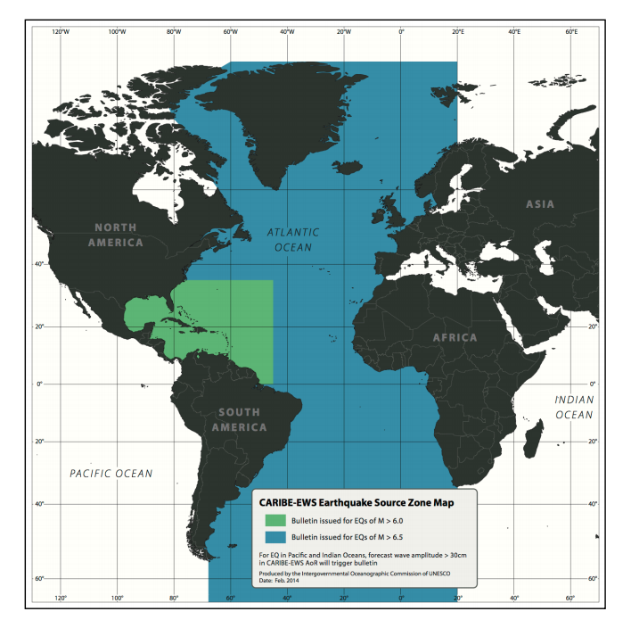
CARIBE-EWS Earthquake Source Zone Map (Reference: IOC/TOWS-WG-VII/3 Annex V, page 19)

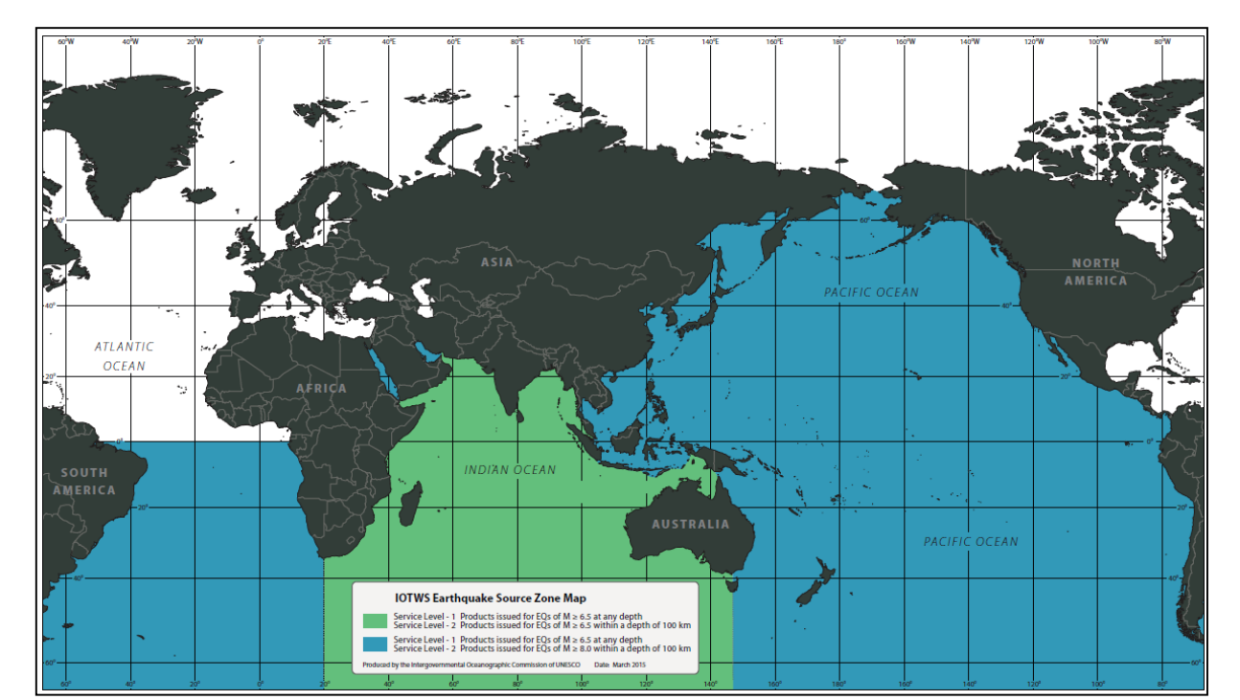
IOTWMS Earthquake Source Zone Map (Reference: IOC/TOWS-WG-VIII/3 Annex VI, page 14)
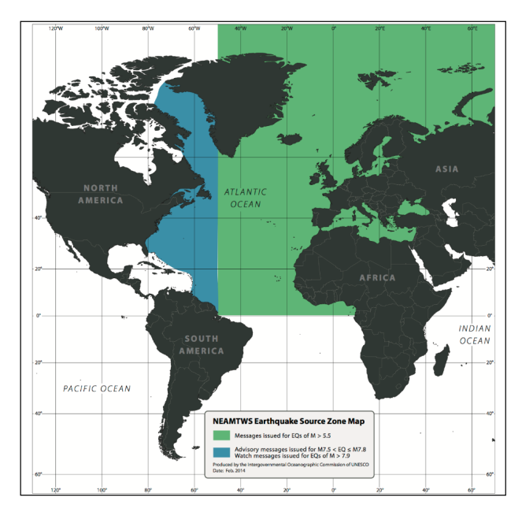
NEAMTWS Earthquake Source Zone Map (Reference: IOC/TOWS-WG-VII/3 Annex V, page 21)

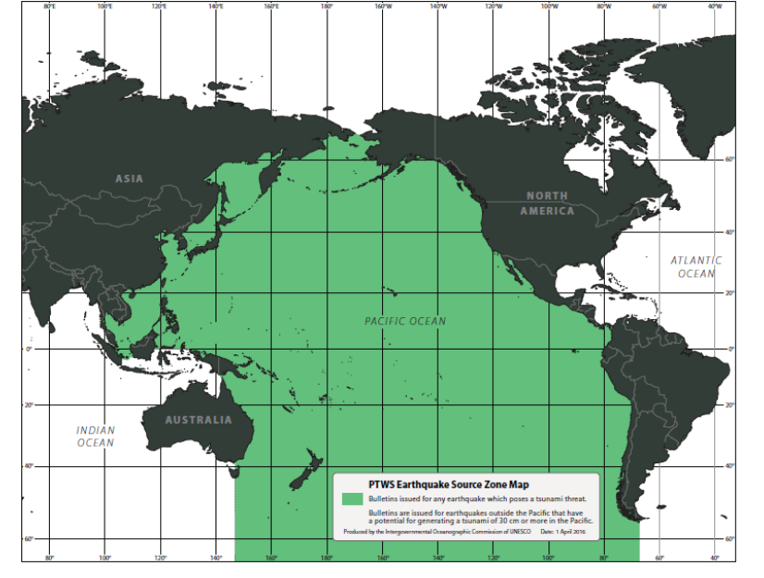
PTWS Earthquake Source Zone Map (Reference: IOC/TOWS-WG-IX/3 Annex IV, page 52)

ANNEX II - List of Acronyms

AoR | Area of Responsibility of an RTWS
AoS | Area of Service of a TSP
CARIBE-EWS | Tsunami and other Coastal Hazards Warning System for the Caribbean and Adjacent Regions
CFP | Coastal Forecast Point
CTBTO | Comprehensive Nuclear Test Ban Treaty Organization
EQ | Earthquake
GFZ | German Research Centre for Geosciences
GSN | Global Seismographic Network
GTS  HTHH | Global Telecommunication System  Hunga Tonga Hunga Ha`apai Volcano
ICG | Intergovernmental Coordination Group
IOC | Intergovernmental Oceanographic Commission [UNESCO]
IOTWMS | Indian Ocean Tsunami Warning and Mitigation System
IRIS | Incorporated Research Institutions for Seismology
KPI | Key Performance Indicators
NEAM | North-Eastern Atlantic, the Mediterranean and Connected Seas region
NEAMTWS | Tsunami Early Warning and Mitigation System in the North-Eastern Atlantic, the Mediterranean and Connected Seas
NTWC | National Tsunami Warning Centre
PTWC | Pacific Tsunami Warning Centre
PTWS | Pacific Tsunami Warning and Mitigation System (formerly ITSU)
RTWS | Regional Tsunami Warning System
SOP | Standard Operating Procedure
TOWS-WG | Working Group on Tsunamis and Other Hazards Related to Sea-Level Warning and Mitigation Systems
TRRP | Tsunami Ready Recognition Program
TSP | Tsunami Service Provider
TTTWO | Task Team on Tsunami Watch Operations
TWFP | Tsunami Warning Focal Point
TNC | Tsunami National Contact
TWS | Tsunami Warning System
UNESCO | United Nations Educational, Scientific and Cultural Organization
USGS | United States Geological Survey
WG | Working Group

