Summary

This document presents the rationale and strategic framework for supporting African Member States in developing National Ocean Science Plans and Strategies (NOSPSs) to address the growing gap between rapid ocean development and limited scientific capacity, as highlighted in the Global Ocean Science Report 2024. It outlines the objectives, core components, guiding principles, and facilitation mechanisms of a proposed IOCAFRICA regional initiative, aligned with Agenda 2063, the Africa Blue Economy Strategy, AIMS 2050, and the UN Ocean Decade. The initiative aims to foster evidence-based, inclusive, and policy-relevant marine science planning to support sustainable ocean governance.
Financial implications: Implementation of this initiative will have financial implications related to toolkit development, technical assistance, training, and pilot country support. These are to be reflected in the work plan and budget of IOCAFRICA. Member States are encouraged to integrate NOSPSs into national budget cycles and to seek support through multilateral and bilateral partnerships.
Decision proposed: The Session is invited to consider the draft decision referenced as Dec. IOCAFRICA-VIII/4.10 in the Provisional Action Paper IOCAFRICA-VIII/AP Prov.

Introduction
- Africa is home to an expansive and diverse marine environment, with 38 coastal and island states, a combined Exclusive Economic Zone of over 13 million square kilometers, and rich biodiversity and ocean-based resources. The ocean plays a central role in supporting the continent’s sustainable development agenda, contributing to food security, climate regulation, energy access, trade, and employment. Recognizing this, ocean-based sectors have become a key focus under the African Union’s Agenda 2063, the Africa Blue Economy Strategy, and the African Ministerial Conference on the Environment (AMCEN) declarations.

- However, ocean development in Africa is rapidly outpacing the scientific understanding required to manage it effectively, as underscored in the Global Ocean Science Report 2024, which highlights that Africa invests less than 1% of global funding in ocean science and has the lowest density of ocean science professionals per capita among world regions Blue economy initiatives are expanding, yet many countries still lack comprehensive national ocean science strategies to ensure that this growth is informed by sound data, coordinated research, and adaptive governance. As a result, policy-making often proceeds in the absence of reliable scientific evidence, undermining efforts to achieve sustainable ocean governance and resilience against climate-related threats.
- Several regional and global frameworks recognize the urgency of closing this gap. The UN Decade of Ocean Science for Sustainable Development (2021–2030) calls for the transformation of ocean science systems to deliver the knowledge needed for action. The IOC Medium-Term Strategy (2022–2029) prioritizes support to countries in strengthening scientific and institutional capacities. At the continental level, the Africa Blue Economy Strategy underscores the need to improve the generation and use of ocean knowledge for effective resource management. The African Union’s Agenda 2063 identifies the blue economy as a key driver for inclusive growth and sustainable development, emphasizing the role of science, technology, and innovation in unlocking Africa’s marine potential. The African Union’s 2050 Africa’s Integrated Maritime Strategy (AIMS) provides a framework for coordinated maritime governance, advocating for research, innovation, and knowledge sharing as drivers of sustainable ocean development. These frameworks collectively advocate for evidence-based planning as a foundation for resilient and inclusive ocean economies.

- Despite this policy momentum, most African coastal and island states continue to face critical challenges in ocean science planning: weak institutional coordination, insufficient funding, limited infrastructure, and lack of long-term research priorities. These constraints contribute to fragmented approaches and missed opportunities for collaborative and strategic investments.

- In this context, this agenda item proposes a regionally coordinated effort under IOCAFRICA to support the development of National Ocean Science Plans and Strategies (NOSPSs). These instruments will serve as structured frameworks to identify national priorities, guide investment, foster partnerships, and align science efforts with pressing development and conservation needs. Through NOSPSs, countries can ensure that scientific research, technology, and knowledge dissemination are central to achieving national goals and international commitments.

Strategic rationale for ocean science plans and strategies
- The need for National Ocean Science Plans and Strategies (NOSPSs) arises from a critical mismatch between the pace of ocean development and the current scientific capacity to support and sustain it. While fisheries, maritime trade, coastal infrastructure, energy exploration, tourism, and marine spatial planning are expanding across Africa, these developments often outpace the availability and application of reliable ocean data, forecasting systems, and research-based policy tools. This imbalance not only threatens ecological sustainability but also limits Africa’s ability to unlock the full socioeconomic potential of its ocean spaces.

- Effective NOSPSs would provide countries with a framework to elevate science as the foundation for all ocean-related decision-making. They would facilitate a transition from fragmented, project-based research to coherent national strategies that are aligned with Africa’s long-term development priorities. These strategies would help countries systematize marine data collection, enhance scientific infrastructure, promote interdisciplinary collaboration, and ensure that ocean science is mainstreamed into governance frameworks across key sectors such as environment, fisheries, climate adaptation, and economic planning.

- National Ocean Science Plans and Strategies (NOSPSs) serve as essential frameworks to ensure that ocean development is evidence-based, coherent, and sustainable. They provide governments with a structured tool to:
- Define a shared national vision for marine science and innovation that aligns with broader sustainable development goals;
- Coordinate across institutions and sectors, reducing duplication, improving efficiency, and fostering policy coherence;
- Integrate science into national policy frameworks, including climate adaptation, biodiversity conservation, pollution control, and the blue economy;
- Facilitate engagement with regional mechanisms such as the African Union’s 2050 Africa’s Integrated Maritime Strategy (AIMS), the Nairobi Convention’s Regional Ocean Governance Strategy (ROGS), the Africa Blue Economy Strategy, and Agenda 2063;
- Enable collaboration with global partners, including the IOC, UNEP, FAO, and the private sector;
- Strengthen investment cases for ocean science, ensuring alignment with donor priorities and national development financing plans; and
- Build accountability, through clear monitoring indicators and mechanisms for tracking scientific, environmental, and socioeconomic outcomes.
- Without NOSPSs, Member States risk pursuing fragmented and reactive ocean science initiatives, which can lead to inefficiencies in resource use, missed opportunities for investment and capacity-building, and reduced competitiveness in global maritime governance. The NOSPS framework provides a pathway to leapfrog these challenges by institutionalizing science-driven ocean development and positioning African countries as leaders in the global marine knowledge economy.

Objectives of the regional support initiative
- The regional initiative led by IOCAFRICA seeks to catalyze a transformative shift in how African countries approach ocean science planning and policy formulation. Its objectives are carefully designed to support Member States in building sustainable, inclusive, and science-informed ocean governance structures. Specifically, the initiative aims to:
- Promote the formulation of National Ocean Science Plans and Strategies (NOSPSs) across all IOCAFRICA Member States by providing tools, templates, technical guidance, and pilot support. This will enable each country to define a long-term vision for ocean science aligned with its unique context and development goals.
- Strengthen institutional capacities for both planning and implementation by building the technical skills of government agencies, research institutions, and coordination bodies. This includes training on data systems, policy design, forecasting tools, and integration of marine science into decision-making processes.
- Foster inter-sectoral collaboration and inclusive stakeholder engagement by creating structured platforms for dialogue and participation across ministries (e.g., fisheries, environment, transport, energy), academia, private sector, youth, women, and Indigenous knowledge holders. This will help ensure that ocean science planning is socially responsive and contextually grounded.
- Support the integration of NOSPSs into national development, climate, and environmental policy frameworks, including national development plans, climate adaptation strategies, biodiversity action plans, and ocean economy roadmaps. This integration ensures that science is not siloed but mainstreamed into broader governance systems.
- Align national ocean science priorities with regional and global agendas, including Agenda 2063, the Africa Blue Economy Strategy, the 2050 Africa’s Integrated Maritime Strategy (AIMS), the Nairobi Convention Regional Ocean Governance Strategy (ROGS), the Abidjan Convention, and the UN Decade of Ocean Science for Sustainable Development. This alignment maximizes synergies, attracts partnerships, and positions African nations to lead in global marine governance forums.
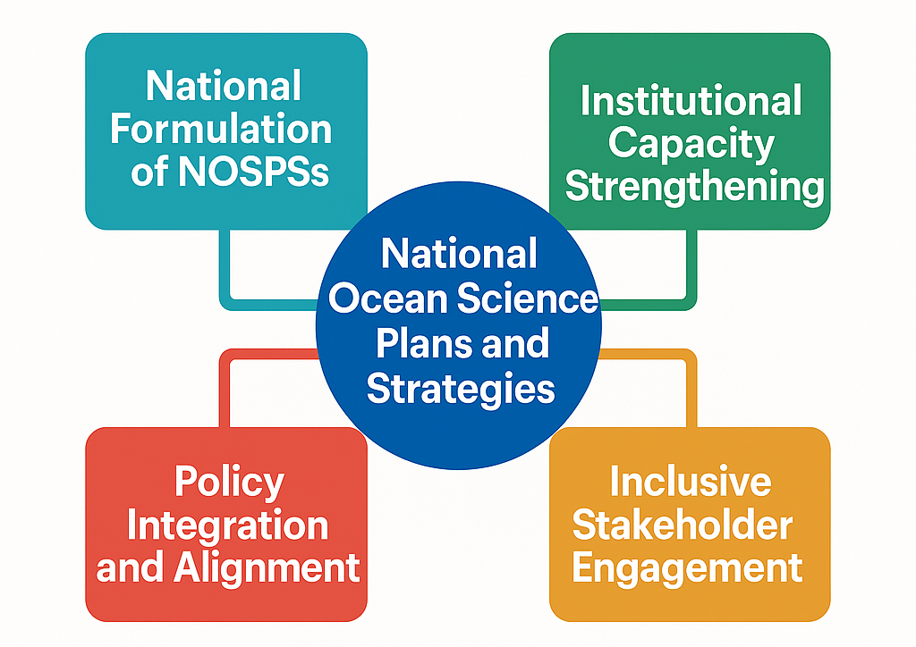
Figure 1: This diagram illustrates the core pillars of the regional support initiative. Each pillar contributes to a more resilient, scientifically robust, and strategically guided approach to ocean governance on the continent.

Core components of National Ocean Science Plans and Strategies
- Effective National Ocean Science Plans and Strategies (NOSPSs) are comprehensive, structured, and forward-looking frameworks. Each component plays a specific role in guiding the planning, implementation, and sustainability of national ocean science efforts:
- Situational Analysis
This is the foundation of any NOSPS. It involves a critical assessment of the existing institutional, technical, and scientific landscape. It helps countries understand their current strengths, weaknesses, and gaps in ocean science capacity, data infrastructure, legislation, and human resources. This step ensures that planning is evidence-based and tailored to national realities.
- Strategic Vision and Mission
A compelling vision and mission articulate the long-term ambition and purpose of the plan. The vision provides a shared direction for stakeholders, while the mission defines the plan’s overarching goals, such as enhancing resilience, promoting innovation, or driving inclusive blue growth.
- Priority Research Themes and Challenges
This section identifies the most pressing scientific and societal challenges the country aims to address, such as climate change impacts, marine pollution, sustainable fisheries, or habitat degradation. Prioritizing themes ensures that limited resources are directed toward the most urgent and impactful issues, and aligns national efforts with regional and global frameworks like SDG 14.
- Infrastructure, Capacity, and Data Needs
This component focuses on what is required to implement the strategy—labs, vessels, observation platforms, data centers, digital tools, and trained personnel. Addressing infrastructure and capacity bottlenecks is crucial for enhancing scientific output and ensuring knowledge is accessible and usable by decision-makers.
- Implementation Roadmap
The roadmap translates the vision into action. It lays out clear timelines, roles, milestones, and coordination mechanisms. This part of the NOSPS ensures that activities are sequenced logically, responsibilities are distributed, and progress can be measured and managed over time.
- Monitoring and Evaluation Framework
To track the effectiveness of implementation, this component defines indicators, performance metrics, review cycles, and mechanisms for learning and adaptation. A strong M&E system promotes transparency, accountability, and continuous improvement.
- Financing Strategy and Resource Mobilization Plan
Finally, a realistic financing plan is essential for operationalizing the NOSPS. This includes identifying national budget lines, tapping into development partner resources, private-sector investments, and exploring innovative financing tools. It ensures that the strategy is not just aspirational, but fundable and sustainable.
- Together, these components form an integrated planning architecture that supports informed policy, guides investment, builds capacity, and facilitates international cooperation. Each step builds logically on the last—from diagnosis (situational analysis) through to delivery (implementation and financing), creating a dynamic blueprint for effective ocean science development.

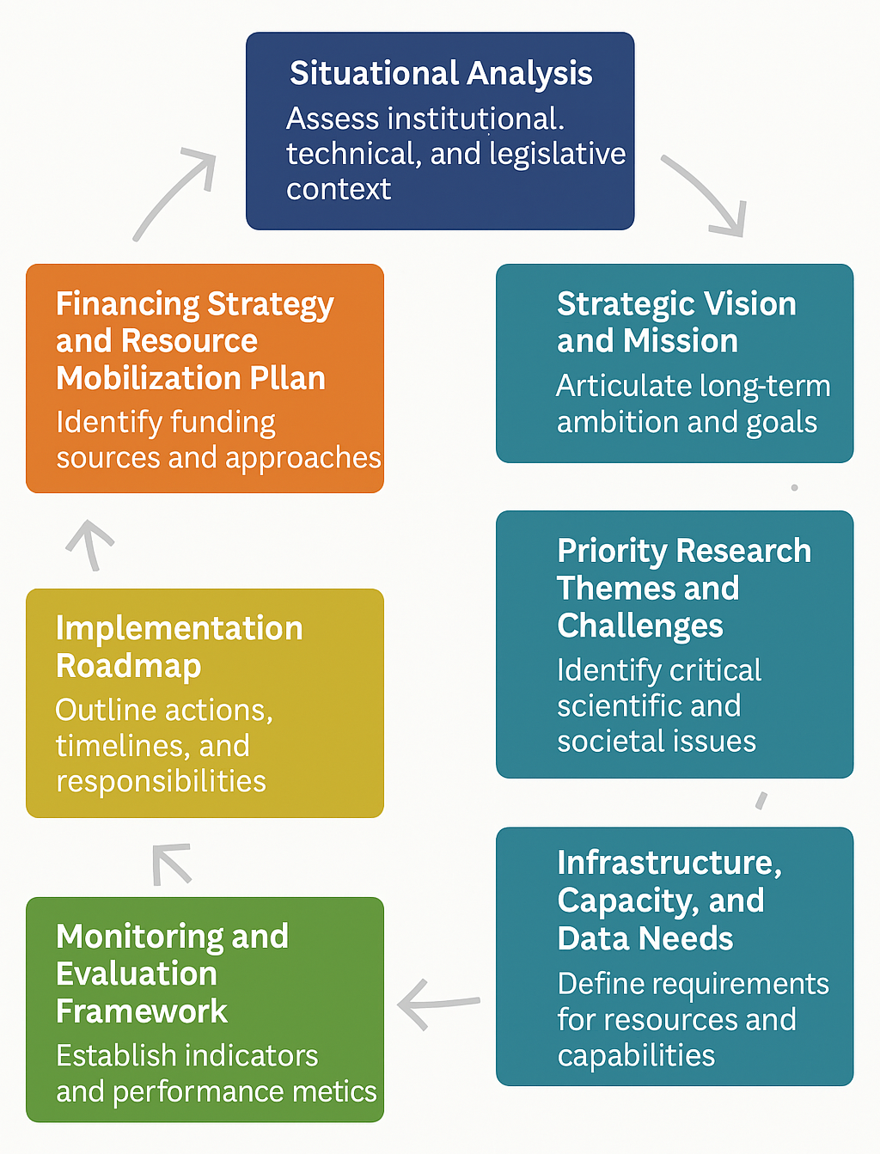
Figure 2: Overview of the process to core components of a National Ocean Science Plans and Strategies

Guiding principles for NOSPSs development
- The success and sustainability of National Ocean Science Plans and Strategies depend heavily on the principles that guide their design and implementation. These guiding principles are not just theoretical ideals—they are practical prerequisites for ensuring that NOSPSs are relevant, inclusive, robust, and fit for purpose. The development of NOSPSs is proposed to follow the below key principles to ensure relevance and sustainability:
- National leadership and ownership
National governments must lead the NOSPS process from inception to implementation. This ensures alignment with national priorities and enhances accountability. Leadership also fosters institutional commitment, enabling countries to mobilize domestic resources and shape partnerships that reflect their specific developmental and ocean governance needs.
- Whole-of-society engagement
The development of a NOSPS should be an inclusive process that reflects the voices and knowledge of all stakeholders—including youth, women, local communities, and vulnerable populations. Ocean governance affects all segments of society, and their inclusion in planning processes enhances the relevance, equity, and legitimacy of the strategy. Broad engagement fosters social buy-in and supports long-term sustainability.
- Evidence-informed and data-driven decision-making
NOSPSs must be grounded in science and built upon the best available data. This principle ensures that policy decisions are not arbitrary but guided by rigorous analysis, environmental baselines, forecasting models, and impact assessments. It also promotes a culture of learning and accountability in marine governance.
- Integration of scientific, indigenous, and local knowledge
Indigenous and local communities often hold valuable insights and traditional knowledge that are crucial for understanding coastal and marine ecosystems. Blending modern scientific approaches with time-tested community wisdom enhances the richness and applicability of NOSPSs. This integrative approach also strengthens cultural relevance and local stewardship.
- Flexibility for adaptive learning and continuous improvement
The ocean is dynamic, and so too must be the strategies for understanding and managing it. NOSPSs should be designed with built-in mechanisms for reflection, review, and adjustment. This ensures that countries can respond effectively to emerging challenges such as climate change impacts, marine hazards, or new scientific discoveries.
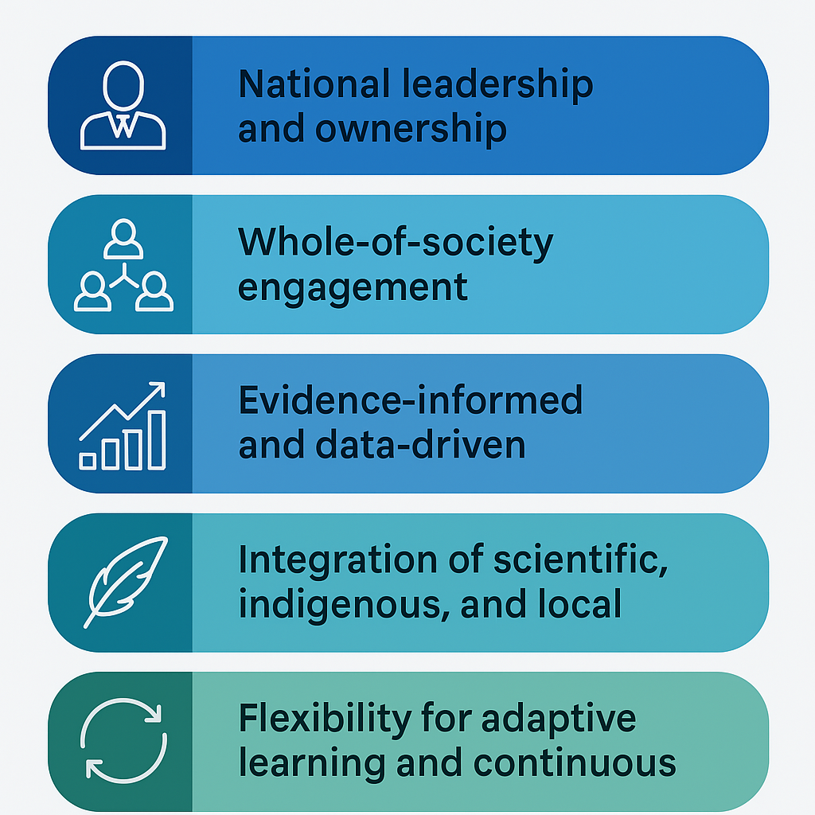
Figure 3: Guiding principles for NOSPSs development
- Collectively, these principles serve as the ethical and operational compass of a NOSPS. They ensure that the strategy is nationally relevant, socially legitimate, scientifically rigorous, and responsive to change. When embedded from the outset, these principles create a resilient foundation for long-term impact and regional leadership in sustainable ocean development.

IOCAFRICA’s facilitation framework
- To ensure that Member States are not left to undertake the complex process of developing National Ocean Science Plans and Strategies (NOSPSs) alone, IOCAFRICA will play a central facilitative and coordination role. This support framework is designed to address capacity gaps, promote shared learning, and align national efforts with continental and global priorities.
- A regional NOSPS toolkit will be developed to serve as a practical, user-friendly guide. It will include step-by-step methodologies, adaptable templates, and sample case models drawn from leading practices within Africa and globally. This toolkit will help countries navigate each phase of strategy development, from stakeholder consultation to implementation and monitoring.
- Capacity-building workshops and expert advisory missions will be organized to strengthen institutional and human capacities required to achieve the core objectives of NOSPSs. These engagements will be tailored to support national efforts in: (i) formulating inclusive and evidence-based ocean science plans; (ii) equipping stakeholders with the tools and methodologies necessary for long-term implementation; and (iii) ensuring alignment with national development goals and global ocean science agendas. Specific areas of focus will include ocean data management systems, integrated marine spatial planning, science-policy interfacing, policy drafting, and inter-agency coordination. These activities will not only build technical skills but also foster a culture of collaboration and innovation across ocean governance institutions.
- Peer review and knowledge exchange platforms will be established to enable continuous learning among countries. These platforms will allow countries to share experiences, troubleshoot challenges, and refine their approaches based on real-world feedback and lessons learned.
- Pilot programmes will be launched with a select group of Member States to test and refine the NOSPS framework. These countries will receive tailored support and serve as demonstration models for replication and adaptation across the region.
- Partnership brokering will be actively pursued to connect countries with relevant development partners, technical organizations, and funding agencies. IOCAFRICA will serve as a convening and matchmaking hub, helping to mobilize resources and catalyze multi-stakeholder collaborations in support of NOSPS implementation.
Through this facilitation framework, IOCAFRICA aims to ensure that each country’s NOSPS process is inclusive, scientifically rigorous, policy-aligned, and fully actionable.

Anticipated outcomes by 2027
- By 2027, this effort is expected to deliver a measurable shift in the way ocean science is governed, resourced, and applied across Africa. These outcomes are directly linked to the objectives of the NOSPS framework and respond to the continent’s growing demand for more structured, evidence-based ocean governance.
- At least 5 Member States will have developed and initiated implementation of NOSPSs, positioning themselves to make informed decisions on sustainable ocean use, and embedding science into national development and policy processes.
- Increased national investment in ocean science, infrastructure, and human resources will be mobilized through clearer prioritization, budgetary alignment, and enhanced donor confidence. This includes expanded data platforms, upgraded research infrastructure, and strengthened scientific institutions.
- Better alignment of ocean research with national development priorities and Sustainable Development Goal 14 (Life Below Water) will ensure that scientific outputs are directly informing areas such as fisheries management, marine spatial planning, climate resilience, and coastal protection.
- Strengthened regional and intergovernmental collaboration on marine science, supported by IOCAFRICA, will promote data sharing, harmonized methodologies, and collective advocacy in global ocean governance platforms.
- Broader recognition of Africa’s scientific contributions to global ocean agendas will emerge as Member States implement coordinated strategies, participate in global assessments, and contribute to international research initiatives under the UN Decade of Ocean Science for Sustainable Development.
These outcomes will collectively enhance Africa’s capacity to manage its ocean space sustainably and equitably, while reinforcing its leadership role in shaping a more informed, inclusive, and just global ocean future.

Financing and sustainability
- Initial funding for technical assistance, training, and pilot initiatives will be secured through IOCAFRICA’s Regular Program fund, partnerships and extrabudgetary resources. Member States are encouraged to allocate domestic resources and integrate NOSPSs into national development frameworks. Long-term sustainability will be supported through strategic partnerships with the African Union, Regional Economic Communities, and international development partners.

Proposed decision
Recalling the IOC Medium-Term Strategy (2022–2029), which emphasizes the importance of strengthening national institutional capacities and promoting science-based policy frameworks for ocean governance;
Recognizing the objectives of the UN Decade of Ocean Science for Sustainable Development (2021–2030), particularly the call for transformative ocean science that delivers actionable knowledge for sustainable development;
Acknowledging the African Union’s Agenda 2063, the Africa Blue Economy Strategy, and the 2050 Africa’s Integrated Maritime Strategy (AIMS), which highlight the blue economy and marine governance as critical pillars for Africa’s growth and resilience;
Noting the continued gap between rapid ocean development and the scientific capacity required to manage this growth sustainably across many African coastal and island states;
Recognizing the role of IOCAFRICA in supporting Member States to strengthen ocean science planning and governance;
Further noting the findings of the Global Ocean Science Report 2024, which underscore that Africa invests less than 1% of global funding in ocean science and has the lowest density of ocean science professionals per capita among world regions;
The Sub-Commission:
- Endorses the launch of a regionally coordinated initiative under IOCAFRICA to support the development and implementation of National Ocean Science Plans and Strategies (NOSPSs) by Member States;
- Requests the IOCAFRICA Secretariat, in consultation with Member States and partners, to finalize and disseminate a NOSPSs guidance toolkit, and to initiate targeted technical assistance, including capacity development and pilot programmes;
- Invites Member States to designate national focal institutions to lead the NOSPS process and facilitate inclusive, evidence-based planning and coordination at the national level;
- Urges regional and global partners, including the African Union, Regional Economic Communities, UNEP, UNDP, and development partners, to provide technical and financial support towards the implementation of this initiative;
- Encourages IOCAFRICA to report on progress and lessons learned at its next session and to explore synergies with other regional and international efforts supporting ocean science, governance, and the implementation of the UN Ocean Decade.

