Summary

This document presents the rationale and strategic vision for revitalizing the Ocean Data and Information Network for Africa (ODINAFRICA) under a new name and framework: the IOCAFRICA Ocean Data and Information Network (IOCAFRICA-ODIN). While building on the significant legacy and achievements of the original ODINAFRICA initiative, this transformation positions IOCAFRICA-ODIN as a forward-looking, regionally coordinated platform embedded in the global Ocean Information Hub (OIH) and supported by the Ocean Data and Information System (ODIS). The new network aims to strengthen regional ocean data infrastructure, enhance interoperability, and support African National Oceanographic Data Centres (NODCs) and partners in advancing open, FAIR, and standards-based marine data governance. It outlines a strategic roadmap built around three priority areas: (i) developing data infrastructure and catalogues aligned with ODIS; (ii) enhancing institutional capacities and reactivating NODCs; and (iii) enabling a digital twin of the African ocean space.
Financial implications: Implementation of IOCAFRICA-ODIN will require investments in data infrastructure, training, equipment, stakeholder coordination, and the development of interoperable catalogues and atlases. These financial needs are to be reflected in the IOCAFRICA work plan and budget. Member States and partners are encouraged to mobilize resources through national funding mechanisms and regional and international partnerships.
Decision proposed: The Session is invited to consider the draft decision referenced as Dec. IOCAFRICA-VIII/4.2 in the Provisional Action Paper IOCAFRICA-VIII/AP Prov.

Background
- The Ocean Data and Information Network for Africa (ODINAFRICA) has been one of the most successful initiative of the International Oceanographic Data and Information Exchange programme (IODE) of the Intergovernmental Oceanographic Commission of UNESCO (IOC). Since its inception in 1989, the project has evolved through five dynamic and progressive phases until its last phase, in 2014. The focus of the project has been aimed over time towards addressing the challenges faced in ensuring that ocean and coastal data and information generated in national, regional and global programmes are readily available to a wide range of users. More specifically, the project has enhanced mechanisms to strengthen the pan-African network of National Oceanographic Data Centre (NODCs) and marine related institutions, as a sustained mechanism for application of data, information and products in marine and coastal management in Africa.
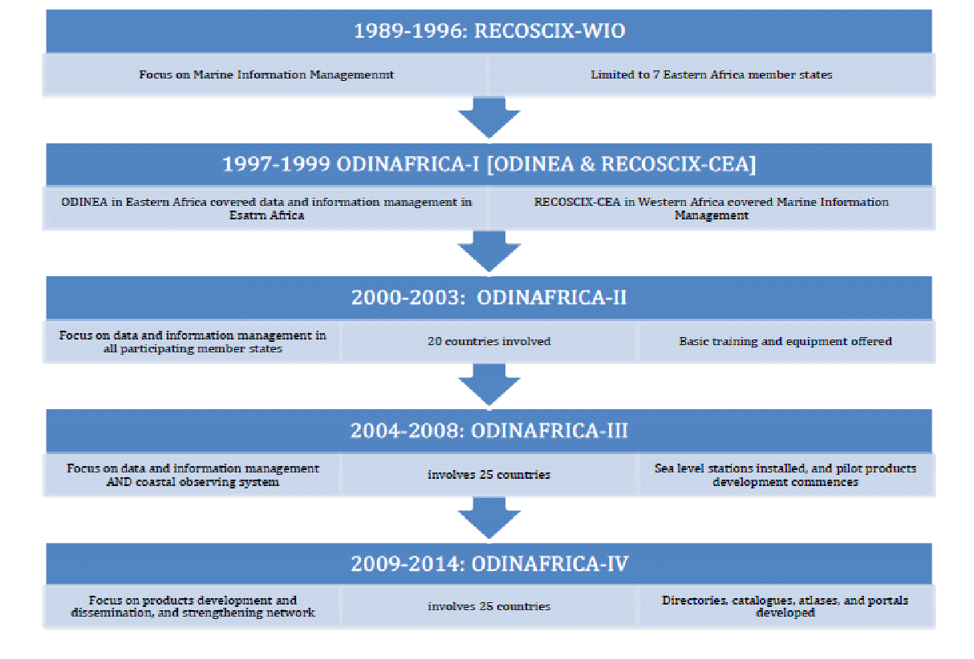
Figure 1: Evolution of ODINAFRICA between 1989 and 2014. Read more about the evolution of ODINAFRICA here
- Some of the key achievements of the ODINAFRICA in its past phases include:
- Improved access to literature and other information by developing library catalogues and links to global networks (IAMSLIC) as well as contributing to the literature repository OceanDocs;
- Conducting capacity development initiatives, mostly focused on improving access to data, skills for analysis and interpretation;
- Strengthening of sea level network, comprising more than 40 sea level station, including providing funding for coastal data collection;
- Spearheading information and coordination of a network of African Experts. The network has enabled the experts to collaborate and assist each other in issues related to data and information management, as well as in addressing local and national priorities
Need for a Revitalised ODINAFRICA
- There is a growing need for improved access to data and information, to facilitate better understanding and management of the marine environment and simultaneously address crosscutting issues in the ocean-data domain. In Africa & the Adjacent Island States, the most pressing issues include:
- Need for an improved focus on user-driven data;
- Challenges in data sharing related to a lack of common platforms & services, or incompatible metadata and data formats
- Lack of standardised policies in relation to open access data;
- Technical capacity and resource limitations; and
- Lack of trust between organisations to share data.
- To address these challenges, recent studies and consortia, including the Regional Gap Analysis, Regional Decade Consultations and the Sixth Session of IOC Sub Commission for Africa and the Adjacent Island States (IOCAFRICA-VI), strongly recommended the reactivation of the Ocean Data and Information Network for Africa (ODINAFRICA).

Revitalizing ocean data infrastructure in Africa: Launching AFRICA-ODIN
- To respond to the growing needs of the African region in ocean data and information services, the former Ocean Data and Information Network for Africa (ODINAFRICA) is being reimagined and relaunched under a new identity: the IOCAFRICA Ocean Data and Information Network (AFRICA-ODIN). This revitalization reflects both a continuity in purpose and a deliberate shift in scope and ambition. While recognizing and building upon the achievements of the ODINAFRICA initiative—which significantly advanced marine data management capacity across the continent—the AFRICA-ODIN represents a strategic transformation from a time-bound project into a forward-looking, integrated, and institutionally anchored regional mechanism.

- This rebranded network, will function as the Ocean Data and Information System (ODIS). which underpins a decentralized, standards-based framework for ocean data exchange and collaboration, an effort that began with the Ocean Information Hub (OIH) Project. The OIH project, which commenced in 2020, seeks to improve discoverability and access to global oceans information, data and knowledge products for management and sustainable development, through the creation of a worldwide connected network of ocean data nodes. The AFRICA-ODIN will adopt and promote this open digital architecture, initially focusing on six thematic areas:
- Experts and institutions
- Documents and publications
- Spatial data and maps
- Ocean observation platforms
- Training and educational resources
- Marine and coastal projects across Africa
- In alignment with this mandate, the network will begin developing a comprehensive, standards-based plan for data sharing and cataloguing across the continent, tailored to the needs of African National Oceanographic Data Centres (NODCs), research institutions, and coastal governance bodies.

- In March 2022, UNESCO’s IOCAFRICA, in partnership with OIH Project, organised a virtual meeting to allow different stakeholders to deliberate on the reactivation of ODINAFRICA to support the development of the African regional node for OIH project (see detailed report of the meeting). The meeting focused on discussing the status, roles, challenges and opportunities of National Oceanographic Data and Information Centre (NODCs) as well as the steps towards developing a joint framework for member states and institutions in the region to actively engage and contribute to a reactivated ODINAFRICA network.

- One of the key outcomes of the meeting was the establishment of an ODINAFRICA Steering Group, with representatives from various member states, as well as the Ocean InfoHub. The steering group now meets on a bi-weekly basis to deliberate on the plans and activities of the ODINAFRICA project.

- Looking ahead, AFRICA-ODIN will serve as a catalyst for strengthening African engagement in global ocean data systems, while anchoring its activities in local needs. It will proactively seek input from NODCs, regional institutions, and end-users to shape a responsive and inclusive network capable of supporting ocean science, climate resilience, and sustainable blue economy goals across the continent.

- Building on the Open technology and Open standards supported through ODIS, we will expand ODINAFRICA's presence and influence, representing regional needs and sharing key data globally. As such, under the auspices of the OIH project, the revitalised ODINAFRICA will begin to develop an updated plan for a standards-based architecture for publishing, sharing, and discovering Ocean data catalogues and services throughout Africa.

- The AFRICA-ODIN will begin to actively seek for feedback and input from pan-African NODCs and other institutions regarding their needs and challenges in terms of accessing and sharing their Ocean data products and services

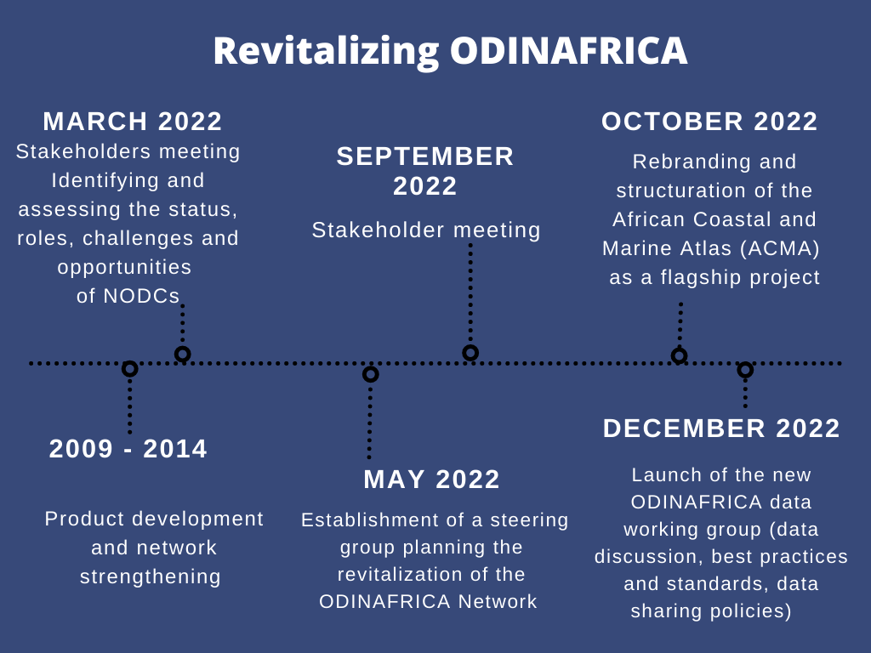
Figure 2: Short-term target milestones towards developing structure for the revitalised ODINAFRICA.
How will IOCAFRICA-ODIN contribute to regional and global processes?
- Ultimately, the revitalised AFRICA-ODIN will enable members to meet the knowledge needs of national and regional requirements for sourcing marine data and information. At the regional level, the network will contribute towards addressing data-related gaps stipulated in the AU 2063 and Agenda 2050 Africa's Integrated Maritime Strategy (2050 AIM Strategy). More importantly, the revitalised AFRICA-ODIN project will address gaps/ issues articulated Ocean Decade Africa Roadmap including: Challenges in data sharing due to lack of common platforms, and incompatible metadata and data formats; Insufficient standardised policies in relation to access and sharing of data; Limited trust between organisations to share data; Limited technical capacities and resources; and need to empower local/regional scientists with skills and tools to enable them to analyse and interpret the large number of data sets available in the region.

- At the national level, the AFRICA-ODIN will assist countries in their reporting requirements for the Sustainable Development Goals (particularly goals 4,9, 14 and 17), contribute to key aims of the UN Decade of Ocean Science for Sustainable Development, the Paris Agreement, the Sendai Framework for disaster Risk Reduction and Marine Biological Diversity of Areas Beyond National Jurisdiction. The network will also assist IOC member states to report on ocean science capacities through the Global Ocean Science Report (GOSR).
AFRICA-ODIN ROAD MAP 2022-2030
- The aim of the project 2022-2030 is to adopt a multi-stakeholder approach towards achieving improved gathering, processing, sharing and access to ocean-related data and information, in order to facilitate better understanding and management of the marine environment in the region.

- To achieve this aim, we outline three priority areas, taking into account recommendations by reports emanating from the different consortia.
Goal 1: Establish IOCAFRICA-ODIN as the African regional node for tOcean Data and Information System (ODIS).
The Ocean Information Hub (OIH) Project started in 2020, and is coordinated by the IOC Project Office for IODE (Oostende, Belgium), building on its 59-year history of supporting member states in the exchange and management of marine data and information. The aim of the OIH initiative is to streamline access to ocean science data and information for management and sustainable development.
Notably, the Ocean InfoHub Project is not establishing a new database, but will be supporting discovery and interoperability of existing information systems through the development of a lightweight Ocean Data and Information System (ODIS) architecture. This enables users from Member States and other partners to discover data, data products, data services, information products and services.
The initial thematic focus of OIH has been data on (i) Experts and institutions/organisations, (ii) Documents, (iii) Spatial data and maps, (iv) Research vessels, (v) Education and training opportunities, (vi) Projects.
IOCAFRICA formally requested for the OIH project during the Fifth session of IOC Sub-Commission for Africa and the Adjacent Island States (IOCAFRICA V) IN 2019.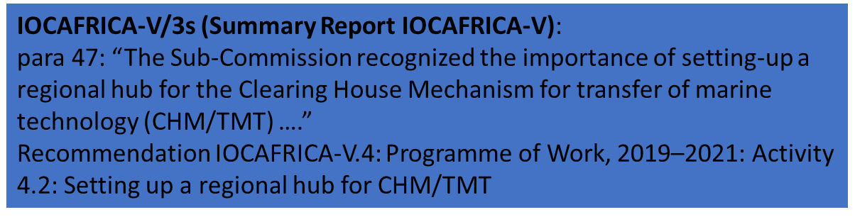
The specific objectives under this goal are to:
- Support the development and updating of requisite data platforms including discoverable and accessible catalogues, services/APIs, and databases, so that they are discoverable through the ODIS architecture.
- Reactivate the African Ocean Biodiversity Information System (OBIS) nodes
- Develop the African Coastal and Marine Atlases (ACMA) in close collaboration with the Caribbean Marine Atlas, and incorporating the mapping of corals, mangroves, natural resources, marine protected areas, waste dumping, dredging and other vital ecosystems and processes.
- Facilitate access to, and exchange of ocean data while exploring opportunities for collaboration with other networks (e.g. RAFISMER) and private sector, including petroleum companies to facilitate the collection and exchange of data.
- Examine how the 6 thematic patterns (or “profiles”) supported by ODIS fit the needs of the pan-African NODCs & institutions, and possibly assist to add other needed patterns/profiles. The initial 6 core ODIS patterns for ocean data are: Experts and Institutions, Documents, Spatial Maps, Projects, Training, and Vessels.
Operational measures towards achieving Goal 1

Targets | Specific Indicators
Developed and populated database and sharing platforms  - Databases of experts and institutions, marine related projects, ocean-related documents, and the Ocean observation platforms. Each of the databases should be exposed through a Catalogue Service that must be JSON-LD - compatible and ODIS-Arch compliant, to allow the OIH to harvest data from them. | - Presence/ absence of African nodes in the ODIS search portal  - Number of interoperable databases developed  - experts and institutions,  - marine related projects,  - ocean-related documents,  - research vessels, past & upcoming research cruises in the region, and other ocean observation platforms,  - Number of data providers per respective database  - Number of data entries added per respective database
The African Ocean Biodiversity Information System (OBIS) nodes reactivated | - Number of new entries added into OBIS  - Number of data providers engaged  - Number of stakeholder meetings/ training workshops conducted
African Coastal and Marine Atlases (ACMA) operationalised as a flagship project | - Number of new data entries entered  - Number of Partners actively involved in the flagship project  - NODCs  - Regional programmes  - Institutions  - Number of data themes integrated in the ACMA  - mapping of corals, mangroves, natural resources, protected areas, waste dumping, dredging and other vital ecosystems)  - Number of stakeholder meetings/ training workshops conducted
New partnerships with ocean data-affiliated networks initiated | - Number of formal and informal partnerships established and/or enhanced  - Local, Regional and Global Programmes and Institutions  - IGO’s

Goal 2: Ensure capacity development for safe and efficient ocean data gathering, quality control, processing, summarization, dissemination, and preservation of data generated by national and international agencies.
Capacity Development is an essential tenet of UNESCO/IOC’s mission. It enables all Member States to participate in, and benefit from, ocean research and services that are vital to sustainable development and human welfare on the planet. The revitalised ODINAFRICA will continue to enable its member states to access data from other data centres worldwide, develop skills and infrastructure for processing, archival, analysis and dissemination of data and information products.
Under this goal, the specific objectives are to:
- Reactivate NODCs
- Develop and diffuse detailed guidelines outlining standards and recommended architecture for different national data catalogues.
- Conduct and promote trainings on data management (including capacity building in configuring metadata, services, and sharing of ocean datasets) among different stakeholder groups
- Strengthen configuration of NODCs to gather more data and to provide services to data user communities
- Closely collaborate with existing partners, such as GOOS-Africa, OpenStreetMap-Africa, etc., to leverage existing ocean data communities, and promote shared training events with these existing partners.
Operational Measures for Goal 2:
Targets | Specific Indicators
NODCs reactivated | - Number of surveys on status of NODCs conducted  - Number of NODCs reactivated  - Number of consultative and feedback meetings between ODINAFRICA and NODCs conducted
Standards and recommended architecture for national data catalogues outlined, documented and shared with NODCs | - Number of guidebooks / cookbooks developed and shared with stakeholders  - Number of training sessions conducted with NODCs and other institutions
Stakeholders trained on data collection, management and sharing | - Number of multi-stakeholder training sessions conducted  - Number of personnel trained  - Number of NODCs and other institutions involved in the trainings
NODCs supported in acquisition and maintenance of requisite equipment | - Number and type of NODCs supported.  - Number and type of equipment acquired or maintained

Priority Area 3: Establish and advance the development of a regional ‘digital twin’ for Africa
Background
The creation of a comprehensive digital representation of the ocean is one of the ten challenges of Decade of the Ocean, which aims to help the global community implement Sustainable Development Goal 14: “to conserve and sustainably use the oceans, seas and marine resources”. The digital twin would be instrumental in centralising marine data gathering, handling/ management, computing infrastructures and interoperability, data sharing, big data analysis, validation, training and collaboration.
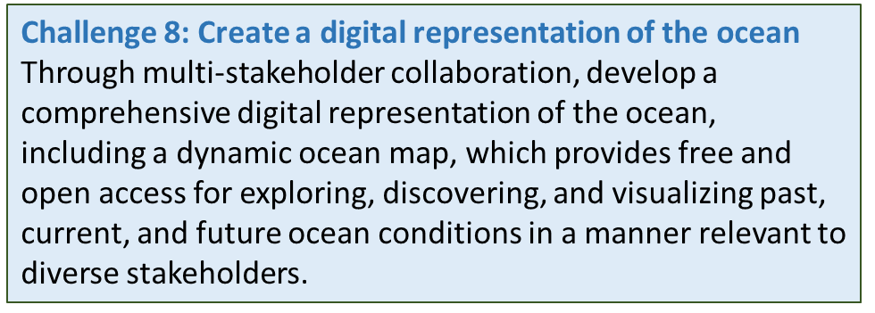
A digital twin is a dynamic virtual copy of a physical asset, process, system or environment that looks like and behaves identically to its real-world counterpart. A digital twin ingests data and replicates processes so you can predict possible performance outcomes and issues that the real-world product might undergo. The use of dynamic / evolving data means that a key strength of the digital twin approach is that it provides an accurate description of objects that change over time.
In a marine context, the digital twin of the ocean has three key components
- The physical Component
This component comprises observation systems in the sea and space providing in situ and satellite data, and ocean models. The observation networks feed and update the digital twin, which in turn can inform and optimise them, thus creating a “virtuous circle”
- Virtual entity (simulations of the ocean)
This component entails a data infrastructure which ensures open and equitable access, interconnection between ocean observatories and integration of all available data – in situ measurements from ships or autonomous systems at sea, satellite observations, historical data from several scientific disciplines, and data from industry or citizen science, etc. This infrastructure relies on high-performance computing capabilities, partly in the cloud, and a governance framework defining standards and protocols for data exchange. It also integrates predictive analysis and modelling tools, based on AI and machine learning, to process data and test different scenarios.
N.B. The physical realisation step in the virtual-to-physical connection of Ocean Digital Twins can be facilitated by human intervention (e.g. fisheries management, sampling strategy development, ocean governance, stakeholder engagement, designation of protected areas, cruise-planning etc)

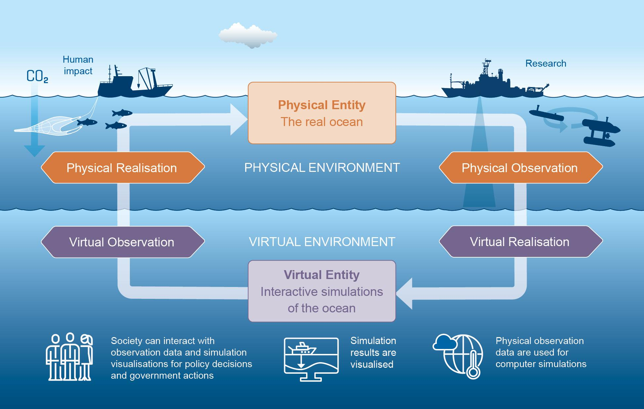
Illustration on the components and interactions of a Digital Twin Ocean. (Christoph Kersten/GEOMAR)
- A User interface
This component allows users to view, interact with and customise the data and models according to their requirements
The knowledge generated by the DTO will provide stakeholders and other citizens with an effective means and agency to better understand the ocean and make informed decisions, collectively sharing the responsibility to monitor, preserve and enhance marine and coastal habitats. Further, it will enable users and partners to answer the ‘What if’ questions in support of a wide range of use in the context of sustainable ocean management, while addressing key issues such as marine spatial planning and Blue Economy scenarios.
The specific objectives under this goal are to:
- Empower institutions and experts in the region to increase their capacities for developing and operationalising analytical algorithms for strengthened big data analysis;
- Work with NODCs to improve the storage and processing capacities of their existing infrastructure, to enable storage and management of the huge heterogeneous datasets with moderate requirements on hardware and software infrastructure
- Develop community standards and well-designed data management plans ensuring Findable, Accessible, Interoperable and Reusable (FAIR) data.
- Increase collaborations between marine scientists, computer scientists, data scientists, socio-economic scientists and data managers in the form of working groups and the involvement of data scientists in the design of marine research.
Operational measures towards achieving Goal 3.
Targets | Specific Indicators
Development and utilisation of analytical algorithms (for strengthened scalability, effectiveness, fault-tolerance, and parallelization of big data analysis) | - Sets of operational algorithms developed  - Number of institutions involved in developing and testing the algorithms
Develop community standards and well-designed data management plans | - Number of community standards developed and shared with stakeholder community groups  - Number of community groups adopting new standards  - Number of data management plans developed
Enhanced collaborations between marine scientists, computer scientists, data scientists, socio-economic scientists and data managers in the form of working groups and the involvement of data scientists in the design of marine research. | - Number of meetings and Sessions organised and held to provide common platform for marine scientists, computer scientists, data scientists, socio-economic scientists and data managers  - Number of products e.g. manuals, developed by the multi-expert groups

ODINAFRICA Strategic Framework
Outcome: Increased access to the ocean with open and equitable access to data, information and
technology, and innovation
Priority 1: Establish ODINAFRICA as the Coordinator for NODCs (contributing nodes) of the Ocean Data and Information System (ODIS)
Output 1: Data and information sharing platforms developed and operationalised | Support the development and updating of requisite data platforms including discoverable and accessible catalogues, services/APIs, and databases, so that they are discoverable through the ODIS architecture. | Develop interoperable databases of experts and institutions, marine related projects, ocean-related documents, and the Ocean observation platforms.
 |  | Support NODCs and other institutions in the development and updating of requisite data platforms including discoverable and accessible catalogues, services/APIs, and databases, so that they are discoverable through ODIS.
 | Reactivate the African Ocean Biodiversity Information System (OBIS) nodes | Reactivate the African Ocean Biodiversity Information System (OBIS) nodes
 | Develop the African Coastal and Marine Atlases (ACMA) and incorporate the mapping of corals, mangroves, natural resources, marine protected areas, waste dumping, dredging and other vital ecosystems and processes. | Operationalise the African Coastal and Marine Atlases (ACMA), incorporating the mapping of corals, mangroves, natural resources, marine protected areas, waste dumping, dredging and other vital ecosystems and processes along Africa’s coastline.
 | Facilitate access to, and exchange of ocean data while exploring opportunities for collaboration with other networks and private sector to facilitate the collection and exchange of data | Initiate partnerships to facilitate access and exchange of ocean data with other key networks and private sector  Facilitate availability of ocean data and information to inform policy formulation and other national and regional processes
Priority Area 2: Ensure capacity development for safe and efficient ocean data gathering, quality control, processing, summarization, dissemination, and preservation of data generated by national and international agencies
Output 2: Capacity of stakeholders (Including NODCs, Marine-Affiliated Institutions and Experts) Enhanced for efficient ocean data gathering, quality control, processing, summarization, dissemination, and preservation of data | Reactivate the ODINAFRICA network of NODCs to support the regional development of OIH | Reactivate the ODINAFRICA network of NODCs
 | Conduct and promote trainings on data management (including capacity building in configuring metadata, services, and sharing of ocean datasets) among different stakeholder groups | Conduct trainings on data management (including configuring metadata, services, and sharing of ocean datasets)
 |  | Strengthen configuration, including coordination mechanisms, of NODCs to gather more data and to provide services to data user communities
 |  | Develop and diffuse detailed guidelines outlining standards and recommended architecture for different national data catalogues.
 | Closely collaborate with existing partners, such as GOOS-Africa, OpenStreetMap-Africa, etc., to leverage on existing ocean data communities, and promote shared training events with these existing partners. | Undertake joint training events with these existing partners.
 | Work with NODCs to enable their mandate in providing data to inform national and regional processes | Empower NODCs through capacity building initiatives and financing to ensure their active contribution towards key national processes (i.e development of environmental decision support modelling systems, formulation of policy strategies monitoring systems, fisheries etc)
Priority Area 3: Establish and advance the development of a regional ‘digital twin’ for Africa
Outputs | Objectives | Activities
Output 3.1: Marine Researchers in the Region empowered to develop and utilise algorithms for big data gathering, analysis, model training & calibration | Empower partner institutions and experts to increase their capacities for developing and utilising analytical algorithms for effective analysis of big data | * Organise training sessions for marine researchers on developing and utilisation of algorithms for big data analysis  * Work with different stakeholders to develop sets of operational standardised algorithms and community maintained datasets that can be used for model training and calibration
 | Increase collaborations between trans disciplinary scientists (marine, computer, data, socio-economic) in the form of working groups in the design of marine research. | Organise joint sessions for trans disciplinary (Marine, computer, data , socio-economic and data) scientists to inform regional design of marine research
Output 3.2: Capacities for data and information preservation increased among stakeholders | Work with NODCs to improve the data / information storage and processing capacities of their existing infrastructure | Support NODCs to upgrade their capacities for long term preservation of data and associated information, required for correct interpretation of the data
 | Develop community standards and well-designed data management plans ensuring | Develop community standards, well-designed data management plans and shareable best practices for marine-related data

Project Timeline
Year/ Activity | 2022 | 2023 | 2024 | 2025 | 2026 | 2027 | 2028 | 2029 | 2030
Organise training sessions for marine researchers on developing and utilisation of algorithms for big data analysis |  | x | x | x
List and make an inventory of partner institutions, and stakeholders with their details, inventory of capacities and main technical issues to be addressed |  | x | x | x |  | x
Establish a calendar and hold technical tag-ups with the NODCs network to tackle any technical issues and to exchange progress/results in the reactivation of the NODC for each state member |  | x |  |  | x
Create a working group with specific tasks for coordinating the creation of data management plans | x | x
Develop data management plans |  |  | x | x
Develop SOPs for trained personnel on maintenance of data processing and storage infrastructure |  | x |  | x
Work with different stakeholders to develop sets of operational standardised algorithms and community maintained datasets that can be used for model training and calibration |  | x | x | x | x
Organise joint sessions for trans disciplinary (Marine, computer, data , socio-economic and data) scientists to inform regional design of marine research |  | x | x | x | x | x | x | x | x
Support NODCs to upgrade their capacities for long term preservation of data and associated information, required for correct interpretation of the data |  |  | x | x
Develop community standards, well-designed data management plans and shareable best practices for marine-related data | x | x | x | x
Develop interoperable databases of experts and institutions, marine related projects, ocean-related documents, and the Ocean observation platforms. | x | x | x
Support NODCs and other institutions in the development and updating of requisite data platforms including discoverable and accessible catalogues, services/APIs, and databases, so that they are discoverable through ODIS. |  | x | x | x | x | x
Reactivate the African Ocean Biodiversity Information System (OBIS) nodes |  | x | x
Operationalise the African Coastal and Marine Atlases (ACMA) | x | x | x |  | x
Initiate partnerships to facilitate access and exchange of ocean data with other key networks and private sector |  | x |  | x |  | x | x | x | x
Reactivate the ODINAFRICA network of NODCs | x | x | x |  | x
Conduct trainings on data management (including configuring metadata, services, and sharing of ocean datasets) | x | x | x | x | x
Strengthen configuration, including coordination mechanisms, of NODCs to gather more data and to provide services to data user communities | x | x | x |  | x |  | x | x | x
Develop and diffuse detailed guidelines outlining standards and recommended architecture for different national data catalogues. |  | x | x
Empower NODCs through capacity building initiatives and financing to ensure their active contribution towards key national processes (i.e development of environmental decision support modelling systems, formulation of policy strategies monitoring systems, fisheries etc) |  | x | x |  | x | x | x | x | x
Develop a “Dashboard” for pan-African data services, allowing monitoring of the various service nodes, types of ocean data shared, service status, number of records, listing the various service endpoints (urls), and contact person |  | x

