Intergovernmental Oceanographic Commission Technical Series

Pacific Tsunami Warning System (PTWS)

29 July 2025 M8.8 Kamchatka Earthquake and Tsunami

Post-Event Assessment of PTWS Performance

UNESCO 2025

IOC Technical Series, XX
Paris, November 2025
English only

The designations employed and the presentation of the material in this publication do not imply the expression of any opinion whatsoever on the part of the Secretariats of UNESCO and IOC concerning the legal status of any country or territory or its authorities, or concerning the delimitation of the frontiers of any country or territory.

For bibliographic purposes, this document should be cited as follows:
Intergovernmental Oceanographic Commission Pacific Tsunami Warning System (PTWS) 29 July 2025 M8.8 Kamchatka Earthquake and Tsunami ‒ Post-Event Assessment of PTWS Performance. IOC Technical Series No. XX. UNESCO 2025 (English)

(IOC/2010/TS/XX)

Report prepared by XX.

Special thanks to the Government of Japan, whose generous support to UNESCO’s Natural Science Sector through the Emergency Fund enabled this report.

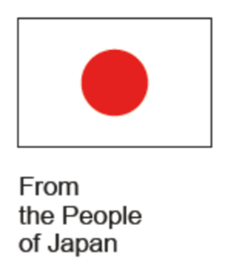

Printed in 2025
by United Nations Educational, Scientific
and Cultural Organization

7, Place de Fontenoy, 75352 Paris 07 SP

© UNESCO 2025
Printed in France

Table of content
List of figures i
List of tables iii
List of acronyms iv
Executive summary v
1. Introduction 1
2. Event characteristics 1
2.1. Earthquake 1
2.1.1. Regional tectonic 2
2.1.2. Subduction zone geometry 2
2.1.3. Regional seismicity 3
2.1.4. 29 July 2025 Mw 8.8 Kamchatka Earthquake 4
2.1.5. Finite Fault Modelling 5
2.2. Tsunami 9
2.2.1. Tsunami amplitudes 9
2.2.2. Coastal sea level gauges and Deep-ocean Assessment and Reporting of Tsunamis 10
2.3. Warning messages issued by key agencies 12
3. Survey questionnaire 12
4. Performance report 14
4.1. Tsunami service providers 14
4.1.1. Initial information for the event 16
4.1.2. Pacific Tsunami Warning Center 17
4.1.3. Northwest Pacific Tsunami Advisory Center 19
4.1.4. Other sources of information 19
4.2. National actions (Section B of the questionnaire) 21
4.2.1. Actions BEFORE receiving the PTWC messages 21
4.2.2. Actions AFTER receiving the PTWC messages 21
4.2.3. Information issued to agencies or organizations 23
4.2.4. Information released to the public 25
4.2.5. Information released to the media 28
4.2.6. Cancellation of the warning 31
4.3. National response (Section C of the questionnaire) 32
4.3.1. National Disaster Management Offices 32
4.3.2. Local or Regional Disaster Management Offices 33
4.3.3. Evacuations 34
4.3.4. Self-evacuations BEFORE an issued warning 34
4.4. Monitoring and modelling (Section D of the questionnaire) 35
4.4.1. Sea level data 35
4.4.2. Numerical model tsunami scenario 36
4.5. Community preparedness (Section E of the questionnaire) 37
4.6. Capacity development requirements (Section F of the questionnaire) 42
5. Country reports 44
5.1. Australia 45
5.2. Chile 47
5.3. China 49
5.4. Colombia 51
5.5. Cook Islands 53
5.6. Costa Rica 55
5.7. Ecuador 57
5.8. El Salvador 59
5.9. Fiji 61
5.10. French Polynesia 64
5.11. Guatemala 66
5.12. Honduras 68
5.13. Indonesia 70
5.14. Japan 72
5.15. Kiribati 74
5.16. Malaysia 76
5.17. Mexico 78
5.18. Nauru 80
5.19. New Zealand 82
5.20. Peru 84
5.21. Philippines 86
5.22. Republic of Korea 88
5.23. Russian Federation 90
5.24. Samoa 94
5.25. Solomon Islands 96
5.26. Tonga 98
5.27. Tuvalu 100
5.28. United States 102
5.29. Vanuatu 108
5.30. Viet Nam 110
6. Key findings 112
6.1. Participation and completeness summary 112
6.2. Key achievements 112
6.3. Challenges and gaps 113
Annex 1 – Questionnaire 115

List of figures
Figure 1. Map of regional tectonic (USGS). 2
Figure 2. Cross-section of seismicity (1990 through 6 August 2025) for the northern Kuril-Kamchatka subduction zone. 3
Figure 3. W-phase moment tensor. 4
Figure 4. Kuril-Kamchatka seismicity and distribution of foreshock and aftershock. 5
Figure 5. Slip distribution along the fault interface. 6
Figure 6. Rate of seismic moment release based on finite fault modelling of the Mw 8.8 Kamchatka earthquake. 6
Figure 7. Moment rate of major earthquakes. 7
Figure 8. Cross-section of slip distribution. 7
Figure 9. Surface projection of the slip distribution superimposed on GEBCO bathymetry. 8
Figure 10. Source time function. 8
Figure 11. NOAA tsunami map. 10
Figure 12. Model tsunami source area (shaded unit sources) based on DART 21416, 21419 and 21415 inversions. Inserts show model comparison at 5 closest DARTs. 11
Figure 13. Tsunami model peak amplitudes and selected DART sea-level records comparing model (red) with data (black). Tsunami model amplitude information is shown color-coded according to the scale bar. 11
Figure 14. Country-wise percentage of unanswered questions. 14
Figure 15. Time and source of the first information received about the event (Q.A1 – Answered 30, Skipped 0). 16
Figure 16. Way of receiving the first information about the event (Q.A2 – Answered 29, Skipped 1). 17
Figure 17. Elapsed time for receiving PTWC messages for respondent Member States (Q.A4 – Answered 28, Skipped 2). 18
Figure 18. Methods used to receive PTWC messages (Q.A5 – Answered 28, Skipped 2). 18
Figure 19. Methods used to receive NWPTAC messages (Q.A9 – Answered 9, Skipped 21). 19
Figure 20. Methods used to receive information from other sources (Q.A13 – Answered 19, Skipped 11). 20
Figure 21. Time reported by countries before first action after receiving PTWC messages (Q.B2 – Answered 28, Skipped 2). 21
Figure 22. Type of information released to agencies or organisations (Q.B4 – Answered 27, Skipped 3). 23
Figure 23. Agencies or organisations receiving tsunami-related information (Q.B6 – Answered 27, Skipped 3). 24
Figure 24. Method used to issue the warning or tsunami-related information to agencies or organisations (Q.B7 – Answered 27, Skipped 3). 25
Figure 25. Type of tsunami-related information issued to the public (Q.B9 – Answered 27, Skipped 3). 26
Figure 26. Authority issuing information public (Q.B11 – Answered 12, Skipped 18). 26
Figure 27. Source of information for making the decision to issue a tsunami warning to the public (Q.B12 – Answered 27, Skipped 3). 27
Figure 28. Type of information issued to the public in case of a tsunami warning or marine warning / advisory (Q.B13 – Answered 25, Skipped 5). 27
Figure 29. Methods of public communication for tsunami warnings / information (Q.B14 – Answered 26, Skipped 4). 28
Figure 30. Entities responsible for communicating with the media (Q.B15 – Answered 13, Skipped 17). 29
Figure 31. Method of communication used to send information to national media (Q.B17 – Answered 24, Skipped 6). 30
Figure 32. Type of electronic media used for information broadcast by national media (Q.B18 – Answered 25, Skipped 5). 30
Figure 33. Methods of information broadcast (Q.B20 – Answered 23, Skipped 7). 31
Figure 34. Methods of communication to the public for cancellation of warnings and marine advisories (Q.B24 – Answered 23, Skipped 7). 32
Figure 35. Information shared by NTWCs to NDMOs, or equivalent (Q.C4 – Answered 24, Skipped 6). 33
Figure 36. Information shared by NDMOs to LDMOs, or equivalent (Q.C6 – Answered 22, Skipped 8). 34
Figure 37. Sea level data monitoring during the event (Q.D1 – Answered 29, Skipped 1). 35
Figure 38. Tools for monitoring stations (Q.D2 – Answered 28, Skipped 2). 36
Figure 39. Tools and numerical models used by the NTWCs (Q.D4 – Answered 29, Skipped 1). 37
Figure 40. Scientifically-assessed level of tsunami hazard (Q.E2 – Answered 16, Skipped 14). 39
Figure 41. Level of community awareness (Q.E3 – Answered 16, Skipped 14). 39
Figure 42. Level of pre-existing community tsunami preparedness (QE4 – Answered 16, Skipped 14). 40
Figure 43. Preparedness activities conducted in communities or nationally (Q.E6 – Answered: 16, Skipped: 14). 41
Figure 44. Government support with regards to preparedness areas (Q.E7 – Answered: 20, Skipped: 10). 41
Figure 45. IOC training or assistance useful for NTWC, NDMO and other organizations (Q.F1 – Answered 29, Skipped 1). 42

List of tables
Table 1. Responses of the Member States to the survey. 13
Table 2. Issuance of products by TSPs (PTWC and NWPTAC). 15
Table 3. Other sources than PTWC and/or NWPTAC for tsunami-related information. 20
Table 4. Actions taken by the countries BEFORE receiving the TSP PTWC messages (Q.B1 – Answered 29, Skipped 1). 22
Table 5. Specific communication challenges encountered (Q.B25 – Answered 25, Skipped 5). 32
Table 6. Communities affected by the event with their ranking in scientifically assessed level (SAL) of tsunami hazard, community awareness level (CAL) of that hazard, pre-existing community tsunami preparedness level (PPL). 38
Table 7. Requests for capacity development training by Member States (● = YES, ○ = NO, N/A = Not Answered). 43

List of acronyms

BMKG Indonesia’s Meteorology, Climatology, and Geophysics Agency
CATAC Caribbean Tsunami Advisory Center
CPPT Centre Polynésien de Prévention des Tsunamis
CISN California Integrated Seismic Network
DART Deep-ocean Assessment and Reporting of Tsunamis
FFM Finite Fault Modelling
GA Geoscience Australia
GFZ GeoForschungsZentrum or German Research Centre for Geosciences
GNS Institute of Geological and Nuclear Sciences
GTS Global Telecommuniation System
ICG/PTWS Intergovernmental Coordination Group for the Pacific Tsunami Warning and Mitigation System
InaTEWS-BMKG Indonesia Tsunami Early Warning System
INOCAR Instituto Oceanográfico y Antártico de la Armada del Ecuador
INSIVOMEH Instituto Nacional de Sismologia, Vulcanologia, Meteorologia e Hidrologia
IOC Intergovernmental Oceanographic Commission
IOC SLMF IOC Sea Level Station Monitoring Facility
ITEWC Indian Tsunami Early Warning Centre
ITIC International Tsunami Information Center
JATWC Joint Australian Tsunami Warning Centre
JMA Japan Meteorological Agency
MS Member State
Msg Message
Mw Magnitude
NDMO National Disaster Management Office
NOAA National Oceanic and Atmospheric Administration
NTWC National Tsunami Warning Centre
NWPTAC Northwest Pacific Tsunami Advisory Center
PTWC Pacific Tsunami Warning Center
PTWS Pacific Tsunami Warning and Mitigation System
SHOA Servicio Hidrografico y Oceanografico de la Armada de Chile
TIC Tsunami Information Centre
TNC Tsunami National Contact
TOWS-WG Working Group on Tsunami and other Hazards related to Sea-Level Warning and Mitigation Systems
TRRP Tsunami Ready Recognition Programme
TSP Tsunami Service Provider
TWFP Tsunami Warning Focal Point
USGS United States Geological Survey
US NTWC United States National Tsunami Warning Center
UTC Coordinated Universal Time

Executive summary

On 29 July 2025, a powerful magnitude 8.8 earthquake struck off the eastern coast of the Kamchatka Peninsula, Russian Federation, at a depth of 35 km. This earthquake was among the ten largest globally since 1900, but also the strongest since the devastating 2011 Tohoku event in Japan. The Kamchatka earthquake triggered a Pacific-wide tsunami.

In accordance with the protocols of the Intergovernmental Oceanographic Commission (IOC), a post-event assessment was initiated. The threshold for such an assessment was met (forecasted tsunami amplitudes exceeding 1 meter), and the process was coordinated through the International Tsunami Information Center (ITIC) and the PTWS Steering Committee. The assessment relied on a standardized questionnaire, distributed to Tsunami National Contacts and Warning Focal Points in 46 Member States (MS) of the Pacific Tsunami Warning and Mitigation System (PTWS). The survey explored six critical components of the end-to-end tsunami warning system: upstream information from service providers, national actions, national response, monitoring and modelling, community preparedness, and capacity development needs.

Participation in the survey was robust, with 30 Member States responding (a 65% participation rate) and an average completion rate of 94% for the 77 mandatory questions. Responses were received from all regions of the Pacific, providing a comprehensive overview of system performance and national experiences.

The PTWS and its Tsunami Service Providers (TSPs) issued initial threat messages within 10–16 minutes of the earthquake, with most countries receiving alerts in under 10 minutes, primarily via email. Most countries received all PTWC messages, with only a few reporting delays or missed bulletins. NWPTAC messages were also received in some countries, with rapid delivery times. Most countries reported effective multi-channel communication. Email, websites, and social media were the primary channels for disseminating warnings to agencies, public, and media. Redundant communication methods ensured broad coverage, though some technical and connectivity challenges were reported, especially in remote areas. High engagement with national and local disaster management agencies was reported.

Over half of the countries took actions before receiving PTWC messages, relying on national seismic monitoring. After receiving official warnings, 62% of countries initiated response actions within 30 minutes. Tsunami warnings and advisories were disseminated to agencies, the public, and the media using multiple communication channels, with email and social media being the most common.

Ten countries reported evacuations, with processes generally proceeding smoothly. Most affected communities had high or very high levels of hazard awareness and preparedness, supported by regular drills, education, and government initiatives. Gaps remain in the availability and use of tsunami inundation and evacuation maps. Although many countries reported high levels of community awareness and preparedness, others assessed their communities as having low to moderate levels, highlighting disparities in readiness.

Many Member States requested further training and support from UNESCO-IOC, particularly in seismic and sea level monitoring, risk assessment, inundation modelling, evacuation mapping, and media communication. Sharing best practices and lessons learned was also highlighted as a priority.

The 2025 Kamchatka event demonstrated the effectiveness of PTWS in providing timely, actionable warnings across the Pacific and effective coordination among international, national, and local agencies. However, it also highlighted areas for improvement, including:
- Enhancing early warning systems,
- Promoting redundant communication technologies,
- Strengthening community education and preparedness,
- Addressing technical gaps,
- Broadening multi-sectoral engagement.

In conclusion, the 2025 Kamchatka earthquake and tsunami event reaffirmed the Pacific Tsunami Warning System’s ability to deliver timely and actionable warnings. At the same time, it revealed key areas for improvement in communication, technical capacity, and community engagement. Addressing these gaps will be essential to further strengthen tsunami resilience across the Pacific.

- Introduction

At 23:24 UTC on 29 July 2025, a major undersea earthquake with a magnitude of 8.8 (United States Geological Survey – USGS) occurred off the coast of Kamchatka, Russian Federation, at a depth of 21 km. Within ten minutes, the Pacific Tsunami Warning Center (PTWC), acting as the Tsunami Service Provider (TSP) for the Intergovernmental Coordination Group for the Pacific Tsunami Warning and Mitigation System (ICG/PTWS), issued a Tsunami Threat Message. Based on preliminary parameters (magnitude 8.0, depth 74 km), the advisory identified a potential risk of hazardous tsunami waves affecting coastal areas of Russia and Japan within a 300 km radius of the epicentre.

This event ranks among the ten most powerful earthquakes recorded globally since 1900 and is the strongest since the 2011 Tohoku earthquake in Japan. It was preceded by a significant seismic sequence over ten days, comprising more than 50 earthquakes of magnitude 5.0 or greater, including a magnitude 7.4 event on 20 July and three magnitude 6.6 events.

In line with the recommendations of the Intergovernmental Oceanographic Commission (IOC) Task Team on Tsunami Watch Operations and the Task Team on Disaster Management and Preparedness, a post-event assessment is advised when forecasted tsunami amplitudes exceed 1 meter for any country within the affected region. Beyond this threshold, the decision to initiate an assessment lies with the regional Tsunami Information Centre (TIC), in coordination with the ICG Steering Group and the UNESCO-IOC Secretariat and is contingent upon whether the tsunami triggered a national response.

For this event, forecast polygons and sea-level data included in PTWC’s final bulletin confirmed that the threshold for initiating a post-event assessment was met. Following consultations with the International Tsunami Information Center (ITIC) and the PTWS Steering Committee, it was agreed that a system performance evaluation was warranted.

This assessment was carried out using the standardized questionnaire developed by the Working Group on Tsunami and Other Hazards Related to Sea-Level Warning and Mitigation Systems (TOWS-WG), as endorsed by the IOC Assembly in June 2015. The objective is to evaluate the operational performance of PTWS, assess its status, and identify any gaps or areas for improvement.

- Event characteristics

The data presented in this section is derived from sources as follows:
- Seismicity: United States Geological Survey (USGS) and affiliated research partners.
- Tsunami: National Oceanic and Atmospheric Administration (NOAA) Center for Tsunami Research, National Weather Service, Pacific Tsunami Warning Center (PTWC), IOC Sea Level Station Monitoring Facility (IOC SLMF).

  - Earthquake

- Epicentre: 52.495°N, 160.240°E, located off the eastern coast of the Kamchatka Peninsula, Russia (± 6.8 km)
- Origin time: 23:24:52 UTC on 29 July 2025
- Depth: 35.0 km (± 1.8)
- Magnitude: Mw 8.8 (USGS), making it one of the ten largest earthquakes globally since 1900 and the strongest since the 2011 Tohoku event in Japan
- Tectonic setting: Occurred along the Kuril-Kamchatka subduction zone, where the Pacific Plate subducts beneath the Okhotsk microplate at a rate of approximately 79–80 mm/year
- Regional tectonic

The Kuril-Kamchatka subducting plate boundary (Kuril-Kamchatka trench) extends approximately 2,100 km from Hokkaido, Japan, along the Kuril Islands and the Pacific coast of the Kamchatka Peninsula, until terminating at its intersection with the Aleutian subduction zone (Figure 1). It marks the region where the Pacific plate subducts into the mantle beneath the North America plate. This subduction is responsible for the generation of the Kuril Islands chain, arc volcanoes along the entire subduction zone boundary, and the deep Kuril-Kamchatka trench. Relative to a fixed North America plate, the Pacific plate is moving northwest at a rate of approximately 80 mm/yr.

Along most of this boundary, the convergence is dominantly trench normal. Cross-sections of the subduction zone reveal a well-defined Wadati-Benioff zone extending to depths of 650 km, consistent with the relatively old age of the Pacific plate in the region (>125 Ma) and its continuous subduction for approximately 100 Myr or longer. As the subduction boundary approaches its northern terminus off the coast of the Kamchatka Peninsula, at the intersection with the Aleutian trench, the character of subduction changes with more oblique subduction (trench parallel motion) along the westernmost extent of the Aleutian boundary.

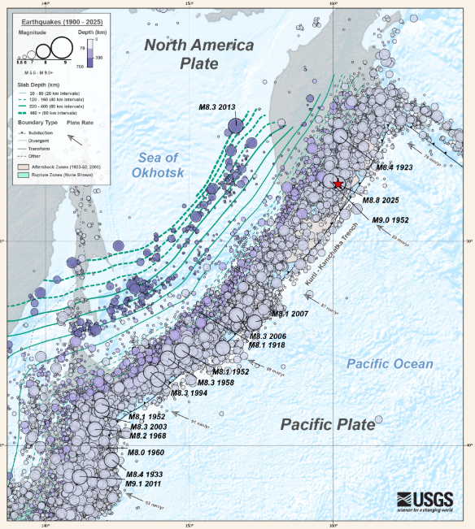
Figure 1. Map of regional tectonic (USGS).

- Subduction zone geometry

The Kuril-Kamchatka subduction zone is one of the most seismically active regions in the world. In the 125 years since the beginning of the 20th century, the Kuril-Kamchatka subduction zone has had one magnitude (Mw) 9 earthquake, eleven Mw 8 or larger earthquakes, and ninety-one Mw 7 or larger earthquakes.

Deformation of the overriding North America plate generates shallow crustal earthquakes, while slip on the subduction zone interface between the Pacific and North America plates generates earthquakes that extend from near the trench to depths of 40 to 60 km. At depths greater than 60 km earthquakes occur within the subducting Pacific plate to depths of >600 km. The Kamchatka Peninsula and Kuril Island chain are also known for volcanic activity, due to melting processes in the mantle wedge between the overriding North America plate and the subducting Pacific plate.

- Regional seismicity

The largest megathrust (subduction interface) earthquake to occur along the Kuril-Kamchatka subduction zone in the 20th century was the 4 November 1952 Mw 9.0 event; to date that is the fifth largest instrumentally recorded earthquake in history. That earthquake generated a devastating tsunami with run-up wave heights as high as 12 m along the coast of Kamchatka, causing significant damage to the city of Severo-Kurilsk. Another notable earthquake off the east coast of Kamchatka was the 3 February 1923 Mw 8.4 approximately 220 km to north.

Intraplate earthquakes have also been known to cause significant damage in the region. On 4 October 1994 a large Mw 8.3 intraplate event occurred within the subducted oceanic lithosphere of the Pacific plate off the coast of Shikotan Island, causing intense ground shaking, landslides, and a tsunami with run-up heights up to 10 m on the island.

While most large earthquakes along the Kuril-Kamchatka arc occur at shallow or intermediate depths, the region also hosts large events that rupture at depths greater than 300 km. The most significant of these deep-focus earthquakes was the 24 May 2013 Mw 8.3 event beneath the Sea of Okhotsk, currently the largest deep-focus earthquake on record. The earthquake occurred as the result of normal faulting within the subducted Pacific slab approximately 600 km below the Earth's surface and was felt as far away as Moscow, Russia, nearly 6,500 km to the west.

Figure 2 shows earthquakes in the Kuril-Kamchatka subduction zone from 1990 to 6 August 2025 projected along a cross-section perpendicular to the trench. Earthquakes within 400 km on either side of the cross-section are plotted, with events prior to 19 July 2025 coloured by depth, the 19-29 July foreshock sequence shown in blue, and aftershocks of the 2025 Mw 8.8 shown in orange.

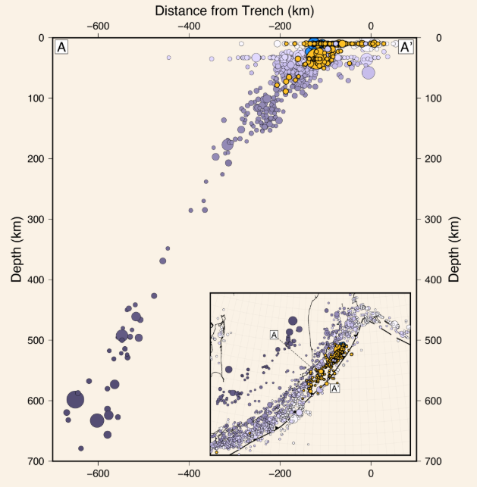
Figure 2. Cross-section of seismicity (1990 through 6 August 2025) for the northern Kuril-Kamchatka subduction zone.

Seismicity in this subduction zone extends to depths of nearly 700 km along a well-defined Wadati-Benioff zone, indicating the geometry of the cold, brittle Pacific slab as it descends westward into the mantle. At shallow depths of less than approximately 50 km, seismicity dominantly occurs along the plate interface, but many upper-plate and intraslab earthquakes can be found as well.

- 29 July 2025 Mw 8.8 Kamchatka Earthquake

The 29 July 2025 Mw 8.8 earthquake, east of Petropavlovsk-Kamchatsky, Russia, occurred as the result of shallow, low-angle thrust faulting, typically about 400 km by 150 km in size (length x width). At the location of this earthquake, the Pacific plate is moving west-northwest with respect to the North America plate at about 80 mm/yr. The 2025 earthquake’s location, depth, and sense of fault motion are consistent with faulting on the subduction zone plate interface of the Kuril-Kamchatka plate boundary (Figure 3).

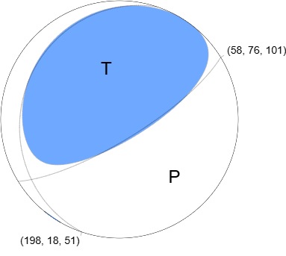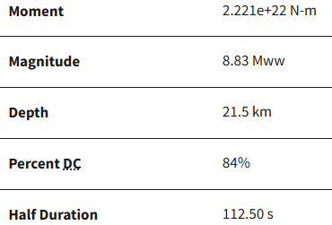
Figure 3. W-phase moment tensor.

- Foreshocks: The mainshock was preceded by significant seismic activity (10 days earlier), including fifty earthquakes of Mw 5.0 or larger earthquakes, such as one Mw 7.4 earthquake on 20 July 2025 and three Mw 6.6 earthquakes.

A Mw 7.4 earthquake occurred on 20 July 2025, nine days before the Mw 8.8 earthquake. The sequence of smaller earthquakes after the Mw 7.4 event was initially considered an aftershock sequence. Once the larger Mw 8.8 event occurred, the earthquakes in the nine days preceding it became a foreshock sequence. The proximity in time and space of these two large earthquakes suggests a possible triggering relationship, in which strain and stress changes produced by the Mw 7.4 foreshock sequence on the megathrust may have promoted fault slip at the location of the Mw 8.8 hypocentre.

The foreshock sequence extends approximately 80 km from up-dip (east) of the Mw 8.8 epicentre along the subduction zone to the north and east. The epicentre of the Mw 7.4 foreshock sits near the northern edge of the foreshock region, 48 km northeast of the mainshock epicentre. Like the main shock, the Mw 7.4 foreshock and most of the other foreshocks were low-angle thrust faulting events occurring along the subduction plate interface. One foreshock (a Mw 6.0 event on 22 July) was a shallow, normal faulting earthquake located within the North America plate. Historically, earthquakes in this subduction zone have also occurred east of the trench, but no such events occurred in the 19-29 July foreshock sequence.
- Aftershocks: The event was followed by numerous aftershocks, including 24 greater than Mw 5.0 within the first day.

After an earthquake the size of the 29 July 2025 Mw 8.8 Kamchatka earthquake, aftershocks are expected to continue for days, weeks, months and even years, with the rate of aftershock occurrence decreasing over time. In some cases, large earthquakes are followed by an even a larger earthquake; when this happens, the first earthquake is referred to as a “foreshock” preceding the new (larger magnitude) mainshock.

Aftershocks of the 29 July 2025 Mw 8.8 earthquake primarily occurred southwest of the mainshock epicentre. The zone of aftershocks extends for more than 400 km and most of these events—like the foreshock and mainshock—lie on the interface between the overriding North America plate (upper plate) and the subducting Pacific plate (Figure 4).

Some of the aftershocks occurred east of the trench, within the “outer rise” region of the subducting Pacific plate that forms as the plate bends into the subduction zone. The largest magnitude outer rise aftershocks are shallow earthquakes on trench-parallel normal faults. These events can be triggered by large magnitude plate interface earthquakes, such as the 2025 Mw 8.8 Kamchatka earthquake, because the mainshock deformation and stress changes promote extension and normal faulting in the outer rise region.

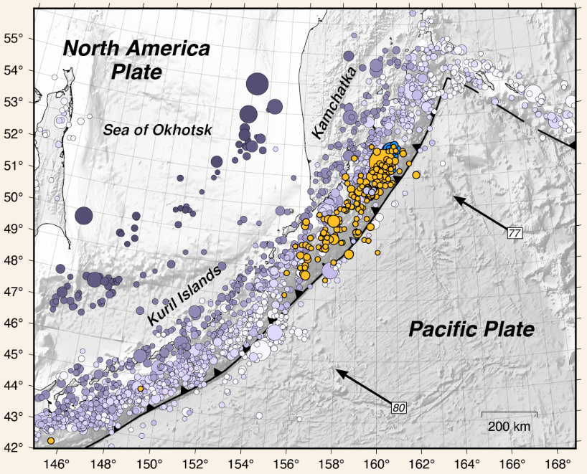
Figure 4. Kuril-Kamchatka seismicity and distribution of foreshock and aftershock.

- Finite Fault Modelling

- Slip distribution

Finite Fault Modelling (FFM) using currently available observations indicate that the earthquake ruptured unilaterally to the south along the subduction zone interface for approximately 400 km and over a depth of approximately 30 km. Maximum slip of approximately 14 m occurred approximately 100 km south of the mainshock epicentre, and with a broad region of 8‒10 m slip along the subduction zone interface (Figure 5).

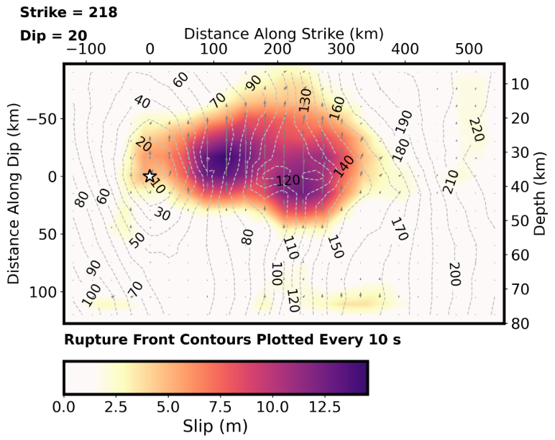
Figure 5. Slip distribution along the fault interface.

- Relative moment

A plot of the relative moment (energy released) rate for the earthquake (Figure 6) shows the earthquake rupture lasted for more than 200 s. Maximum release of energy from the earthquake occurred approximately 120 s after the initial (origin time) of the earthquake.

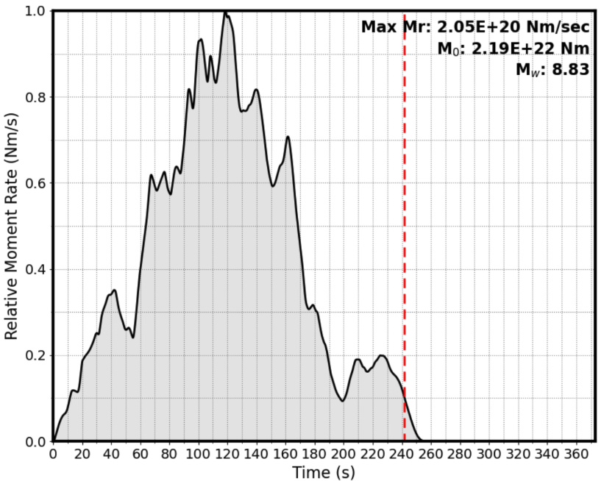
Figure 6. Rate of seismic moment release based on finite fault modelling of the Mw 8.8 Kamchatka earthquake.

- Complexity of the rupture process

Figure 7 illustrates the substantial variability in the rupture process of these large magnitude events. For example, the 2011 Mw 9.1 Tohoku earthquake was (relatively) brief but incredibly intense; it reached its highest rate of energy release—4x greater than the maximum moment rates seen in the 2004 Mw 9.2 Sumatra and 2025 Mw 8.8 Kamchatka events-about 80 s after origin time and had a total source duration of about 200 s. The total rupture length of the fault was approximately 400 km. In contrast, the 2004 Mw 9.2 Sumatra earthquake reached its peak rate of moment release at about
180 s, but continued with seismic moment release for about 600 s. The rupture length of the 2004 Mw 9.2 Sumatra earthquake was approximately 1,000 km. The 2025 Mw 8.8 Kamchatka earthquake reached a peak seismic moment release rate like that of the 2004 Mw 9.2 Sumatra earthquake at about 120 s, with a total moment duration of 240 s and a total rupture length of approximately
400 km. The final example shown is the 2025 Mw 7.4 Kamchatka foreshock, which simply illustrates just how small Mw 7 earthquakes are compared to the largest megathrust earthquakes.

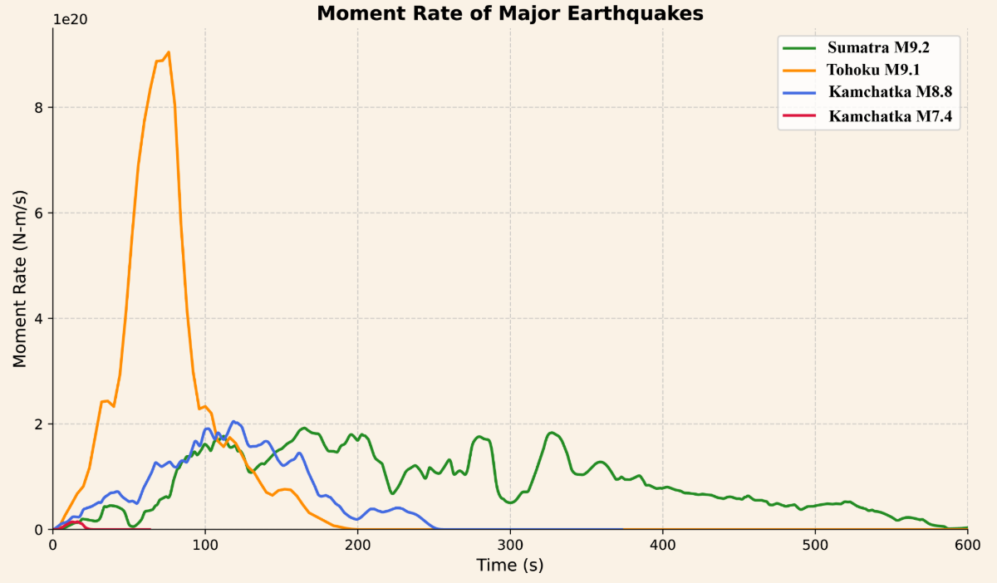
Figure 7. Moment rate of major earthquakes.

- Cross-section of slip distribution

The strike direction is indicated above each fault plane, and the hypocentre location is denoted by a star (Figure 8). Slip amplitude is shown in colour and the motion direction of the hanging wall relative to the footwall (rake angle) is indicated with arrows. Contours show the rupture initiation time in seconds.

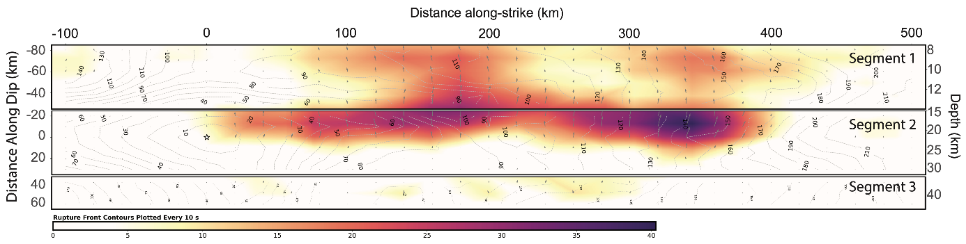
Figure 8. Cross-section of slip distribution.

- Surface Projection

Surface projection of the slip distribution superimposed on GEBCO bathymetry (Figure 9). Thick white lines indicate major plate boundaries. Gray circles, if present, are aftershock locations, sized by magnitude.
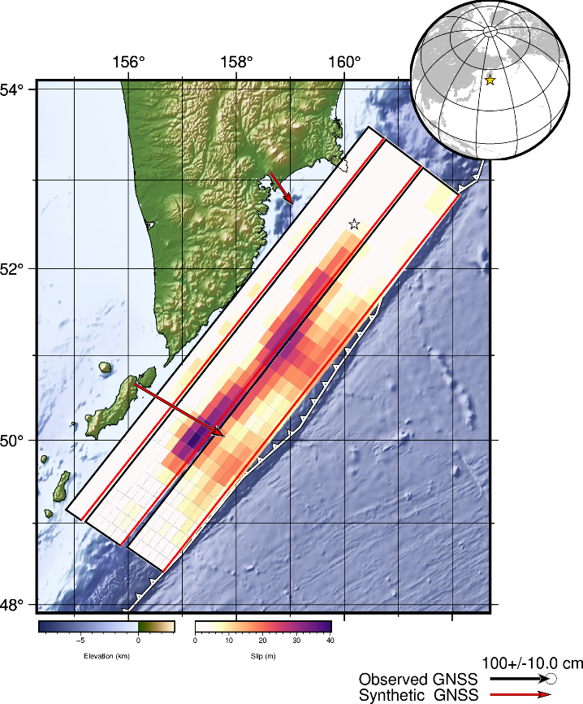
Figure 9. Surface projection of the slip distribution superimposed on GEBCO bathymetry.

- Moment rate function

Source time function describes the rate of moment release with time after earthquake origin, relative to the peak moment rate (Figure 10). The red dashed line represents the interpreted end of the event.

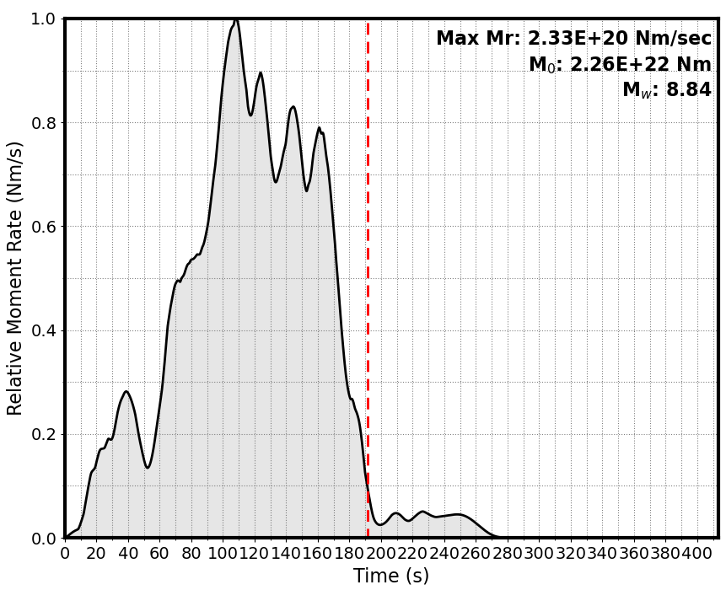
Figure 10. Source time function.

  - Tsunami

- Tsunami generation: The earthquake triggered a Pacific-wide tsunami, with maximum observed run-up heights reaching up to 19 m in Baikovo (Shumshu Island, Northern Kuriles) and 18 m in Vestnik Bay (located at the Kamchatka east coast about 180 km to south from Petropavlovsk-Kamchatsky). It took approximately 6 hours to cross the Pacific Ocean and hit Hawaii, and approximately 7‒9 hours to arrive along the west coast of North America. The fault slip was greatest at depths of 20‒45 km, with limited slip shallower than 15 km. The resulting tsunami was large, but the lack of shallow fault slip is likely one reason for a smaller tsunami than other earthquakes of comparable size.
- Tsunami amplitudes: Significant tsunami amplitudes were recorded across the Pacific, including 1.74 m in Kahului, Maui (Hawaii), 1.13 m in Crescent City (California), 1.04 m in Baltra (Galapagos Islands, Ecuador), and 1.12 m in Coliumo (Chile).
- Coastal gauge system: n > 100 tsunami measurements on coastal gauges – largest 1.74 m, Kahalui, Maui, Hawaii.
- DART buoy data: PTWC reported readings on 8 DARTs across the Pacific. The largest deep-ocean amplitude recorded was 0.9 m off the coast of the Kamchatka peninsula, the closest to the epicentre, the second largest DART amplitude ever observed. The amplitudes on other DARTs reported by PTWC ranged from 2 to 28 cm. The observations from the five DARTs in the Northwest Pacific were used by the PTWC to provide the final inversion source for the tsunami forecast.

- Tsunami amplitudes

The tsunami generated by the Kamchatka earthquake produced significant wave run-up locally along the Kamchatka peninsula and Kuril Islands coasts. The tsunami waves also crossed the Pacific Ocean, producing significant run-up in northern Japan (>60 cm in numerous locations), Hawaii (>50‒150 cm at multiple sites), and northern California (>100 cm at Crescent City, and 50‒100 cm at numerous sites along the coast).

NOAA tsunami map for the 2025 Mw 8.8 Kamchatka earthquake (using earthquake parameters and deep ocean sea level data) shows tsunami travel times as contour lines and open ocean wave amplitudes indicated by colours (Figure 11). Near the earthquake and along the Kamchatka coast the open-ocean tsunami amplitude was greater than 1 m. As the wave crossed the ocean its amplitude decreased as its energy dispersed. Details of the seafloor morphology can also focus and amplify these waves. For example, the higher amplitude waves heading from Kamchatka toward the northern California coast is partly a result of the location of the offshore Mendocino escarpment and is also one of the reasons that Crescent City, California, often has the highest tsunami heights along the west coast of the United States. The large variations in observed tsunami heights result from details of the coastal bathymetry and shape of the coastline.

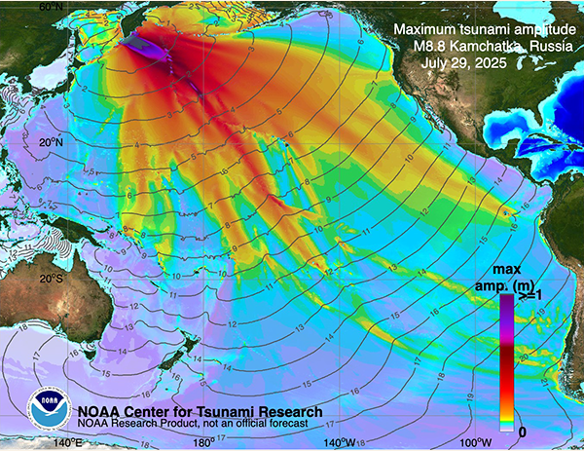
Figure 11. NOAA tsunami map.

- Coastal sea level gauges and Deep-ocean Assessment and Reporting of Tsunamis

The analysis sequence for the Kamchatka tsunami was initiated with initial estimates of the earthquake location and magnitude, which understated the actual magnitude of the earthquake by at least a factor of 10—a common phenomenon during initial analysis for large seismic events. The initial forecast based on seismic data gave estimates of tsunami amplitudes at nearby Deep-ocean Assessment and Reporting of Tsunamis (DART) systems.

About 35 minutes after the earthquake, tsunami recording of DART 21416 peaked at a maximum amplitude of 0.85 m, the second largest DART amplitude ever recorded. The absolute largest DART amplitude was detected during the March 11, 2011, Japan tsunami (about 1.9 m). The DART record was used to update the tsunami forecast. The tsunami model with the best fit for DART 21416 used the source with magnitude Mw 8.7. Two more DARTs 21419 and 21415 recorded max amplitudes of 31 cm and 25 cm, respectively, within one hour from the earthquake time. These three DARTs were used to provide the final inversion source for the tsunami forecast for this event around 1.5 hours after the earthquake. The model tsunami source uses the combination of “unit sources” from the pre-computed generation/propagation forecast database. This final forecast source covered the area of 500 km x 150 km to the south of the epicentre (Figure 12).

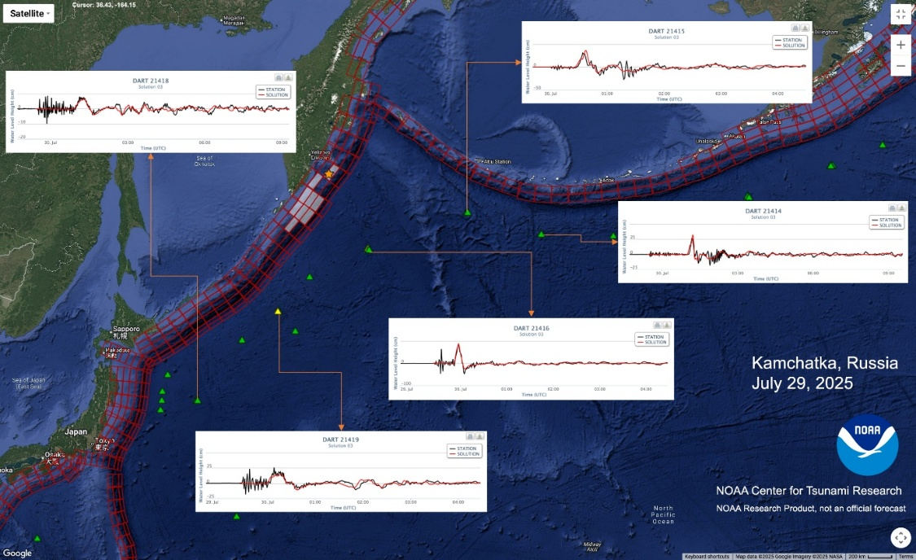
Figure 12. Model tsunami source area (shaded unit sources) based on DART 21416, 21419 and 21415 inversions.
Inserts show model comparison at 5 closest DARTs.

NOAA NCTR research product NOT an official forecast. The model results are preliminary and produced during the tsunami propagation as a test of forecast capability, not for operational forecast. The tsunami source is estimated from DART data and earthquake information as described. The forecast of tsunami propagation globally was produced based on the 3-DART inversion (Figure 11) using the NOAA forecast method with the MOST model.

During the tsunami propagation the model showed good comparisons with DARTs further away confirming the accuracy of the propagation forecast model (Figure 13).

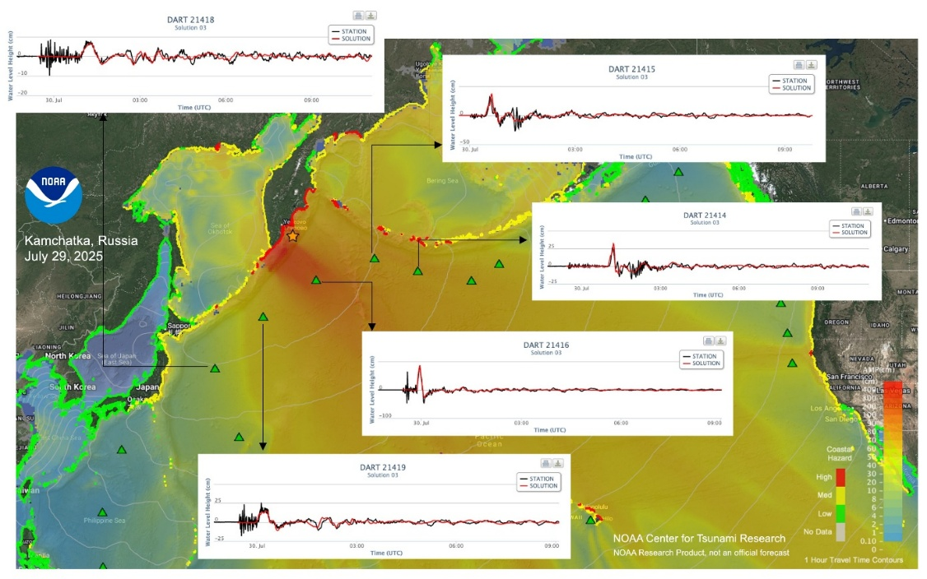
Figure 13. Tsunami model peak amplitudes and selected DART sea-level records comparing model (red) with data (black). Tsunami model amplitude information is shown color-coded according to the scale bar.

  - Warning messages issued by key agencies

During the 29 July 2025 M8.8 Kamchatka earthquake and tsunami, multiple official agencies issued warning messages and updates.

Key agencies involved were:
- the Pacific Tsunami Warning Center (PTWC), for the Pacific Tsunami Warning System (PTWS),
- the Northwest Pacific Tsunami Advisory Center (NWPTAC), operated by JMA, for the Northwest Pacific region, including Japan and neighbouring countries,
- the United States National Tsunami Warning Center (US NTWC) – for North America (US and Canada),
- the Caribbean Tsunami Advisory Center (CATAC), although primarily focused on the Caribbean, also relayed relevant information and advisories for this Pacific-wide event, including platforms like WhatsApp.

For the same event, threat messages were also issued by the Northwest Pacific Tsunami Advisory (JMA), IOTWMS Tsunami Service Providers Australia (JATWC), India (ITEWC) and Indonesia (InaTEWS-BMKG).

- Survey questionnaire

On 8 August 2025, the ICG/PTWS Secretariat circulated an online survey to the Tsunami National Contacts (TNCs) and Tsunami Warning Focal Points (TWFPs) of ICG/PTWS Member States via IOC Circular Letter 3052. The TNCs were responsible for overseeing and coordinating the completion of the survey in consultation with national stakeholders involved in end-to-end tsunami warning process, including National Tsunami Warning Centres (NTWCs) and National Disaster Management Offices (NDMOs).

The questionnaire (Annex 1) focused on six key components of an end-to-end tsunami warning system, covering both upstream and downstream elements:
- Information from Tsunami Service Providers (TSPs): PTWC and NWPTAC (questions A1 to A14),
- National actions (questions B1 to B25),
- National response (questions C1 to C15),
- Monitoring and modelling (questions D1 to D4),
- Community preparedness (questions E1 to E7),
- Capacity development requirements (question F1).

The initial deadline for submitting responses was 5 September 2025, later extended to 21 September 2025.

A total of thirty PTWS Member States (MS) responded to the survey, representing a 65% participation rate (Table 1).

Table 1. Responses of the Member States to the survey.
Complete survey | Incomplete survey | No response
Australia – AU  Chile – CL  China – CN  Colombia – CO  Costa Rica – CR  Ecuador – EC  El Salvador – SV  Fiji – FJ  France – French Polynesia – FP  Guatemala – GT  Honduras – HN  Indonesia – ID  Japan – JP  Kiribati – KI  Malaysia – MY  Mexico – MX  Nauru – NR  New Zealand – NZ  Peru – PE  Philippines – PH  Republic of Korea – KR  Russian Federation – RU  Samoa – WS  Solomon Islands – SB  Tonga – TO  Tuvalu – TV  United States – US  Vanuatu – VU  Viet Nam – VN | Cook Islands – CK | Brunei Darussalam  Cambodia  Canada  Democratic Republic of Korea  Federated States of Micronesia  France – New Caledonia  France – Wallis and Futuna  Marshall Islands  Nicaragua  Niue  Palau  Panama  Papua New Guinea  Singapore  Thailand  Timor-Leste  Tokelau  United Kingdom

Out of the 77 mandatory questions and sub-questions, the average response rate was 94%. The Cook Islands were excluded from this calculation due to incomplete submission, with 69% of the questions left unanswered (Figure 14).

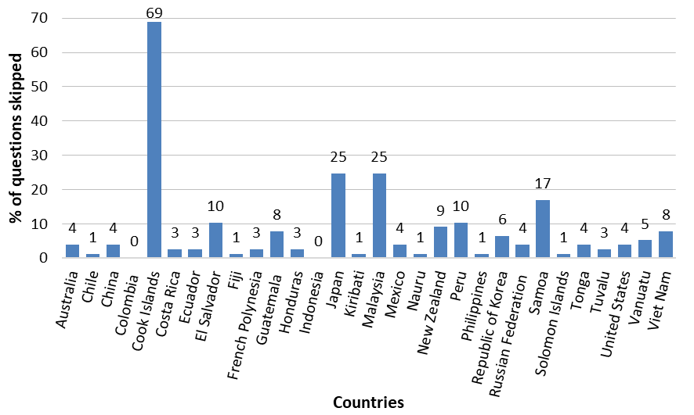
Figure 14. Country-wise percentage of unanswered questions.

- Performance report
  - Tsunami service providers
PTWS Tsunami Service Providers (TSPs) issued 1st threat message 10 min after earthquake origin time (Table 2). PTWC monitored and issued 24 threat forecast information bulletins until waves hit Chile, 26 hours later. NWPTAC issued 15 bulletins in 20 hours.

Table 2. Issuance of products by TSPs (PTWC and NWPTAC).
23:24 UTC, 29 July – Earthquake occurs
PTWC Messages (Msg) |  | NWPTAC Messages (Msg)
23:34 UTC, 29 Jul, Msg 1 | Mw=8.0, Threat for Russia and Japan, no forecast yet | 23:45 UTC, 29 Jul, Msg 1 | Mw=8.0, based on pre-simulated DB
00:16 UTC, 30 Jul, Msg 2 | Mw=8.7, forecast for NW Pacific based on PTWC WCMT | 00:49 UTC, 30 Jul, Msg 2 | Mw=8.7
01:07 UTC, 30 Jul, Msg 3 | Forecast for entire Pacific based on USGS WCMT | 01:19 UTC, 30 Jul, Msg 3 | Bulletin issued with graphical products
01:48 UTC, 30 Jul, Msg 4 | Forecast for entire Pacific based on PTWC WCMT | 01:44 UTC, 30 Jul, Msg 4 | Bulletins issued with observed sea level changes - Provided ETA and Wave Amplitude for 45 Forecast Points out of 61 points
03:07 UTC, 30 Jul, Msg 5 | Forecast for entire Pacific based on PTWC WCMT | 02:18 UTC, 30 Jul, Msg 5
04:37 UTC, 30 Jul, Msg 6 | Forecast for entire Pacific based on PTWC WCMT | 02:55 UTC, 30 Jul, Msg 6
06:23 UTC, 30 Jul, Msg 7 | Mw=8.8 (USGS) – Forecast unchanged | 03:51 UTC, 30 Jul, Msg 7
07:24 UTC, 30 Jul, Msg 8 | Forecast unchanged | 04:43 UTC, 30 Jul, Msg 8
08:35 UTC, 30 Jul, Msg 9 | Forecast unchanged | 05:39 UTC, 30 Jul, Msg 9
09:36 UTC, 30 Jul, Msg 10 | Forecast unchanged | 08:10 UTC, 30 Jul, Msg 10
11:03 UTC, 30 Jul, Msg 11 | Forecast unchanged | 10:52 UTC, 30 Jul, Msg 11
12:04 UTC, 30 Jul, Msg 12 | Forecast unchanged | 13:57 UTC, 30 Jul, Msg 12
13:11 UTC, 30 Jul, Msg 13 | Forecast unchanged | 14:21 UTC, 30 Jul, Msg 13
14:17 UTC, 30 Jul, Msg 14 | Forecast unchanged | 17:01 UTC, 30 Jul, Msg 14
15:18 UTC, 30 Jul, Msg 15 | Forecast unchanged | 19:23 UTC, 30 Jul, Msg 15 | Final message
16:32 UTC, 30 Jul, Msg 16 | Forecast unchanged
17:36 UTC, 30 Jul, Msg 17 | Forecast unchanged
18:36 UTC, 30, Jul, Msg 18 | Forecast unchanged
20:27 UTC, 30, Jul, Msg 19 | Forecast unchanged
21:36 UTC, 30, Jul, Msg 20 | Forecast unchanged
22:36 UTC, 30, Jul, Msg 21 | Forecast unchanged
23:38 UTC, 30, Jul, Msg 22 | Forecast unchanged
00:37 UTC, 31, Jul, Msg 23 | Forecast unchanged
01:57 UTC, 31, Jul, Msg 24 | Final message

- Initial information for the event

Seventy percent (70%) of the Member States (MS) relied on the initial information provided by the PTWC (Figure 15), which was received between 10 and 16 minutes following the event. Nearly half of the respondent countries (47%) obtained the message within 10 minutes of the event. The earliest alert was issued at 23:27 UTC, just three (3) minutes after the earthquake, via a seismic alarm (reported by the United States). By 23:29 UTC, five minutes post-event, two countries had received notifications through either the SeisComP 5 Processing System (Malaysia) or the Yuzhno-Sakhalinsk seismic station (Russian Federation). In total, five respondent countries (17%) received their first notification within seven minutes of the official earthquake time.

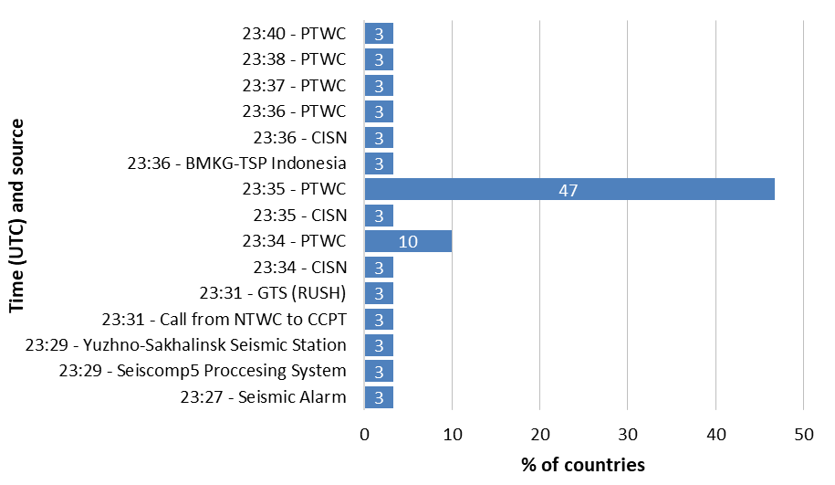
Figure 15. Time and source of the first information received about the event (Q.A1 – Answered 30, Skipped 0).

Sixty-six percent of countries (66%) received the initial earthquake notification via email (Figure 16). Additional sources of information included websites (14%), the Global Telecommunication System (GTS) (7%), and phone calls (3%). The “Other” category comprises the California Integrated Seismic Network (CISN) and the dedicated system in French Polynesia, which features an office audio siren alert accompanied by a voice message describing the event, as well as SMS and phone calls directed to the on-duty geophysics officer. Fax and SMS were not utilized for the initial dissemination of information during this event.

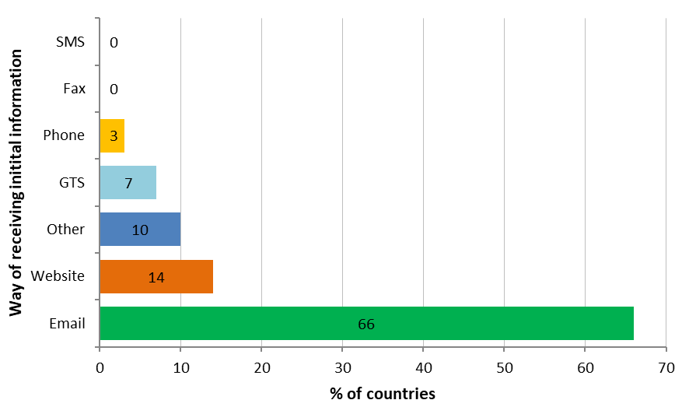
Figure 16. Way of receiving the first information about the event (Q.A2 – Answered 29, Skipped 1).

- Pacific Tsunami Warning Center

Ninety-three percent (93%) of the respondent countries received tsunami messages from the Pacific Tsunami Warning Center (PTWC, Q.A3 – Answered 30, Skipped 0). Guatemala was the only country that did not receive information from PTWC, instead relying on its national agency INSIVUMEH. Nevertheless, real-time data monitoring was maintained via the PTWC website. The United States also did not receive PTWC messages as it is the originating source of these alerts. Among the 28 countries that received PTWC notifications, 24 (86%) successfully received all 24 tsunami threat messages.

For most of these messages, reception times ranged from 0 to 10 minutes, with an average delay of about 4 minutes (Figure 17). However, three Member States experienced significantly longer delays for specific messages: Indonesia (Message 1 – 27 minutes), Costa Rica (Message 20 – 74 minutes), and China (Message 24 – 43 minutes).

Several comments and issues were reported by some countries:
- Colombia’s NTWC did not receive the email containing the P-TIME message.
- For the Cook Islands, threat maps were very useful in identifying possible areas of impact.
- PTWC Threat Message 20 reached Costa Rica at 22:50, whereas Threat Maps 20 and Regional Maps 2 of 2 (20) had arrived earlier at 21:39.
- Bulletin No. 4: PTWC Tsunami Threat Maps were missing associated map products (French Polynesia). PTWC messages were checked only by the NTWC to provide communication and elements to explain differences between the NTWC forecast and the TSP overestimate forecast (mostly due to the earthquake source used).
- PTWC Message 24 was not received by Samoa.
- The predicted wave heights of 1–3 meters turned out to be a false alarm (Solomon Islands).

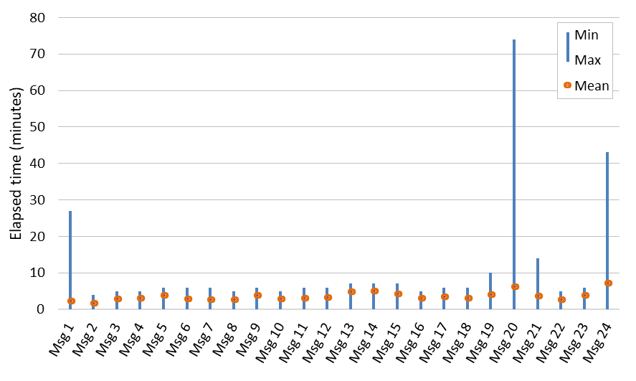
Figure 17. Elapsed time for receiving PTWC messages for respondent Member States (Q.A4 – Answered 28, Skipped 2).

Among the 28 countries, the majority (68%) received PTWC messages via email. A smaller proportion (14%) received notifications through both the Global Telecommunications System (GTS) and email. For less than 10% of the countries, the messages were accessed through email and the PTWC website (7%), GTS alone (7%), or a combination of GTS, email, and website (4%, Figure 18). The PTWC website was reported to be accessible by 80% of the countries (Q.A6 – Answered 24, Skipped 6), while the remaining 20% (6 Member States) did not consult the website during the event.

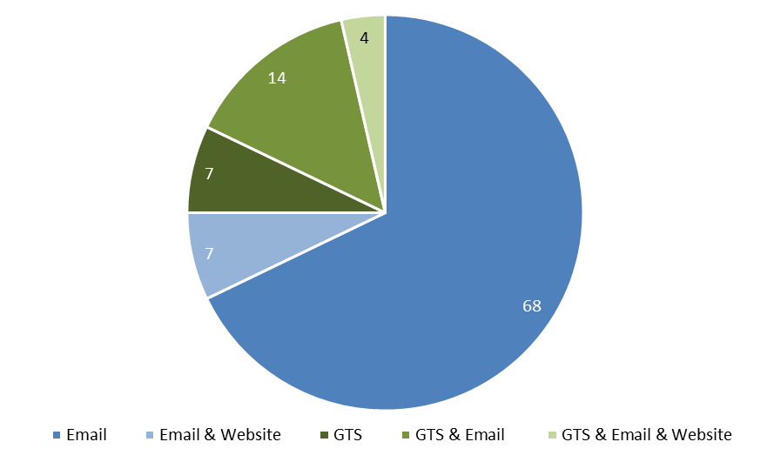
Figure 18. Methods used to receive PTWC messages (Q.A5 – Answered 28, Skipped 2).

- Northwest Pacific Tsunami Advisory Center

Nine countries (30%) received tsunami notifications from the Northwest Pacific Tsunami Advisory Center (NWPTAC, Q.A7 – Answered 30, Skipped 0). For all messages, the reported delivery times ranged from 0 to 1 minute (Q.A8 – Answered 9, Skipped 21). All countries successfully received the full set of 15 messages, except for Indonesia. Vanuatu was unable to provide detailed survey responses due to the absence of archived message records.

Several comments and issues were reported by some countries:
- French Polynesia recommended that subsequent bulletins eliminate the term "POSSIBILITY" in the risk assessment and adopt a more definitive tone based on observed data. The final bulletin should not continue to state "THERE IS A POSSIBILITY OF A DESTRUCTIVE OCEAN-WIDE TSUNAMI" under evaluation, as seen in Message No. 14. Instead, it should clearly state "END OF WARNING, TSUNAMI THREAT HAS PASSED".
- Indonesia did not receive Bulletin No. 3.
- In the Solomon Islands, the predicted wave heights of 0.3–1 meter closely matched the observed heights of 0.3–0.5 meter.

Most countries received messages via email (45%), followed by the GTS (33%), while 22% received notifications through both channels (Figure 19).

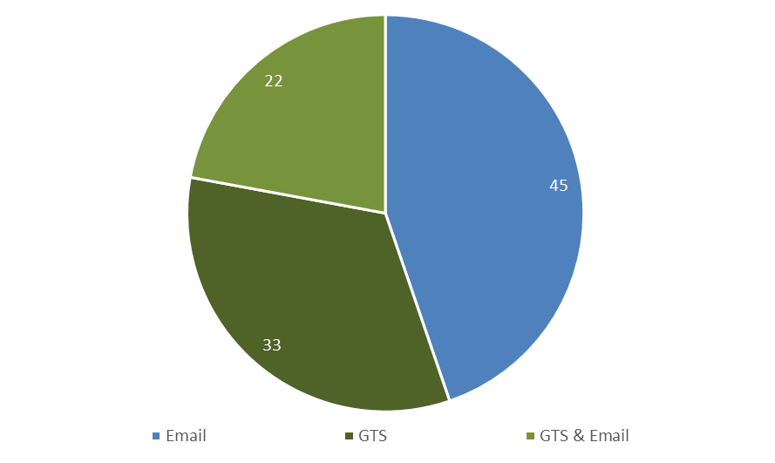
Figure 19. Methods used to receive NWPTAC messages (Q.A9 – Answered 9, Skipped 21).

Five countries confirmed that the NWPTAC website was accessible during the event. Three countries did not consult the website, and Vanuatu did not answer the question (Q.A10 – Answered 9, Skipped 21).

- Other sources of information

Nineteen respondent countries (63%) reported receiving tsunami-related information from sources other than the PTWC and/or NWPTAC (Q.A11 – Answered 30, Skipped 0). These alternative sources are summarized in Table 3 (Q.A12 – Answered 19, Skipped 11).
Table 3. Other sources than PTWC and/or NWPTAC for tsunami-related information.
Source | # | Countries
Own NTWC | 6 | Chile (SHOA), French Polynesia (CCPT), Guatemala (INSIVUMEH), Indonesia (BMKG), New Zealand (GNS), United States (US NTWC)
USGS | 3 | Chile, Fiji, United States
CPPT | 3 | Fiji, United States
CATAC | 2 | Costa Rica, Honduras
Seismic stations | 2 | Russian Federation, Samoa
GFZ | 1 | Chile
INOCAR | 1 | Mexico
SHOA | 1 | Ecuador
Sea level station monitoring facility | 1 | Vanuatu
PAAQ, WIX, RUSH Websites | 1 | Republic of Korea

Email is the most widely used method for receiving tsunami-related information from other sources, representing 37% of total usage across countries (Figure 20). The second most common approach, used by 21% of countries, combines email with website access. Both website-only access and the use of GTS in conjunction with email each account for 11% of usage. Four additional categories—Email & Other (WhatsApp groups or phone calls), Email & Website & Other (phone calls), GTS & Website, and Other (network) – each comprise 5% of the total.

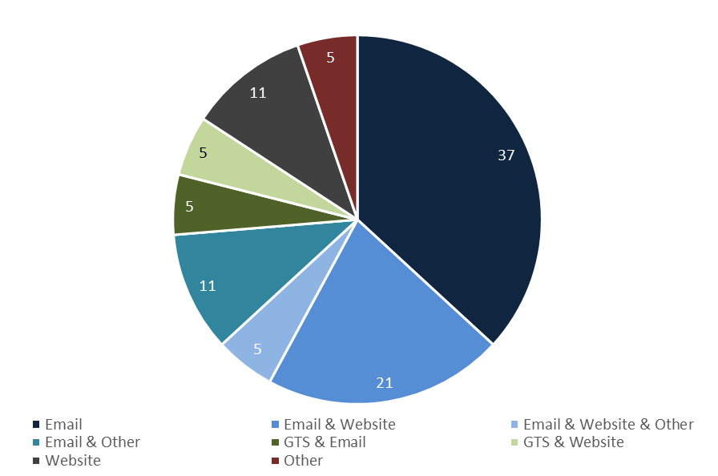
Figure 20. Methods used to receive information from other sources (Q.A13 – Answered 19, Skipped 11).

Accessibility to the websites of other information sources was reported by 62.5% of respondent countries (Q.A14 – Answered 16, Skipped 14). It is important to note that some sources do not have a website.

  - National actions (Section B of the questionnaire)
- Actions BEFORE receiving the PTWC messages

Fifty-two percent (52%) of the respondent countries managed to act before receiving the TSP PTWC messages (Table 4).

- Actions AFTER receiving the PTWC messages

Out of the 26 respondent countries, 16 (62%) reported a minimal lapse time – less than 30 minutes – before initiating action upon receiving PTWC messages (Figure 21). In contrast, Kiribati (852 minutes), Vanuatu (823 minutes), and Fiji (754 minutes) exhibited the longest response times.

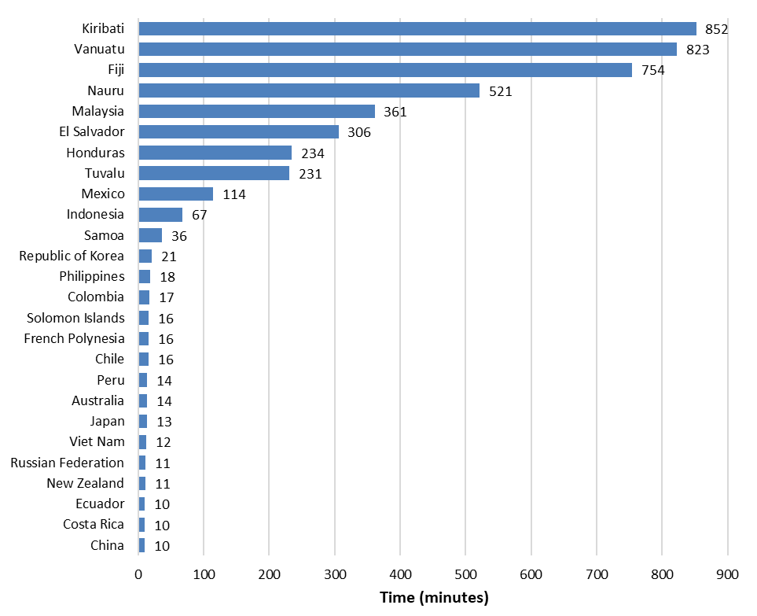
Figure 21. Time reported by countries before first action after receiving PTWC messages (Q.B2 – Answered 28, Skipped 2).

Table 4. Actions taken by the countries BEFORE receiving the TSP PTWC messages (Q.B1 – Answered 29, Skipped 1).
Country | Time (UTC) | Action
Australia | 23:30 | The Tsunami Warning process for Australia is independent of PTWC. Seismic analysis is undertaken in real time by Geoscience Australia (GA) with first Solution from GA sent for a Mw=7.8.
China | - | Issuing tsunami information message
Costa Rica | - | Information from USGS was reviewed
Ecuador | - | Actions not described in SM
French Polynesia | - | Tsunami Warning with preliminary level and impact evaluation with estimated tsunami first arrival time for all islands.
Indonesia | 23:33 | Independent analysis of tsunami event: TSP INDONESIA BULL-1 ISSUED EQ Mag:7.6,23:24UTC
Japan | - | Japan Meteorological Agency (JMA) has notified the earthquake by their own analysis.
Malaysia | 23:30 | A TOAST simulation was carried out using data detected by SeisComP5. The analysis confirmed that no tsunami threat to Malaysia.
New Zealand | - | Through monitoring of an open-source product called Global Quake, near real world earthquake monitoring is achieved. Upon observing the large Kamchatka earthquake, NEMA New Zealand entered a response stance until official PTWC earthquake and tsunami information was received then acted upon.
Peru | - | The current protocols of the National Tsunami Warning Center were activated, and the population and competent authorities were informed.
Republic of Korea | - | The information about the Kamchatka earthquake was disseminated to the media and disaster management officials.
Russian Federation | 23:29 | Communication with Emergency Department
Solomon Islands | 23:30 | The California Integrated Seismic Network reported a magnitude 8.0 earthquake in Russia. An initial coastal threat assessment indicated no threat to the Solomon Islands. Following the upgrade of the magnitude to 8.8, wave heights were monitored through tide gauges and buoys across the northern Pacific. Observations recorded wave heights of 0.3 to 0.6 meters. Thus, similar wave heights are expected to reach the Solomon Islands.
United States | - | The two US TWCs (PTWC, US NTWC) that cover US Pacific states and territories do their own analyses and do not depend upon TSP messages for guidance.
Viet Nam | 23:28 | Processing the earthquake data

- Information issued to agencies or organizations

Tsunami warnings and related information were issued by the National Tsunami Warning Centres (NTWCs) in 93% of the respondent countries, either to other agencies, organizations, or directly to the public (Q.B3 – Answered 29, Skipped 1). Malaysia and Viet Nam were the only two countries that did not report issuing such communications.

During the event, 70% of respondent countries issued marine warnings or advisories to relevant agencies or organizations (Figure 22). Information bulletins were disseminated by 56% of countries, while less than half issued formal warning (37%) and watch (48%) bulletins. Three countries – Kiribati, Tonga, and the United States – provided all four types of communication, representing 11% of countries. Australia, Guatemala, and the Republic of Korea issued only “no tsunami threat” information, also accounting for 11%. Several countries also reported cancellation bulletins once the tsunami threat had passed.

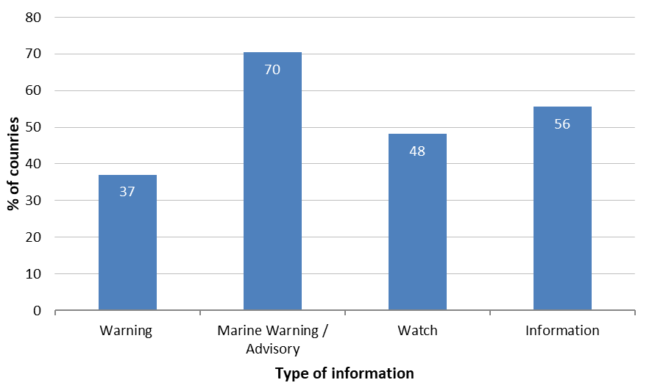
Figure 22. Type of information released to agencies or organisations (Q.B4 – Answered 27, Skipped 3).

Over 80% of countries released tsunami-related information to National Emergency Management Agencies (NEMA – 89%), Media (85%), and Marine Authorities (81%), identifying these as the primary recipients of communication during the event (Figure 23). First responders were also widely engaged, with 70% of countries reporting information dissemination to this group. Other sectors were involved to a lesser extent, with Critical Infrastructure operators and Civil Society organizations each receiving information in 44% of cases, followed by the Health and Education sectors (33%) and the Tourism sector (26%). This distribution highlights a clear prioritization of emergency management, media, and maritime authorities in tsunami communication strategies. However, the comparatively lower engagement with sectors such as tourism, education, and health points to opportunities for enhancing multi-sectoral coordination and outreach in future preparedness and response efforts.

In addition to the primary agencies, several countries reported sharing tsunami-related information with other entities. These included county or municipal emergency management organizations in the United States, local governments in Japan, and local and regional civil Défense groups as well as senior government officials in New Zealand. Tuvalu reported dissemination to the public, while Honduras involved state institutions in its communication efforts.

Five countries (19%) reported disseminating tsunami-related information to all listed types of agencies and organizations, demonstrating comprehensive outreach across sectors. All respondent countries contacted at least two distinct agencies, indicating a minimum level of multi-agency coordination during the event.

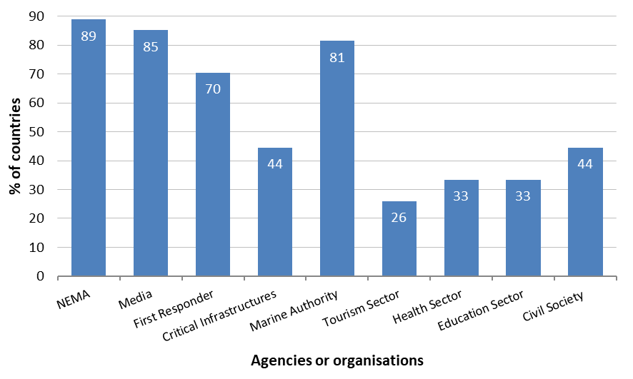
Figure 23. Agencies or organisations receiving tsunami-related information (Q.B6 – Answered 27, Skipped 3).

Email was the primary method of tsunami information dissemination, used by 93% of respondent countries (Figure 24). This was followed by social media platforms (74%) and dedicated phone lines (56%). Less than half of the countries relied on dedicated radio channels (44%), SMS alerts (37%), other methods (33%), and commercial phone lines (30%). The least utilized method was fax, reported by only 15% of countries (4 in total). All countries use at least two communication channels.

Several countries also reported using alternative or specialized communication channels (other methods), including:
- MS teams and embedded meteorologists (Australia),
- press release and conferences (Costa Rica),
- FR-Alert (cell broadcast) and VIAPPEL systems (SMS and vocal) (French Polynesia),
- warning receiver system, website and mobile application (Indonesia),
- dedicated information communication system (Japan),
- website and application (Mexico),
- HF radio, Chatty beetles, hard copies (Tuvalu),
- dedicated websites (Solomon Islands, New Zealand, Vanuatu).

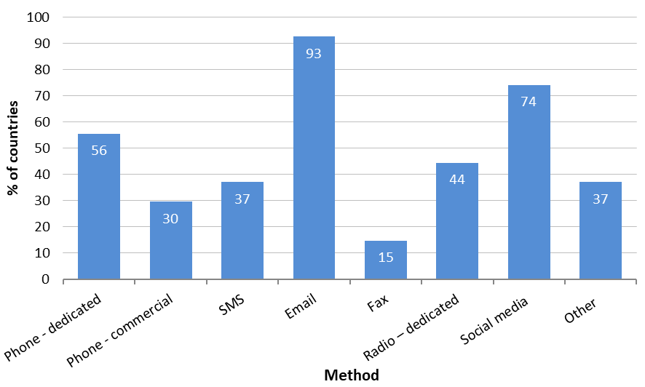
Figure 24. Method used to issue the warning or tsunami-related information to agencies or organisations
(Q.B7 – Answered 27, Skipped 3).

- Information released to the public

A total of 96% of respondent countries (27 out of 28) confirmed that tsunami warnings and related information were issued to the public (Q.B8 – Answered 28, Skipped 2).

The most disseminated types of information were Marine Warnings / Advisories and Information bulletins, each reported by 67% of countries (Figure 25). Watch alerts were issued by 52%, while Warning messages were shared by 44%. Additionally, 11% of countries indicated the use of other types of information, including cancellation notices, evacuation timing bulletins, newsletters, observed tsunami heights, and estimated tsunami arrival times.

Although 60% of countries did not respond to this question, among those that did, the most frequently cited authority responsible for issuing tsunami-related information to the public was the National Disaster Management Office (NDMO) / National Emergency Management Agency (NEMA), reported by 42% of respondents (Figure 26). This was followed by the National Tsunami Warning Centre (NTWC) at 25%, and Local Disaster Management Offices (LDMO) / Emergency Management Agencies (EMA) at 17%. Notably, Solomon Islands indicated that both NTWC and NDMO/NEMA are involved in public communication, while Fiji reported the involvement of all three entities.
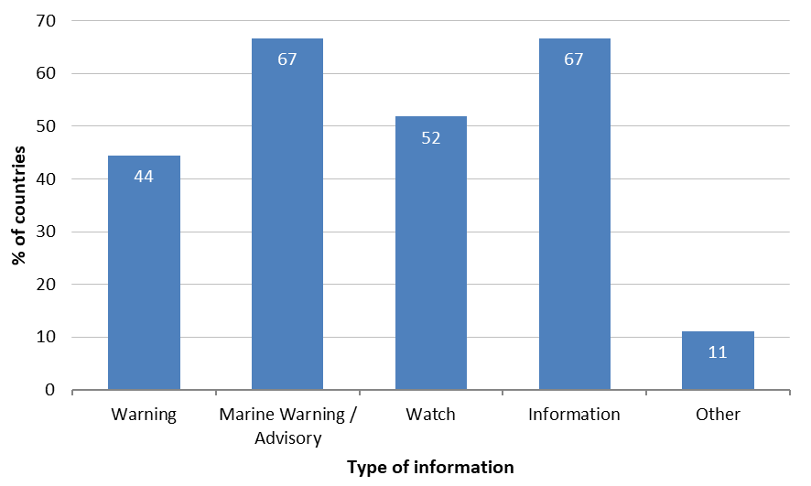
Figure 25. Type of tsunami-related information issued to the public (Q.B9 – Answered 27, Skipped 3).

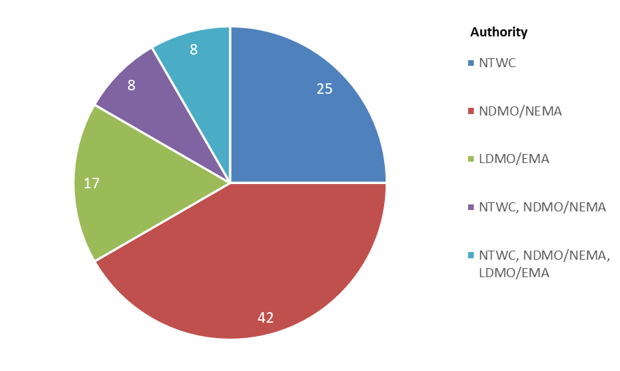
Figure 26. Authority issuing information public (Q.B11 – Answered 12, Skipped 18).

The NTWC is the primary source of information used to determine whether to issue a tsunami warning to the public, cited by 89% of respondent countries (Figure 27). The TSP PTWC is also widely used, with 52% of countries relying on its data. Eleven countries use both NTWC and TSP PTWC (41%). Additionally, 15% of countries reported using other sources to support their decision-making. These include regional wave buoy monitoring (Samoa), the Yuzhno-Sakhalinsk Seismic Station (Russian Federation), and national emergency services (Nauru).

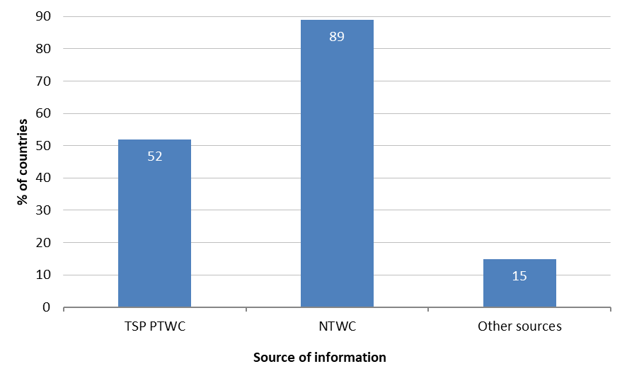
Figure 27. Source of information for making the decision to issue a tsunami warning to the public
(Q.B12 – Answered 27, Skipped 3).

In the event of a tsunami warning or marine warning/advisory, 68% of countries reported issuing both the estimated tsunami arrival time and wave height forecast to the public (Figure 28). An additional 28% provided only the arrival time forecast. Notably, one country (Vanuatu) indicated that no specific information was issued to the public in such cases.

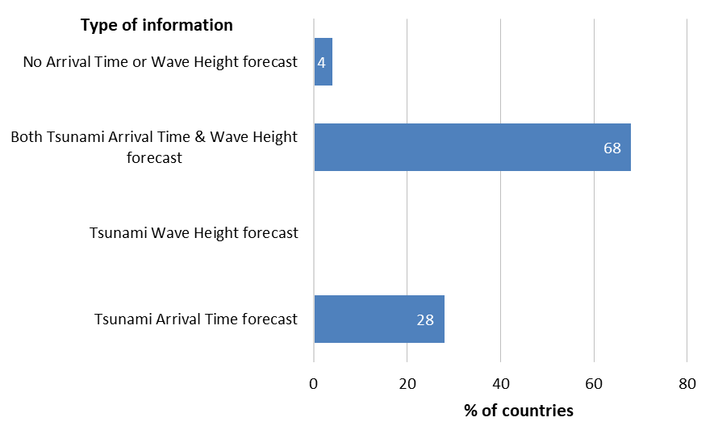
Figure 28. Type of information issued to the public in case of a tsunami warning or marine warning / advisory
(Q.B13 – Answered 25, Skipped 5).

The most widely used methods for communicating tsunami warnings and related information to the public are websites (81%), social media platforms (Facebook 77% and Twitter 54%), radio (54%) and mobile phone broadcast (50%) (Figure 29). Other channels are less commonly employed, with usage rates below 31% (police announcements– 31%, telephone and SMS alerts – 27%, sirens – 23%, RSS feeds – 19%, and door-to-door announcements – 15%).

In addition, several countries reported using alternative or specialized communication channels, such as:
- private companies like mobile communication, broadcasting, weather companies (Japan),
- fax transmission (Philippines),
- Chatty beetles and HF radios (Tuvalu),
- Platforms such as Weibo, WeChat, and TikTok (China).

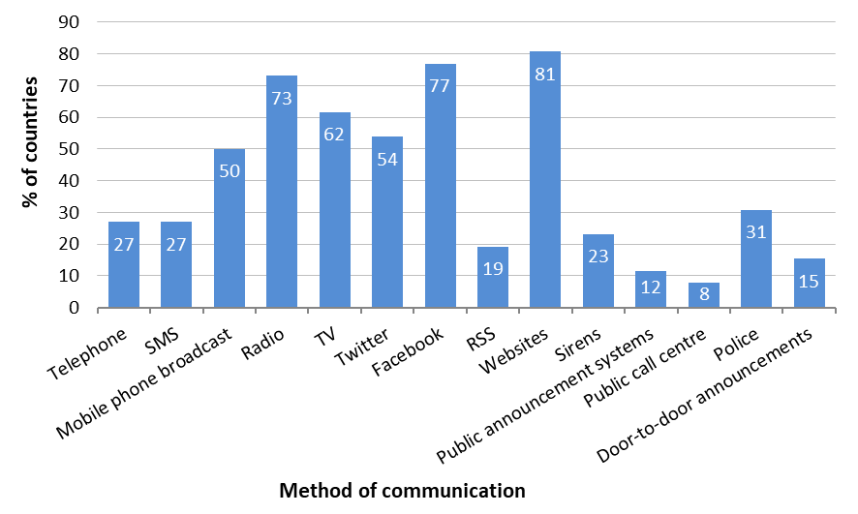
Figure 29. Methods of public communication for tsunami warnings / information (Q.B14 – Answered 26, Skipped 4).

- Information released to the media

Among the countries that responded to this question, the most cited entities responsible for communicating tsunami-related information to the media were both NTWC/TWFP and NDMO, reported by 54% of respondents (Figure 30). This was followed by NDMO alone (15%), NTWC/TWFP alone (8%), and local or regional DMOs (8%). Due to the limited number of responses (13 out of 30, or 43%), these findings should be interpreted with caution as they lack strong statistical significance.

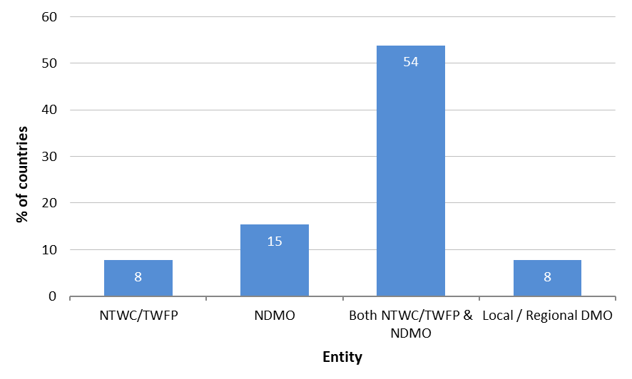
Figure 30. Entities responsible for communicating with the media (Q.B15 – Answered 13, Skipped 17).

A total of 89% of respondent countries (25 out of 28) confirmed that tsunami warnings or related information were issued to national media by either their NTWC or DMO (Q.B16 – Answered 28, Skipped 2).

Email stands out as the most used method of communication with national media, employed by 63% of countries (Figure 31). Phone communication remains significant at 50%, while SMS is used by 25% of countries. The “Other” category, accounting for 46%, includes a diverse range of platforms such as television broadcasts, WhatsApp groups, Telegram, press conferences, official webpages, social media (e.g. Facebook), and RSS feeds. Fax, by contrast, has been entirely phased out, with no countries reporting its use.

In terms of communication strategy, 42% of countries rely on a single channel, whereas a majority (58%) opt for redundancy by utilizing multiple methods to ensure broader reach and reliability.

Social media is the primary electronic media used by national media for broadcasting information, closely followed by official websites, which are utilized by 84% of countries, and traditional channels such as television and radio, used by 80% (Figure 32).

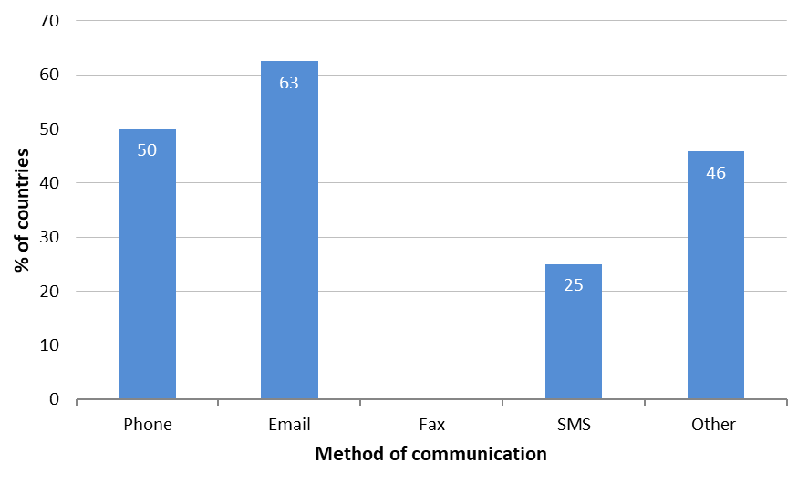
Figure 31. Method of communication used to send information to national media (Q.B17 – Answered 24, Skipped 6).

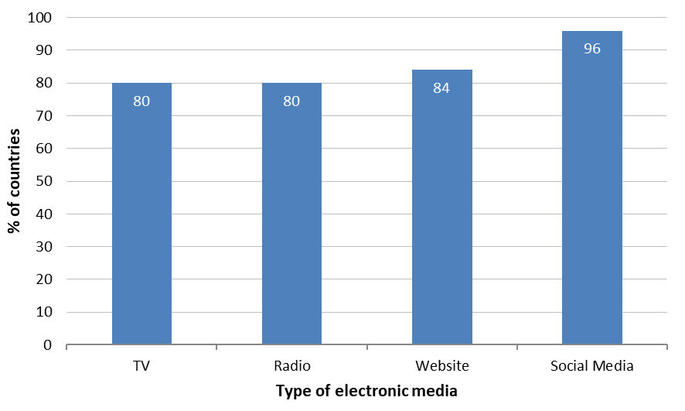
Figure 32. Type of electronic media used for information broadcast by national media (Q.B18 – Answered 25, Skipped 5).

An analysis of national media broadcasting approaches revealed the following distribution of methods used to disseminate information (Figure 33):
- Combined use of programme interruption (via television and radio) and scrolling text (television) with 35% of countries.
- Programme interruption only with 26% of countries.
- Programme interruption with public engagement (live interviews and public feedback mechanisms) reported by one country (Tonga, 4%).

- Alternative methods adopted by 35% of countries:
- Regular news segments (Australia),
- Television news coverage (Costa Rica, Ecuador, French Polynesia, Peru),
- Bulletin dissemination (Guatemala),
- Broadcast tsunami updates once received from NTWC (Tuvalu),
- Social media platforms and radio broadcasts (Vanuatu).

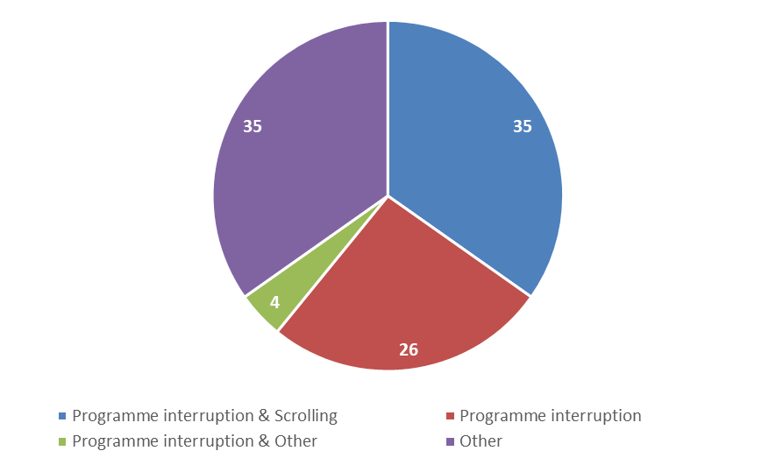
Figure 33. Methods of information broadcast (Q.B20 – Answered 23, Skipped 7).

- Cancellation of the warning

A total of 23 countries (77%) reported having cancelled a warning or marine advisory issued during the event (Q.B22 – 23 responses, 7 skipped). The primary reason cited for cancellation—by 57% of respondents—was the absence of damaging waves (Q.B23 – 23 responses, 7 skipped). Additional reasons provided include:
- The tsunami waves and associated risks had passed (Fiji, French Polynesia).
- No damage was expected following the cancellation (Japan).
- Receipt of updated messages from PTWC (Nauru).
- Strong and unusual currents below 30 cm near the shoreline were considered low to minimal risk, justifying cancellation (New Zealand).
- Wave activity had returned to normal levels (Samoa).
- Confirmation from neighbouring countries that the forecasted wave had passed without causing damage or impact (Tuvalu).
- Either no hazardous waves observed, or wave activity dropped below hazardous levels (United States).
- The overall threat level was deemed low (Vanuatu).

Cancellation messages were communicated through a variety of channels, with all respondent countries—except Samoa—utilizing at least two methods. Samoa reported relying solely on Facebook.

The data indicates a predominant use of digital platforms and mass media, while localized or institutional approaches were less commonly employed. Websites and Facebook emerged as the most frequently used channels, each cited by 78% of countries (Figure 34). Twitter was also notable, though less prominent, at 48%. Traditional media continues to play a significant role, with radio used by 65% of respondents and television by 52%. Mobile-based alert systems were moderately represented: mobile phone broadcasts (35%), telephone calls (30%), and SMS (22%). In contrast, physical and community-based methods showed limited use—sirens (17%), public announcement systems (13%), door-to-door communication (4%), and public call centres (4%). Institutional involvement was similarly modest, with police reported by 17% of countries.

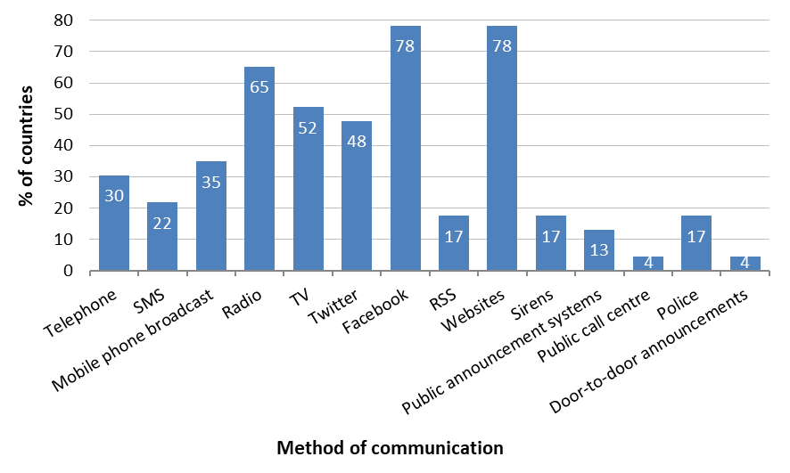
Figure 34. Methods of communication to the public for cancellation of warnings and marine advisories
(Q.B24 – Answered 23, Skipped 7).

Seven countries (28%) reported experiencing difficulties in disseminating tsunami warning or cancellation messages (Table 5). Nauru did not provide details.

Table 5. Specific communication challenges encountered (Q.B25 – Answered 25, Skipped 5).
Country | Challenge
Chile | Minor technical issues with cell broadcast messaging
Colombia | Difficulty reaching individuals by phone; network disruptions reported in certain areas
Honduras | Challenges contacting individuals by phone
Kiribati | Connectivity problems in outer islands with limited or no network infrastructure
Samoa | Slow office internet connection caused minor delays in accessing online information
United States | Persistent communication issues during tsunami alerts, including areas lacking internet or cellular coverage, overly broad wireless alert zones, and absence of sirens in some regions

  - National response (Section C of the questionnaire)
- National Disaster Management Offices

Seventy-six percent (76%) of the respondent countries indicated that their National Disaster Management Office (NDMO), or an equivalent national response agency, acted during the event (Q.C1 – Answered 29, Skipped 1). These actions are documented in the respective country timelines (Section 5, Q.C2 – Answered 19, Skipped 11).
Communication was maintained throughout the event between NTWC and NDMO (or equivalent) in 86% of the countries (Q.C3 – Answered 28, Skipped 2).

Most NTWCs consistently delivered essential tsunami-related information to NDMOs or their equivalents. All respondent countries (100%) reported sharing tsunami wave observations and alert levels, while 96% provided tsunami source information (Figure 35). Twenty-nine percent (29%) issued evacuation guidance or reports, and 38% communicated safe-to-return or all-clear messages. These latter figures align with the proportion of countries that carried out actual evacuations during the event. Another type of information shared included maritime warning recommendations, as reported by Costa Rica.

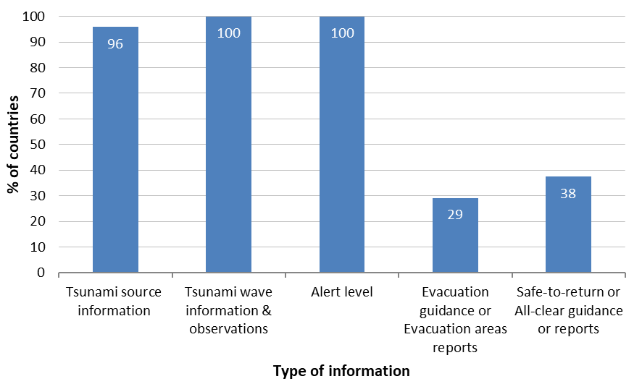
Figure 35. Information shared by NTWCs to NDMOs, or equivalent (Q.C4 – Answered 24, Skipped 6).

- Local or Regional Disaster Management Offices

Communication between NDMOs and Local or Regional Disaster Management Organisations (LDMOs), or equivalent, was maintained throughout the event in 82% of respondent countries (Q.C5 – Answered 28, Skipped 2).

Information was actively shared between NDMOs and LDMOs, ensuring coordination across levels (Figure 36). This mostly included alert levels (91%) and tsunami related information on source (82%) and waves (86%). Forty-five percent (45%) issued evacuation guidance or reports, and 50% communicated safe-to-return or all-clear messages. Like the information provided by NTWCs to NDMOs, maritime warning recommendations were also shared between NDMOs and LDMOs, as reported by Costa Rica.

Fifty-four percent (54%) of the respondent countries indicated that their LDMO, or equivalent, acted during the event (Q.C7 – Answered 28, Skipped 2). These actions are documented in the respective country timelines (Section 5, Q.C8 – Answered 14, Skipped 16).

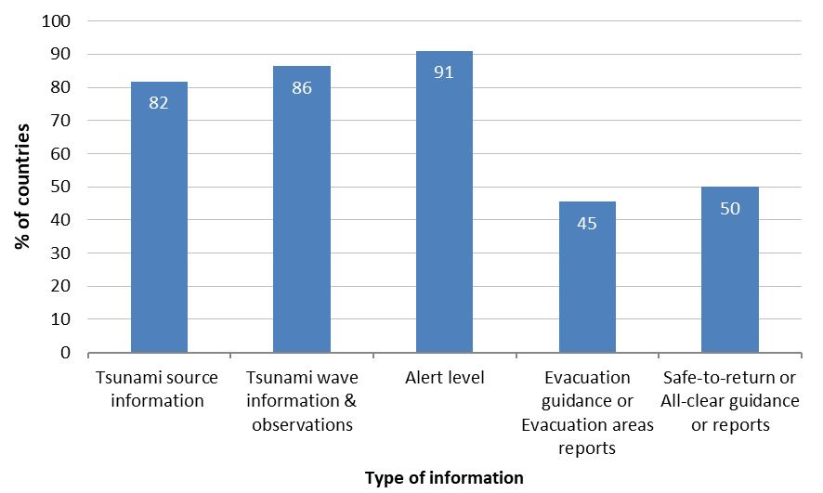
Figure 36. Information shared by NDMOs to LDMOs, or equivalent (Q.C6 – Answered 22, Skipped 8).

- Evacuations

Ten countries reported evacuations during the event (34%, Q.C9 – Answered 29, Skipped 1). Details per country are given below (Q.C10 – Answered 8, Skipped 22) or in each country timeline (Section 5):
- Chile, Easter Island and continental territory evacuations between Arica and Aysen regions.
- French Polynesia, 3 094 people total, Nuku-Hiva (3 025), Hiva-Oa (2 375), and Ua-Huka (719).
- Japan, 24 891 people total, Hokkaido (7 856), Tohoku region (8 367), Kanto region (3 988), Tokai region (2 378), Kansai region (1 653), Chugoku region (83), Shikoku region (135), and Kyushu region (431).
- New Zealand, no details provided.
- Peru, no details provided.
- Philippines, over 2 200 people total, Cagayan Province (1 600), Aurora Province (600), and Northern Samar Province.
- Russian Federation, 300 people total, Severo-Kurilsk seaport.
- Samoa, no details provided.
- Tonga, schools, businesses, and communities located in vulnerable zones evacuated.
- United States.

Regarding materials available to the population in evacuated areas, 33% of the nine respondent countries reported providing tsunami inundation maps (Q.C11 – Answered 9, Skipped 21), while 67% made tsunami evacuation maps available (Q.C12 - Answered 9, Skipped 21). Evacuation processes were reported to have proceeded smoothly in 78% of these countries (Q.C13 – Answered 9,
Skipped 21).

- Self-evacuations BEFORE an issued warning

Sixty-eight percent (68%) of the countries declared no self-evacuation before a warning was issued. For nine countries (32%), territorial-level data on self-evacuation was not made available (Colombia, Fiji, Honduras, Malaysia, Mexico, New Zealand, Philippines, Republic of Korea, Vanuatu) (Q.C14 – Answered 28, Skipped 2).
  - Monitoring and modelling (Section D of the questionnaire)
- Sea level data

During the event, 55% of respondent countries monitored sea level data across all Pacific stations, while 38% did so for selected stations (Figure 37). Nauru, one of the countries that did not conduct monitoring, cited the need for technical assistance and training as the primary reason.

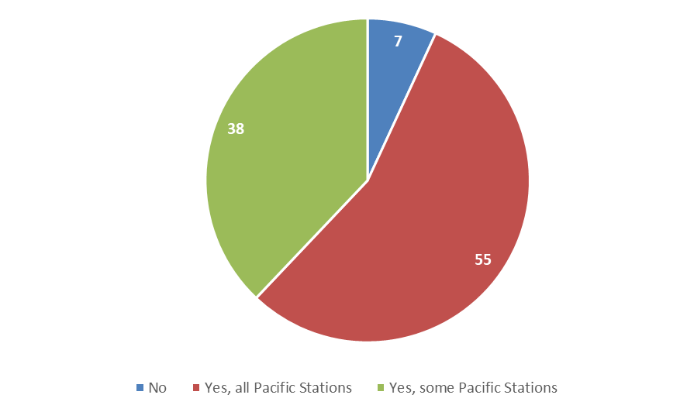
Figure 37. Sea level data monitoring during the event (Q.D1 – Answered 29, Skipped 1).

Stations were monitored using the IOC Sea Level Station Monitoring Facility (89%), followed by Tide Tool (61%) and GTS via NTWC tools (54%) (Figure 38).

Additionally, 43% of countries reported using alternative sources or tools for sea level monitoring, including:
- NTWC tools with direct data feeds and third-party websites (Australia).
- National stations utilizing Hydras software (Colombia).
- NTWC acquisition and analysis tools (French Polynesia).
- Tide Tool deployed locally, with training needs identified (Nauru).
- SIFT inversion software for data feeds (New Zealand).
- Data Boy Center (Peru).
- Local Sea Level Monitoring Stations (Philippines).
- JMA website (NWPTAC) (Republic of Korea).
- National tide gauges (Indonesia, Mexico, Tuvalu).
- Tide Tool via GTS used by PTWC as an NTWC; the US NTWC employs its own analysis software, Tide View (United States).

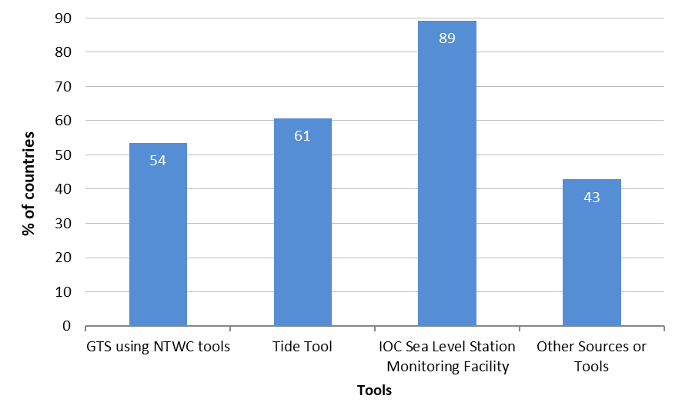
Figure 38. Tools for monitoring stations (Q.D2 – Answered 28, Skipped 2).

Two countries did not monitor sea level data during the event (Q.D3 – Answered 2, Skipped 28). Nonetheless, their respective NTWCs have access to relevant monitoring resources:
- Guatemala: GTS, IOC Facility, and Tide Tool.
- Nauru: Tide Tool.

- Numerical model tsunami scenario

Numerical tsunami scenario models were utilized by NTWCs in 76% of respondent countries during the event, supporting both deep-ocean propagation and coastal inundation assessments. The most used models were COMCOT, EasyWave (TOAST), and MOST, each reported by three countries (Figure 39). In terms of analytical tools, TsuCAT was used by three countries and ComMIT by two.

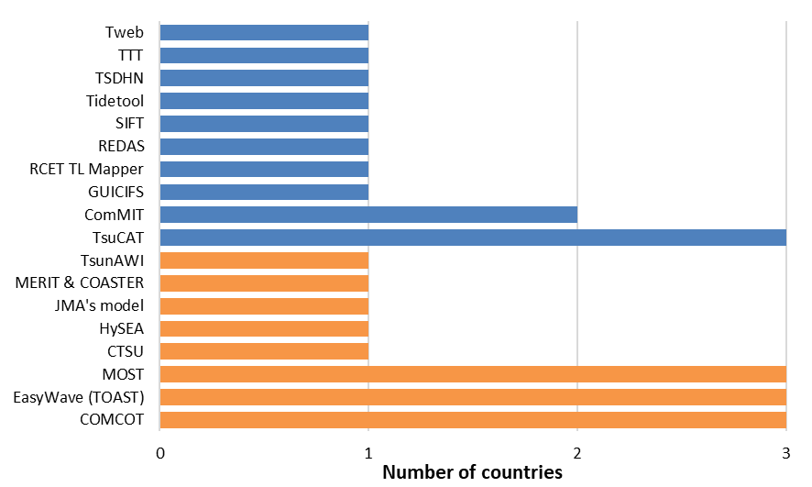
Tools
Models
Figure 39. Tools and numerical models used by the NTWCs (Q.D4 – Answered 29, Skipped 1).

  - Community preparedness (Section E of the questionnaire)

Sixteen respondent countries (53%) identified five principal communities impacted by the event
(Table 6) (Q.E1 – Answered 16, Skipped 14).

For each community, countries assessed three key domains using a scale from 0 (none) to 4 (very high):
- the scientifically-assessed level of tsunami hazard,
- the level of community awareness of that hazard, and
- the level of pre-existing community tsunami preparedness.

Table 6. Communities affected by the event with their ranking in scientifically assessed level (SAL) of tsunami hazard, community awareness level (CAL) of that hazard, pre-existing community tsunami preparedness level (PPL).
Member State | Community 1 |  |  | Community 2 |  |  | Community 3 |  |  | Community 4 |  |  | Community 5
Member State | SAL | CAL | PPL | SAL | CAL | PPL | SAL | CAL | PPL | SAL | CAL | PPL | SAL | CAL | PPL
Chile | O'Higgins Region |  |  | Coquimbo Region |  |  | Atacama Region |  |  | Biobío Region |  |  | Arica & Parinacota Region
Chile | 4 | 4 | 4 | 4 | 4 | 4 | 4 | 4 | 4 | 4 | 4 | 4 | 4 | 4 | 4
Colombia | Chocó |  |  | Valle del Cauca |  |  | Cauca |  |  | Nariño
Colombia | 3 | 3 | 2 | 3 | 3 | 2 | 3 | 3 | 2 | 3 | 3 | 2
Costa Rica | Cuajiniquil |  |  | Flamingo |  |  | Samara |  |  | Pochote |  |  | Uvita
Costa Rica | 0 | 0 | 0 | 4 | 4 | 3 | 4 | 3 | 4 | 3 | 3 | 4 | 3 | 3 | 4
Ecuador | Puerto Baquerizo Moreno |  |  | Puerto Ayora |  |  | Puerto Villamil |  |  | Baltra
Ecuador | 2 | 4 | 4 | 2 | 4 | 4 | 2 | 4 | 4 | 2 | 4 | 4
Fiji | Rotuma |  |  | Cikobia |  |  | Yasawa |  |  | Mali |  |  | Kia
Fiji | 1 | 1 | 2 | 1 | 1 | 2 | 1 | 1 | 2 | 1 | 1 | 2 | 1 | 1 | 2
French Polynesia | Marquesas islands |  |  | Society islands |  |  | Tuamotu Islands |  |  | Austral islands |  |  | Gambier Islands
French Polynesia | 4 | 4 | 3 | 3 | 3 | 3 | 3 | 2 | 3 | 3 | 2 | 3 | 2 | 2 | 3
Honduras | Marcovia, Choluteca |  |  | San Lorenzo, Valle |  |  | Amapala, Valle |  |  | Alianza, Valle
Honduras | 1 | 3 | 3 | 1 | 2 | 2 | 1 | 2 | 1 | 1 | 2 | 1
Indonesia | Papua |  |  | North Sulawesi |  |  | West Papua |  |  | North Molucca |  |  | Gorontalo
Indonesia | 4 | 3 | 3 | 3 | 4 | 4 | 3 | 3 | 3 | 2 | 3 | 3 | 1 | 3 | 3
Mexico | Puerto Vallarta |  |  | Manzanillo |  |  | Acapulco |  |  | Huatulco |  |  | Puerto Chiapas
Mexico | 3 | 3 | 3 | 3 | 3 | 3 | 3 | 3 | 3 | 3 | 2 | 2 | 3 | 2 | 2
Philippines | Cagayan Province |  |  | Aurora Province |  |  | Northern Samar Province
Philippines | 4 | 3 | 2 | 4 | 3 | 2 | 4 | 3 | 2
Russian Federation | Severo-Kurilsk |  |  | Yuzhno-Kurilsk |  |  | Malokurilskoe
Russian Federation | 4 | 4 | 4 | 4 | 4 | 4 | 4 | 4 | 4
Solomon Islands | Wagina, Choiseul Province
Solomon Islands | 4 | 3 | 3
Tonga | All of Tonga
Tonga | 2 | 3 | 2
Tuvalu | Lofegai community |  |  | Kavatoetoe community |  |  | Fakaifou community |  |  | Vaiaku Community |  |  | Outer island communities
Tuvalu | 4 | 3 | 3 | 4 | 3 | 3 | 2 | 3 | 3 | 2 | 3 | 3 | 3 | 3 | 2
United States | Hawaii |  |  | Alaska and US West Coast |  |  | American Samoa |  |  | Guam and CNMI
United States | 4 | 4 | 4 | 4 | 4 | 4 | 4 | 4 | 4 | 4 | 4 | 4
Viet Nam | Da Nang |  |  | Quang Nam
Viet Nam | 2 | 2 | 2 | 2 | 2 | 2

Figures 40 to 42 show that over 55% of respondent countries consider their communities to be ranked at high (3) or very high (4) levels across all three tsunami-related domains: knowledge (55–71%), awareness (57–81%), and preparedness (57–69%). In contrast, Fiji, Honduras, and Viet Nam assess their communities globally between levels 1 and 2, corresponding to very low to low. Costa Rica reports no scientifically-assessed level for its communities.

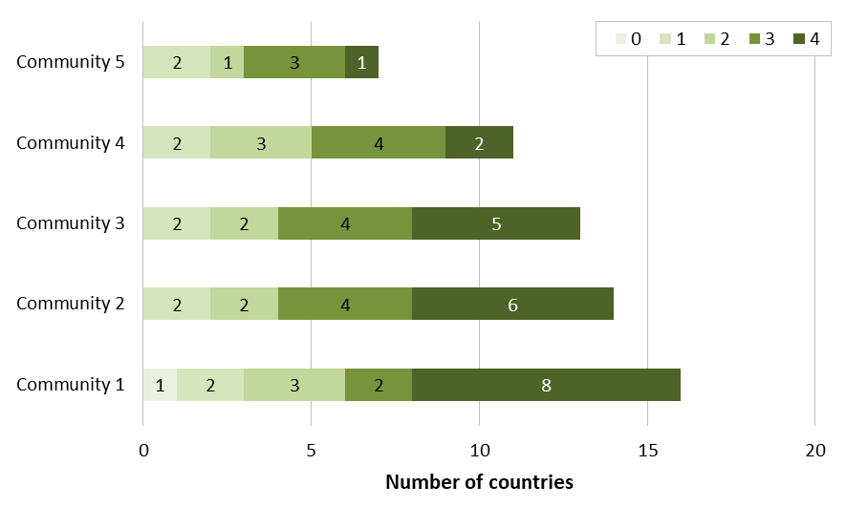
Figure 40. Scientifically-assessed level of tsunami hazard (Q.E2 – Answered 16, Skipped 14).

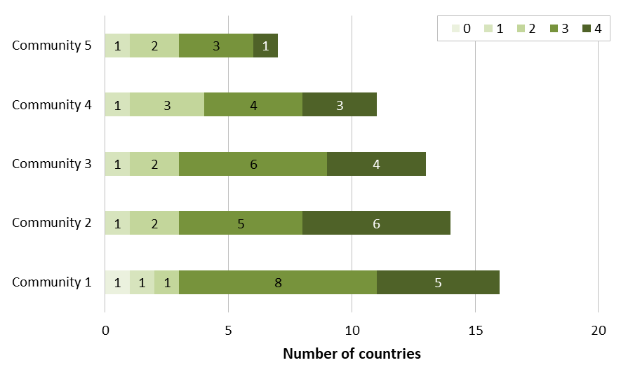
Figure 41. Level of community awareness (Q.E3 – Answered 16, Skipped 14).

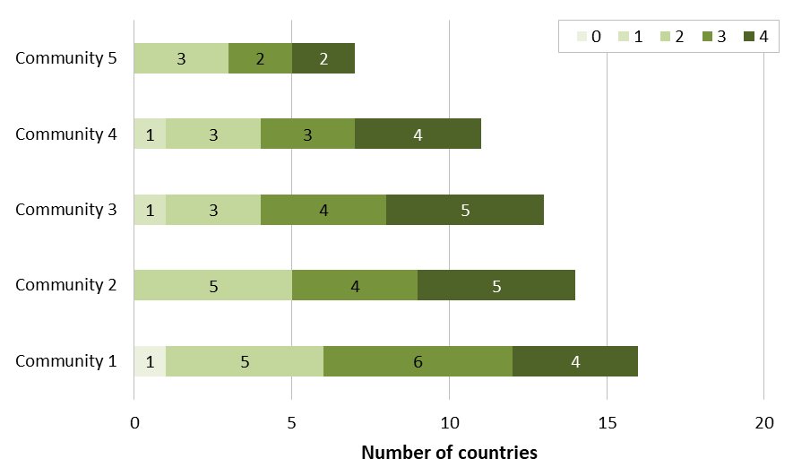
Figure 42. Level of pre-existing community tsunami preparedness (QE4 – Answered 16, Skipped 14).

Tsunami preparedness activities were in place at the community or national level prior to the event in 76% of respondent countries (16 out of 21, Q.E5 – Answered 21, Skipped 9). Notable examples given include:
- Regular awareness and outreach initiatives (Chile, United States).
- Tsunami exercises and drills, more specifically in schools (Chile, French Polynesia, Mexico, Nauru, United States).
- Routine updates of evacuation plans (Chile).
- Implementation of Tsunami Ready Recognition Programme (TRRP, Ecuador).

Figure 43 presents the tsunami preparedness activities implemented across respondent countries, all of which reported undertaking at least two such measures. The most widely adopted activity was the organization of tsunami exercises, reported by 88% of countries. This was closely followed by tsunami education in schools and participatory evacuation planning, each cited by 75% of respondents. The identification of evacuation facilities and the development of evacuation maps were reported by 63% and 56% of countries, respectively. Notably, 44% of countries (7 out of 16) reported implementing all five preparedness activities.

Detailed descriptions of specific activities are available in the country reports (Section 5).

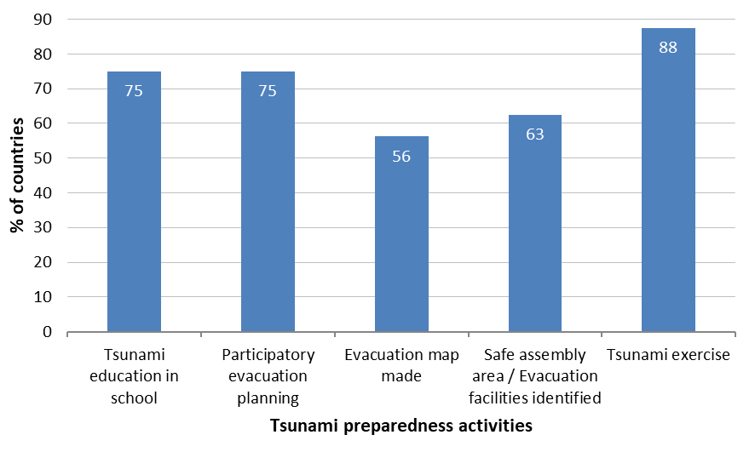
Figure 43. Preparedness activities conducted in communities or nationally (Q.E6 – Answered: 16, Skipped: 14).

All respondent countries reported some level of government support for tsunami preparedness, at minimum for tsunami signage—except for Honduras, which indicated that no state-level funding is available for tsunami prevention. Notably, five countries (20%) reported comprehensive engagement across all preparedness topics. Tsunami signage emerges as the primary focus, reported by 85% of respondent countries. This is followed by the development of hazard maps (75%), evacuation maps (65%), and evacuation route mapping (60%). Vertical evacuation sites and procedures remain a marginal topic, addressed by only 35% of respondents (Figure 44).

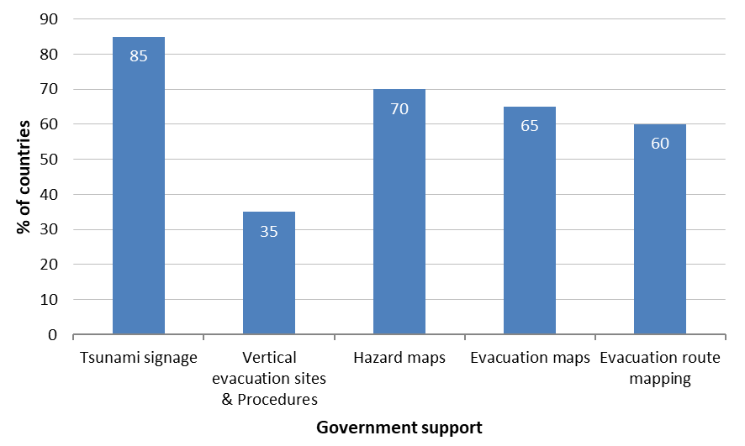
Figure 44. Government support with regards to preparedness areas (Q.E7 – Answered: 20, Skipped: 10).
  - Capacity development requirements (Section F of the questionnaire)

Twenty-four countries (67%) specified which types of training from IOC would be beneficial for their National Tsunami Warning Centres (NTWC), National Disaster Management Offices (NDMO), or other relevant organizations (Table 7). Eleven countries (37%) requested assistance in all areas, while the remainder indicated needs in at least two areas. More than half of the respondent countries expressed a need for training or support from IOC in the following domains (Figure 45):
- 52% for seismic training,
- 55% for evacuation mapping, community awareness and preparedness, as well as exercises and drills,
- 62% for standard operating procedures (SOPs) and media awareness,
- 66% for sea level training,
- 69% for inundation modelling, and
- 72% for risk assessment.

Five countries indicated that they do not require any training or assistance from IOC. However, one country (Australia) noted that it may be able to support some of these activities.

Additionally, two countries (Philippines and United States) highlighted the importance of sharing best practices and lessons learned on these topics.

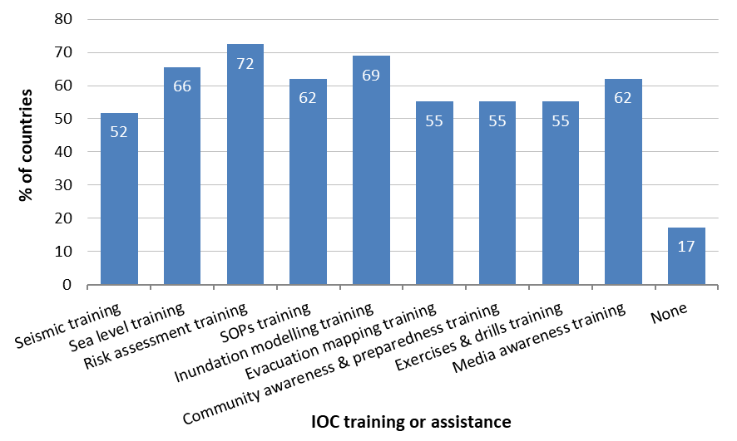
Figure 45. IOC training or assistance useful for NTWC, NDMO and other organizations (Q.F1 – Answered 29, Skipped 1).

Table 7. Requests for capacity development training by Member States (● = YES, ○ = NO, N/A = Not Answered).
Member State | Seismic Training | Sea Level Training | Risk Assessment Training | SOPs Training | Inundation Modelling Training | Evacuation Mapping Training | Community Awareness & Preparedness Training | Exercises & Drills Training | Media Awareness Training
Australia | ○ | ○ | ○ | ○ | ○ | ○ | ○ | ○ | ○
Chile | ○ | ○ | ○ | ○ | ○ | ○ | ○ | ○ | ○
China | ○ | ○ | ● | ○ | ● | ● | ○ | ○ | ○
Colombia | ● | ● | ● | ● | ● | ● | ● | ● | ●
Cook Islands | N/A | N/A | N/A | N/A | N/A | N/A | N/A | N/A | N/A
Costa Rica | ○ | ○ | ● | ● | ○ | ○ | ○ | ○ | ●
Ecuador | ● | ● | ● | ● | ● | ● | ● | ● | ●
El Salvador | ● | ● | ● | ● | ● | ● | ● | ● | ●
Fiji | ● | ● | ● | ● | ● | ● | ● | ● | ●
French Polynesia | ○ | ○ | ○ | ○ | ○ | ○ | ● | ● | ● (1)
Guatemala | ● | ● | ● | ● | ● | ● | ● | ● | ●
Honduras | ● | ● | ○ | ● | ● | ○ | ○ | ○ | ○
Indonesia | ● | ● | ● | ● | ● | ● | ● | ● | ●
Japan | ○ | ○ | ○ | ○ | ○ | ○ | ○ | ○ | ○
Kiribati | ○ | ● | ● | ● | ● | ● | ● | ● | ●
Malaysia | ● | ● | ● | ● | ● | ● | ● | ● | ●
Mexico | ● | ● | ● | ● | ● | ● | ● | ● | ●
Nauru | ○ | ● | ● | ● | ● | ● | ● | ● | ●
New Zealand | ○ | ○ | ○ | ○ | ○ | ○ | ○ | ○ | ○
Peru | ● | ● | ● | ○ | ○ | ○ | ○ | ○ | ○
Philippines | ○ | ● | ● | ○ | ● | ● | ● | ● | ●
Republic of Korea | ○ | ○ | ● | ● | ○ | ○ | ○ | ○ | ○
Russian Federation | ○ | ● | ○ | ○ | ● | ○ | ○ | ○ | ○
Samoa | ● | ● | ● | ● | ● | ● | ● | ● | ●
Solomon Islands | ● | ● | ● | ● | ● | ○ | ○ | ○ | ●
Tonga | ● | ● | ● | ● | ● | ● | ● | ● | ●
Tuvalu | ● | ● | ● | ● | ● | ● | ● | ● | ●
United States | ○ | ○ | ○ | ○ | ○ | ○ | ○ | ○ | ○
Vanuatu | ○ | ● (1) | ● (2) | ○ | ● (3) | ● (4) | ● (5) | ● (6) | ●
Viet Nam | ● | ○ | ● | ● | ● | ○ | ○ | ○ | ○
- Australia does not require direct assistance from the IOC but may be able to support some of their activities.
- French Polynesia emphasizes that media awareness training is their priority, aiming to develop language resources, appropriate wording, educational support, and videos to ensure the information is shared effectively.
- Philippines mentioned the “Sharing of best practices of other countries” and United States the “Sharing of lessons learned on the topics”.
- Country reports
  - Australia

Sea level data (D1-D3)
- Monitoring of: All Pacific stations
- Using: GTS using NTWC tools, IOC Sea Level Station Monitoring Facility, Other: NTWC tools using direct data feeds, other 3rd party websites
- Access when there is no monitoring: N/A

USE OF Numerical model TSUNAMI SCENARIOS AND TOOLS BY NTWC (D4)
YES – TTT and MOST

COMMUNITY RANKING (Q.E1-E4) | Community 1 |  |  | Community 2 |  |  | Community 3 |  |  | Community 4 |  |  | Community 5
COMMUNITY RANKING (Q.E1-E4) | SAL | CAL | PPL | SAL | CAL | PPL | SAL | CAL | PPL | SAL | CAL | PPL | SAL | CAL | PPL
Australia | - |  |  | - |  |  | - |  |  | - |  |  | -
Scientifically assessed level (SAL) of tsunami hazard, community awareness level (CAL) of that hazard, pre-existing community tsunami preparedness level (PPL)

Training events (Q.F1): Don't need direct assistance from the IOC but may be able to support some of these IOC activities

General comments (Q.G1): Conflicting public advice about Marine Threat from PTWC made communication of the National No Threat more difficult. As per previous recommendations, Australia ask PTWC to consider changes to public facing products to minimize confusion during these rare events.

  - Chile

Sea level data (D1-D3)
- Monitoring of: All Pacific stations
- Using: GTS using NTWC tools, IOC Sea Level Station Monitoring Facility
- Access when there is no monitoring: N/A

USE OF Numerical model TSUNAMI SCENARIOS AND TOOLS BY NTWC (D4)
YES – Hy SEA and COMCOT

COMMUNITY RANKING (Q.E1-E4) | Community 1 |  |  | Community 2 |  |  | Community 3 |  |  | Community 4 |  |  | Community 5
COMMUNITY RANKING (Q.E1-E4) | SAL | CAL | PPL | SAL | CAL | PPL | SAL | CAL | PPL | SAL | CAL | PPL | SAL | CAL | PPL
Chile | O'Higgins Region |  |  | Coquimbo Region |  |  | Atacama Region |  |  | Biobío Region |  |  | Arica & Parinacota Region
Chile | 4 | 4 | 4 | 4 | 4 | 4 | 4 | 4 | 4 | 4 | 4 | 4 | 4 | 4 | 4
Scientifically assessed level (SAL) of tsunami hazard, community awareness level (CAL) of that hazard, pre-existing community tsunami preparedness level (PPL)

Training events (Q.F1): None

General comments (Q.G1): Not answered

  - China

Sea level data (D1-D3)
- Monitoring of: All Pacific stations
- Using: GTS using NTWC tools, Tide tool
- Access when there is no monitoring: N/A

USE OF Numerical model TSUNAMI SCENARIOS AND TOOLS BY NTWC (D4)
YES – CTSU

COMMUNITY RANKING (Q.E1-E4) | Community 1 |  |  | Community 2 |  |  | Community 3 |  |  | Community 4 |  |  | Community 5
COMMUNITY RANKING (Q.E1-E4) | SAL | CAL | PPL | SAL | CAL | PPL | SAL | CAL | PPL | SAL | CAL | PPL | SAL | CAL | PPL
China
Scientifically assessed level (SAL) of tsunami hazard, community awareness level (CAL) of that hazard, pre-existing community tsunami preparedness level (PPL)

Training events (Q.F1): Risk assessment training, Inundation modelling training, Evacuation mapping training

General comments (Q.G1): Not answered

  - Colombia

Sea level data (D1-D3)
- Monitoring of: Some Pacific stations
- Using: GTS using NTWC tools, Tide tool, IOC Sea Level Station Monitoring Facility, Other: National Stations using Hydras software
- Access when there is no monitoring: N/A

USE OF Numerical model TSUNAMI SCENARIOS AND TOOLS BY NTWC (D4)
YES - MOST

COMMUNITY RANKING (Q.E1-E4) | Community 1 |  |  | Community 2 |  |  | Community 3 |  |  | Community 4 |  |  | Community 5
COMMUNITY RANKING (Q.E1-E4) | SAL | CAL | PPL | SAL | CAL | PPL | SAL | CAL | PPL | SAL | CAL | PPL | SAL | CAL | PPL
Colombia | Chocó |  |  | Valle del Cauca |  |  | Cauca |  |  | Nariño
Colombia | 3 | 3 | 2 | 3 | 3 | 2 | 3 | 3 | 2 | 3 | 3 | 2
Scientifically assessed level (SAL) of tsunami hazard, community awareness level (CAL) of that hazard, pre-existing community tsunami preparedness level (PPL)

Training events (Q.F1): Seismic training, Sea level training, Risk assessment training, SOPs training, Inundation modelling training, Evacuation mapping training, Community awareness and preparedness training, Exercises and drills training, Media awareness training

General comments (Q.G1): Please verify that P-TIME messages were sent to the NTWC in Colombia, as none were received for this event.

  - Cook Islands

Sea level data (D1-D3)
- Monitoring of: Not answered
- Using: Not answered
- Access when no monitoring: Not answered

USE OF Numerical model TSUNAMI SCENARIOS AND TOOLS BY NTWC (D4)
Not answered

COMMUNITY RANKING (Q.E1-E4) | Community 1 |  |  | Community 2 |  |  | Community 3 |  |  | Community 4 |  |  | Community 5
COMMUNITY RANKING (Q.E1-E4) | SAL | CAL | PPL | SAL | CAL | PPL | SAL | CAL | PPL | SAL | CAL | PPL | SAL | CAL | PPL
Cook Islands | - |  |  | - |  |  | - |  |  | - |  |  | -
Scientifically assessed level (SAL) of tsunami hazard, community awareness level (CAL) of that hazard, pre-existing community tsunami preparedness level (PPL)

Training events (Q.F1): Not answered

General comments (Q.G1): Not answered

  - Costa Rica

Sea level data (D1-D3)
- Monitoring of: All Pacific stations
- Using: Tide tool, IOC Sea Level Station Monitoring Facility
- Access when there is no monitoring: N/A

USE OF Numerical model TSUNAMI SCENARIOS AND TOOLS BY NTWC (D4)
YES – Tweb and ComMIT

COMMUNITY RANKING (Q.E1-E4) | Community 1 |  |  | Community 2 |  |  | Community 3 |  |  | Community 4 |  |  | Community 5
COMMUNITY RANKING (Q.E1-E4) | SAL | CAL | PPL | SAL | CAL | PPL | SAL | CAL | PPL | SAL | CAL | PPL | SAL | CAL | PPL
Costa Rica | Cuajiniquil |  |  | Flamingo |  |  | Samara |  |  | Pochote |  |  | Uvita
Costa Rica | 0 | 0 | 0 | 4 | 4 | 3 | 4 | 3 | 4 | 3 | 3 | 4 | 3 | 3 | 4
Scientifically assessed level (SAL) of tsunami hazard, community awareness level (CAL) of that hazard, pre-existing community tsunami preparedness level (PPL)

Training events (Q.F1): Risk assessment training, SOPs training, Media awareness training

General comments (Q.G1): Costa Rica recommends that the time at which the forecasting was calculated is included in PTWS messages, so they can know if they have been updated or not during an event.

  - Ecuador

Sea level data (D1-D3)
- Monitoring of: All Pacific stations
- Using: GTS using NTWC tools, Tide tool, IOC Sea Level Station Monitoring Facility
- Access when there is no monitoring: N/A

USE OF Numerical model TSUNAMI SCENARIOS AND TOOLS BY NTWC (D4)
YES, MOST and TsuCAT

COMMUNITY RANKING (Q.E1-E4) | Community 1 |  |  | Community 2 |  |  | Community 3 |  |  | Community 4 |  |  | Community 5
COMMUNITY RANKING (Q.E1-E4) | SAL | CAL | PPL | SAL | CAL | PPL | SAL | CAL | PPL | SAL | CAL | PPL | SAL | CAL | PPL
Ecuador | Puerto Baquerizo Moreno |  |  | Puerto Ayora |  |  | Puerto Villamil |  |  | Baltra
Ecuador | 2 | 4 | 4 | 2 | 4 | 4 | 2 | 4 | 4 | 2 | 4 | 4
Scientifically assessed level (SAL) of tsunami hazard, community awareness level (CAL) of that hazard, pre-existing community tsunami preparedness level (PPL)

Training events (Q.F1): Seismic training, Sea level training, Risk assessment training, SOPs training, Inundation modelling training, Evacuation mapping training, Community awareness and preparedness training, Exercises and drills training, Media awareness training

General comments (Q.G1): The training of technical staff as well as the community is important to improve the response capacity of the CNAT. Ecuador needs to broaden the knowledge about the handling of data from tide gauges and easily understood numerical models, as well as help communities where there is little information.

  - El Salvador

Sea level data (D1-D3)
- Monitoring of: Some Pacific stations
- Using: GTS using NTWC tools, Tide tool, IOC Sea Level Station Monitoring Facility
- Access when there is no monitoring: N/A

USE OF Numerical model TSUNAMI SCENARIOS AND TOOLS BY NTWC (D4)
YES

COMMUNITY RANKING (Q.E1-E4) | Community 1 |  |  | Community 2 |  |  | Community 3 |  |  | Community 4 |  |  | Community 5
COMMUNITY RANKING (Q.E1-E4) | SAL | CAL | PPL | SAL | CAL | PPL | SAL | CAL | PPL | SAL | CAL | PPL | SAL | CAL | PPL
El Salvador | - |  |  | - |  |  | - |  |  | - |  |  | -
Scientifically assessed level (SAL) of tsunami hazard, community awareness level (CAL) of that hazard, pre-existing community tsunami preparedness level (PPL)

Training events (Q.F1): Seismic training, Sea level training, Risk assessment training, SOPs training, Inundation modelling training, Evacuation mapping training, Community awareness and preparedness training, Exercises and drills training, Media awareness training

General comments (Q.G1): Not answered

  - Fiji

Sea level data (D1-D3)
- Monitoring of: All Pacific stations
- Using: Tide tool, IOC Sea Level Station Monitoring Facility
- Access when there is no monitoring: N/A

USE OF Numerical model TSUNAMI SCENARIOS AND TOOLS BY NTWC (D4)
YES

COMMUNITY RANKING (Q.E1-E4) | Community 1 |  |  | Community 2 |  |  | Community 3 |  |  | Community 4 |  |  | Community 5
COMMUNITY RANKING (Q.E1-E4) | SAL | CAL | PPL | SAL | CAL | PPL | SAL | CAL | PPL | SAL | CAL | PPL | SAL | CAL | PPL
Fiji | Rotuma |  |  | Cikobia |  |  | Yasawa |  |  | Mali |  |  | Kia
Fiji | 1 | 1 | 2 | 1 | 1 | 2 | 1 | 1 | 2 | 1 | 1 | 2 | 1 | 1 | 2
Scientifically assessed level (SAL) of tsunami hazard, community awareness level (CAL) of that hazard, pre-existing community tsunami preparedness level (PPL)

Training events (Q.F1): Seismic training, Sea level training, Risk assessment training, SOPs training, Inundation modelling training, Evacuation mapping training, Community awareness and preparedness training, Exercises and drills training, Media awareness training

General comments (Q.G1): Timeline of Event & Action from the Observatory – 30thJuly, 2025 The tabulated results given below briefly summarizes the timeline on the Earthquake and Tsunami information/Watch/Cancellation dissemination through the official Seismology yahoo email and official Earthquake Major Viber Platform. The teleseismic event was ongoing for approximately 10 hours before the team had disseminated the Tsunami Cancellation for the Fiji Region.
11:58 AM - Media Management Cc: Tier 1 - EQ Major - Earthquake information - A major earthquake with a shallow depth source occurred 104 km ESE from Kamchatka Krai, Russia. However, this does not pose any immediate tsunami threat to the Fiji region
12:07 PM - EQ Viber Major - Viber dissemination - Based on preliminary information; there is no tsunami threat from this earthquake. the seismology unit will continue monitoring this event for further updates
12:45 PM - Media Management Cc: Tier 1 - EQ Major time dissemination (12:49 PM) - Tsunami Information 001 - There is no current tsunami warning being imposed by this earthquake event to the Fiji region. However, the seismology section of MRD will continue to closely monitor the situation during this time until alert level may change once more information is known. Tsunami Information Period for the Fiji Group
1:40 PM - Media Management Cc: Tier 1 - EQ Major time of dissemination (01:47 PM) - Tsunami Watch Message 001 - We advise the public and particularly all residents on low lying coastal Areas to take necessary precautions and be on standby and alert for the next available updates. The seismology will continue to closely monitor the situation During this time until the threat is over section of MRD. Tsunami Watch Period for the Fiji Group
5:07 PM - Media Management Cc: Tier 1 - EQ Major time of dissemination (05:25 PM) - Tsunami Watch Message 002 - We advise the public and particularly all residents on low lying coastal. Areas to take necessary precautions and be on standby and alert for the next Available updates. All low-lying coastal areas are to experience strong and unusual currents and Unpredictable surges at the shore. The Seismology section of MRD will continue to closely monitor the situation. During this time until the threat is over. Tsunami Watch Period for the Fiji Group - Estimated Time of Arrival (FJ Time): o Entering Fiji boundary – 9:40pm (Rotuma, Yasawa, Cikobia) o Suva - 09:57 PM
8:57 PM - Media Management Cc: Tier 1 - EQ Major time of dissemination (09:01 PM) - Tsunami Watch Message 003 - The Seismology unit continues to monitor the situation, and a tsunami watch - Remains in place for the Fiji region. Tsunami Watch Period for the Fiji Group - Estimated Time of Arrival (FJ Time): o Entering Fiji boundary – 9:00 PM (Rotuma, Yasawa, Cikobia) o Suva - 09:17 PM o Tsunami waves were recorded at Funafuti, Tuvalu at 7:50pm with waves recorded at about 0.1m
10:24 PM - Media Management Cc: Tier 1 - EQ Major time of dissemination (10:28 PM) - Tsunami cancellation message - This bulletin is final and is issued to inform the public. In general, especially coastal communities of Fiji that the tsunami watch is over and is now cancelled. The seismology observatory (MRD) upon its assessments Has now verified and confirmed the cancellation of the Tsunami watch is the to the whole Fiji group. The public is now advised to await instructions from NDMO for ‘all clear information’ before returning to low or coastal areas. Public is also advised to remain vigilant as aftershocks are expected to occur along the earthquake source zones.

  - French Polynesia

Sea level data (D1-D3)
- Monitoring of: All Pacific stations
- Using: Other: NTWC acquisition and analysis tools
- Access when there is no monitoring: N/A

USE OF Numerical model TSUNAMI SCENARIOS AND TOOLS BY NTWC (D4)
YES, MERIT & COASTER

COMMUNITY RANKING (Q.E1-E4) | Community 1 |  |  | Community 2 |  |  | Community 3 |  |  | Community 4 |  |  | Community 5
COMMUNITY RANKING (Q.E1-E4) | SAL | CAL | PPL | SAL | CAL | PPL | SAL | CAL | PPL | SAL | CAL | PPL | SAL | CAL | PPL
French Polynesia | Marquesas islands |  |  | Society islands |  |  | Tuamotu Islands |  |  | Austral islands |  |  | Gambier Islands
French Polynesia | 4 | 4 | 3 | 3 | 3 | 3 | 3 | 2 | 3 | 3 | 2 | 3 | 2 | 2 | 3
Scientifically assessed level (SAL) of tsunami hazard, community awareness level (CAL) of that hazard, pre-existing community tsunami preparedness level (PPL)

Training events (Q.F1): Community awareness and preparedness training, Exercises and drills training, Media awareness training (priority to producing also languages and wording as well as educational support and video for them to be able to share the best way the information)

General comments (Q.G1): Scientific reports should be submitted soon with field survey and analysis and then would be shared with Pacific Community in a second priority since priority has been to produce French reports and feedback to all communities and stakeholders. Detailed report as usual would be integrated in the next ICG/PTWS national report as well.

  - Guatemala

Sea level data (D1-D3)
- Monitoring of: None
- Using: N/A
- Access when there is no monitoring: GTS, IOC Sea Level Station Monitoring Facility, Tide Tool

USE OF Numerical model TSUNAMI SCENARIOS AND TOOLS BY NTWC (D4)
NO

COMMUNITY RANKING (Q.E1-E4) | Community 1 |  |  | Community 2 |  |  | Community 3 |  |  | Community 4 |  |  | Community 5
COMMUNITY RANKING (Q.E1-E4) | SAL | CAL | PPL | SAL | CAL | PPL | SAL | CAL | PPL | SAL | CAL | PPL | SAL | CAL | PPL
Guatemala | - |  |  | - |  |  | - |  |  | - |  |  | -
Scientifically assessed level (SAL) of tsunami hazard, community awareness level (CAL) of that hazard, pre-existing community tsunami preparedness level (PPL)

Training events (Q.F1): Seismic training, Sea level training, Risk assessment training, SOPs training, Inundation modelling training, Evacuation mapping training, Community awareness and preparedness training, Exercises and drills training, Media awareness training

General comments (Q.G1): Not answered

  - Honduras

Sea level data (D1-D3)
- Monitoring of: Some Pacific stations
- Using: IOC Sea Level Station Monitoring Facility
- Access when there is no monitoring: N/A

USE OF Numerical model TSUNAMI SCENARIOS AND TOOLS BY NTWC (D4)
NO

COMMUNITY RANKING (Q.E1-E4) | Community 1 |  |  | Community 2 |  |  | Community 3 |  |  | Community 4 |  |  | Community 5
COMMUNITY RANKING (Q.E1-E4) | SAL | CAL | PPL | SAL | CAL | PPL | SAL | CAL | PPL | SAL | CAL | PPL | SAL | CAL | PPL
Honduras | Marcovia, Choluteca |  |  | San Lorenzo, Valle |  |  | Amapala, Valle |  |  | Alianza, Valle
Honduras | 1 | 3 | 3 | 1 | 2 | 2 | 1 | 2 | 1 | 1 | 2 | 1
Scientifically assessed level (SAL) of tsunami hazard, community awareness level (CAL) of that hazard, pre-existing community tsunami preparedness level (PPL)

Training events (Q.F1): Seismic training, Sea level training, SOPs training, Inundation modelling training

General comments (Q.G1): Since no impact was recorded in the country due to the tsunami warning, no post-tsunami assessment report was prepared.

  - Indonesia

Sea level data (D1-D3)
- Monitoring of: Some Pacific stations
- Using: IOC Sea Level Station Monitoring Facility, Other: Indonesia Tide Gauge and Tsunami Gauge Network
- Access when there is no monitoring: N/A

USE OF Numerical model TSUNAMI SCENARIOS AND TOOLS BY NTWC (D4)
YES, TsunAWI and EasyWave (TOAST)

COMMUNITY RANKING (Q.E1-E4) | Community 1 |  |  | Community 2 |  |  | Community 3 |  |  | Community 4 |  |  | Community 5
COMMUNITY RANKING (Q.E1-E4) | SAL | CAL | PPL | SAL | CAL | PPL | SAL | CAL | PPL | SAL | CAL | PPL | SAL | CAL | PPL
Indonesia | Papua |  |  | North Sulawesi |  |  | West Papua |  |  | North Molucca |  |  | Gorontalo
Indonesia | 4 | 3 | 3 | 3 | 4 | 4 | 3 | 3 | 3 | 2 | 3 | 3 | 1 | 3 | 3
Scientifically assessed level (SAL) of tsunami hazard, community awareness level (CAL) of that hazard, pre-existing community tsunami preparedness level (PPL)

Training events (Q.F1): Seismic training, Sea level training, Risk assessment training, SOPs training, Inundation modelling training, Evacuation mapping training, Community awareness and preparedness training, Exercises and drills training, Media awareness training

General comments (Q.G1): Some of the tsunami gauges recorded small tsunami waves (report to be sent).

  - Japan

Sea level data (D1-D3)
- Monitoring of: All Pacific stations
- Using: GTS using NTWC tools, IOC Sea Level Station Monitoring Facility
- Access when there is no monitoring: N/A

USE OF Numerical model TSUNAMI SCENARIOS AND TOOLS BY NTWC (D4)
YES, JMA’s model

COMMUNITY RANKING (Q.E1-E4) | Community 1 |  |  | Community 2 |  |  | Community 3 |  |  | Community 4 |  |  | Community 5
COMMUNITY RANKING (Q.E1-E4) | SAL | CAL | PPL | SAL | CAL | PPL | SAL | CAL | PPL | SAL | CAL | PPL | SAL | CAL | PPL
Japan | - |  |  | - |  |  | - |  |  | - |  |  | -
Scientifically assessed level (SAL) of tsunami hazard, community awareness level (CAL) of that hazard, pre-existing community tsunami preparedness level (PPL)

Training events (Q.F1): None

General comments (Q.G1): Not answered

  - Kiribati

Sea level data (D1-D3)
- Monitoring of: All Pacific stations
- Using: Tide tool, IOC Sea Level Station Monitoring Facility
- Access when there is no monitoring: N/A

USE OF Numerical model TSUNAMI SCENARIOS AND TOOLS BY NTWC (D4)
YES

COMMUNITY RANKING (Q.E1-E4) | Community 1 |  |  | Community 2 |  |  | Community 3 |  |  | Community 4 |  |  | Community 5
COMMUNITY RANKING (Q.E1-E4) | SAL | CAL | PPL | SAL | CAL | PPL | SAL | CAL | PPL | SAL | CAL | PPL | SAL | CAL | PPL
Kiribati | - |  |  | - |  |  | - |  |  | - |  |  | -
Scientifically assessed level (SAL) of tsunami hazard, community awareness level (CAL) of that hazard, pre-existing community tsunami preparedness level (PPL)

Training events (Q.F1): Sea level training, Risk assessment training, SOPs training, Inundation modelling training, Evacuation mapping training, Community awareness and preparedness training, Exercises and drills training, Media awareness training

General comments (Q.G1): Not answered

  - Malaysia

Sea level data (D1-D3)
- Monitoring of: Some Pacific stations
- Using: Tide tool, IOC Sea Level Station Monitoring Facility
- Access when there is no monitoring: N/A

USE OF Numerical model TSUNAMI SCENARIOS AND TOOLS BY NTWC (D4)
YES, EasyWave (TOAST)

COMMUNITY RANKING (Q.E1-E4) | Community 1 |  |  | Community 2 |  |  | Community 3 |  |  | Community 4 |  |  | Community 5
COMMUNITY RANKING (Q.E1-E4) | SAL | CAL | PPL | SAL | CAL | PPL | SAL | CAL | PPL | SAL | CAL | PPL | SAL | CAL | PPL
Malaysia | - |  |  | - |  |  | - |  |  | - |  |  | -
Scientifically assessed level (SAL) of tsunami hazard, community awareness level (CAL) of that hazard, pre-existing community tsunami preparedness level (PPL)

Training events (Q.F1): Seismic training, Sea level training, Risk assessment training, SOPs training, Inundation modelling training, Evacuation mapping training, Community awareness and preparedness training, Exercises and drills training, Media awareness training

General comments (Q.G1): Not answered

  - Mexico

Sea level data (D1-D3)
- Monitoring of: Some Pacific stations
- Using: GTS using NTWC tools, Tide tool, IOC Sea Level Station Monitoring Facility, Other: Mexican tsunami national tide gauge networks
- Access when there is no monitoring: N/A

USE OF Numerical model TSUNAMI SCENARIOS AND TOOLS BY NTWC (D4)
YES, TsuCAT, Tide tool

COMMUNITY RANKING (Q.E1-E4) | Community 1 |  |  | Community 2 |  |  | Community 3 |  |  | Community 4 |  |  | Community 5
COMMUNITY RANKING (Q.E1-E4) | SAL | CAL | PPL | SAL | CAL | PPL | SAL | CAL | PPL | SAL | CAL | PPL | SAL | CAL | PPL
Mexico | Puerto Vallarta |  |  | Manzanillo |  |  | Acapulco |  |  | Huatulco |  |  | Puerto Chiapas
Mexico | 3 | 3 | 3 | 3 | 3 | 3 | 3 | 3 | 3 | 3 | 2 | 2 | 3 | 2 | 2
Scientifically assessed level (SAL) of tsunami hazard, community awareness level (CAL) of that hazard, pre-existing community tsunami preparedness level (PPL)

Training events (Q.F1): Seismic training, Sea level training, Risk assessment training, SOPs training, Inundation modelling training, Evacuation mapping training, Community awareness and preparedness training, Exercises and drills training, Media awareness training

General comments (Q.G1): Not answered

  - Nauru

Sea level data (D1-D3)
- Monitoring of: None
- Using: Other: There's a tide tool on island but need training
- Access when there is no monitoring: Tide Tool

USE OF Numerical model TSUNAMI SCENARIOS AND TOOLS BY NTWC (D4)
NO

COMMUNITY RANKING (Q.E1-E4) | Community 1 |  |  | Community 2 |  |  | Community 3 |  |  | Community 4 |  |  | Community 5
COMMUNITY RANKING (Q.E1-E4) | SAL | CAL | PPL | SAL | CAL | PPL | SAL | CAL | PPL | SAL | CAL | PPL | SAL | CAL | PPL
Nauru | - |  |  | - |  |  | - |  |  | - |  |  | -
Scientifically assessed level (SAL) of tsunami hazard, community awareness level (CAL) of that hazard, pre-existing community tsunami preparedness level (PPL)

Training events (Q.F1): Sea level training, Risk assessment training, SOPs training, Inundation modelling training, Evacuation mapping training, Community awareness and preparedness training, Exercises and drills training, Media awareness training - Nauru currently lacks technical capacity across all listed areas. To strengthen national tsunami preparedness and multi-hazard response, Nauru requests comprehensive support and training.

General comments (Q.G1): Nauru currently has a draft National Tsunami Response Plan, which provides a foundational framework for preparedness and response. However, to operationalize this plan effectively, Nauru requires technical assistance in the following areas: Finalizing and validating the plan through multi-agency workshops and stakeholder engagement / Establishing a standardized reporting system to support timely decision-making and coordination / Strengthening inter-agency collaboration protocols, particularly between NES, police, education, health, and community sectors. Support in these areas will ensure the draft plan transitions into a fully integrated and actionable national framework. Nauru welcomes any guidance, tools, or training that IOC and regional partners can provide to assist in this process.

  - New Zealand

Sea level data (D1-D3)
- Monitoring of: Some Pacific stations
- Using: Tide tool, IOC Sea Level Station Monitoring Facility, Other: Feed through SIFT inversion software
- Access when there is no monitoring: N/A

USE OF Numerical model TSUNAMI SCENARIOS AND TOOLS BY NTWC (D4)
YES, COMCOT, EasyWave (TOAST), ComMIT, RCET TL Mapper, SIFT

COMMUNITY RANKING (Q.E1-E4) | Community 1 |  |  | Community 2 |  |  | Community 3 |  |  | Community 4 |  |  | Community 5
COMMUNITY RANKING (Q.E1-E4) | SAL | CAL | PPL | SAL | CAL | PPL | SAL | CAL | PPL | SAL | CAL | PPL | SAL | CAL | PPL
New Zealand | - |  |  | - |  |  | - |  |  | - |  |  | -
Scientifically assessed level (SAL) of tsunami hazard, community awareness level (CAL) of that hazard, pre-existing community tsunami preparedness level (PPL)

Training events (Q.F1): None

General comments (Q.G1): Not answered

  - Peru

Sea level data (D1-D3)
- Monitoring of: Some Pacific stations
- Using: IOC Sea Level Station Monitoring Facility, Other: Data boy Center
- Access when there is no monitoring: N/A

USE OF Numerical model TSUNAMI SCENARIOS AND TOOLS BY NTWC (D4)
YES, TSDHN

COMMUNITY RANKING (Q.E1-E4) | Community 1 |  |  | Community 2 |  |  | Community 3 |  |  | Community 4 |  |  | Community 5
COMMUNITY RANKING (Q.E1-E4) | SAL | CAL | PPL | SAL | CAL | PPL | SAL | CAL | PPL | SAL | CAL | PPL | SAL | CAL | PPL
Peru | - |  |  | - |  |  | - |  |  | - |  |  | -
Scientifically assessed level (SAL) of tsunami hazard, community awareness level (CAL) of that hazard, pre-existing community tsunami preparedness level (PPL)

Training events (Q.F1): Seismic training, Sea level training, Risk assessment training

General comments (Q.G1): Not answered

  - Philippines

Sea level data (D1-D3)
- Monitoring of: All Pacific stations
- Using: Tide tool, IOC Sea Level Station Monitoring Facility, Other: Local Sea Level Monitoring Stations
- Access when there is no monitoring: N/A

USE OF Numerical model TSUNAMI SCENARIOS AND TOOLS BY NTWC (D4)
YES, REDAS

COMMUNITY RANKING (Q.E1-E4) | Community 1 |  |  | Community 2 |  |  | Community 3 |  |  | Community 4 |  |  | Community 5
COMMUNITY RANKING (Q.E1-E4) | SAL | CAL | PPL | SAL | CAL | PPL | SAL | CAL | PPL | SAL | CAL | PPL | SAL | CAL | PPL
Philippines | Cagayan Province |  |  | Aurora Province |  |  | Northern Samar Province
Philippines | 4 | 3 | 2 | 4 | 3 | 2 | 4 | 3 | 2
Scientifically assessed level (SAL) of tsunami hazard, community awareness level (CAL) of that hazard, pre-existing community tsunami preparedness level (PPL)

Training events (Q.F1): Sea level training, Risk assessment training, Inundation modelling training, Evacuation mapping training, Community awareness and preparedness training, Exercises and drills training, Media awareness training, Other (Sharing of best practices of other countries)

General comments (Q.G1): An actual training or immersion of Tsunami Operations in PTWC is recommended to have the tsunami watch standers of different national tsunami warning agencies fully understand how its operation and how are being managed. This can be adapted by the national tsunami warning agencies.

  - Republic of Korea

Sea level data (D1-D3)
- Monitoring of: All Pacific stations
- Using: GTS using NTWC tools, IOC Sea Level Station Monitoring Facility, Other: JMA website (NWPTAC)
- Access when there is no monitoring: N/A

USE OF Numerical model TSUNAMI SCENARIOS AND TOOLS BY NTWC (D4)
YES, COMCOT

COMMUNITY RANKING (Q.E1-E4) | Community 1 |  |  | Community 2 |  |  | Community 3 |  |  | Community 4 |  |  | Community 5
COMMUNITY RANKING (Q.E1-E4) | SAL | CAL | PPL | SAL | CAL | PPL | SAL | CAL | PPL | SAL | CAL | PPL | SAL | CAL | PPL
Republic of Korea | - |  |  | - |  |  | - |  |  | - |  |  | -
Scientifically assessed level (SAL) of tsunami hazard, community awareness level (CAL) of that hazard, pre-existing community tsunami preparedness level (PPL)

Training events (Q.F1): Risk assessment training, SOPs training

General comments (Q.G1): Not answered

  - Russian Federation

Sea level data (D1-D3)
- Monitoring of: All Pacific stations
- Using: GTS using NTWC tools, Tide tool, IOC Sea Level Station Monitoring Facility
- Access when there is no monitoring: N/A

USE OF Numerical model TSUNAMI SCENARIOS AND TOOLS BY NTWC (D4)
YES

COMMUNITY RANKING (Q.E1-E4) | Community 1 |  |  | Community 2 |  |  | Community 3 |  |  | Community 4 |  |  | Community 5
COMMUNITY RANKING (Q.E1-E4) | SAL | CAL | PPL | SAL | CAL | PPL | SAL | CAL | PPL | SAL | CAL | PPL | SAL | CAL | PPL
Russian Federation | Severo-Kurilsk |  |  | Yuzhno-Kurilsk |  |  | Malokurilskoe
Russian Federation | 4 | 4 | 4 | 4 | 4 | 4 | 4 | 4 | 4
Scientifically assessed level (SAL) of tsunami hazard, community awareness level (CAL) of that hazard, pre-existing community tsunami preparedness level (PPL)

Training events (Q.F1): Sea level training, Inundation modelling training

General comments (Q.G1): There were no casualties from the tsunami, only material damage.

Kamchatka, Russian Federation

Sea level data (D1-D3)
- Monitoring of: All Pacific stations
- Using: GTS using NTWC tools, Tide tool, IOC Sea Level Station Monitoring Facility
- Access when there is no monitoring: N/A

USE OF Numerical model TSUNAMI SCENARIOS AND TOOLS BY NTWC (D4)
NO

COMMUNITY RANKING (Q.E1-E4) | Community 1 |  |  | Community 2 |  |  | Community 3 |  |  | Community 4 |  |  | Community 5
COMMUNITY RANKING (Q.E1-E4) | SAL | CAL | PPL | SAL | CAL | PPL | SAL | CAL | PPL | SAL | CAL | PPL | SAL | CAL | PPL
Russian Federation  Kamchatka | - |  |  | - |  |  | - |  |  | - |  |  | -
Scientifically assessed level (SAL) of tsunami hazard, community awareness level (CAL) of that hazard, pre-existing community tsunami preparedness level (PPL)

Training events (Q.F1): Seismic training, Sea level training, Inundation modelling training

General comments (Q.G1): Not answered

  - Samoa

Sea level data (D1-D3)
- Monitoring of: All Pacific stations
- Using: GTS using NTWC tools, Tide tool, IOC Sea Level Station Monitoring Facility
- Access when there is no monitoring: N/A

USE OF Numerical model TSUNAMI SCENARIOS AND TOOLS BY NTWC (D4)
NO

COMMUNITY RANKING (Q.E1-E4) | Community 1 |  |  | Community 2 |  |  | Community 3 |  |  | Community 4 |  |  | Community 5
COMMUNITY RANKING (Q.E1-E4) | SAL | CAL | PPL | SAL | CAL | PPL | SAL | CAL | PPL | SAL | CAL | PPL | SAL | CAL | PPL
Samoa | - |  |  | - |  |  | - |  |  | - |  |  | -
Scientifically assessed level (SAL) of tsunami hazard, community awareness level (CAL) of that hazard, pre-existing community tsunami preparedness level (PPL)

Training events (Q.F1): Seismic training, Sea level training, Risk assessment training, SOPs training, Inundation modelling training, Evacuation mapping training, Community awareness and preparedness training, Exercises and drills training, Media awareness training

General comments (Q.G1): Not answered

  - Solomon Islands

Sea level data (D1-D3)
- Monitoring of: Some Pacific stations
- Using: GTS using NTWC tools, Tide tool, IOC Sea Level Station Monitoring Facility
- Access when there is no monitoring: N/A

USE OF Numerical model TSUNAMI SCENARIOS AND TOOLS BY NTWC (D4)
NO

COMMUNITY RANKING (Q.E1-E4) | Community 1 |  |  | Community 2 |  |  | Community 3 |  |  | Community 4 |  |  | Community 5
COMMUNITY RANKING (Q.E1-E4) | SAL | CAL | PPL | SAL | CAL | PPL | SAL | CAL | PPL | SAL | CAL | PPL | SAL | CAL | PPL
Solomon Islands | Wagina, Choiseul Province
Solomon Islands | 4 | 3 | 3
Scientifically assessed level (SAL) of tsunami hazard, community awareness level (CAL) of that hazard, pre-existing community tsunami preparedness level (PPL)

Training events (Q.F1): Seismic training, Sea level training, Risk assessment training, SOPs training, Inundation modelling training, Media awareness training

General comments (Q.G1): Not answered

  - Tonga

Sea level data (D1-D3)
- Monitoring of: All Pacific stations
- Using: Tide tool, IOC Sea Level Station Monitoring Facility
- Access when there is no monitoring: N/A

USE OF Numerical model TSUNAMI SCENARIOS AND TOOLS BY NTWC (D4)
YES, TsuCAT

COMMUNITY RANKING (Q.E1-E4) | Community 1 |  |  | Community 2 |  |  | Community 3 |  |  | Community 4 |  |  | Community 5
COMMUNITY RANKING (Q.E1-E4) | SAL | CAL | PPL | SAL | CAL | PPL | SAL | CAL | PPL | SAL | CAL | PPL | SAL | CAL | PPL
Tonga | All of Tonga
Tonga | 2 | 3 | 2
Scientifically assessed level (SAL) of tsunami hazard, community awareness level (CAL) of that hazard, pre-existing community tsunami preparedness level (PPL)

Training events (Q.F1): Seismic training, Sea level training, Risk assessment training, SOPs training, Inundation modelling training, Evacuation mapping training, Community awareness and preparedness training, Exercises and drills training, Media awareness training

General comments (Q.G1): Not answered

  - Tuvalu

Sea level data (D1-D3)
- Monitoring of: All Pacific stations
- Using: GTS using NTWC tools, IOC Sea Level Station Monitoring Facility, Other: Tide gauges
- Access when there is no monitoring: N/A

USE OF Numerical model TSUNAMI SCENARIOS AND TOOLS BY NTWC (D4)
YES, GUICIFS

COMMUNITY RANKING (Q.E1-E4) | Community 1 |  |  | Community 2 |  |  | Community 3 |  |  | Community 4 |  |  | Community 5
COMMUNITY RANKING (Q.E1-E4) | SAL | CAL | PPL | SAL | CAL | PPL | SAL | CAL | PPL | SAL | CAL | PPL | SAL | CAL | PPL
Tuvalu | Lofegai community |  |  | Kavatoetoe community |  |  | Fakaifou community |  |  | Vaiaku Community |  |  | Outer island communities
Tuvalu | 4 | 3 | 3 | 4 | 3 | 3 | 2 | 3 | 3 | 2 | 3 | 3 | 3 | 3 | 2
Scientifically assessed level (SAL) of tsunami hazard, community awareness level (CAL) of that hazard, pre-existing community tsunami preparedness level (PPL)

Training events (Q.F1): Seismic training, Sea level training, Risk assessment training, SOPs training, Inundation modelling training, Evacuation mapping training, Community awareness and preparedness training, Exercises and drills training, Media awareness training

General comments (Q.G1): Tuvalu will send M8.8 Kamchatka Earthquake report on the event.

  - United States

Sea level data (D1-D3)
- Monitoring of: All Pacific stations
- Using: GTS using NTWC tools, Tide tool, IOC Sea Level Station Monitoring Facility, Other: The PTWC (as a NTWC) uses Tide Tool with data received through the GTS. The US NTWC currently uses its own analysis software, called Tide View
- Access when there is no monitoring: N/A

USE OF Numerical model TSUNAMI SCENARIOS AND TOOLS BY NTWC (D4)
YES

COMMUNITY RANKING (Q.E1-E4) | Community 1 |  |  | Community 2 |  |  | Community 3 |  |  | Community 4 |  |  | Community 5
COMMUNITY RANKING (Q.E1-E4) | SAL | CAL | PPL | SAL | CAL | PPL | SAL | CAL | PPL | SAL | CAL | PPL | SAL | CAL | PPL
United States | Hawaii |  |  | Alaska and US West Coast |  |  | American Samoa |  |  | Guam and CNMI
United States | 4 | 4 | 4 | 4 | 4 | 4 | 4 | 4 | 4 | 4 | 4 | 4
Scientifically assessed level (SAL) of tsunami hazard, community awareness level (CAL) of that hazard, pre-existing community tsunami preparedness level (PPL)

Training events (Q.F1): All training is routinely required to support TWCs and DMOs, but support for these is not needed from the IOC. However, lessons learned on topics by other MS can contribute to US capabilities through the IOC process.

General comments (Q.G1): Not answered

Hawaii, United States

Commonwealth of the Northern Mariana Islands (CNMI), United States

American Samoa, United States
 | Lessons learned
Hawaii | - Public Education and Expectation Setting  - Evacuation Planning: What is an executable evacuation plan?  - Vulnerable Population Planning  - Coordination of Public Message with Focus on Local Primacy  - Alert Cancelation Protocols and Re-entry  - Enhanced Forecasting/Modeling to Allow for Targeted Evacuations
CNMI | - Public Information and Messaging Coordination  - Need to quickly stand-up Public Information Team/JIC to counter misinformation  - Pre-Scripted Messaging and Templates  - Critical for timely, consistent communication  - Public Outreach, Education, and Community Preparedness  - Outreach efforts are effective (many self-evacuated), but reinforcement is needed to reduce unnecessary evacuations, and strengthen understanding of hazard zones, routes, and protective actions
American Samoa | - Coastal villages (Bay Area, Masefau and Fagasa Villages) chose to self-evacuate to higher grounds in an “Advisory” event. Fagatogo and Fagasa utilized the village bell system in an “Advisory” event  - Public called EOC to confirm definition of advisory level, and asked for recommendations  - Villages situated inland and/or higher grounds did not deem necessary or urgent to evacuate  - Outreaches have proven to be an effective tool in helping to navigate actions to take during a tsunami event
Guam | - Highlight any Education and Outreach lessons learned  - Educating on the Differences in Tsunami Alert Levels  - Guam advertises the worst case scenario maps not regional & distant  - Public sentiment varied from different sources – the AHAWS sirens were not utilized and some social media commenters wondered why. GHS/OCD worked to explain in local media interviews that our office was prepared to use the AHAWS sirens if Guam was upgraded to a Tsunami Warning, instead of an Advisory
Washington | - Inconsistencies in Everbridge message titles and contents – additional training for duty officers and corrections to SOPs  - Continuing to advocate for alerting improvements within NTWC’s systems (removal of “danger still being evaluated” phrasing, additional breakpoints for WA, clarity on tsunami bulletin content and NTWC processes)  - Improving internal staffing patterns for extended tsunami response  - NANOOS NVS Tsunami Evac app only showed CA’s warning, not OR and WA alert levels  - More canned messaging for “undetermined danger” and “why we don’t know what we don’t know”, “what to expect when/if this happens”
California | - Test systems  - Event duration  - Education and Outreach

  - Vanuatu

Sea level data (D1-D3)
- Monitoring of: Some Pacific stations
- Using: GTS using NTWC tools, Tide tool, IOC Sea Level Station Monitoring Facility
- Access when there is no monitoring: N/A

USE OF Numerical model TSUNAMI SCENARIOS AND TOOLS BY NTWC (D4)
NO

COMMUNITY RANKING (Q.E1-E4) | Community 1 |  |  | Community 2 |  |  | Community 3 |  |  | Community 4 |  |  | Community 5
COMMUNITY RANKING (Q.E1-E4) | SAL | CAL | PPL | SAL | CAL | PPL | SAL | CAL | PPL | SAL | CAL | PPL | SAL | CAL | PPL
Vanuatu | - |  |  | - |  |  | - |  |  | - |  |  | -
Scientifically assessed level (SAL) of tsunami hazard, community awareness level (CAL) of that hazard, pre-existing community tsunami preparedness level (PPL)

Training events (Q.F1): Sea level training, Risk assessment training, Inundation modelling training, Evacuation mapping training, Community awareness and preparedness training, Exercises and drills training, Media awareness training

General comments (Q.G1): Not answered

  - Viet Nam

Sea level data (D1-D3)
- Monitoring of: Some Pacific stations
- Using: GTS using NTWC tools, Tide tool, IOC Sea Level Station Monitoring Facility
- Access when there is no monitoring: N/A

USE OF Numerical model TSUNAMI SCENARIOS AND TOOLS BY NTWC (D4)
NO

COMMUNITY RANKING (Q.E1-E4) | Community 1 |  |  | Community 2 |  |  | Community 3 |  |  | Community 4 |  |  | Community 5
COMMUNITY RANKING (Q.E1-E4) | SAL | CAL | PPL | SAL | CAL | PPL | SAL | CAL | PPL | SAL | CAL | PPL | SAL | CAL | PPL
Viet Nam | Da Nang |  |  | Quang Nam
Viet Nam | 2 | 2 | 2 | 2 | 2 | 2
Scientifically assessed level (SAL) of tsunami hazard, community awareness level (CAL) of that hazard, pre-existing community tsunami preparedness level (PPL)

Training events (Q.F1): Seismic training, Risk assessment training, SOPs training, Inundation modelling training

General comments (Q.G1): Not answered

- Key findings
  - Participation and completeness summary

Participation rate
Out of 46 PTWS Member States, 30 responded to the post-event survey, representing a 65% participation rate.

Survey completeness
Responses to the 77 mandatory questions averaged a 94% completion rate across submissions. The Cook Islands were the sole exception, submitting a partially completed survey with 69% of questions left unanswered.

  - Key achievements

Efficient information dissemination and access during the event
- Frequent bulletin updates: PTWC and NWPTAC issued 24 and 15 bulletins over 26 and 20 hours, respectively.
- Prompt initial information: PTWC released its first threat message within 10 minutes of the earthquake origin time. Most countries (70%) received initial notifications within 10–16 minutes, primarily via email (66%). Five countries received alerts within 7 minutes through seismic alarms or national seismic networks.
- PTWC message coverage: 93% of countries received tsunami messages from PTWC. Guatemala and the United States relied on their national agencies. Of those, 86% successfully received all 24 threat messages, with an average delay of approximately 4 minutes.
- NWPTAC message reach: 30% of countries received NWPTAC messages, mostly via email (45%). All were delivered within 1 minute of issuance, except for one missed bulletin by Indonesia.
- Website accessibility: Consulting countries confirmed access to both PTWC and NWPTAC websites throughout the event.
- Use of other sources: 63% of the countries reported relying on alternative information sources to supplement or substitute for TSP messages.

Effective use of monitoring and modelling tools
- Sea level monitoring: 55% of countries monitored sea level data from all Pacific stations during the event.
- Scenario modelling: 76% employed numerical tsunami scenario models to support real-time analysis and decision-making.

Robust multi-channel communication strategy
- Diverse dissemination channels: Tsunami warnings and advisories were effectively distributed to agencies, the public, and media through a range of communication platforms, including email, GTS, websites, social media, radio, and SMS. This redundancy ensured broad and reliable coverage.
- Primary and supplementary tools: Email was the primary method for both receiving and disseminating warnings. Social media and dedicated phone lines were also widely used.

Response and evacuation measures
- Strong institutional engagement: Most countries reported active coordination with disaster management agencies — 76% at the national level and 82% at the local level.
- Early national actions: Prior to receiving PTWC messages, 52% of countries initiated response measures based on their own seismic monitoring systems.
- Timely post-warning responses: Following official alerts, 62% of countries reported initiating actions within 30 minutes.
- Evacuations efforts: Ten countries carried out evacuations, with 78% reporting smooth execution. Coordination between national and local agencies was consistently effective.

Community preparedness and awareness
- High levels of readiness: 55% of countries rated their communities as having high or very high levels of knowledge, awareness and preparedness regarding tsunami hazards.
- Proactive engagement: Prior to the event, 76% of countries reported implementing preparedness activities such as regular drills, public education initiatives, and government-supported efforts in signage and evacuation mapping.

Capacity development status and regional support
- No immediate training needs: Five countries reported that they do not currently require training or assistance from UNESCO-IOC.
- Potential regional support: Australia expressed willingness to contribute to capacity-building efforts and may be able to support related activities in other countries.

  - Challenges and gaps

Message delivery delays and technical challenges
- Delayed or missing alerts: Several countries, including Indonesia, Costa Rica, and China, reported significant delays in receiving specific warning messages. Additionally, some countries, such as French Polynesia, Samoa, and Indonesia, experienced missing bulletins or threat maps from PTWC and NWPTAC.
- Transmission failures: Technical issues disrupted message delivery in certain cases, notably with Colombia’s NTWC, which did not receive the P-TIME message.
- Connectivity limitations: Slow internet connections in some offices, such as in Samoa, led to minor delays in accessing online information.

Limitations in data access and modelling capabilities
- Tool accessibility: Several countries lacked access to numerical tsunami scenario models or comprehensive sea level monitoring systems. Some relied on limited local resources or required technical assistance to use available tools (e.g., Guatemala and Nauru).
- Forecasting constraints: Some NTWCs do not use or have access to advanced numerical tsunami scenario models, limiting their ability to provide accurate local forecasts.

Downstream communication challenges
- Infrastructure and capacity gaps: Several countries reported limitations in technical capacity and communication infrastructure, particularly in remote areas or outer islands, leading to difficulties in reaching all stakeholders promptly (e.g., Chile, Colombia, Kiribati, Nauru, Samoa, United States).
- Phone connectivity issues: Network disruptions and limited coverage affected the ability to reach individuals by phone in several countries, notably Colombia, Honduras, and the United States.

Inconsistent public messaging
- Forecast discrepancies: Some countries experienced confusion due to overestimated or underestimated wave height predictions. For example, the Solomon Islands received a PTWC bulletin that resulted in a false alarm, while Australia reported conflicting public guidance between PTWC marine threat messages and its own national “No Threat” forecast.
- Ambiguity in bulletin language: Countries such as French Polynesia highlighted the need for clearer, data-driven language in NWPTAC bulletins. Phrases like “possibility of a destructive ocean-wide tsunami” were seen as too vague and potentially misleading.

Disparities in community preparedness and self-evacuation
- Uneven levels of readiness: While some countries rated their communities as well-prepared, others, such as Costa Rica, Fiji, Honduras, and Viet Nam, reported no to low levels of hazard knowledge, awareness, and preparedness, underscoring significant disparities.
- Mapping limitations: Gaps remain in the availability and use of tsunami inundation and evacuation maps in some countries.
- Limited early action: 68% of countries indicated that no self-evacuation occurred prior to receiving official warnings, suggesting a need for stronger public education and proactive preparedness measures.

Gaps in multi-sectoral engagement
- Sectoral imbalance: While communication efforts largely focused on emergency management, media, and marine authorities, engagement with other key sectors, such as tourism, education, and health, was notably lower. This highlights an opportunity to enhance coordination across a broader range of stakeholders.

Training and capacity development needs
- Broad demand for support: Numerous countries expressed the need for additional training and technical assistance from UNESCO-IOC across key areas, including seismic and sea level monitoring, risk assessment, standard operating procedures, inundation modelling, evacuation mapping, community awareness, exercises, and media awareness.
- Comprehensive capacity gaps: Countries such as Nauru reported limited technical capabilities in all listed domains and requested full-spectrum support to build foundational capacity.
- Knowledge sharing priorities: The importance of exchanging best practices and lessons learned was emphasized by countries like the Philippines and the United States, highlighting the value of peer-to-peer learning and regional collaboration.

The 2025 Kamchatka event demonstrated the effectiveness of PTWS in providing timely, actionable warnings across the Pacific and effective coordination among international, national, and local agencies. However, it also highlighted areas for improvement, including:
- Enhancing early warning systems,
- Promoting redundant communication technologies,
- Strengthening community education and preparedness,
- Addressing technical gaps,
- Broadening multi-sectoral engagement.

Annex 1 – Questionnaire
 | No. | Question
A. Information from Tsunami Service Providers | A.1. | When did you receive the 1st information on the 29 July 2025 23:24 UTC M8.8 Kamchatka earthquake? Who provided this information? Please list the time (UTC) and information source.
A. Information from Tsunami Service Providers | A.2. | How did you receive the 1st information on the 29 July 2025 23:24 UTC M8.8 Kamchatka earthquake?
A. Information from Tsunami Service Providers | A.3. | Did you receive tsunami messages from the PTWS TSP?
A. Information from Tsunami Service Providers | A.4. | What time were the messages received (UTC)?
A. Information from Tsunami Service Providers | A.5. | How were the messages received?
A. Information from Tsunami Service Providers | A.6. | Was the TSP (PTWC) website accessible?
A. Information from Tsunami Service Providers | A.7. | Did you receive tsunami messages from the NWPTAC TSP?
A. Information from Tsunami Service Providers | A.8. | What time were the messages received (UTC)?
A. Information from Tsunami Service Providers | A.9. | How were the messages received?
A. Information from Tsunami Service Providers | A.10. | Was the TSP (NWPTAC) website accessible?
A. Information from Tsunami Service Providers | A.11. | Did you receive tsunami-related information from other sources? If yes, please provide the time (UTC)
A. Information from Tsunami Service Providers | A.12. | What time was this information received (UTC) from other sources?
A. Information from Tsunami Service Providers | A.13. | How was this information received from other sources?
A. Information from Tsunami Service Providers | A.14. | Was the Other Information Source's website accessible?
B. National actions | B.1. | Was any action taken BEFORE receiving the TSP PTWC messages?
B. National actions | B.2. | What action was taken AFTER receiving the PTWC messages? Please list times (UTC) as well as actions. Include details of organizations or government agencies contacted.
B. National actions | B.3. | Did your National Tsunami Warning Centre issue a tsunami warning and other tsunami related information to other agencies or organizations, and/or the Public?
B. National actions | B.4. | Type of Information released to agencies or organisations
B. National actions | B.5. | Time of Information released to agencies or organisations (please list times (UTC) as needed)
B. National actions | B.6. | Information released directly to which agencies or organisations
B. National actions | B.7. | How was the warning or other tsunami related information issued to agencies or organisations?
B. National actions | B.8. | Was a tsunami warning and other tsunami related information issued to the Public?
B. National actions | B.9. | Type of Information issued to Public
B. National actions | B.10. | Time of Information issued to Public (please list times (UTC) as needed)
B. National actions | B.11. | Authority issuing information to Public
B. National actions | B.12. | Was the decision to issue or not to issue a tsunami warning to the Public based on information from the TSP (PTWC), from Other Sources, and/or determined by your NTWC?
B. National actions | B.13. | If a Tsunami Warning or Marine Warning / Advisory was issued to the Public, was a tsunami arrival time or wave height forecast provided?
B. National actions | B.14. | How was the warning/information communicated to the Public?
B. National actions | B.15. | Who is responsible for communicating with the Media?
B. National actions | B.16. | Did your National Tsunami Warning Centre or Disaster Management Office send tsunami warning or other tsunami related information to the National Media?
B. National actions | B.17. | Method of communication used to send information to National Media
B. National actions | B.18. | Type of electronic media used for Information broadcast by National Media
B. National actions | B.19. | If TV or Radio is used, please list the TV and radio stations
B. National actions | B.20. | Method of information broadcast by National Media
B. National actions | B.21. | Time (UTC) of first broadcast by National Media
B. National actions | B.22. | If a Warning or Marine Warning/Advisory was issued, at what time was it cancelled (UTC)?
B. National actions | B.23. | What was the reason for the cancellation?
B. National actions | B.24. | How was this information communicated to the Public?
B. National actions | B.25. | Were there any communication problems with distributing the tsunami warning or cancellation information?

 | No. | Question
C. National response | C.1. | Were any actions taken by the National Disaster Management Office (NDMO, or equivalent national response organization)?
C. National response | C.2. | If the answer to question C.1. is Yes, what actions were taken? Please list times (UTC) as well as actions. Include details of organizations or government agencies.
C. National response | C.3. | Did the National Disaster Management Office (or equivalent national response organization) maintain communication with the National Tsunami Warning Centre throughout the event?
C. National response | C.4. | If the answer to question C.3. is Yes, what information was shared
C. National response | C.5. | Did the National Disaster Management Office (or equivalent national response organization) maintain communication with Local or Regional disaster management organisations (or equivalent)?
C. National response | C.6. | If the answer to question C.5. is Yes, what information was provided by the NDMO (or equivalent national response organization)
C. National response | C.7. | Were any actions taken by the Local or Regional disaster management offices (or equivalent)?
C. National response | C.8. | If the answer to question C.7. is Yes, what actions were taken? Please list times (UTC) and actions. Include details of organizations or government agencies.
C. National response | C.9. | Were any areas evacuated?
C. National response | C.10. | If the answer to question C.9. is Yes, provide details on the areas evacuated, time (UTC), and estimated number of people evacuated.
C. National response | C.11. | Were Tsunami Inundation Maps available for evacuated areas?
C. National response | C.12. | Were Tsunami Evacuation Maps available for evacuated areas?
C. National response | C.13. | If an evacuation occurred, did the process happen smoothly?
C. National response | C.14. | Did people in some areas self-evacuate before a Warning was issued?
C. National response | C.15. | If the answer to question C.14. is Yes, please provide details on the area, time (UTC), and estimated number of people who self-evacuated.
D. Monitoring & modelling | D.1. | Were sea level data monitored during the event?
D. Monitoring & modelling | D.2. | How where the stations monitored?
D. Monitoring & modelling | D.3. | If the answer to question D.2. is No, does your National Tsunami Warning Centre know how to access sea level data over the GTS, on the IOC Sea Level Station Monitoring Facility, or by Tide Tool?
D. Monitoring & modelling | D.4. | Did your National Tsunami Warning Centre use any numerical model tsunami scenarios during the event (deep-ocean propagation and/or coastal inundation models)?
E. Community preparedness | E.1. | From 0 (none) to 4 (very high), please rank the scientifically-assessed level of tsunami hazard, the level of community awareness of that hazard, and the level of pre-existing community tsunami preparedness in 5 of the main communities affected by this event. Please list the names of the communities
E. Community preparedness | E.2. | Scientifically-assessed Level of Tsunami Hazard
E. Community preparedness | E.3. | Level of Community Awareness
E. Community preparedness | E.4. | Level of Pre-existing Community Tsunami Preparedness
E. Community preparedness | E.5. | Were there any Tsunami Preparedness activities in these Communities, or nationally, prior to the event?
E. Community preparedness | E.6. | If the answer to question E.5. is Yes, what Preparedness activities were conducted? Please provide dates in Comments
E. Community preparedness | E.7. | Has there been any government support with regards to the following prior to the event?
F. Capacity dev required | F.1. | What training events or other assistance from IOC would be useful for your NTWC, NDMO, and other response organizations in the next 12 months?
 | G.1. | Please feel free to provide any further information you would like to be included in the report. This could include comments which you can type below, or attachments such as photographs, or any other documents you consider relevant. We would particularly welcome copies of any national post-event assessment reports that are available. Please send attachments to the PTWS Technical Secretary or the ITIC Director.

