
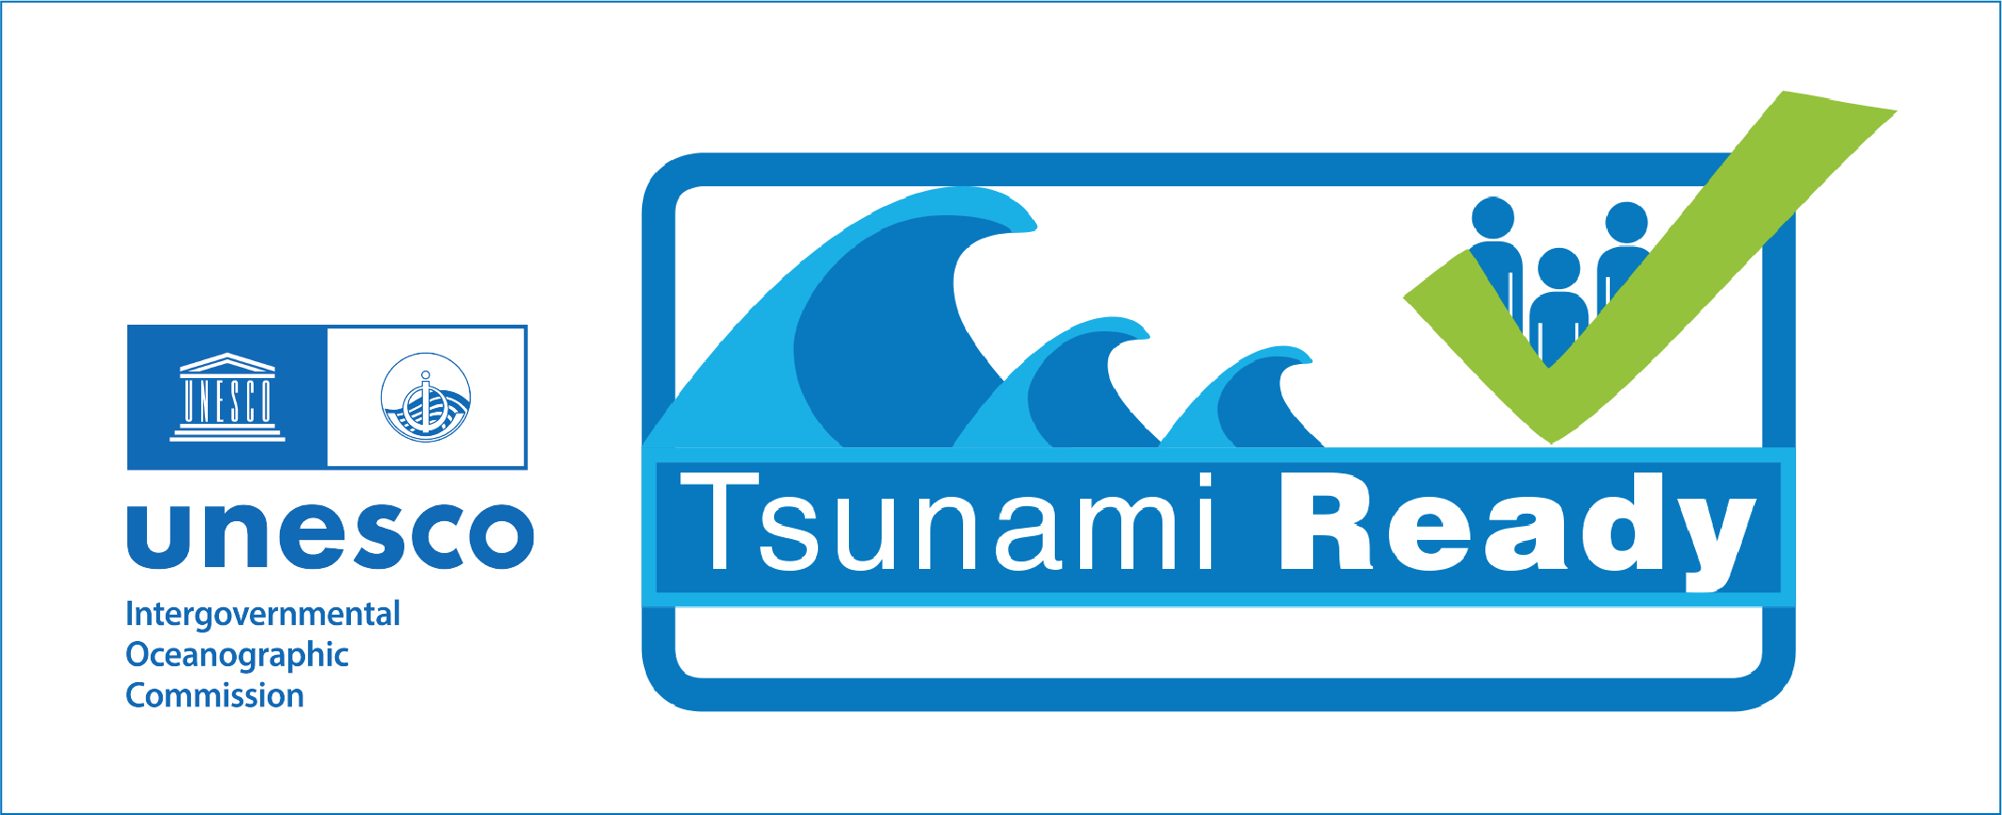
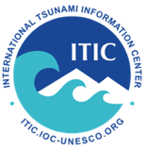


PALAU TSUNAMI WARNING AND PREPAREDNESS

PALAU TSUNAMI READY
Making 100% of communities at risk from tsunamis prepared and resilient to tsunamis

Tsunami Warning and Preparedness Strengthening Workshop
21 January 2026, 9 am to 3:30 pm
22 and/or 23 January 2026 (3 hrs total) 1:30 - 4:30 pm
WSO or NEMO Conference Room

In order to sustain and strengthen tsunami warning and preparedness in the Republic of the Palau, NOAA will facilitate a strengthening workshop with the Weather Service Office Palau (WSO) and the National Emergency Management Office (NEMO) on January 21 to 23, 2026. The workshop will review and update the existing Palau tsunami documents. The Group will also review their response and highlight challenges from the 2023 and 2025 off-Philippines, the 29 Jul 2025 Kamchatka tsunami and earlier events, where an evacuation was not required but there was potentially still a danger. Based on these events, it is suggested to establish Palau Tsunami Advisory level language, which will be a lower level of warning. The Palau Tsunami Advisory language is recommended when the Pacific Tsunami Warning Center (PTWC) or the Japan Northwest Pacific Tsunami Advisory Center (NWPTAC) issues an International Threat Message with a forecast tsunami wave amplitude between 0.3 and 1 meter. The product informs the public of actions to take, including to stay out of the water due to potentially strong currents or unusual waves. Participants are expected to be operational staff from the WSO Palau and Palau NEMO.

Resource Persons:
In-person:
Dr. Laura Kong, Director, International Tsunami Information Centre (ITIC), UNESCO-IOC NOAA, Honolulu, HI USA
Dr. Charles 'Chip' McCreery, Director, Pacific Tsunami Warning Center (PTWC), NOAA, Honolulu, HI USA
Landon Aydlett, Warning Coordination Meteorologist, Weather Forecast Office Guam, Agana, Guam USA
Marie Eblé, Tsunami Ready Project Manager, ITIC, Retired Deputy Director, NOAA PMEL/National Center for Tsunami Research
Ardito Kodijat, International Consultant for Tsunami Ready, Retired Head, IOC Indian Ocean Tsunami Information Centre, Banten, Indonesia (Jan 19-22)

Online (21 January 2026, 9 am - 12 noon):
Akira Okagaki, Senior Scientific Officer, Japan Northwest Pacific Tsunami Advisory Center

Meeting Web site:
https://oceanexpert.org/event/4937
Workshop documents and presentations will be posted on this web site
PROVISIONAL AGENDA
(version 19 January 2026)

DAY 1 - 21 January 2026

Session | Start Time | End Time | Topic | Speaker
1-5 |  |  | Wednesday, 21 January 2026
1-3 |  |  | Opening and Refreshers
1 | 9:00 | 9:15 | Welcome, Self-Introductions, Workshop Goal | Laura Kong, ITIC, All
2 | 9:15 | 9:30 | Refresher: Palau Tsunami Hazard Assessment, Tsunami Inundation Modelling | Kong
3 |  |  | Refresher: TSP Products
3.1 | 9:30 | 10:00 | PTWC Products | Chip McCreery
3.2 | 10:00 | 10:30 | NWPTAC Products | Akira Okagaki
 | 10:30 | 10:45 | COFFEE/TEA BREAK
4 |  |  | Review recent events: TSP products and  Palau response (challenges, gaps, needs). | All
PTWC, NWPTAC, ITIC, WFO Guam
Palau WSO and NEMO
4.1 | 10:45 | 11:30 | 2 Dec 2023 and 2025 - off-Philippines -  'local' tsunami | Kong, McCreery, Okagaki, All
4.2 | 11:30 | 12:00 | 29 July 2025 - Kamchatka event -  'regional/distant' tsunami | McCreery, Kong, Okagaki, All
 | 12:00 | 13:30 | LUNCH
5 |  |  | Review and Revision of Existing Tsunami Operations Documents. How to strengthen, minimize challenges, overcome gaps and needs
5.1 | 13:30 | 14:00 | Update existing SOPs, Alert Criteria, Messages, Communications Flow Chart  - National Tsunami Support Plan  - Criteria Table, SOPs  - Templates - Improving public text message content/format  - Timeline-driven SOPs - local, regional, distant  - States Tsunami Support Plan | Kong, All
5.2 | 14:00 | 14:30 | Event Staffing during events (PTWC, NWPTAC, WFO Guam, WSO, NEMO)  - Update Communications Flow, Contact Lists | Landon Aydlett, WFO Guam
5.3 | 14:30 | 15:00 | Strengthening Local Tsunami Procedures | McCreery, Kong
5.4 | 15:00 | 15:30 | Adding 'advisory' level language to existing products | McCreery, Kong

Tsunami Exercise and Drill - organized by Ministry of Education, NEMO
  - January 22, 9 am, Tsunami Tabletop - State Office
  - January 23, 9 am, Melekeok Elementary School Evacuation Drill and hotwash

DAY 2 - 22 and/or 23 January 2026, Afternoon

Session | Start Time | End Time | Topic | Speaker
6-8 |  |  | Thursday, 22 January 2026
6 |  |  | Sustaining Readiness through Regular Tsunami Communication Exercises
6.1 | 13:30 | 14:00 | Review of IOC Resources | Laura Kong, ITIC, All
6.2 | 14:00 | 14:30 | Establish Palau Tsunami Exercise Program (regular communication exercises with TSP products) | Kong, Aydlett
7 |  |  | Tabletop Tsunami Exercises
 | 14:30 | 16:00 | Local, Regional, Distant scenario (using TsuCAT to drive discussion exercise) | All
8 | 16:00 | 16:30 | Wrap-up and next steps | All

Additional Mission Needs
- Sustaining Tsunami Ready Recognition - Eble, WSO Majuro, NEMO
  - Renewal requirements
  - Using Indicator Activity Log for documenting renewal progress
  - Indicator activities support requests - Preparedness, Response

