Guidelines on Planning, Conducting and Evaluating UNESCO/IOC NeamWAVE 26 Tsunami Wave Exercise at the Local Levels

Contents
1.PLAN THE EXERCISE 3
1.1 Establish Exercise Tsunami Wave Planning Team 3
1.2 Arrange exercise planning meetings 4
1.3 Establish the Exercise Aim 4
1.4 Define Exercise Objectives 4
1.5 Appoint Evaluators 4
1.6 Confirm Agency Participation 4
1.7 Prepare Exercise Documentation 4
1.8 Pre-Determine Messages and Injects 5
1.9 Decide Master Schedule of Events List (Msel) 5
1.10 Set up the Exercise 6
1.11 Train the Evaluators 6
2. CONDUCT THE EXERCISE 8
2.1 Provide Exercise Briefings 8
2.2 Start the Exercise 8
2.3 Utilize MSEL 8
2.4 Encourage Spontaneity and Maintain Control 8
2.5 Sustain And Control Exercise Activity 9
2.6 End the Exercise 9
3. EVALUATE THE EXERCISE 9
3.1 Organize Debriefs 9
3.2 Evaluate Through Validation 10
3.3 Prepare Final Exercise Report 10
3.4 Follow-up Actions 10
ANNEX 1. CHECKLIST 12
Annex 2. Neamwave 26 tsunami exercise local level evaluation form 13
Annex 3. Neamwave 26 local level observers form 17
Annex 4. Sample press release for local media for neamwave 26 exercise 18
Annex 5. Neamwave 26 tsunami exercise- local level exercise controller master schedule of events 19
Annex 6. Log of events for agencies organizing the exercise 20

1.PLAN THE EXERCISE
  - Establish Exercise Tsunami Wave Planning Team
The Planning team should include:
- Exercise control staff: Director, coordinators, evaluators and agency representative
- Director: Coordination of the teams, planning, preparation, timing, implementation and documentation Monitoring master of schedule of events to ensure the exercise is proceeding according to plan. Preparedness of the exercise report.
- Planning coordinators: Maps, documentation, master schedule of events list, forms, exercise documents, reporting, liabilities, organizing cold and hot debriefs
- Technical coordinators: Communications and IT (lines, phones, printers, exercise log, stationaries etc.)
- Field support: Exercise venue (site access, car parking, approvals to use the sites, site inspection, safety requirements etc.), safety briefings, field video recordings, distribution of maps,brochures
- Public and media support: Media involvement, public relations, rooms for media, communication equipment training team-train the team and the evaluators
- Welcoming team: Accommodation, travel, meal, refreshments, observers etc.
- Agency Representatives: (Emergency responders, police, fire, first aid or similar) Representatives on behalf of their agency during the design and delivery phases:
- Being the main point of contact for their agency.
- Providing expert advice and input from the agency they represent.
- Having input into the scenario and providing control documents as required.
- Ensuring their agency’s input is consistent with that of other agencies.
- Responding to requests from exercise participants through either prepared control documents or the creation of new control documents.
- Evaluators: (experts in warning center, emergency response, or specific agency), evaluating and reporting on the achievement of outcomes and the extent to which the overall exercise objectives have been met, evaluating the effectiveness of exercise facilitation and management and providing input into the exercise debrief
- Observers (invited guests from other agencies) ,observing and assessing processes, procedures, and techniques.
  - Arrange exercise planning meetings
1. Concept and objectives meeting
2. Initial planning meeting
3. Mid-term planning meeting
4. Final planning meeting

  - Establish the Exercise Aim
The aim should be a clear, concise, achievable statement beginning with a verb and broadly defining what the exercise intends to accomplish.
  - Define Exercise Objectives
Objectives should be clear, measurable and performance-focused. A maximum of ten objectives per agency is recommended. Each objective should include an observable action, conditions and expected performance standards.
  - Appoint Evaluators
Each participating agency should appoint at least two evaluators. Evaluators must receive written instructions and evaluation tools before the exercise. If country/agency exercise evaluators are appointed, the in-country National Exercise Planning Team should provide them with a document in writing that provides the evaluator instructions and the evaluator tools. The overall evaluation tool/forms will be prepared and disseminated by the Exercise Tsunami Wave Task Team.
  - Confirm Agency Participation
Participation levels in exercise planning and execution: Full, partial, facilitation, not engaged.
  - Prepare Exercise Documentation
Documentation may include:
- Planning meetings/ agendas and minutes.
- Local level Master Schedule of Events List (MSEL)-printed
- Message/inject recording sheets for all control staff
- Guidance document for all Staff
- Exercise Program
- Printed evacuation maps
- Staff Memos
- Exercise Briefing notes/brochures and presentations to participants.
- Participant lists.
- Safety Briefings
- Media or press release templates
- Guidelines for evaluators
- Evaluators program
- Evaluators sheet
- Observer invitations
- Observer program
- Observers sheet
- Financial records
- Collated feedback from hot and cold debriefs.
- Corrective action plans.
Each participating agency should issue some guidance to staff participating in the exercise. A General Instruction should be issued once the Tsunami Wave manual is released.
Documents should be allocated a version number and distributed to participants during the exercise in an accurate and timely manner.
  - Pre-Determine Messages and Injects
Tsunami Warning Centre products are message injects. Standard message form should include a space for a message number, the time that the message is to be delivered, and the information that will prompt the action to be taken.
Messages and injects serve the purpose to generate a response. They can be transmitted in various ways:
- Landline telephone
- Cellular telephone, voice, or simple text message
- Satellite phone
- Mass media broadcasts, such as through Radio or Television
- In-person
- Written note
- Fax
- Email
In Tsunami Wave exercises, most messages are pre-determined, but it is advisable to anticipate potential challenges and provide the Exercise Director with ideas for handling unforeseen situations.
  - Decide Master Schedule of Events List (Msel)
List is a detailed sequence of events used by Exercise Control staff (programme, script, or running sheet). The local Master Schedule of Events List is prepared by the Director.
A Master Schedule of Events List is usually a spreadsheet that contains the following items:
- Contents
- Serial number
- Day/date
- Time
- Activity of event
- Location
- Desired outcome
- Control documents
- Comments/Remarks
- Initiator (who puts the message in)
- Recipient (who receives the message)
  - Set up the Exercise
The Exercise Planning Team will be responsible for the preparation and setup of the exercise per responsibilities given above.
To ensure a realistic simulation, it is crucial to conduct the exercise in the actual location(s) where normal operations occur and replicate the setup as it would be during a real event. The setup may vary based on the exercise's scale and complexity. When utilizing control staff, it is necessary to establish a dedicated exercise control room or facility for effective communication and coordination with the players.
  - Train the Evaluators
Evaluator training must take place before the exercise and address all aspects of the exercise, including:
- The exercise aim and objectives,
- The scenario,
- Participants roles
- Evaluator roles and responsibilities.
Before or during the training, provide evaluators with copies of the following materials to review before the exercise starts:
Exercise documents, such as the Exercise Pacific Wave manual, and agency General Instruction.
Evaluation materials such as: Exercise Evaluation tool/form, Master schedule of events list, Relevant plans, policies, procedures, and agreements of the exercising agency.
Evaluator training should also include guidance on observing the exercise discussion or operations, what to look for, what to record, and how to use the exercise evaluation tools. To promote effective observation, evaluators must be instructed to do the following:
- Be at the designated position when players arrive,
- Observe player actions (or player discussion) but avoid getting in the way or becoming involved,
- Focus on observing the activities and tasks in relevant exercise evaluation guidelines to ensure exercise objectives are accomplished,
- Take legible, detailed notes, including times and sequence of events,
- Remain at the assigned post at key times,
- Allow players to act and answer questions without prompting.
Evaluators should not interfere with exercise play. However, it may be necessary for an evaluator to interact with players during the exercise if he or she has a question about something observed.
Evaluators should wait until there is a break in activity to ask questions. These questions must not prompt or lead players in any way, and conversation should remain brief and focused.
- After the exercise, when writing preliminary analyses, evaluators should consider the following questions:
- Were the objectives of the exercise met?
- Did the discussion suggest that all personnel would be able to successfully complete the tasks necessary to execute each activity? If not, why?
- What are the key decisions associated with each activity?
- Did the discussion suggest that all personnel are adequately trained to complete the activities or tasks needed to demonstrate a capability?
- Did the discussion identify any resource shortcomings that could inhibit the ability to execute an activity?
- Do the current plans, policies, and procedures support the performance of activities? Are players familiar with these documents?
- Do personnel from multiple agencies need to work together to perform a task, activity, or capability? If so, are the agreements or relationships in place to support the coordination required?
- What should be learned from this exercise?
What strengths were identified for each activity?
What areas for improvement are recommended for each activity?
- CONDUCT THE EXERCISE
  - Provide Exercise Briefings
The Director can provide briefings to the Control staff and to the participants of the exercise. Various communication methods such as meetings, newsletters, and website visits can be used to share information, and a final briefing should be held prior to the exercise.
An initial exercise briefing is provided by the director to exercise participants, Exercise Control staff, and evaluators before the exercise begins. It should include the following key points: timing, Exercise boundaries, Locations, Expected outcomes, Safety briefing, and Exercise logistics briefings.
A second briefing must be given to Control staff to expand on the initial briefing and to state the range and limitations of their activities, including Roles and responsibilities, exercise documents, methods to be used, departures from scripts, responding to participant actions, and keeping notes for later debriefs.
Prior to the exercise, evaluators meet with the Exercise Director to confirm roles and responsibilities and receive updates. A briefing ensures clarity and may include a site tour for operations-based exercises, with a focus on prioritizing important events for evaluation.
  - Start the Exercise
Tsunami Wave exercises may be started immediately following the last participant briefing. The international and regional tsunami warning centers are responsible for sending the initial “Exercise Start Message” which will indicate the start of the exercise.
  - Utilize MSEL
The Exercise Director utilizes the Master Schedule of Events List (MSEL) to oversee and maintain the exercise, addressing any issues and adjusting the flow as needed to achieve objectives. Exercise Control staff play a crucial role by maintaining communication with the Exercise Director throughout the exercise to ensure its smooth operation.
  - Encourage Spontaneity and Maintain Control
Exercise Control staff must be well trained and prepared to handle the unexpected so that events can be brought back under control if required.
  - Sustain And Control Exercise Activity
Sustaining exercise activity involves a continuous injection of information to participants, carefully monitoring the timing, and adjusting the rate of injects based on their reactions. Control is important to manage unexpected participant responses and prevent disruptions, and the Exercise Director can intervene and use spontaneous injects to maintain the exercise's flow.
The Director also ensures proper marking and tracking of injects while being prepared to temporarily pause the exercise to resolve issues. Controlling the pace is achieved by adjusting inject flow to maintain a positive experience for participants and simulate real-world communication challenges.
  - End the Exercise
Concluding the exercise is a controlled process led by the Exercise Director, who determines the pre-planned ending time, such as with an international cancellation tsunami bulletin. Following the exercise, an immediate hot debrief is conducted to capture valuable feedback from participants and staff.
- EVALUATE THE EXERCISE
  - Organize Debriefs
Reviewing and validating the exercise helps evaluate an agency's Standard Operating Procedures (SOPs) and assess areas such as the availability of written SOPs, standardized communication templates, and stakeholder education.
The evaluation and validation serve two main purposes: identifying areas for improvement and determining if the exercise successfully achieved its objectives.
A post-exercise debrief is a crucial evaluation that assesses the exercise's performance, identifies areas of success and issues encountered, and provides recommendations for improvement. Organizational debriefing aims to gather staff experiences to identify lessons learned, which can then be used to enhance plans, procedures, training, and overall response capabilities. Inclusive participation of all staff, regardless of seniority, is essential, emphasizing improvement rather than assigning blame. Activities following the exercise include report preparation, organizational debriefs, plan and arrangement reviews, and documenting and implementing lessons.
Hot debrief: Conducted immediately after an exercise, allows participants to provide feedback while the experience is still fresh. It typically includes a short break, initial feedback from the Exercise Director, round-table feedback from participants, feedback from evaluators, and appropriate acknowledgments.
Cold debrief: Formal evaluation held within four weeks after the exercise. It involves discussing what occurred during the exercise, identifying strengths and areas for improvement, determining necessary amendments to plans and procedures, addressing follow-up actions and capability gaps, assessing the exercise's realism, and seeking suggestions for improvement.
  - Evaluate Through Validation
The evaluation forms must be completed and collated, and a validation of the exercise conducted. The validation will be presented in the form of an end-of-exercise report, prepared by the Exercise Tsunami Wave Task Team.
The final stage of the exercise process assesses whether the exercise has achieved its objectives and provided a realistic performance opportunity. It involves measuring the exercise's value and identifying strategic improvements. Validation answers questions about addressing identified needs, resemblance to real-world scenarios, and impact on agency policies and individual performance.
  - Prepare Final Exercise Report
The final Exercises Tsunami Wave Summary Report:
- Provides a description of what happened.
- Describes best practices or strengths.
- Identifies areas for improvement.
- Provides recommendations for improvement.
- Collates and provides a summary of the country evaluations.
  - Follow-up Actions
In each country/agency, the Tsunami Wave National Contact or Exercise Coordinators should assign responsibility for each action point, establish a monitoring plan, and provide regular progress reports to senior officials. Additional follow-up actions may include returning equipment, settling exercise-related accounts, and issuing letters of appreciation.

Please see the checklist (Annex 1) for the summary of the actions before, during and after the exercise

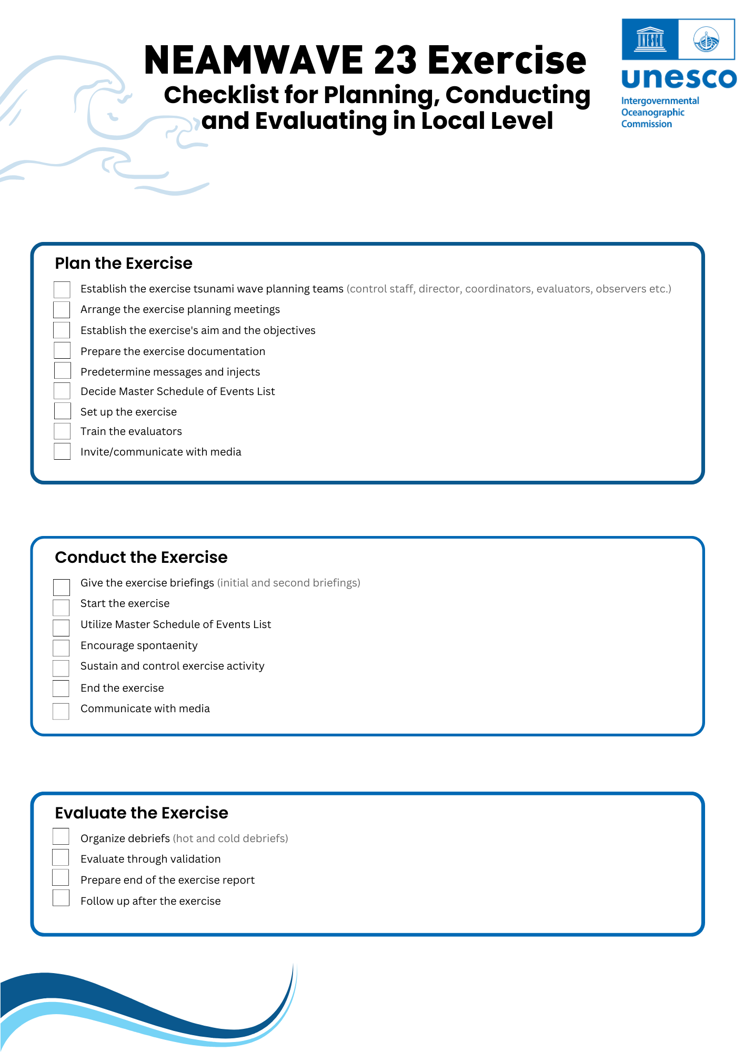
ANNEX 1. CHECKLIST

ANNEX 2. NEAMWAVE 26 TSUNAMI EXERCISE LOCAL LEVEL EVALUATION FORM

Exercise director’s name
Type of Exercise
Evaluator’s name and organization
Evaluator’s email
Date and location
Weather conditions (temp./rainny-sunny etc.)

The objective of this evaluation is to assess the efficiency of the Tsunami Response Plan and local authorities through the exercise to identify areas that need to be strengthened in the plan or at the community level to ensure a better response in case of a real event.
Please consider the following Exercise objectives. Check if the followings are true:
- The warning system is timely and efficient.
- Tsunami warning systems are heard in the entire evacuation area.
- The community is well prepared and trained to respond in case of a tsunami.
- Tsunami evacuation is carried out in time and in an orderly manner.
- The system takes care of people with disabilities.

Timeline of Actions to Evaluate
Type of Message | Sender of message | Receiver (organization/entity) of the message | Time sent (local time) | Communication method | Response

Actions | Time (hr) (example:3:15pm) | Yes/no
First message received
Decision of sending the alert
Preparation of the statement together with the alert
Activation of public notification systems
Ending time of tsunami warning cancellation
Total time of the exercise
Population evacuated?
The evacution map was available ?
The media was informed?
Was the “all clear” message sent?

Actions Taken After Receiving the Messages

- Were the messages disseminated to other organizations or entitites? If so, to which organizations?

- What kind of measures were taken?

- Message dissemination methods used:

- The media were informed? (yes/no):

- A hot debrief after the exercise was organized? (yes/no) , if yes, hot lessons learnt:

- Community knowledge level about the tsunami risk and your evaluations: (high/low/none etc.)

- Do you think that the exercise improved tsunami planning and community tsunami warning capacity? (Yes/no, why?)

- Please rate the exercise planning, development, format and style (poor/average/good/excellent, why?):

- What improvements are needed in the future exercise?:

Please attach this form to your report and submit to CoastWAVE project coordinator. The evaluation form can be adapted accordingly.

ANNEX 3. NEAMWAVE 26 LOCAL LEVEL OBSERVERS FORM

Weather:
Other notes to mention:
Name of Exercise Director
Name and contact info. of the Observer
Type of Exercise: | Location of Exercise: |  | Scheduled Date/  time:
Objectives of exercise:
Involved agencies/entities:

Hot lessons learnt:

ANNEX 4. Sample Press Release for Local Media for Neamwave 26 Exercise

[Use agency letterhead]
Contact:
[Name, Occupation,E-mail, phone number]
FOR IMMEDIATE RELEASE
DATE: [--/--/----]

[Insert community name] will participate in a tsunami response exercise on [insert date]. The purpose of this exercise is to evaluate local tsunami response plans, increase tsunami preparedness, and improve coordination throughout the community.
[insert a promotional comment from a local official, such as "The 2010 Haiti, 2010, 2014, 2015 Chilean, 2011 Japan, and the recent 2018 Sulawesi earthquakes and tsunamis have reminded the world of the urgent need to be more prepared to such events,” said (insert name of appropriate official]. “This important exercise will test the current procedures of the Tsunami Warning System and help identify operational strengths and weaknesses in each community.” [Please modify for uniqueness]
The exercise, [insert title], will simulate a widespread Tsunami Threat situation throughout [insert location] which requires implementation of local tsunami response plans. The exercise will [insert “include” or “not include”] public notification.
[Insert paragraph tailored for specific community. Please identify agencies and specific plans. Please describe current early warning programs, past tsunamis exercises (if any), ongoing mitigation and public education programs, etc. Please specify tsunami threats, history of tsunami hazards, if any].
If any real tsunami threat occurs during the time period of the exercise, the exercise will be terminated.
For more information on the NEAMWave23 Tsunami Exercise, follow the link.

ANNEX 5. NeamWAVE 26 Tsunami Exercise- Local Level Exercise Controller Master Schedule of Events

Time received  (local) | Event | Receivers (ex. School director, EMA, NTWC etc.)
 | Earthquake Occurs
 | Large P-wave signals at seismic stations in west of Crete trigger earthquake alarms
 | Alexandria Radio calls NTWC. Their building was swaying. What has just happened? Where was the earthquake?
 | Alexandria television informed the people feel the earth shook and some people are confused. Traffic started to get congested in Alexandria.
 | NTWC reports Preliminary earthquake hypocenter and magnitude from TSP: 35.31 N 23.26 E, 20km depth, Mw=7.5
 | TSP Message 1 received (Mw=…)
 | Information begins circulating on social media that tsunami has flooded the west coast of Alexandria. The school started to be inundated.
 | TSP Message 2 received (Mw upgraded to…)
 | Local media calls EMA to ask about the earthquake and whether it will generate a tsunami in Alexandria. If yes, when will it hit?
 | TSP Message 3 received with a regional forecast (Mw…) and some initial observations.
 | School in Egypt director is to ask about the earthquake and whether it will generate a tsunami in Sidi Barani. If yes, when will it hit? Should they start evacuating the students?
 | EMA of Alexandria, Egypt calls NTWC to ask for any reported wave heights as they are trying to determine if threat exists. Is there anything to be worried about?
 | TSP Message 4

ANNEX 6. Log of Events for Agencies Organizing the Exercise

TEAM/AGENCY NAME:

Time- (local) | From | To | Communication Method | Activity / Action | Comments

