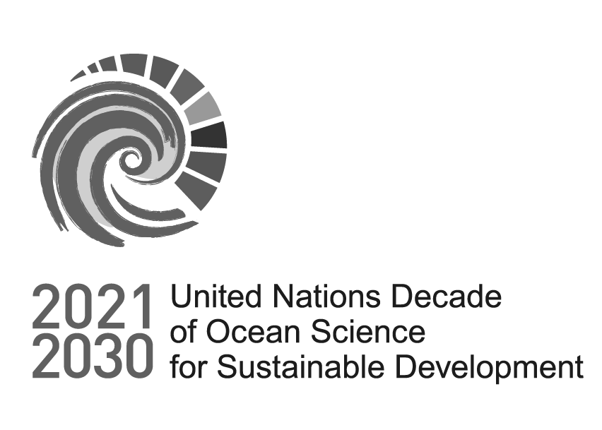
Programme Review: Call for Decade Actions No 10/2025
Dear reviewer,

Thank you for participating in this process.

Please make sure that you have carefully read the proposal and the guidelines before proceeding with your assessment.

IMPORTANT: If you have a conflict of interest with the proposal assigned to you, please do not proceed with the assessment and notify us by submitting your Conflict of Interest (see Annex I of the Guidelines) to oceandecade@unesco.org.
- 1. Name of the Reviewer

- 2. Email of the Reviewer

  - 3. Programme proposal being reviewed

  - 4. Conflict of Interest Statement
I confirm that I do not have any Conflict of Interest with the proposal assigned to me.

Part A: Programme Eligibility
Programme Review: Call for Decade Actions No 10/2025

In this first part of your assessment, the aim is to gather feedback on whether the submission meets the requirements to be considered at the scale of a Decade programme, rather than another type of Decade Action.

5. Is the approach and/or team's expertise multidisciplinary in nature?
Yes No

6. Are the listed partners international in scope?
Yes No

7. Does the lead institution have an international remit and experience that matches the submission’s ambition??
Yes No

8. Does this proposal explain well how capacity development will be included?
Yes No

9. Does this proposal demonstrate an ability to expand (add partners, grow geographically)?
Yes No

10. Does this proposal go beyond work that is already being undertaken (beyond business as usual)?
Yes No

11. Does the proposal have clear pathways for scientific knowledge to inform decision- making processes?
Yes No
Part B: Alignment to the Ocean Decade’s Endorsement Criteria
Programme Review: Call for Decade Actions No 10/2025

In this section, please assess whether the proponent has adequately addressed how their proposal aligns with the endorsement criteria (Questions 35–42 of the application form).

12. Please rate, on a scale from 0 to 5, how well the proponents have addressed each endorsement criterion.
Please consult the Guidelines to understand what each score means.

Score
Contributes to achieving one or more of the following Decade objectives: Objective 1: Identify critical ocean knowledge; Objective 2: Build capacity and generate knowledge; Objective 3: Increase the use of ocean knowledge
Accelerates the generation or use of knowledge and understanding of the ocean, with a specific focus on knowledge that will contribute to the achievement of the SDGs and complementary policy frameworks and initiatives.
Is co-designed and/or co-delivered by knowledge generators and users, and thus facilitating the uptake of science and ocean knowledge for policy, decision-making, management and/or innovation.
Ensures that all data and resulting knowledge are provided in an open access, shared, discoverable manner
Strengthens existing or creates new partnerships across nations and/or between diverse ocean actors, including users of ocean science.
Contributes toward capacity development, including, but not limited to, beneficiaries in SIDS, LDCs and LLDCs.
Overcomes barriers to diversity and equity, including gender, generational and geographic diversity.
Collaborates with and engages local and indigenous knowledge holders.

- 13. Please provide comments supporting your scoring of the proponents’ answers to each endorsement criterion (max. 5000 characters per answer).
Contributes to achieving one or more of the following Decade objectives: Objective 1: Identify critical ocean knowledge; Objective 2: Build capacity and generate knowledge; Objective 3: Increase the use of ocean knowledge

Accelerates the generation or use of knowledge and understanding of the ocean, with a specific focus on knowledge that will contribute to the achievement of the SDGs and complementary policy frameworks and initiatives.

Is co-designed and/or co-delivered by knowledge generators and users, and thus facilitating the uptake of science and ocean knowledge for policy, decision-making, management and/or innovation.

Ensures that all data and resulting knowledge are provided in an open access, shared, discoverable manner
Strengthens existing or creates new partnerships across nations and/or between diverse ocean actors, including users of ocean science.

Contributes toward capacity development, including, but not limited to, beneficiaries in SIDS, LDCs and LLDCs.
Overcomes barriers to diversity and equity, including gender, generational and geographic diversity.

Collaborates with and engages local and indigenous knowledge holders.
Part C: Final Conclusions
Programme Review: Call for Decade Actions No 10/2025

14. Is this proposal aligned with the Decade Challenge selected?
Please refer to Question 1 in the programme proposal.
Yes No

15. Do you recommend that this proposal should be endorsed as a Decade Programme?
Yes No

- 16. Please provide comments that support your assessment (max. 5000 characters).

17. If there are any specific questions you think the proponents should answer to help ensure a more informed decision, please list them below as bullet points.

